Engagement Analysis: mcAMNsmT6uE

Section 0: Image 1 - Speaker Not Found
Time: 10:05 - 10:08

Summary
The image displays a graphic with text and design elements that suggest a promotional or informational context. The main message reads "THANKS FOR WATCHING" and features a stylized speech bubble with the words "SPEAKER NOT FOUND", indicating that no speaker or presenter is visible in this frame.

Representative Frames
10:05  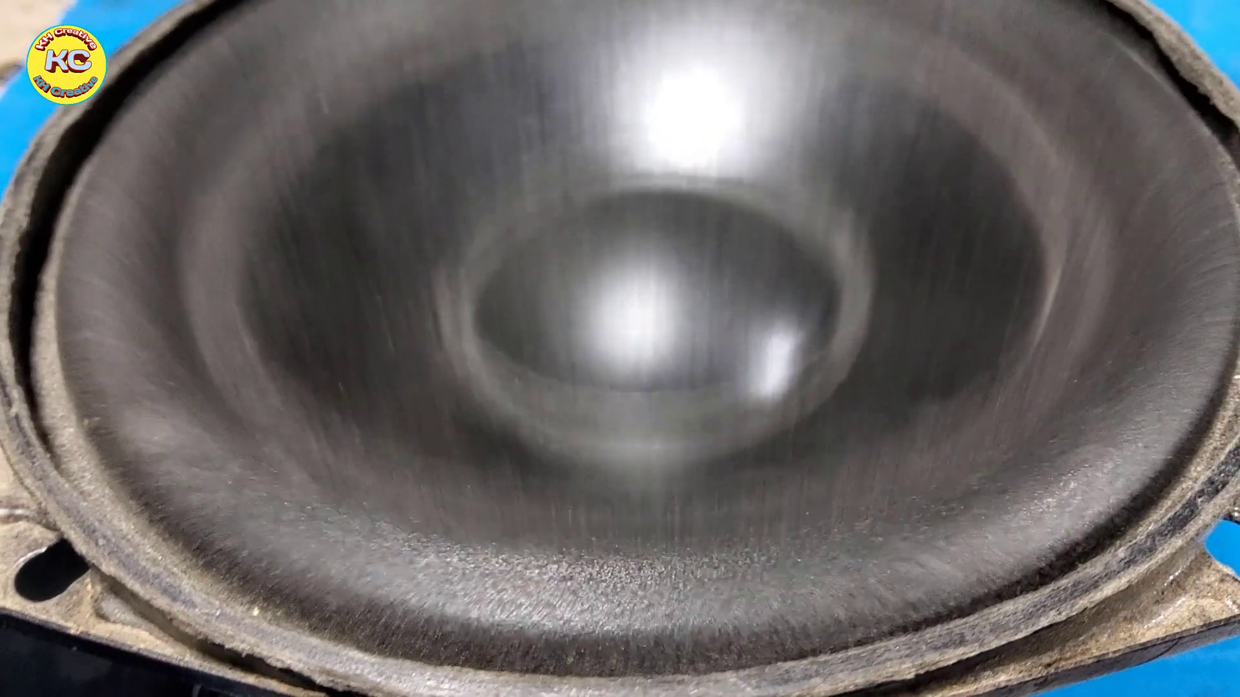 | 10:06   | 10:06   | 10:07   | 10:07  

Transcript
(No speech detected in this section)

Section 0: Image 2 - LIKE & COMMENT!
Time: 10:08 - 10:11

Summary
The image displays a striking visual message displayed against a background. At the top right corner of the screen is a graphic of a thumbs up sign overlaid text that reads "LIKE & COMMENT" in capital letters, indicating an interactive element common to social media platforms.

Representative Frames
10:08   | 10:09   | 10:09  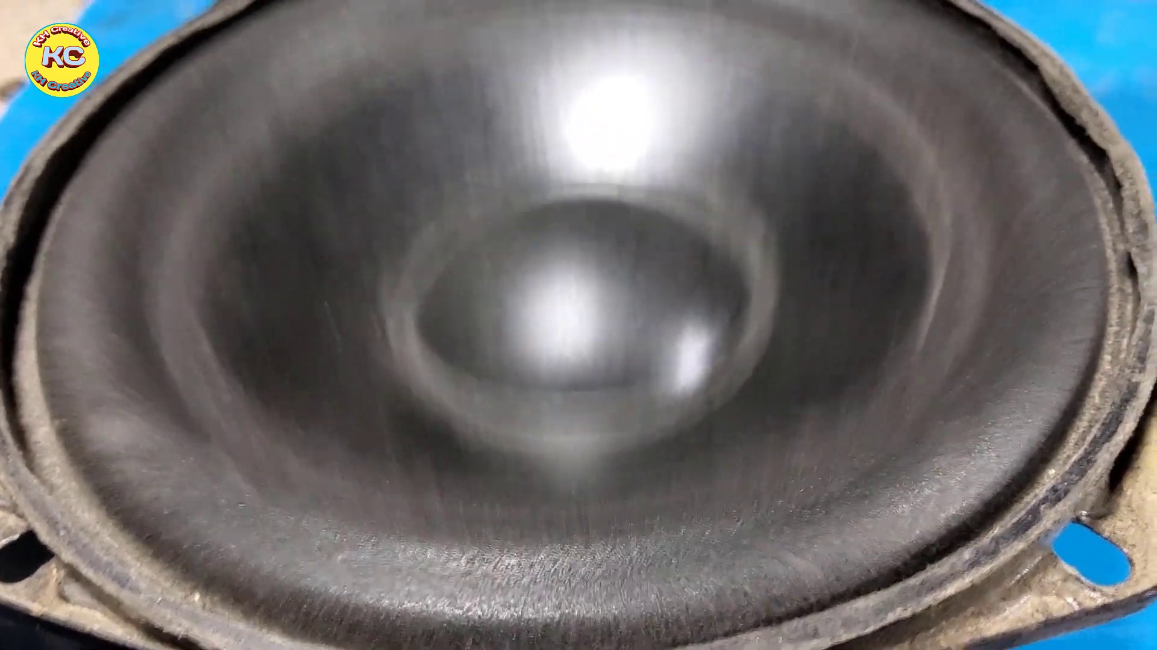 | 10:10   | 10:10  

Transcript
(No speech detected in this section)

Section 0: Image 3 - Subscribe
Time: 10:11 - 11:10

Summary
The image presents a captivating scene centered around the word "Subscribe". Dominating the center of the image is a bright red logo, consisting of a stylized letter "R" inside a circle with a partial view of a planet or moon.

Representative Frames
10:20  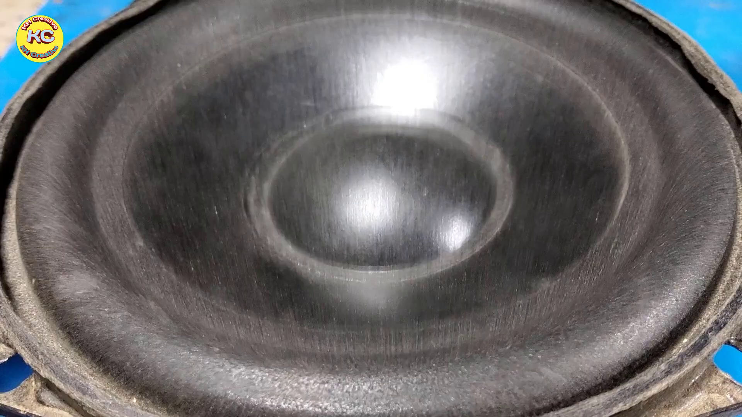 | 10:30  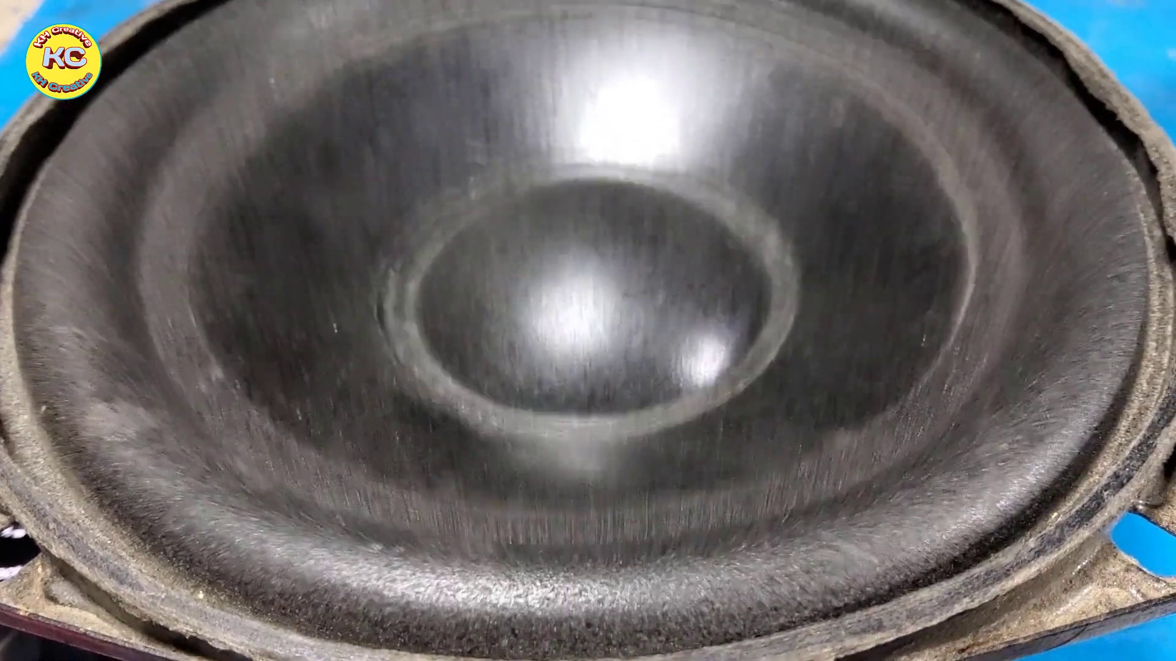 | 10:40  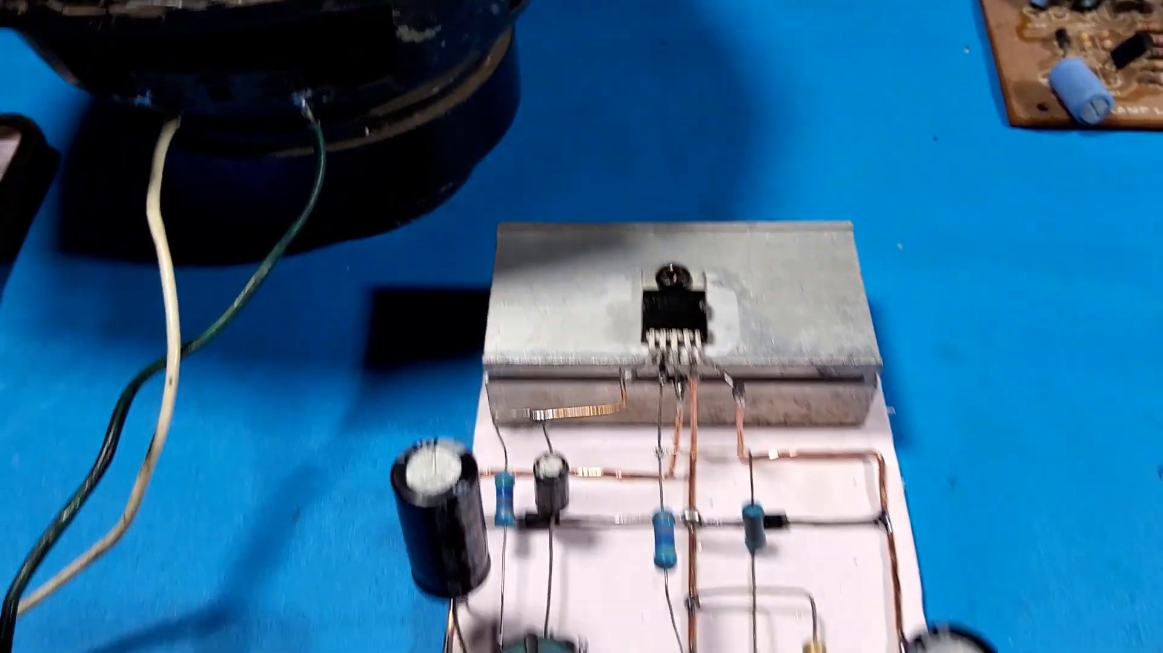 | 10:50   | 11:00  [No Frame]

Transcript
[9:59] Yes, yes, yes, yes
[10:29] Yes, yes, yes, yes
[10:34] Yes, yes, yes
[10:38] Yes, yes, yes
[10:40] Thank you.

