Engagement Analysis: muGlauyfOGsT

Section 0: Image with Computer Screen and Striped Banner
Time: 0:08 - 0:09

Summary
An image featuring a low-resolution video playing on a computer monitor, accompanied by a red and white striped banner against a dark blue background.

Representative Frames
0:08  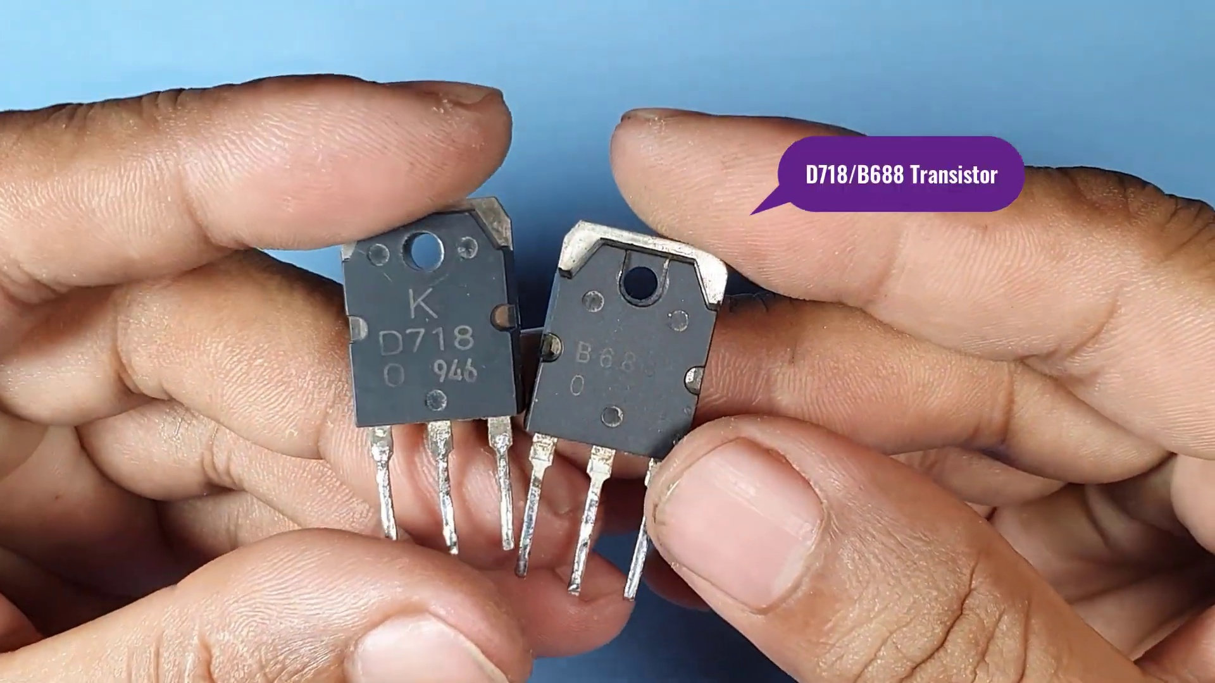 | 0:08   | 0:08   | 0:08   | 0:08  

Transcript
(No speech detected in this section)

Section 0: Call-to-Action Graphic Design
Time: 0:09 - 0:10

Summary
A striking graphic design with a thumbs-up gesture, text, and icons inviting users to like and comment on some content or action.

Representative Frames
0:09   | 0:09   | 0:09   | 0:09   | 0:09  

Transcript
[0:01] Jo Turner

Section 0: Animated Slideshow on Computer Screen
Time: 0:10 - 0:11

Summary
An image featuring an animated slideshow presentation on a computer screen, with a title 'THANKS FOR WATCHING' displayed prominently.

Representative Frames
0:10  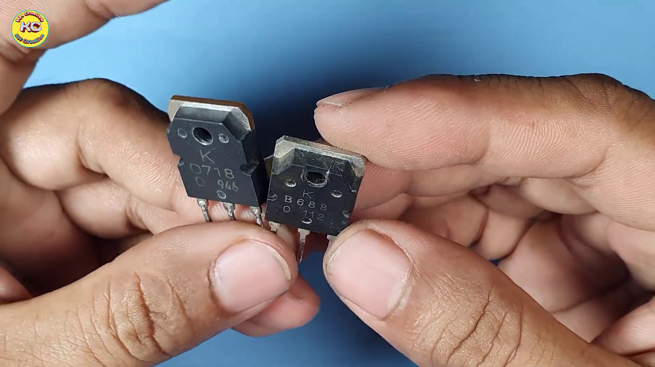 | 0:10   | 0:10   | 0:10   | 0:10  

Transcript
(No speech detected in this section)

Section 0: Thank You Message
Time: 0:11 - 0:12

Summary
A simple 'thank you' message spoken by the narrator.

Representative Frames
0:11   | 0:11   | 0:11   | 0:11   | 0:11  

Transcript
(No speech detected in this section)

Section 0: Computer Screen with Slideshow and Arrow
Time: 0:12 - 0:13

Summary
An image featuring a computer screen displaying a slideshow, accompanied by a bold red arrow extending from the top left corner to the bottom right corner.

Representative Frames
0:12   | 0:12   | 0:12   | 0:12   | 0:12  

Transcript
(No speech detected in this section)

Section 0: Computer Workstation with Electronic Device Creation
Time: 0:13 - 0:14

Summary
An image depicting an individual creating an electronic device at a computer workstation, requiring attention to detail and understanding of electronics.

Representative Frames
0:13   | 0:13   | 0:13   | 0:13   | 0:13  

Transcript
(No speech detected in this section)

Section 0: Thank You Message (Alternative Version)
Time: 0:14 - 8:47

Summary
A thank you message displayed on a black background with the word 'WATCHING' written in red.

Representative Frames
1:39  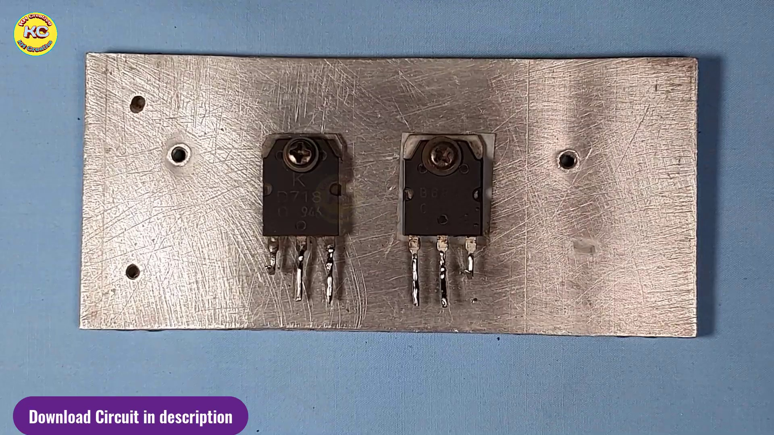 | 3:05  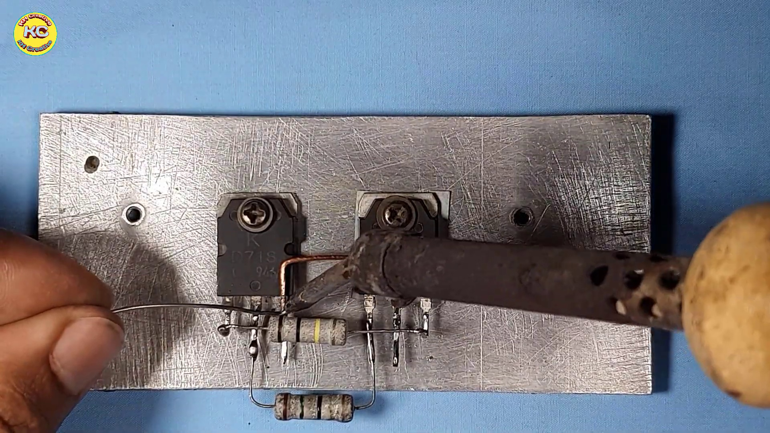 | 4:30  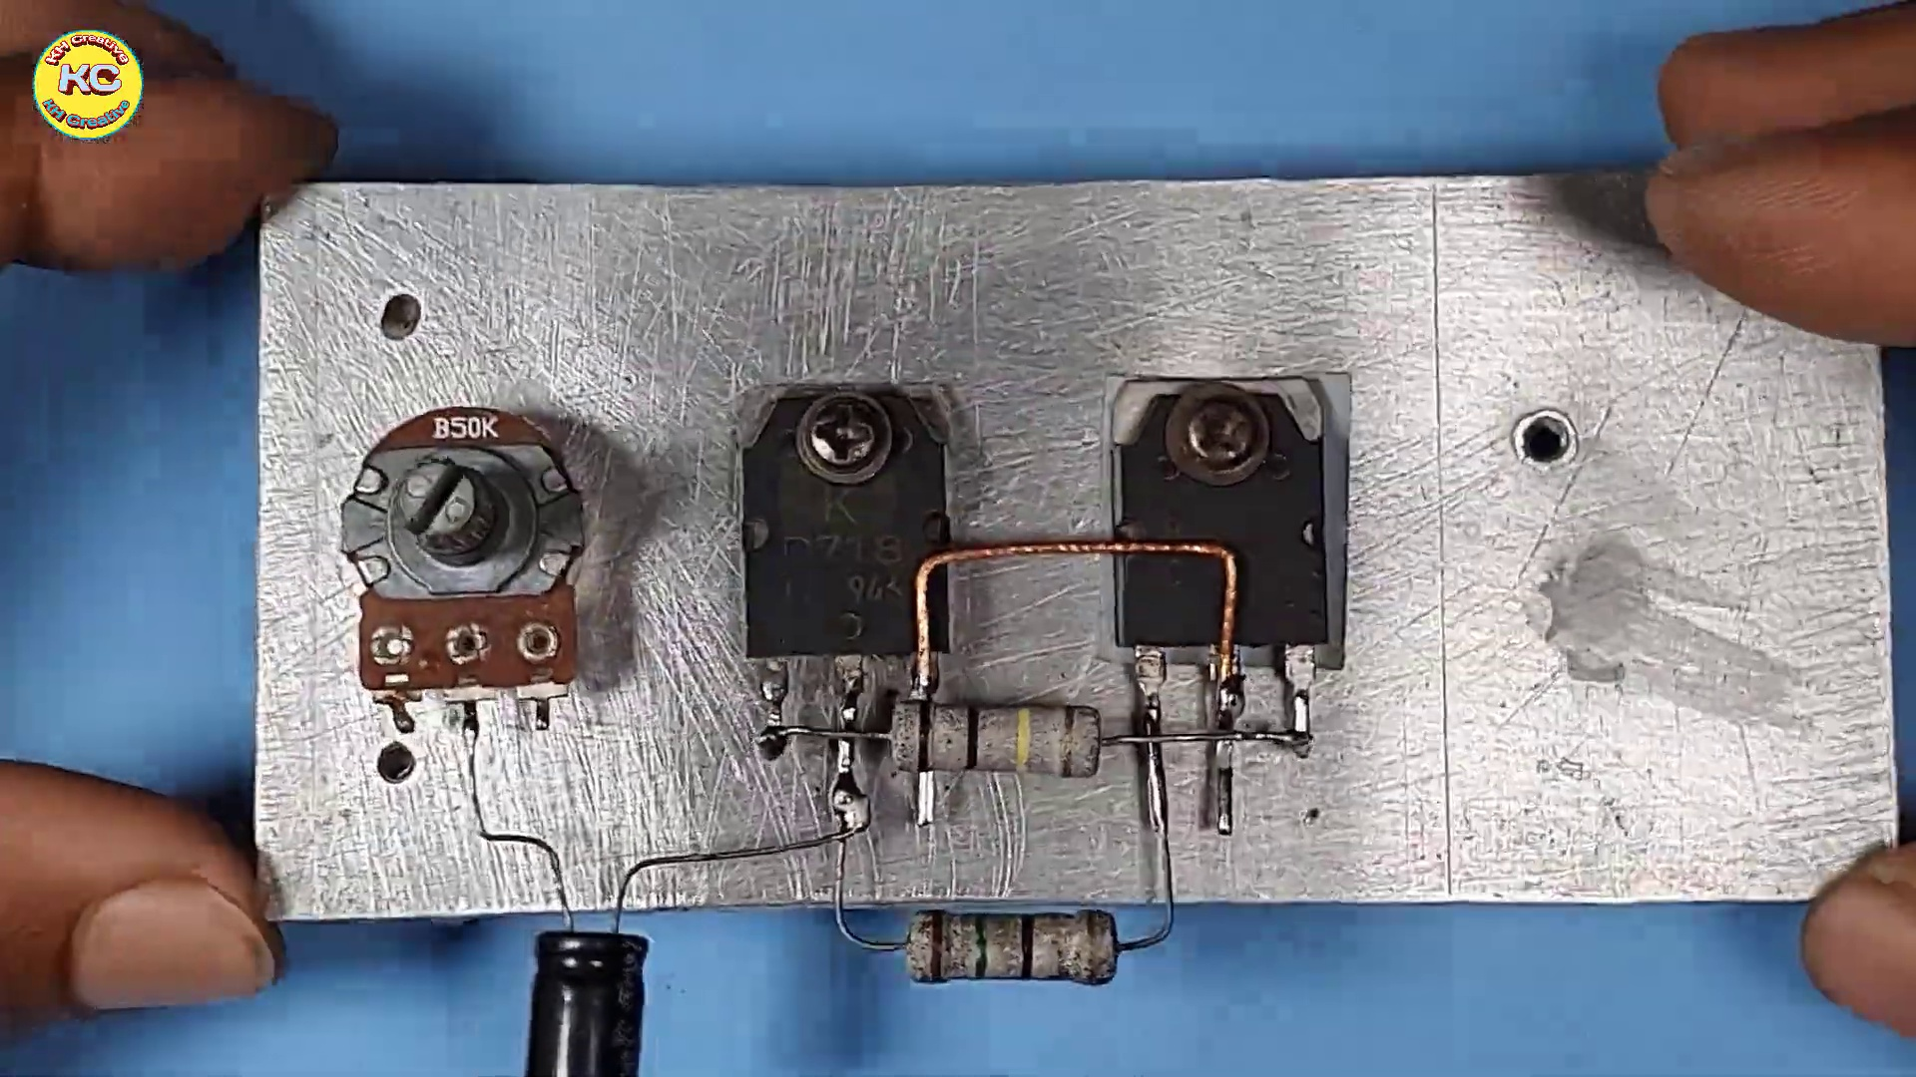 | 5:56  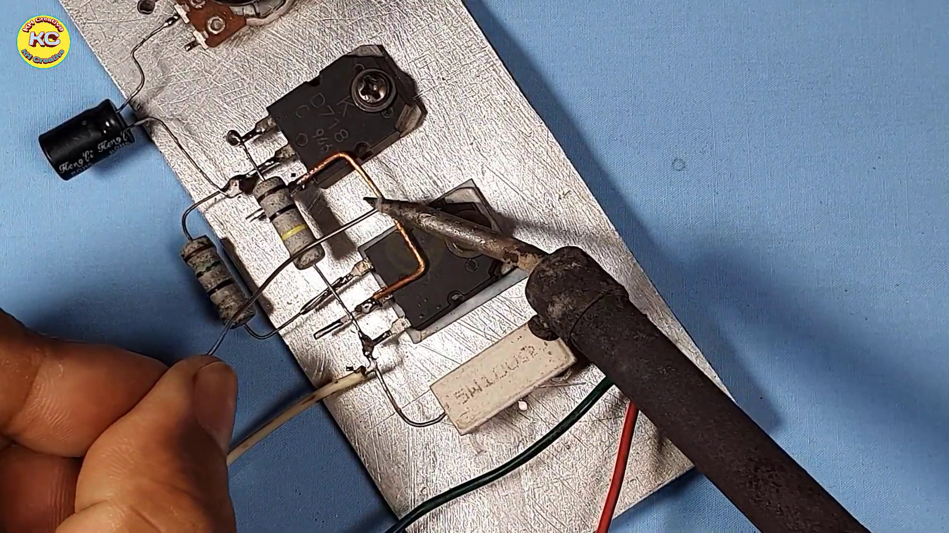 | 7:21  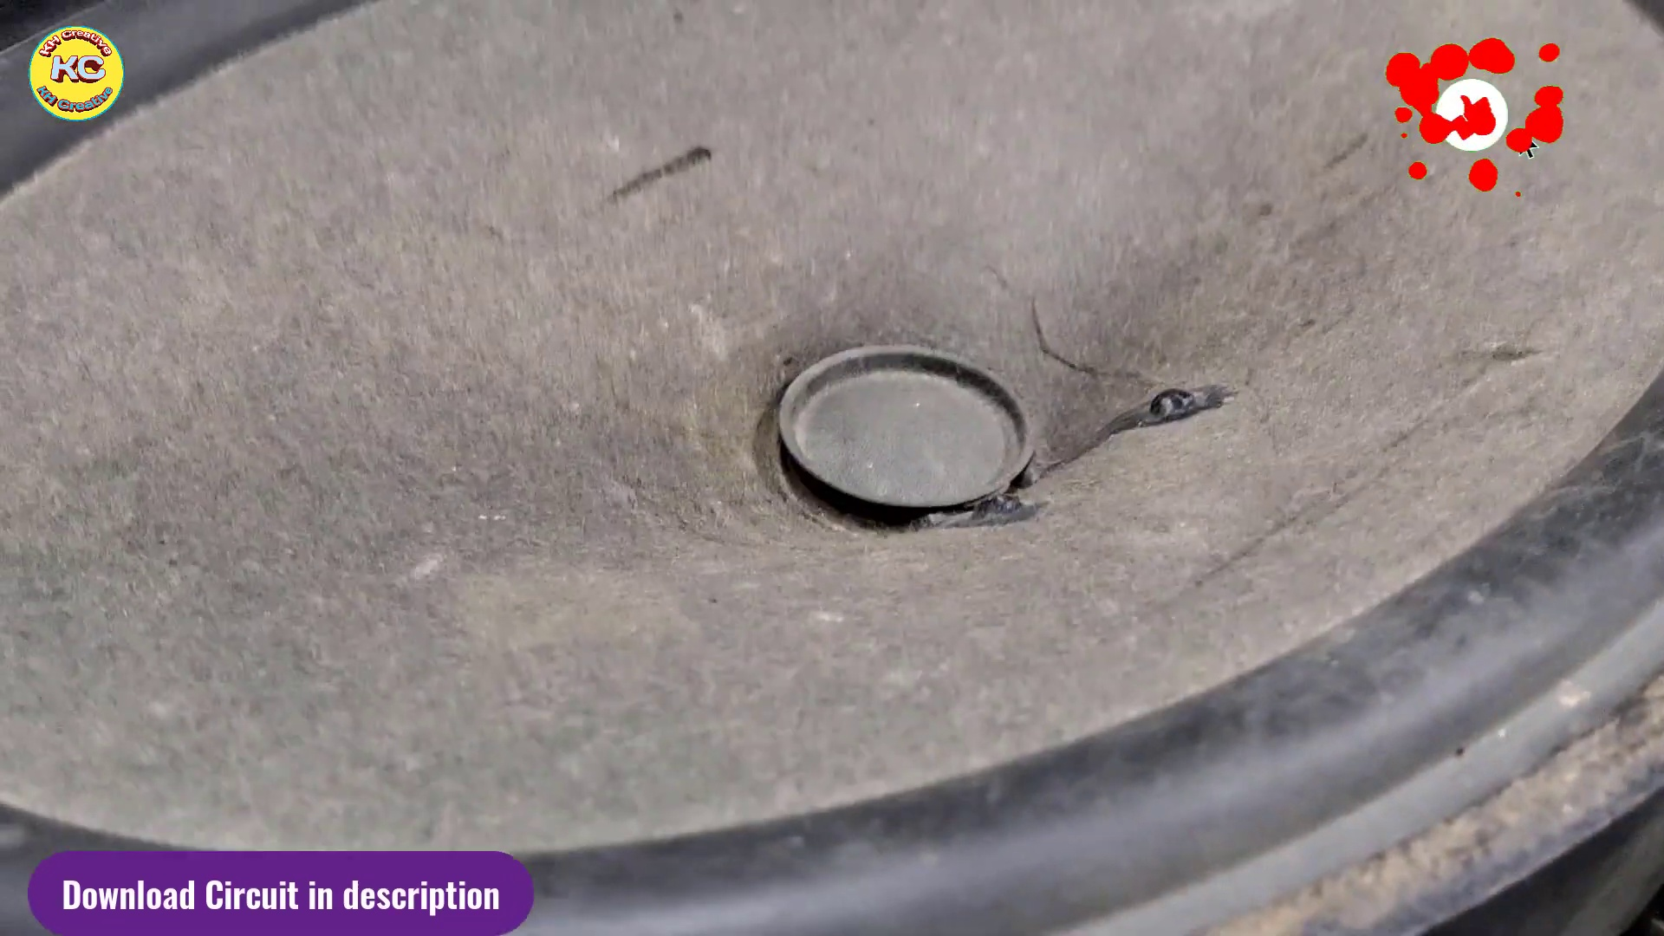

Transcript
[0:18] Click trailer so you can describe how I then access kaikkiού.
[0:26] This is very valuable for following theяжity service
[0:34] In addition you are enjoying the residential food style.
[0:38] This goes on 5th in 145.
[0:41] It's passed around 15 Import normalized
[0:47] Thank you.
[1:17] Thank you.
[1:47] Thank you.
[2:17] Thank you.
[2:47] Thank you.
[3:17] Thank you.
[3:47] Thank you.
[4:17] Thank you.
[4:47] Thank you.
[5:17] Thank you.
[5:47] Thank you.
[6:17] Thank you.
[6:47] Thank you.
[7:17] Thank you.
[7:47] Thank you.
[8:17] Thank you.

