Engagement Analysis: qNLvoSQCx60

Section 0: Introduction to GREATSCOUT Educational Videos
Time: 10:00 - 10:02

Summary
The video series appears to focus on educational and technical content, covering topics such as electronics, engineering, cardiology, and audio production. The videos are likely created by GREATSCOUT or its affiliates.

Representative Frames
10:00  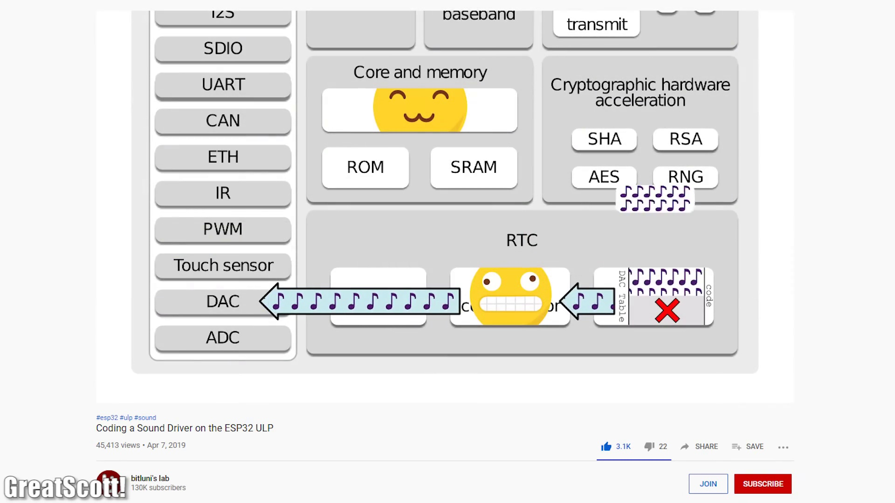 | 10:00   | 10:01   | 10:01   | 10:01  

Transcript
(No speech detected in this section)

Section 0: ECG Monitor Analysis
Time: 10:02 - 10:04

Summary
The video shows an instructor analyzing heartbeat signals on an ECG monitor in a medical or educational setting. The focus is on the display screen and the instructor's hands, indicating that the content is likely related to cardiology.

Representative Frames
10:02   | 10:02   | 10:03   | 10:03   | 10:03  

Transcript
(No speech detected in this section)

Section 0: Oscilloscope Measurement
Time: 10:04 - 10:06

Summary
The video displays an oscilloscope measuring electrical signals in a technical or educational setting. The focus is on the software interface and signal analysis being demonstrated, suggesting that the content is related to electronics or engineering.

Representative Frames
10:04  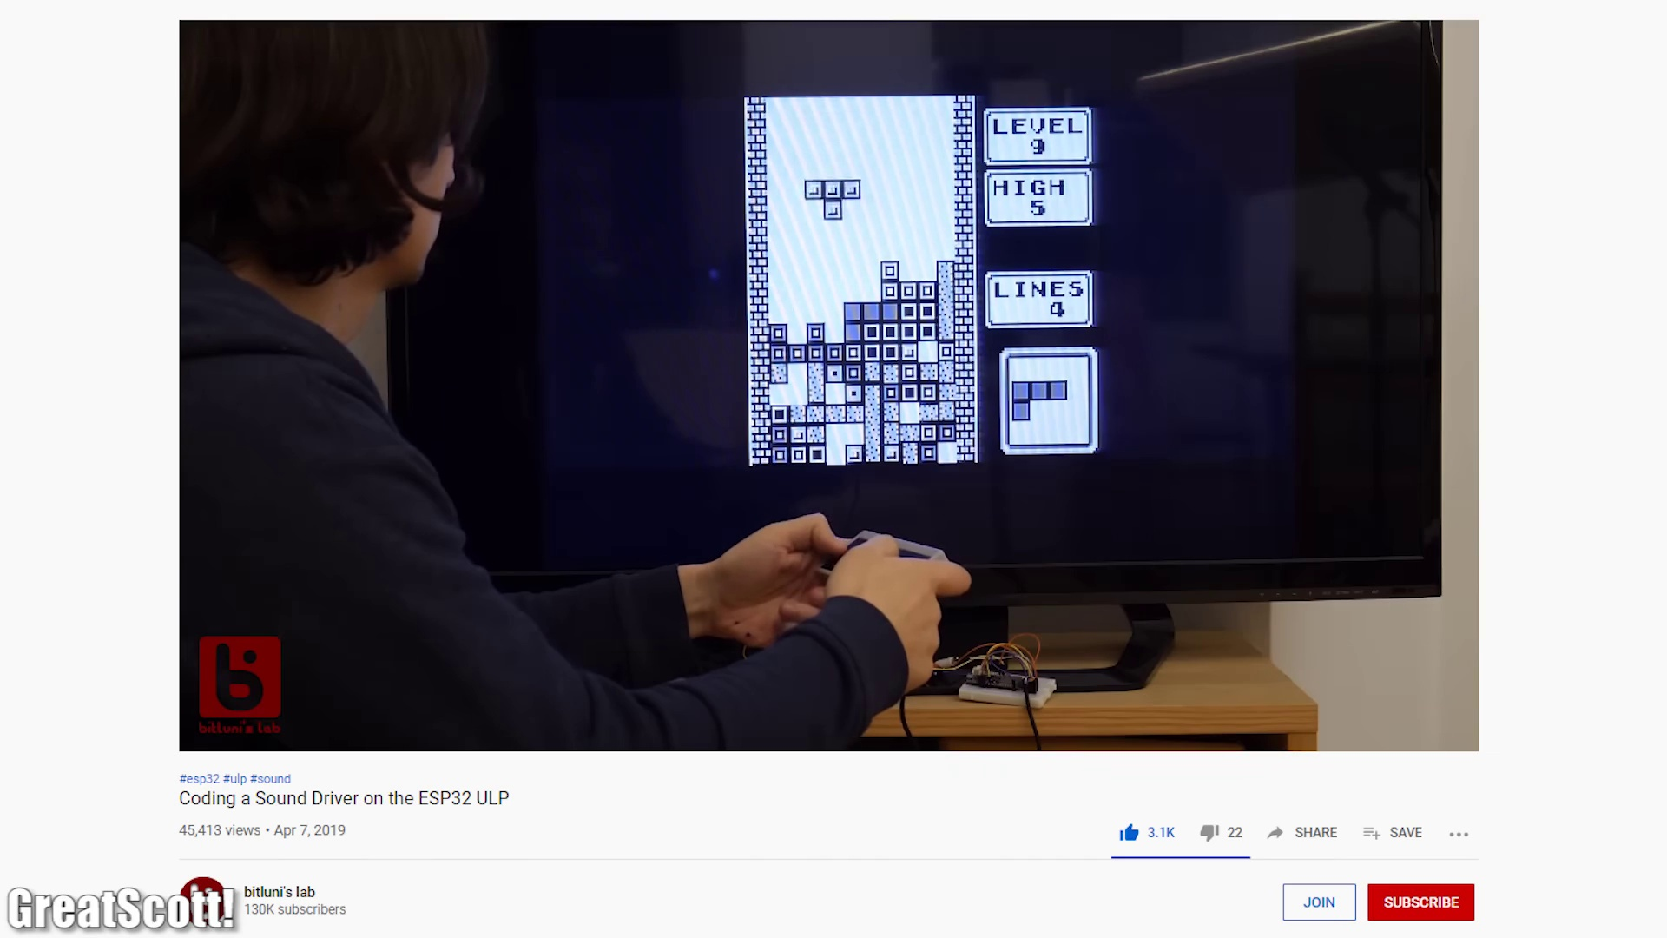 | 10:04   | 10:05   | 10:05   | 10:05  

Transcript
(No speech detected in this section)

Section 0: Audio Production Software Demonstration
Time: 10:06 - 10:08

Summary
The video shows an instructor demonstrating how to use audio production software in a classroom setting. The focus is on the digital audio workstation interface and the waveforms being analyzed, indicating that the content is related to audio production or music editing.

Representative Frames
10:06   | 10:06   | 10:07   | 10:07   | 10:07  

Transcript
(No speech detected in this section)

Section 0: Word Select Analysis Tool
Time: 10:08 - 10:22

Summary
The video shows a tool for analyzing signals and decoding data on a display screen. The focus is on the waveform being displayed, which suggests that the content is related to signal analysis or processing.

Representative Frames
10:10  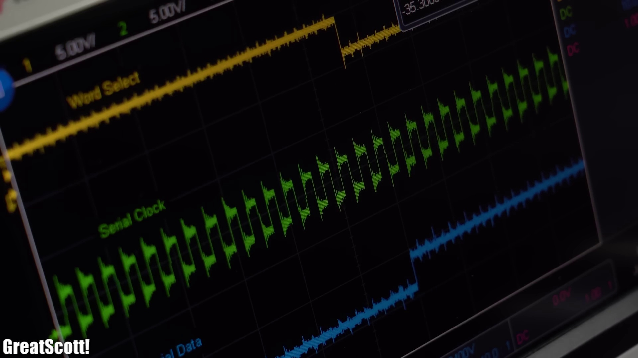 | 10:12  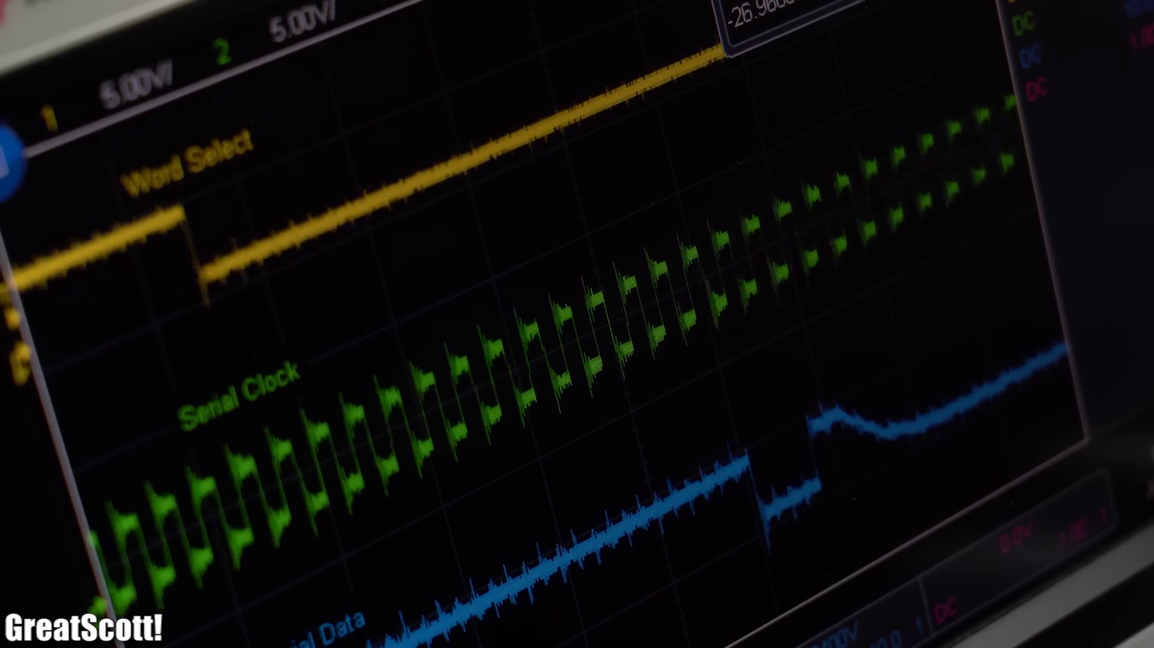 | 10:15   | 10:17  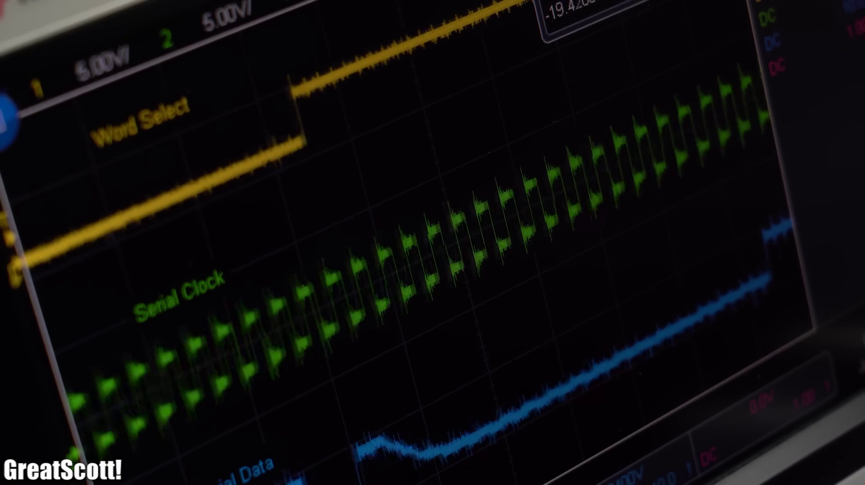 | 10:19  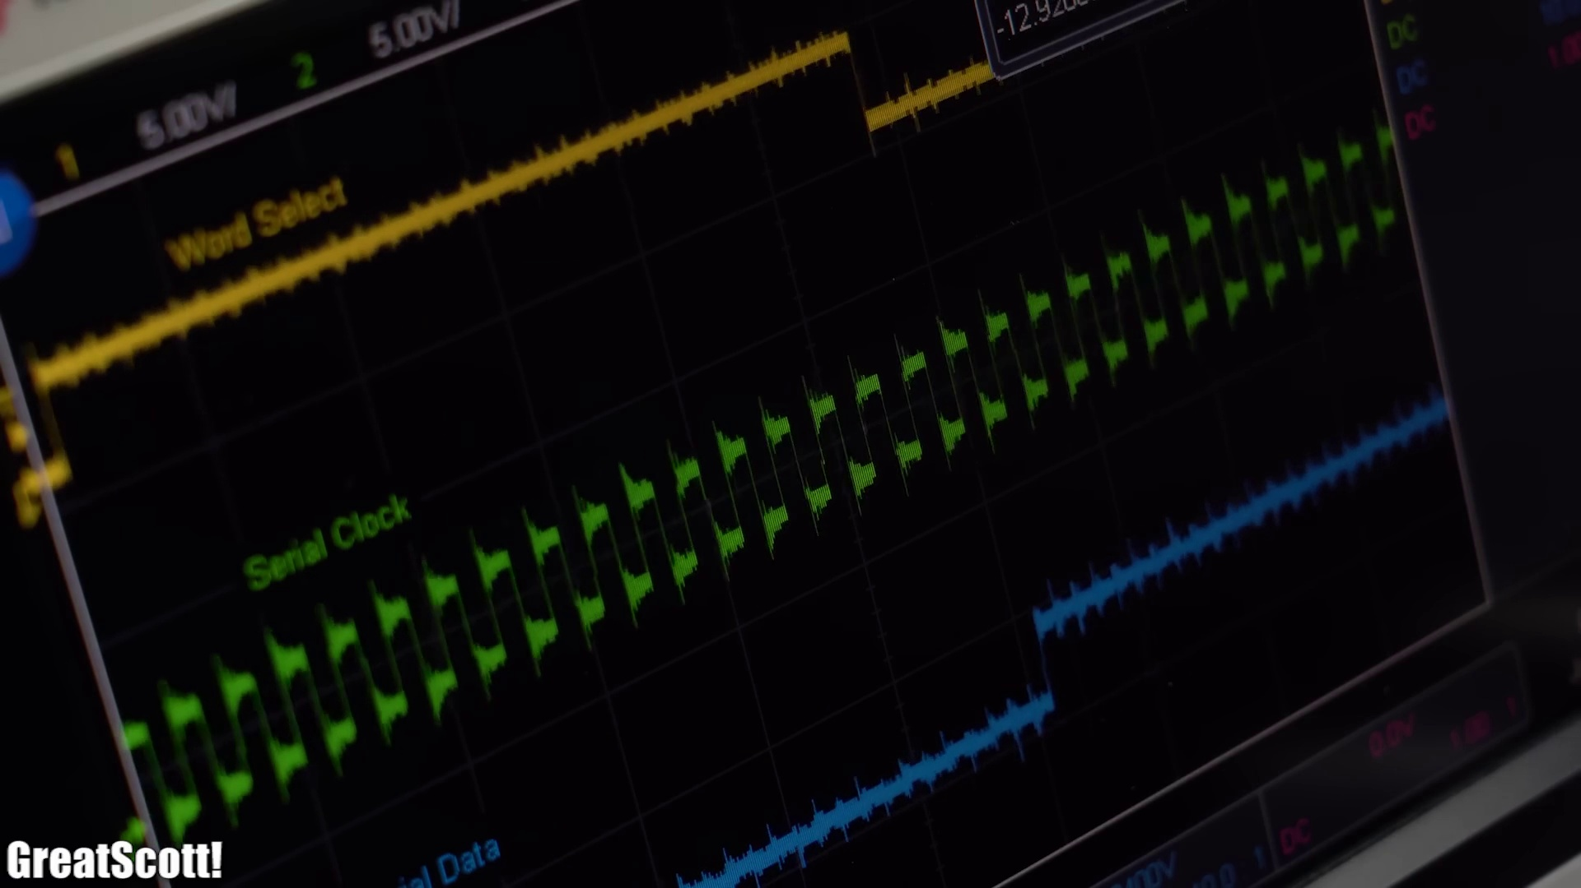

Transcript
[10:06] But anyway I hope you enjoyed this video and learned something new.
[10:12] If so don't forget to like, share, subscribe and hit the notification bell.
[10:18] Stay creative and I will see you next time!

