Engagement Analysis: r0kBl1__VEQ

Section 0: Multiple Images with Descriptions
Time: 0:00 - 0:13

Summary
A series of images showcasing various electronic components, boards, and devices, accompanied by audio descriptions providing context and details about each item.

Representative Frames
0:02  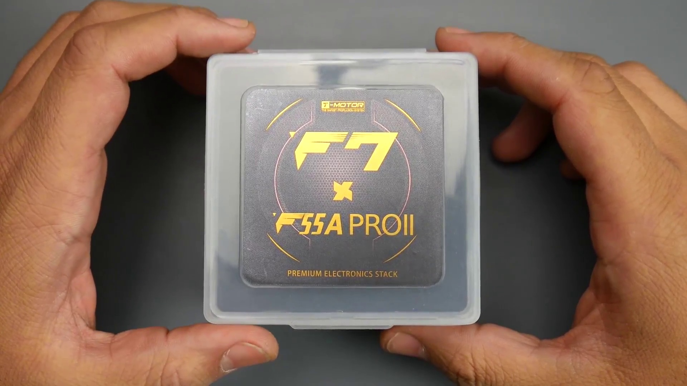 | 0:04  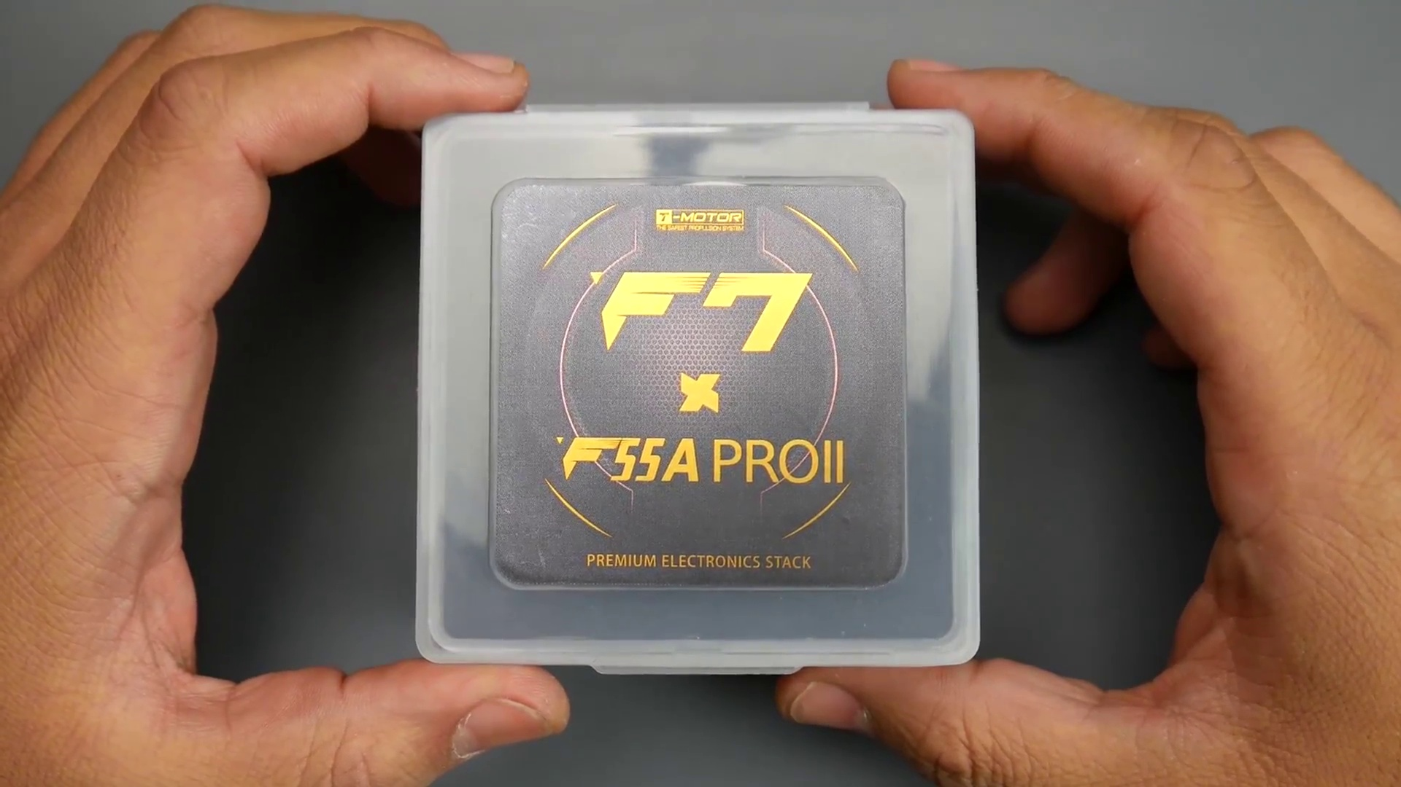 | 0:06  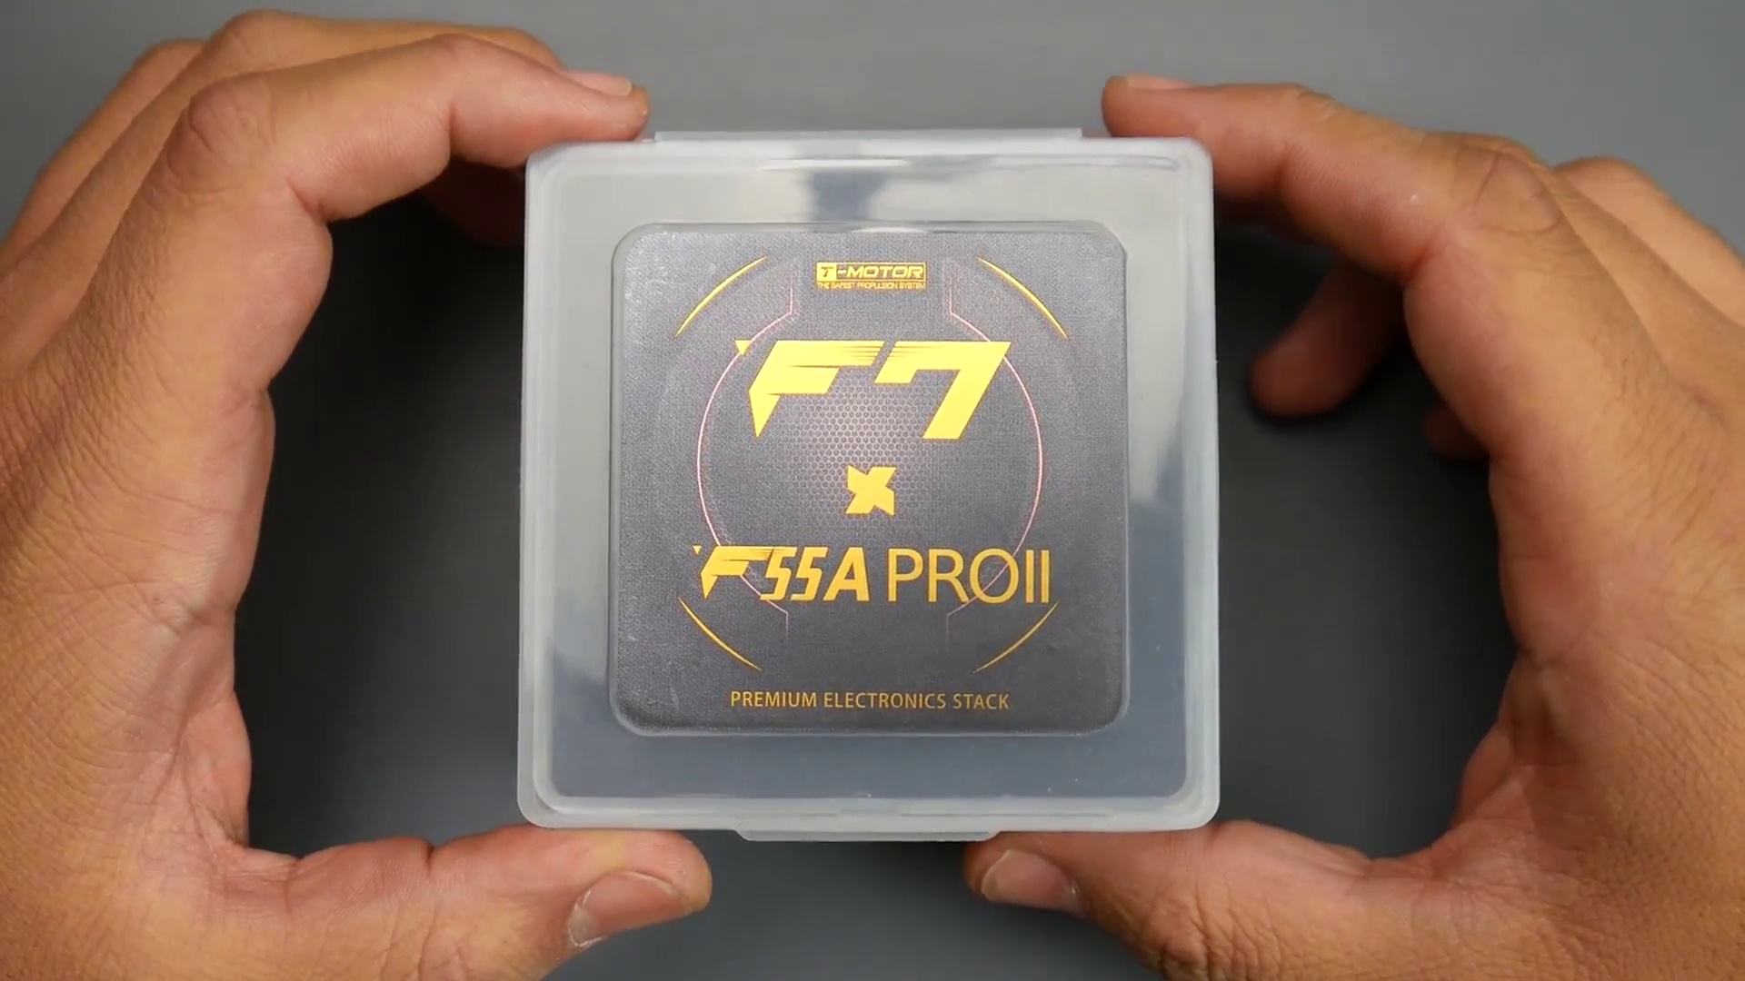 | 0:08  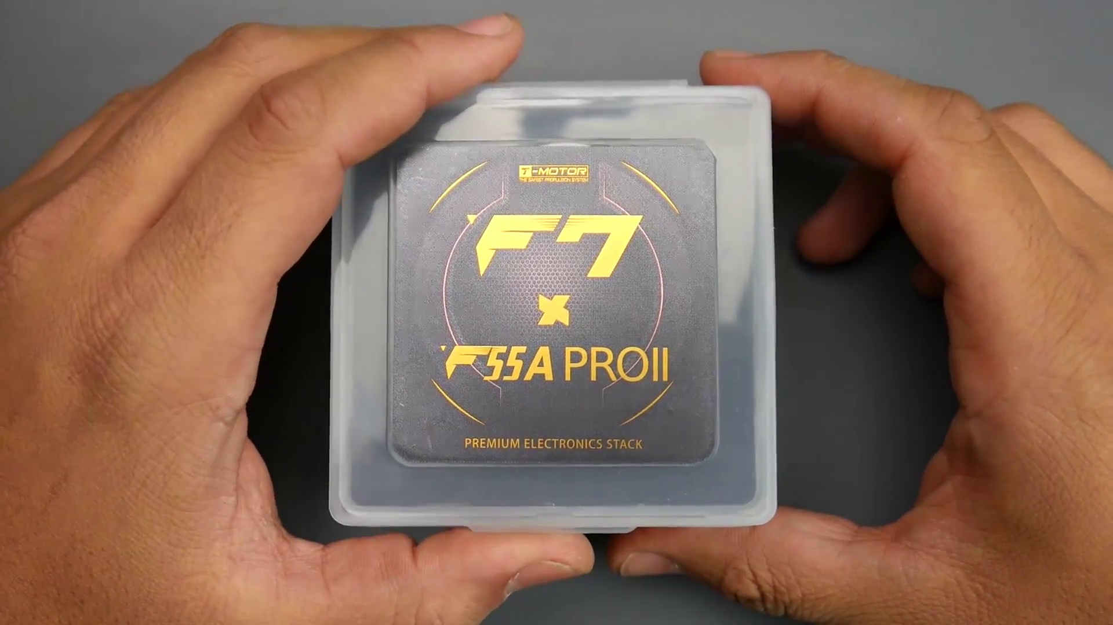 | 0:10  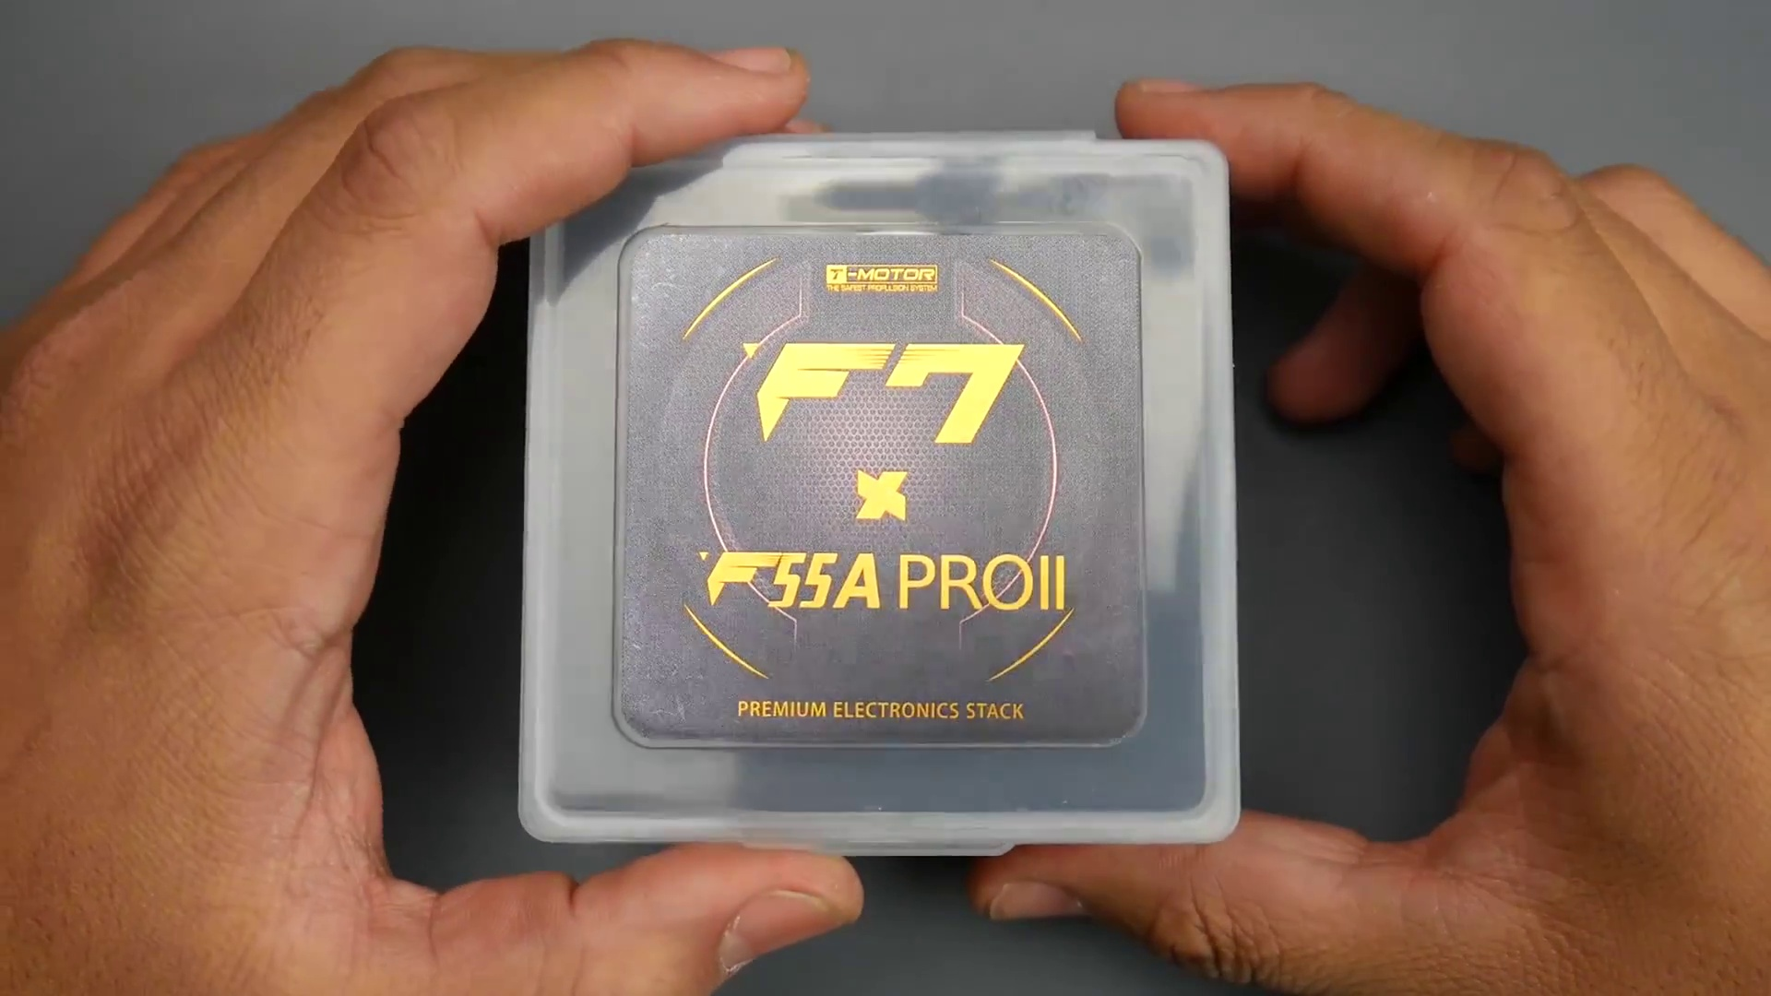

Transcript
[0:00] Today's video, we're going to be looking at a new stack from Team Motor.
[0:03] Now, this is the first official ever F7 flight controller,
[0:07] and to be honest, the most feature-packed flight controller they've ever released.

Section 0: Image 1: Arduino Board and Components
Time: 0:13 - 0:25

Summary
An image of an Arduino board being held against a gray surface, with various components attached to it, such as a speaker, LED, and jumper cable.

Representative Frames
0:15  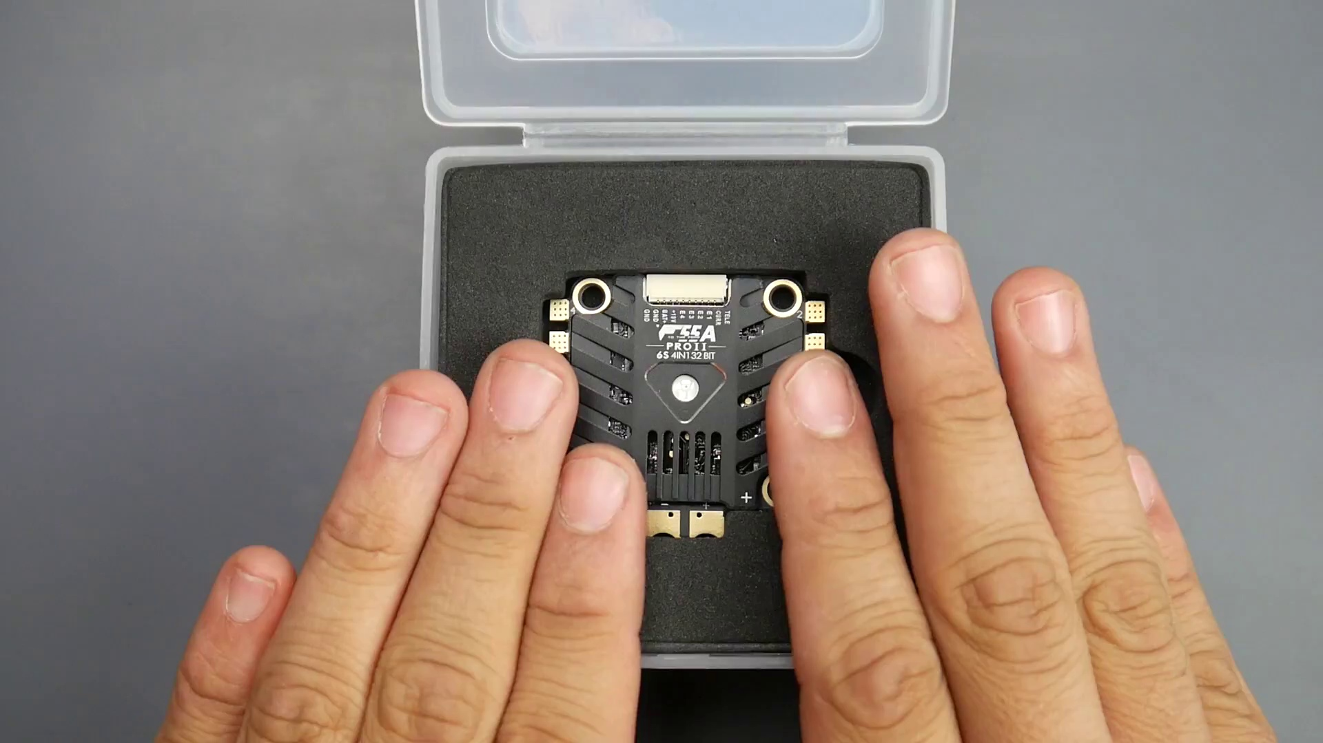 | 0:17  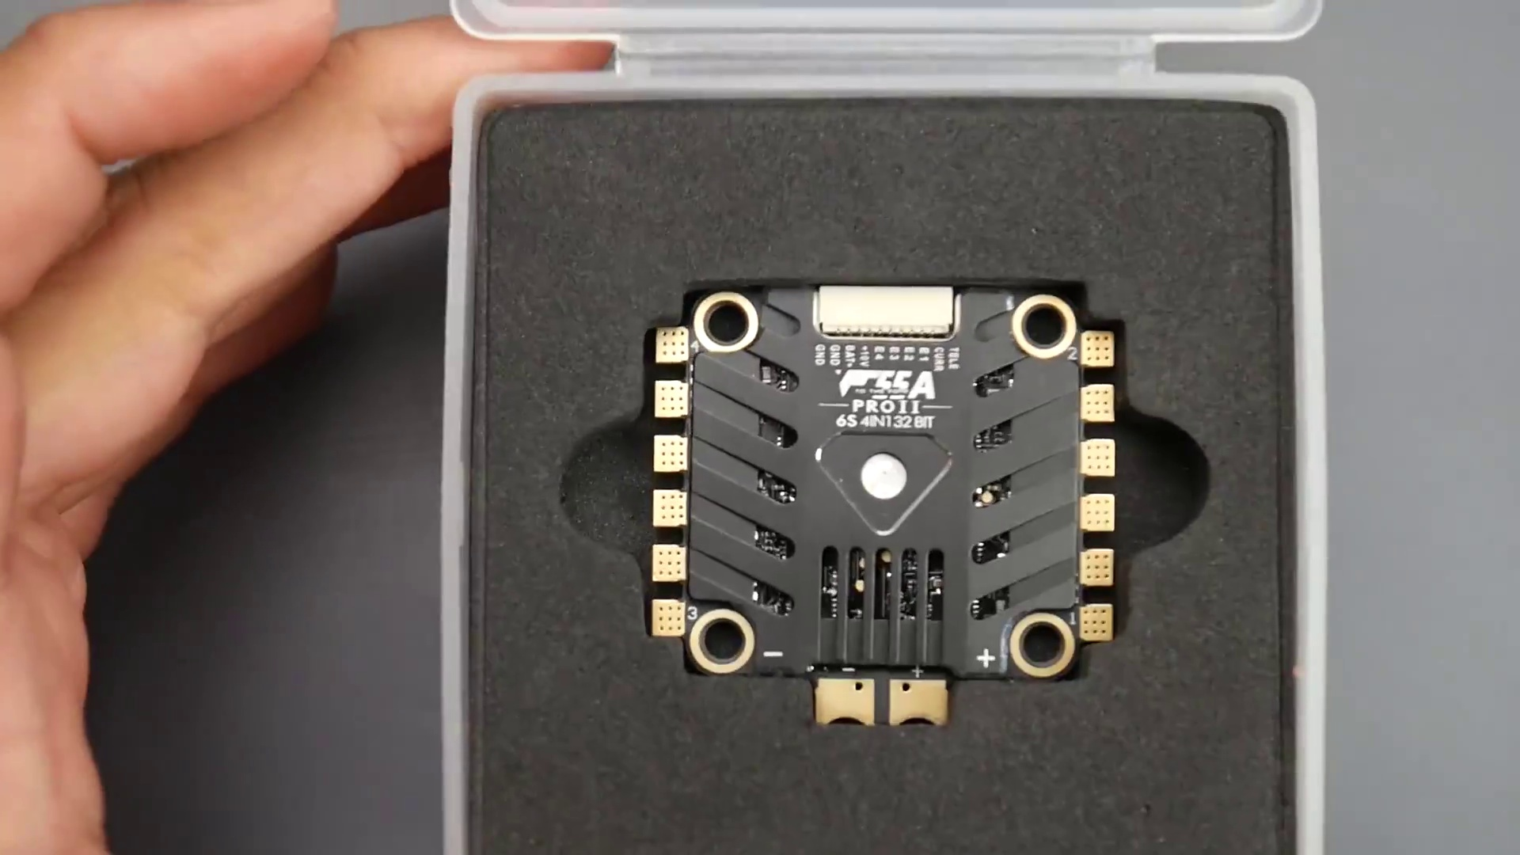 | 0:19  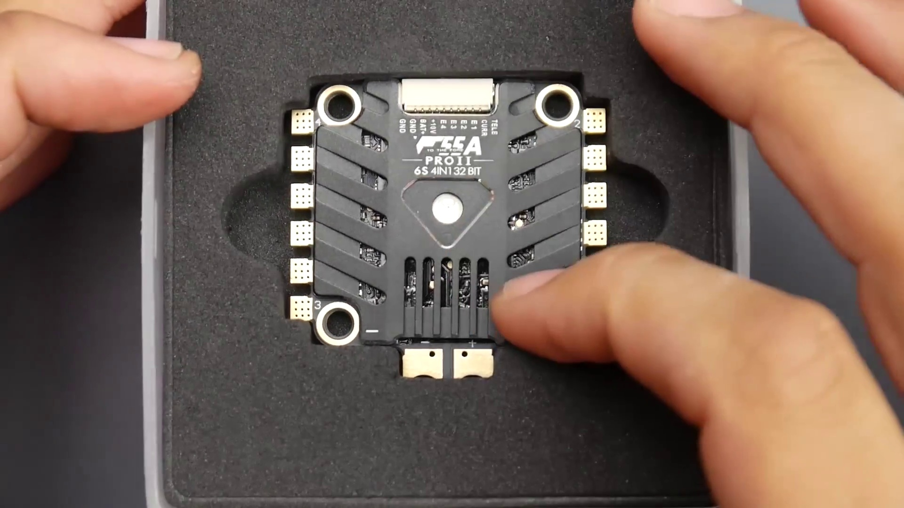 | 0:21  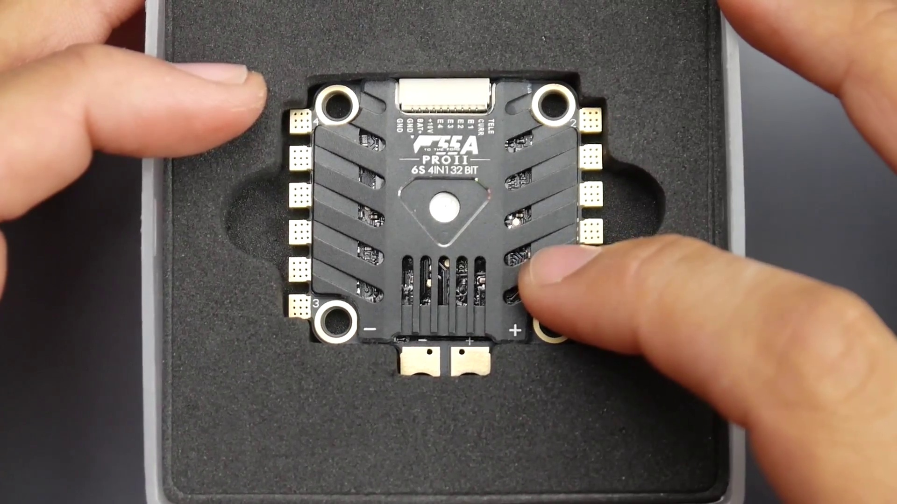 | 0:23  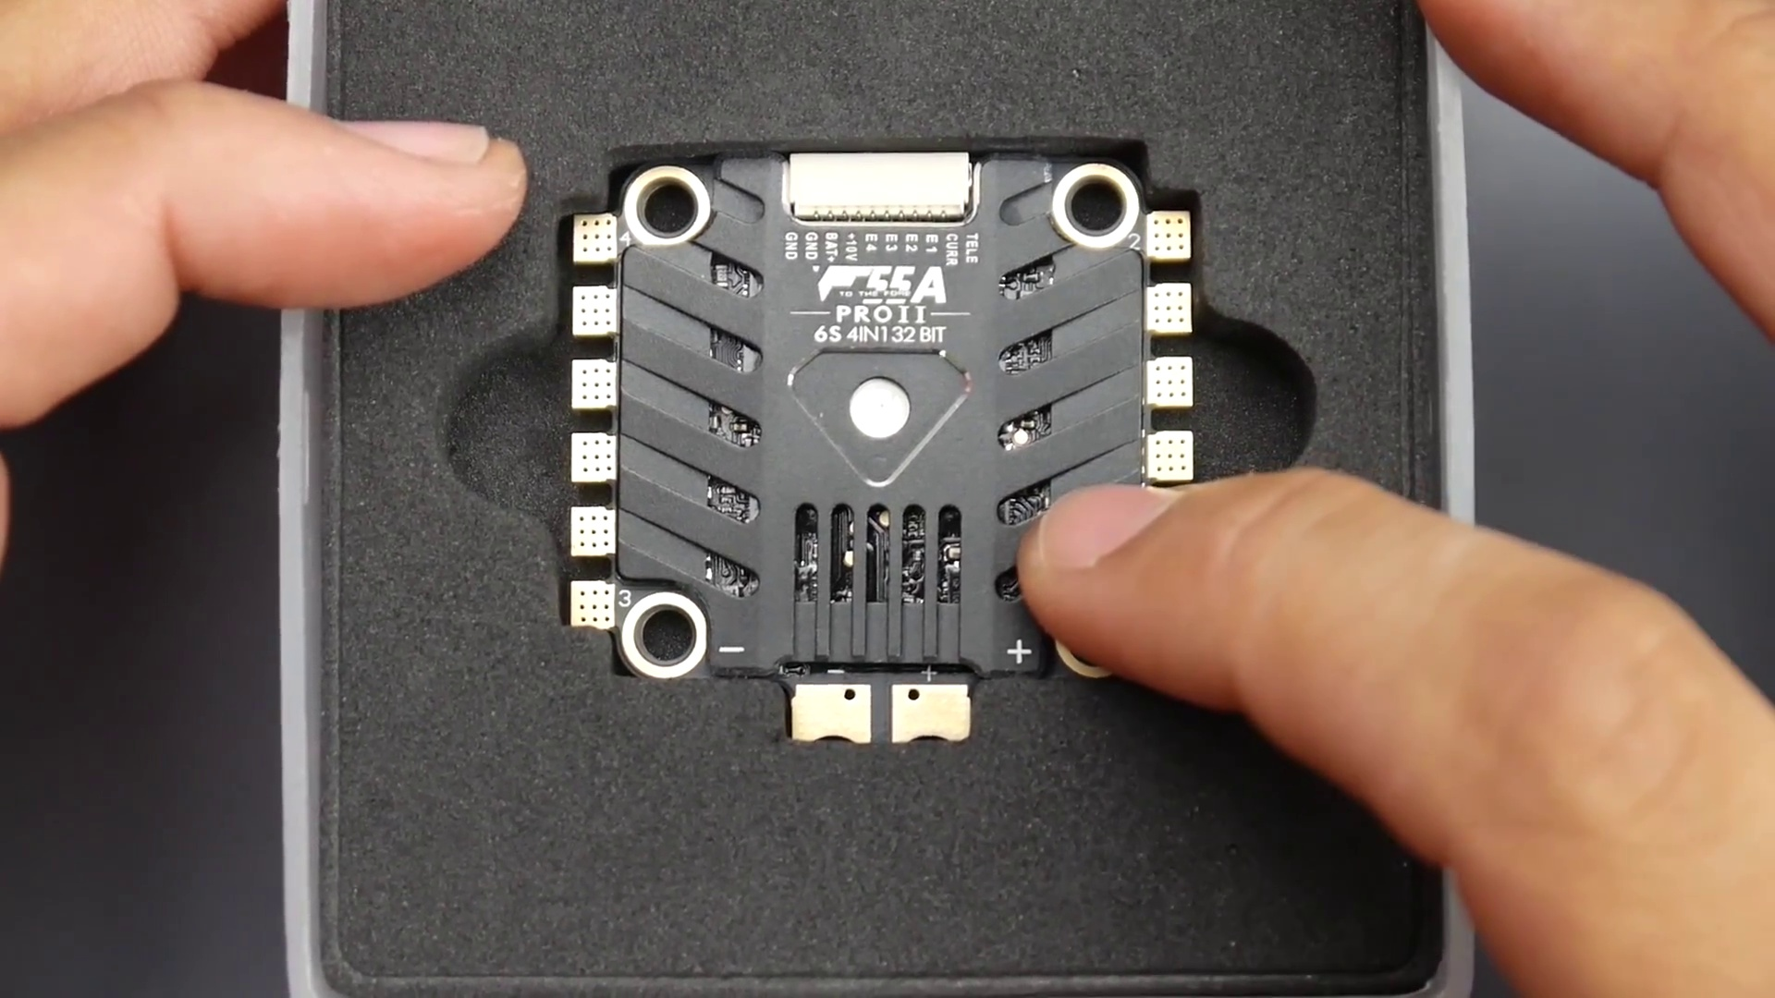

Transcript
[0:11] And not only that, it's bringing back memories from the old Omnibus.
[0:15] Now, first of all, if you don't know this or if you haven't seen my video,
[0:17] this is one of the best 6S ESCs I've ever tested, ever used, and done noise testing on.

Section 0: Image 2: Colorful Circuit Board
Time: 0:25 - 0:37

Summary
A close-up view of someone's hands holding a small, colorful circuit board against a dark background, with recognizable yellow cylindrical resistors and other components attached to it.

Representative Frames
0:27  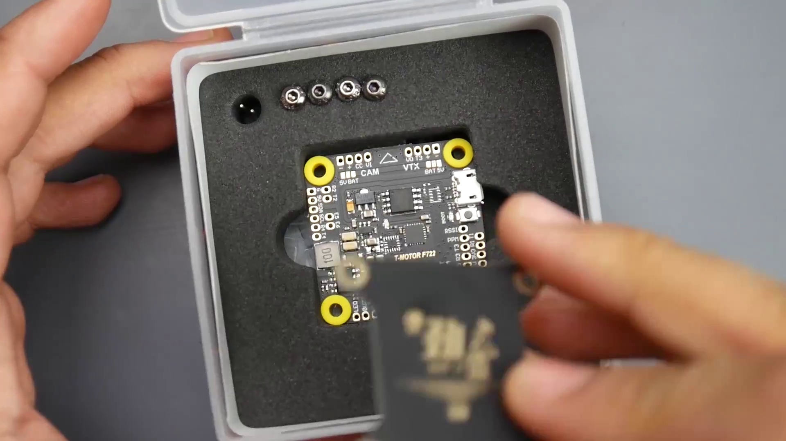 | 0:29  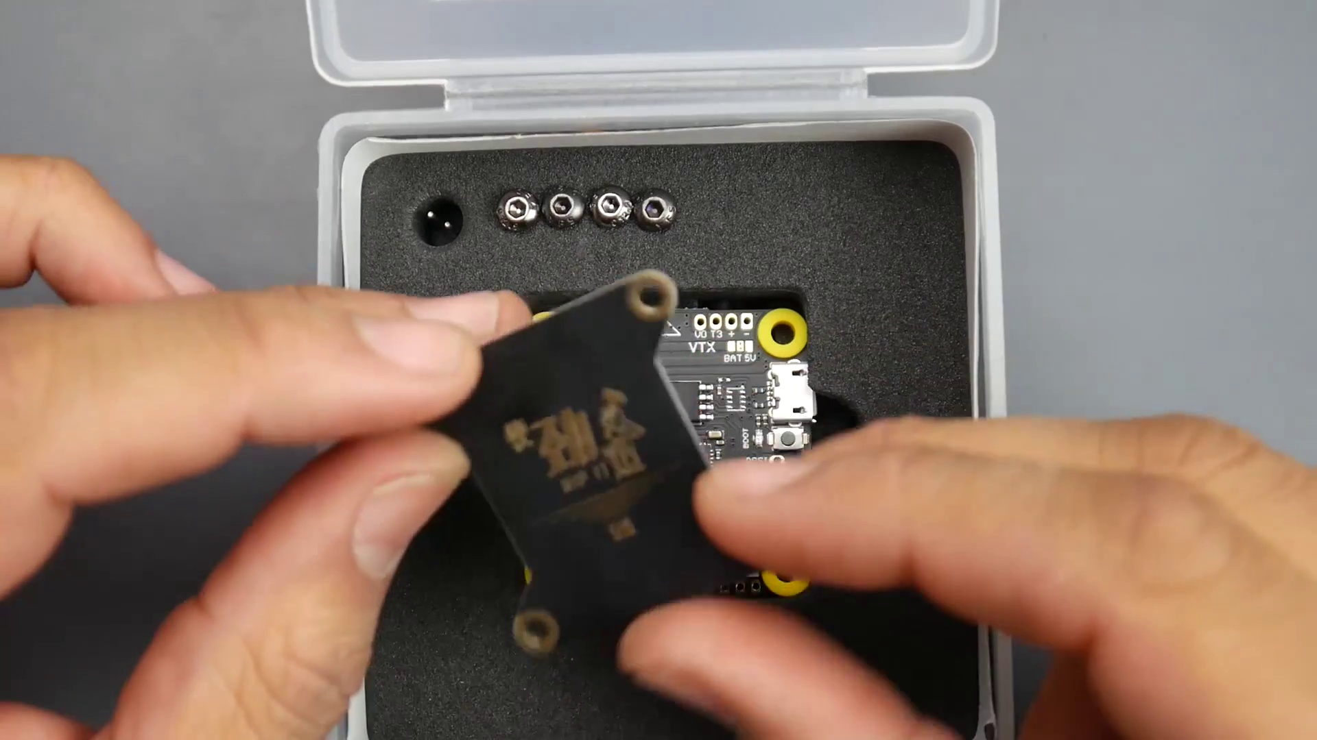 | 0:31  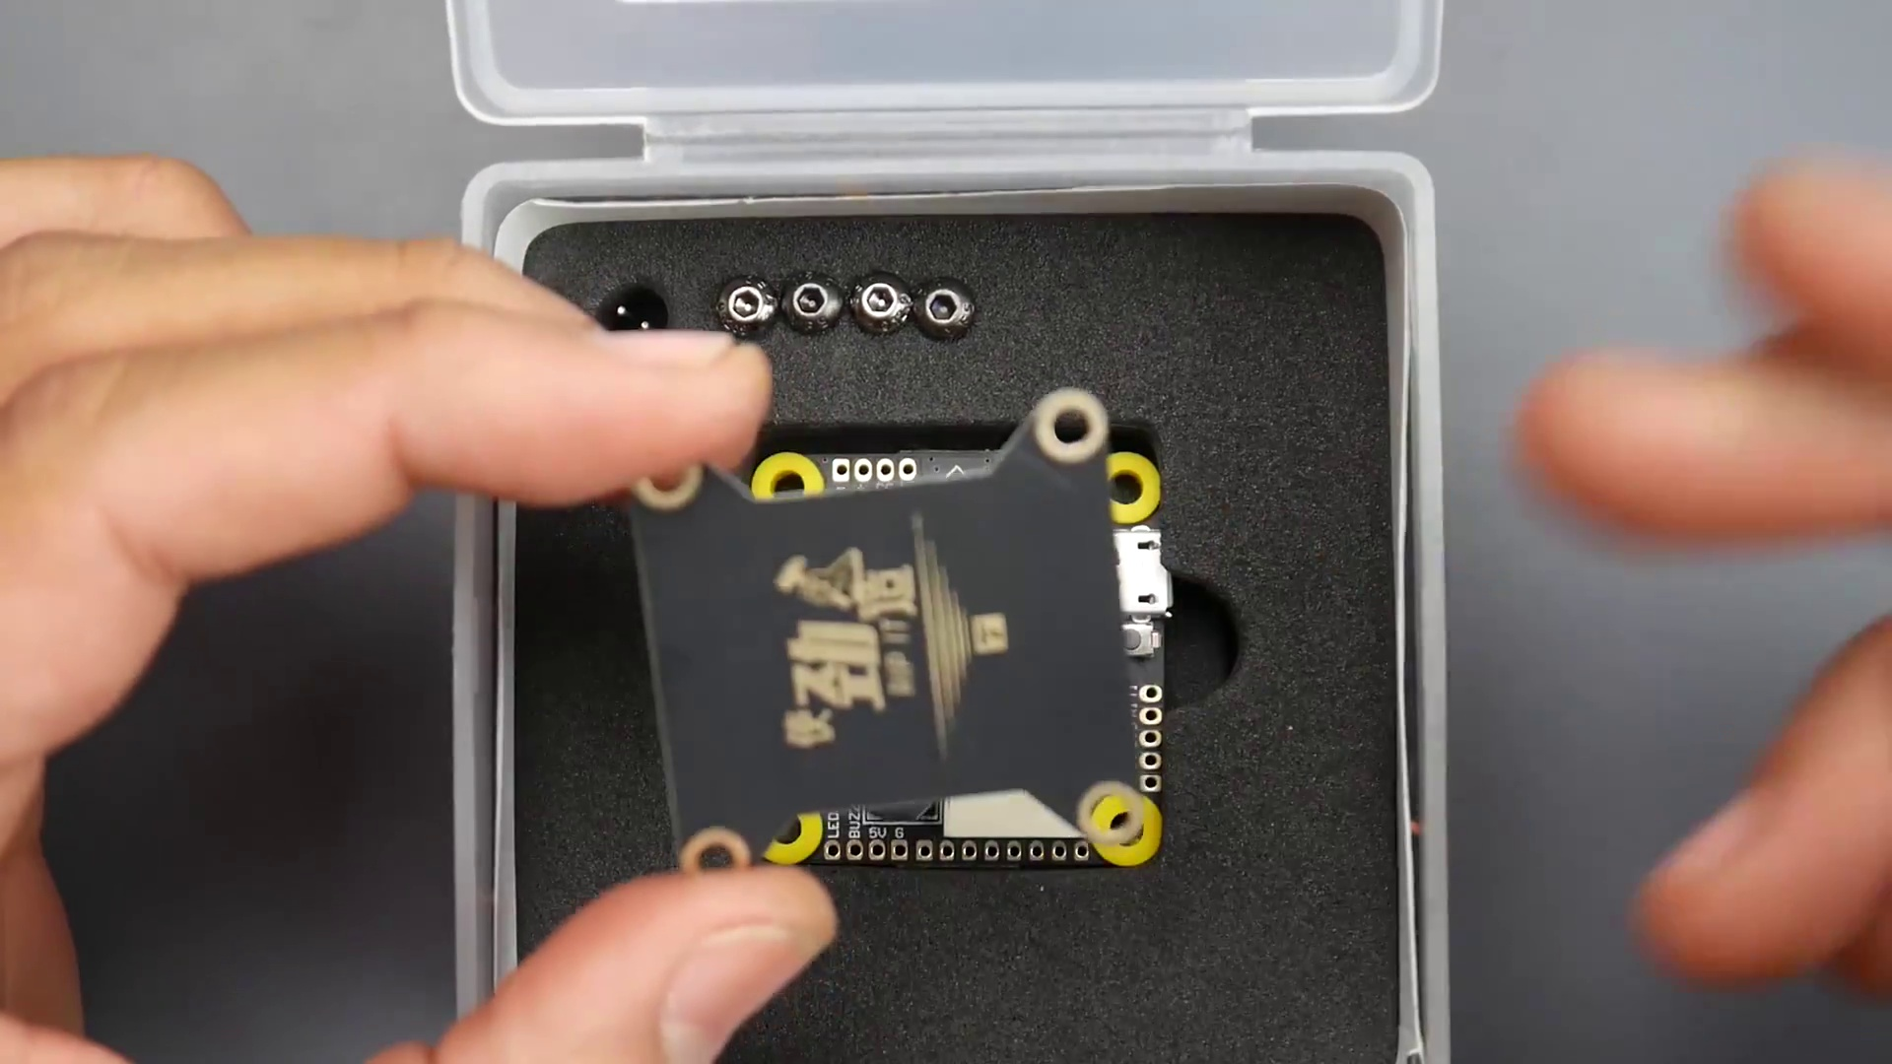 | 0:33  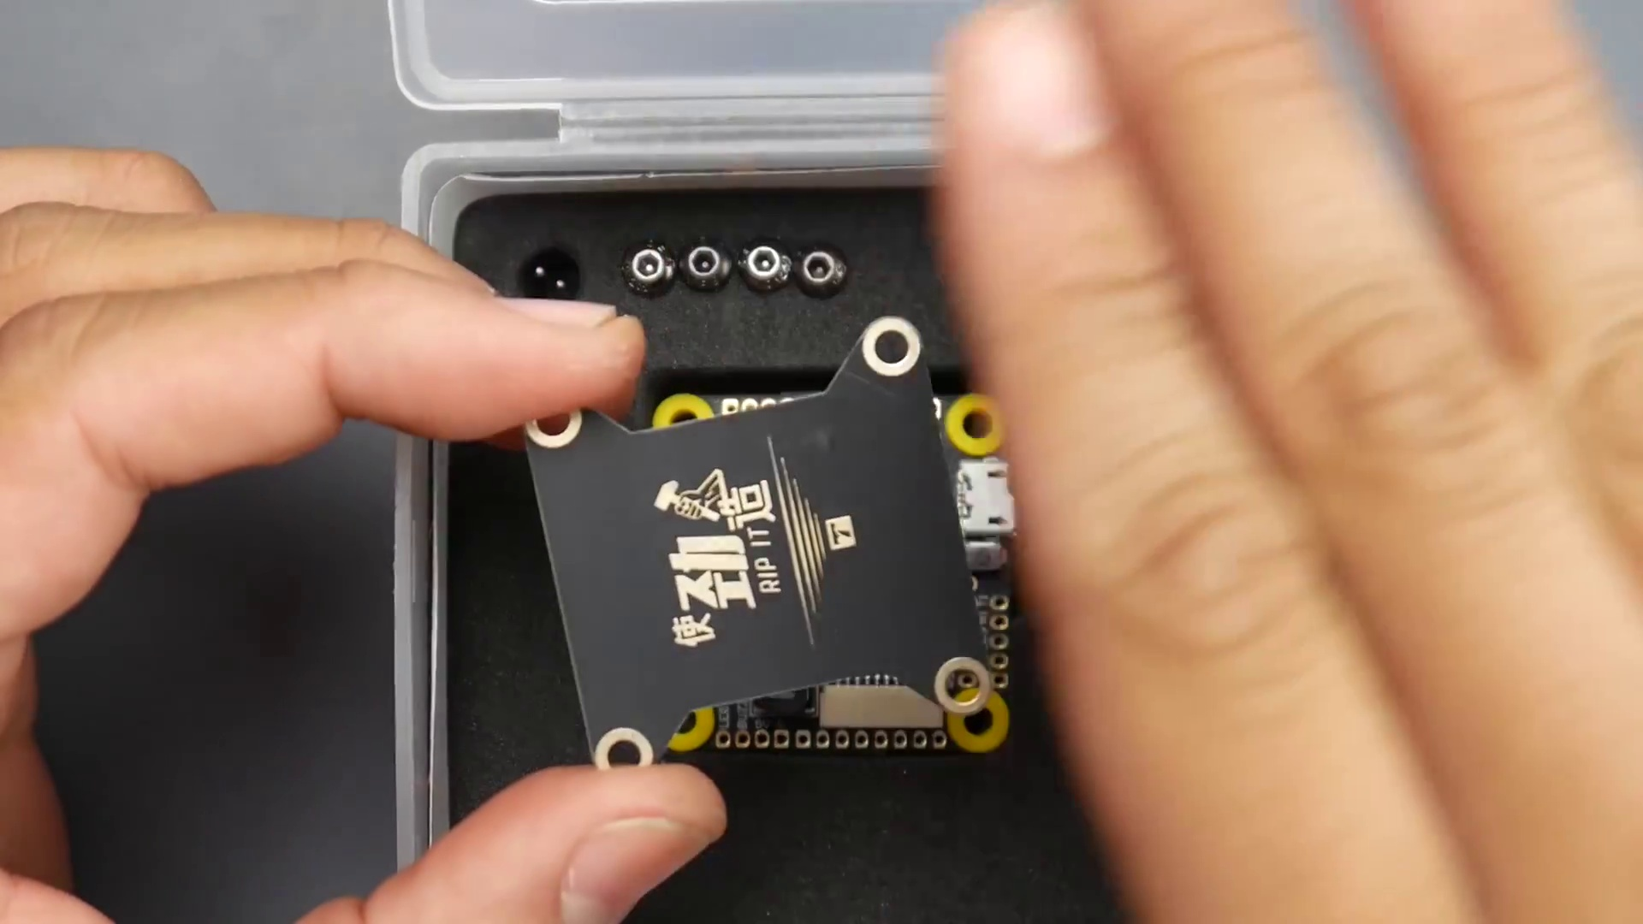 | 0:35  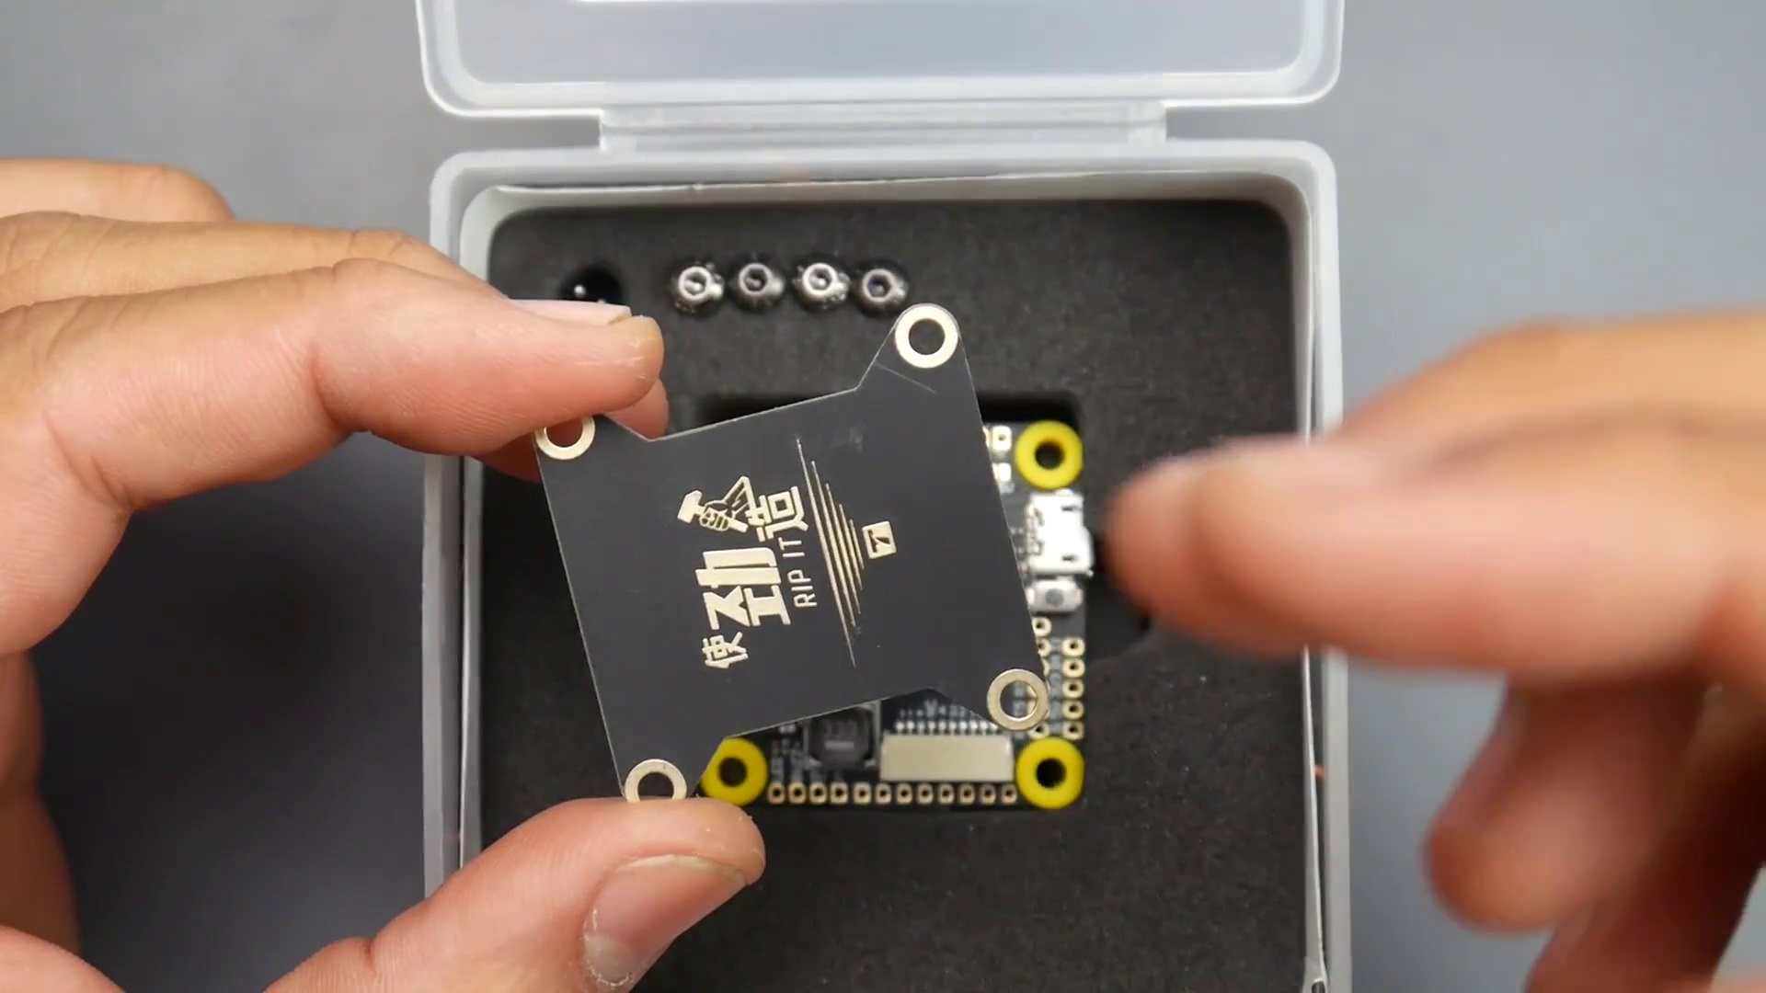

Transcript
[0:23] So right out of the box, you're getting something proper here.
[0:26] They also give us a PCB here.
[0:28] So some of you are like, well, what the heck is this?
[0:29] Well, this can be used for a couple things.
[0:31] It's to protect the flight controller,
[0:33] or even use double-sided tape to hold a video transmitter, a receiver, something of that nature.

Section 0: Image 3: FSA Pro 65 Mini 2.8mm BEC Board
Time: 0:37 - 0:49

Summary
Two hands holding a black and gold FSA Pro 65 Mini 2.8mm BEC board against a gray surface, with the main focus on the board itself and various components attached to it.

Representative Frames
0:39  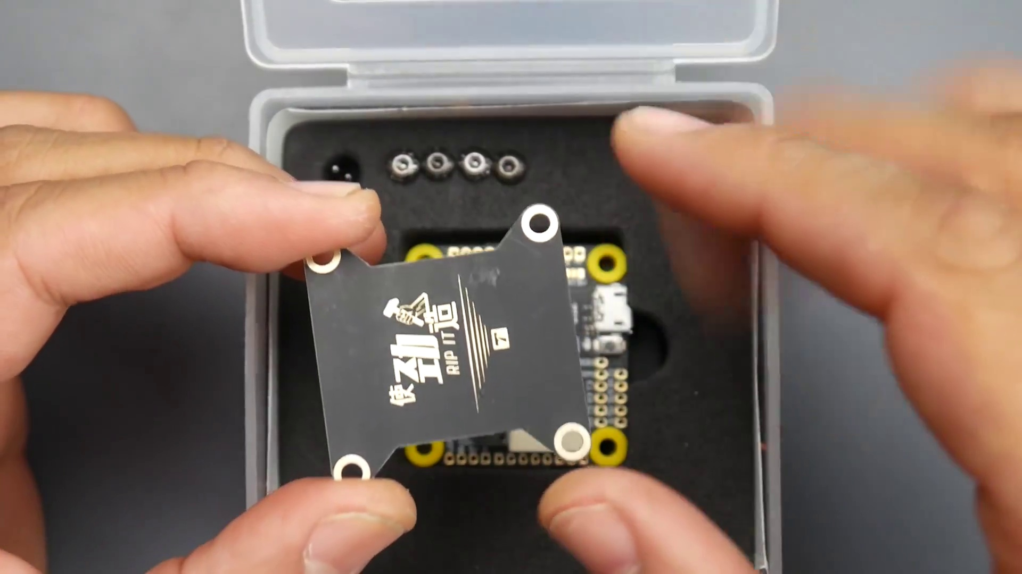 | 0:41  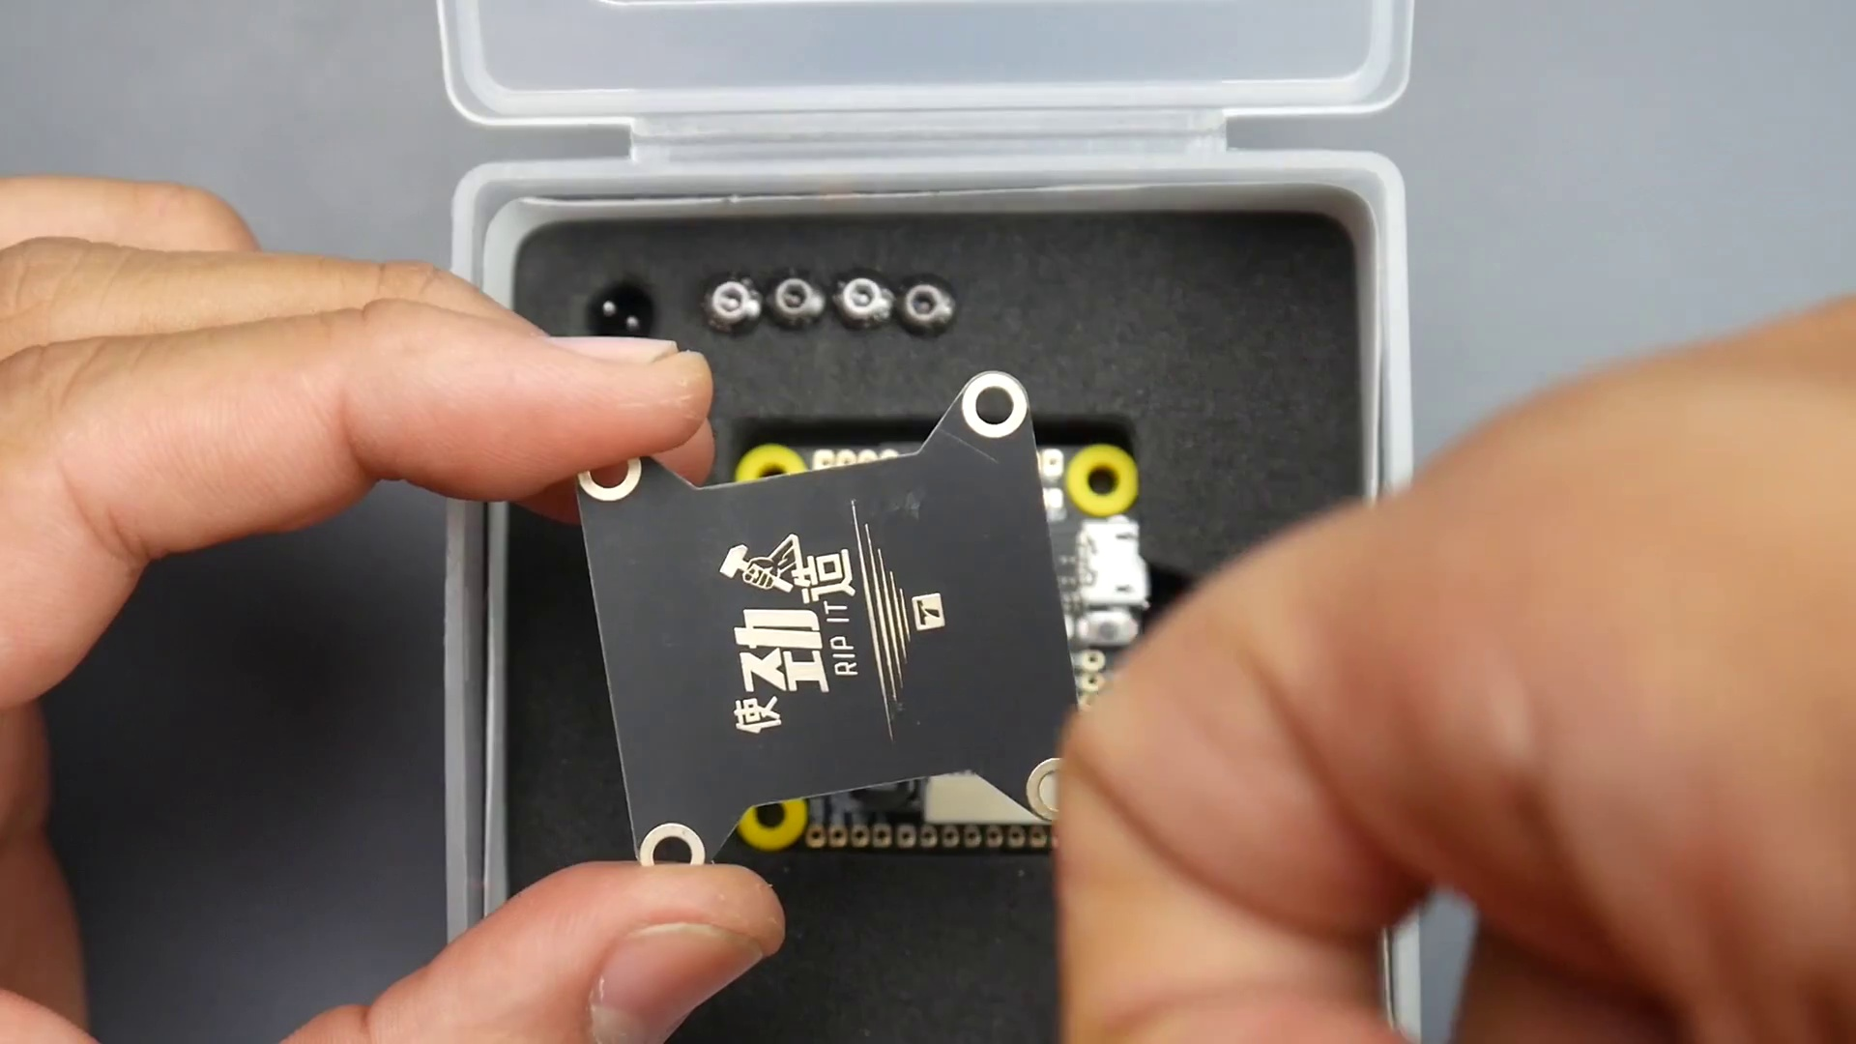 | 0:43  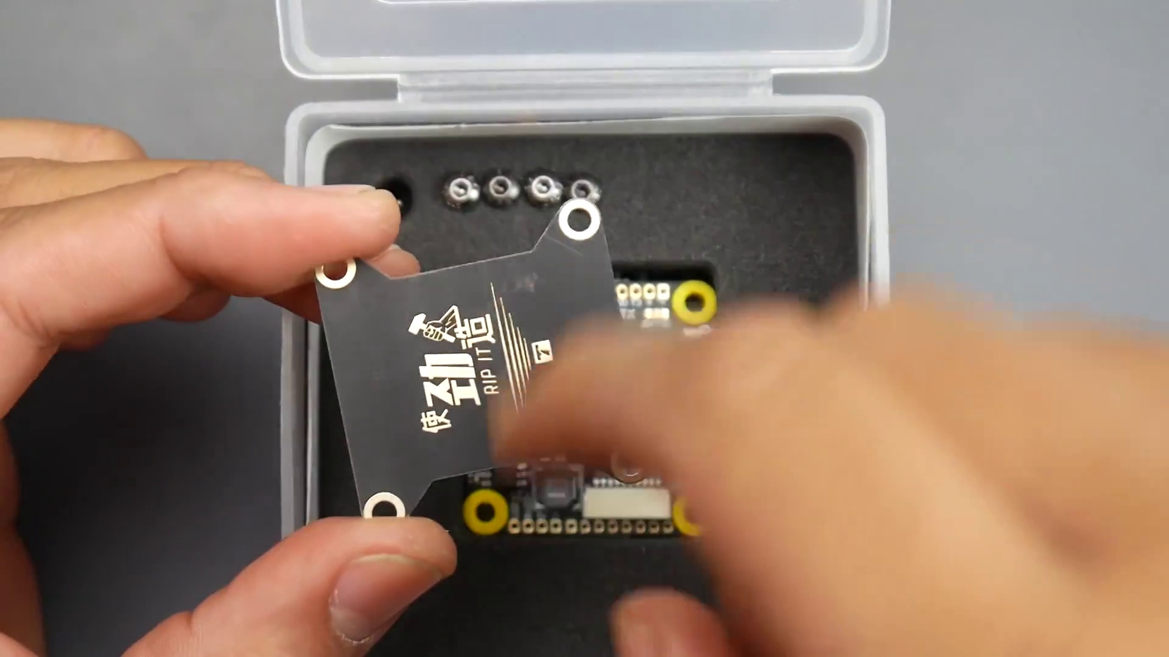 | 0:45  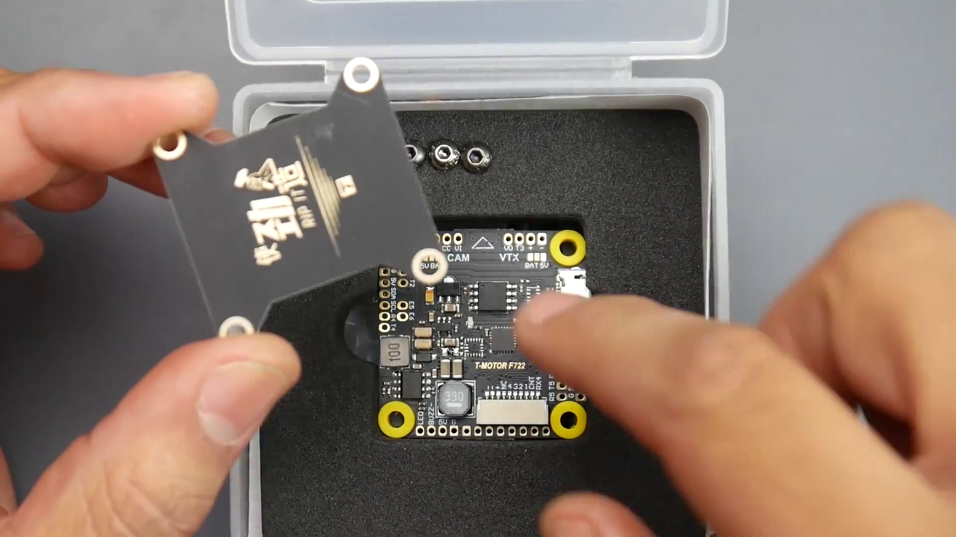 | 0:47  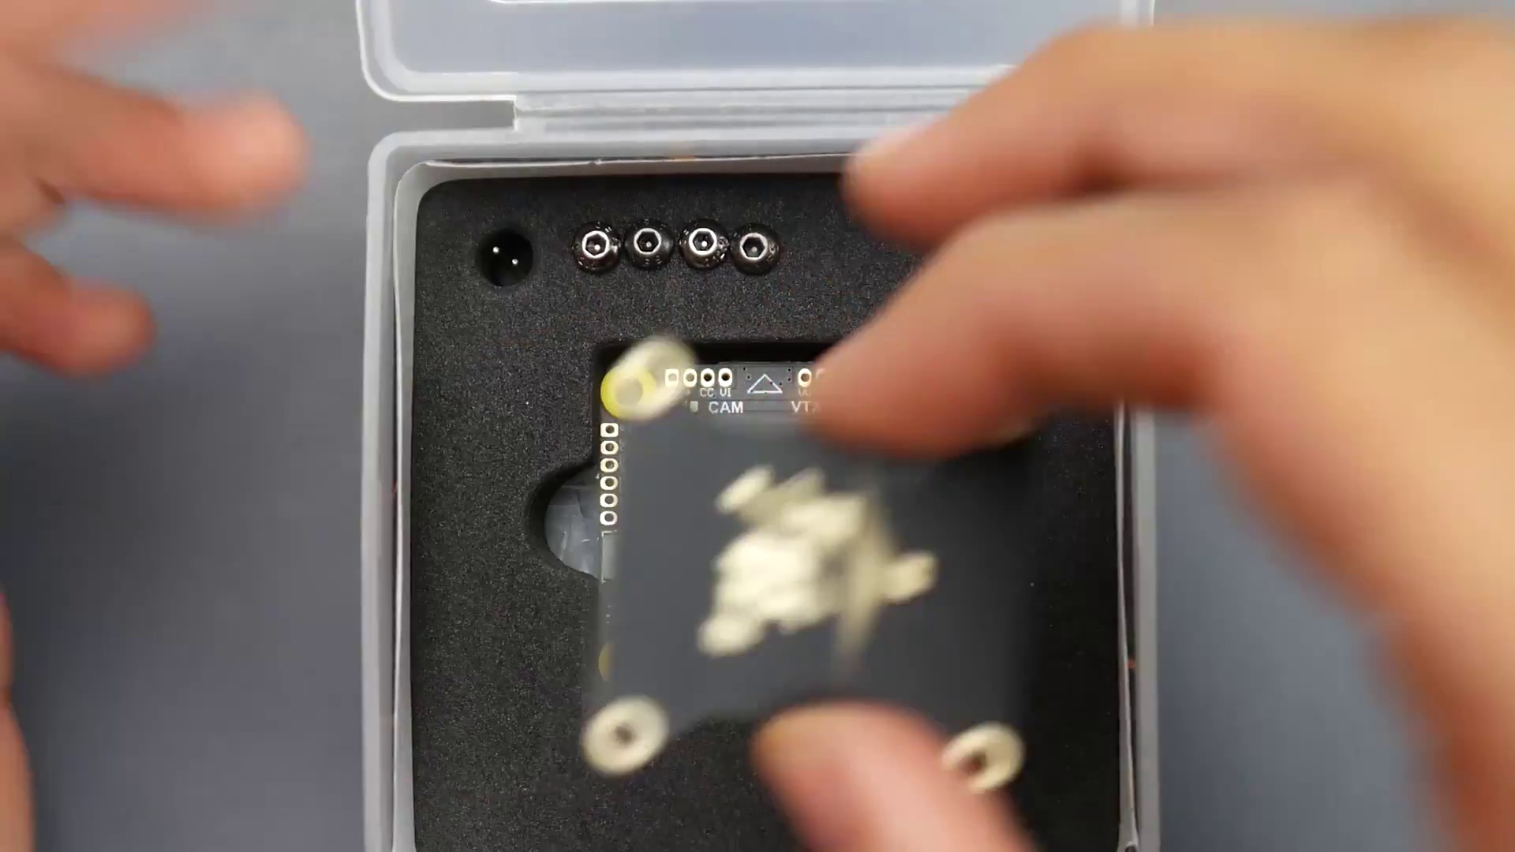

Transcript
[0:38] Or if you have your battery straps coming in from the top of the frame,
[0:41] that battery strap doesn't touch the flight controller,
[0:44] because obviously the gyro is in there,
[0:45] and doesn't move the flight controller and cause unwanted vibration.

Section 0: Image 4: DIY Electronics Project
Time: 0:49 - 1:01

Summary
Two hands working together on a DIY electronics project using an Arduino Uno board and a breakout board or custom-made board with various connectors, such as a speaker, LED, and jumper cable.

Representative Frames
0:51  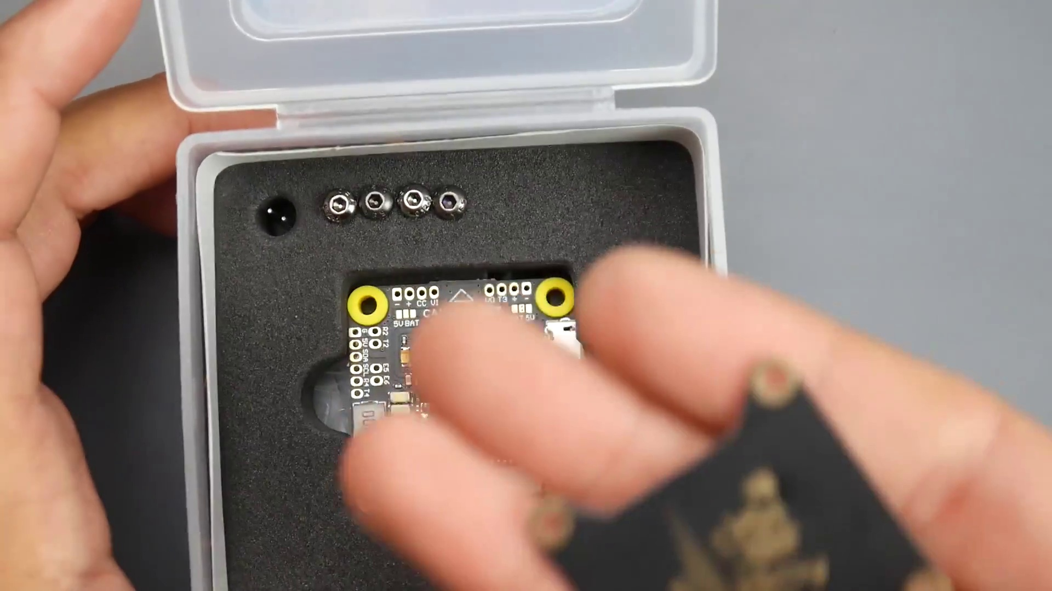 | 0:53  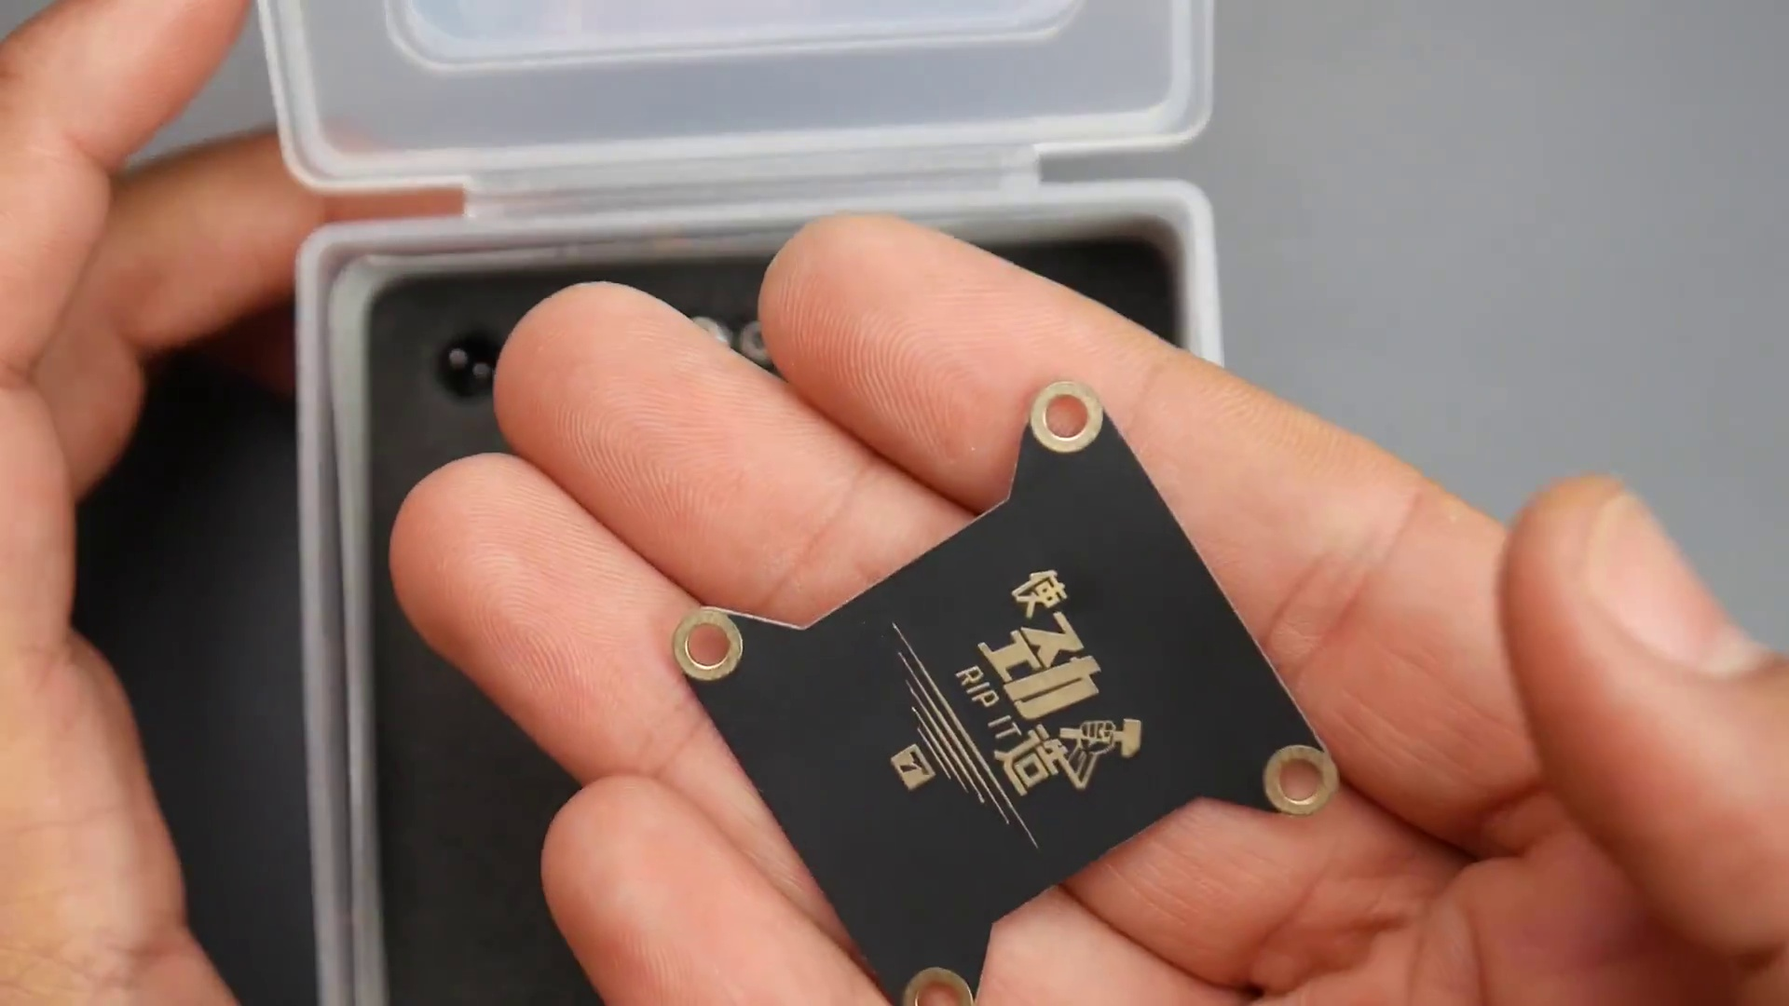 | 0:55  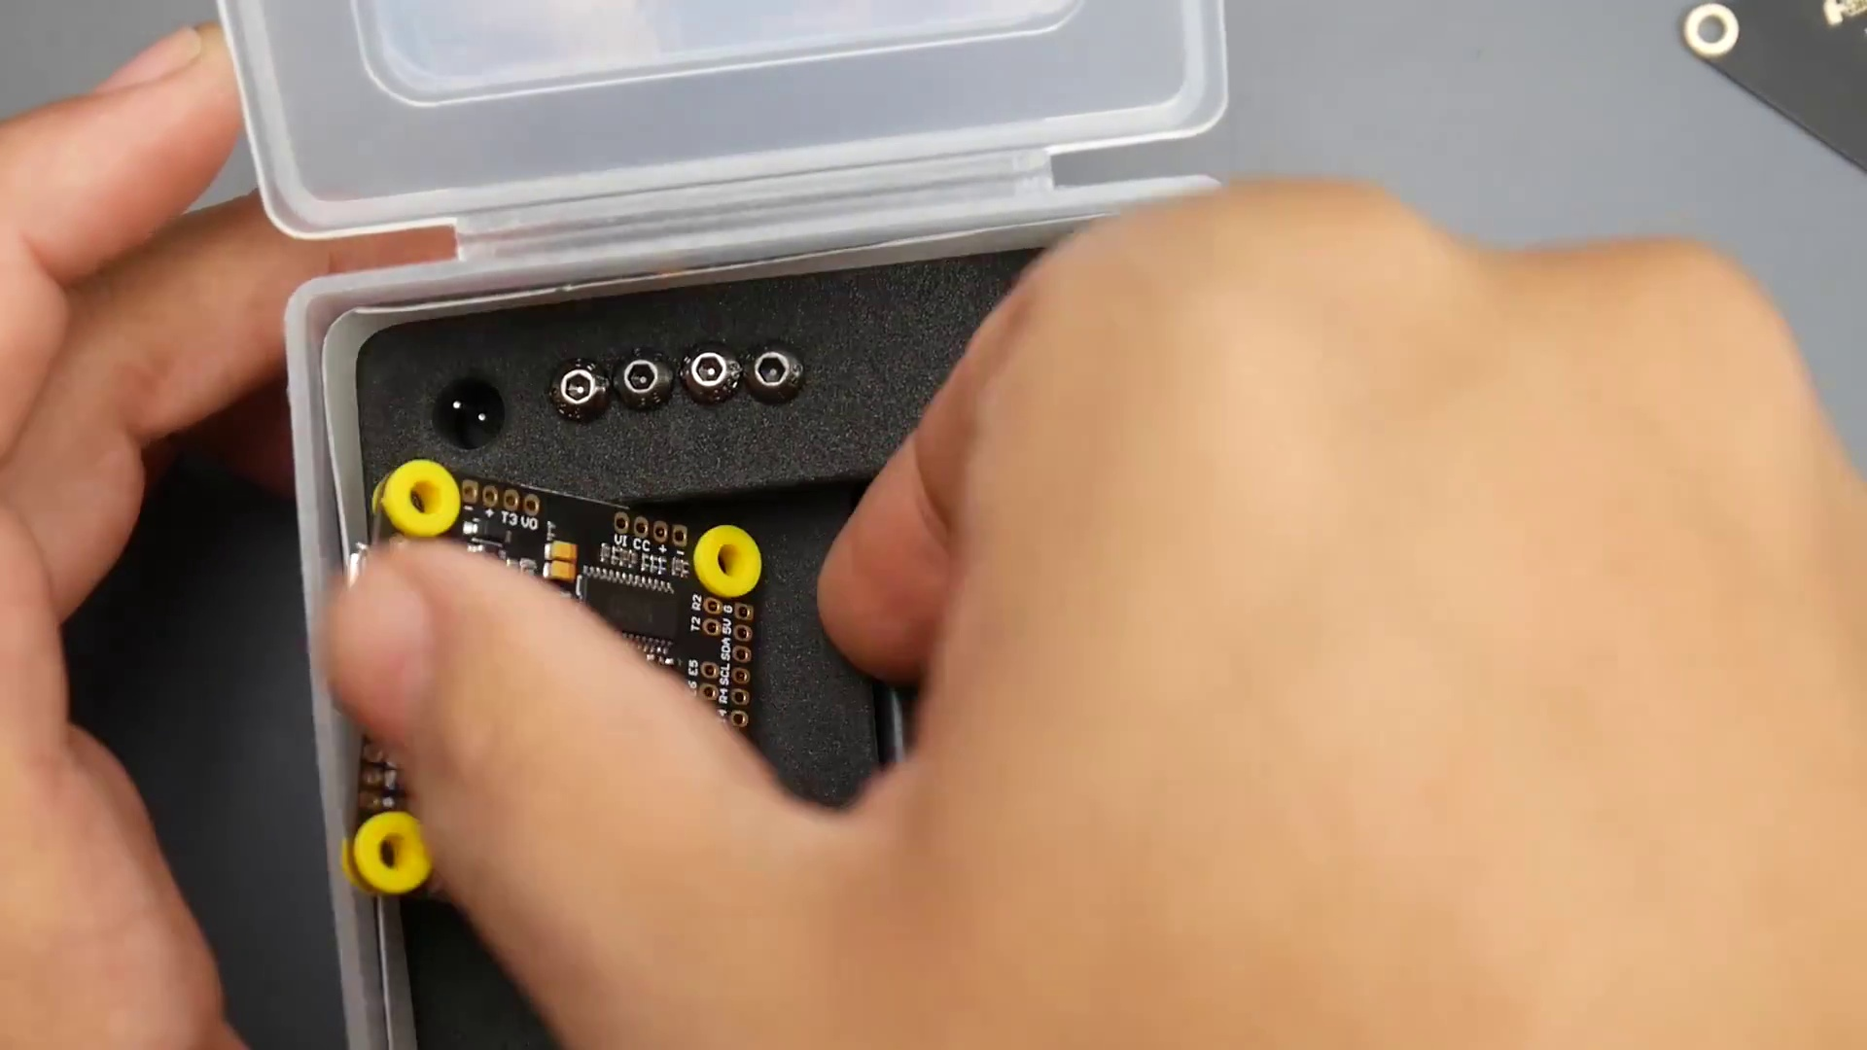 | 0:57  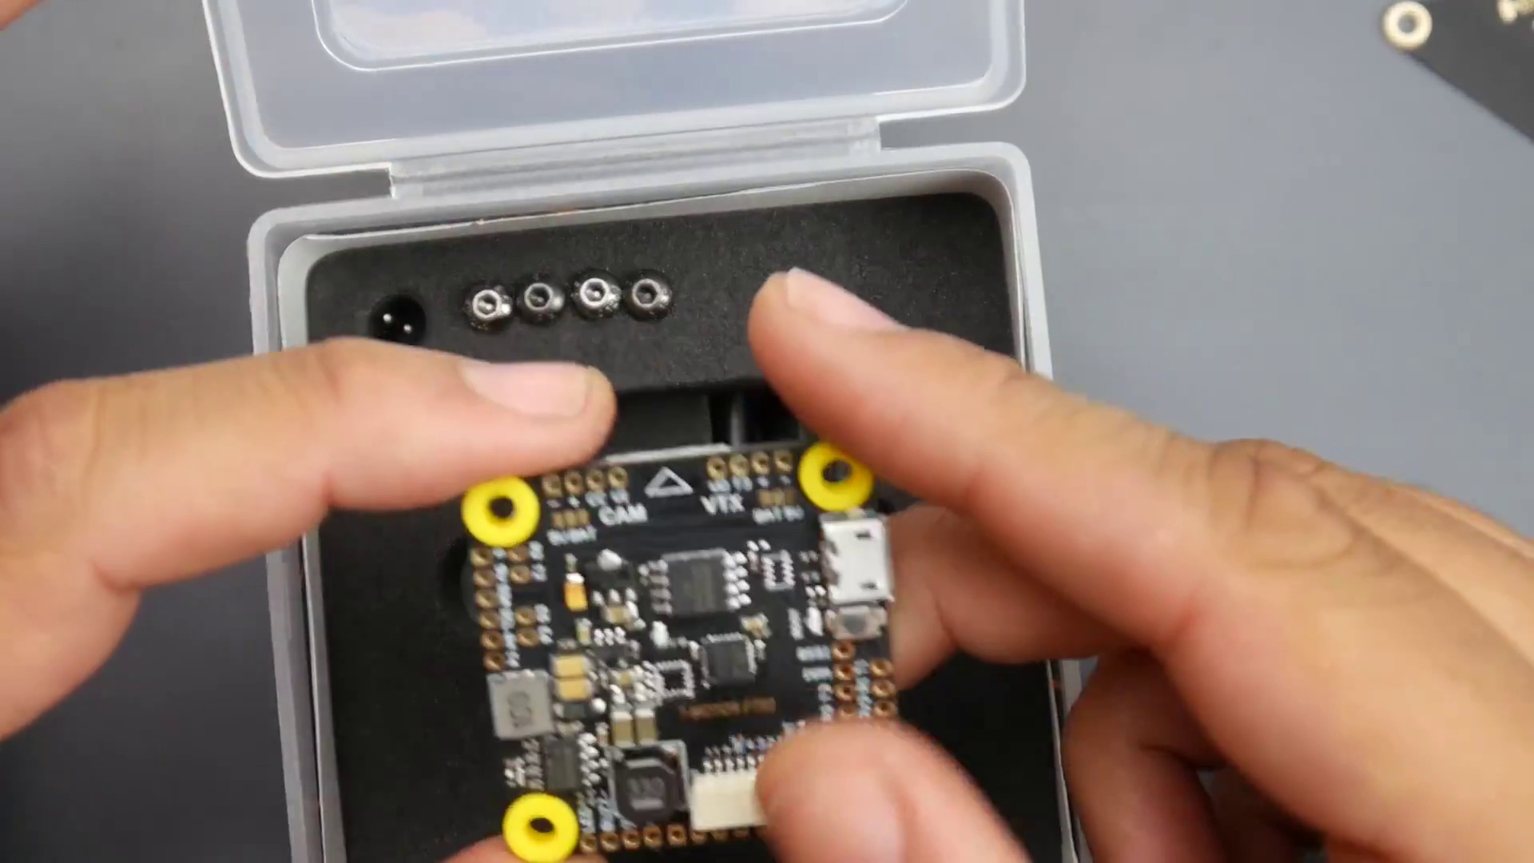 | 0:59  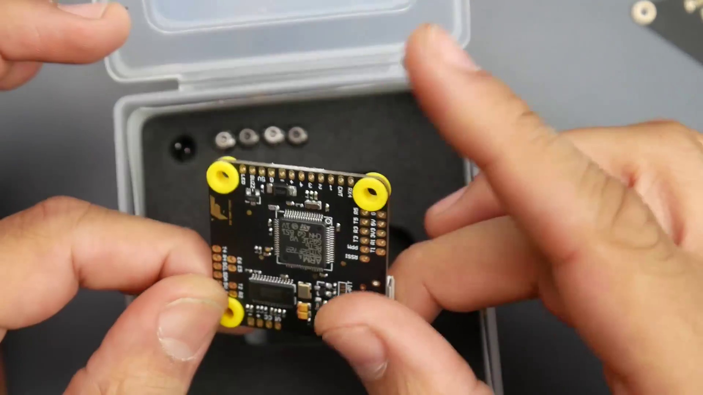

Transcript
[0:48] So it has many purposes.
[0:50] The only other company that usually does this is actually Maytec.
[0:53] So let's put this to the side.
[0:54] Then we get to the flight controller.
[0:55] The flight controller is pretty interesting.
[0:56] And again, this is the first F7.
[0:58] They're using the baby F7, which is the F722 here.

Section 0: Image 5: FAA PRO TRI-ANT-BIT Components
Time: 1:01 - 14:16

Summary
Two electronic components labeled 'FAA PRO TRI-ANT-BIT' placed on a gray surface, with numerous pins indicating they require connections for operation.

Representative Frames
3:13  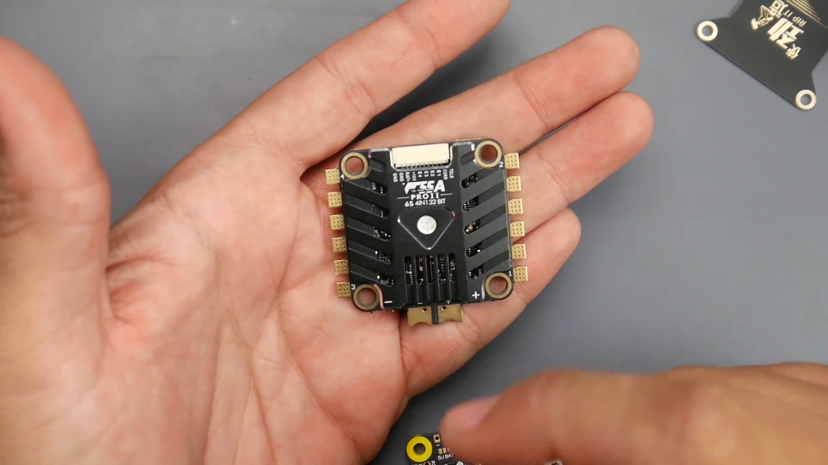 | 5:26  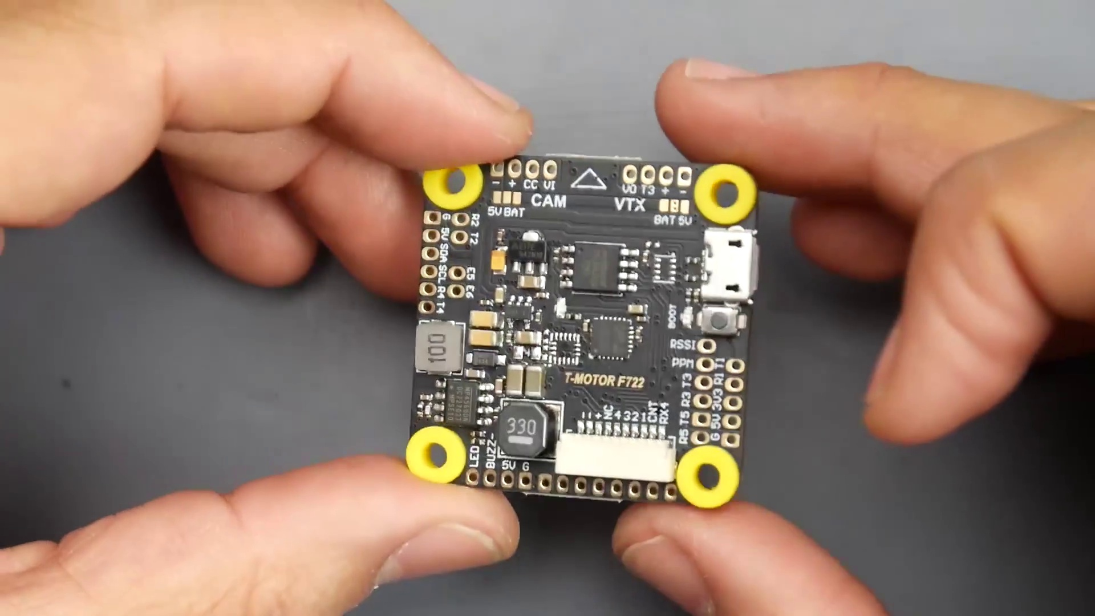 | 7:38  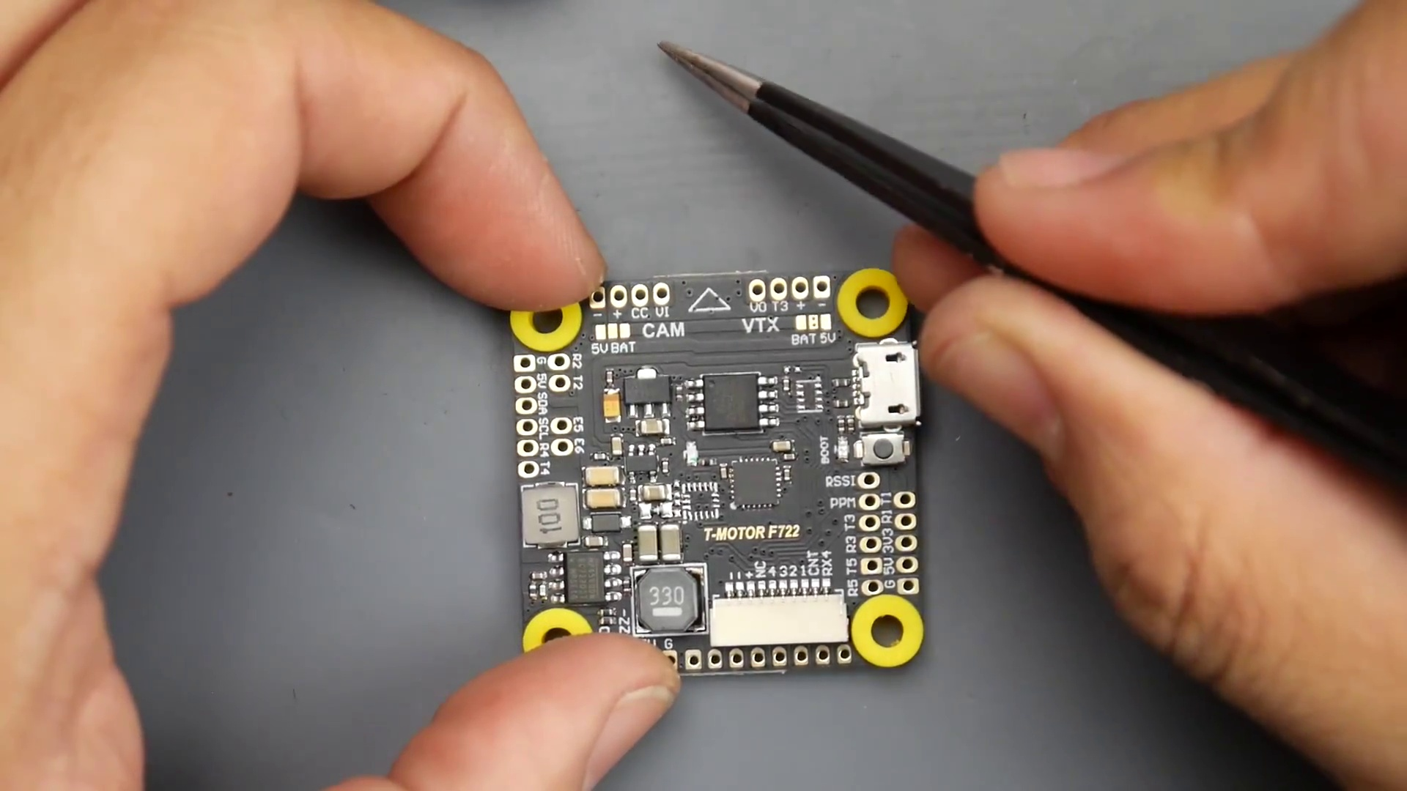 | 9:51  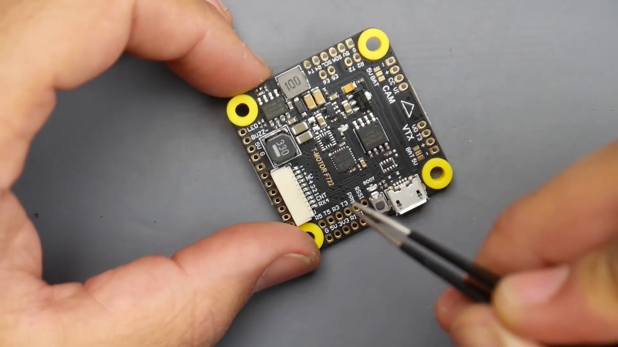 | 12:03  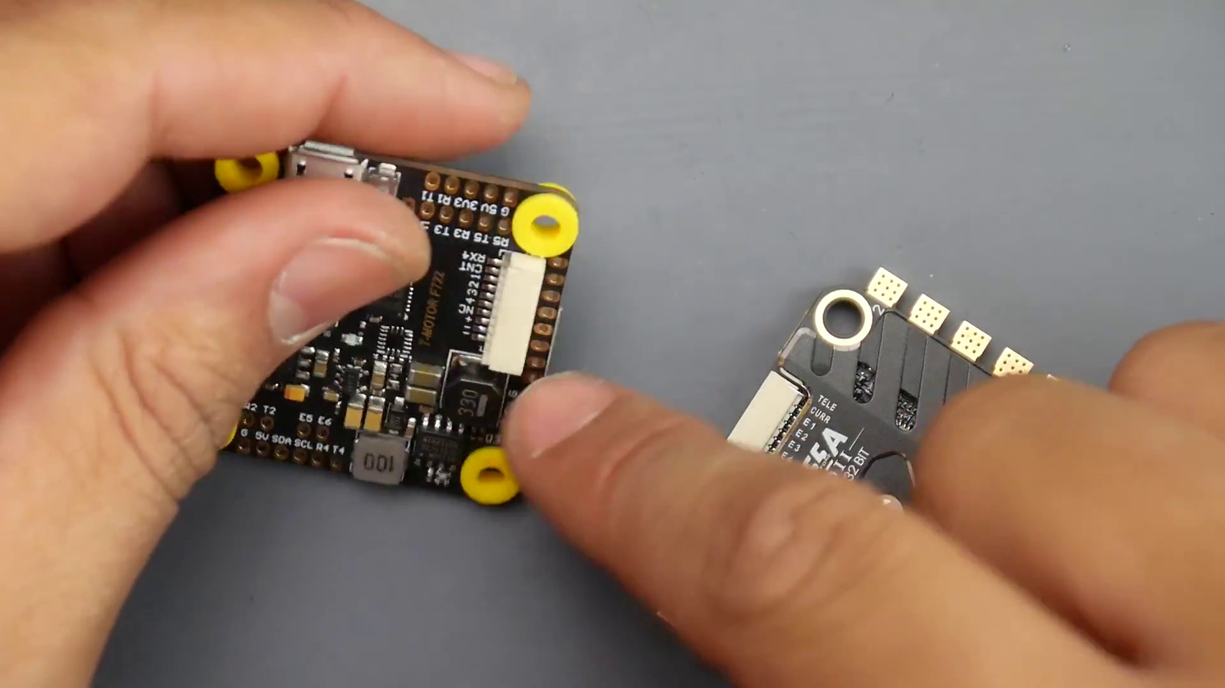

Transcript
[1:01] They have a lot of things going on here, like pit mode.
[1:04] You can activate and deactivate.
[1:06] However, there's no 9-volt regulator, but we're going to get into this in a bit.
[1:09] And we've got a lot of options here that we have to enable and disable in order to get it to work.
[1:13] But it seems pretty proper.
[1:14] Obviously, Gummi's inside.
[1:16] And let's get into this, because I haven't gotten this far just yet.
[1:19] I wanted to keep it preserved for you guys.
[1:21] So here we've got two connectors down there, which we're going to come back to.
[1:24] Here we have four screws, metal screws, very long for the stack.
[1:29] So hopefully that'll fit most frames.
[1:30] We also have our nice, trusty, low ESR capacitor, which is a Rubicon.
[1:35] Awesome.
[1:35] And it is a 35-volt, 470 microfarad.
[1:38] Really great.
[1:39] You're going to need this.
[1:40] You always need this, especially on 6S ESCs.
[1:44] Actually, on everything.
[1:45] They also give us some extra gummies.
[1:47] They give us five, to be exact, which is really great.
[1:49] There's already four on this one.
[1:51] And they've also given us four PCB wires or race wire, whatever you want to call these, in the packaging, which is really great.
[1:58] And let's see what else.
[1:59] Just spacers, the nuts and everything.
[2:01] So that's really nice.
[2:02] Actually, I didn't know they had this in here.
[2:04] And even the XT60, pre-made, really great.
[2:06] Also very, very thick and very, very long.
[2:10] Recommended to shorten this, like, halfway is good here.
[2:13] The longer this is, the more noise will be in your system.
[2:16] And it also gives us two connectors.
[2:17] Now, be careful how you connect them, because one says ESC, one says FC.
[2:21] It's really great.
[2:22] They've done that.
[2:23] And you'll be like, well, why?
[2:24] They're just going straight across.
[2:25] Well, if you go like this, you'll see that they're actually inverted.
[2:28] So I'll actually zoom in here.
[2:29] So this is the top side.
[2:31] And if they weren't inverted, those black wires would be on the same place.
[2:34] So keep that in mind.
[2:35] You could blow this whole thing up if you put these backwards.
[2:38] So where it says ESC, you plug it into this thing.
[2:41] Where it says FC, you plug it into the other thing.
[2:43] That looks like this.
[2:44] And you're good to go.
[2:45] So let's take a closer look at the flight controller.
[2:48] And the ESC, there's really nothing to say about it.
[2:50] Then it's really good.
[2:51] Tested it.
[2:52] Have it on a couple of builds.
[2:53] I even blew a battery and motors.
[2:55] And the ESC still functions, which says a lot.
[2:58] And it does have really great, what is it called?
[3:01] Throttle response, which means no jitters.
[3:03] Especially on 6S, it needs a very fast microcontroller unit.
[3:06] And just an overall great design.
[3:09] And this actually gets an A plus in my opinion.
[3:12] Now, this thing also has a 10 volt regulator.
[3:14] However, it's actually not being utilized, which we'll cover in a bit here.
[3:19] So this has telemetry.
[3:20] It's a BLHeli 32.
[3:21] And everything you want in a 6S ESC.
[3:24] This is it right here.
[3:25] So let's put this to the side for now.
[3:27] And let's start covering the flight controller.
[3:29] Because the ESC has a really nice feature, if you might say.
[3:32] If you want to call it a feature.
[3:33] And the flight controller here does not utilize that feature.
[3:37] But I can understand why.
[3:38] Because of another feature they've added.
[3:40] All right.
[3:40] So now we're going to take a look at the flight controller.
[3:42] See the overall board layout.
[3:44] And what we can see is there's some change of heart, maybe.
[3:47] I think that's the way you put it.
[3:49] Some changes have been made here.
[3:50] And you can easily spot those.
[3:52] So here we have our 16 megabyte of flash memory.
[3:55] So that's really great for black box since we don't have SD card expansion.
[3:58] Our MPU 6000 gyro is right here.
[4:01] And here, I think that we're going to do some sort of either sensor fusion.
[4:05] Or dual gyro setups.
[4:07] Where like an ICM and MPU.
[4:09] But they've gone ahead and removed that.
[4:10] But the legs are still available here.
[4:12] Or the traces for the other gyro.
[4:15] Here they're probably going to use just a full blown resistor.
[4:18] Instead of these four right here.
[4:19] Which is kind of like a multi resistor.
[4:21] I don't know what the actual real name is for these.
[4:23] But instead of this one, this one, this one.
[4:26] There's another one.
[4:26] Yeah, these two right here.
[4:27] They would have just used this.
[4:28] But I guess they changed their mind here.
[4:31] What else do we have?
[4:32] Here we have our switching regulator.
[4:33] It's just a 5 volt regulator.
[4:35] And again, there's no 10 volt regulator.
[4:36] There is just a 5 volt and a 3.3 volt.
[4:39] So that pretty much covers this side of the board.
[4:41] On the back side, nothing special either.
[4:43] No barometer.
[4:45] But we do have a transistor.
[4:47] I think this is the transistor that's in charge of pit mode.
[4:49] Now this is a real pit mode.
[4:50] Where it actually disconnects the power to your video transmitter.
[4:54] And that would be enabled from here.
[4:56] So you're going to have to do some bridges before you get this thing completely going.
[5:00] And this is where I'm going to cover in this video.
[5:02] We have our OSD right here.
[5:04] Little baby tantalum capacitors.
[5:06] Which OSD is this one?
[5:07] This is the 3.3 volt OSD here.
[5:10] So this is a 3.3 volt.
[5:11] It's a Chinese one.
[5:13] And what else do we have?
[5:14] Little baby tantalum capacitors.
[5:16] Our F7.
[5:17] Some diode here.
[5:18] The diode's coming in, I think, from the main battery voltage.
[5:20] Now it's also really nice.
[5:21] This takes raw battery voltage between, I think, basically up to 6S.
[5:26] And I think a minimum of 2S.
[5:28] Just check the documentation.
[5:29] The link's down below.
[5:30] You can go ahead and check this stack up.
[5:31] So now let's cover how we would go about connecting him.
[5:33] So the first thing we need to find is the arrow.
[5:35] And this arrow should be up top and pointing towards the camera.
[5:39] So if our camera was right here, this would be installed on our quadcopter.
[5:41] Just like this.
[5:43] And next thing we have is the video transmitter.
[5:46] Also the camera.
[5:48] And the receiver can be placed on any R-pad, basically.
[5:51] Because it's an F7.
[5:52] So it won't matter if you have S-Bus, I-Bus, FlySky, FRSky, or Spectrum.
[5:57] You can put them on any R-pad.
[5:59] It'll work.
[6:00] However, I don't recommend you put it on RX4.
[6:03] Because RX4 is being utilized for the telemetry here.
[6:06] Keep that in mind.
[6:07] Now, here on the left side, we have camera.
[6:09] So we have our ground, our positive.
[6:12] So ground would be the black wire for your camera.
[6:14] The positive is going to be the red.
[6:17] CC is camera control.
[6:18] So if your camera has OSD, you can actually connect the wire here.
[6:21] It'll enable you to control the OSD of the camera and change its settings, which is really cool.
[6:27] And we have the video input.
[6:28] This would be the yellow wire from your camera.
[6:31] Keep that in mind.
[6:32] However, if you plug it like that, the camera is not going to boot.
[6:36] Because you're going to have to bridge this right here.
[6:39] So if you wanted your camera to get 5 volts, which is highly recommended.
[6:42] And all cameras just basically take 5 volts and up.
[6:45] But the safe side is just to give them 5 volts.
[6:48] Would be to bridge this left one with this middle one.
[6:52] And that would give it 5 volts.
[6:54] But if you wanted to give it battery voltage for the camera,
[6:56] then you're going to have to bridge the middle one with the battery voltage.
[7:00] So keep that in mind.
[7:02] Now, I never recommend adding or giving straight battery voltage to the camera
[7:05] because the onboard filtration for the cameras is absolute trash.
[7:09] So keep that in mind.
[7:10] And I've seen that happen a couple times.
[7:13] So it's recommended just to give them from whatever regulator you have.
[7:17] 9, 10, 5 volts.
[7:18] So 5 volt here is what I would do on mine.
[7:21] And our camera is done there.
[7:23] Now, here is the video transmitter part.
[7:25] Now, the video transmitter can also give 5 volt or battery voltage.
[7:29] Again, most likely going to be going battery voltage.
[7:32] And the way we would connect this would be the yellow wire would go to the VO,
[7:36] which means video output,
[7:37] because the video would come in from the camera to the video input.
[7:41] Go inside.
[7:42] Go to this chip.
[7:43] Put the on-screen display on.
[7:44] And pop it out down to your goggles from your video transmitter.
[7:47] Now, T3 here would be for smart audio.
[7:50] And with that or any other protocol that allow you to change the channel
[7:54] and output power through the on-screen display.
[7:57] So that's where you want to put that.
[7:59] And now, R3 would be not usable anymore.
[8:02] So keep that in mind.
[8:03] So if one of the pads that have a T and R, for example, now the T3 is used,
[8:08] we're not going to be able to use the R3 for anything else.
[8:11] So keep that in mind.
[8:12] Very important to take note of that.
[8:14] And here we have our plus and our minus.
[8:16] Plus is going to be the red wire for your video transmitter.
[8:19] And minus is going to be the black wire.
[8:20] Now, if your video transmitter takes battery voltage,
[8:23] you'd bridge the left one with the middle one.
[8:25] If it takes 5 volts, you'd bridge the right one with the middle one.
[8:29] And you're set to go.
[8:30] If you don't bridge these, these two won't get power.
[8:33] Keep that in mind.
[8:34] Also, a little nice tip or trick, if you might not know this.
[8:37] If you're unable to bridge it, no matter what the hell you did,
[8:40] then you could just take your red wire, put it to battery right there.
[8:44] Because that's basically battery right there.
[8:45] It would be the same thing.
[8:47] And you can do that and get away with it.
[8:48] So yeah, if you didn't want to bridge them, you can do that.
[8:50] If you wanted 5 volt, you could just solder it to this guy and you're good to go.
[8:53] Same thing goes for that one.
[8:54] Next, let's cover the receiver.
[8:57] How would we connect our receiver?
[8:59] Now, IBUS and Spectrum.
[9:01] I mean, sorry.
[9:02] Yeah, IBUS, Spectrum and FR Sky, whatever protocol you're using,
[9:06] is going to be connected in this area right here.
[9:08] The only difference is with Spectrum is you're going to give it possibly 3.3 volts
[9:13] because those take 3.3 volts.
[9:14] Anyways, let's cover IBUS and SBUS.
[9:17] So if you had an IBUS, Flag Sky or an FR Sky receiver,
[9:21] you'd want to put the SBUS or IBUS signal on the R5 right here.
[9:25] That's where I would want to put it.
[9:27] So you put it right there.
[9:28] And then you want to put the black wire, which is the ground, right here on the G.
[9:32] And this would be 5 volts.
[9:34] So that would be the red wire.
[9:35] And then now you have a connected receiver.
[9:38] So you're good in that perspective.
[9:39] Now, Spectrum, usually 3.3 volts.
[9:41] I would still put the signal on R5.
[9:44] I would still give it ground.
[9:46] But instead of 5 volts, I would give it 3.3 volts for the red wire.
[9:50] And you're good.
[9:51] Just that's it.
[9:52] And this is really cool because it even supports PPM without having to do anything.
[9:56] So if you're still using a receiver that uses PPM,
[9:59] you just take it right there and you're good to go.
[10:01] Now, if we take a closer look here, we also see we have an R3 and a T3 pad.
[10:05] However, you will not be able to use these two if you're using the T3 up here.
[10:11] So keep that in mind.
[10:12] So if you are using smart audio or some kind of a TRAMP protocol,
[10:15] you can't use these for anything else.
[10:17] So keep that in mind and don't screw up.
[10:19] We also have a dedicated RSSI pad.
[10:21] So if your receiver gives some sort of RSSI signal from a dedicated wire,
[10:26] then you can just install that there and you should have that set up.
[10:29] And here we see we have R1 and T1.
[10:32] Now, you'll be able to use this for whatever your heart desires,
[10:35] which is really great.
[10:36] And you can use any sensor or anything.
[10:39] For example, I would actually possibly put TBS Crossfire here
[10:44] because, you know, that's how it would work.
[10:46] It uses a full UR, the R and the T.
[10:48] I'll probably put the, you know, TBS Crossfire right here
[10:51] and I'll be good to go.
[10:52] Now, if we take a look on this side right here,
[10:56] we see we have E5 and E6.
[10:59] You know, like what the hell is E5 and E6?
[11:01] These are two extra motor output signals
[11:04] that can be remapped to do anything you want,
[11:06] which is also something really nice that they've done that here.
[11:09] They didn't have to, but it's also, you know,
[11:11] it's just a little couple extra pads.
[11:13] You can do whatever you want with,
[11:14] not whatever you want with, but you can do quite a lot with.
[11:16] Here we have an R2 and a T2,
[11:19] which is not being used by anything else.
[11:21] So you'll be able to use these for anything you wanted to,
[11:24] which is really great.
[11:25] And we also have a ground 5 volt, SCL and SDA.
[11:28] These would be for like a magnometer.
[11:30] Some sensors use these pads so you can connect those there.
[11:33] And then this is very important.
[11:34] Now, R4 and T4, if you're using ESC telemetry,
[11:37] it's on RX4 right here.
[11:39] So you're not gonna be able to use these.
[11:40] So keep that in mind.
[11:41] If you have the, you know, the connector with this ESC plugged in
[11:44] and ESC telemetry working,
[11:45] these are basically used up.
[11:47] You can't use these two,
[11:49] which is something very important to take note of here.
[11:52] Now, if you take a look at the pads here,
[11:55] also this connector,
[11:56] but we're gonna take a look at the pads
[11:57] because it's the same thing.
[11:58] For example, if you're not using the same ESC,
[12:01] you're gonna have to solder to this right here,
[12:03] unless you wanna play with the wires.
[12:04] But if you have to solder, it's very simple.
[12:06] Everything is really well labeled here.
[12:08] For example, here's the RX4.
[12:10] This would be for the ESC telemetry.
[12:11] Then the current wire, motors 1, 2, 3, and 4.
[12:15] And then we have positive.
[12:16] This would be battery voltage.
[12:18] So up to 6S.
[12:20] So keep that in mind, not 5 volt.
[12:22] This would be battery voltage.
[12:23] And then this would be a ground here.
[12:26] And here we have another ground 5 volt buzzer and LED.
[12:28] These are separate here.
[12:30] These are, if you wanted to connect a buzzer and or LEDs,
[12:34] this is where you'd connect them right here.
[12:36] So for example, for connecting a buzzer,
[12:37] I'd put the buzzer positive on 5 volt
[12:39] and the negative on buzz minus.
[12:41] It's very important because the buzzers get initialized
[12:44] through the ground here.
[12:45] LED, kind of the same thing,
[12:47] but I wouldn't use the buzzer ground.
[12:49] I would give it ground, which is a black wire.
[12:51] Red wire is the 5 volt.
[12:53] And then the LED signal here.
[12:54] This is the signal that's going to change the color on the LED.
[12:57] So keep that in mind.
[12:58] Hopefully that made sense.
[12:59] All right.
[12:59] So this area here is very important
[13:01] because this area has to do with your video transmitter
[13:03] if you gave it power from the video transmitter part.
[13:06] Because this is where the transistor
[13:07] that's in charge of your video transmitter is.
[13:10] Now, whether you can choose the video transmitter always on
[13:13] or you can choose pit mode,
[13:16] which means you could assign a switch on your controller
[13:20] in order to give power to the video transmitter.
[13:23] So you can do it both ways.
[13:24] Now, if you're really not experienced,
[13:26] just bridge the left two together
[13:28] and you won't have a headache.
[13:30] Overall layout seems to be pretty good.
[13:32] I've seen better.
[13:33] But, you know, I wish they've gotten away,
[13:35] just, you know, removed these here
[13:37] from their latest design before going into production.
[13:39] Because this doesn't feel very professional.
[13:42] Unlike their ESCs, their ESCs are really great.
[13:44] Hopefully their flight controller is good.
[13:46] I still haven't used one of their flight controllers yet,
[13:48] if I remember correctly.
[13:49] This might be the first one.
[13:50] Not sure yet.
[13:51] I still have a bunch of builds to go fly and test,
[13:53] which I haven't still tested.
[13:55] So, yeah.
[13:55] Everything here is linked down below.
[13:57] Let me know what you guys think down in the comment section
[13:58] if anyone's used any of these.
[14:00] And I'll see you in the next one.
[14:03] Thank you.

