Engagement Analysis: raTtiqWOFW8

Section 0: Overview of Images Described
Time: 0:00 - 0:08

Summary
This response contains a series of descriptive titles and summaries for each image, along with their corresponding start times.

Representative Frames
0:01   | 0:02   | 0:04  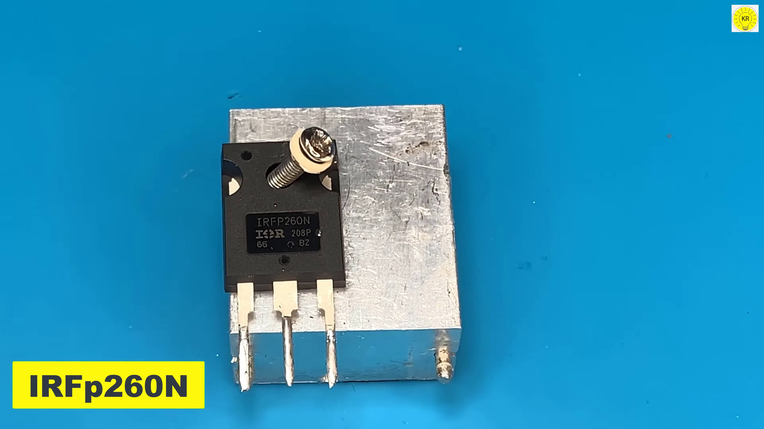 | 0:05   | 0:06  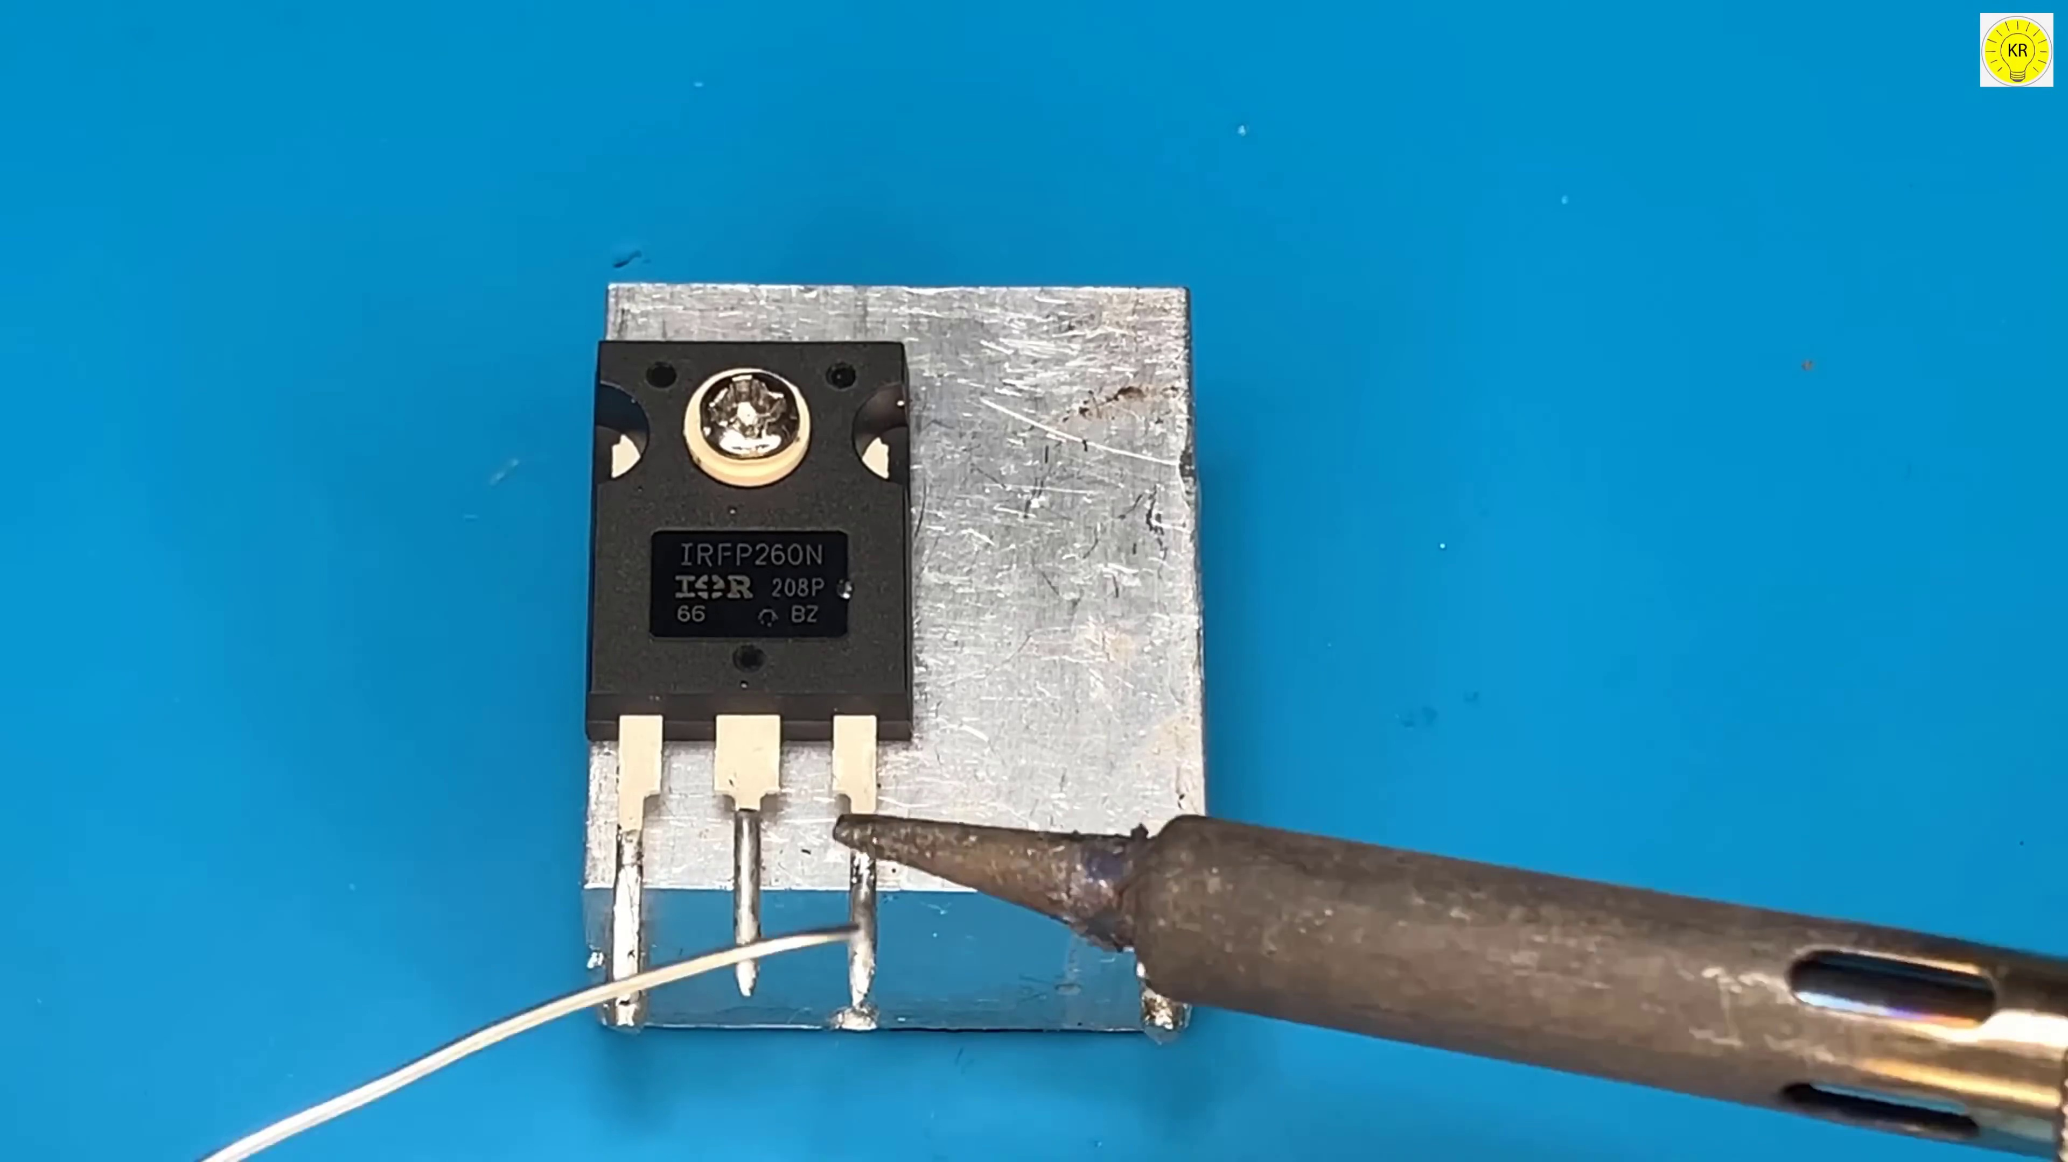

Transcript
(No speech detected in this section)

Section 0: Image 1: A Person Working on Their Computer
Time: 0:08 - 0:12

Summary
The first image is a person working on their computer, with a detailed description of the screen and its various elements, such as icons, buttons, and text fields.

Representative Frames
0:08   | 0:09   | 0:10  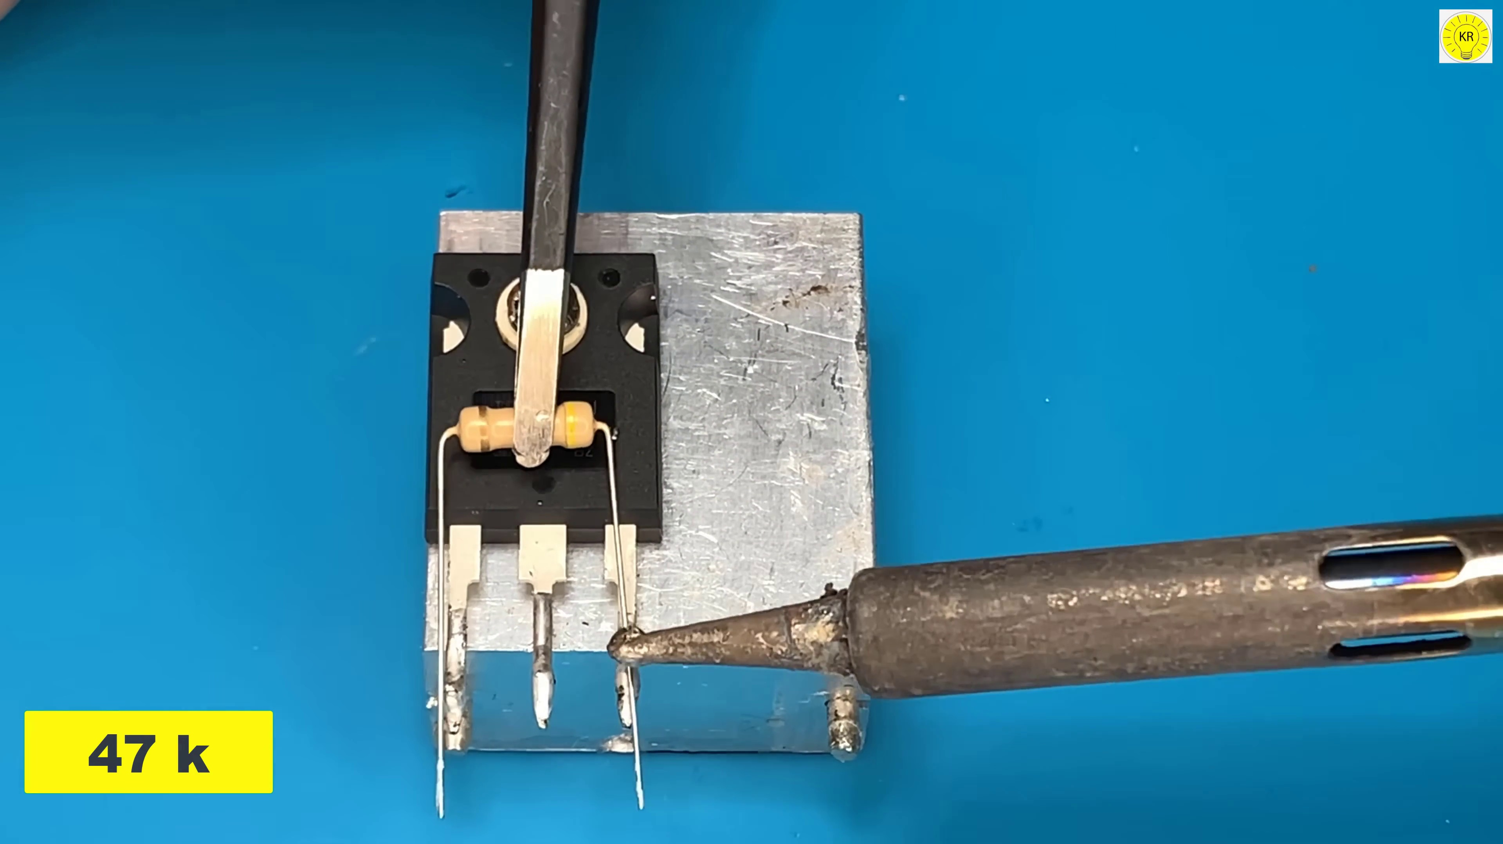 | 0:10   | 0:11  

Transcript
(No speech detected in this section)

Section 0: Image 2: A Website Interface
Time: 0:12 - 0:16

Summary
The second image is a website interface, with a logo at the top left corner and navigation bar below it. The user can interact with the site using icons, buttons, and text fields.

Representative Frames
0:12   | 0:13  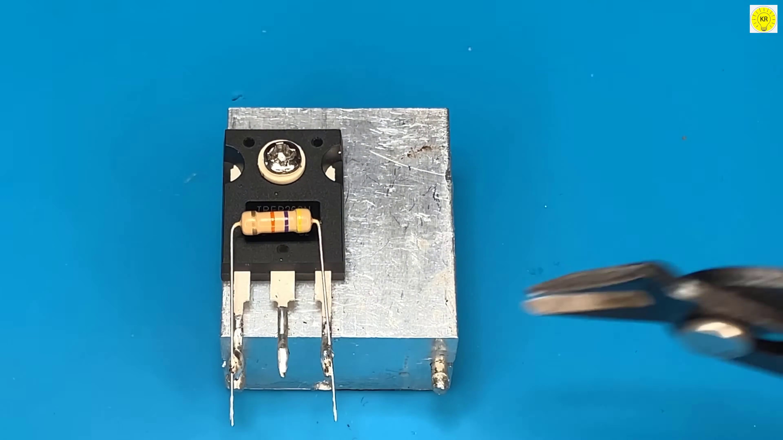 | 0:14   | 0:14   | 0:15  

Transcript
[0:00] Let's get started.

Section 0: Image 3: A Man Standing in Front of a Large Screen
Time: 0:16 - 0:19

Summary
The third image is a man standing in front of a large screen displaying two video boxes. The website on the computer monitor has a subscription button at the bottom right corner.

Representative Frames
0:16   | 0:17  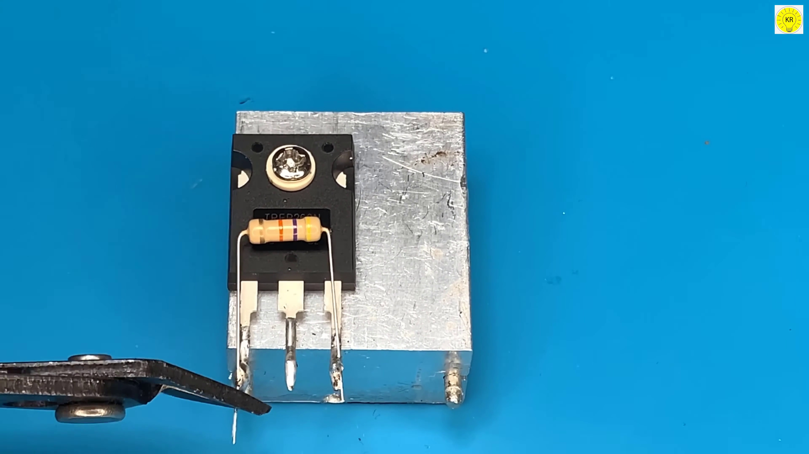 | 0:17   | 0:18   | 0:18  

Transcript
(No speech detected in this section)

Section 0: Image 4: A Digital Advertisement for Cool Videos
Time: 0:19 - 0:22

Summary
The fourth image is a digital advertisement for cool videos, with a large circular button that says 'CHECK OUT' in bold, white letters against a striking combination of red and orange background.

Representative Frames
0:19   | 0:20  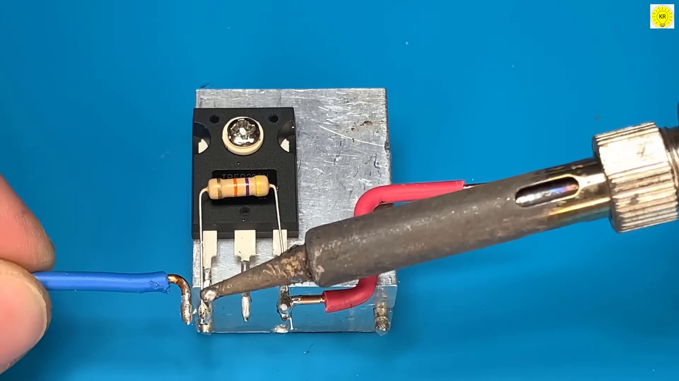 | 0:20   | 0:21   | 0:21  

Transcript
(No speech detected in this section)

Section 0: Image 5: A Digital Banner with Modern Design
Time: 0:22 - 8:29

Summary
The fifth image is a digital banner with a modern and minimalist design. It features an instructional graphic that says 'CLICK TO SEE THE VIDEO' along with an arrow pointing to the right, indicating where to click.

Representative Frames
1:43  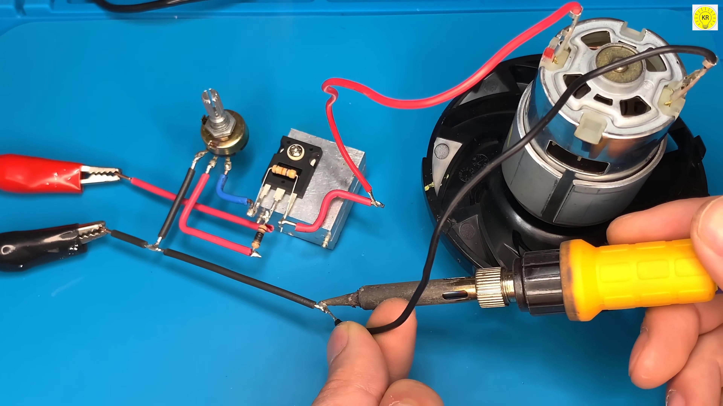 | 3:04  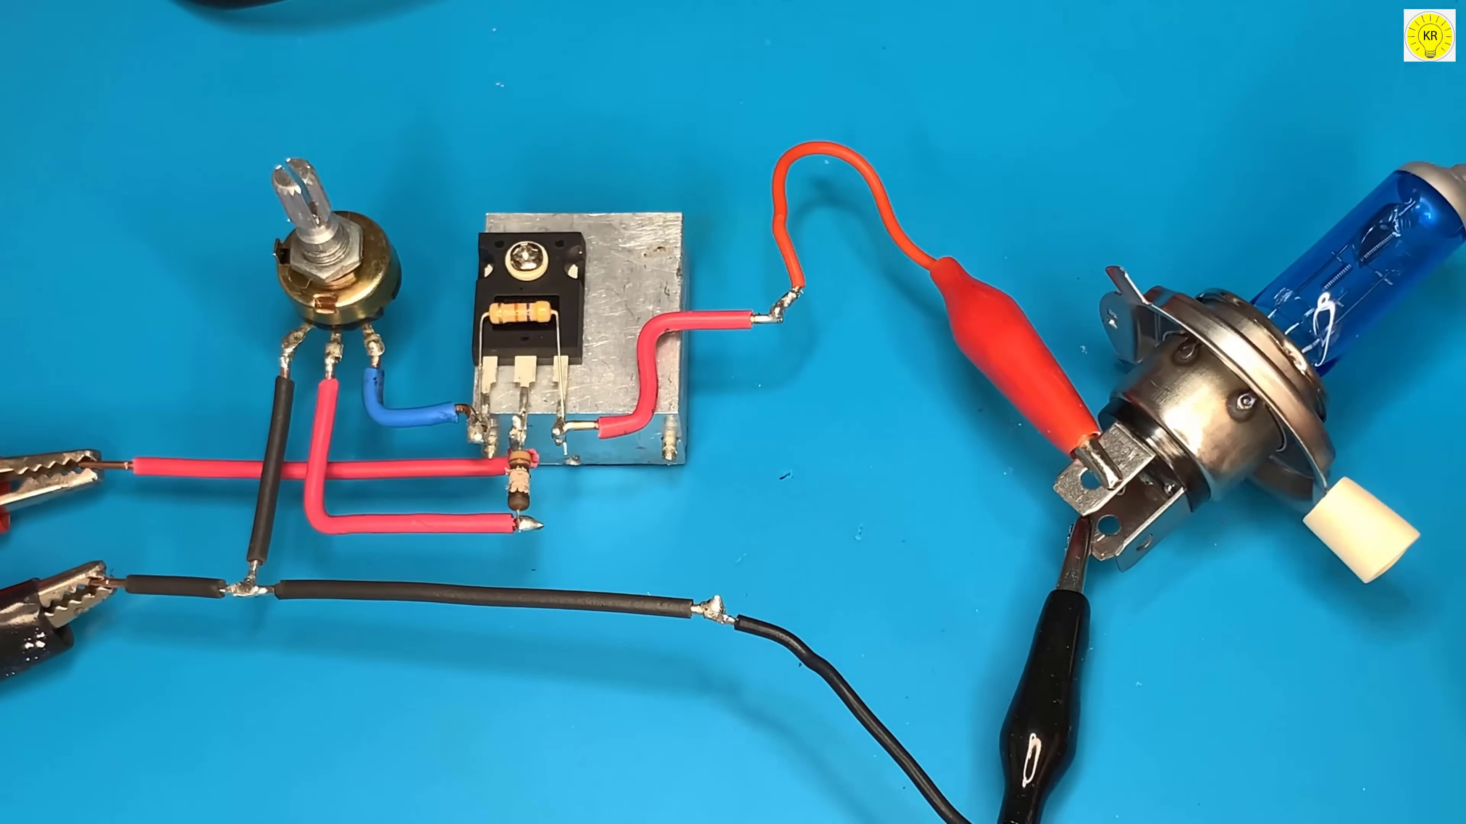 | 4:25  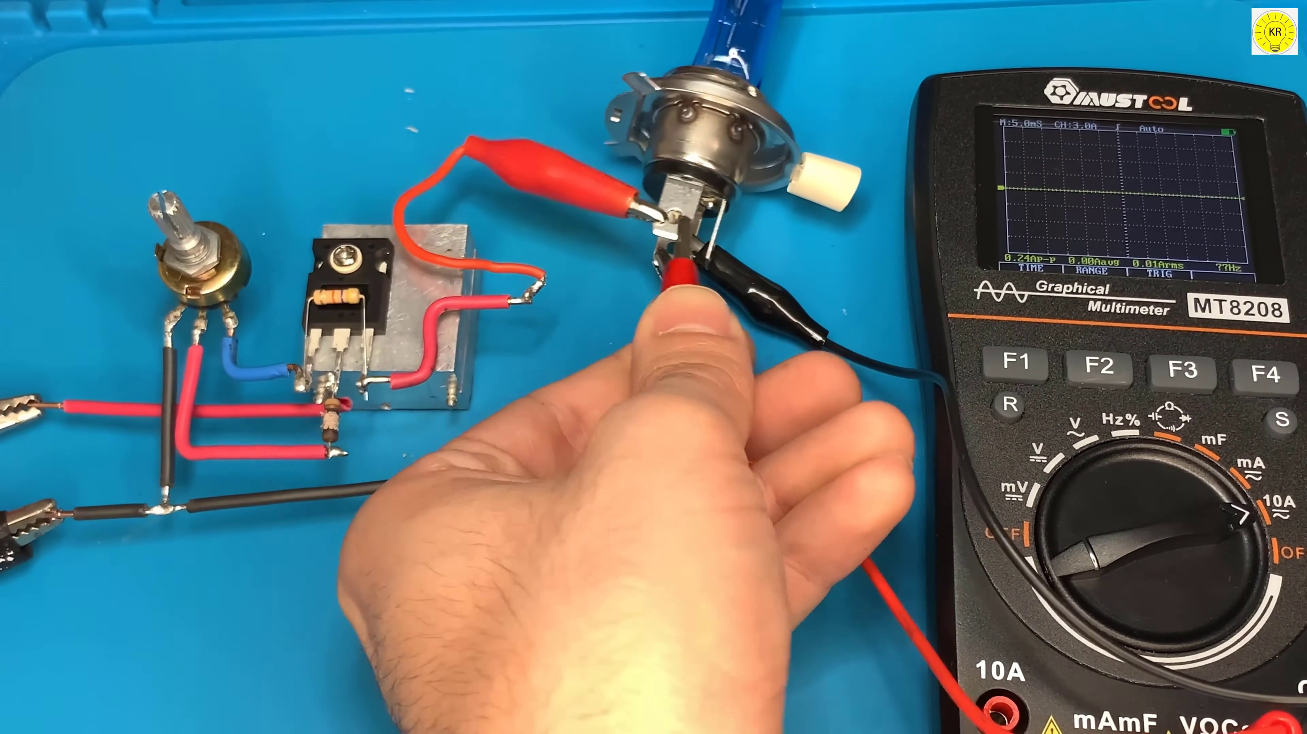 | 5:47  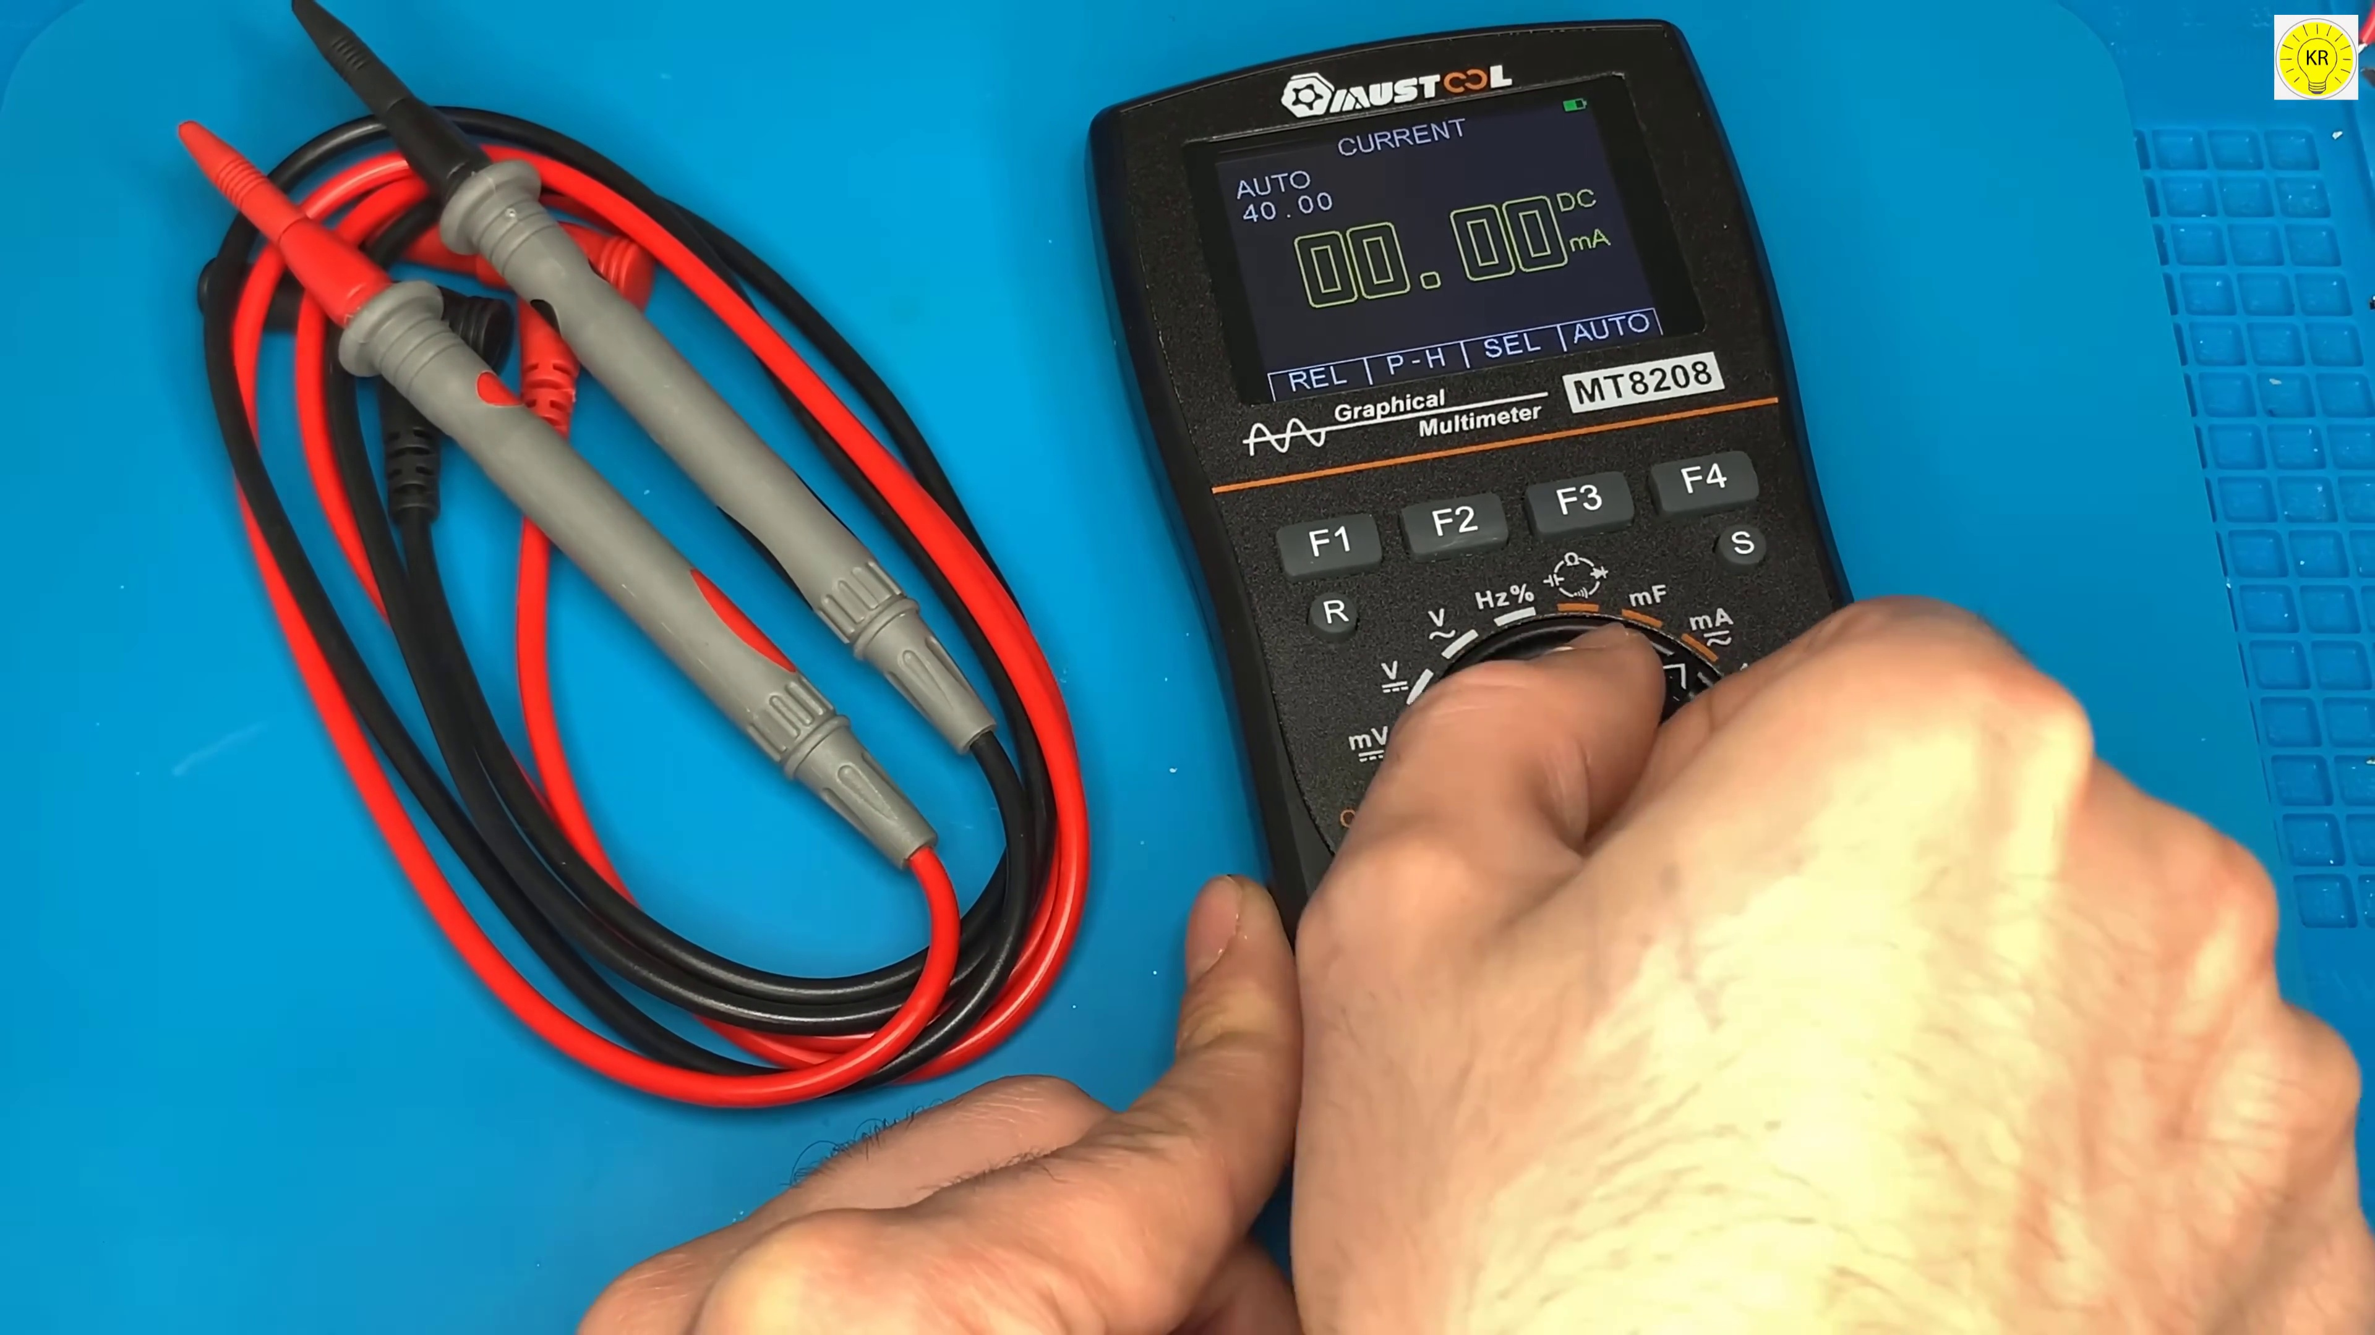 | 7:08  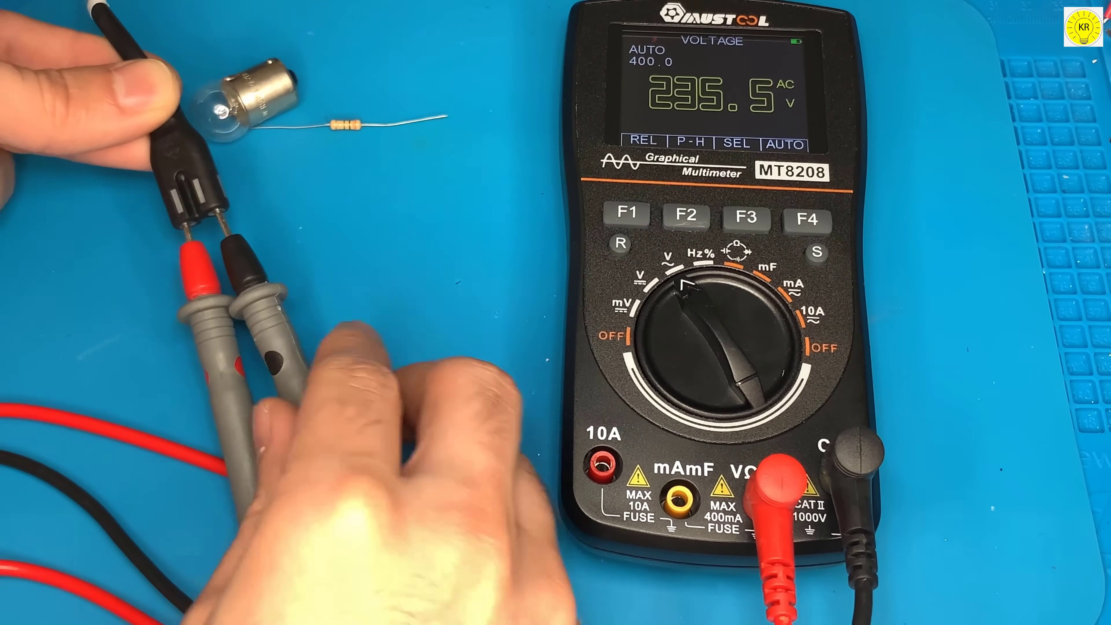

Transcript
[0:30] Thank you.
[1:00] Thank you.
[1:30] Thank you.
[2:00] Thank you.
[2:30] Thank you.
[3:00] Thank you.
[3:30] Thank you.
[4:00] Thank you.
[4:30] Thank you.
[5:00] Thank you.
[5:30] Thank you.
[6:00] Thank you.
[6:29] Thank you.
[6:59] Thank you.
[7:29] Thank you.
[7:59] Thank you.

