Engagement Analysis: rw3I118gQa8

Section 0: A series of images depicting various electronics projects and setups
Time: 9:00 - 9:54

Summary
The provided text describes a sequence of images showcasing different electronics projects, including audio equipment, oscilloscope interfaces, and electronic components. The scenes are set in outdoor workshop or laboratory settings, with informal and possibly educational tones.

Representative Frames
9:09  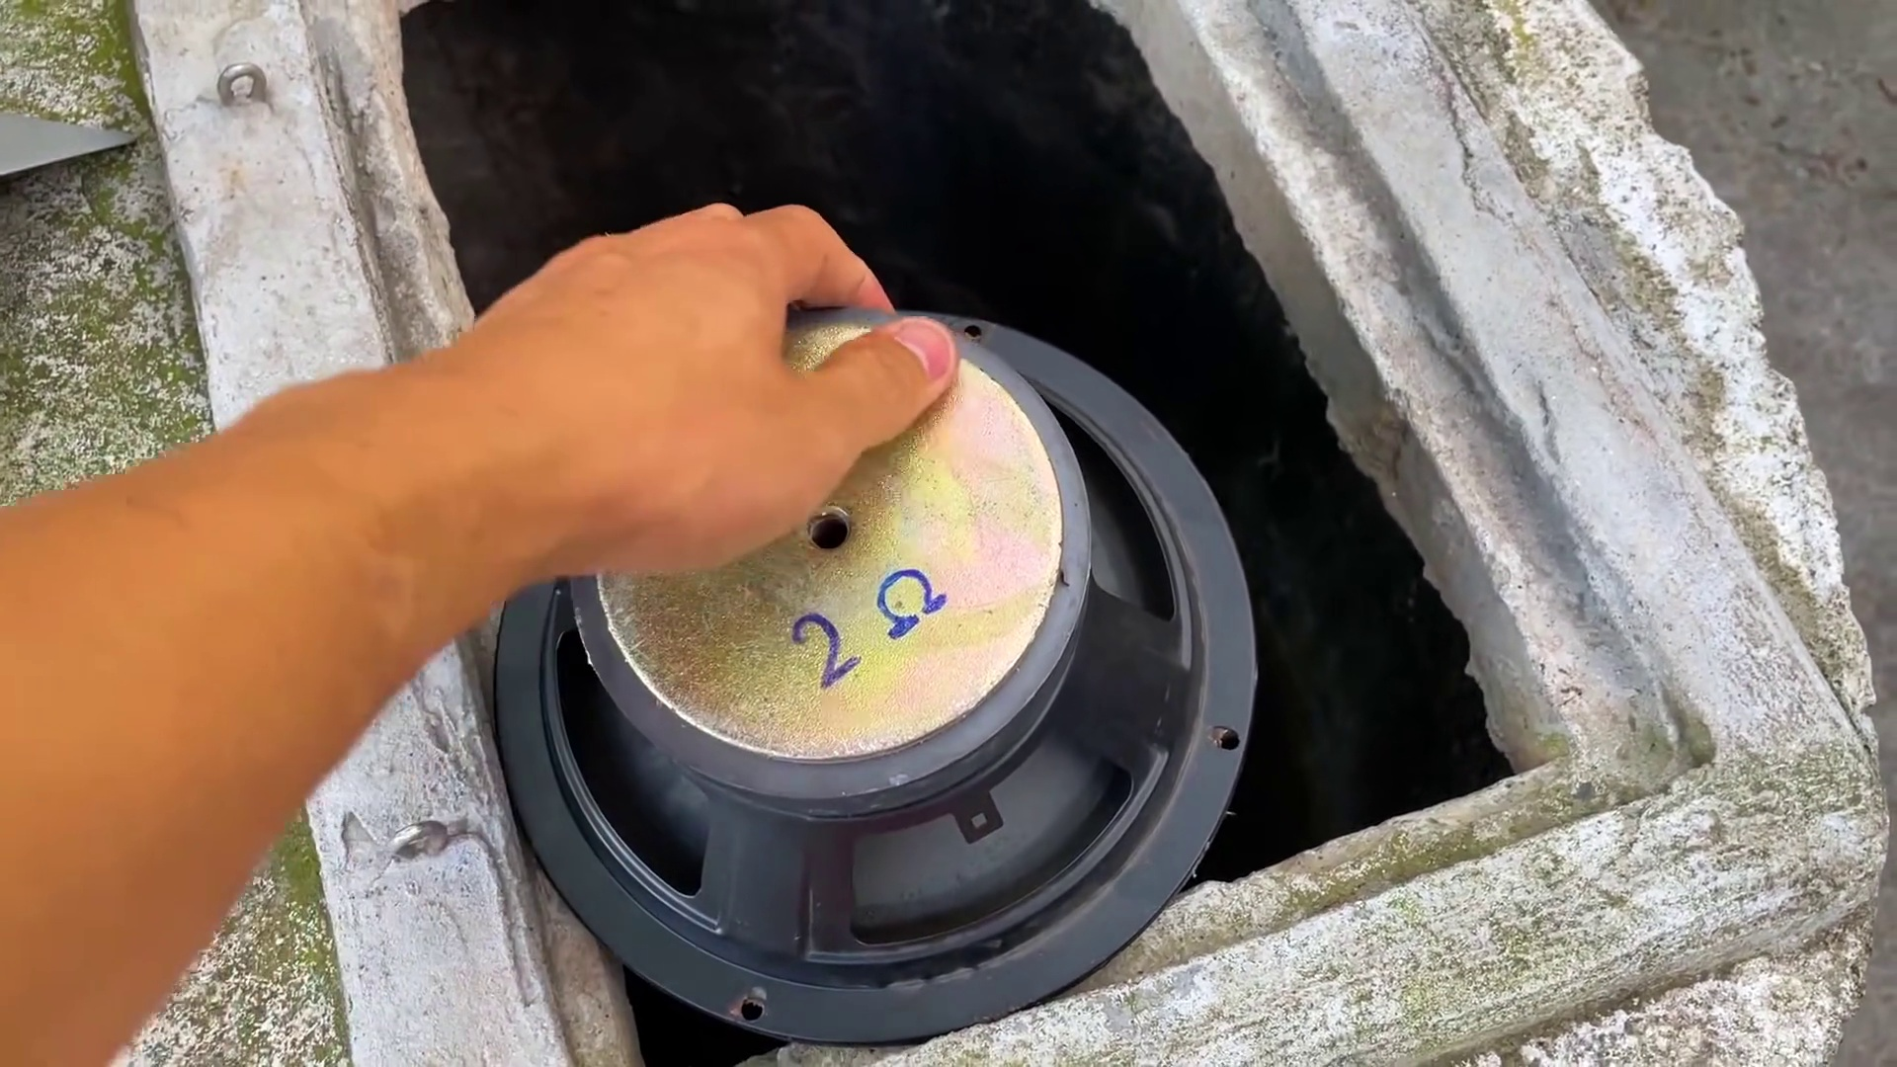 | 9:18  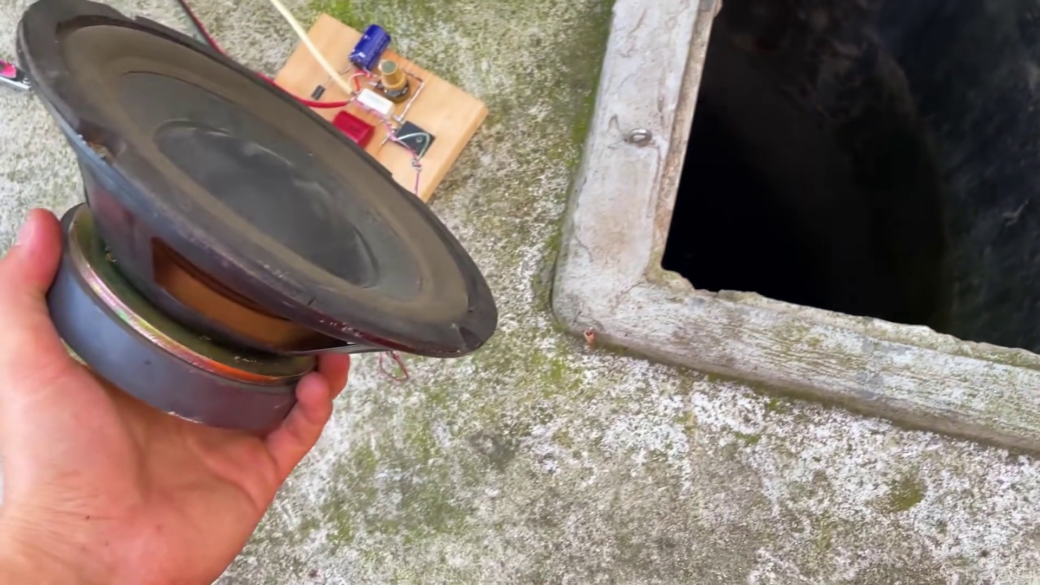 | 9:27  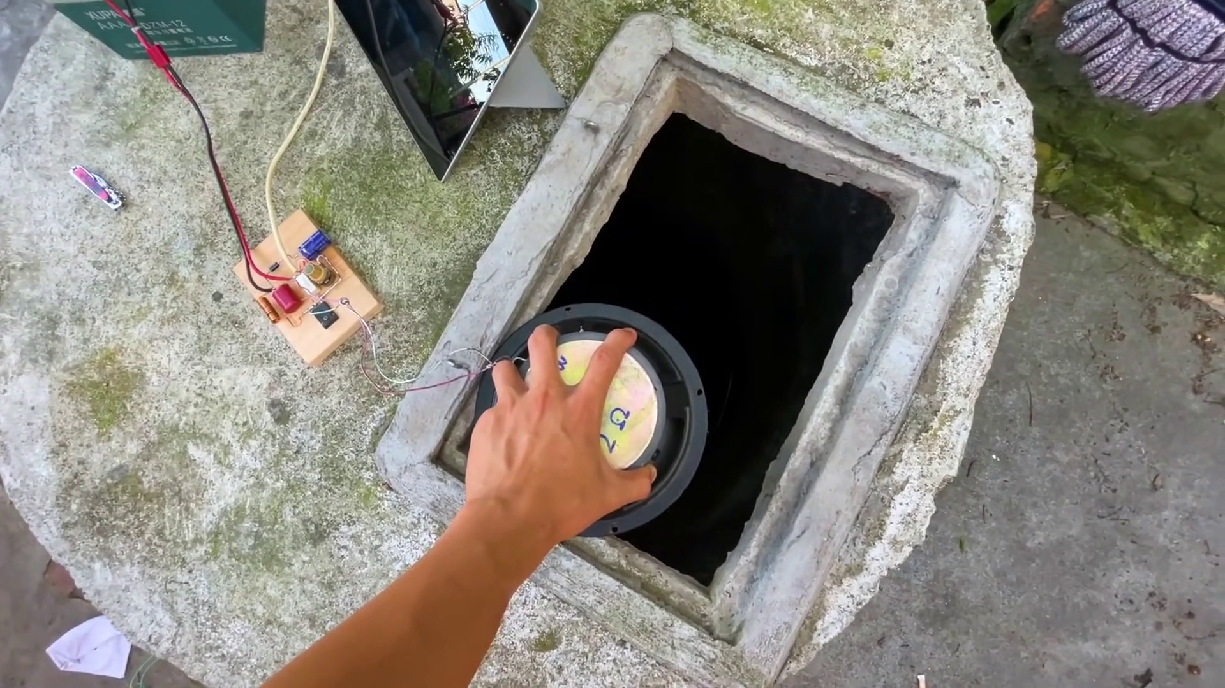 | 9:36  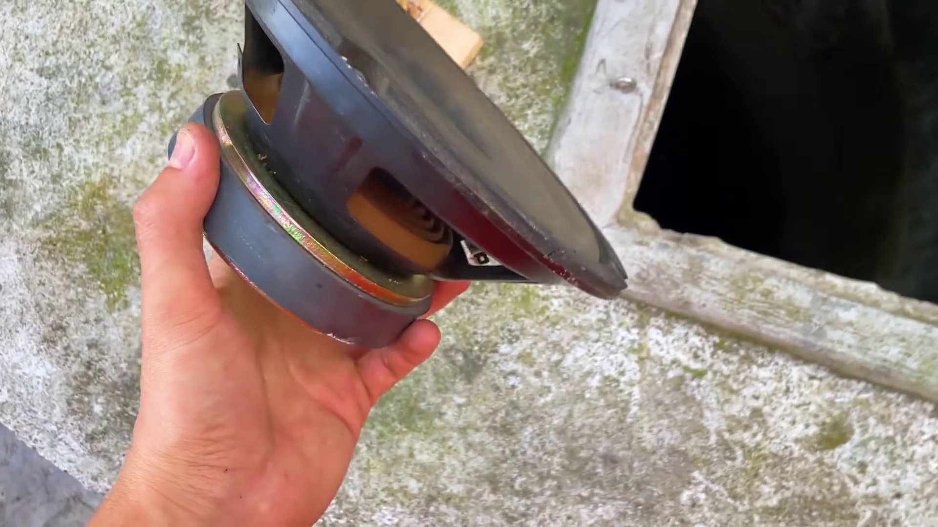 | 9:45  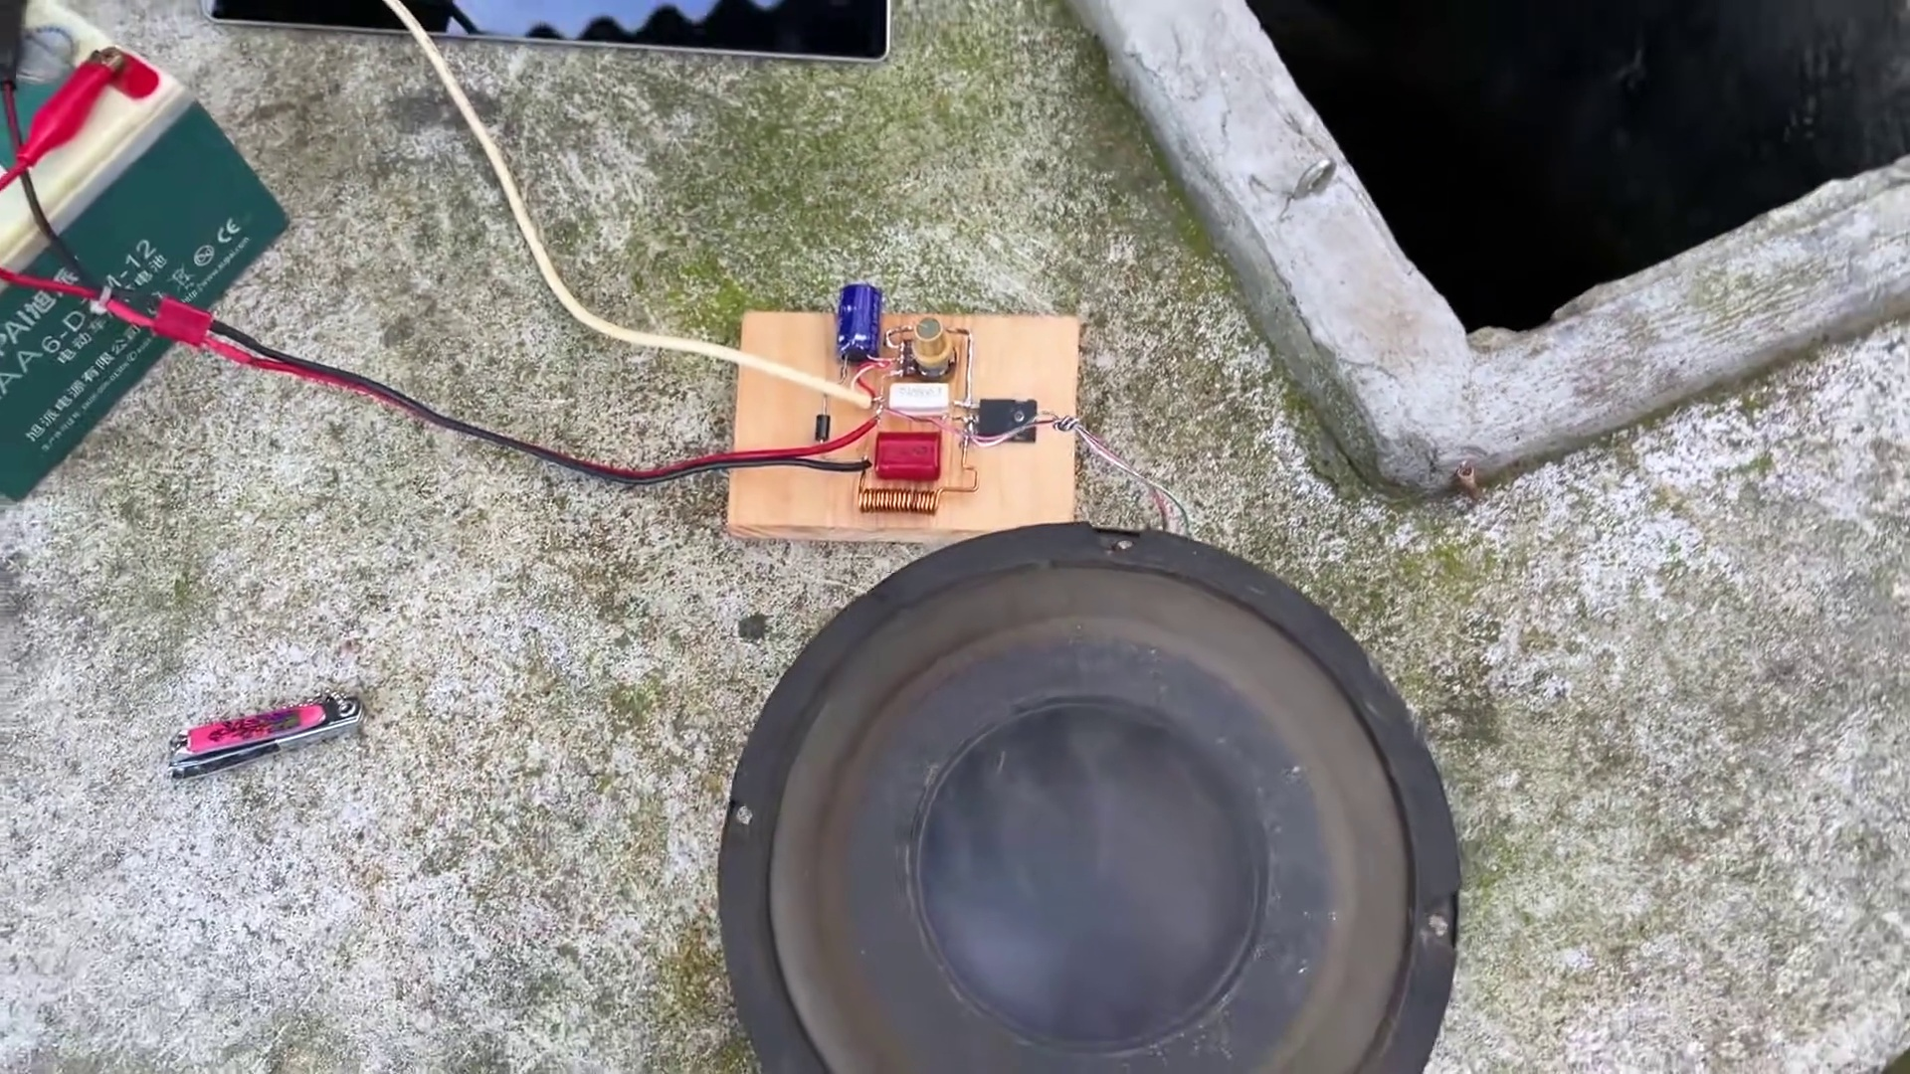

Transcript
[9:01] 다음 영상에서 만나요.
[9:31]

