Engagement Analysis: s0dNRe0XWJ8

Section 0: Introduction to the Conversation
Time: 0:00 - 0:10

Summary
The conversation begins with a series of images being shared, featuring a person with various facial expressions and settings. The narrator mentions that these images will be broken down into multiple parts.

Representative Frames
0:01  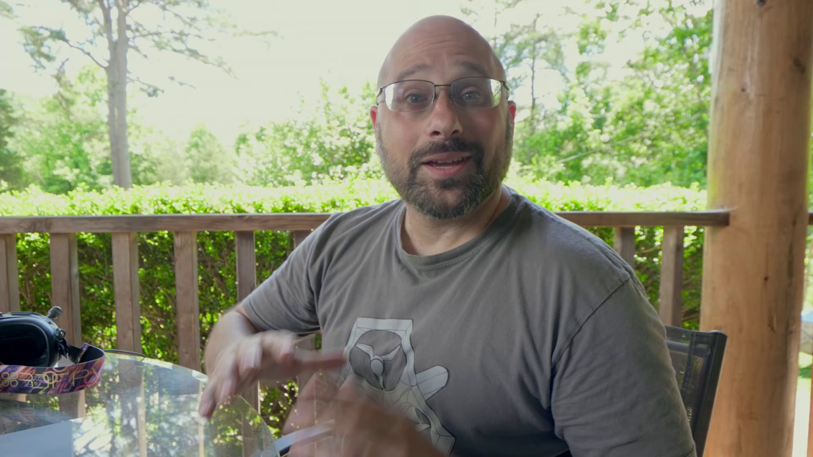 | 0:03   | 0:05  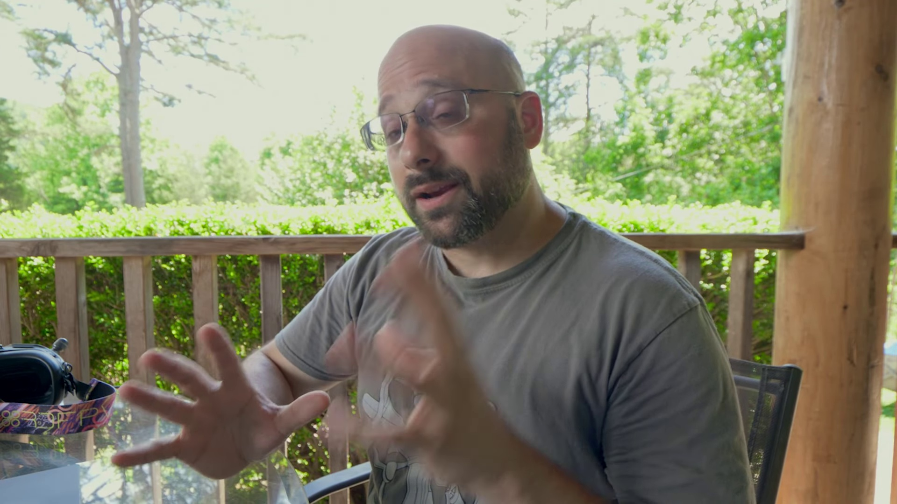 | 0:06   | 0:08  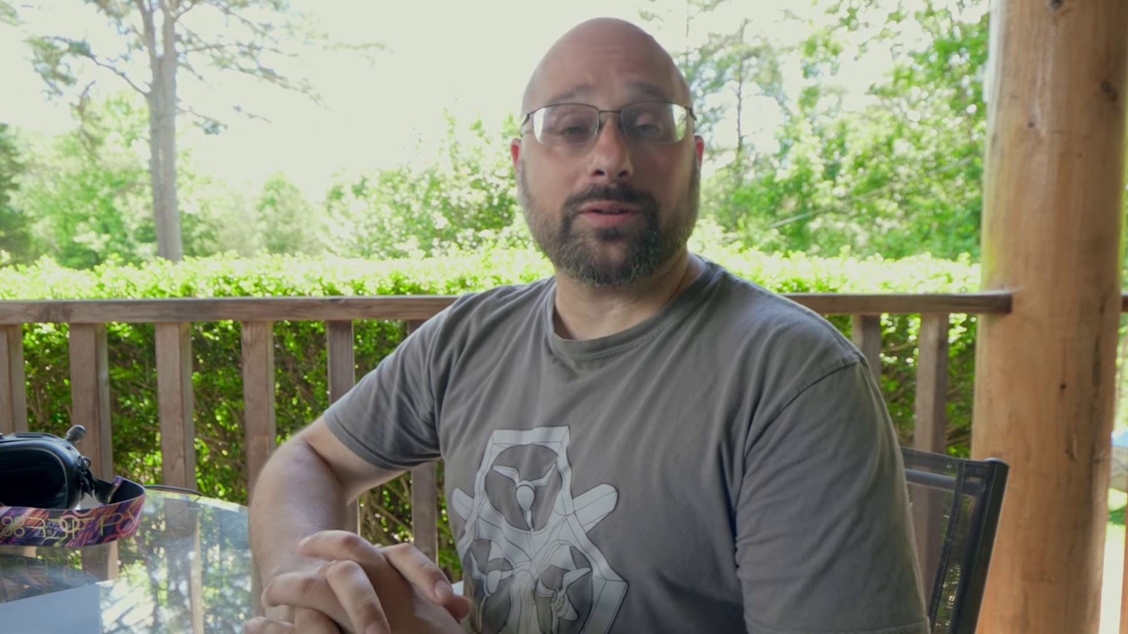

Transcript
[0:00] If you don't know who Chris Rosser is, get with the times. He is an aerospace engineer who is
[0:05] tearing up the world of FPV with his information on frame resonance analysis,

Section 0: Image Description 1
Time: 0:10 - 0:20

Summary
A bald man with glasses is shown making a funny gesture with his right hand in a casual, informal setting. There is no additional context or information provided about the image.

Representative Frames
0:11  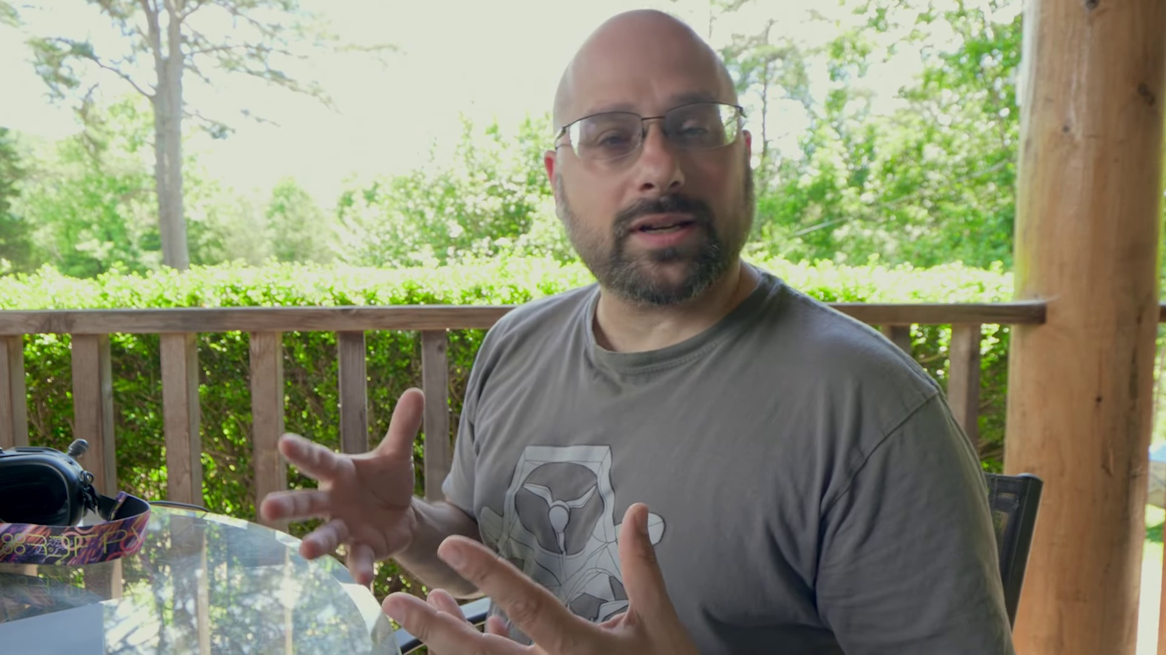 | 0:13   | 0:15  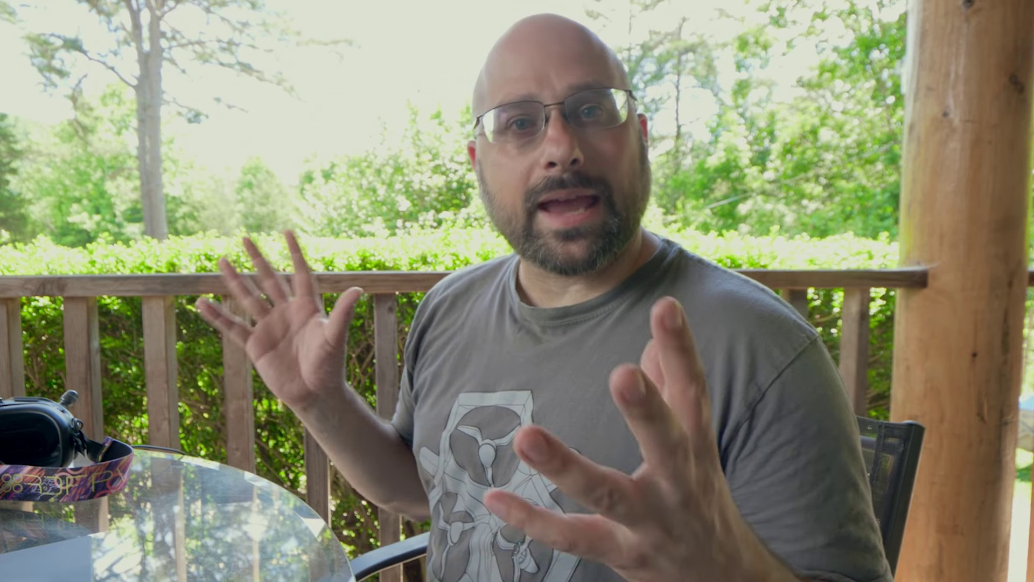 | 0:16   | 0:18  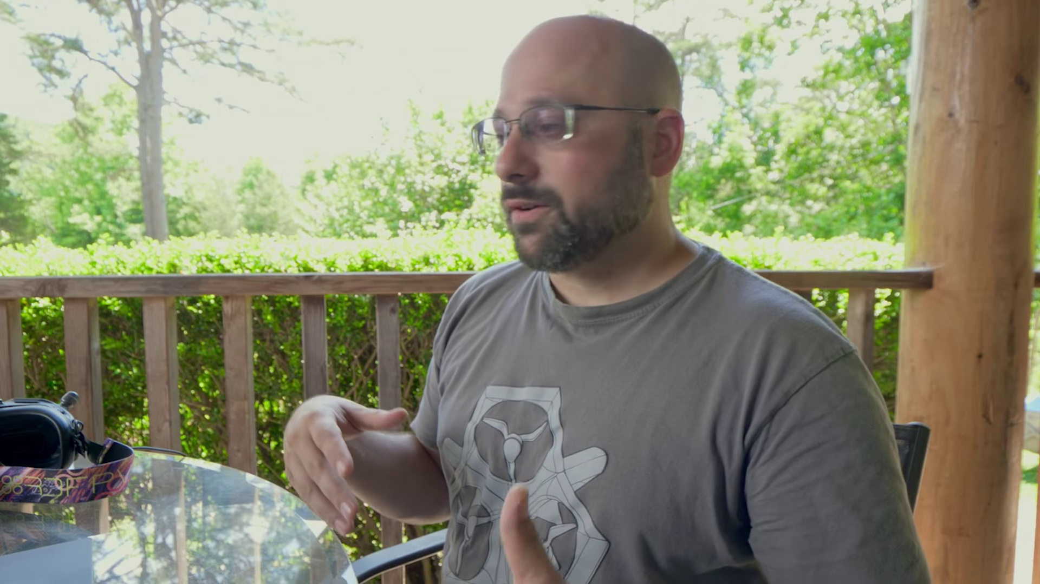

Transcript
[0:11] PID tuning, frame design, just bringing an academic and professional engineering perspective
[0:15] to a field that all too often is made up of yahoos like me who just try things and see what works

Section 0: Image Description 2
Time: 0:20 - 0:30

Summary
A person is lying on their side outdoors, wearing a short-sleeved shirt and smiling at the camera. The background suggests a natural environment with trees and a wooden structure or fence.

Representative Frames
0:21  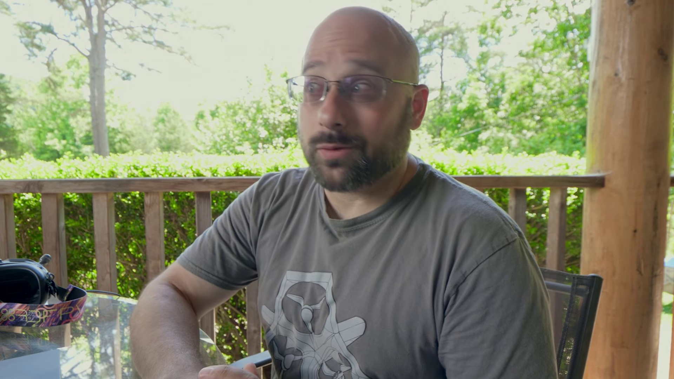 | 0:23   | 0:25  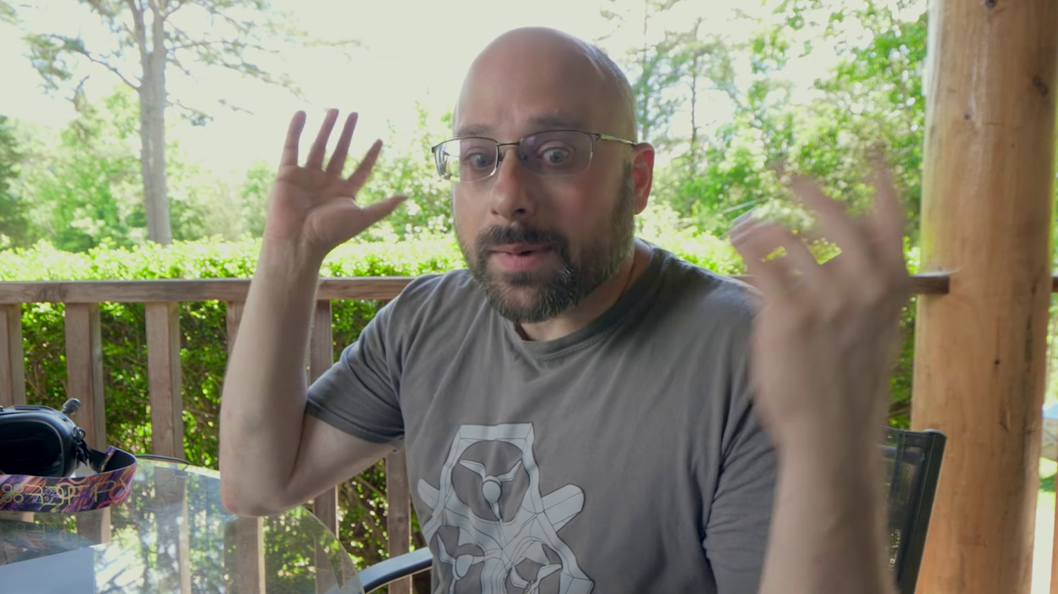 | 0:26   | 0:28  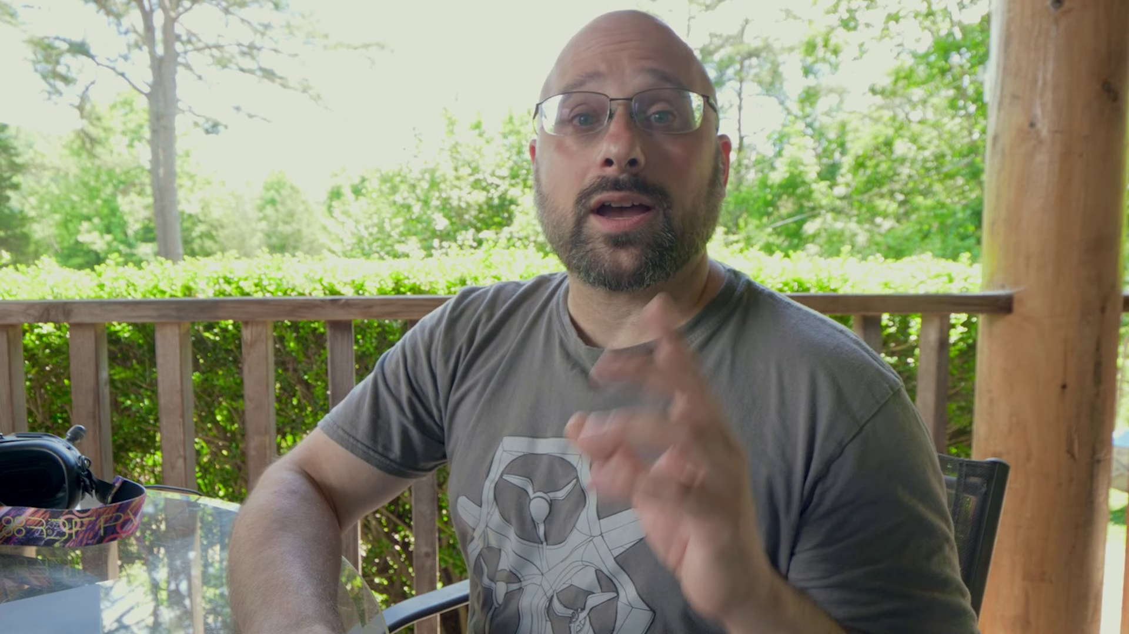

Transcript
[0:22] and talk about it. But he's an actual professional. And that's why I'm so excited today to be making

Section 0: Image Description 3
Time: 0:30 - 0:40

Summary
A person is taking a selfie outdoors, wearing a gray shirt and black glasses. They are smiling broadly at the camera and looking directly into it. The background is blurred but creates a sense of depth and perspective.

Representative Frames
0:31  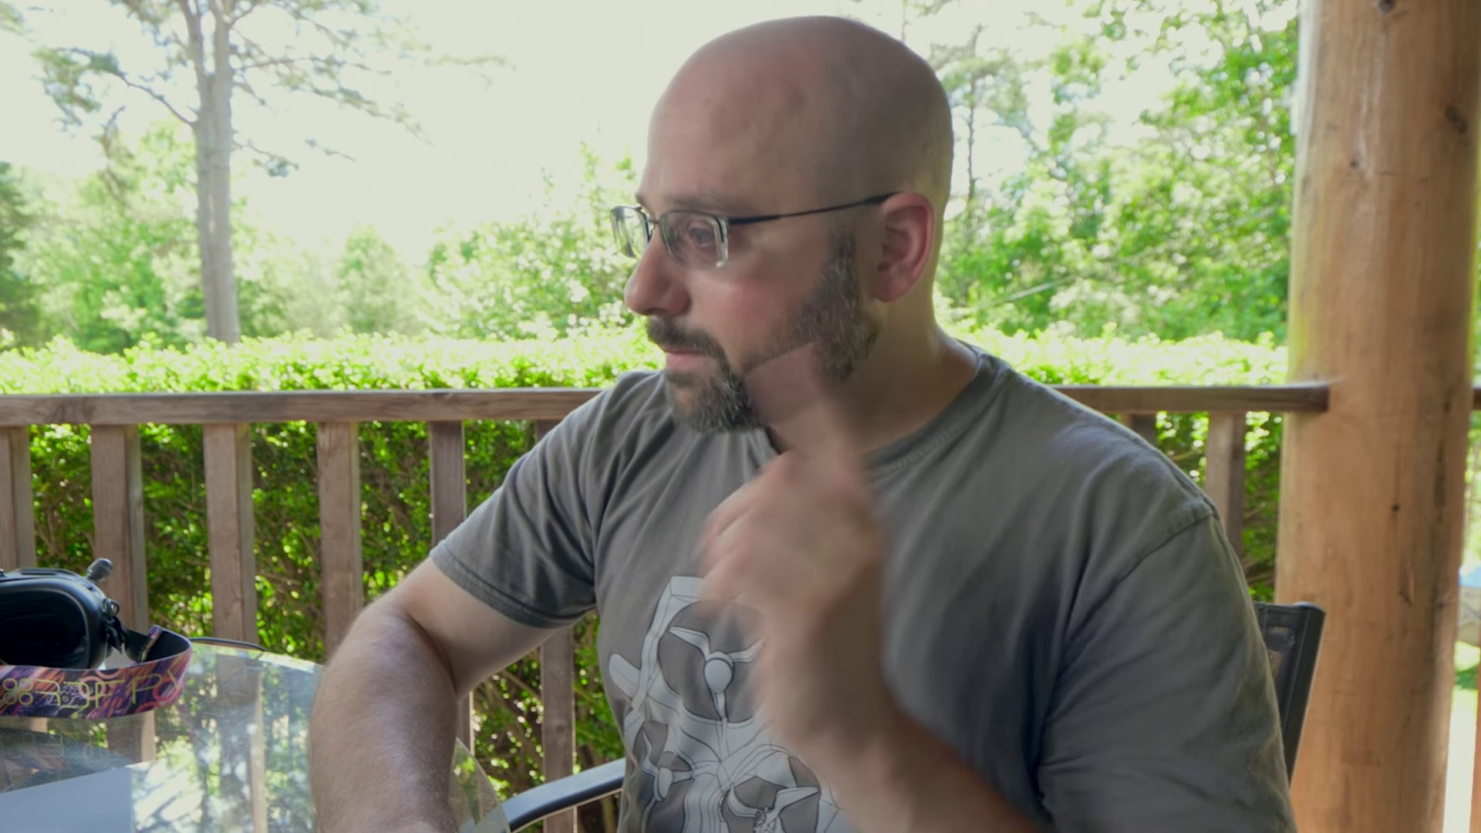 | 0:33   | 0:35  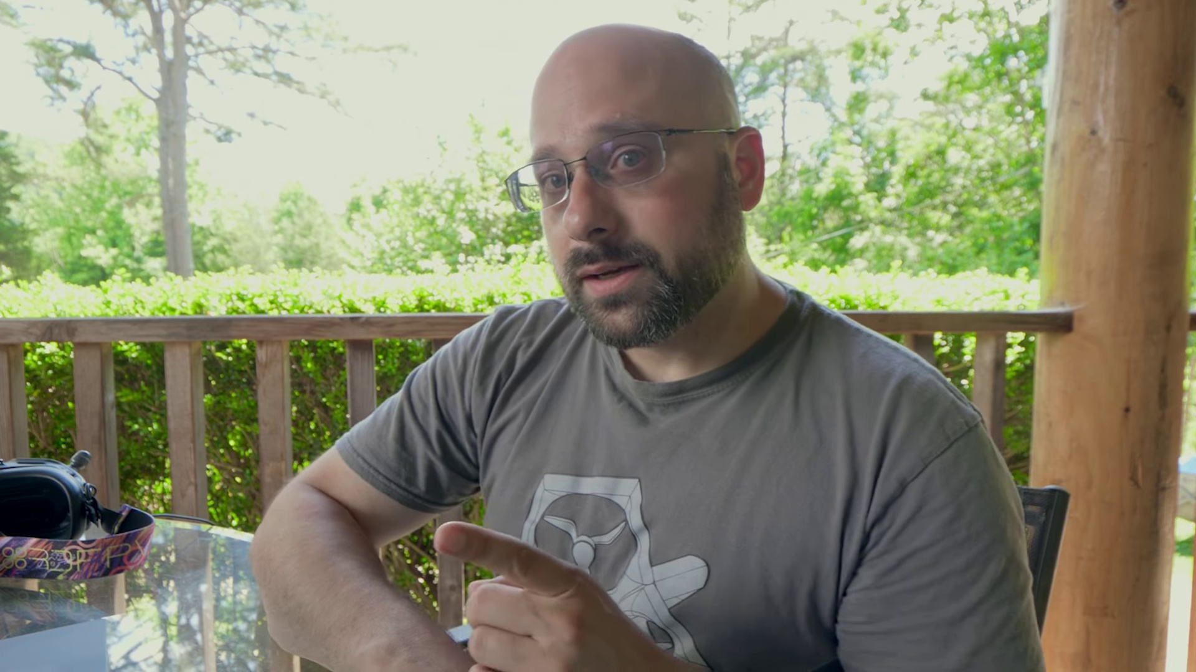 | 0:36   | 0:38  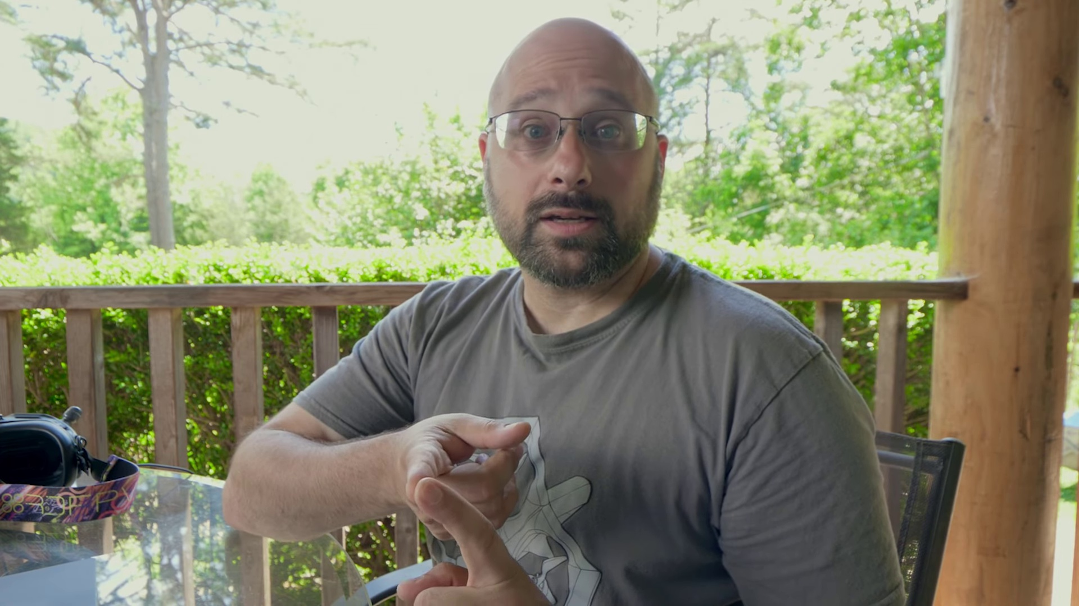

Transcript
[0:29] this video. Because he has just released two videos. One on how to tune filters in Betaflight

Section 0: Image Description 4
Time: 0:40 - 0:50

Summary
A person with a bald head and glasses is smiling broadly as they lean on something, likely a table. They are dressed in a white t-shirt and appear to be enjoying the moment captured in the image.

Representative Frames
0:41  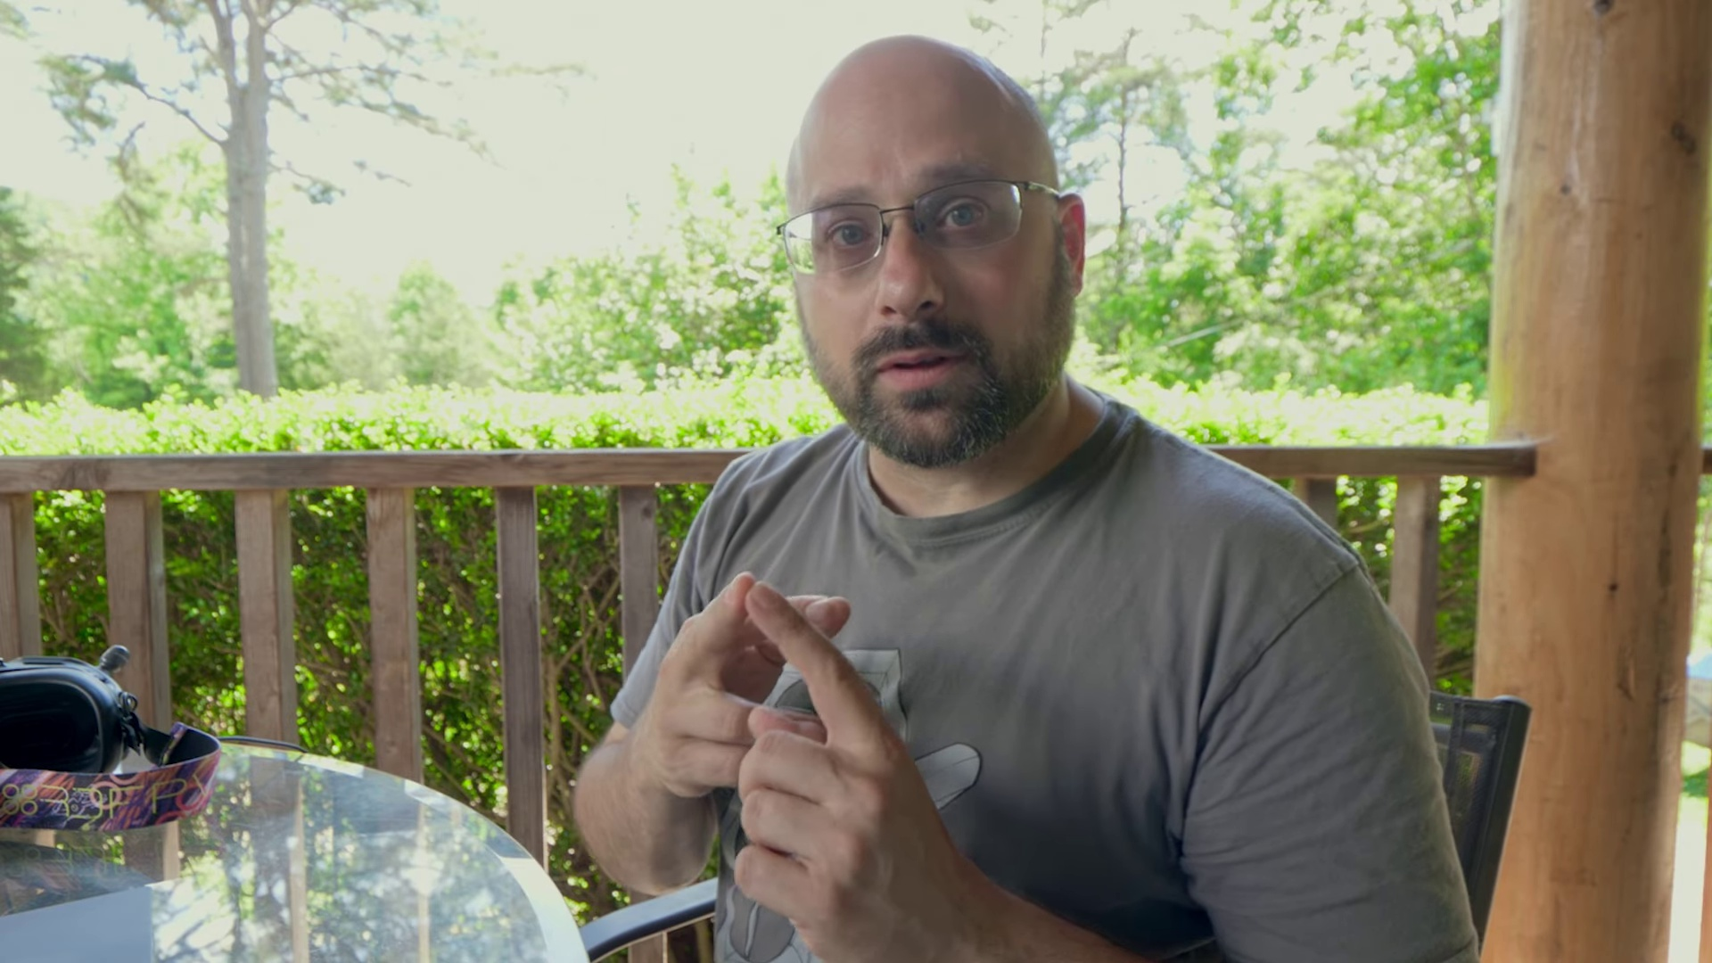 | 0:43   | 0:45  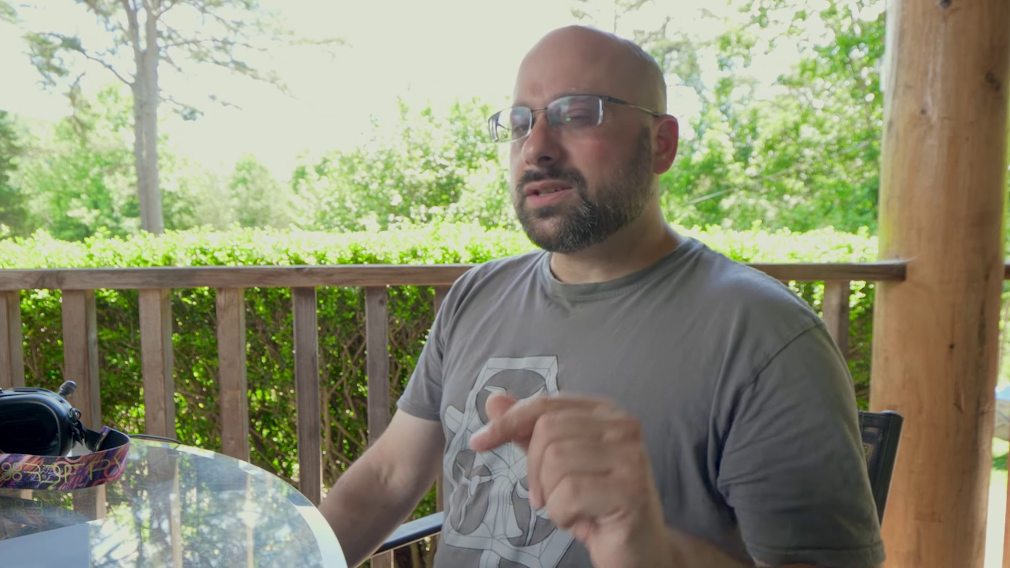 | 0:46   | 0:48  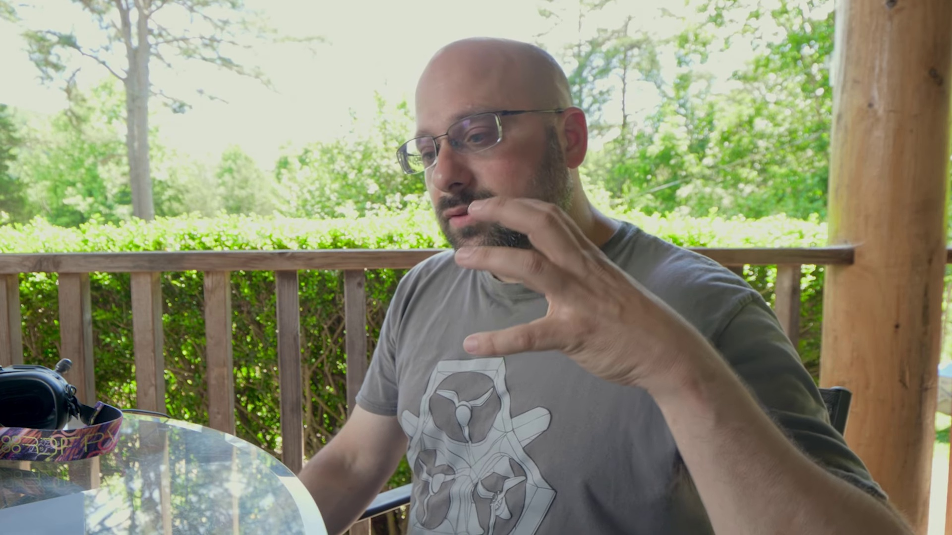

Transcript
[0:36] and then the other on the beginning of PID tuning, how to tune PD and feed forward. Chris's tutorials
[0:44] have really laid out PID tuning and filter tuning in a very simple and understandable way that I

Section 0: Conclusion
Time: 0:50 - 16:56

Summary
The conversation concludes with the narrator thanking the listener for their attention and inviting them to subscribe and hit the notification bell for future content.

Representative Frames
3:31  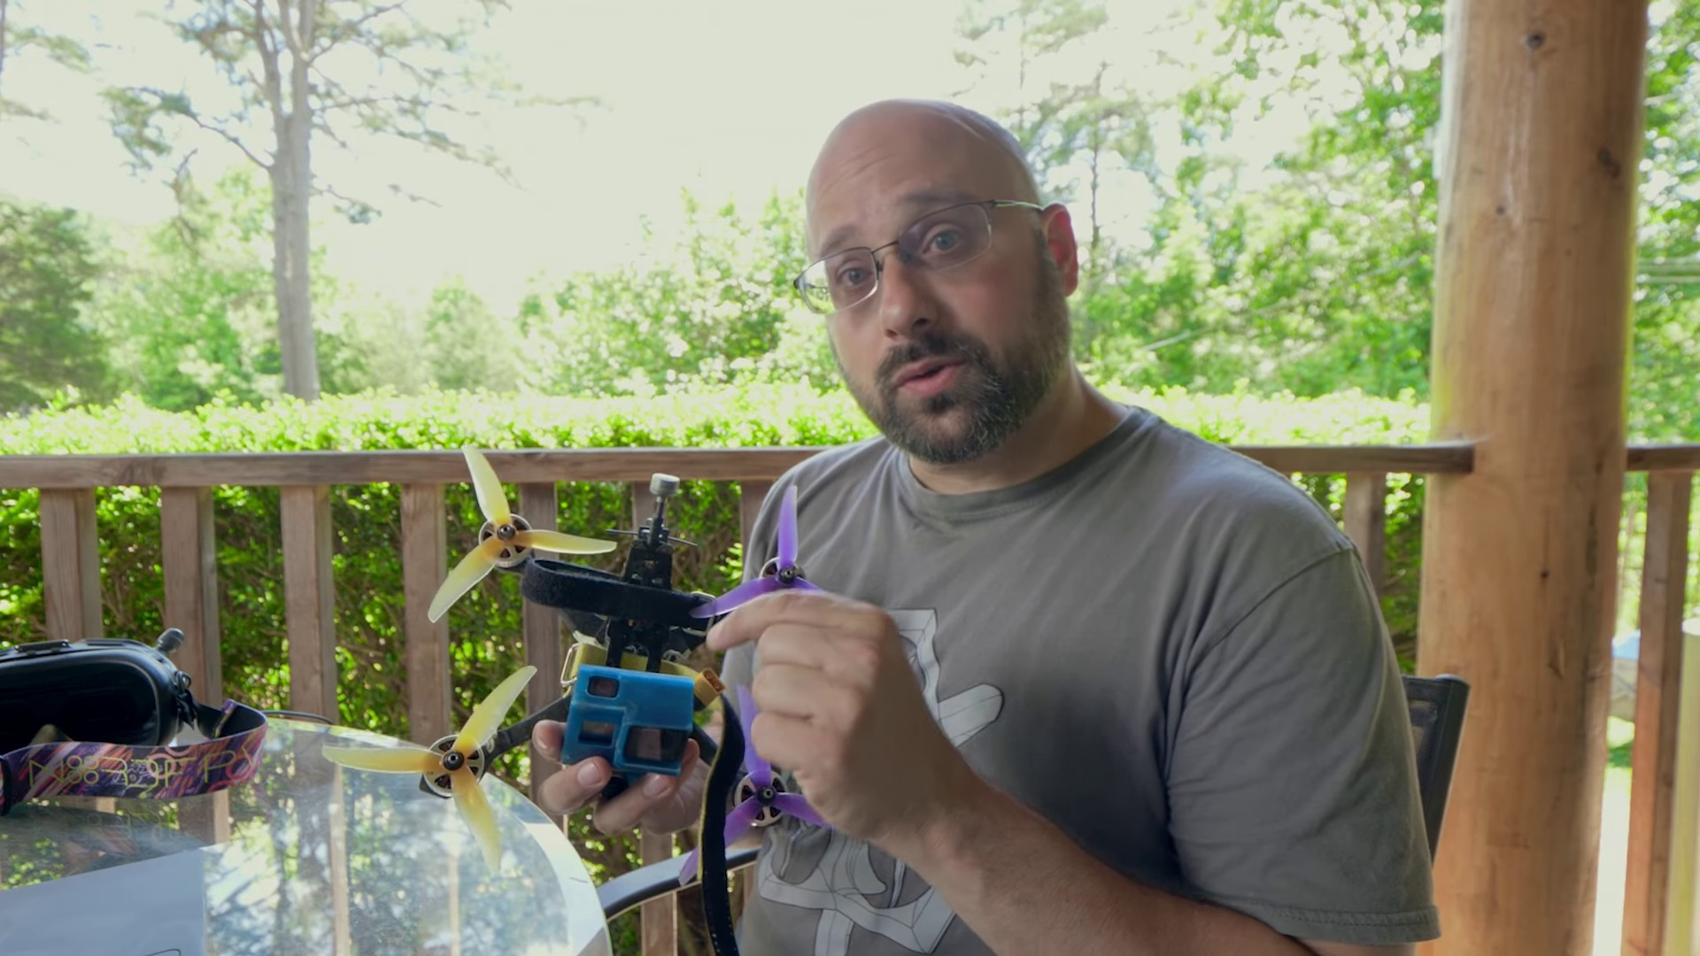 | 6:12  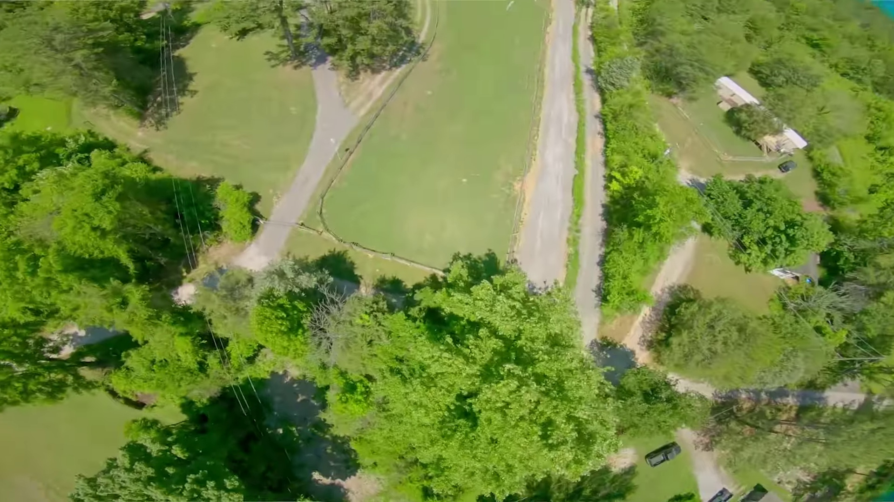 | 8:53  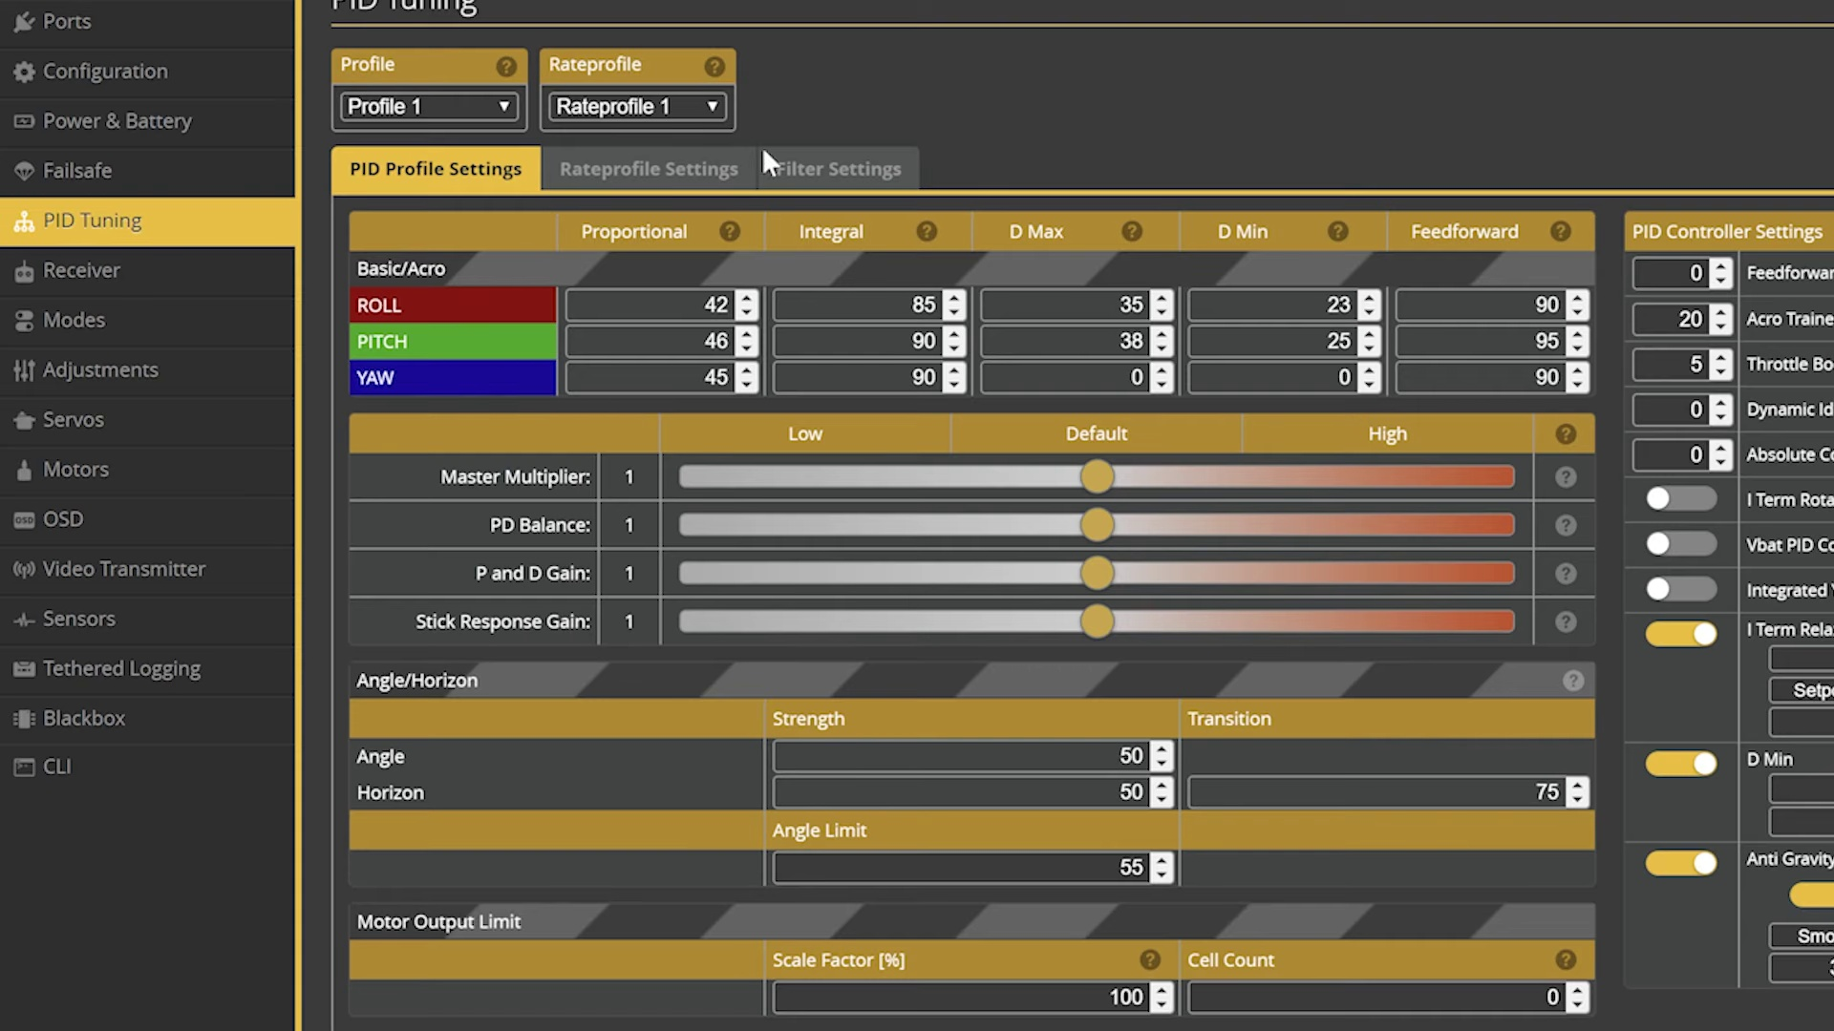 | 11:34  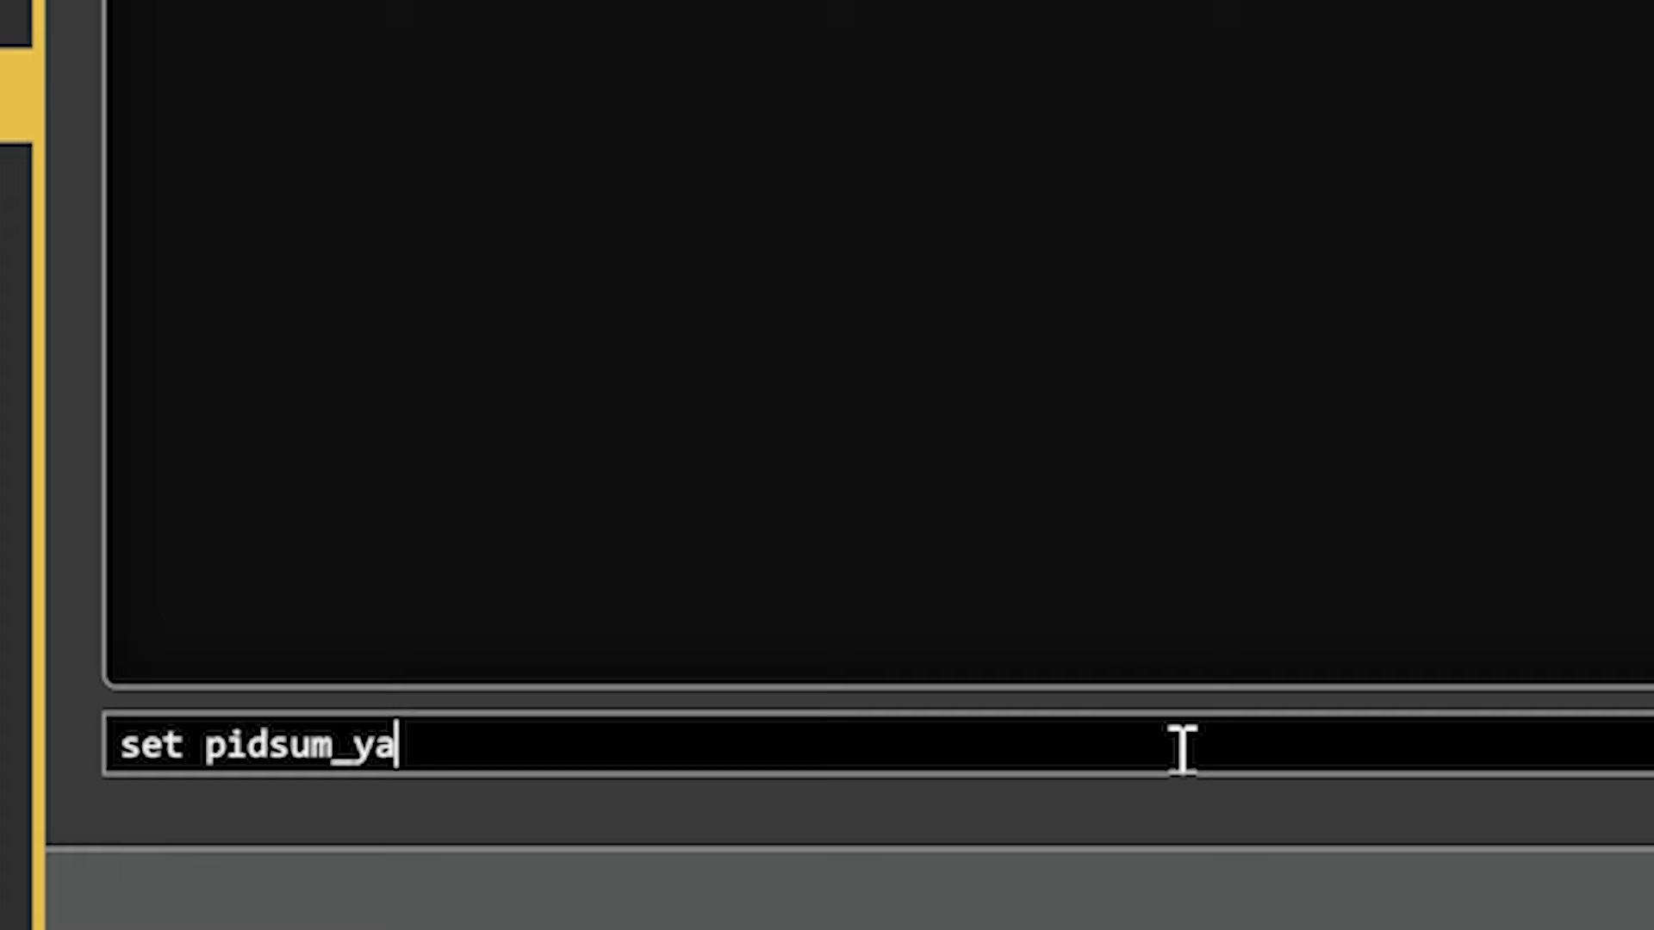 | 14:15  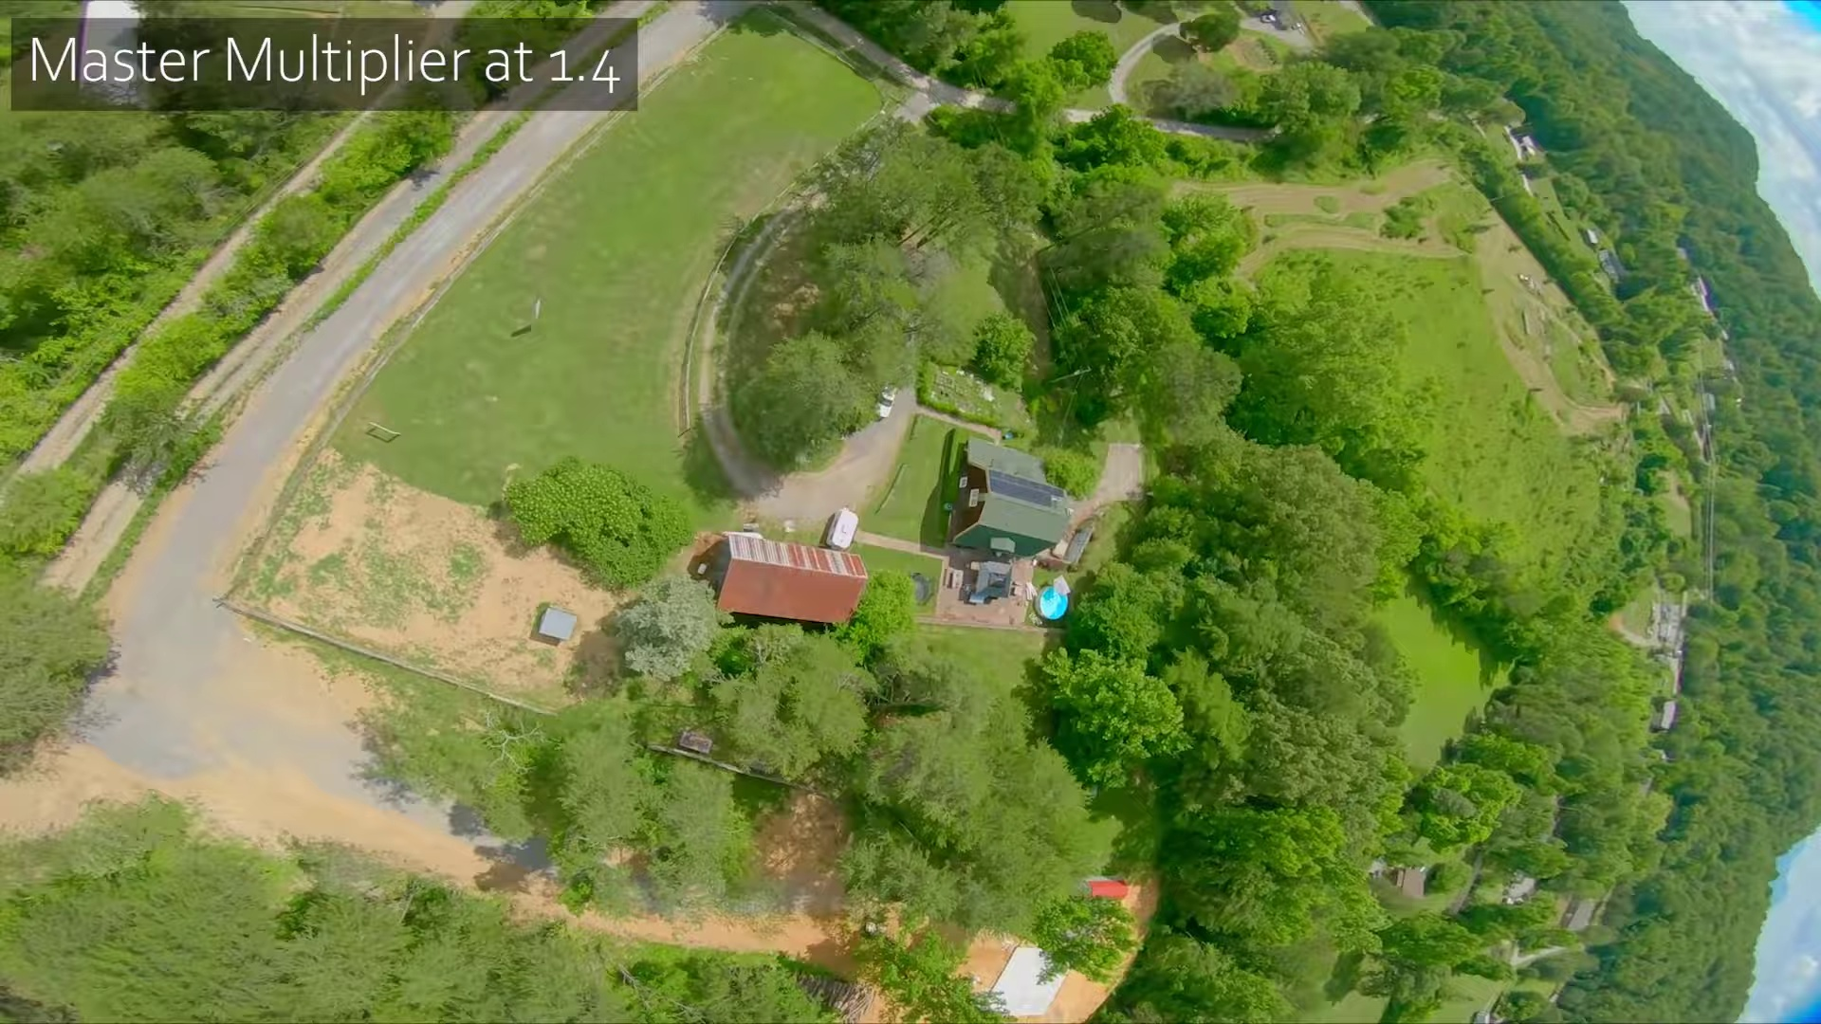

Transcript
[0:52] think that most everybody could follow. Well, many people could follow without necessarily having a
[0:58] deep, deep understanding of PID tuning and filtering. So what we're going to do today is we're going to
[1:02] go through those steps on my perfect freestyle build that I just finished building. And we're
[1:07] going to see if we can work out a PID tune. I'm Joshua Bardwell and you're going to learn something today.
[1:19] Before we dive into this video, you should know that some of the things Chris Rosser recommends
[1:23] that you do are explicitly disagreed with by, well, Kevin Plazier, the emu flight dev specifically spoke
[1:28] out against one of the decisions that Chris makes. And the other decisions Chris makes are different
[1:34] from the Betaflight defaults. And the reason the Betaflight defaults are the way that they are
[1:39] is that some people who don't use the defaults will have flyaways or smoked motors. So don't just dive in
[1:47] and follow these steps. This is not a safe for everyone PID tuning process. You need to pay attention
[1:53] to the gotchas and caveats. And if you do not meet all the qualifications of step one, do not proceed
[1:59] to step two, three, four, five, six, seven, go back and stop and get step one right. This is a really
[2:04] aggressive tune at the end and your quad will fly amazing if it can handle it. Enough said.
[2:12] When the oneiden is working, when the
[2:25] mosquitoes work together are very beautiful, I don't know how toень effect the heights of the
[2:30] most ratherigiousarius. Interesting to help one is the Ter towards Bernardino,
[2:36] that means this isn't something that is natural for you. And with his ProfIO,
[2:39] Whoooa!
[2:42] Whoooa!
[2:43] Whoa!
[2:47] Whoooa!
[2:51] Whoooo!
[2:54] Whoooa!
[2:55] Whoooa!
[3:00] Whoooa!
[3:05] Whooooa!
[3:07] Whooa!
[3:07] Whoooa!
[3:08] Whoooa!
[3:09] That's a pretty good PID tune.
[3:21] Let's see how I got there.
[3:22] The very first thing Chris tells you to do in his filter tuning video, and this is the
[3:26] beginning of every PID tune, is to make sure your aircraft is mechanically sound.
[3:32] So often people reach out to me asking for a PID tuning solution to a mechanical issue.
[3:39] And I like to say it's like trying to hike on a sprained ankle.
[3:43] You could get some crutches and you could sort of limp along, but the real thing to do is
[3:48] to heal up your sprained ankle and then come at it from a healthy perspective.
[3:52] And if your quadcopter is not mechanically sound, then you can't really start PID tuning
[3:58] effectively or you're going to be PID tuning around the problem and it's going to really
[4:02] hold you back.
[4:02] Now Chris has some suggestions for specific things that you want to check because when
[4:06] I say mechanically sound, what does that even mean?
[4:09] So you definitely want to check these things.
[4:11] These are, this is a really, really excellent summary of like the top five or six things
[4:16] that need to be right about your frame.
[4:18] The only thing I would add to this is you want to check your frame for cracks.
[4:23] Like if you have an arm that's beginning to delaminate or a bottom plate that's beginning
[4:26] to crack, this could be very easy to overlook.
[4:29] But when you start trying to PID tune, it can make a problem that can't be solved.
[4:33] And you just got to kind of just look at it and make sure you don't have any cracks or anything.
[4:36] The next thing Chris advises is to fly the quad on default PIDs and log.
[4:40] And that's what we've got here.
[4:42] But before we do that, let's talk about the quad itself.
[4:46] You're going to want to fly your quad in the same setup, in the same situation as it'll
[4:52] be flown in real life.
[4:53] So if you're going to be flying in real life with a GoPro on, you're going to want
[4:56] to tune with a GoPro on.
[4:58] If you're going to be flying in real life with a 1300 milliamp hour pack, you're going
[5:02] to want to tune with a 1300 milliamp hour pack.
[5:04] Every tune will have a little bit of flexibility.
[5:07] Like taking the GoPro, unless you tune to the absolute edge of performance, you'll be able
[5:12] to fly the quad with a GoPro on or off or switch between a 1000 milliamp hour and a 1250
[5:17] milliamp hour pack without making too many changes in the tune.
[5:20] But the further you push the tune toward that nth degree of perfection, the less flexibility
[5:26] you'll have to change things about the quad.
[5:29] So you may want, after you get a good tune, you may want to test it out with different
[5:33] batteries or with or without the GoPro.
[5:35] The one thing I am going to point out to you though is you can see I am not flying brand
[5:39] new props.
[5:40] And I would recommend, unless you are going to be 100% scrupulous about flying on brand
[5:46] new props every time, if you ever feel like you might need to turtle mode and come home
[5:50] on a broken or a bent prop, fly with some beat up props.
[5:53] Do your tuning that way.
[5:54] And that way you will build in just a little bit of headroom.
[5:57] Your quad will just fly that much better when you have clean props, new props.
[6:00] But if you ever do break a prop or bend a prop, you won't immediately smoke a motor.
[6:04] So let's put the quad up in the air and do our first test flight.
[6:07] And Chris's video has instructions for how to set up your black box logging and for how
[6:12] to get the black box logs off the quad and import them into black box viewer.
[6:17] So link in the video description to Chris's video if you need instructions for how to do
[6:21] that.
[6:21] As we do the tuning flight, we're going to make sure that it includes a lot of full stick
[6:26] 360 rolls, full stick 360 flips and yaw spins, as well as some gradual ramps from zero to full
[6:33] throttle.
[6:33] And we're going to want to make those ramps smooth and gradual so any resonance in the
[6:38] frame gets a good chance to come out.
[6:40] We're not just going to do full throttle punches and we're going to want to hold at full throttle
[6:43] and ramp back down.
[6:45] Now at this point, if your motors don't sound completely smooth on the stock beta flight
[6:50] defaults.
[6:51] Oh, that's what we're flying on, the stock beta flight defaults.
[6:54] 1.0 on all the filter sliders, 1.0 on all the pin sliders.
[6:57] If anything doesn't sound completely smooth, if you have any signs of vibration or gyro problems,
[7:03] go back to step one, you have a mechanical issue.
[7:06] At least for 5 inch mini quads and smaller.
[7:09] If you're flying like a 7 inch or a 10 inch or a 13 inch frame, the default filtering from
[7:15] beta flight may not be right for you and you may need to tweak it, but that's a topic for
[7:18] another video.
[7:19] So let's open up this black box log in black box viewer and we're using Mark Spatz's presets
[7:26] for these different views, all these different views here.
[7:29] They can be downloaded from theuavtech.com.
[7:33] I'll put a link to that down in the video description, as well as if you need to know how to download
[7:37] and open them, I'll link to a video that shows how to do that.
[7:40] But what we want to see is the gyro scaled.
[7:45] And we're going to click there.
[7:47] And that brings up this.
[7:48] We're going to just go ahead and expand that.
[7:50] And we're going to change from frequency to frequency versus throttle.
[7:54] And this graph looks really freaking good.
[7:58] Let's just turn that up a little bit so we can see it a little better.
[8:01] We have a small amount of resonance around 200 hertz.
[8:05] Nothing too extreme.
[8:06] A little bit of resonance here, lower than that.
[8:09] But on roll, there's nothing crazy that jumps out.
[8:14] On pitch, we can see a little more resonance.
[8:19] But nothing too bad.
[8:21] Nothing higher than about 200 hertz.
[8:23] And on yaw, again, just a little bit of resonance at 200 hertz and the normal amount of motor noise.
[8:29] Based on the fact that my black box log looks pretty clean,
[8:32] and Chris actually looked at a black box log of a previous flight that I did,
[8:36] which had similar characteristics to this.
[8:38] Chris made some filter recommendations that were more or less the same as his suggestions here for clean builds.
[8:44] So we're going to go ahead and implement these filter suggestions as shown here,
[8:48] and then we'll move on.
[8:49] We'll go to the PID tuning tab.
[8:51] We'll go to Filter Settings.
[8:53] Chris says to turn off the gyro low-pass filters
[8:55] because if you're doing RPM filtering and dynamic filtering,
[8:59] you probably can get away with not having any gyro filtering.
[9:01] They will do a sufficient job.
[9:03] Chris suggests 0, 250, 100, and 400 for the dynamic notch filter.
[9:10] And he suggests a single static bi-quad filter at 100 hertz to help clean up the D-turn.
[9:20] And we'll go ahead and save that.
[9:21] But the next thing Chris has to do is to find your maximum D gain.
[9:26] And this is a really great way to approach PID tuning.
[9:30] A lot of times people used to approach PID tuning by finding the P gain first
[9:33] and then tuning D as best they could.
[9:36] But mechanical filters, D gain, then P actually makes a lot more sense
[9:42] because you want your D gains to be as high as they need to be.
[9:46] You'll always get a better flying quad with high D gains up to the point where you'll start to get flyaways or smoke motors.
[9:53] So you want to push your D gains as high as they can be while still having acceptably cool motors
[9:59] and acceptably low risk of flyaway and then find the P balance that works best for you there.
[10:05] And that'll probably give you a good flying quad.
[10:07] As Chris said, the more D gain you have, the hotter your motors will get,
[10:11] the more likely you are to get oscillations, especially if you've been to prop.
[10:14] So it is really a question of your tolerance as to how much risk you're willing to get.
[10:19] A lot of racers will fly ultra-high D gains.
[10:21] The quad is practically on the limit of smoking a motor at all times,
[10:24] but they have a really, really sharp flying quad.
[10:26] For a typical freestyle or a casual pilot,
[10:30] you may want to give up just a little bit of that flight feel and performance
[10:33] for less risk of damaging your equipment.
[10:36] Chris gives a range of recommended D gains for people flying a 5-inch freestyle
[10:41] from stock of around 30, which is really conservative,
[10:46] up to 45+, which has a much higher risk of smoking motors.
[10:50] I will say, these are fine guidelines, but even these may be a little conservative.
[10:54] I've had, like, I've personally played around with PID tuning on this build
[10:59] and had D gains at 50 or 55+, without really seeming to have much sign of smoked motors,
[11:05] but everybody's build is going to be different.
[11:07] But before we start doing our test flights,
[11:09] we're going to go in and make this change in the CLI.
[11:12] And I'm not really sure why Betaflight does this.
[11:16] Betaflight, by default, limits the PID controller to 40% of its maximum authority.
[11:22] And if it exceeds that, then, well, it's not allowed to exceed that.
[11:27] So, we're going to set PID sum limit equals 1,000, which is 100%.
[11:32] There's probably a good reason why Betaflight has you do this.
[11:35] I'm sure they didn't just do it for no reason.
[11:38] So, maybe something bad will happen to some people if they make this change.
[11:42] But if you're trying to get a really good PID tune,
[11:44] this is definitely something you should start with.
[11:47] And then what we're going to do is we're going to go out and fly
[11:49] and we're just going to try to make the motors as hot as possible
[11:52] by doing sharp turns, by doing full throttle punches,
[11:56] and we're going to listen for signs of runaway,
[12:00] signs of warbling, oscillation, unsmooth motors,
[12:03] or we're going to feel for hot motors at the end of each flight.
[12:07] And we're going to turn up the master multiplier gradually, 0.1 to 0.2 at a time,
[12:11] and try to find the point where that starts to happen, then back off.
[12:14] And I'm going to do something in the interest of time.
[12:18] Normally, what Chris suggests is to raise the master
[12:20] in little increments of 0.1 or 0.2.
[12:23] I'm going to make a bigger jump,
[12:25] and then if I overshoot, I'm going to work my way back.
[12:28] I don't necessarily suggest you do that.
[12:31] I'm going to be a little careful here,
[12:32] because if I have gone too far,
[12:33] the quad could want to fly away or something dumb like that.
[12:38] Motors aren't complaining.
[12:40] I don't hear any signs of them complaining.
[12:44] Little hitch there.
[12:57] Little hitches there.
[12:58] You see those little hitches?
[13:02] Yeah, so that's too far.
[13:05] Sorry, my mom's going.
[13:07] All right, so we had little hitches there.
[13:20] Motors still aren't super hot,
[13:22] but that's too far.
[13:25] Let's try dialing that back down a little bit.
[13:28] Here on PID tuning.
[13:33] We're just going to knock that down.
[13:35] Oh, I need to disable D-Man.
[13:36] I forgot to do that.
[13:37] I don't think that...
[13:39] Yeah, I need to disable D-Man.
[13:40] I forgot that step.
[13:41] That's also stuff.
[13:42] We're going to take that down to 1.4,
[13:44] and we're going to see how we do.
[13:52] Let's see if 1.4 clears that up.
[13:53] Also, we've disabled D-Man,
[13:55] which I should have done first.
[13:58] Tiny little hitch there.
[14:13] Littlest of hitches
[14:14] if I do extended full throttle punches.
[14:17] I feel like this is a good place
[14:18] for me to be, though.
[14:21] Remember, we are a little bit on bed props,
[14:23] so on clean props,
[14:25] fresh props,
[14:26] that probably would go away.
[14:30] But I feel like if I just do normal flying,
[14:33] none of that will come out.
[14:48] No, see?
[14:49] No.
[14:50] See?
[14:50] Already...
[14:53] I feel like we're flying really good.
[14:58] Even just tuning that master slider
[15:00] has made a big freaking difference.
[15:03] I mean, so often when I fly,
[15:05] I just fly on the defaults.
[15:08] I'm like, whatever.
[15:09] I just want to get in the air.
[15:10] Just freaking turning this up
[15:12] has made such a big difference.
[15:15] It's still pretty smooth.
[15:17] Like, you can see that there's no hitches here.
[15:24] Even if I do a big punch,
[15:25] it's only if I do
[15:26] a really extreme punch
[15:29] that I start to see those little blips.
[15:31] So I feel like this is a good place to be.
[15:33] Oh, yeah.
[15:42] So next,
[15:44] we'll start to dial in our V-game.
[15:51] Oh.
[15:52] So good.
[15:53] That's so good.
[16:07] Damn, son.
[16:09] That's so good.
[16:10] Whew.
[16:14] That quad's flying real good,
[16:15] ain't it, folks?
[16:16] Oh, man.
[16:17] Boy, I bet you can't wait
[16:18] to see the rest of this process.
[16:21] Whew.
[16:23] Yeah.
[16:24] It's going to be a multi-parter.
[16:26] This is part one.
[16:28] I'm going to upload the rest of it
[16:29] to the channel
[16:30] over the subsequent days.
[16:32] Don't worry.
[16:32] It's all shot.
[16:33] It's all done.
[16:34] I just got to finish editing it.
[16:35] But I wanted to give you part one today
[16:37] just to get it out.
[16:38] There will be links down in the video description
[16:40] to part two
[16:41] and if there's,
[16:42] I think it's going to be two
[16:42] or maybe three parts.
[16:44] But there will be links down below.
[16:45] Or, hey, you know,
[16:46] you could get subscribed
[16:47] and hit that notification bell
[16:49] if you wanted to be sure
[16:50] to not miss it.
[16:51] I mean, you know,
[16:51] it's up to you.
[16:54] Yeah.
[16:55] See you tomorrow.

