Engagement Analysis: sF0KOVWj9p8

Section 0: A person is working on a circuit board with an oscilloscope and multimeter.
Time: 0:01 - 0:02

Summary
The image shows a close-up of a person's hands working on a circuit board, surrounded by various electronic components and tools.

Representative Frames
0:01  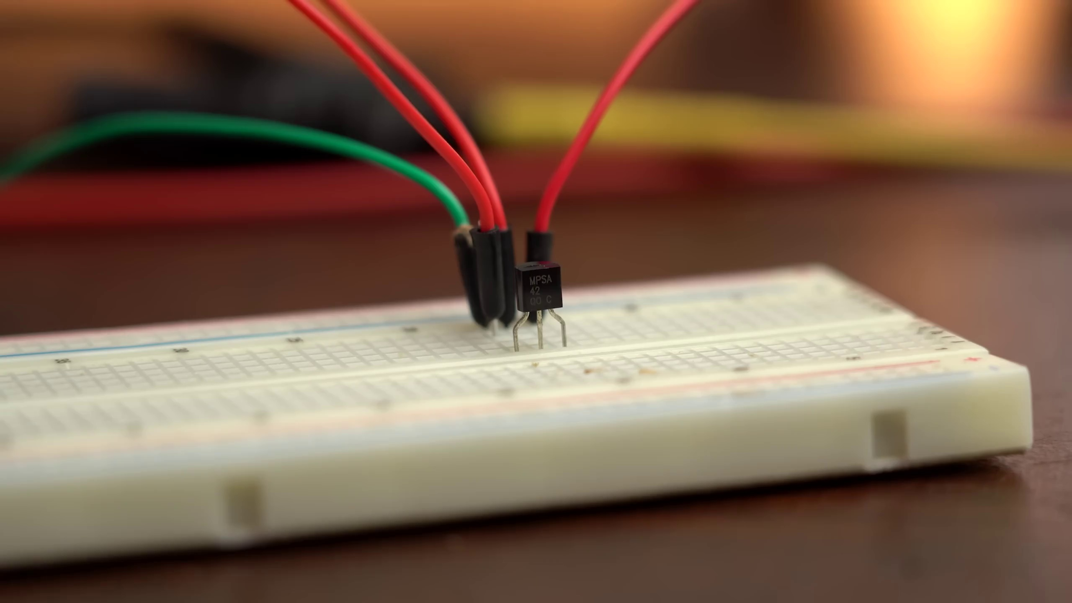 | 0:01   | 0:01   | 0:01   | 0:01  

Transcript
(No speech detected in this section)

Section 0: A person is experimenting with electronics in a home or personal lab space.
Time: 0:02 - 0:03

Summary
The scene depicts a person standing at a wooden desk with a workspace setup, surrounded by various electronics and tools.

Representative Frames
0:02   | 0:02   | 0:02   | 0:02   | 0:02  

Transcript
(No speech detected in this section)

Section 0: A person is working on a project requiring signal analysis or measurement.
Time: 0:03 - 0:04

Summary
The image shows a person holding an oscilloscope, connected to cables attached to it, displaying waveforms on its screen.

Representative Frames
0:03   | 0:03  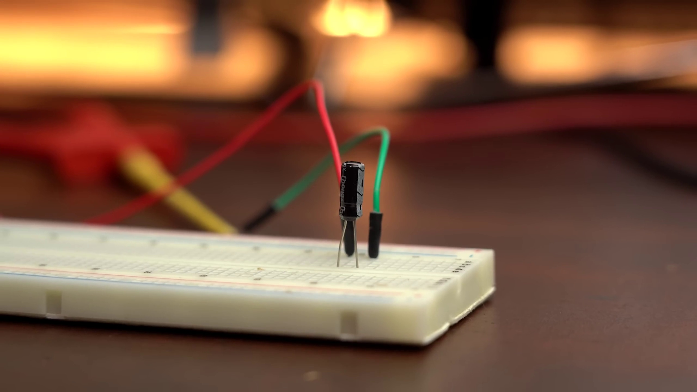 | 0:03   | 0:03   | 0:03  

Transcript
(No speech detected in this section)

Section 0: A person is engaged in hands-on experimentation with electronics and tools.
Time: 0:04 - 0:05

Summary
The scene captures a moment of experimentation on a desk, where a person clad in a white lab coat is meticulously working on a circuit board.

Representative Frames
0:04   | 0:04   | 0:04   | 0:04   | 0:04  

Transcript
(No speech detected in this section)

Section 0: A person is debugging an electronic project using a multimeter and oscilloscope.
Time: 0:05 - 0:06

Summary
The image shows a person holding a green circuit board, looking at it possibly in the process of assembling or debugging an electronic project.

Representative Frames
0:05   | 0:05   | 0:05   | 0:05   | 0:05  

Transcript
[0:00] Sometimes when building circuits mistakes can happen, which can be a reverse voltage,

Section 0: A person is working on a tabletop setup with various electronic devices and equipment.
Time: 0:06 - 0:07

Summary
The image shows a tabletop setup with various electronic devices, a laptop screen open displaying data graphs or waveform patterns related to the signal being measured.

Representative Frames
0:06   | 0:06   | 0:06   | 0:06   | 0:06  

Transcript
(No speech detected in this section)

Section 0: A person is working on an educational or experimental setting focused on electronics.
Time: 0:07 - 12:09

Summary
The scene suggests an educational or experimental setting focused on electronics, possibly in a laboratory or workshop environment.

Representative Frames
2:07   | 4:07   | 6:08  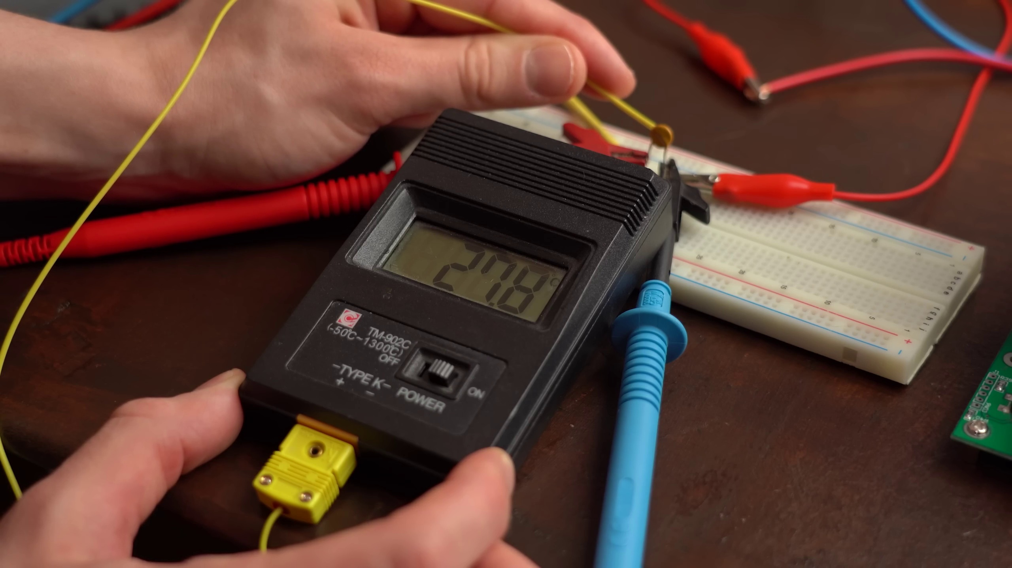 | 8:08  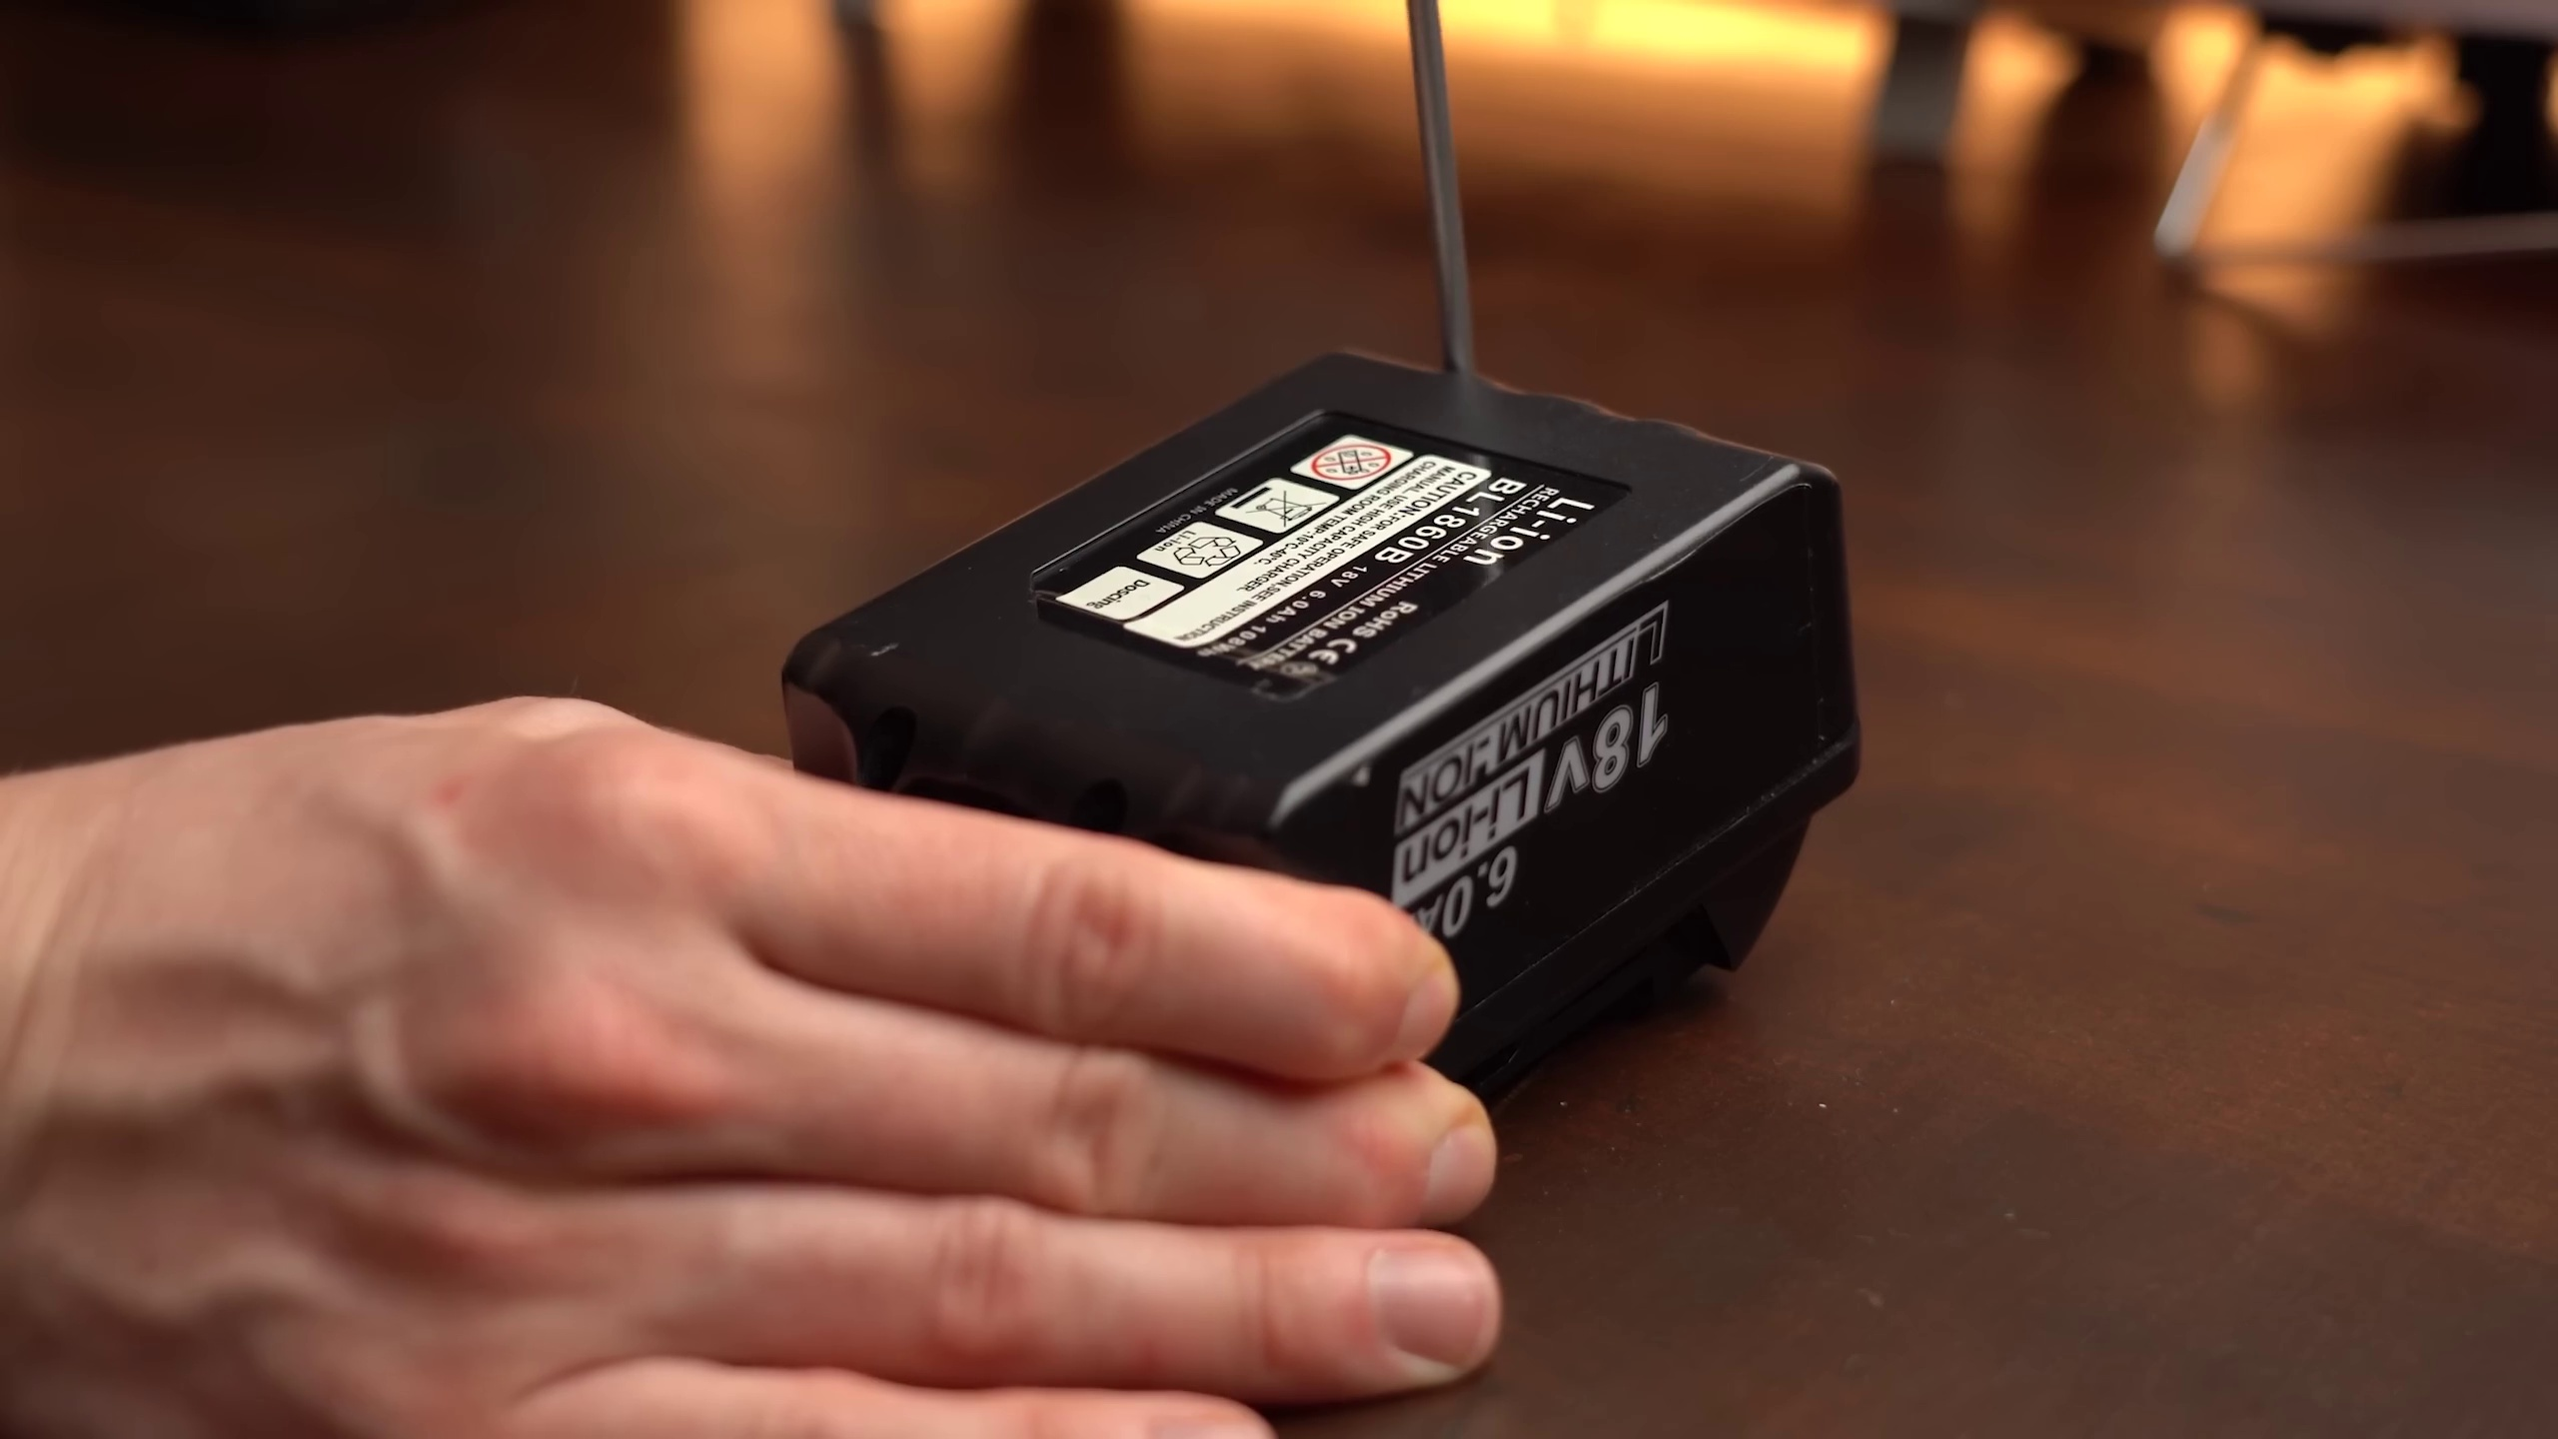 | 10:09  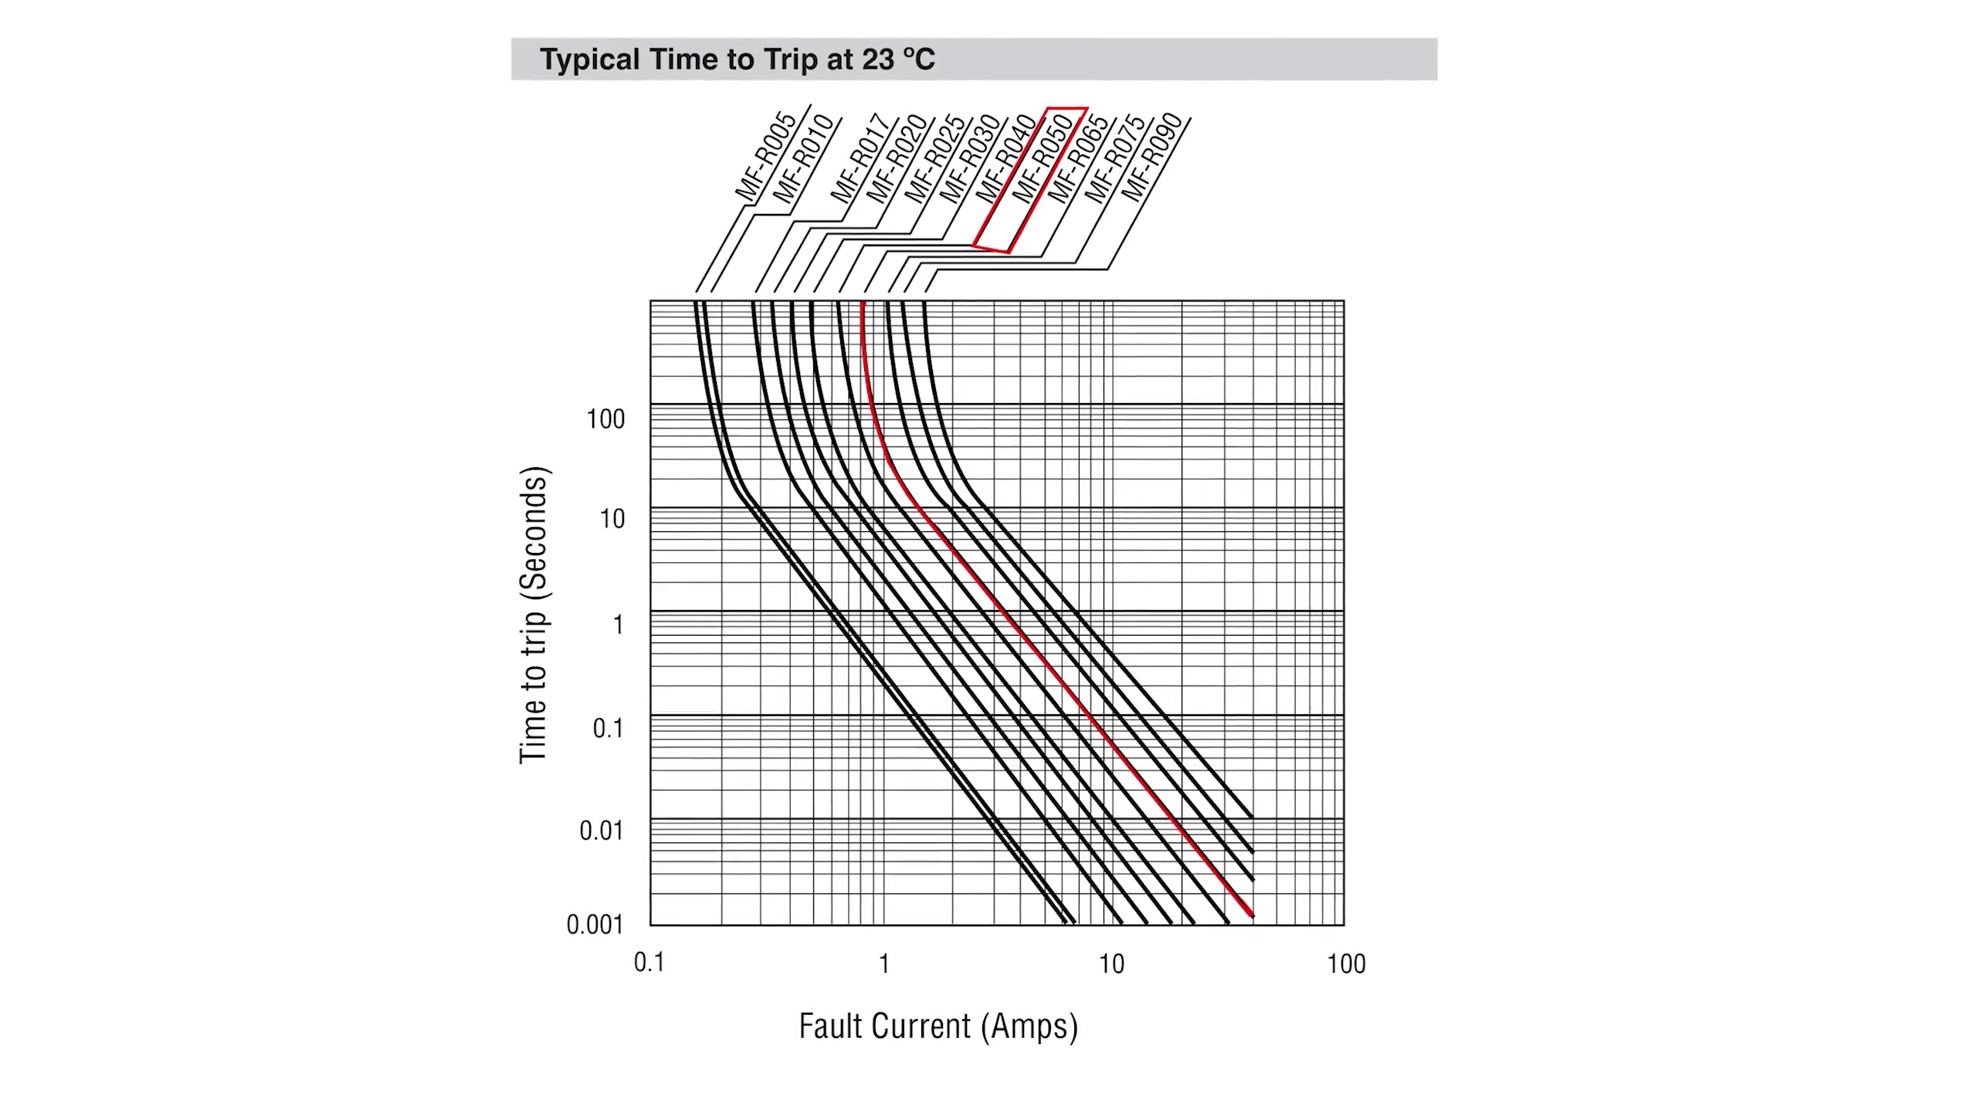

Transcript
[0:11] a voltage applied to the wrong pin, components failing due to their age or wrong usage or
[0:17] you simply accidentally short something.
[0:20] No matter the cause, the now appearing overcurrent is the root of all evil that needs to get
[0:26] stopped so that nothing explodes or burns down completely.
[0:31] To do that I think pretty much everyone is familiar with such glass fuses that you just
[0:37] put in series to your circuit and as soon as too much current is flowing the thin metal
[0:43] inside of it melts and thus interrupts the current flow.
[0:47] Only problem is that replacing such fuses can be cumbersome.
[0:51] It can get expensive if you are testing stuff and constantly destroy them and in case of
[0:57] enclosed electronics like your smartphone there is simply no way to replace such a fuse.
[1:04] The solution to all these problems though are resettable fuses like these ones which I often
[1:11] feel like not many people know about.
[1:14] So in this video I will show you exactly how to use them and with what limitations they
[1:20] come with.
[1:21] Because even though they are resettable and thus reusable they are certainly not perfect.
[1:28] Let's get started!
[1:38] This video is sponsored by Mauser Electronics.
[1:42] Now truth be told I've been searching for fitting resettable fuses for a while on the internet.
[1:47] Mauser was the only seller that not only came with a big selection of them but most of them
[1:53] were also in stock, I could easily filter for preferences and best of all they sell to
[2:00] private people like you and me and not just companies.
[2:04] I have been ordering my components from them since 2018 and I can tell you for sure that they
[2:10] have all the components you could ever need.
[2:14] And you usually receive them within 3 or sometimes even only 2 days.
[2:19] So feel free to check out Mauser Electronics if I piqued your interest.
[2:25] Now first off if you want to use resettable fuses then you always have the choice between the
[2:30] through hole ones that I feel like are easier to use and small SMD ones which you probably
[2:37] already have seen on devices like the Raspberry Pi.
[2:42] Sometimes resettable fuses are also known as a multi fuse, poly fuse or poly switch but
[2:48] if we want to be technically correct then they are actually called PPTC which stands for
[2:54] Polymeric Positive Temperature Coefficient device and wait a minute PTCs are actually quite
[3:02] popular.
[3:04] What they do and what their name basically implies is that they increase their resistance when
[3:09] they get hotter.
[3:11] You can actually find their relative the NTC aka Negative Temperature Coefficient on lots
[3:17] of 3D printers because they decrease their resistance when their temperature rises and thus they both
[3:24] can be used to measure temperature.
[3:26] But back to the resettable fuse which does in fact increase its resistance when temperature
[3:31] rises but it still features lots of differences to normal PTCs or NTCs.
[3:38] So as a practical example let's say I got a circuit that normally draws around 500mA at
[3:44] 12V like this RGB LED strip right here and I want to protect it from shorts so that the
[3:51] fitting power supply does not get damaged.
[3:55] Now to choose a suitable resettable fuse we only have to worry about 4 crucial properties
[4:01] and those are the maximum voltage and current as well as the hold current and trip current.
[4:08] And I think the maximum voltage and current is pretty self explanatory meaning that if you
[4:13] exceed them you basically risk damaging your fuse.
[4:18] The hold and trip current is a tiny bit more complicated but still pretty easy to understand.
[4:25] The hold current basically stands for the current that can flow continuously without having to
[4:30] worry about that the fuse will ever trip.
[4:34] And the trip current of course is the current that needs to flow so that the fuse will activate
[4:40] and thus interrupt the over current.
[4:43] Pretty simple.
[4:45] So with these 4 rough values in mind for my circuit I went on to a search on Mauser Electronics
[4:51] and decided on this PPTC that can do 60V and 40A max and comes with a hold current of 0.5A and
[5:00] a trip current of 1A.
[5:03] And if you are asking yourself right now why not use a fuse with slightly higher ratings for
[5:08] a bit of wiggle room then just wait a few more minutes for a little revelation.
[5:15] Because first off it was time for a small experiment in which I simulated my to be protected circuit
[5:21] with a constant load to which I of course added my resettable fuse in series and powered it
[5:27] all with 12V.
[5:30] Now by slowly increasing the current flow through my fuse I also directly measured and wrote
[5:35] down the voltage drop across it.
[5:38] Because those electrical values give us insight about the power the fuse wastes which directly
[5:44] determines its temperature and also what resistance it currently possesses.
[5:50] So first big stop was the hold current of 500mA at which point only a small voltage drop across
[5:57] the fuse occurred that at some point also did not increase anymore meaning the temperature
[6:03] of the fuse was stable and thus it would never trip at this point.
[6:09] Next was the trip current of 1A and here the voltage drop did in fact increase over time until
[6:16] the fuse ultimately reached its high resistance state in which my constant load could no longer
[6:22] draw 1A and thus turned off.
[6:25] Now you might be thinking that these 22-6 seconds it took for the fuse to activate are way too
[6:31] long but as a comparison let's see how a 1A rated glass fuse would react to 1A of current.
[6:40] And yes we could sit here forever because the glass fuse would never trip and even at 2A it
[6:47] still took way longer to activate once again in direct comparison to the resettable fuse.
[6:53] So yeah PPTCs are a bit slow but traditional fuses are even slower.
[7:00] But getting back to topic because next to truly investigate the trip occurrence I added a big
[7:06] power resistor as a load that would normally draw around 1.2A.
[7:12] And by the way these 3 components I added in parallel to the fuse are just a trip indicator
[7:18] which lights up as soon as the fuse enters its high resistance state.
[7:24] Ok so now with the resettable fuse in place the big current the resistor normally draws got
[7:30] quickly limited to only around 103mA.
[7:35] But wait a minute shouldn't a fuse cut down the flowing current to nothing like a normal
[7:41] glass fuse would do?
[7:43] Well such PPTCs cannot do that because they are basically just resistors whose resistance
[7:49] increases drastically at the trip current because of the rising temperature.
[7:55] That does not mean they are useless though because such a drastic current reduction can definitely
[8:01] prevent exploding capacitors, smoking transistors or even save battery packs when things go
[8:07] accidentally wrong.
[8:09] And speaking of battery packs PPTCs also often get used with them since they drip when they
[8:15] get hot and battery packs definitely love to get hot when they are not handled correctly.
[8:22] But getting back to the trip event at which point a so called leakage current keeps flowing
[8:29] that basically keeps the fuse hot enough so that it stays in its high resistance state.
[8:35] I also did some additional measurements in this state to find out that no matter what input
[8:40] voltage gets applied the resettable fuse basically creates a power loss of around 1.2W which is
[8:48] quite a bit more than what the datasheet claims.
[8:52] And speaking of datasheet this is a good time to try out a PPTC with slightly higher ratings.
[8:58] Like this one that holds at 0.9A and triggers at 1.8A.
[9:06] I pretty much did the same tests and measurements as before.
[9:10] And the differences are that the bigger fuse features less power losses during normal operation
[9:17] but wastes more power when it got tripped.
[9:20] So the choice is up to you what is more important for you.
[9:25] Now the last thing we have to take a look at is the area between the hold and trip current.
[9:31] And here the resettable fuse can trigger but does not have to.
[9:36] For example at 700mA the voltage drop and thus temperature only increases very slowly.
[9:44] Meaning eventually this fuse might drip if the ambient temperature is also high.
[9:50] But at 900mA the voltage and temperature increases way faster and thus the fuse tripped in my
[9:57] case after around 1 minute and 42 seconds.
[10:02] This typical time to trip diagram given by the datasheet can also help you out a lot regarding
[10:08] those questions.
[10:10] And by the way the PPTC also becomes rather quickly conductive again as soon as the current
[10:16] decreases.
[10:18] But after tripping once its resistance will take quite a long time until it will reach
[10:24] its initial value once again.
[10:27] And with that being said you should now be familiar with most of the basics when it comes
[10:32] to resettable fuses.
[10:34] And yes they are definitely a good fit for the LED strip example we started with and they
[10:40] are also a standard when it comes to many other protection tasks.
[10:45] Of course traditional fuses are a bit more efficient, meaning they produce less power losses.
[10:52] But then again E-fuses which I presented you in a previous video pretty much come with the
[10:58] same low power losses as traditional fuses.
[11:02] And even better they do trip in a way more precise and fast way, since they do not rely
[11:08] on a rising temperature that burns a metal or increases a resistance.
[11:14] But then again such an E-fuse is a bit more complicated to set up, it is more expensive and also not
[11:21] resettable by itself.
[11:23] They can also only be used for limited voltage and current range, while the resettable fuses
[11:29] can handle quite a bit more and traditional fuses are beasts in that regard.
[11:36] What I am trying to say here is that each one of these fuse types is tailored to a specific
[11:41] application and I feel like with this video coming to an end you should now have a very
[11:47] good idea when to use which one.
[11:50] I hope you enjoyed it and learned something new.
[11:54] If so consider supporting me through Patreon to keep the show going.
[11:59] As always don't forget to like, share, subscribe and hit the notification bell.
[12:05] Stay creative and I will see you next time!

