Engagement Analysis: sHwSIcIdeDI

Section 0: Image of speakers on a table
Time: 0:01 - 0:03

Summary
A collection of speakers are arranged on a table, with some electronic devices nearby.

Representative Frames
0:01   | 0:01   | 0:02   | 0:02   | 0:02  

Transcript
(No speech detected in this section)

Section 0: Close-up of speaker cones
Time: 0:03 - 0:05

Summary
Six speaker cones are displayed in a grid-like pattern, each with a unique design and mounted on a gray base.

Representative Frames
0:03   | 0:03   | 0:04  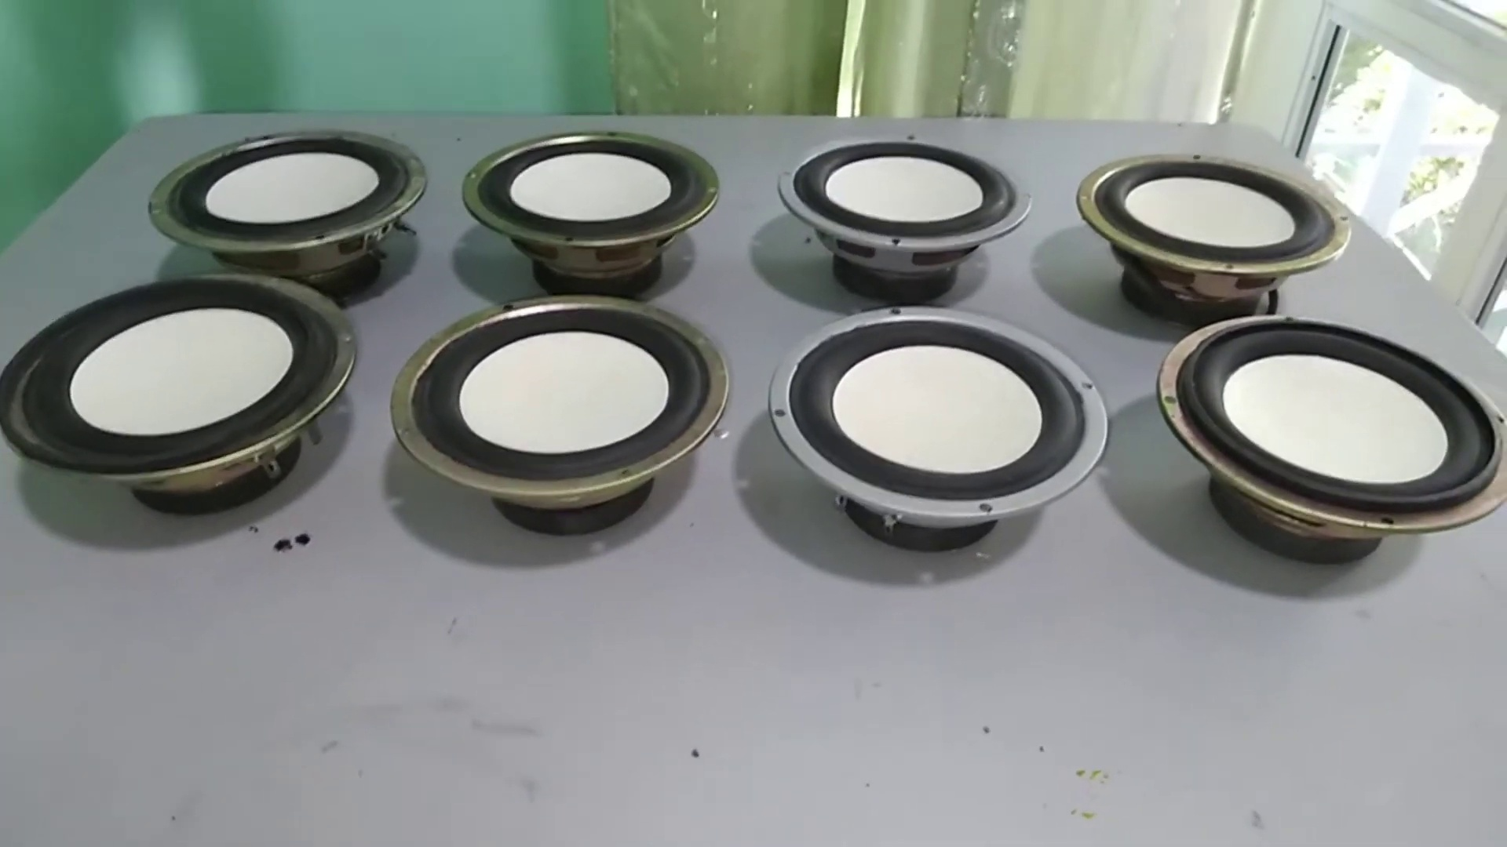 | 0:04   | 0:04  

Transcript
[0:00] STA 182. WOW FUTURE

Section 0: Speakers arranged in concentric circles
Time: 0:05 - 0:07

Summary
A collection of speakers is arranged in two concentric circles, with wires connecting them to an unknown source.

Representative Frames
0:05   | 0:05   | 0:06   | 0:06   | 0:06  

Transcript
(No speech detected in this section)

Section 0: Speaker drivers in various stages of assembly or testing
Time: 0:07 - 0:09

Summary
Five speaker drivers are displayed in various stages of assembly or testing, attached to metal bases and connected by black wires.

Representative Frames
0:07   | 0:07   | 0:08  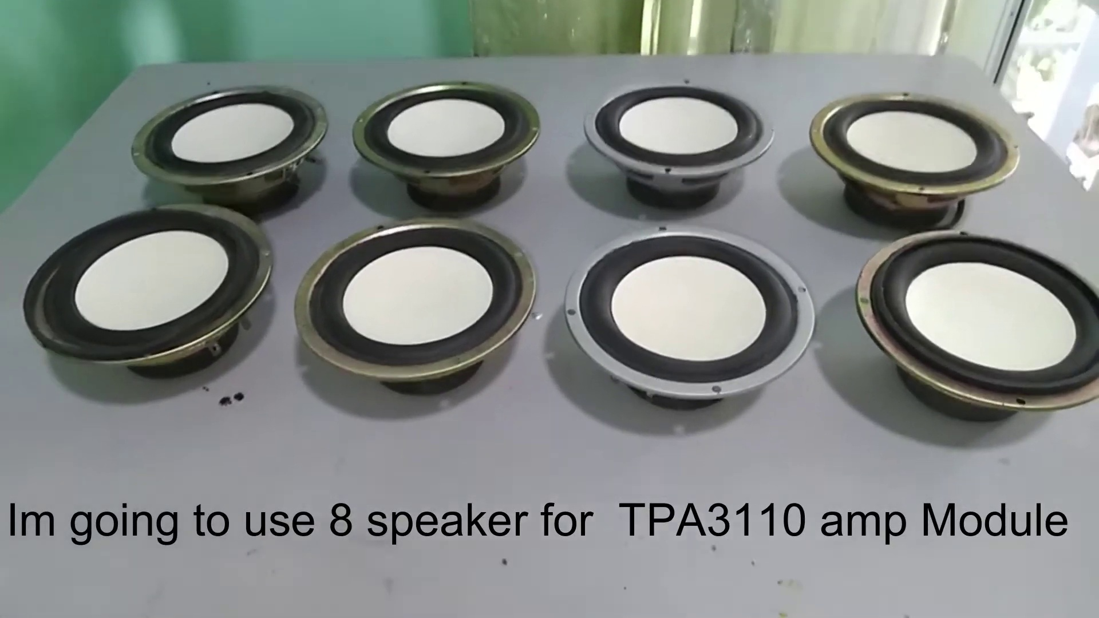 | 0:08   | 0:08  

Transcript
(No speech detected in this section)

Section 0: Video playback interface on a computer monitor
Time: 0:09 - 8:21

Summary
A video playback interface is displayed on a computer monitor, showing a paused video with text overlays.

Representative Frames
1:31  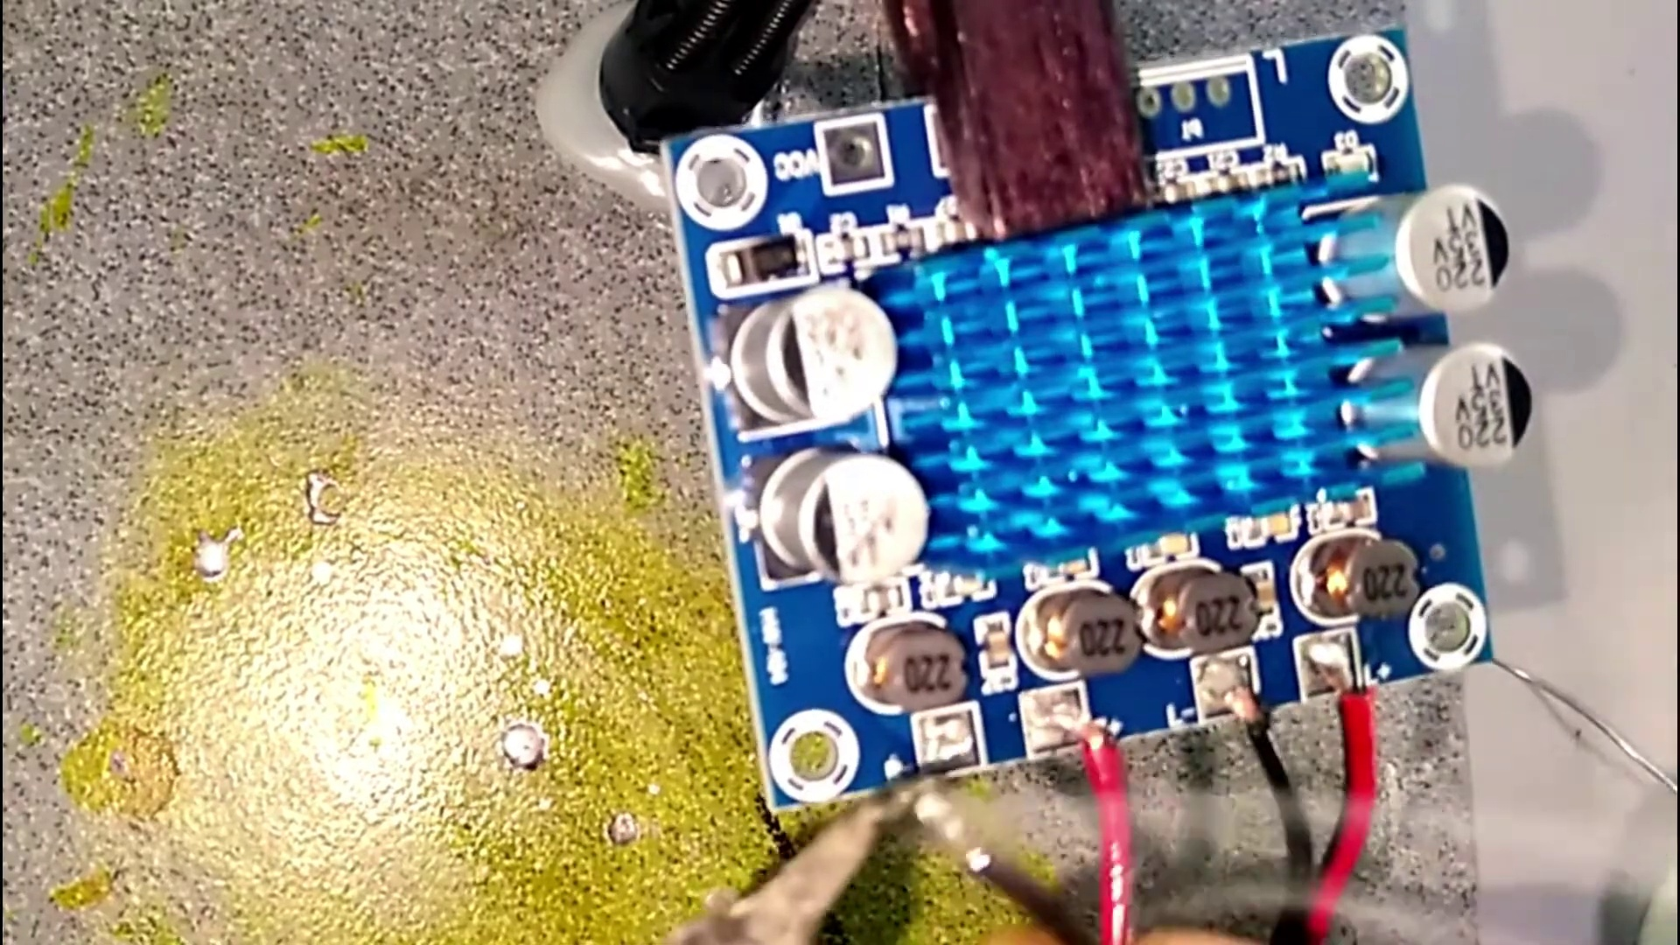 | 2:53  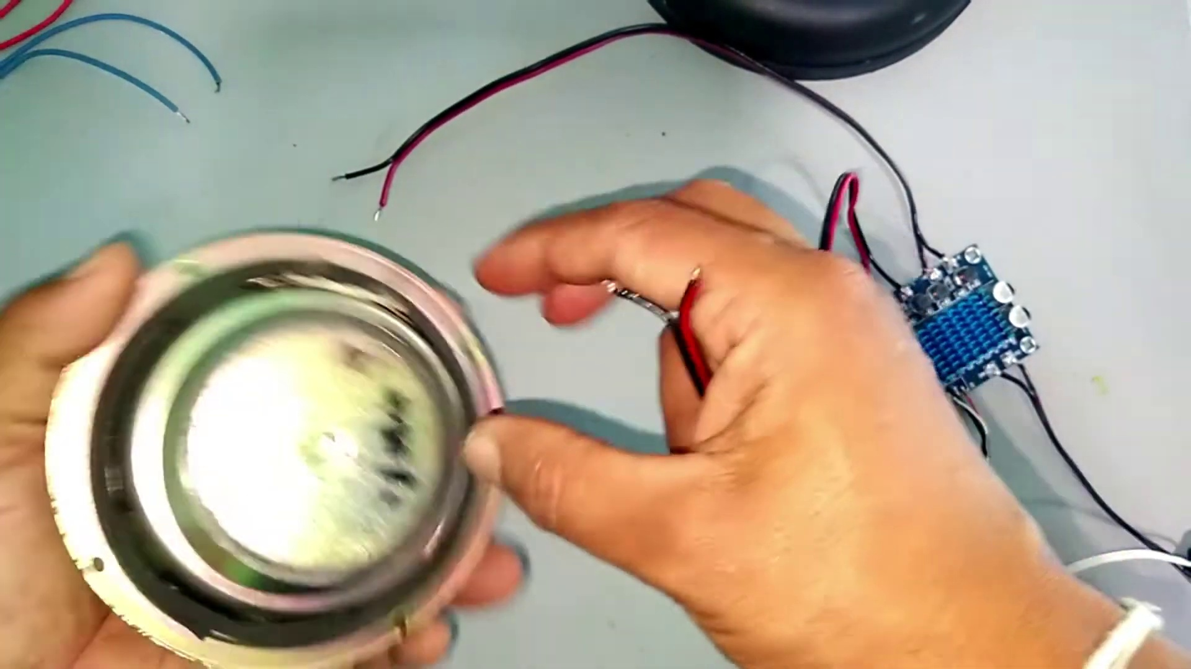 | 4:15  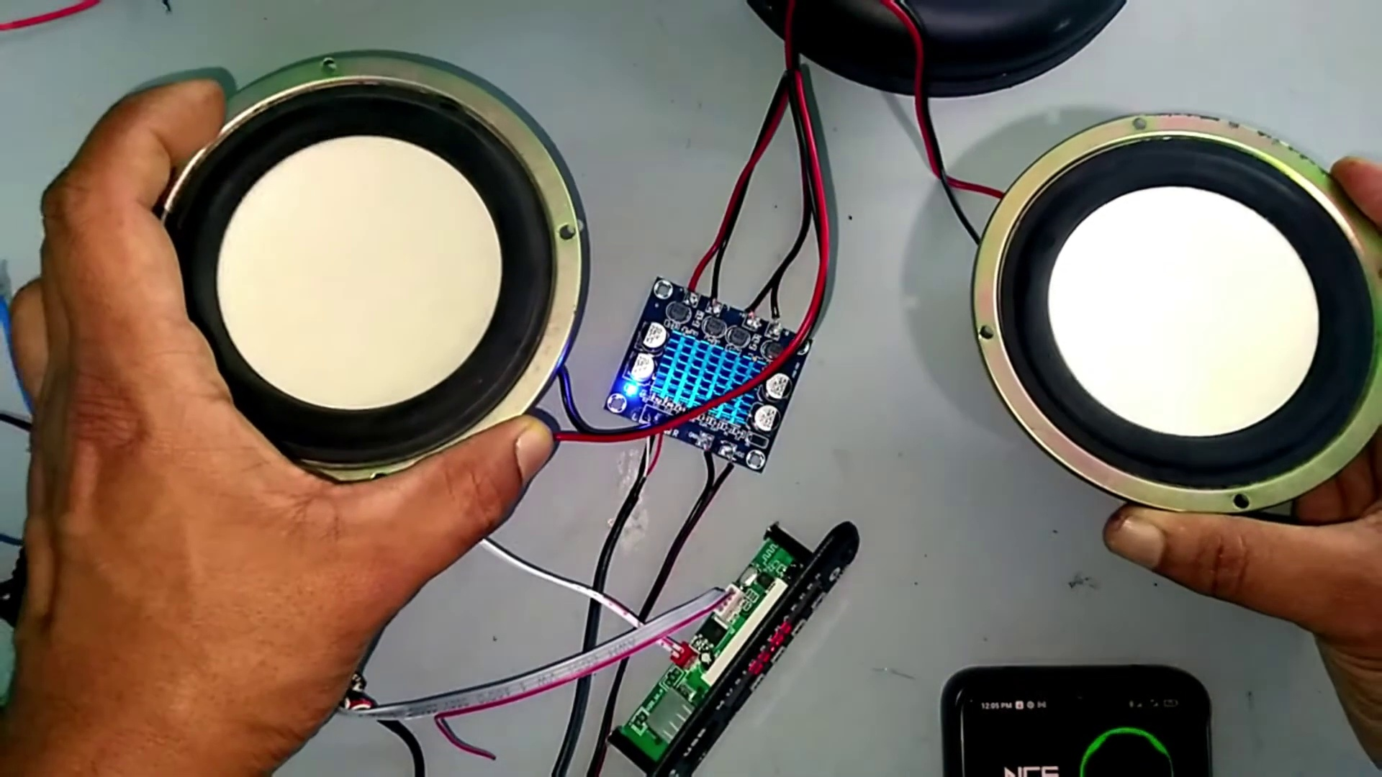 | 5:37  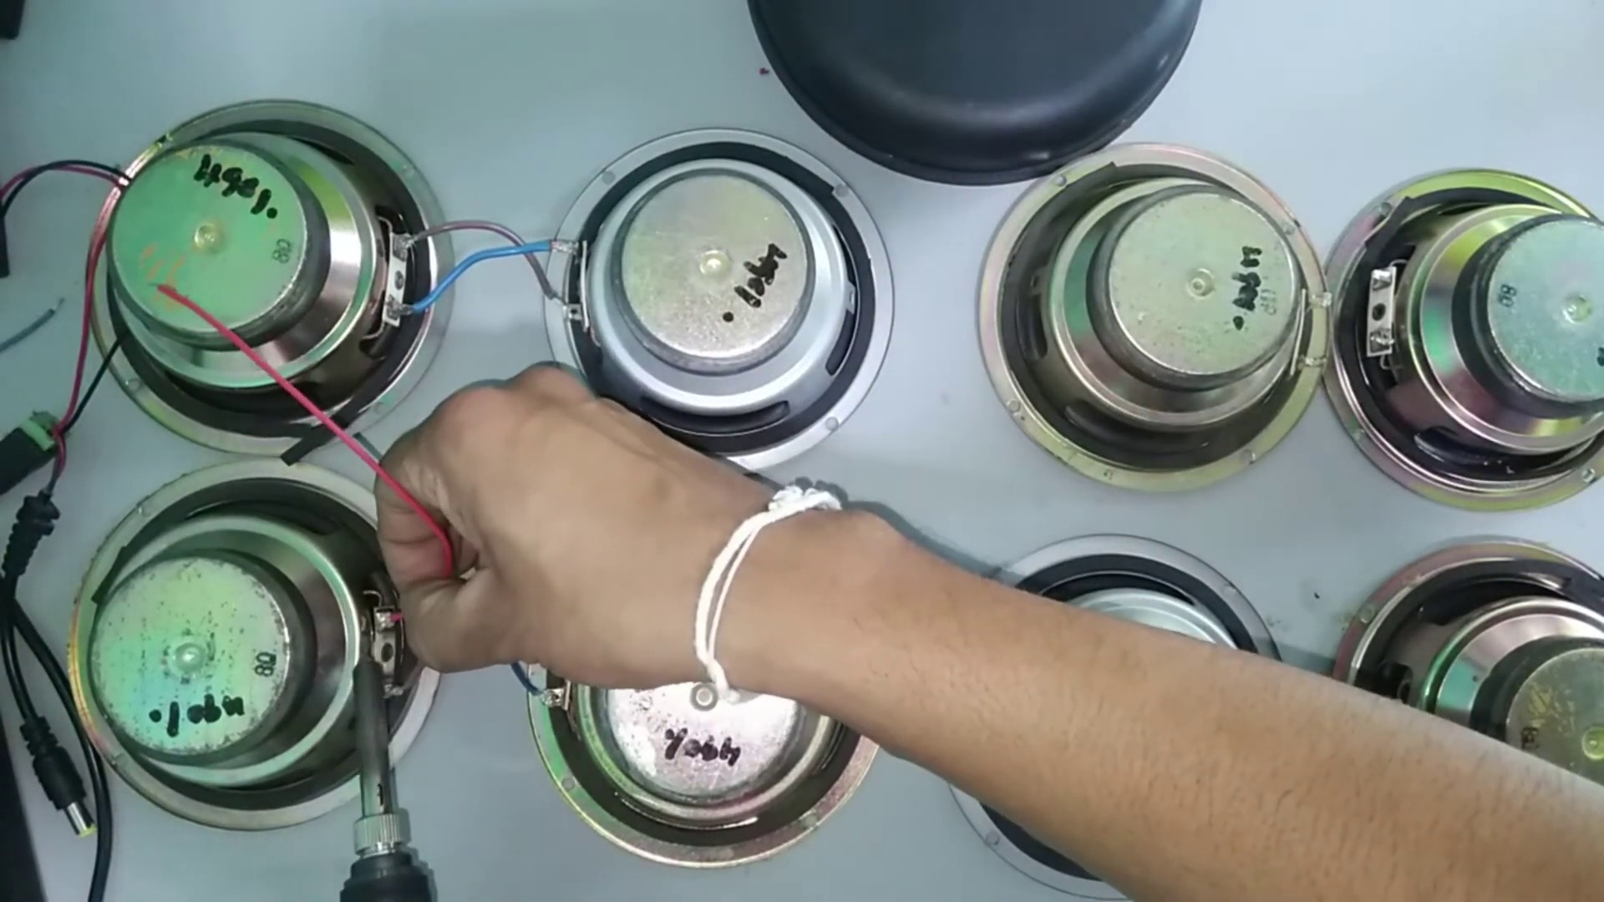 | 6:59  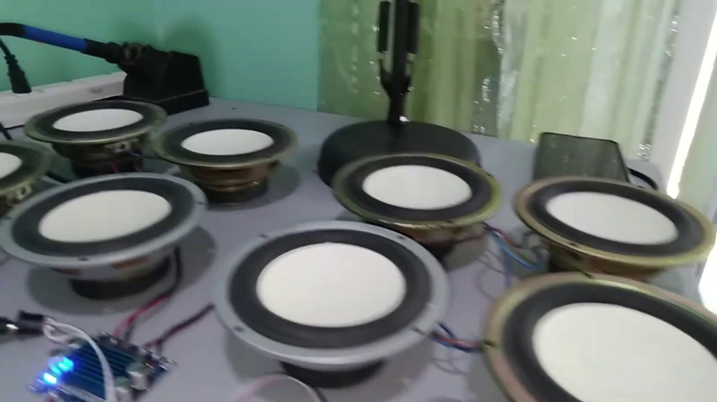

Transcript
[0:07] inclusive connect the코 incorporate into network
[0:13] Thank you.
[0:43] Thank you.
[1:13] Thank you.
[1:43] Thank you.
[2:13] Thank you.
[2:43] Thank you.
[3:13] Thank you.
[3:43] Thank you.
[4:13] Thank you.
[4:43] Thank you.
[5:13] Thank you.
[5:43] Thank you.
[6:13] Thank you.
[6:43] Thank you.
[6:45] Thank you.
[6:47] Thank you.
[6:49] Thank you.
[7:15] Thank you.
[7:45] Thank you.
[8:15] Thank you.

