Engagement Analysis: sI5Ftm1-jik

Section 0: Man Holding Smartphone with Electric Guitar Package
Time: 0:01 - 0:03

Summary
A man is holding a smartphone and discussing electric guitars, possibly within an online tutorial or instructional video series.

Representative Frames
0:01   | 0:01   | 0:02   | 0:02   | 0:02  

Transcript
[0:00] Hi, I want to make a full bridge rectifier.

Section 0: Two Men Engaged in Playful Debate Over Toy Cars
Time: 0:03 - 0:05

Summary
Two men are engaged in a playful debate over toy cars, with one man holding a red toy car and the other holding a blue toy car.

Representative Frames
0:03   | 0:03   | 0:04   | 0:04   | 0:04  

Transcript
(No speech detected in this section)

Section 0: Split-Screen Image with Text 'WATCH I NEXT'
Time: 0:05 - 0:07

Summary
A split-screen image shows two different scenes, with text 'WATCH I NEXT' displayed on the left side, indicating a pause or instruction for an interactive video.

Representative Frames
0:05   | 0:05   | 0:06   | 0:06   | 0:06  

Transcript
[0:03] That's right, it's not a dumb single diode rectifier, it's a full bridge.

Section 0: Man's Face with Bald Spot and Text 'WATCH I NEXT'
Time: 0:07 - 0:09

Summary
A man's face is shown with a bald spot where hair has been shaved off, along with text 'WATCH I NEXT' displayed below.

Representative Frames
0:07   | 0:07   | 0:08   | 0:08   | 0:08  

Transcript
[0:07] What is a rectifier?

Section 0: Two Men Engaged in Different Activities
Time: 0:09 - 0:11

Summary
Two men are engaged in different activities on opposite sides of the screen, with one man holding a wooden toy and tending to it, and the other man interacting with an electronic guitar.

Representative Frames
0:09   | 0:09   | 0:10  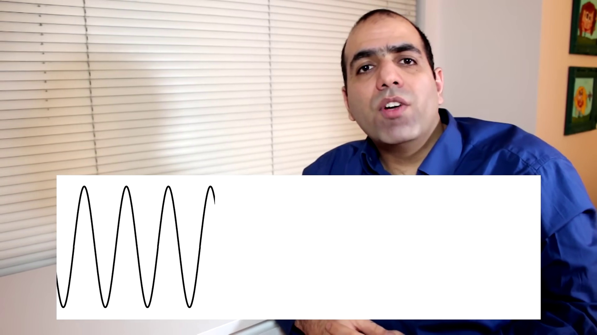 | 0:10   | 0:10  

Transcript
(No speech detected in this section)

Section 0: Man Holding Electronic Guitar
Time: 0:11 - 0:13

Summary
A man is shown holding an electronic guitar, possibly within the context of an online tutorial or instructional video series.

Representative Frames
0:11   | 0:11   | 0:12   | 0:12   | 0:12  

Transcript
[0:09] It basically converts AC alternating current into DC direct current.

Section 0: Men Engaged in Conversation and Text 'WATCH NEXT'
Time: 0:13 - 4:24

Summary
Two men are engaged in conversation, with text 'WATCH NEXT' displayed below them, possibly indicating the next scene or activity in a video series.

Representative Frames
0:54   | 1:36  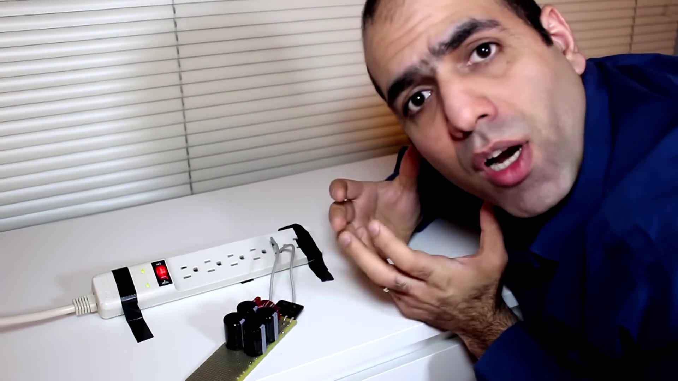 | 2:18  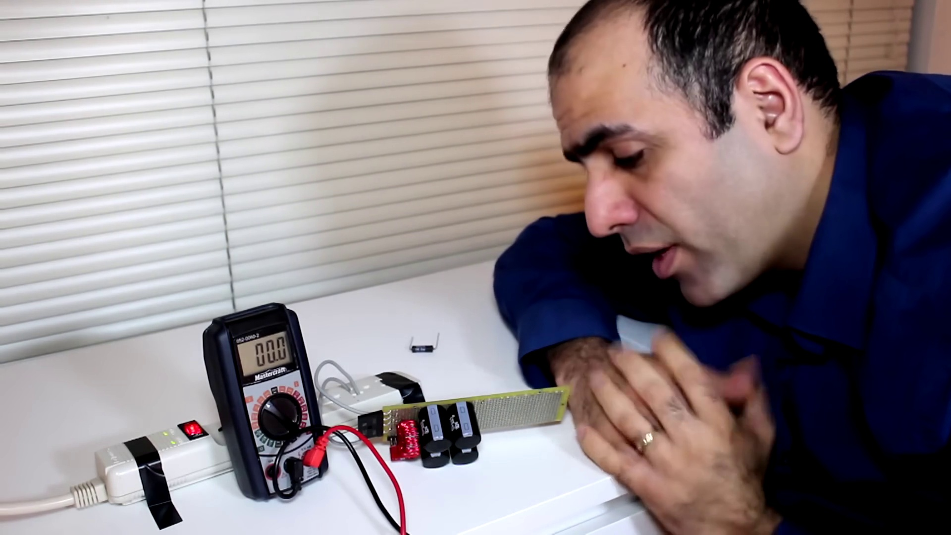 | 3:00  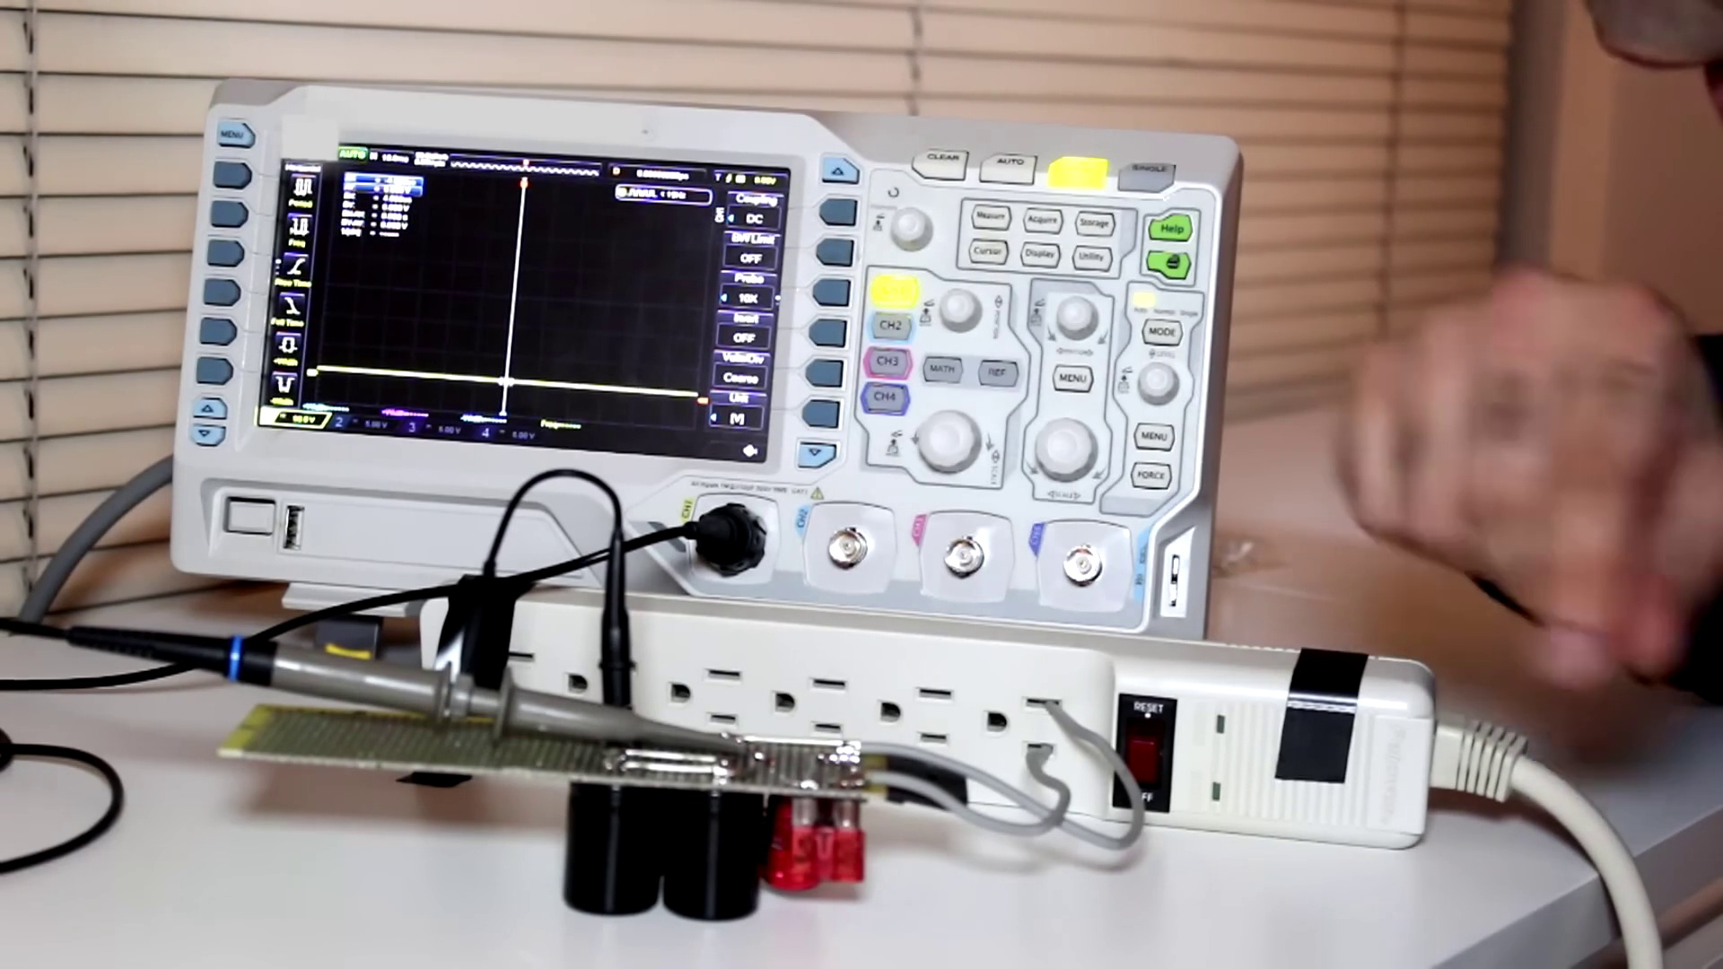 | 3:42  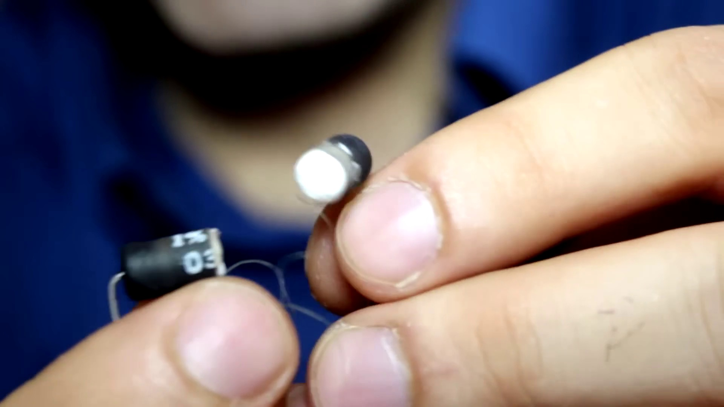

Transcript
[0:13] Full bridge is basically made of four diodes in this arrangement.
[0:16] The rectification can also be done with a single diode.
[0:19] What's a diode?
[0:20] It's like an electrical check valve that allows current in one direction but blocks it from going back.
[0:25] If you provide an AC voltage to a single diode, it outputs the positive half of the wave.
[0:30] If you put a capacitor at its output, it holds the voltage close to the peak of the wave as DC.
[0:35] Now a full bridge rectifier converts both the positive and negative peaks into positive bumps at the output.
[0:42] Adding a capacitor at the output converts it into DC again.
[0:45] Generally, a single diode is used for low power rectification as well as DC reverse polarity protection.
[0:50] But a full bridge rectifier is used for high power rectification as well as reverse polarity protection.
[0:57] Now here's my design.
[0:58] When connected to 120 volt AC line, it is designed to output close to 170 volt DC at no load.
[1:05] And capable of driving 10 amp maximum load.
[1:07] So naturally, there is a 10 amp fuse at the input for protection.
[1:11] Then the diode bridge.
[1:12] The added inductor helps with ripple filtering.
[1:15] Here's what I've made.
[1:16] It is pretty huge, which of course can output over a thousand watts.
[1:19] Unlike your puny wall adapter that can do 20 watts at best.
[1:23] Now let's plug it in.
[1:24] I have some loose wires connected to my circuit, which I will stick into the power plug.
[1:34] As you can clearly see, I have no regards for safety.
[1:37] Don't be like that.
[1:38] See, this electricity is not going to jump at you.
[1:41] Because it doesn't have high enough voltage to jump.
[1:43] The only way you would get hurt is by touching live wire.
[1:46] So insulate your circuit properly, wear safety gloves, and don't touch s*** with your bare hands.
[1:52] Bare hands.
[1:52] Baaah!
[1:53] Why do you call them bare hands?
[1:55] I'm going to touch 170 volt DC with my bare hands.
[1:57] There is 166 volt on the output.
[1:59] Now I'll put my finger across the output.
[2:03] See, I can barely feel it.
[2:04] DC is much less dangerous than AC.
[2:07] Barely.
[2:08] What's up with bears in your language?
[2:10] I feel so barely today.
[2:11] Barely.
[2:12] Bridge rectifiers are widely used in AC to DC converters.
[2:16] As far as I know, all your wall adapters contain one of these circuits.
[2:20] Now I will measure some waveforms.
[2:21] I connected the probe to my output lines, connected my circuit to this power bar, and now I will turn the power bar on.
[2:27] S***!
[2:28] S***!
[2:30] My fuse just blew up.
[2:32] Something I realized the hard way is that the ground of the probe is actually shorted to the earth of the power plug through the scope.
[2:39] So what happens is that when I connect the ground to the negative output of the bridge,
[2:44] it shorts the live wire to earth every negative cycle of the AC.
[2:48] And that's why we have fuses to avoid exciting fires.
[2:51] Now I'm using this tape called Kapton tape to insulate the earth of the power cord.
[2:57] I have the same setup again, and with the probe connected, I turn the power bar on.
[3:02] We are safe now.
[3:03] As you can see on the scope, the output voltage is around 170 volts.
[3:07] Now I like to use my 100 ohm resistor and connect it to the output to see how the waveform changes.
[3:14] S***!
[3:15] S***!
[3:16] S***!
[3:16] S***!
[3:17] S***!
[3:17] S***!
[3:18] A quick calculation shows having 170 volts across 100 ohm generates 300 watts of power.
[3:23] It's like having a 300 watt lamp within your fingers.
[3:26] It burns your skin very quickly.
[3:28] Now I use pliers to hold the resistor.
[3:30] S***!
[3:32] See the output voltage drops, but with very small ripples because there is a lot of filtering.
[3:37] Wow, I was holding that.
[3:39] I let it cool down for a while and s***!
[3:41] The ceramic core takes a long time to cool down, and now you can see that the resistor is made of resistive wires wound around the ceramic core.
[3:50] Anywho, this power supply will eventually feed my high-powered Tesla coil driver circuit.
[3:55] S***!
[3:55] S***!
[3:56] Oh!
[3:57] Remember in such circuits although unplugged the capacitors hold charge for a long period of time so always discharge them with some resistor.
[4:10] eh?!
[4:12] eh?!
[4:12] eh?!
[4:13] eh?!
[4:13] eh?!
[4:14] Thuh!
[4:14] Thuh!
[4:15] Thuh!
[4:15] Thuh!
[4:16] Thuh...
[4:16] Thuh!
[4:17] Thuh...
[4:18] Thuh!
[4:18] Thuh
[4:19] Thuh!
[4:19] Thuh!
[4:19] Thuh!
[4:20] Thuhё!
[4:20] Thuh!
[4:20] Thuh!
[4:21] Ha! Thuh!
[4:22] Thuh! Thuh!
[4:22] Thuh! Thuh!
[4:23] Thuh!
[4:23] Thuh!.import!
[4:23] Thuh! Thuh!
[4:23] place! Thuh!á! Thuh! Thuh! Thuh! Ta!
[4:24] Thuh! Thuh! Thuh! Thuh!

