Engagement Analysis: t4LPzGIr41c

Section 0: Electronics Setup and Assembly
Time: 11:12 - 11:15

Summary
The image shows an electronics setup with a circuit board, wires, and components. A smartphone displays a screenshot of a mobile application interface. The app includes features such as a search bar and icons indicating different categories or functions.

Representative Frames
11:12  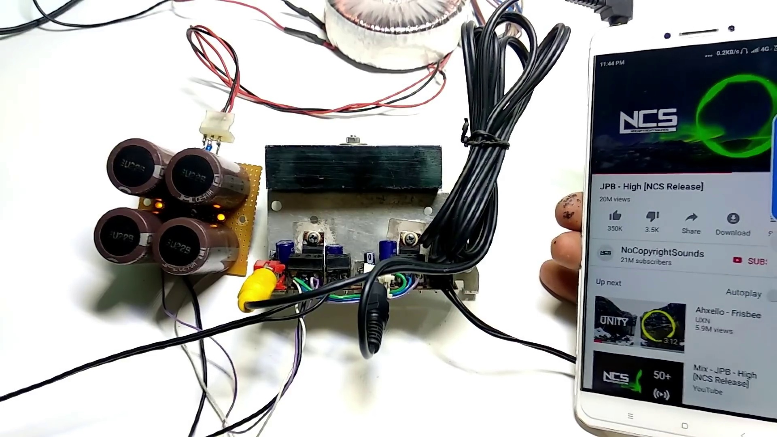 | 11:13   | 11:13   | 11:14   | 11:14  

Transcript
(No speech detected in this section)

Section 0: Electronic Device Connection and Activation
Time: 11:15 - 11:17

Summary
The image captures a scene where an electronic device, resembling a small circuit board, is connected with various wires and components. The label next to the device reads 'NES-PI'. A smartphone displays a social media post or digital photo featuring the same electronic setup.

Representative Frames
11:15   | 11:15  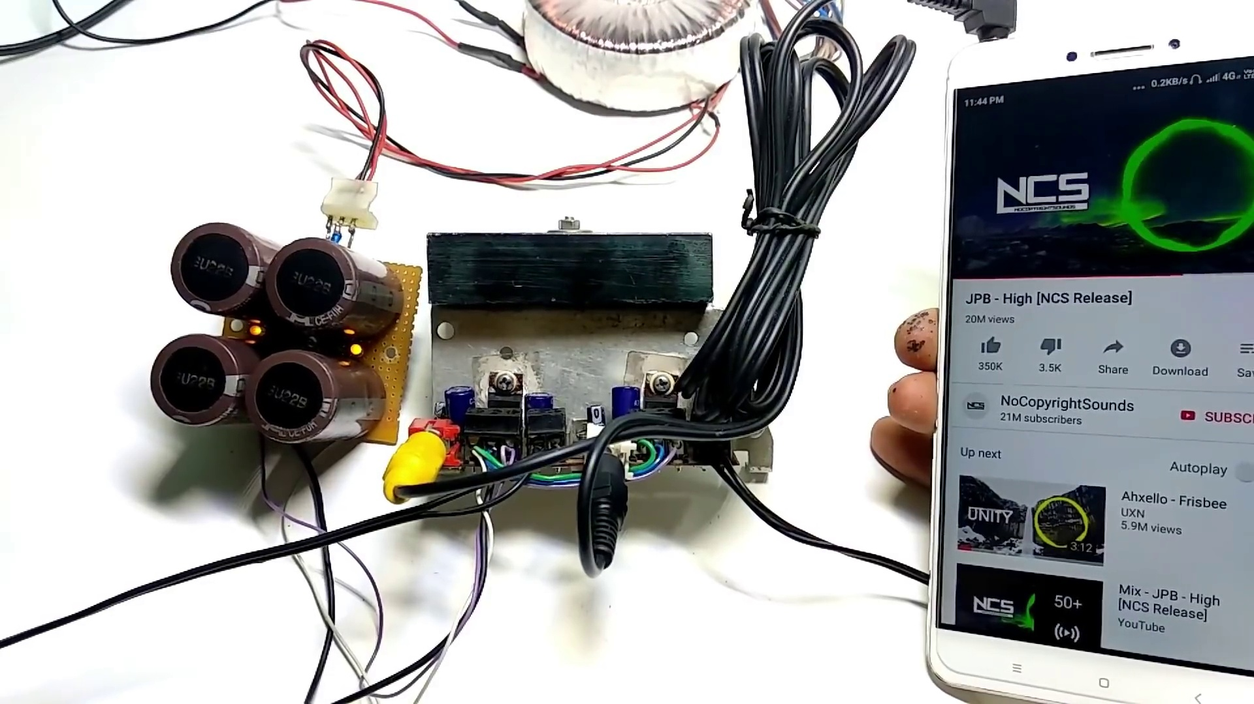 | 11:16   | 11:16   | 11:17  

Transcript
(No speech detected in this section)

