Engagement Analysis: u40kX1DYKdA

Section 0: Setup and Recording of Video
Time: 0:07 - 0:07

Summary
The video shows various setups for recording, including cameras, monitors, and digital stopwatches. The narrator discusses different aspects of the recording process, such as timestamping and playback.

Representative Frames
0:07  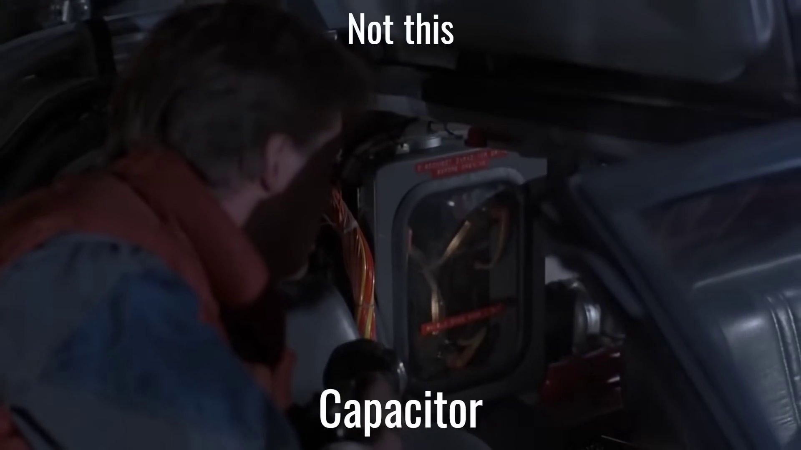 | 0:07   | 0:07   | 0:07   | 0:07  

Transcript
(No speech detected in this section)

Section 0: Camera Display and Controls
Time: 0:07 - 0:07

Summary
The video shows a camera display with various controls, including record, play, stop, and mute. The narrator discusses different aspects of the camera display and its interface.

Representative Frames
0:07   | 0:07   | 0:07   | 0:07   | 0:07  

Transcript
(No speech detected in this section)

Section 0: Stopwatch and Timestamping
Time: 0:07 - 8:03

Summary
The video shows digital stopwatches and timestamping mechanisms in various setups. The narrator discusses how these tools are used to record and playback video content.

Representative Frames
1:26  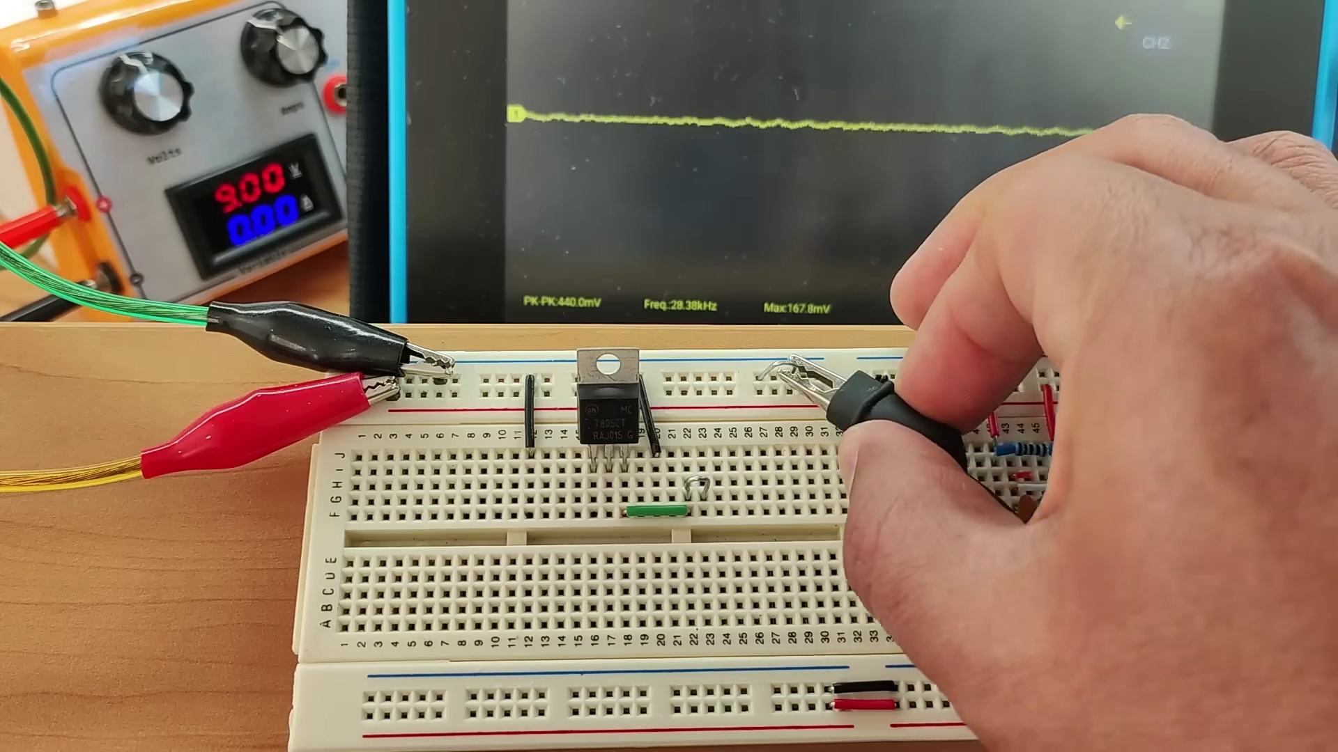 | 2:45  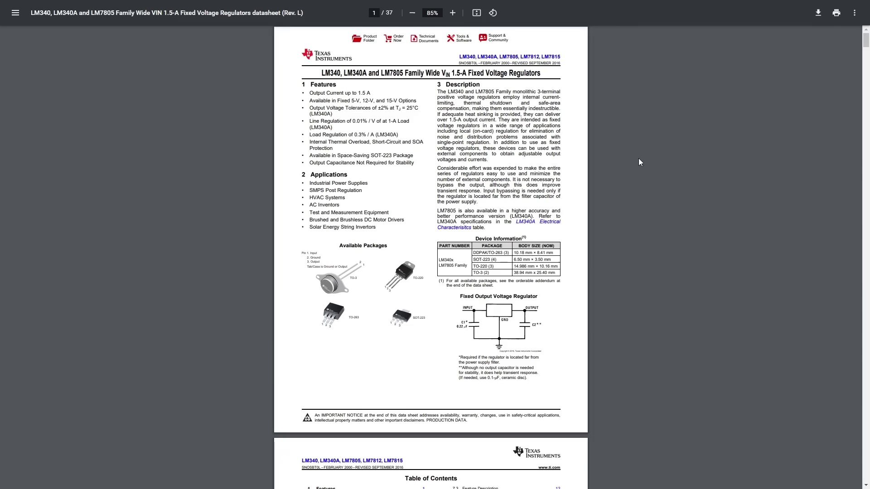 | 4:05  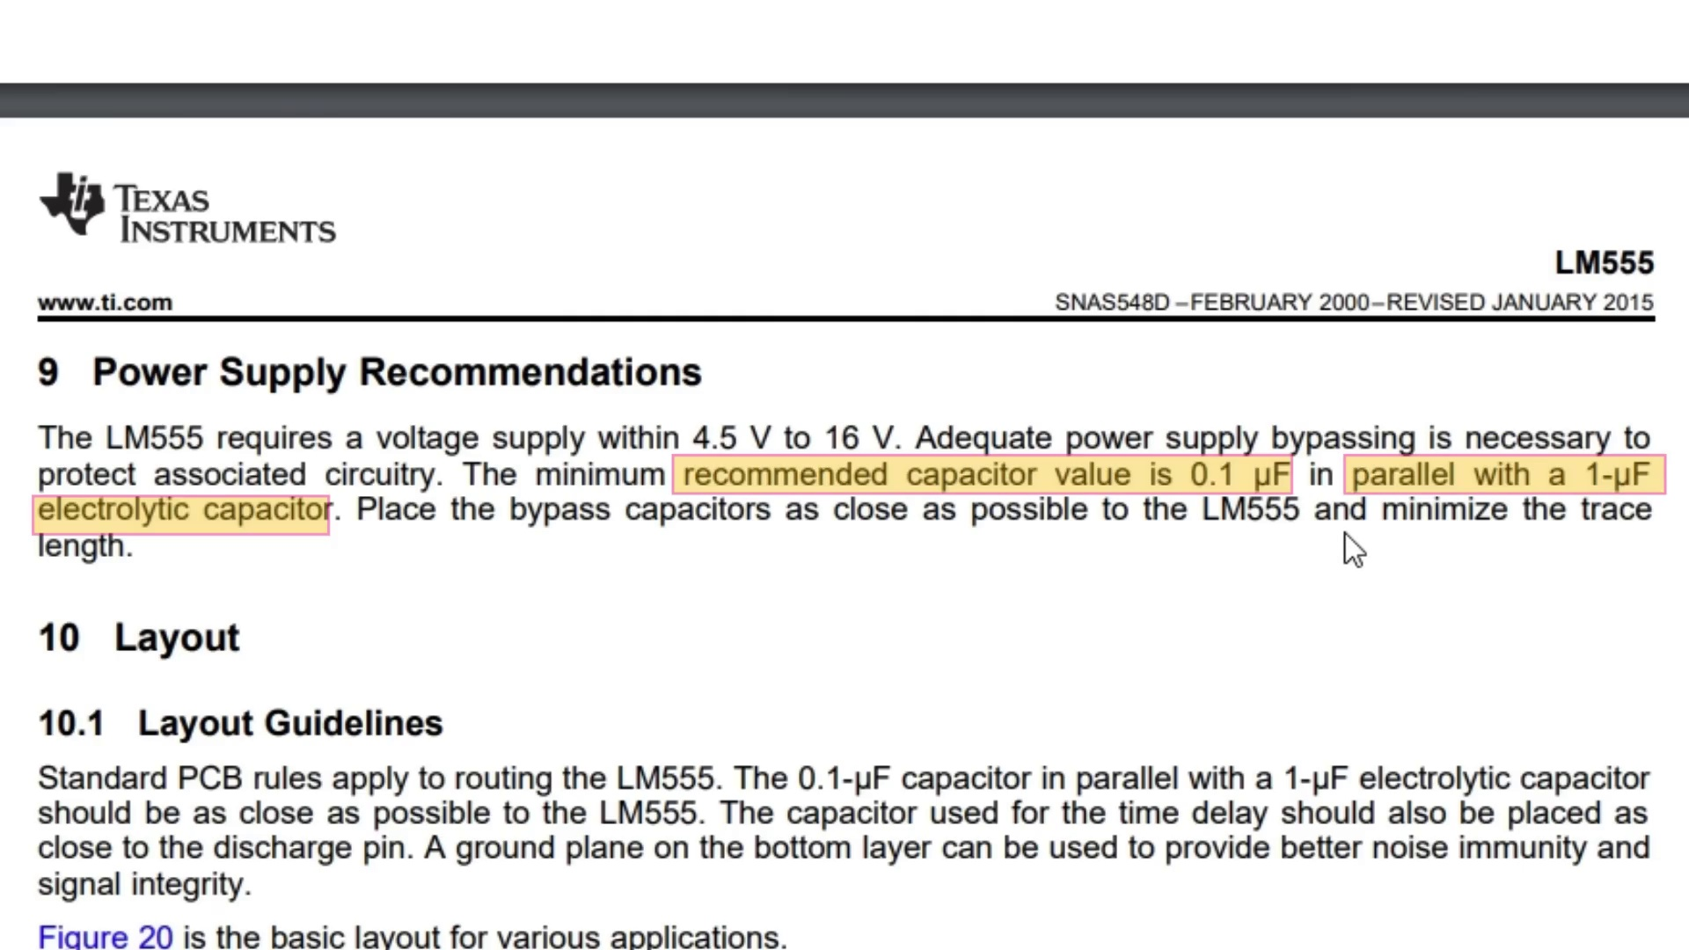 | 5:24  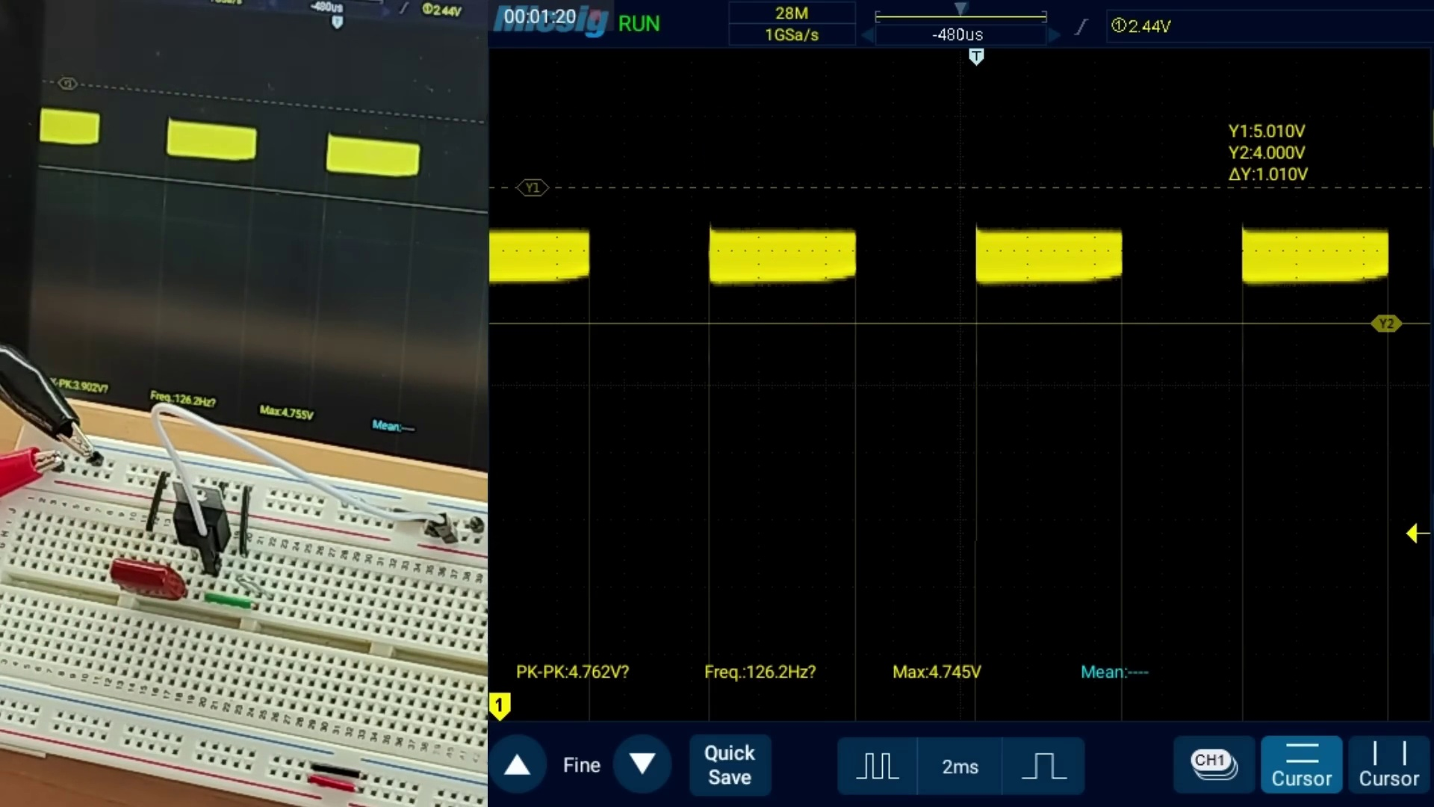 | 6:44  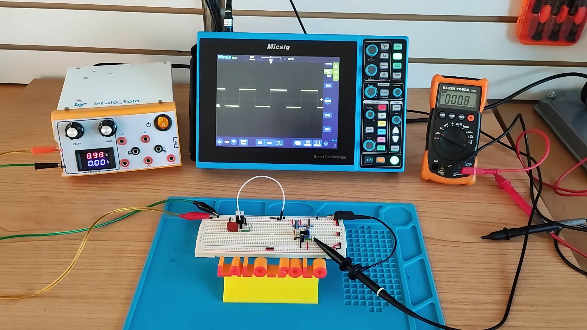

Transcript
[0:07] But do you know why they are so important? In this video,
[0:10] we will delve into them and their significance in electronics design.
[0:21] In electronics, different parts of a circuit can create noise or electrical disturbances
[0:25] that can affect the performance of other parts of the circuits. This noise can be caused by various
[0:31] factors such as switching of transistors, voltage spikes, electromagnetic interference, and so on.
[0:40] The coupling capacitors are used to suppress this noise by providing a low impedance path to ground
[0:45] for high frequency noise. These are two circuits to demonstrate the presence of noise. First,
[0:53] an LM7805 voltage regulator which receives the voltage and stabilizes it to 5V DC.
[1:01] And with this 555 timer, generating an square wave at 123Hz, which is considered low frequency.
[1:10] For the input of the regulator, I am using a switching mode power supply adjusted at 9V DC.
[1:17] By looking into the output with the multimeter, everything appears normal, with an average output of 5V.
[1:26] If we look with the oscilloscope, indeed it appears around 5V. Good.
[1:33] But if we look close there, the line looks fuzzy. This is electrical noise, mainly generated by the power
[1:41] supply, but also by the regulator itself, internally switching at high speed trying to stabilize the output voltage.
[1:49] This noise includes a ripple, seen as a high frequency AC component superimposed on the DC signal,
[1:57] which can cause problems in certain applications, in this case more than 900 mV.
[2:03] If we add some load at the output, let's say this LED with a resistance, guess what happens?
[2:12] Ouch! The regulator gets more stressed due to the load, and the output noise goes even higher,
[2:20] almost 2V peak to peak. This noise is also getting back to the power rail of the circuit.
[2:26] I am enabling the second channel of the scope to see both signals. See the blue line, how the noise
[2:34] increases as I connect the LED, which means that other components on the same circuit will be affected
[2:41] as well. The datasheet recommends adding one capacitor of 0.22uF at the input, and an optional one at the output.
[2:50] The first is the decoupling capacitor because it decouples or isolates this component from the rest,
[2:58] in this case from the power supply. I will use this film capacitor of 0.33uF, which is the closest one that I have.
[3:11] Oh, perfect! The new readings of the peak to peak noise is around 150mV. We have an improvement here.
[3:21] Great! Now let's analyze the 5F5 timer. The signal looks like a classic square wave,
[3:29] but if we zoom in we see this spike on the left, and lots of noise with it. For this circuit the input
[3:37] is 9V, the peak is more than 6V, that's 54%. Hmm, for reference it is too much.
[3:47] I am adding two capacitors at the power lines of the integrated circuit to see the effect.
[3:55] Why too? And how did I know the values of each of them? Well, because they are prescribed in the
[4:02] datasheet of the manufacturer. The final square wave looks much cleaner. The readings this time for the
[4:10] noise amplitude is only 400mV. Compared with the previous one, it is way lower. Perfect!
[4:19] What if we connect the output of the regulator to power the 5F5 timer?
[4:23] We do this by connecting the ground line and then the output of the regulator, this pin 3,
[4:32] to the power line of the 5F5 timer. That means that we are accumulating the power supply,
[4:37] the regulator and the 5F5 timer in series. And actually this is a common array for many circuits.
[4:48] The shape of the square wave reflects the accumulated noise from the power source
[4:53] and from the regulator. So imagine having this kind of behavior in more complex circuits.
[4:59] This is a ripple and noise. Notice this tilted section of the wave. That is not right. We can measure
[5:08] more than 900mV. This is 20% of 5V. Now let's go ahead to add the decoupling capacitor to the input of the regulator.
[5:17] Now we have like 500mV of peak to peak noise. Things are getting better. That's good.
[5:34] Now adding the first of the two decoupling capacitors of the 5F5 timer.
[5:38] First with 0.1uF5 timer. First with 0.1uF5 timer. Or 104 code for a ceramic capacitor.
[5:47] Which should remove higher frequencies. This gives like 140mV for the noise.
[5:56] Now adding the electrolytic capacitor of 1uF5 timer. This one should remove the lower frequencies from the
[6:04] noise. Hmm. This one is only helping to fix the left side of the shape. But not for reducing the overall noise.
[6:15] Anyway we leave it as it is prescribed by the datasheet. Our final signal is squared and flat at the bottom
[6:22] and at the top. And not that thick. And the final noise gives 140mV equivalent to 2.8%.
[6:30] That's a more acceptable value. Not bad. But what if we need a cleaner output signal?
[6:40] First, let's remember that a breadboard is not the best way to measure and eliminate electrical noise.
[6:46] However, there are several techniques that can be used. But those depend on condition of circuit.
[6:52] That includes frequency, amplitude, power, peak amplitude, external interference, radio frequencies,
[7:02] nominal voltage, tolerances, cost, and many others. But those are not covered in this video.
[7:11] Ok, now we have a practical idea of why decoupling capacitors are so important.
[7:16] I hope you liked this video.
[7:20] Knock knock.
[7:25] That's f...
[7:25] That's 50...
[7:27] That's good.
[7:29] Good.
[7:31] Good.
[7:32] Milliballs per...
[7:34] But what...
[7:35] But what if...
[7:37] What if...
[7:53] So that partir.
[7:55] This is not a little too much about d lij
[7:57] bad mão.
[7:58] So that this is still a little too much about all of the miroczyños.
[8:00] That permitir.
[8:02] And it can be Mauricio.

