Engagement Analysis: w49SSxiPK_Q

Section 0: Electronic Components and DIY Projects
Time: 0:00 - 0:03

Summary
The following section showcases various images of electronic components, DIY projects, and speaker setups. The images display a range of devices, including speakers, subwoofers, circuit boards, phones, and measuring tools.

Representative Frames
0:00  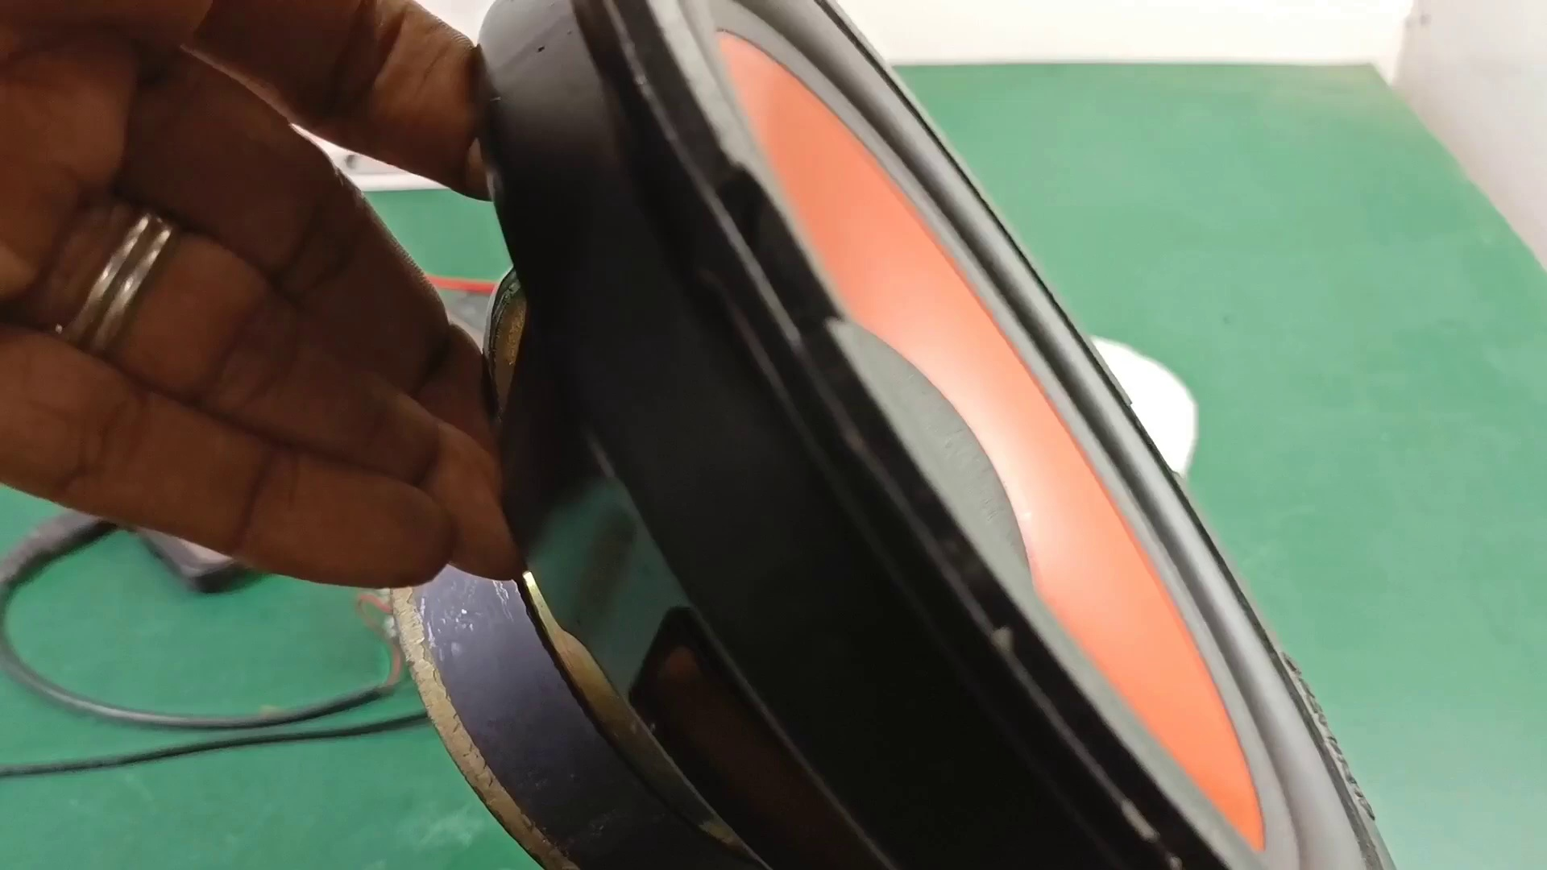 | 0:01   | 0:01   | 0:02   | 0:02  

Transcript
(No speech detected in this section)

Section 0: Image Analysis
Time: 0:03 - 0:06

Summary
The section begins with an image analysis of various electronic components, including speakers, subwoofers, and circuit boards. The images are taken from different perspectives and angles to provide a comprehensive understanding of the devices.

Representative Frames
0:03  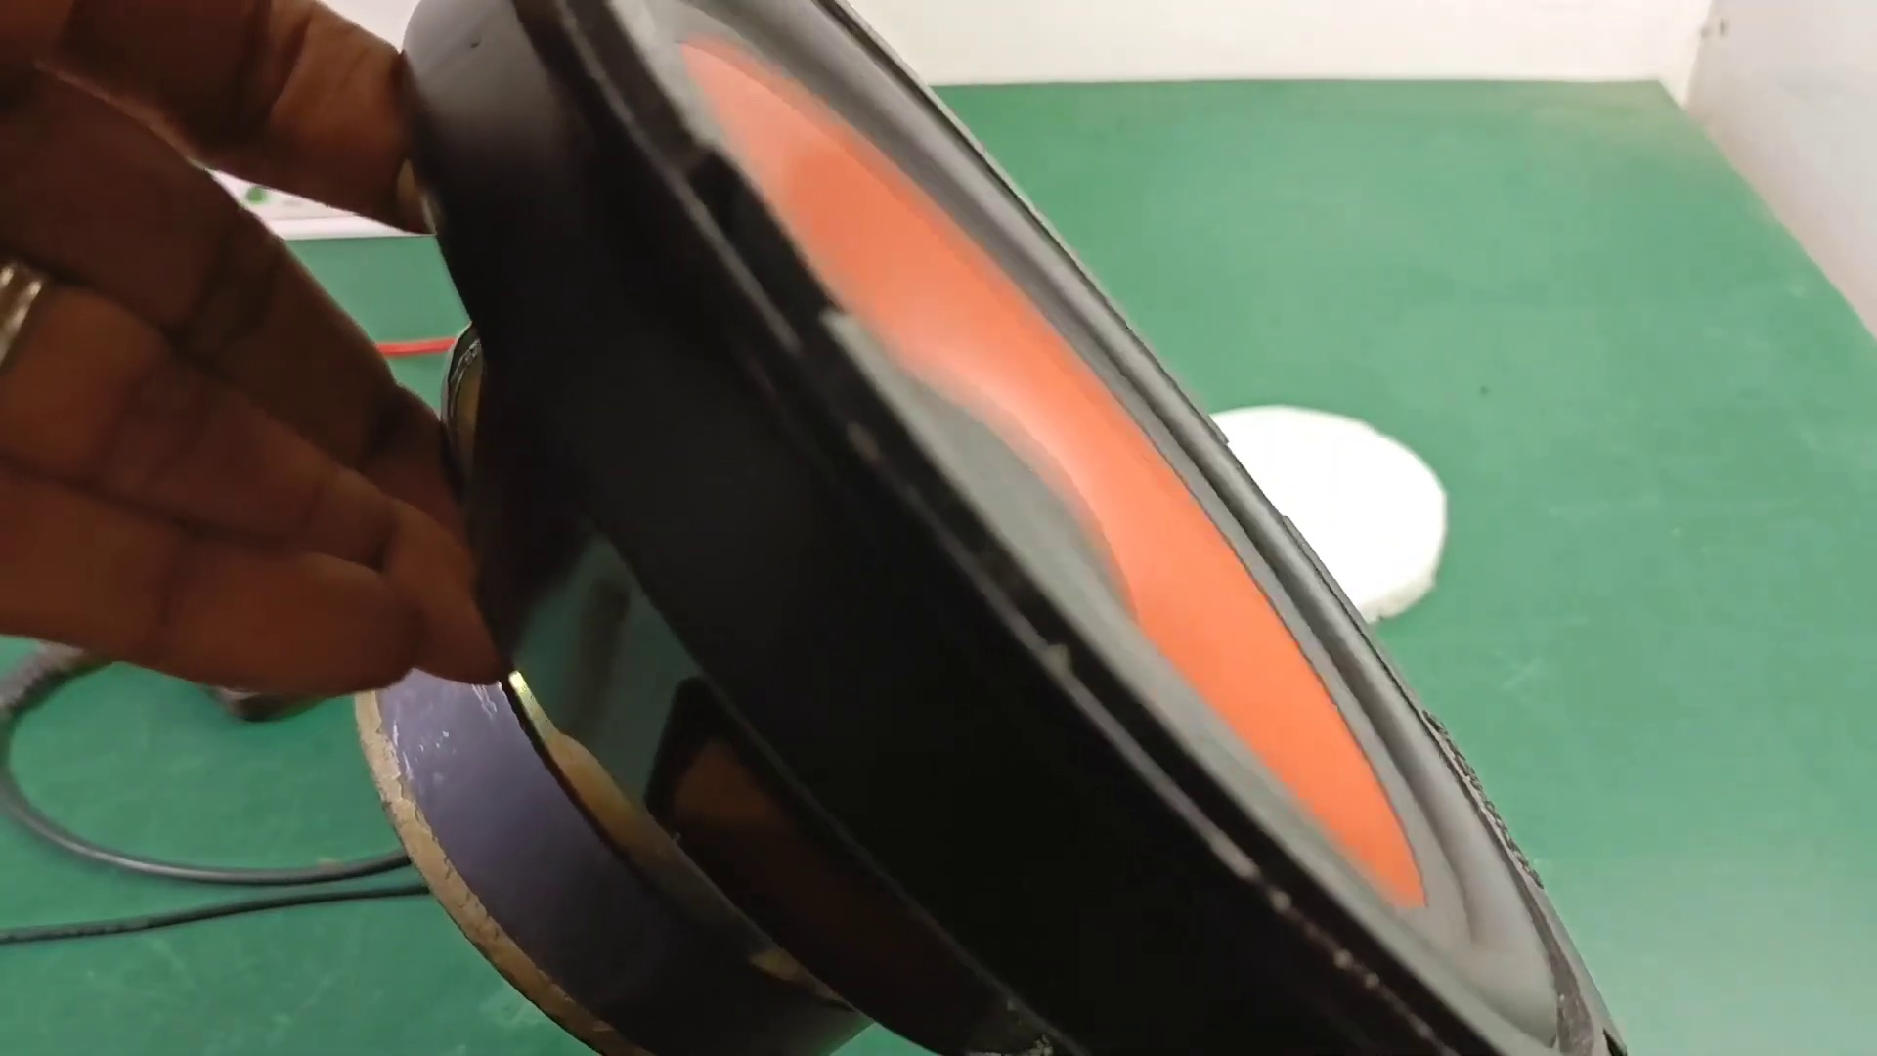 | 0:04   | 0:04   | 0:05   | 0:05  

Transcript
[0:00] The

Section 0: Speaker Setup and DIY Project
Time: 0:06 - 0:09

Summary
The section showcases an image of a speaker setup with multiple connections between components, indicating a homemade or custom setup. The circuit board appears to be a breadboard with various electronic components connected to it.

Representative Frames
0:06   | 0:07   | 0:07   | 0:08   | 0:08  

Transcript
[0:06] introductionic

Section 0: Phone and Circuit Board Connection
Time: 0:09 - 0:12

Summary
The image displays a phone connected to a circuit board, with multiple connections between the components. The speaker is placed in front of the setup, equipped with a black USB cable.

Representative Frames
0:09   | 0:10  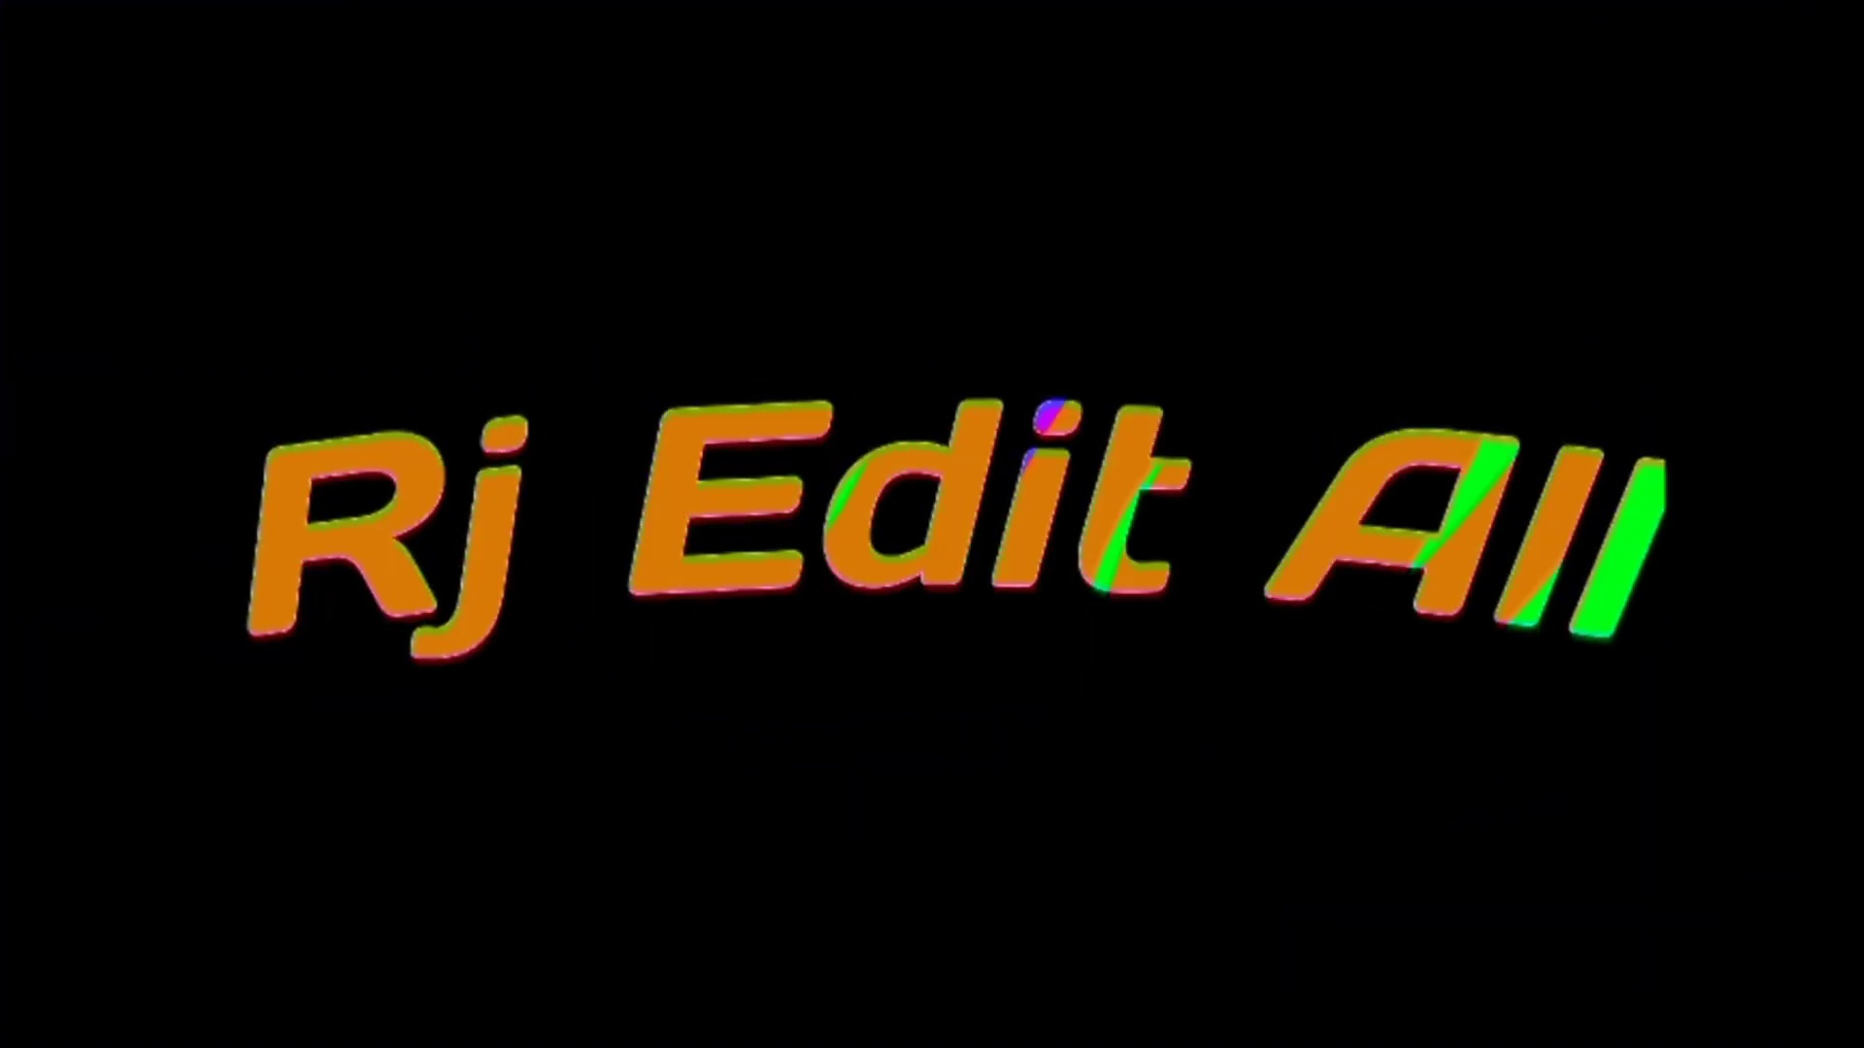 | 0:10   | 0:11   | 0:11  

Transcript
[0:09] the

Section 0: Text Overlay and Message
Time: 0:12 - 0:15

Summary
In the background, there is a text overlay that reads 'DIY speaker with electronic components.' The phone's screen displays a message that reads 'Thanks for watching,' likely a welcome message or appreciation from the speaker manufacturer or workshop owner.

Representative Frames
0:12   | 0:13   | 0:13  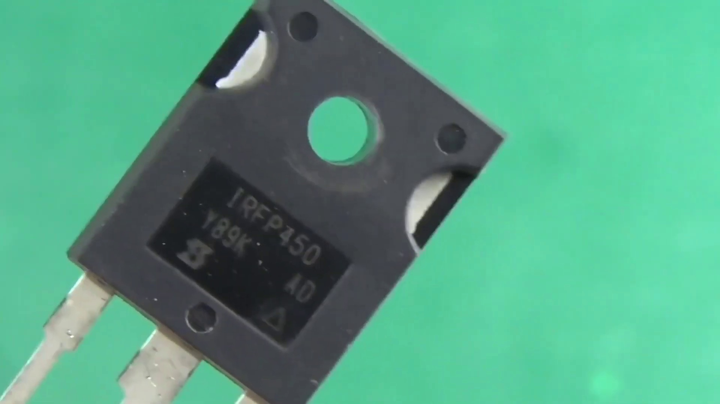 | 0:14   | 0:14  

Transcript
(No speech detected in this section)

Section 0: Subscription Button and Context
Time: 0:15 - 0:18

Summary
The image includes a subscription button, possibly for a YouTube channel or website related to the speaker or workshop. The presence of the USB cable and subscription button suggests that this might be a project related to electronics or DIY projects.

Representative Frames
0:15   | 0:16   | 0:16   | 0:17  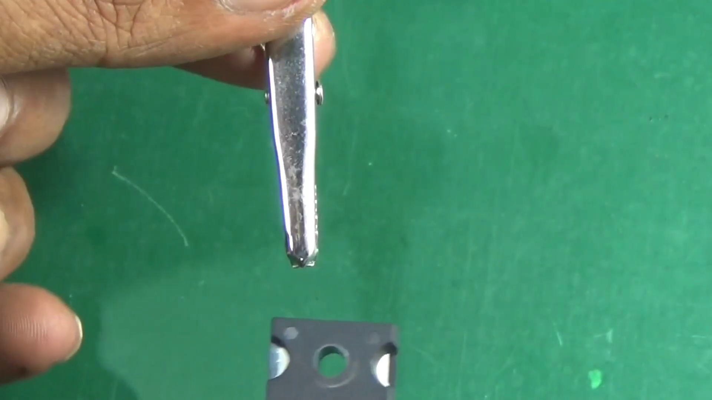 | 0:17  

Transcript
[0:13] the

Section 0: Image Analysis Continued
Time: 0:18 - 0:21

Summary
The section continues with an image analysis, displaying various devices and their connections. The images are taken from different perspectives, providing a comprehensive understanding of the electronic components and DIY projects.

Representative Frames
0:18   | 0:19   | 0:19   | 0:20  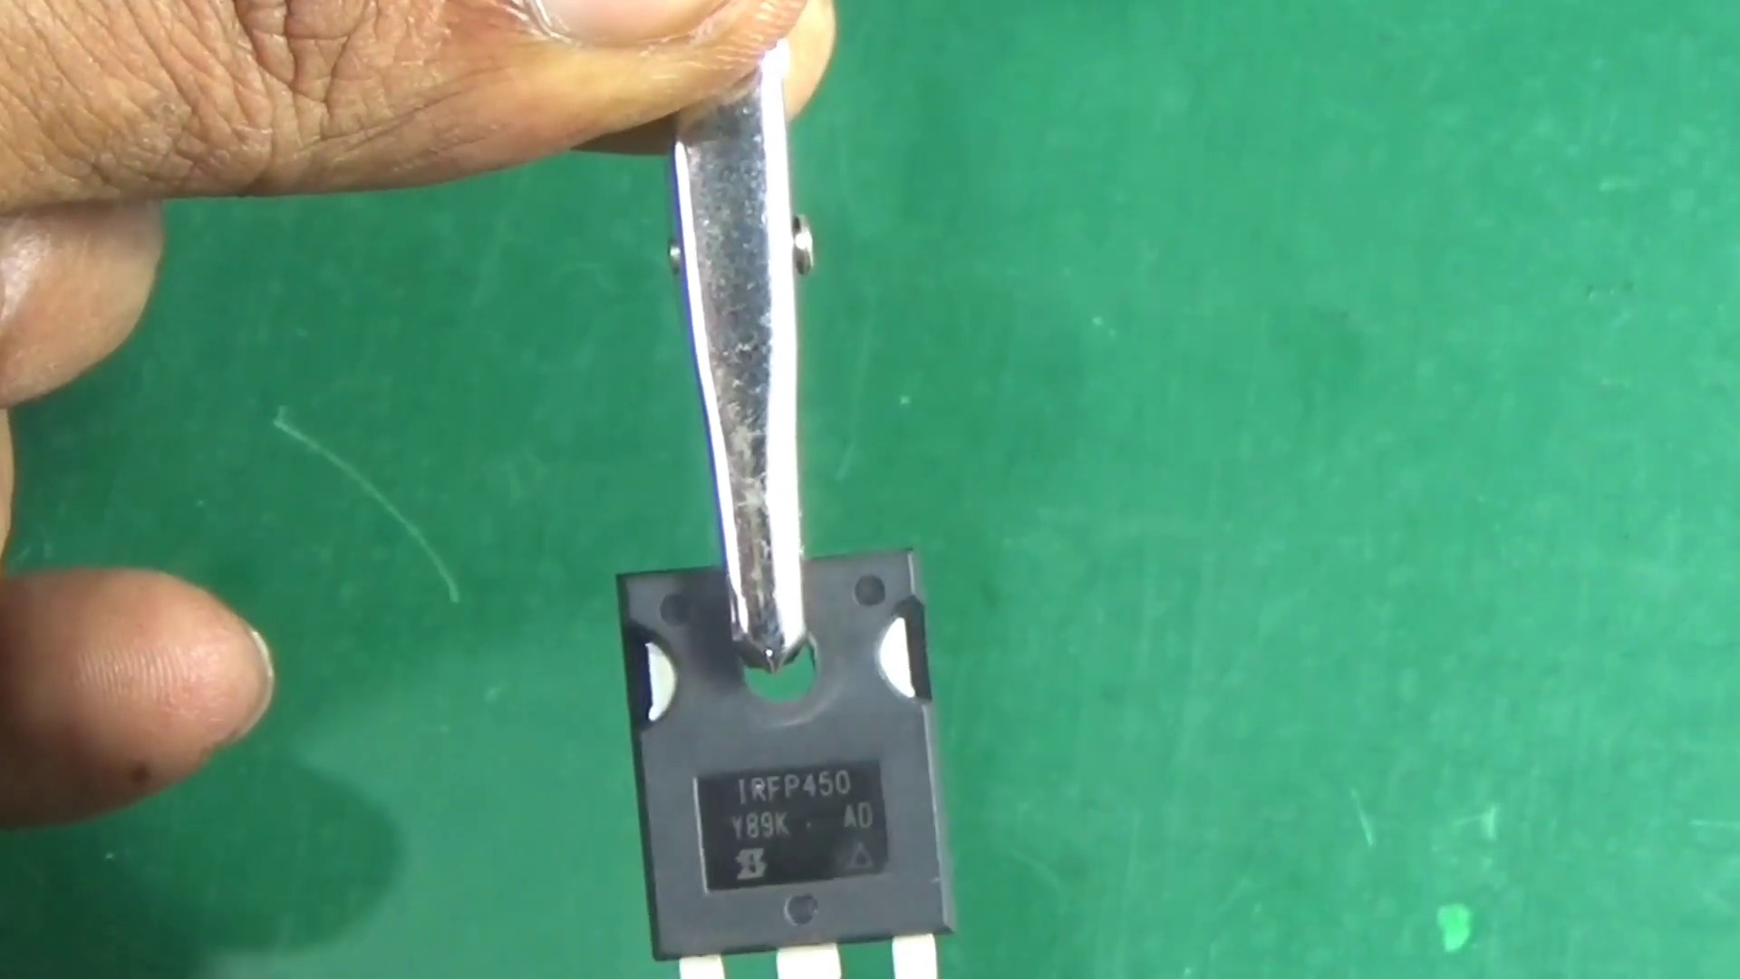 | 0:20  

Transcript
(No speech detected in this section)

Section 0: Speaker Setup and Electronic Components
Time: 0:21 - 0:24

Summary
The section showcases an image of a speaker setup with multiple connections between components. The circuit board appears to be a breadboard with various electronic components connected to it, including speakers, subwoofers, and measuring tools.

Representative Frames
0:21   | 0:22   | 0:22   | 0:23   | 0:23  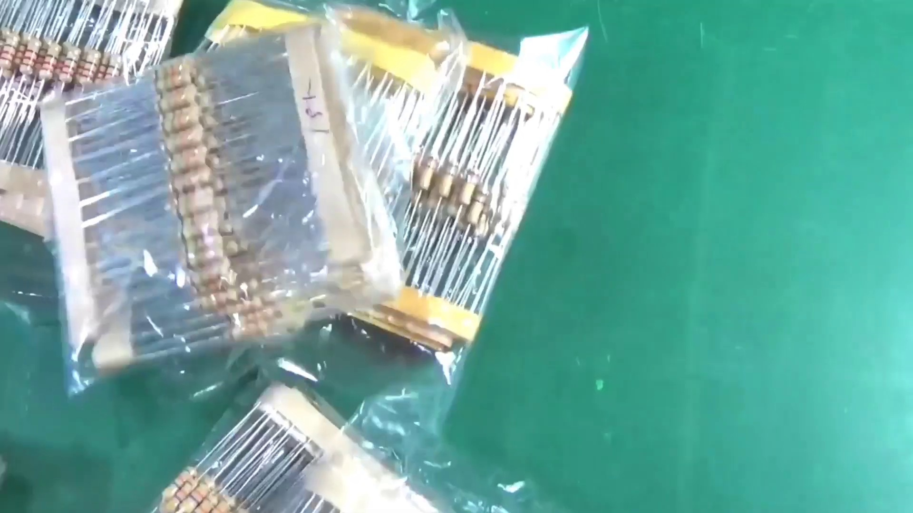

Transcript
[0:18] part

Section 0: Phone Connection and Speaker Setup
Time: 0:24 - 0:27

Summary
The image displays a phone connected to the speaker setup, with multiple connections between the components. The circuit board appears to be a breadboard with various electronic components connected to it.

Representative Frames
0:24   | 0:25   | 0:25   | 0:26   | 0:26  

Transcript
(No speech detected in this section)

Section 0: Text Overlay and Message Continued
Time: 0:27 - 0:30

Summary
In the background, there is a text overlay that reads 'DIY speaker with electronic components.' The phone's screen displays a message that reads 'Thanks for watching,' likely a welcome message or appreciation from the speaker manufacturer or workshop owner.

Representative Frames
0:27  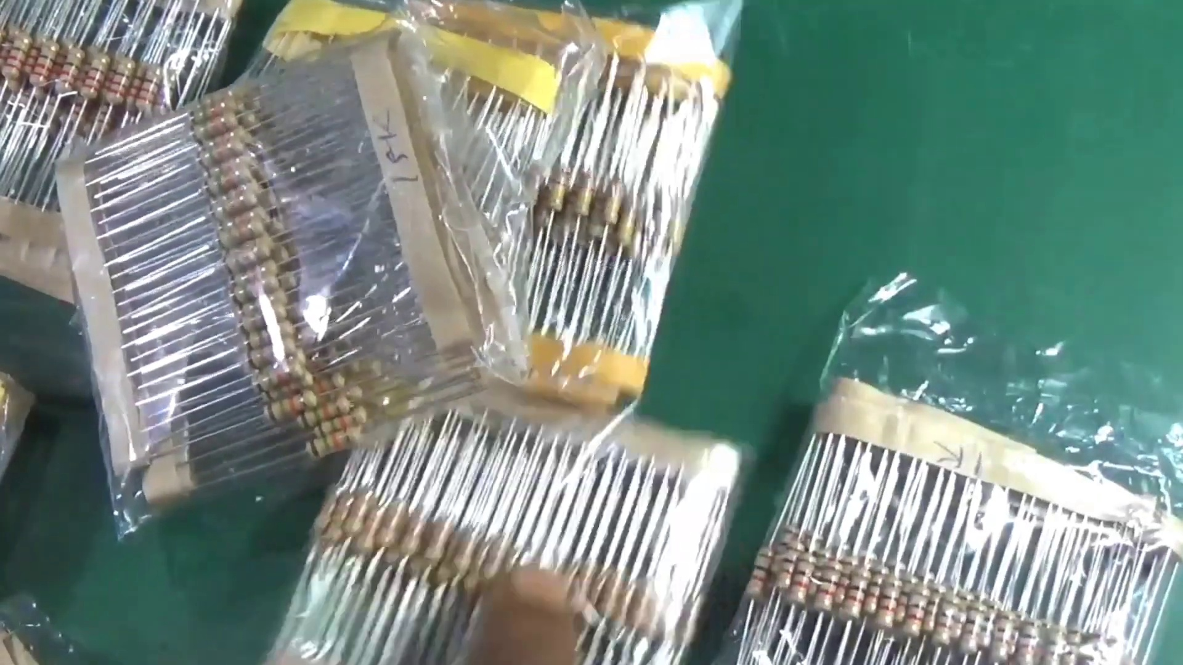 | 0:28   | 0:28   | 0:29   | 0:29  

Transcript
(No speech detected in this section)

Section 0: Subscription Button and Context Continued
Time: 0:30 - 3:56

Summary
The image includes a subscription button, possibly for a YouTube channel or website related to the speaker or workshop. The presence of the USB cable and subscription button suggests that this might be a project related to electronics or DIY projects.

Representative Frames
1:04  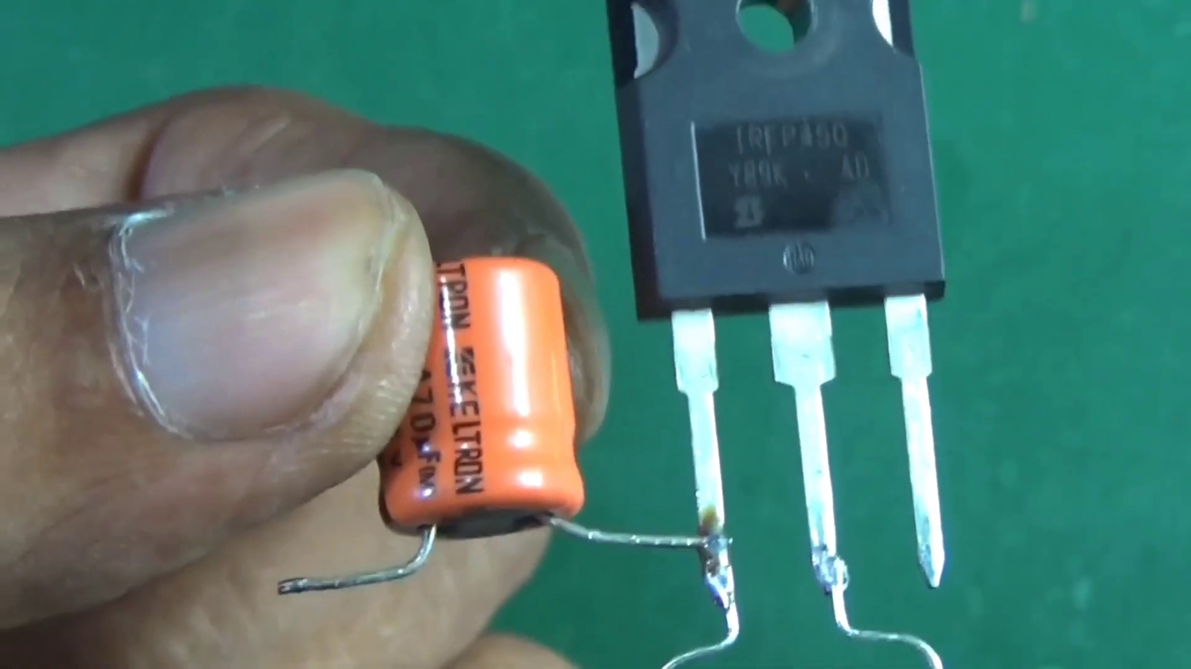 | 1:38  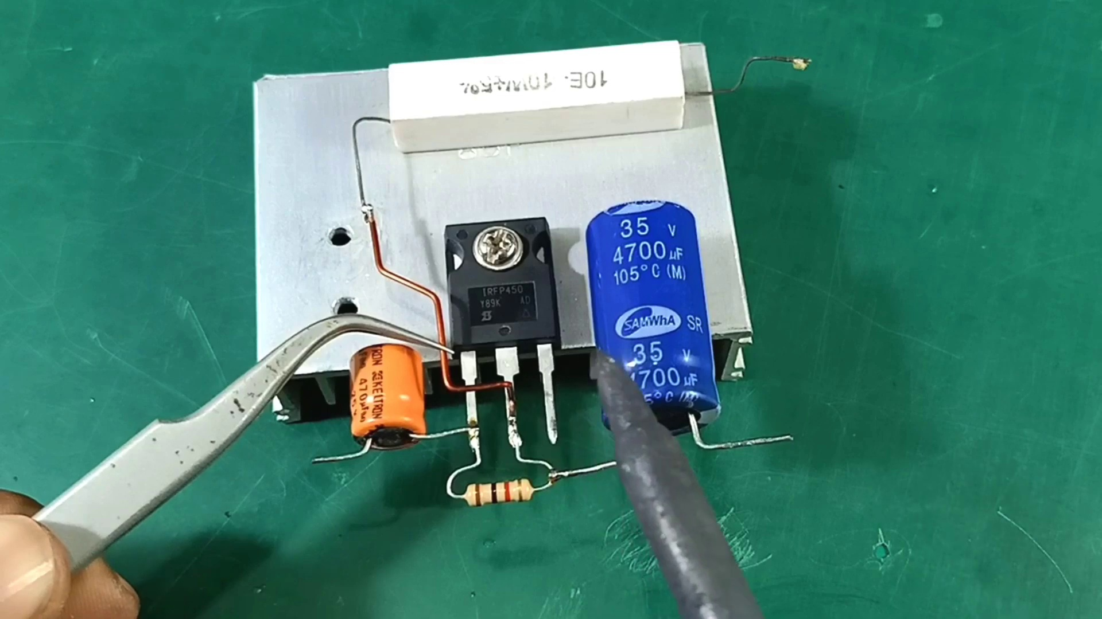 | 2:13  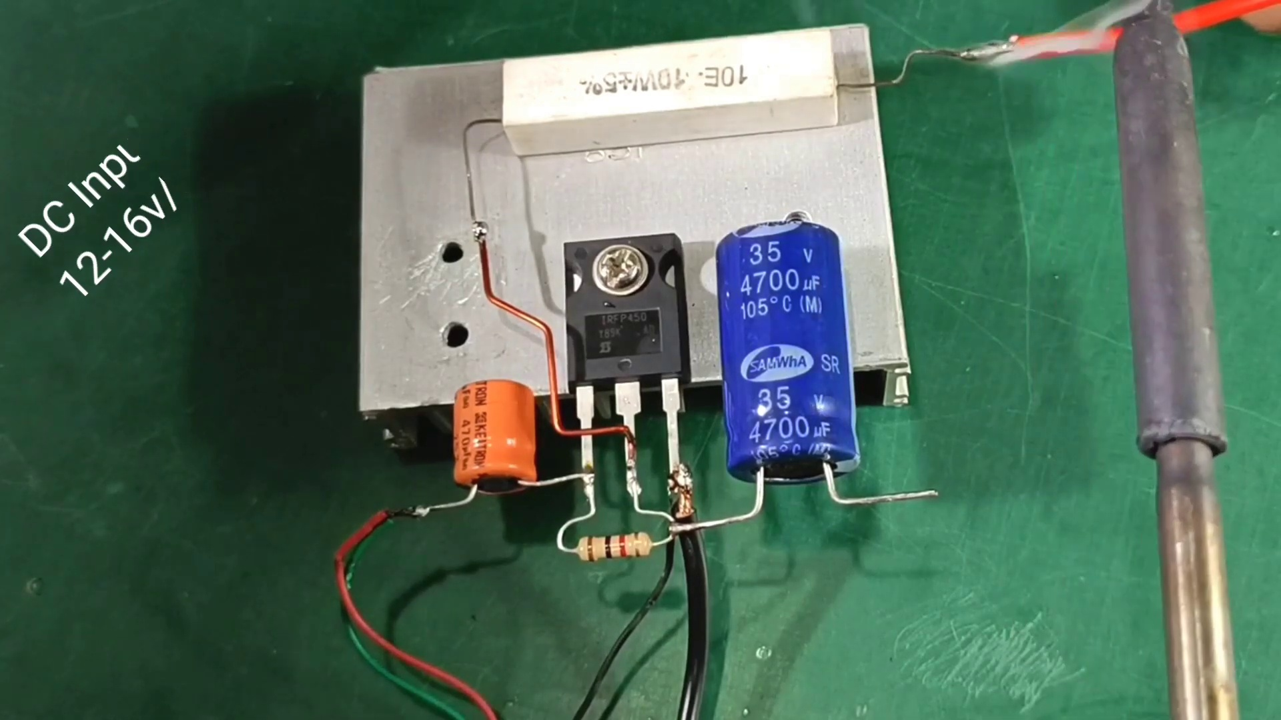 | 2:47  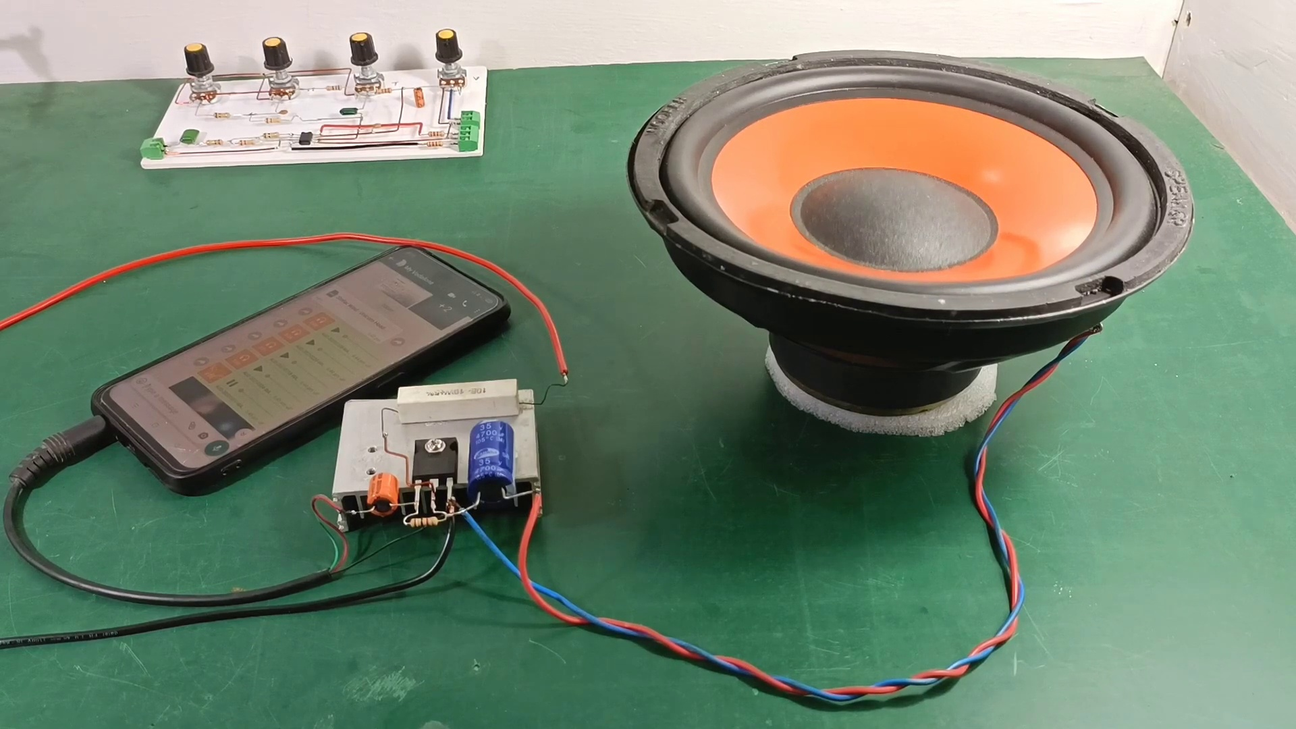 | 3:21  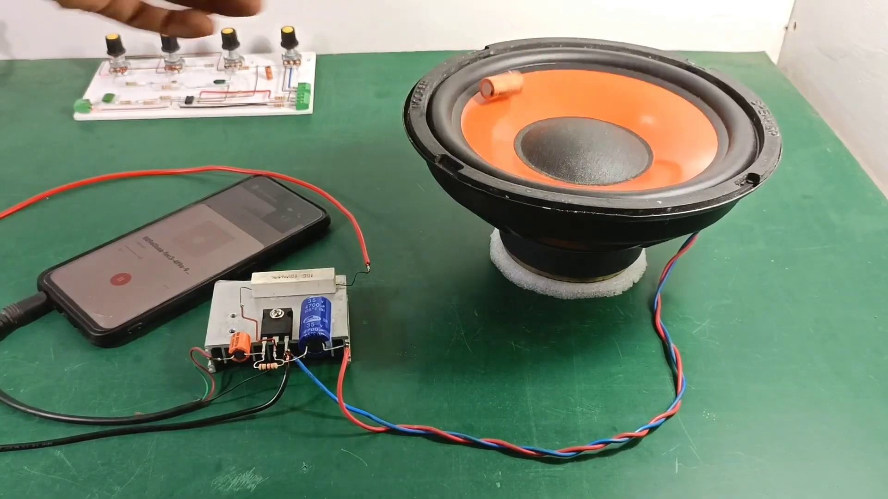

Transcript
[0:24] Thank you.
[0:54] Thank you.
[1:24] Thank you.
[1:54] Thank you.
[2:24] Thank you.
[2:54] Thank you.
[3:24] Thank you.
[3:54] Thank you.

