Engagement Analysis: yPwYNUDkkZs

Section 0: Man sitting at a desk, surrounded by various objects
Time: 19:00 - 19:01

Summary
The man is seated in front of a cluttered desk with multiple electronic devices, technical items, and scattered objects. He appears to be engaged in a conversation or presentation, gesturing with his hands and looking towards the camera.

Representative Frames
19:00  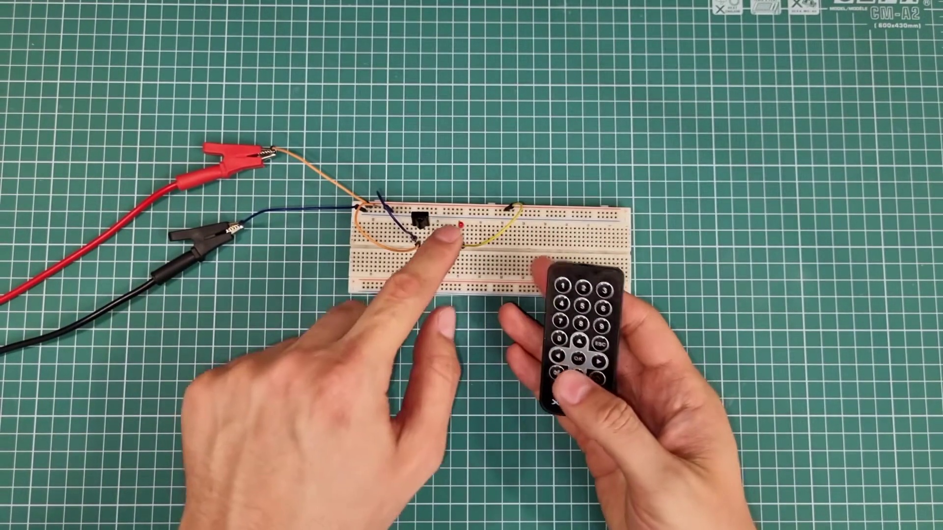 | 19:00   | 19:00   | 19:00   | 19:00  

Transcript
(No speech detected in this section)

Section 0: Man speaking into a microphone
Time: 19:01 - 19:02

Summary
The man is dressed in a bright green shirt and has a microphone clipped to his shirt. He appears to be teaching or presenting, with a smile on his face and a gesture towards the camera.

Representative Frames
19:01   | 19:01   | 19:01   | 19:01   | 19:01  

Transcript
(No speech detected in this section)

Section 0: Close-up of the man's hands gesturing
Time: 19:02 - 19:03

Summary
The man's hands are clasped together, gesturing as if he's speaking or explaining something. His facial expression suggests surprise or shock.

Representative Frames
19:02   | 19:02   | 19:02   | 19:02   | 19:02  

Transcript
(No speech detected in this section)

Section 0: Desk cluttered with various objects
Time: 19:03 - 19:04

Summary
The desk is filled with various items such as an electronic device connected to a black power strip, multiple plugs, and a white paper clip. A blue and white water bottle is also present.

Representative Frames
19:03  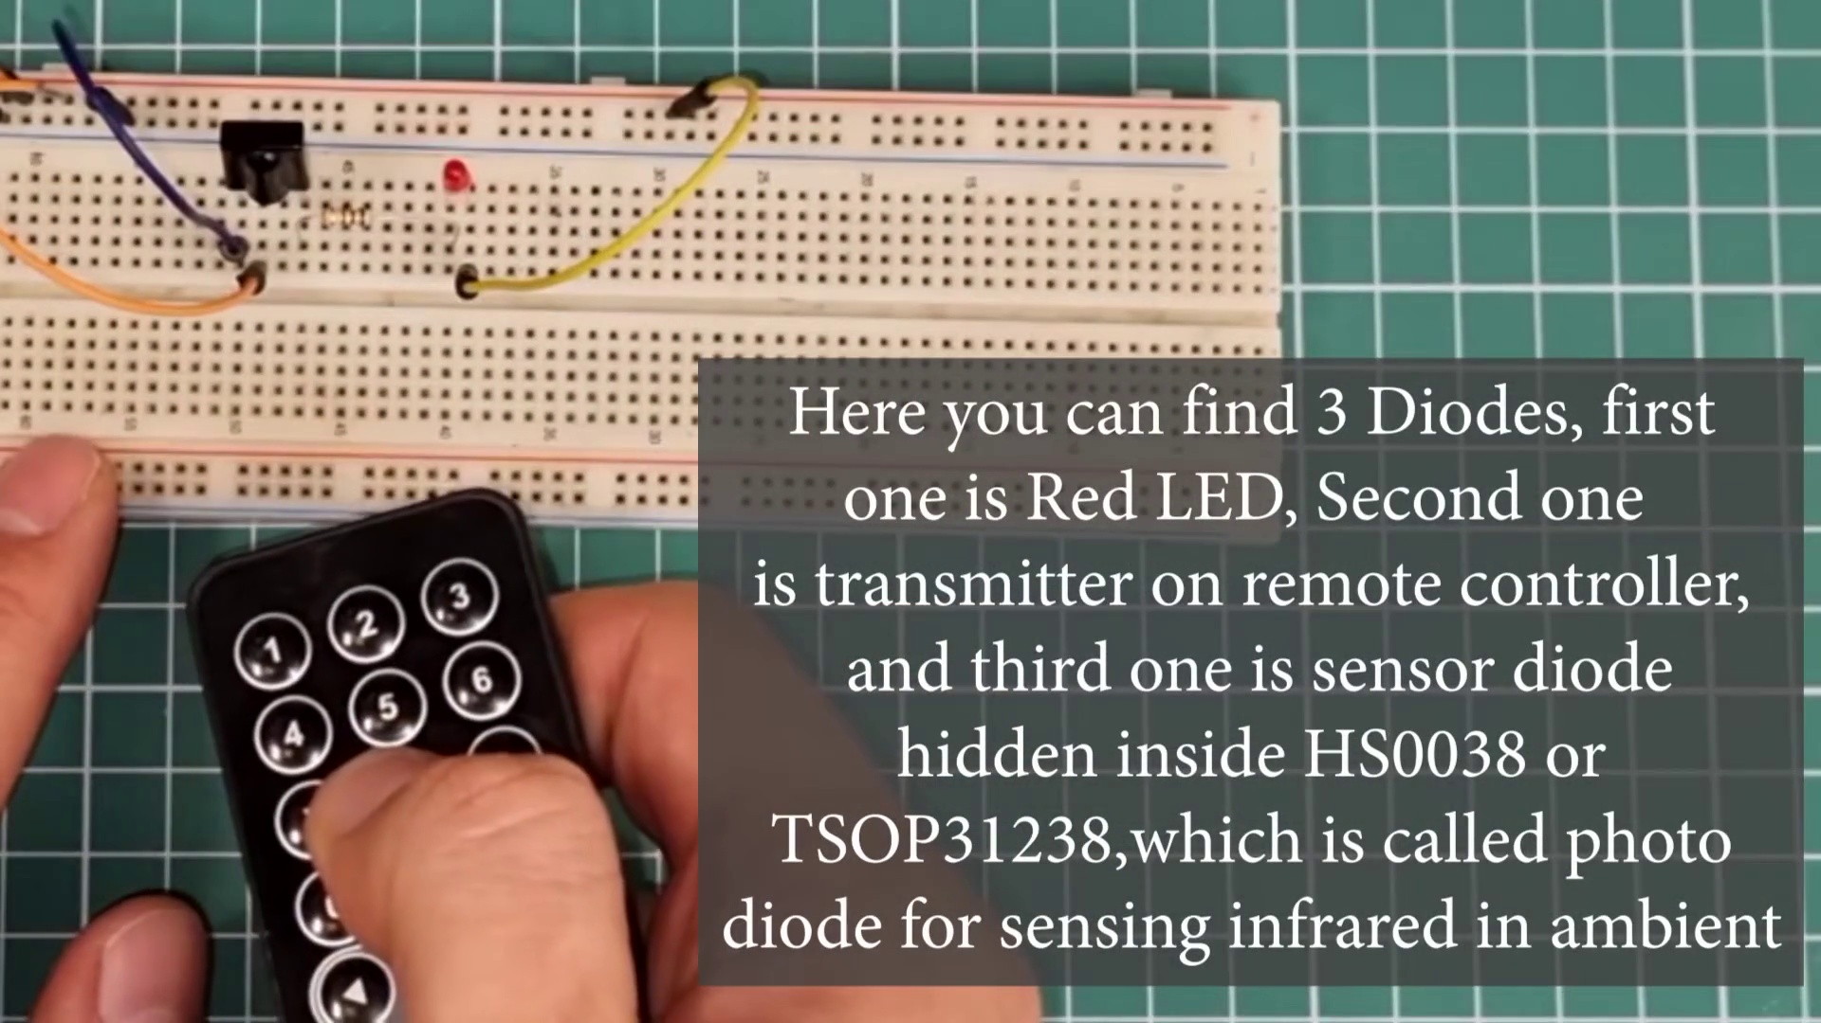 | 19:03   | 19:03   | 19:03   | 19:03  

Transcript
(No speech detected in this section)

Section 0: Man smiling and gesturing towards the camera
Time: 19:04 - 19:05

Summary
The man appears to be engaged in a conversation or presentation, with a smile on his face and a gesture towards the camera. His green shirt stands out against the cluttered background.

Representative Frames
19:04   | 19:04   | 19:04   | 19:04   | 19:04  

Transcript
(No speech detected in this section)

Section 0: Man pointing at something out of frame
Time: 19:05 - 19:06

Summary
The man's right hand gestures, pointing at something to his left, implying an instructional activity or discussion taking place. The desk and cabinet in the background add to the narrative of productivity and creativity.

Representative Frames
19:05   | 19:05   | 19:05   | 19:05   | 19:05  

Transcript
(No speech detected in this section)

Section 0: Man speaking into a microphone with a cluttered background
Time: 19:06 - 19:07

Summary
The man is dressed in a bright green shirt and has a microphone clipped to his shirt. The desk behind him is cluttered with various objects, including a computer keyboard, a screwdriver, a cup, and a bottle of water.

Representative Frames
19:06   | 19:06  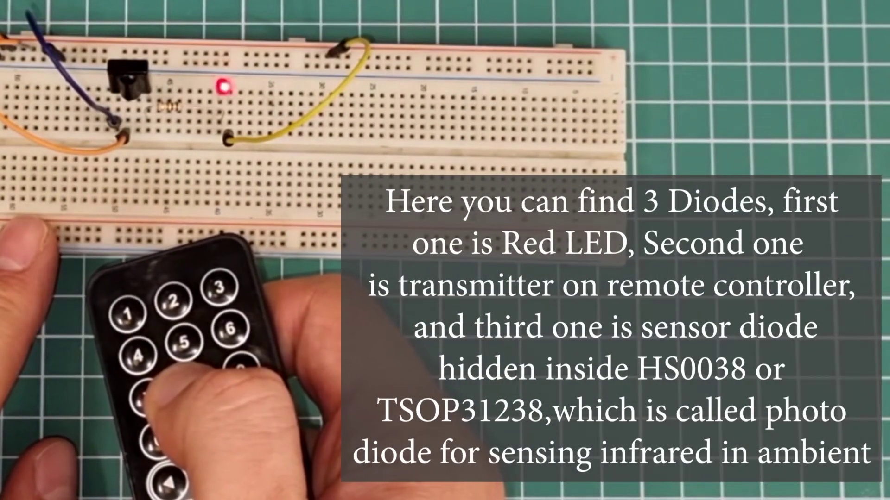 | 19:06   | 19:06   | 19:06  

Transcript
(No speech detected in this section)

Section 0: Man pointing at the computer keyboard
Time: 19:07 - 19:54

Summary
The man appears to be explaining or demonstrating something related to the keyboard. His hand gesture and facial expression suggest engagement in a conversation or presentation.

Representative Frames
19:14  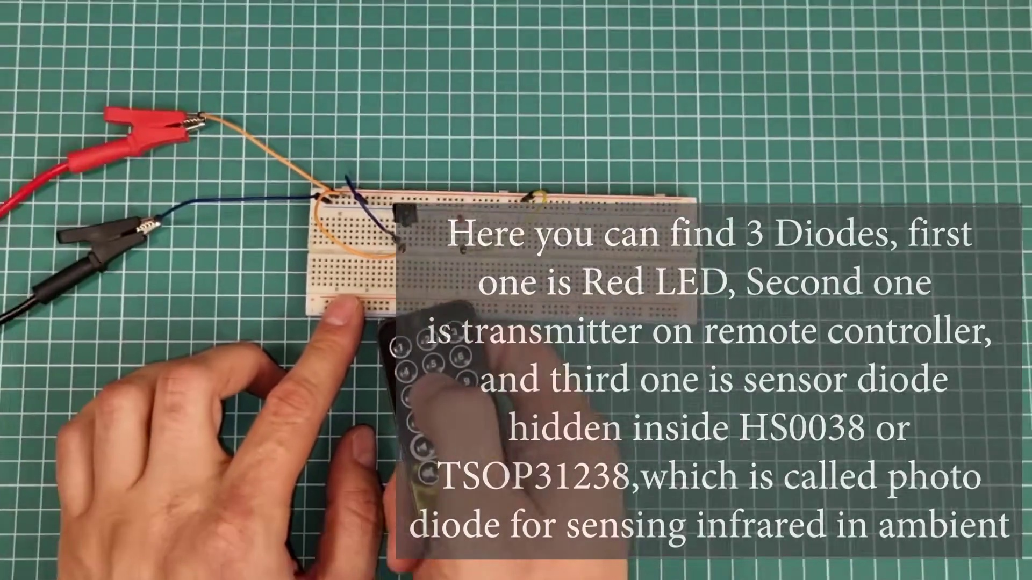 | 19:22  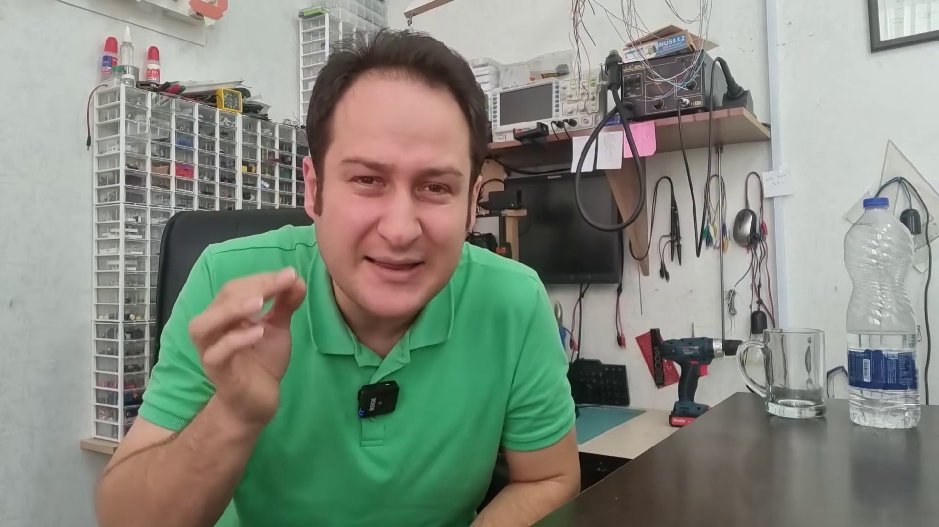 | 19:30  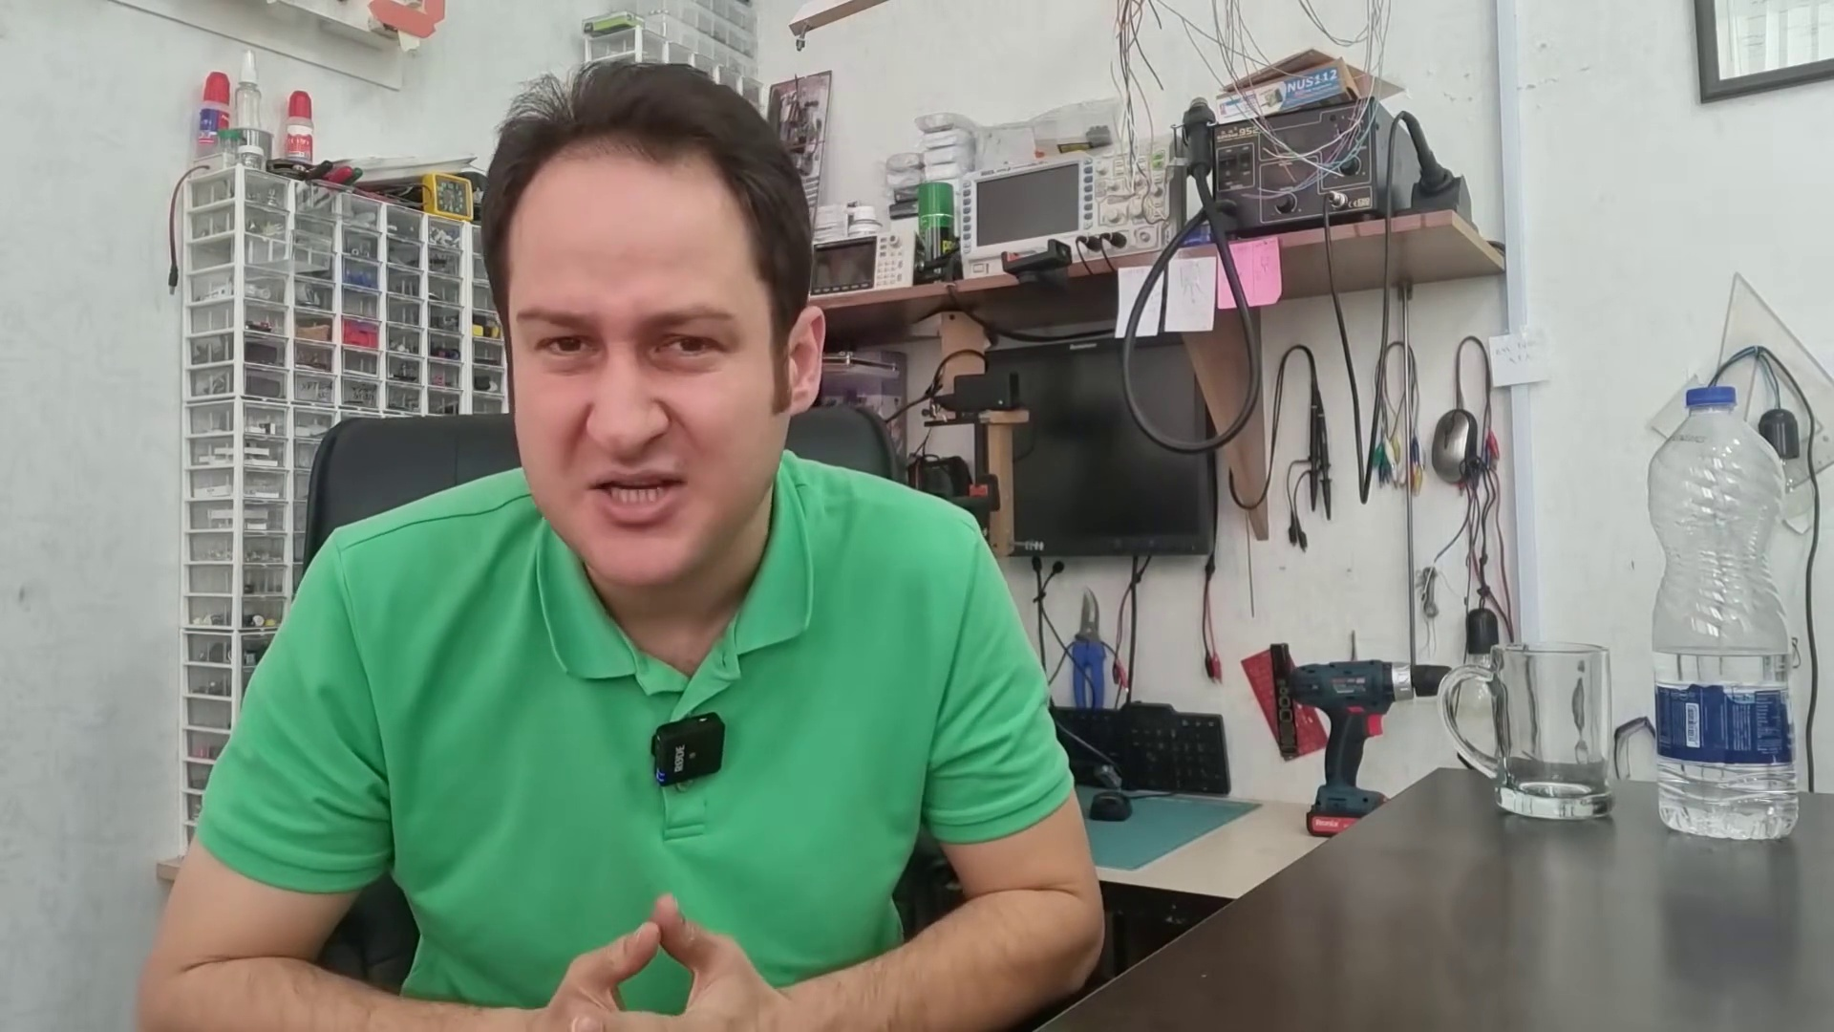 | 19:38  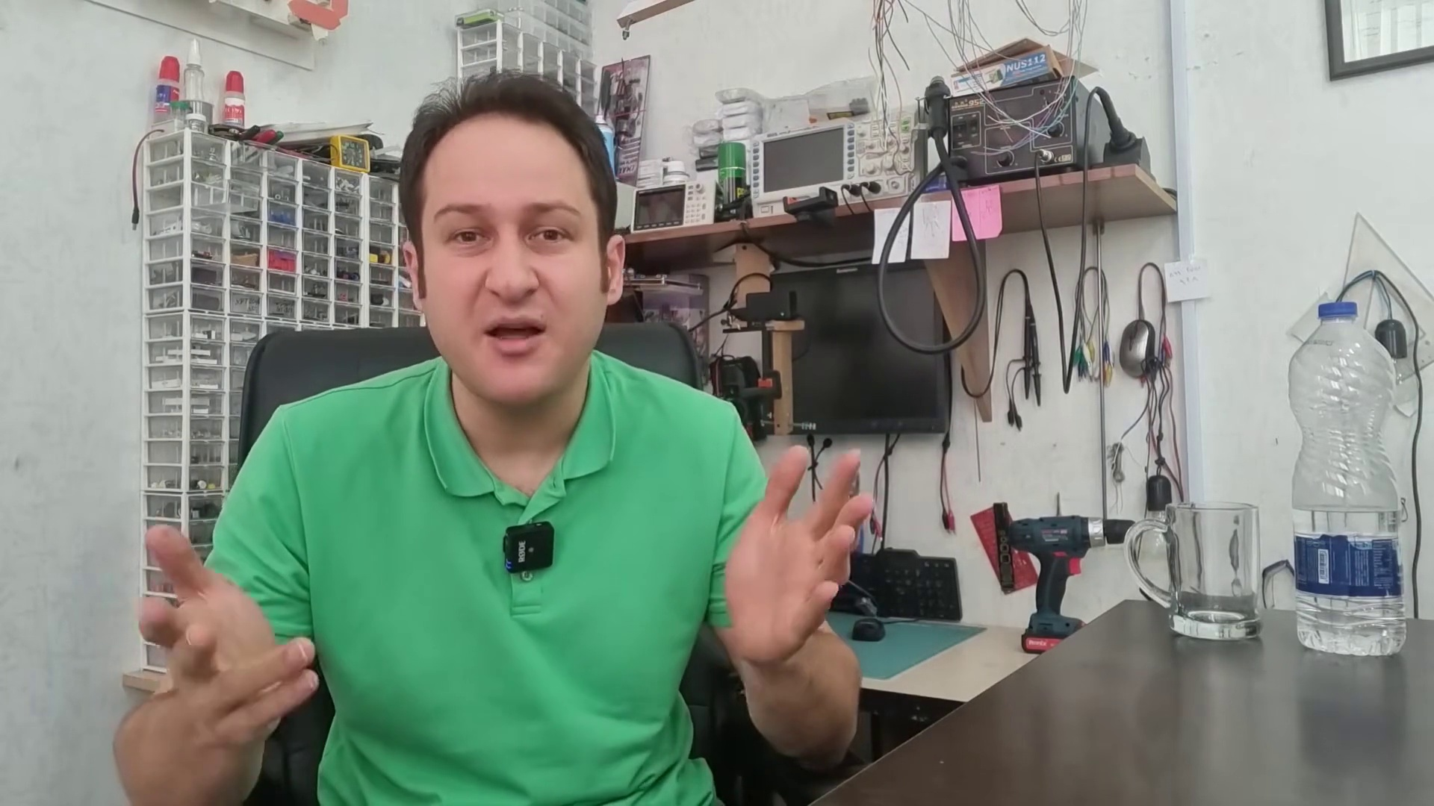 | 19:46  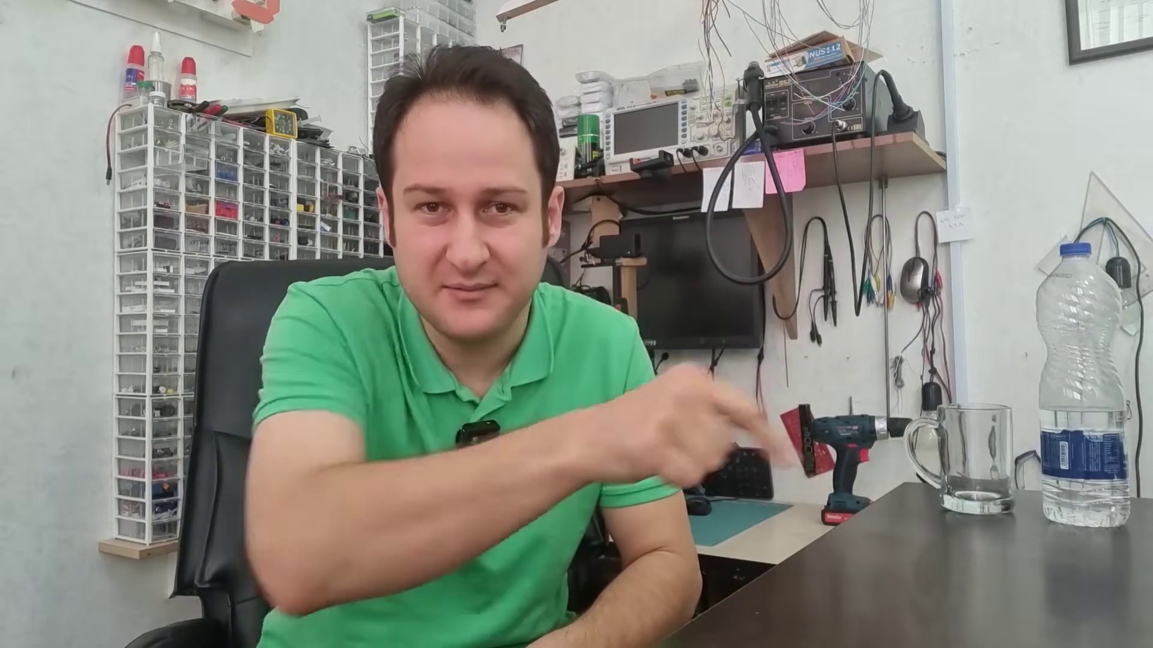

Transcript
[19:09] In one of my next videos, I will fully explain IR remote controllers and receivers, and will make
[19:19] a simple project with them to demonstrate how exactly they work. So, that's it. We considered
[19:27] three main types of diodes with eight applications of them. Even though there are other types of diodes
[19:33] with other applications, I think it's enough for now. I hope you enjoy it. Thanks for watching. If you
[19:40] like this video, make sure to subscribe for more. Here. Hit this button.

