Engagement Analysis: z58RORCUTao

Section 0: Introduction to Video Segments
Time: 0:00 - 0:10

Summary
The video consists of multiple segments, each described and timestamped.

Representative Frames
0:01   | 0:03   | 0:05   | 0:06   | 0:08  

Transcript
[0:00] A few weeks ago, Mark Roper released a video showing these really cool zipline drones that
[0:04] deliver medical supplies in Rwanda. As cool as this is, he kind of glossed over one of the most

Section 0: First Segment - Introduction
Time: 0:10 - 1:30

Summary
The host introduces the topic of discussion, which involves artificial intelligence-generated images.

Representative Frames
0:23   | 0:36   | 0:50   | 1:03  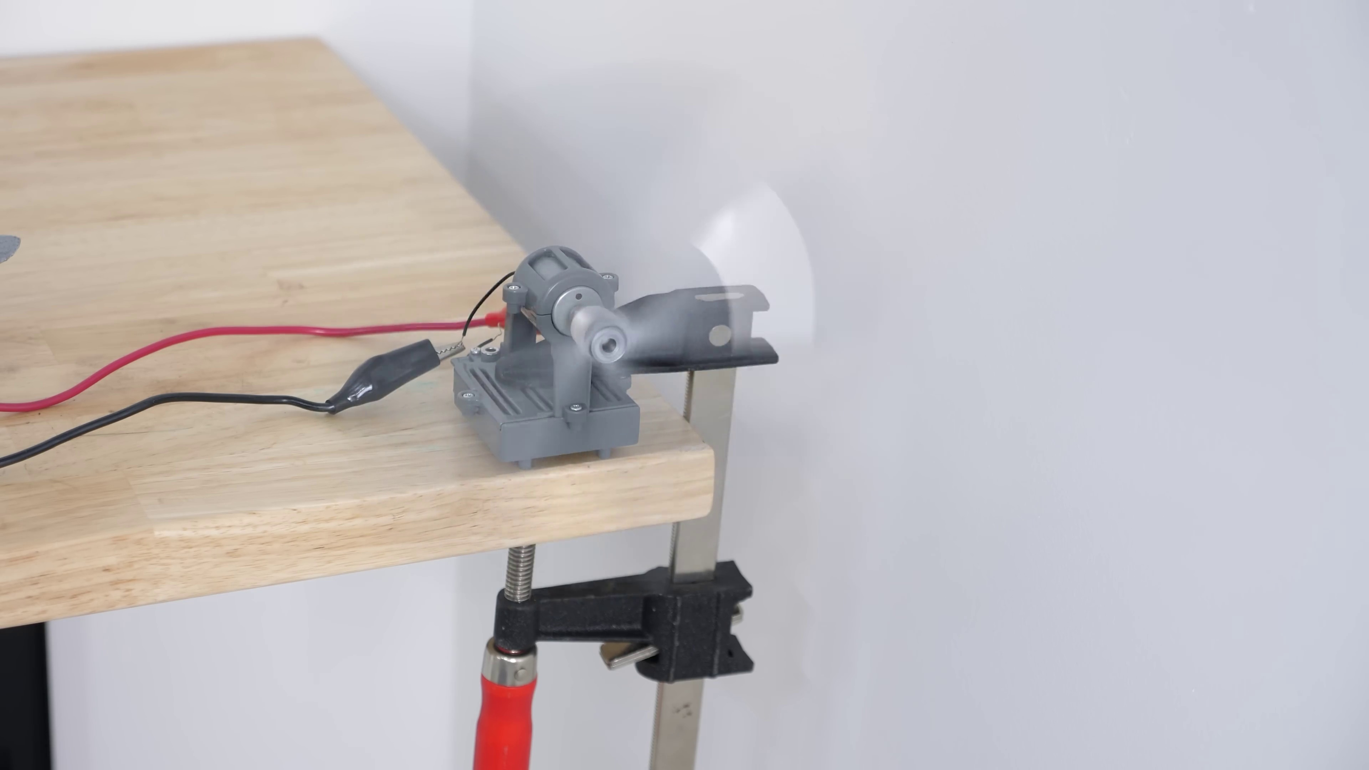 | 1:16  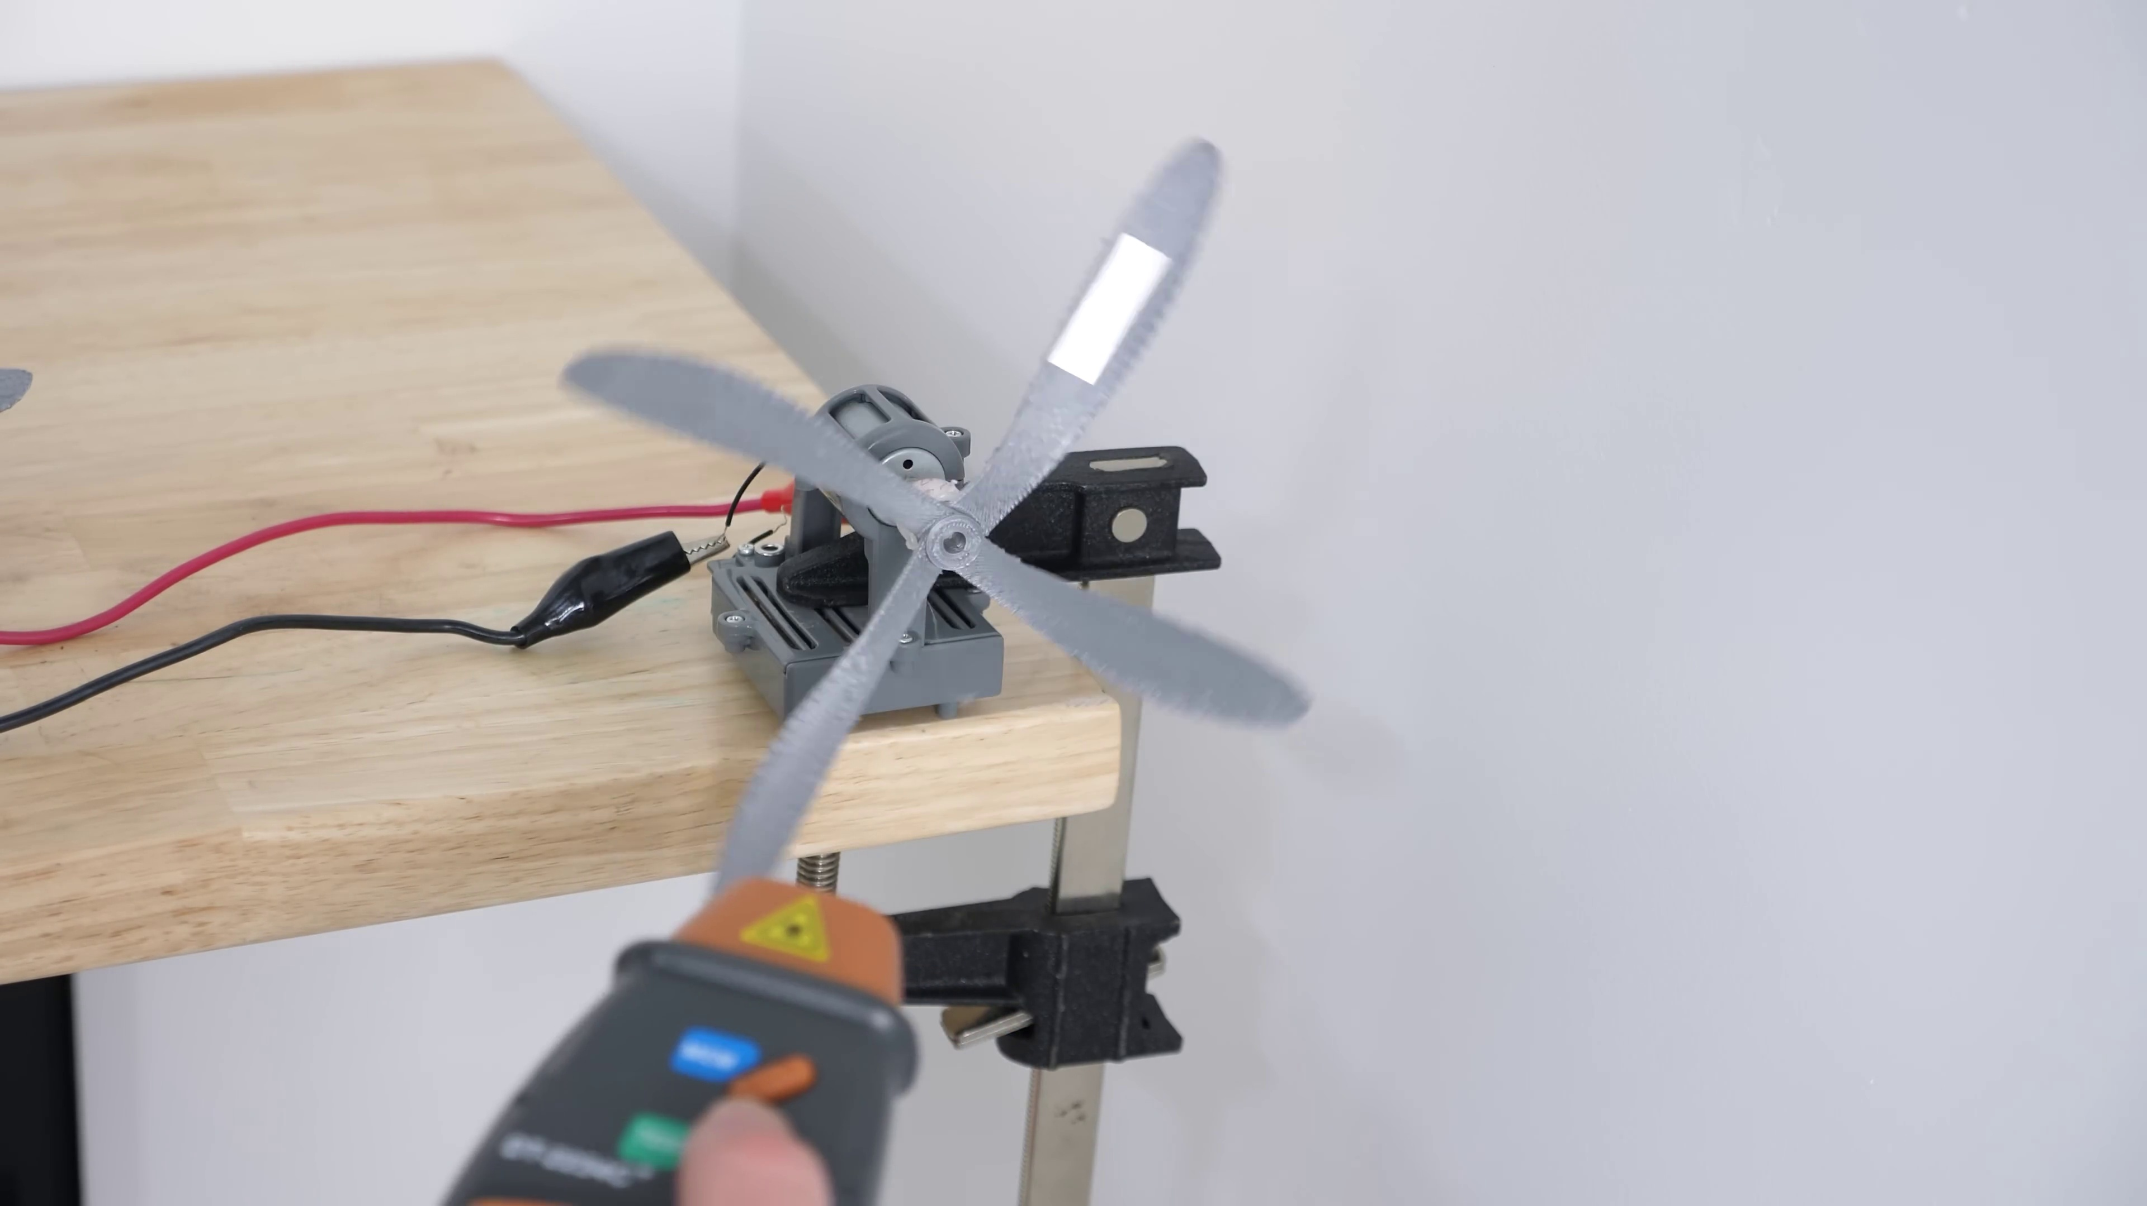

Transcript
[0:10] interesting features of these drones. Look at these propellers. He mentions that they're shaped like
[0:15] that to reduce the noise, but why does this happen? And what is it about the shape that reduces the
[0:21] noise? The internet right now is just buzzing, waiting for someone to make a 3D printable version
[0:26] of these to see how much quieter they actually are. And that's exactly what I have here. But before
[0:31] we listen to these, let me explain why these propellers are shaped this way in the first place.
[0:36] What actually makes sound when a propeller spins really fast? Well, as the blades move past by a
[0:42] stationary point, it creates a pressure disturbance that propagates away from the blade. The frequency
[0:47] that this happens is called the blade passage frequency, and it's equal to the rotational
[0:52] frequency, so how fast the propeller's spinning, times the number of blades on the propeller. So
[0:57] let's say that we have a propeller that has four blades. The traditional way to make these is to
[1:01] space them evenly so that they're 90 degrees apart. When you have a propeller shaped like this, it creates
[1:06] a lot of different frequencies, but it creates a loud frequency at the blade passage frequency, but also
[1:13] it creates frequencies at the harmonics of the blade passage frequency. So if you take an audio recording
[1:18] of this, you'll see peaks at the whole number multiples of the blade passage frequency. But
[1:23] something really interesting happens if you don't space out the blades evenly. So let's say instead

Section 0: Second Segment - AI Video Model
Time: 1:30 - 2:45

Summary
A detailed explanation is provided on how AI video models can create realistic images of people.

Representative Frames
1:42   | 1:55   | 2:07  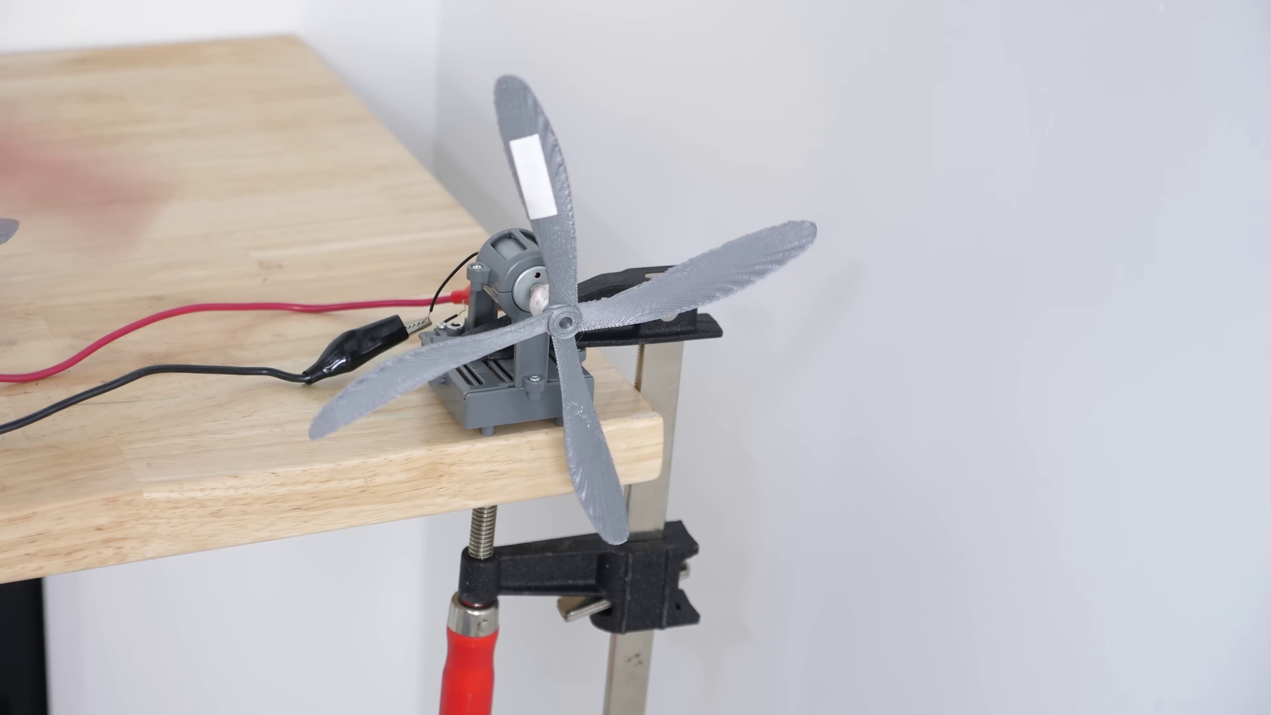 | 2:20  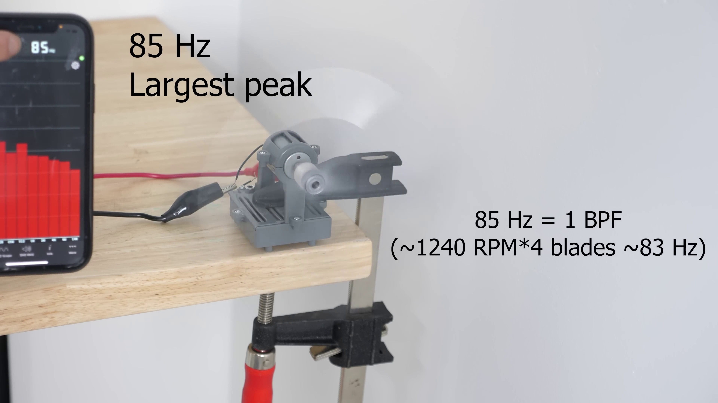 | 2:32  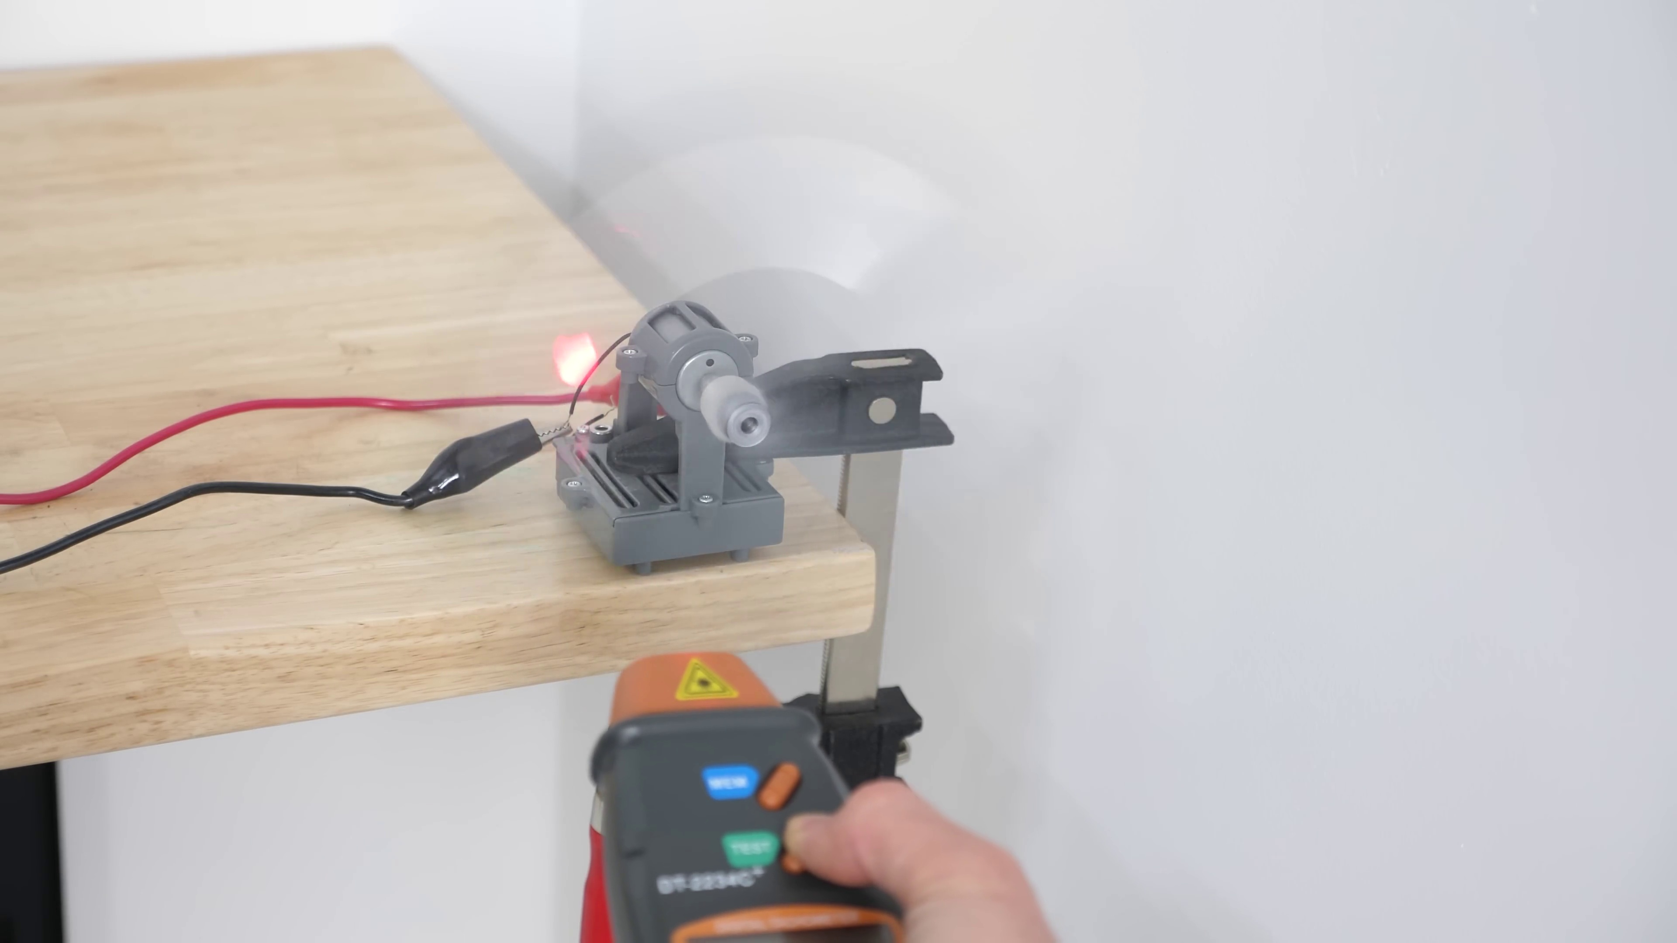

Transcript
[1:28] of having the blades spaced 90 degrees apart, we space them 30 degrees apart only. So there's now a large
[1:33] gap and then a small gap between them, so they aren't evenly spaced. Well then when you record the sound,
[1:39] you get the normal harmonics like before with one, two, three times the blade passage frequency,
[1:43] but you also get 0.5 times the blade passage frequency and 1.5 and 2.5. So for the same
[1:50] acoustic energy, you're spreading out some of the sound into lower frequencies. The most important
[1:56] frequency is the one that's generated, which has half the frequency of the blade passage frequency.
[2:01] You can see this here. So first we'll start with this four blade propeller. I have these little
[2:06] reflective strips on here so I can measure the RPM. So how many times per second that it's spinning
[2:12] around in a circle? So we're at around 1200 RPM right now. So around 85 Hertz is one of the loudest
[2:20] frequencies here. But now if I switch out these propellers to around a 30 degree propeller,
[2:29] let's get it to the same RPM. So that's almost exactly the same RPM around 1200. The other one is around 1249.

Section 0: Third Segment - Man in a Gray T-Shirt
Time: 2:45 - 3:10

Summary
The host discusses the importance of a personal space, using a man dressed in a gray t-shirt with a record player design as an example.

Representative Frames
2:49  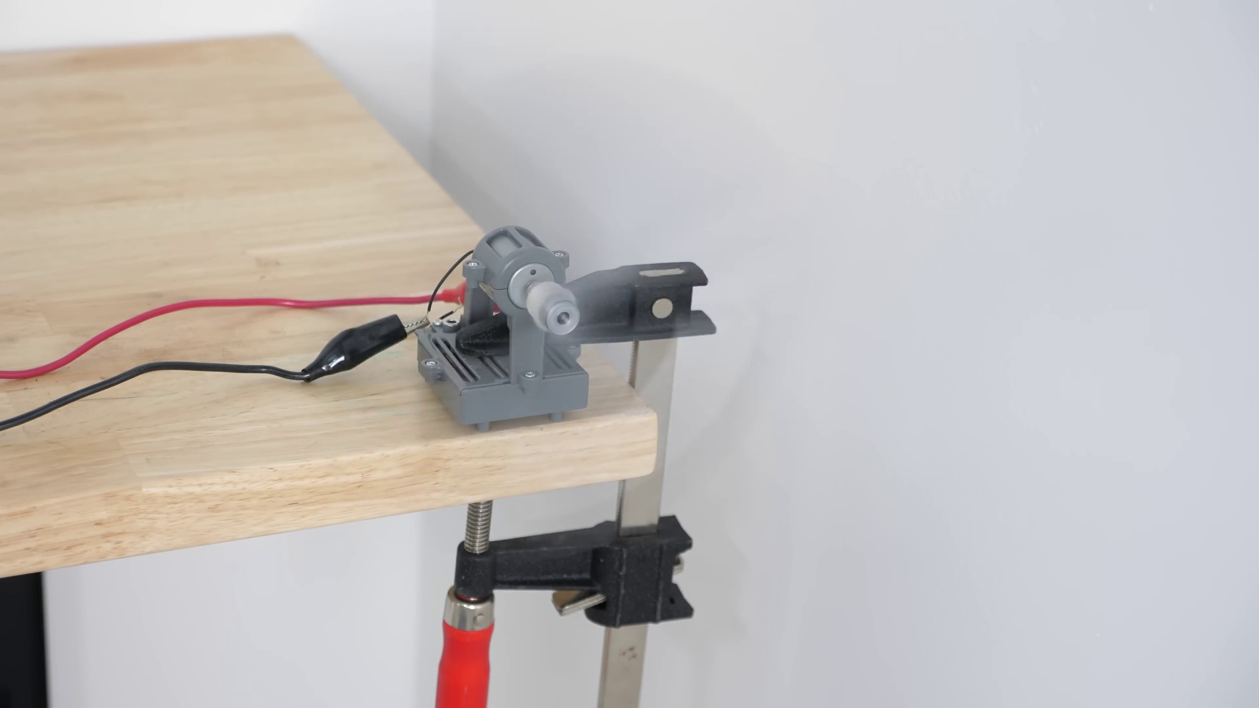 | 2:53  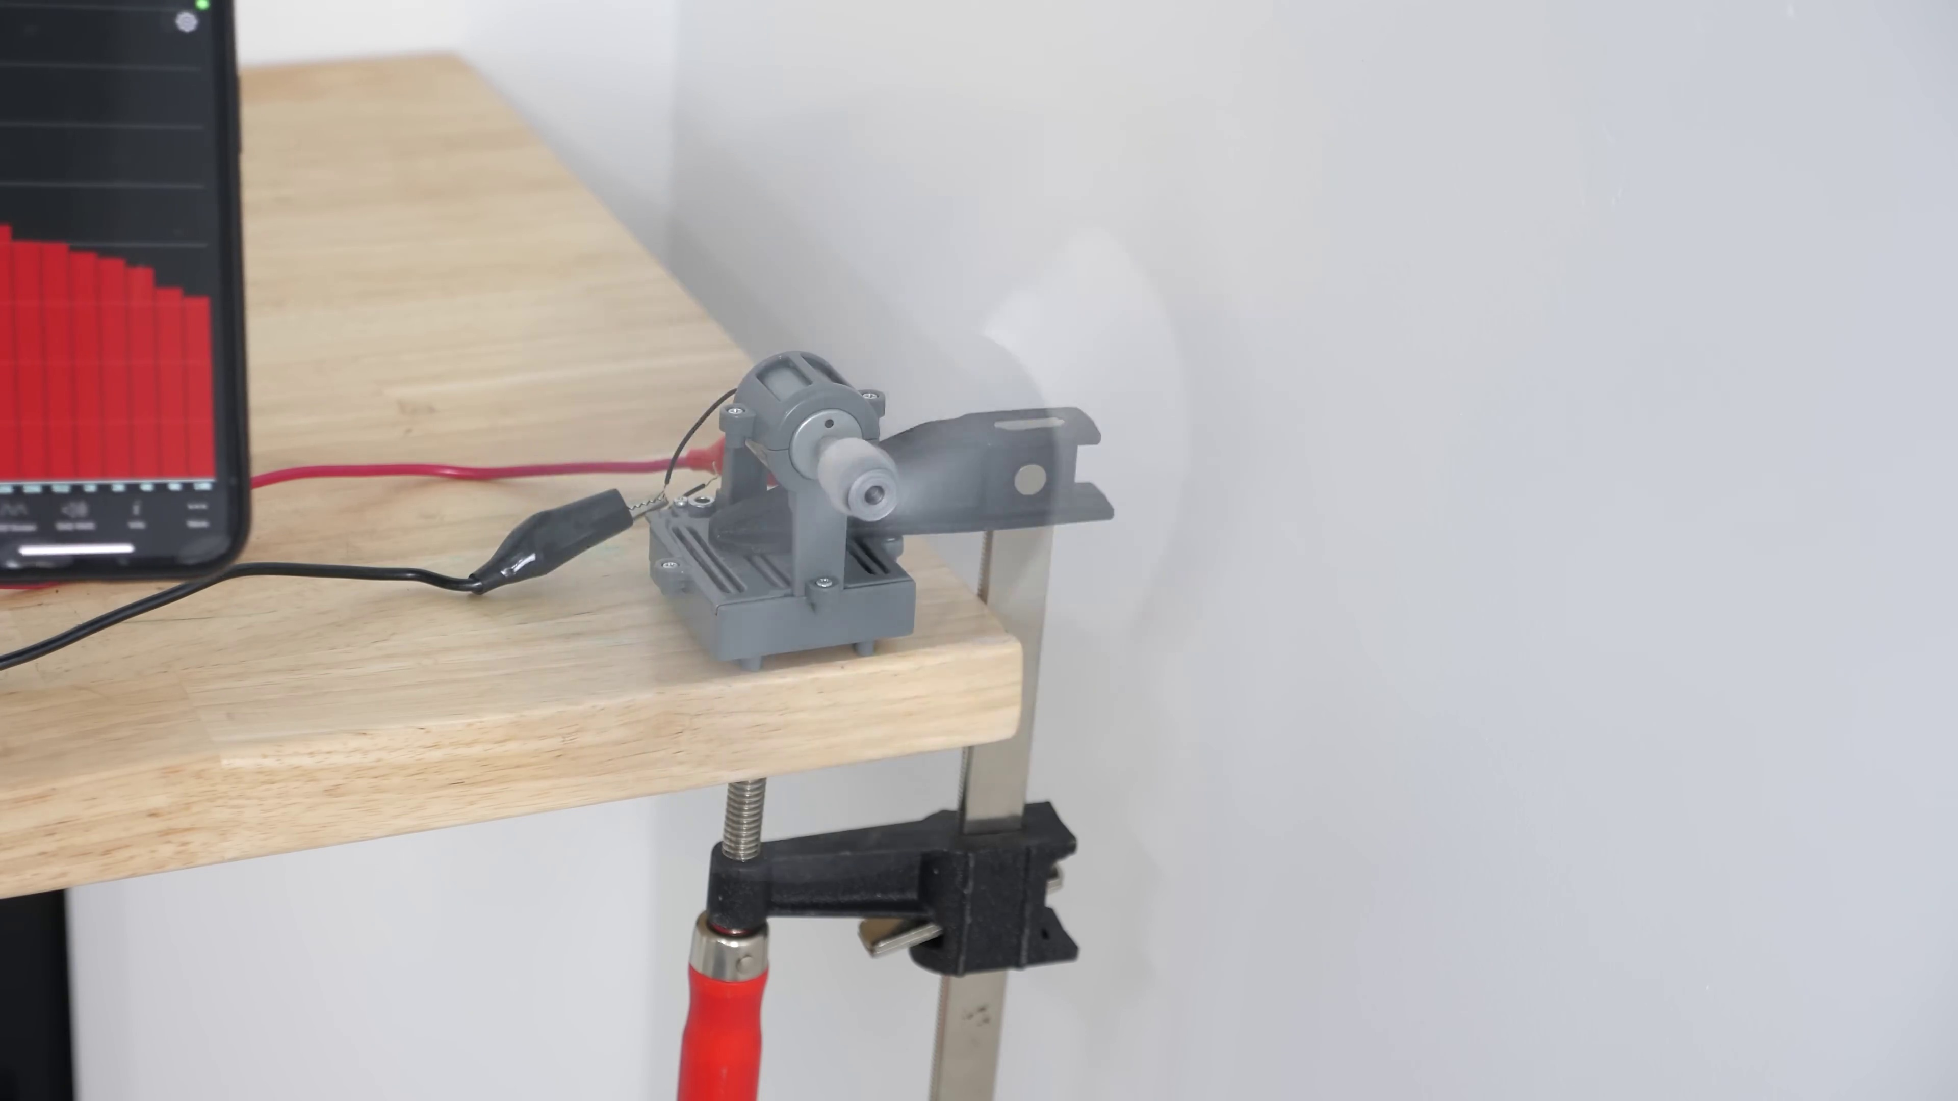 | 2:57  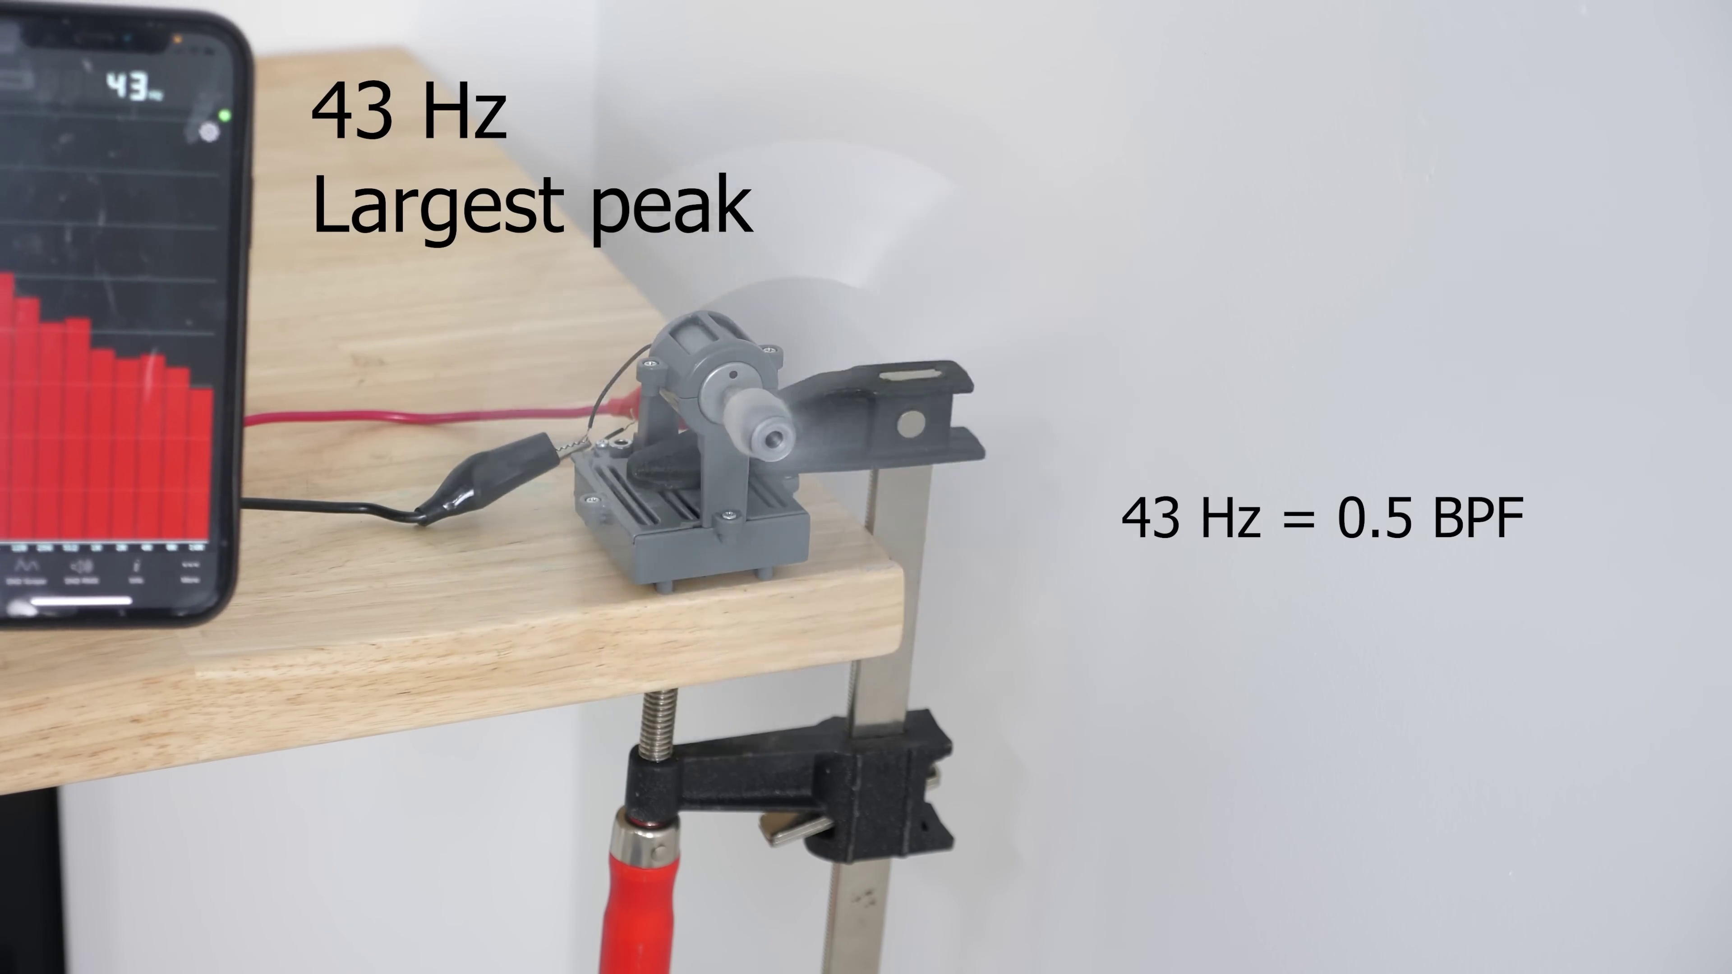 | 3:01  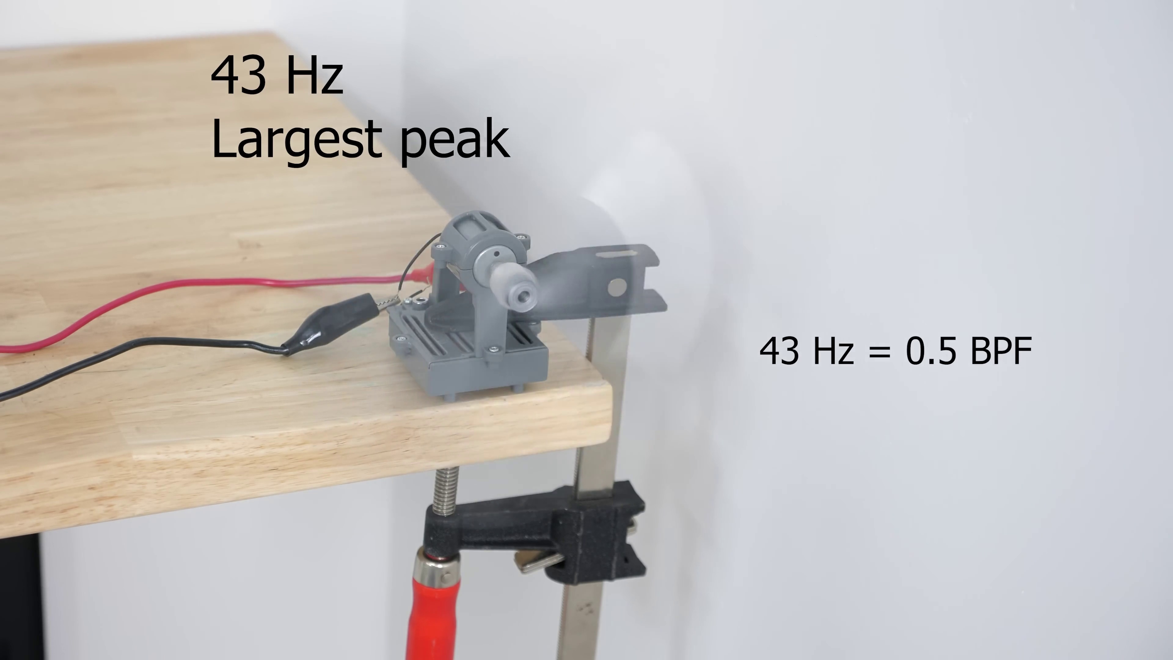 | 3:05  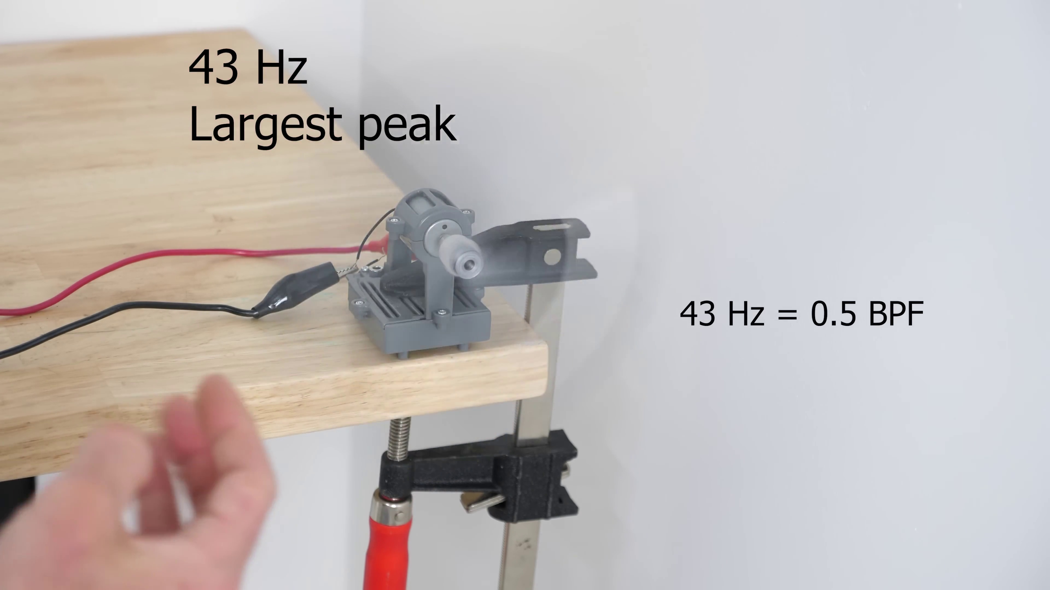

Transcript
[2:42] So they're going the same speed now, but let's measure one of the loudest frequencies. So this is crazy.
[2:52] We're going the same speed with four propellers, but the loudest frequency coming off here is half the
[2:59] frequency of the propeller that has the evenly spaced blades. So it's picking up a lower frequency.
[3:05] The higher one is still there, but the energy is shared between the two frequencies. So what does that do for us?

Section 0: Fourth Segment - Welcome to Area 51
Time: 3:10 - 10:12

Summary
The host showcases various designs and logos related to the 'Welcome to Area 51' theme, including a spaceship design on a black t-shirt.

Representative Frames
4:20  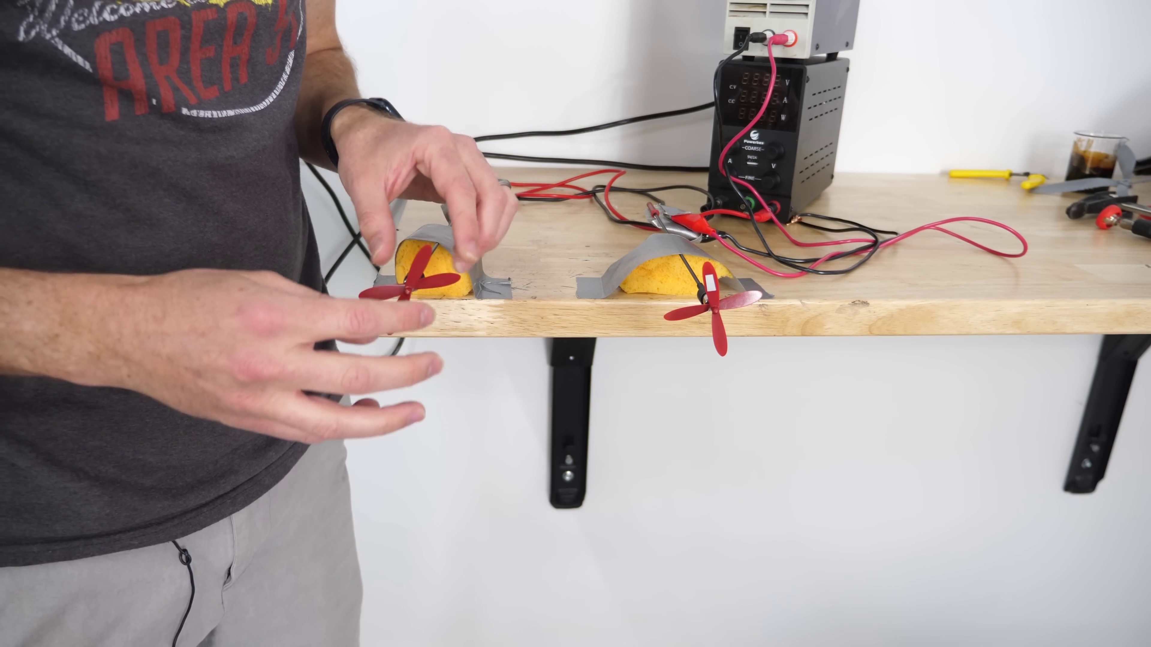 | 5:30  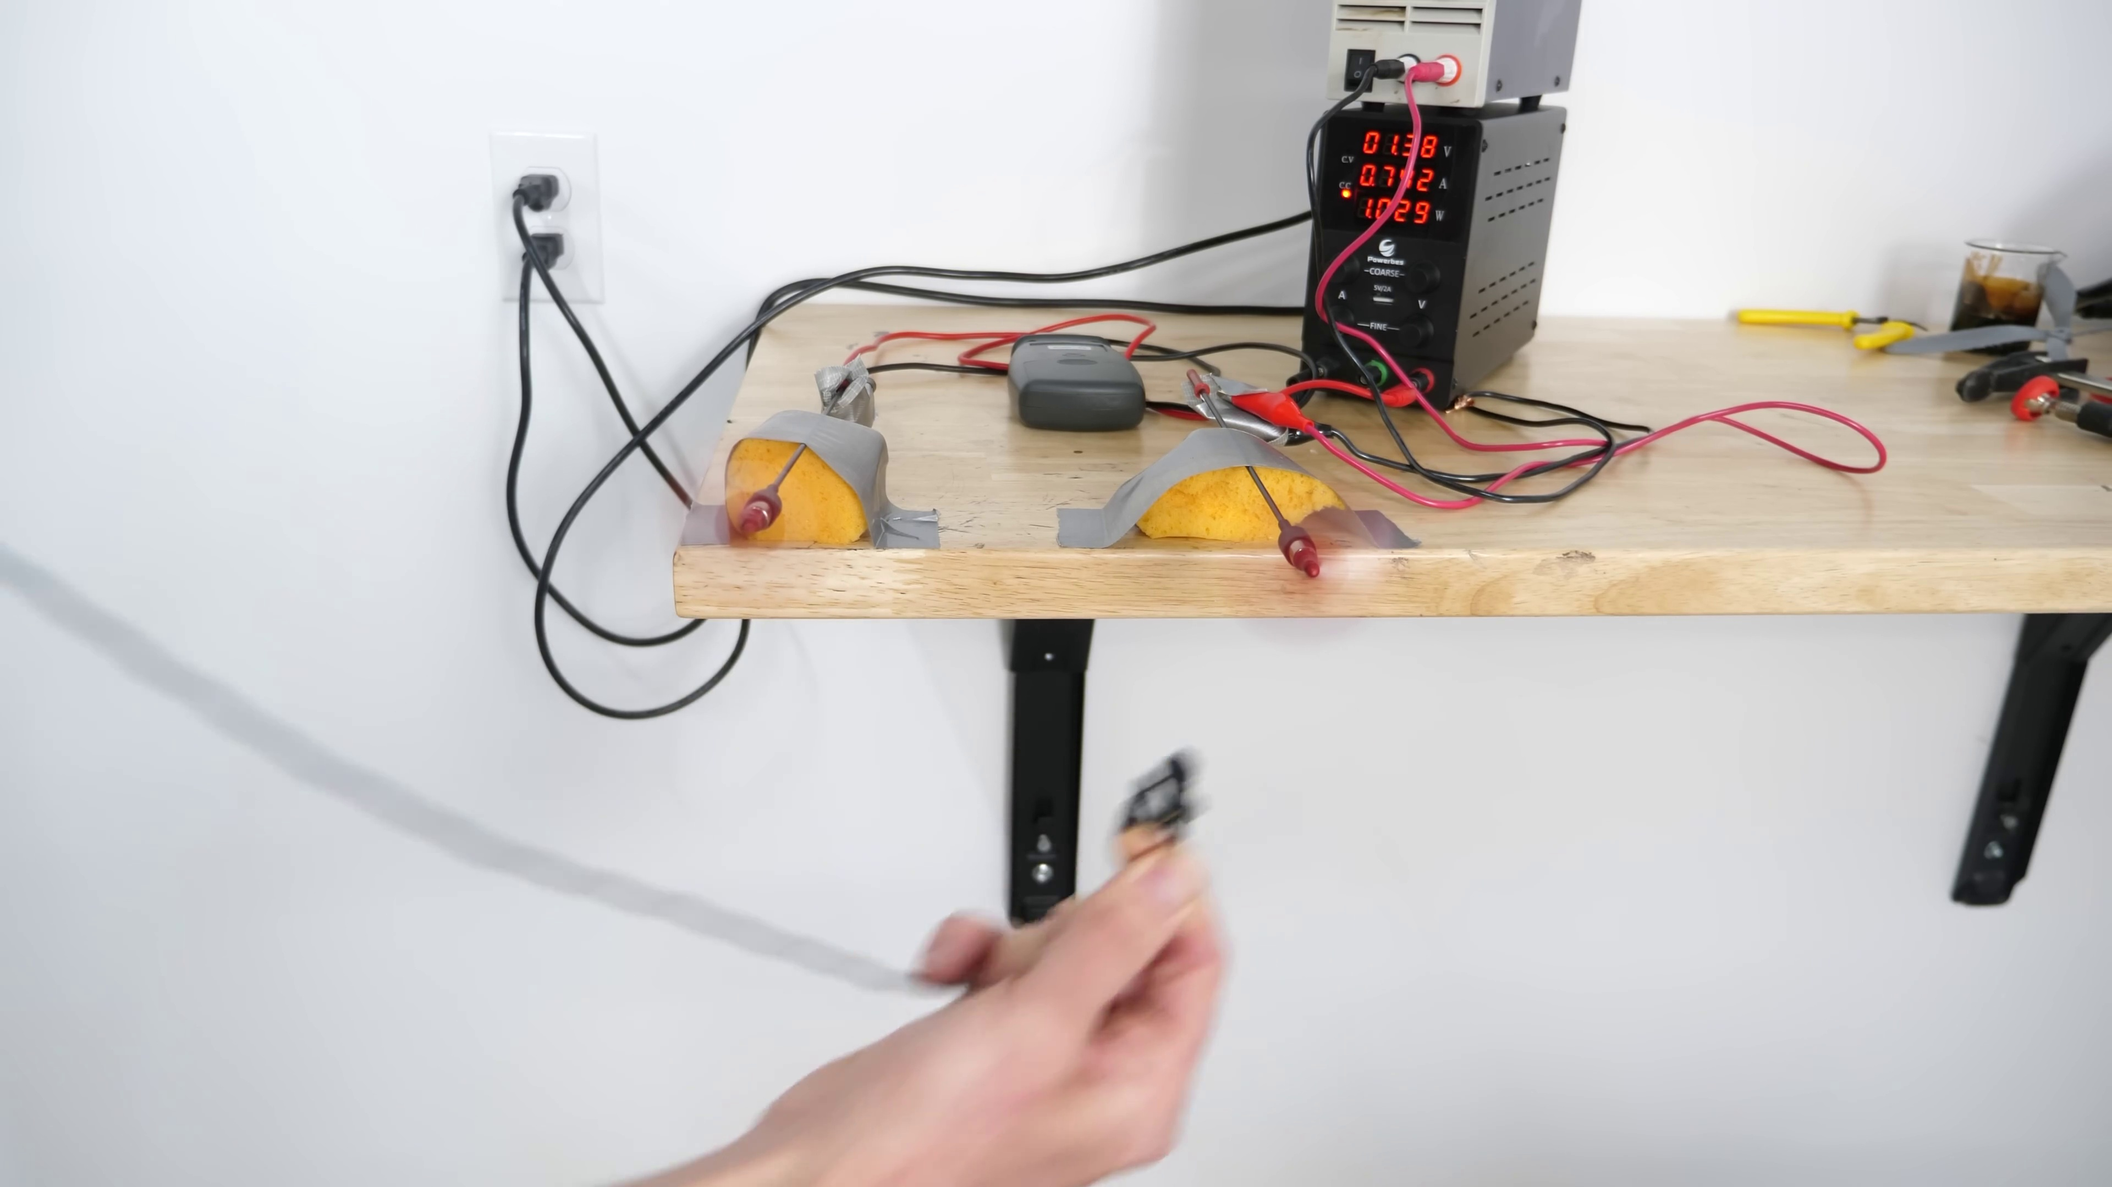 | 6:41  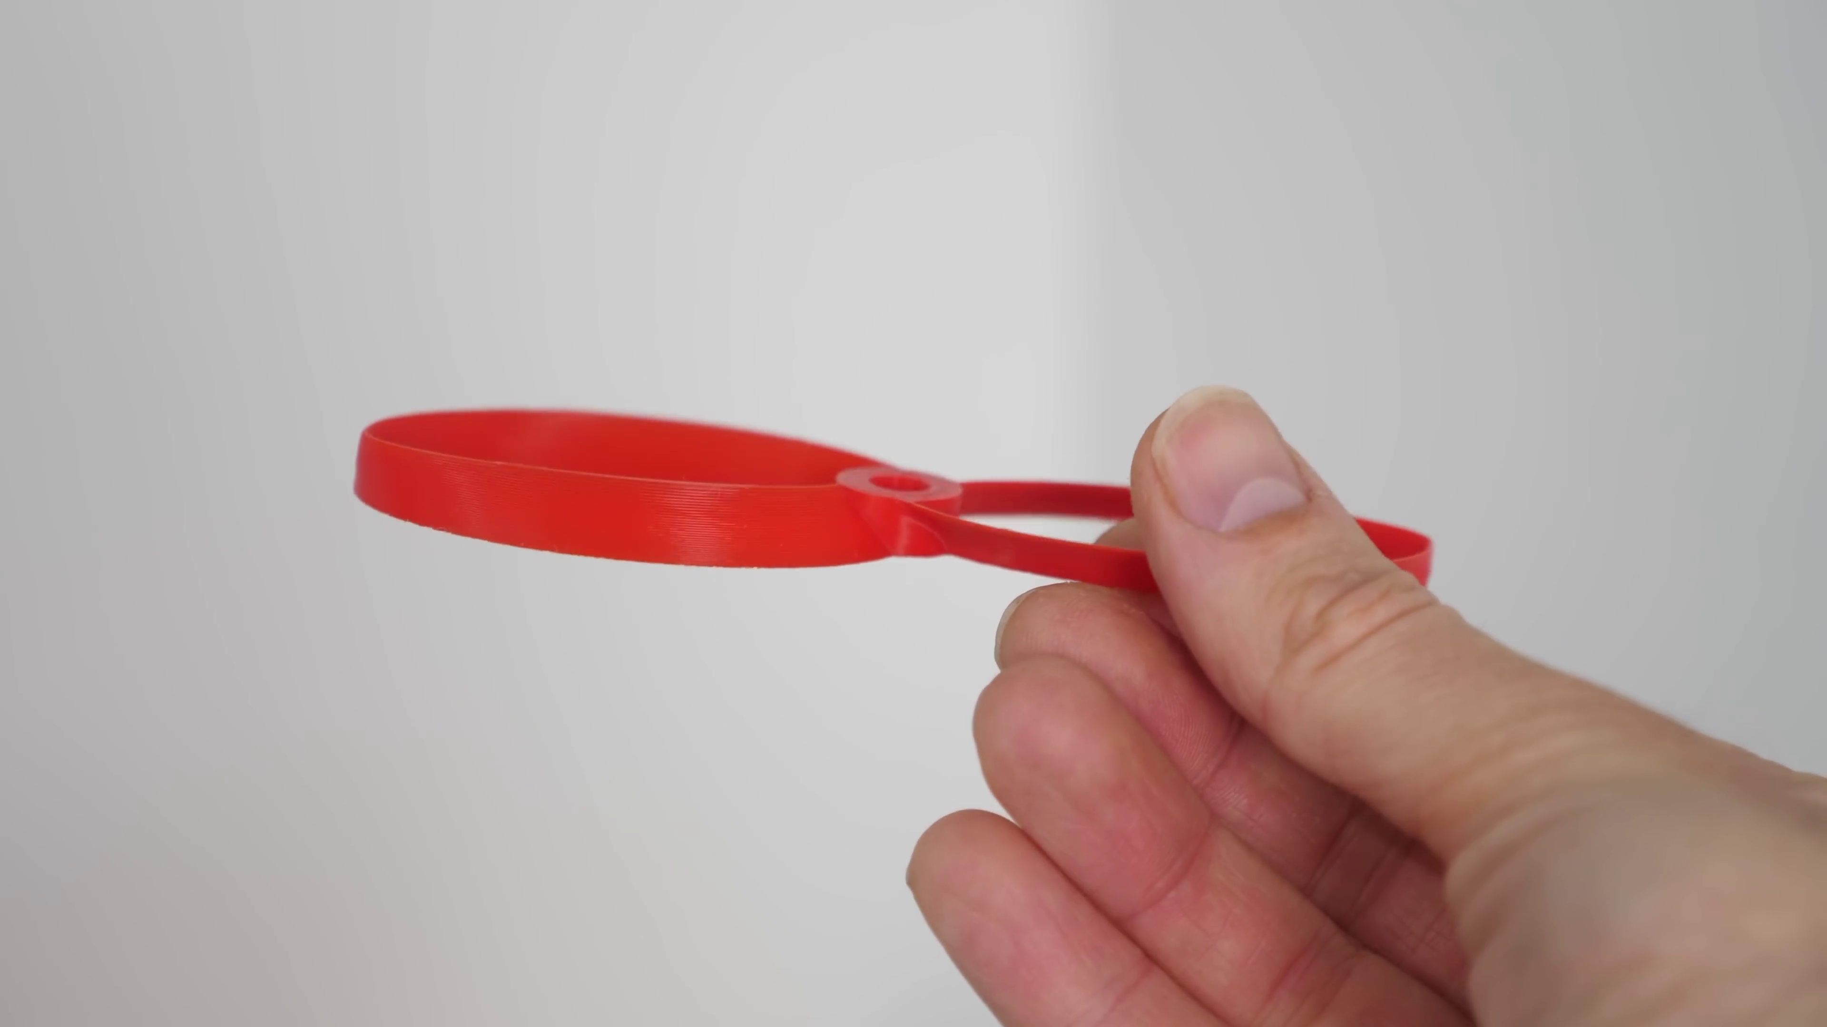 | 7:51   | 9:01  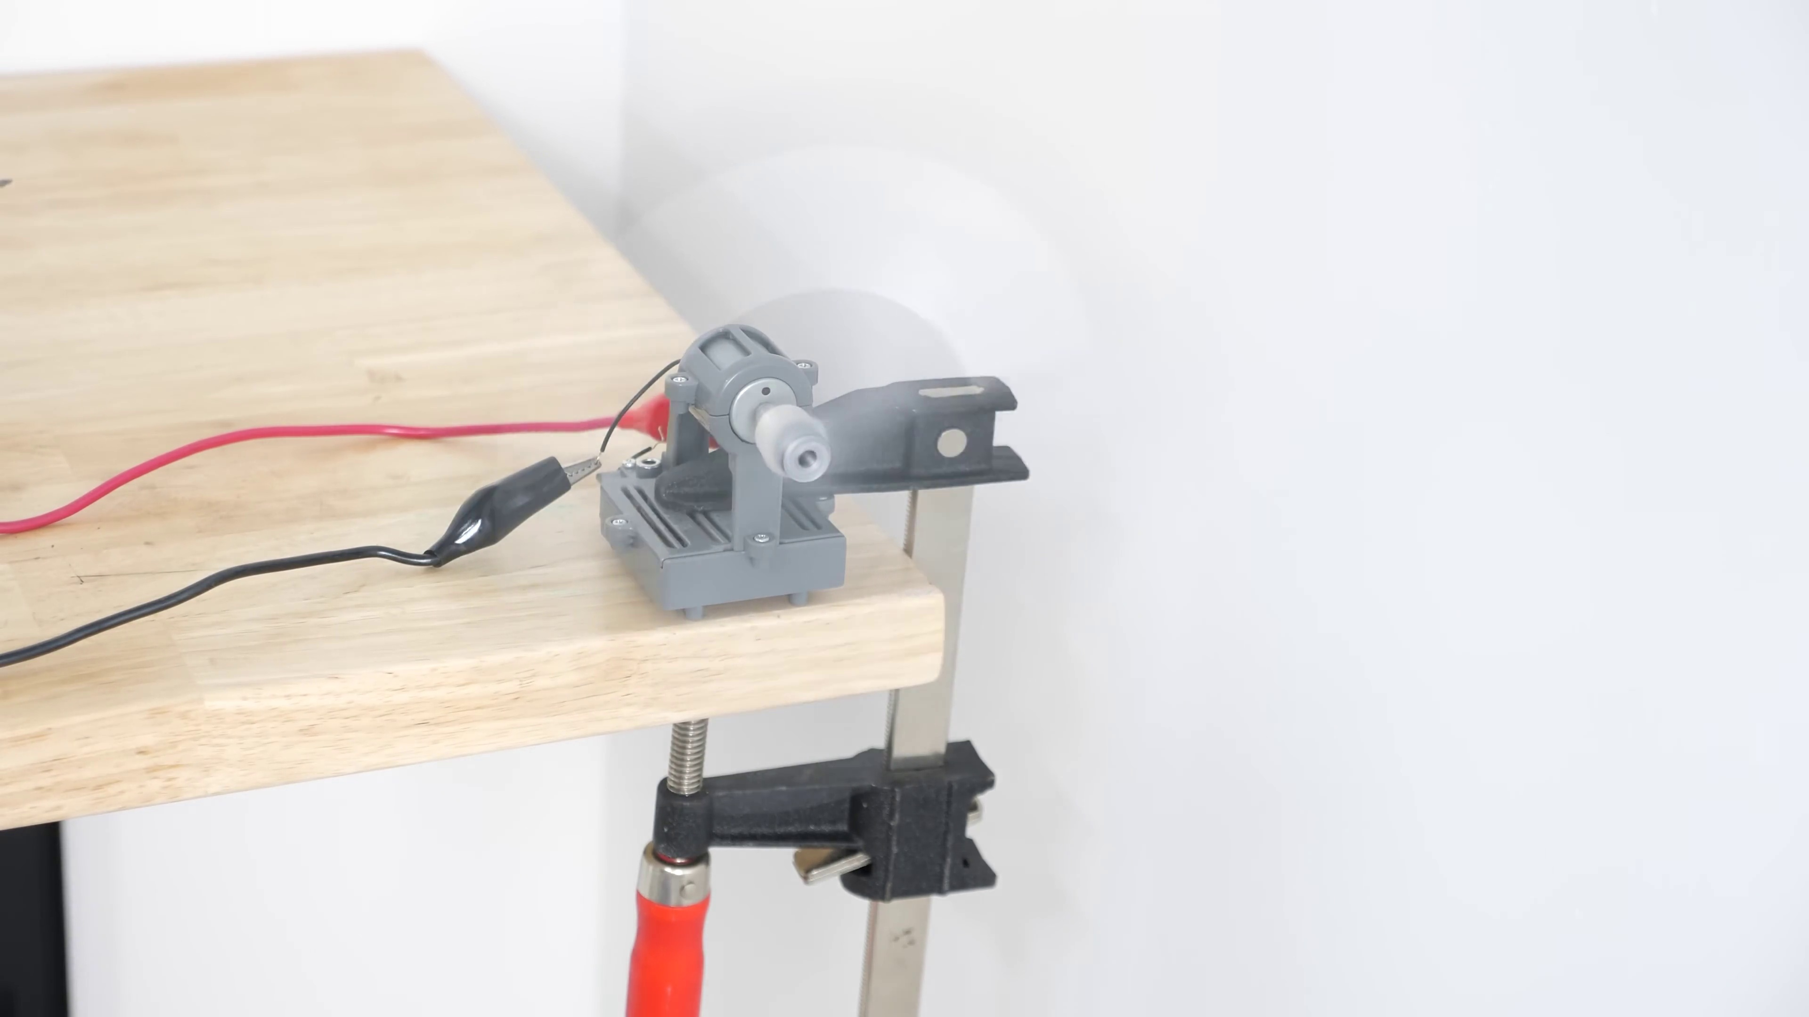

Transcript
[3:11] Well, humans are less sensitive to low frequency sounds. So we perceive them as quieter than they actually are.
[3:18] So what this means is that when you space the blades unevenly, it creates a lower frequency that we perceive as quieter.
[3:25] And this fact has been known for a long time. For example, there are cooling fans and helicopter rotors that use uneven blade spacing.
[3:32] But this design still doesn't quite look like the zip line design that we saw from Mark Rober's video.
[3:38] Why is there this gap between the blades so that they're on different levels?
[3:42] Well, when you have a propeller design like this, there's an interaction that happens where the blades overlap.
[3:47] This causes a lot of broadband noise, meaning just a large spread of many frequencies through the spectrum.
[3:54] So any noise reduction that you gain with the uneven blade spacing gets canceled out with this broadband noise that's created.
[4:00] But if you just get rid of that overlap by raising one of the blades a little bit higher than the other one, then the broadband noise just goes away.
[4:07] So an easy way to create this is just to take two double blade propellers and stack them on top of each other.
[4:13] So I've made two propellers here. These are taken from an FPV airplane propeller that I have.
[4:18] Okay, so what I have here are two different spacings of blades stacked on top of each other.
[4:23] And I put a little sticker on each of them so that I can measure the rotational rate, the RPMs as they're spinning to get them at the same RPM.
[4:31] Okay, so I'm going to turn both of them on.
[4:34] 10,300 RPM.
[4:40] And this one's at 10,000 RPM.
[4:46] 10,200 RPM.
[4:48] So they're really close to the same RPM.
[4:55] Okay, let's listen to both of their sounds.
[4:59] Now in front.
[5:16] 10,300 RPM.
[5:31] Now behind.
[5:44] The high pitch tones are still there with this one, but they're a lot less because of the acoustic noise has been spread out to that lower frequency as well as the high one.
[5:53] Whereas this one has most of the high ones.
[5:56] You can see that the uneven space blades have a noticeably lower tone than the evenly spaced one.
[6:01] What that amounts to is that it sounds quieter and not quite as annoying as the regularly spaced one.
[6:07] So Zipline has made a version of the uneven space blades, but instead of including the four blades, they just have the two of them with a counterbalance on the other side.
[6:16] So it sounds like this.
[6:17] Now mine isn't perfectly balanced, so it doesn't sound a lot quieter.
[6:29] I'd love for someone to make a better version of this in real life that uses the same design as Zipline.
[6:34] Also a few months ago, MIT came up with a propeller called the toroidal propeller.
[6:39] This is the two blade version.
[6:42] And then this is the three blade version.
[6:45] This used a propeller in this shape that reduced the sound in a different way.
[6:50] It actually reduced the vortices formed and slightly reduced the overall sound levels.
[6:55] You can actually see what the flow looks like between a toroidal propeller and a regular one in this simulation here.
[7:01] For the standard props, we see small detached tip vortices from the air rolling off the tip of the blades.
[7:08] These contribute to the high buzz noise that's typical of quadcopter drones.
[7:12] In the case of the toroidal props, this detached vortex is contained within the ring of the prop,
[7:17] and the overall jet of air is much more coherent, so it's quieter.
[7:21] So this will correlate to a reduced overall noise signature due to improved turbulent flow.
[7:26] This simulation is done using real physics using the software from our sponsor for this video, SimScale,
[7:32] the world's first cloud-native engineering simulation platform.
[7:36] SimScale provides engineers and designers access to digital prototyping and simulation early in the design stage,
[7:43] throughout the entire R&D cycle and across the entire enterprise, right in your web browser.
[7:49] If you want to learn more about SimScale, you can click the link in my description and create a free community account.
[7:54] And also you can access thousands of public simulations as well.
[7:58] You can also view the quadcopter project from this video and post-process the simulation results yourself by clicking the link in my description.
[8:06] And thanks to them for sponsoring this video and providing these nice simulations.
[8:10] Now let's get back to the experiment.
[8:12] One problem with this design is notice that with the four propellers,
[8:16] at 1200 RPM we get around 3.1 miles per hour of wind coming off of it.
[8:25] But at the same rotational frequency for the unevenly spaced propellers,
[8:30] we're only getting like 2.5, 2.7 miles per hour.
[8:35] So for the same rotational speed with the same weight, we get less wind coming off of it.
[8:41] Which means to get the same wind speed, you have to speed this one up a little bit faster.
[8:46] But that doesn't actually hurt you sound wise.
[8:49] Because I can turn up the speed to match the four propeller ones.
[8:53] Let's turn it up to get like 3.1.
[8:55] So now I turn up the speed.
[8:59] So overall you have to spin these a little bit faster than you would the evenly spaced blades.
[9:05] So they're less efficient, but you still get the lower frequency,
[9:08] even at the faster speeds to get the same wind speed.
[9:11] So overall these still can be a little bit quieter sounding than the evenly spaced blades.
[9:16] So what's interesting about this apparent noise reduction with uneven blade spacing,
[9:21] is that it depends on the place where you're listening.
[9:24] If you're behind the blades, then the noise reduction is worse for uneven spacing.
[9:29] But when you're in front of the blades or in the same plane as the blade, it's actually better.
[9:33] So this is actually beneficial for flyover noise for planes.
[9:37] Because when they're closest to you, you're in about the same plane as the blade above you, so it's quieter.
[9:43] But unfortunately that means it would be worse for drones because everything's below the blades.
[9:48] But I'm not sure how ziplines blades would sound on a drone.
[9:51] Maybe someone will get a hold of the real blades and do a comparison on a drone.
[9:55] Also I got a lot of this information in this video from a paper on uneven blade spacing.
[10:00] And I'll put a link to that paper in the description as well.
[10:03] And thanks again for watching this video.
[10:05] If you like this video, remember to like this video.
[10:07] And also subscribe to my channel if you haven't yet.
[10:10] And we'll see you next time.

