Engagement Analysis: zZE4AejgDOA

Section 0: Image Descriptions
Time: 0:00 - 0:05

Summary
A series of image descriptions, each describing a different visual representation.

Representative Frames
0:00  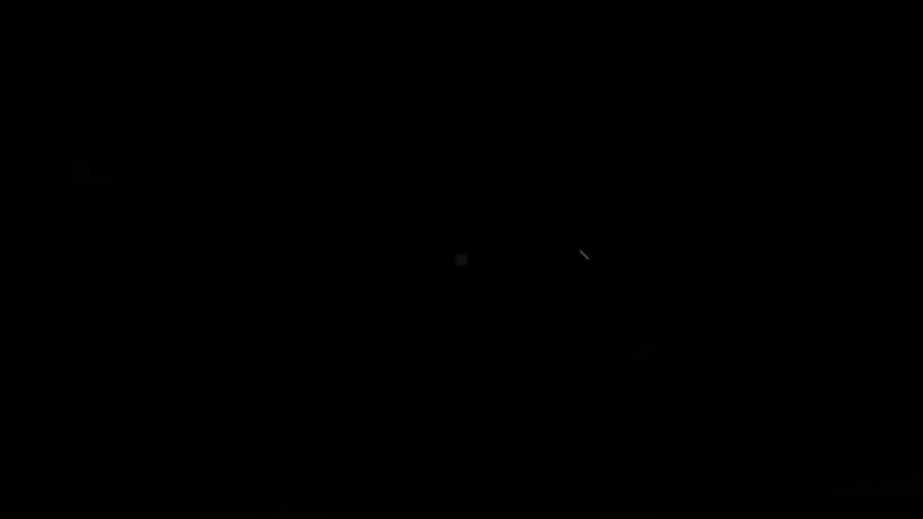 | 0:01   | 0:02   | 0:03  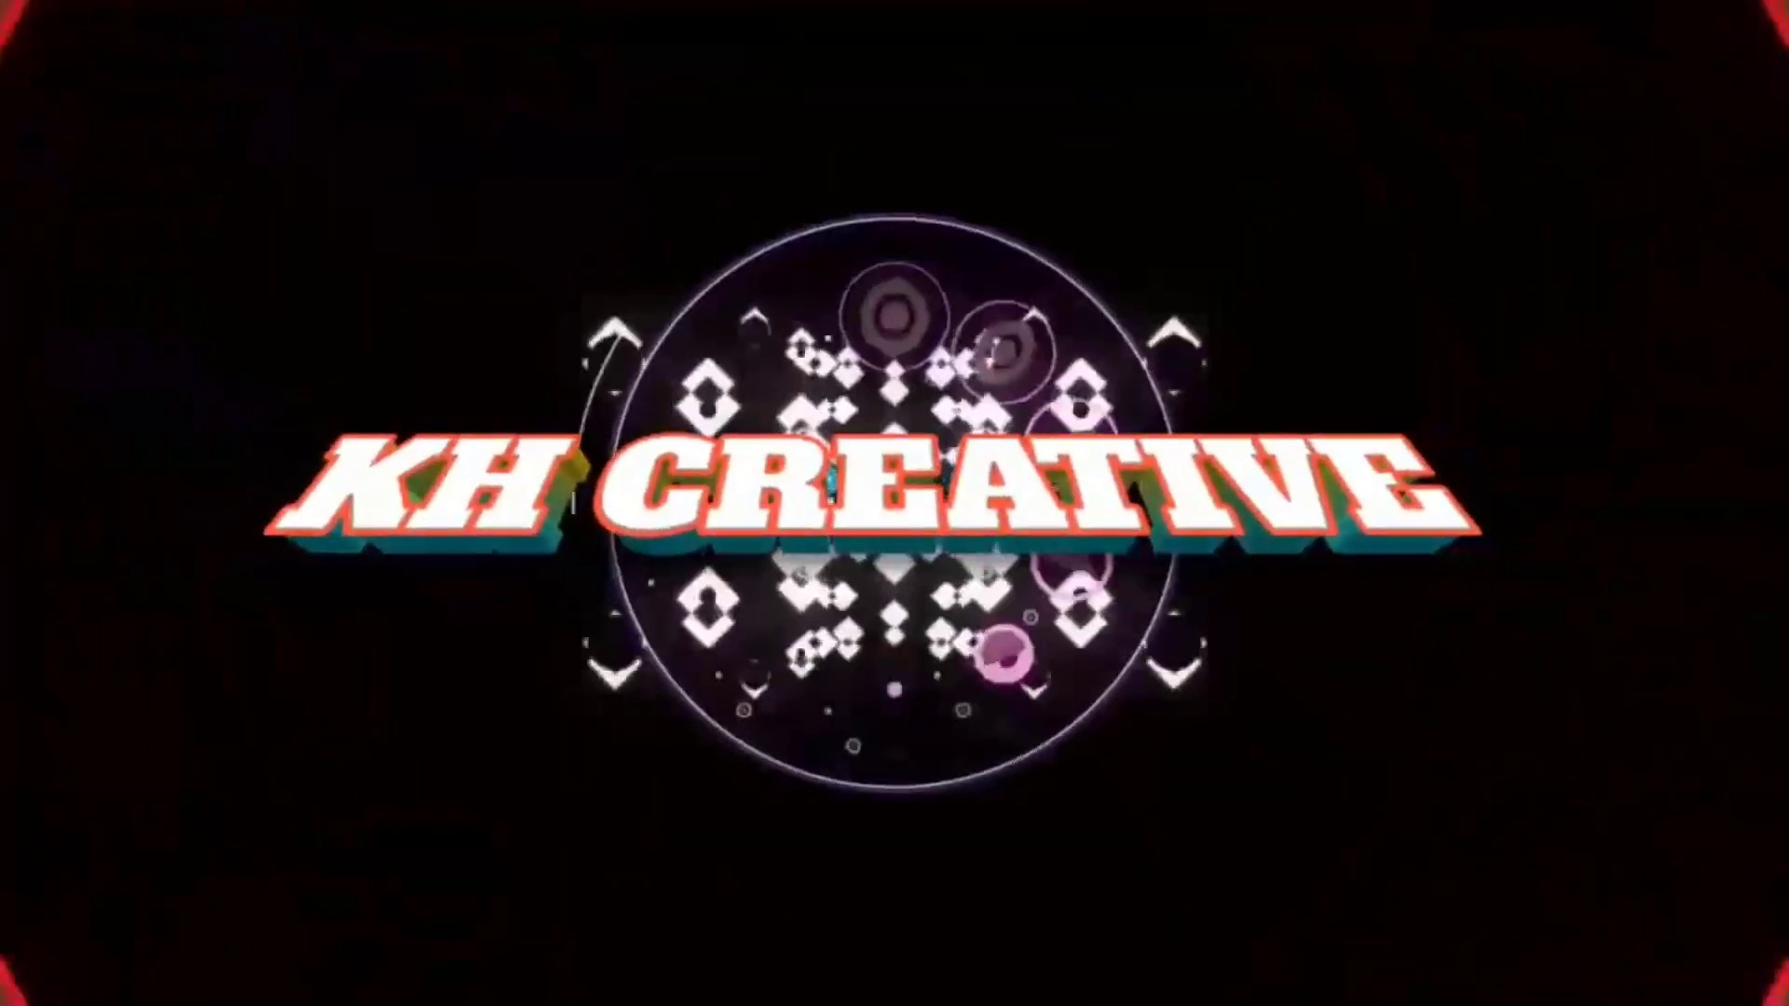 | 0:04  

Transcript
[0:00] Intro

Section 0: First Image: A Technical Diagram
Time: 0:05 - 0:08

Summary
A technical diagram showing a complex system with various components and labels.

Representative Frames
0:05   | 0:06   | 0:06   | 0:07  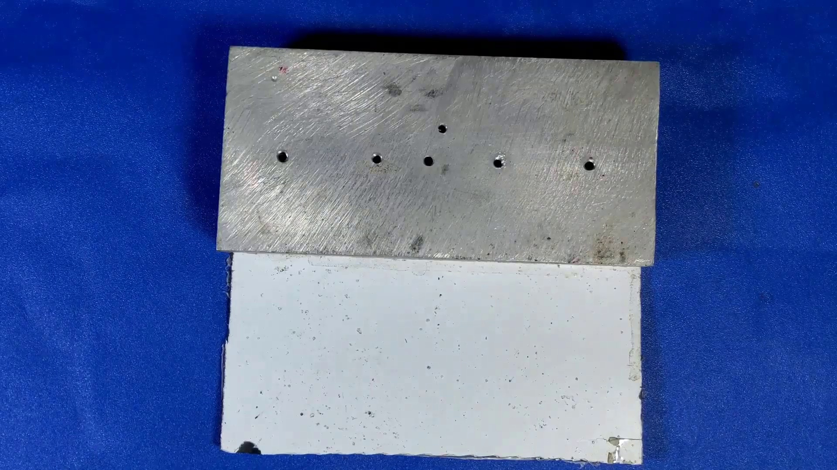 | 0:07  

Transcript
[0:05] akan

Section 0: Second Image: A Circuit Board
Time: 0:08 - 0:11

Summary
A close-up of a circuit board, showing numerous wires and electrical components.

Representative Frames
0:08   | 0:09   | 0:09   | 0:10  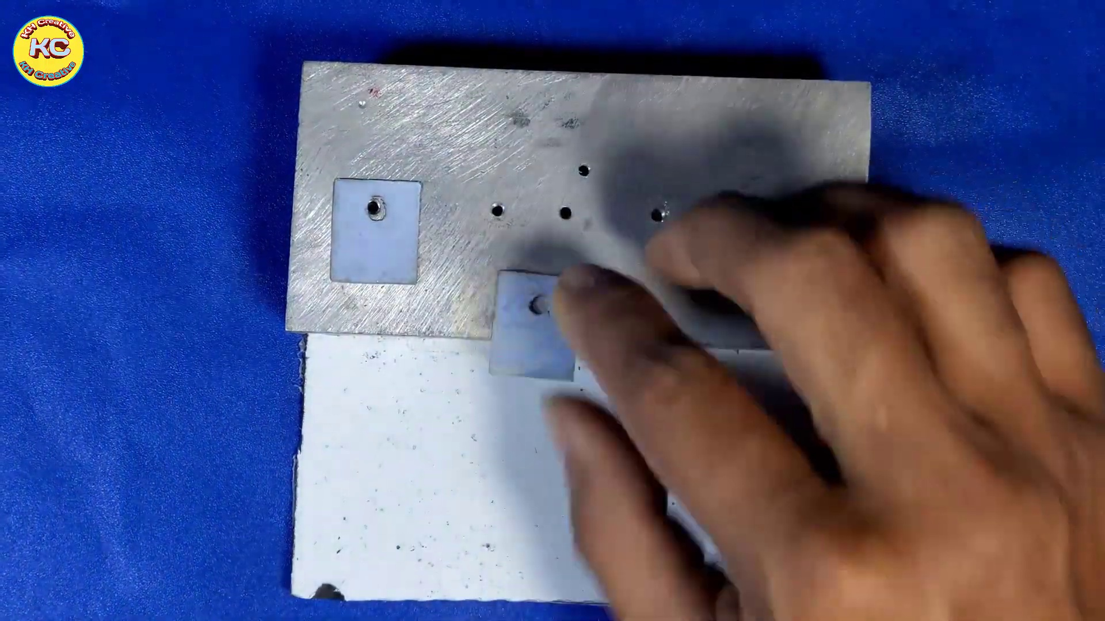 | 0:10  

Transcript
(No speech detected in this section)

Section 0: Third Image: A Technical Illustration
Time: 0:11 - 0:14

Summary
A detailed illustration of a technical concept, with multiple layers and annotations.

Representative Frames
0:11   | 0:12   | 0:12   | 0:13   | 0:13  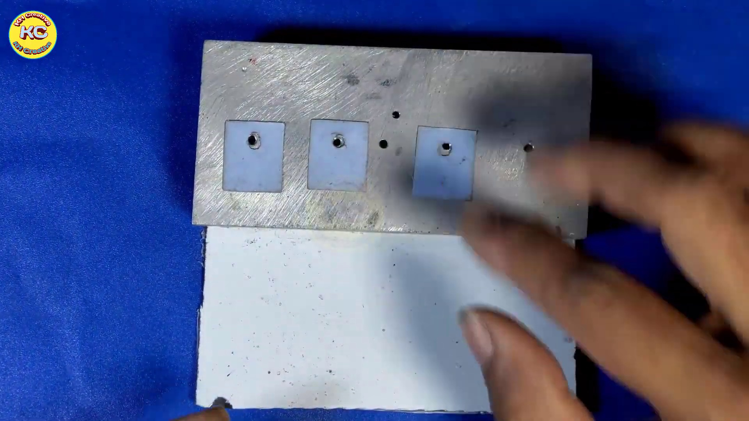

Transcript
[0:08] statistic I'm

Section 0: Fourth Image: A Social Media Post
Time: 0:14 - 0:18

Summary
A social media post featuring a meme and text overlay, encouraging engagement.

Representative Frames
0:14   | 0:15   | 0:16   | 0:16  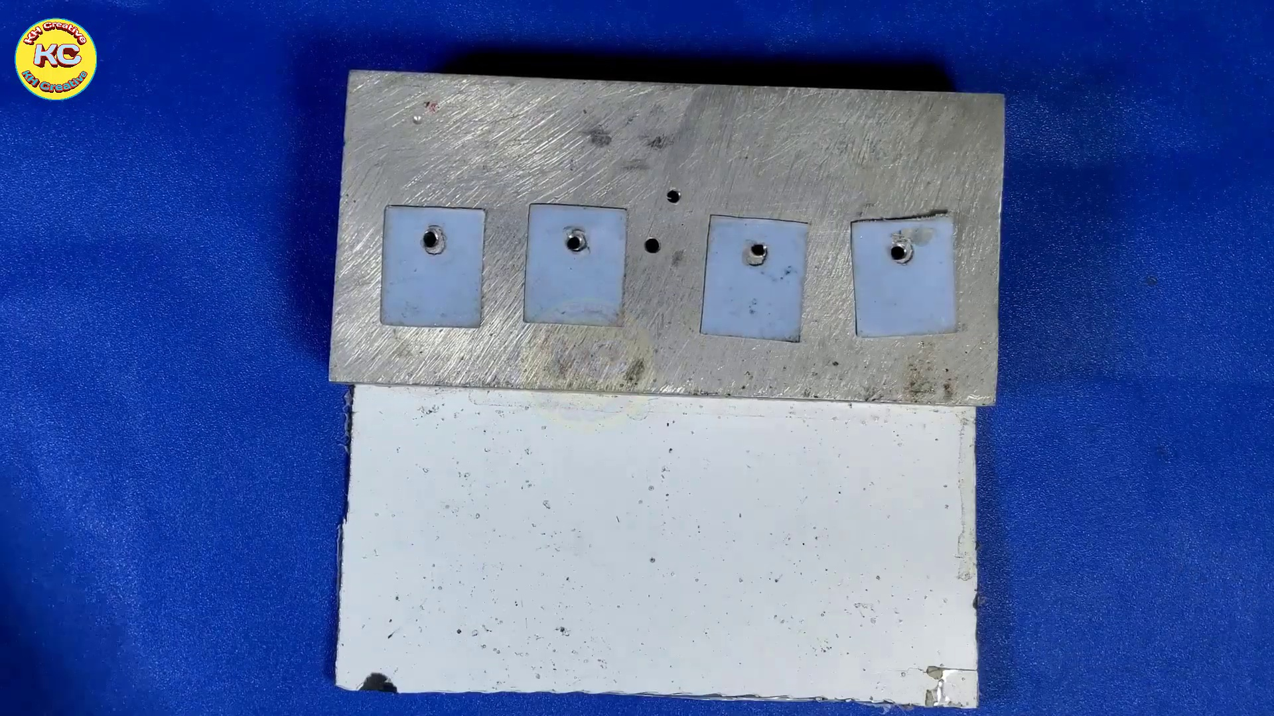 | 0:17  

Transcript
[0:14] saying

Section 0: Fifth Image: A Video Thumbnail
Time: 0:18 - 10:00

Summary
A video thumbnail with a red button and white text, promoting subscription to educational content.

Representative Frames
1:55  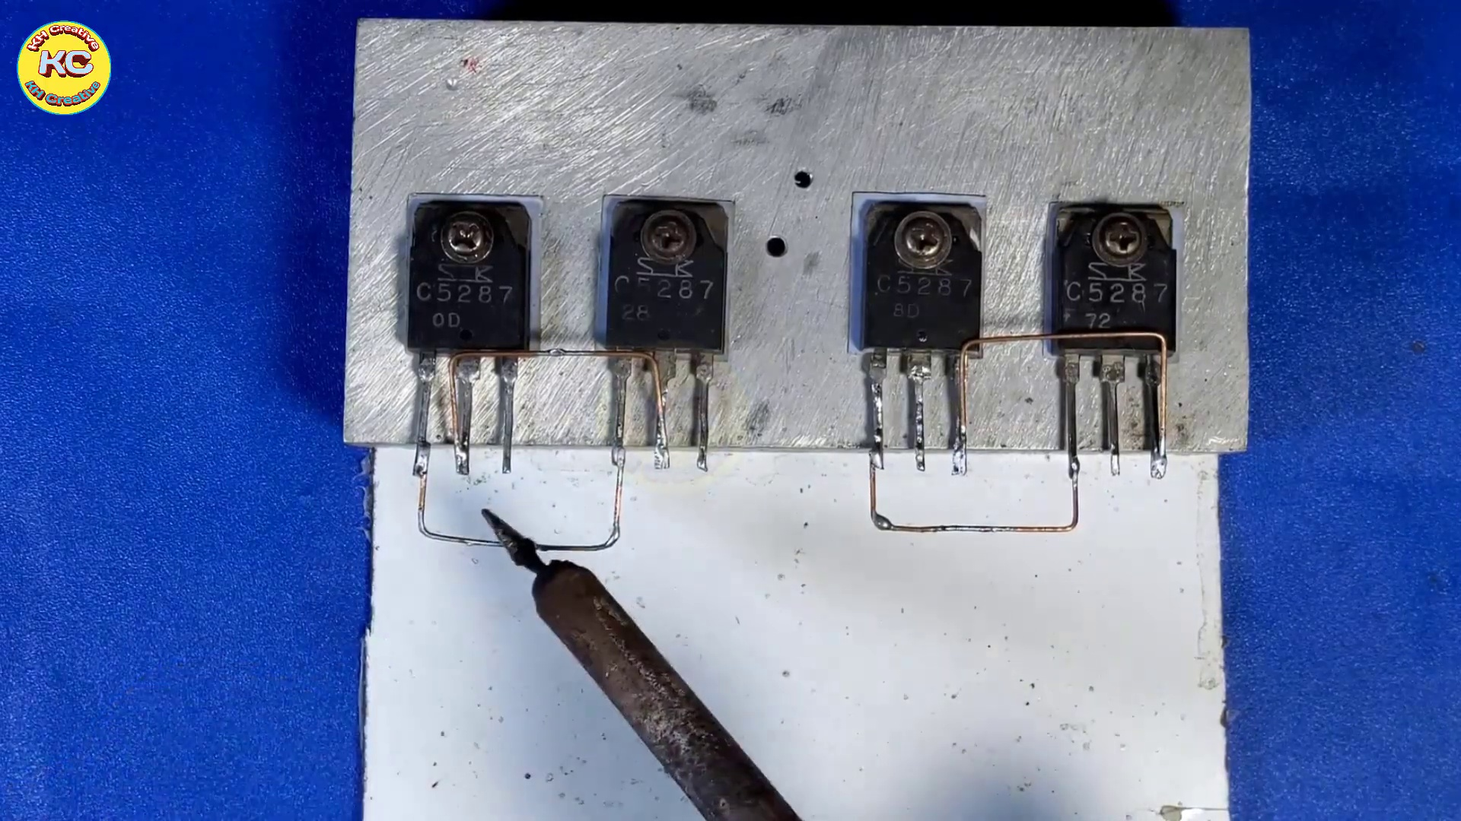 | 3:32  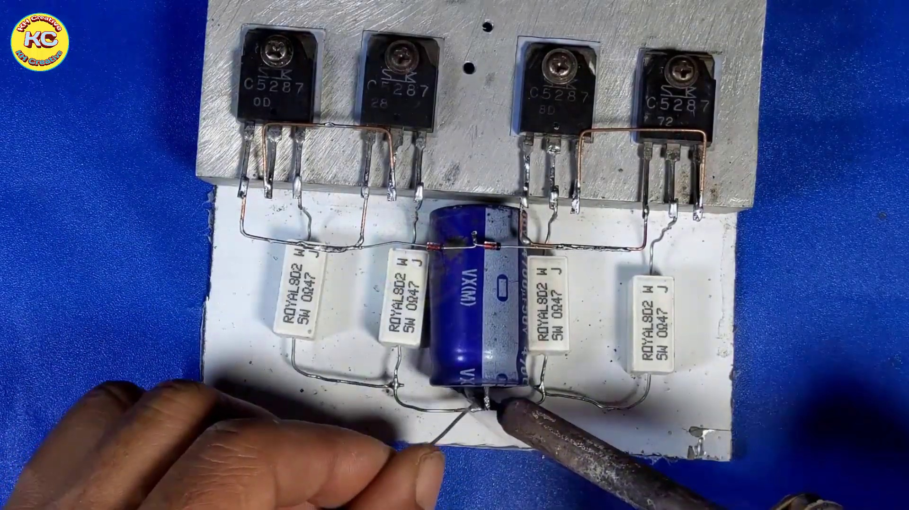 | 5:09  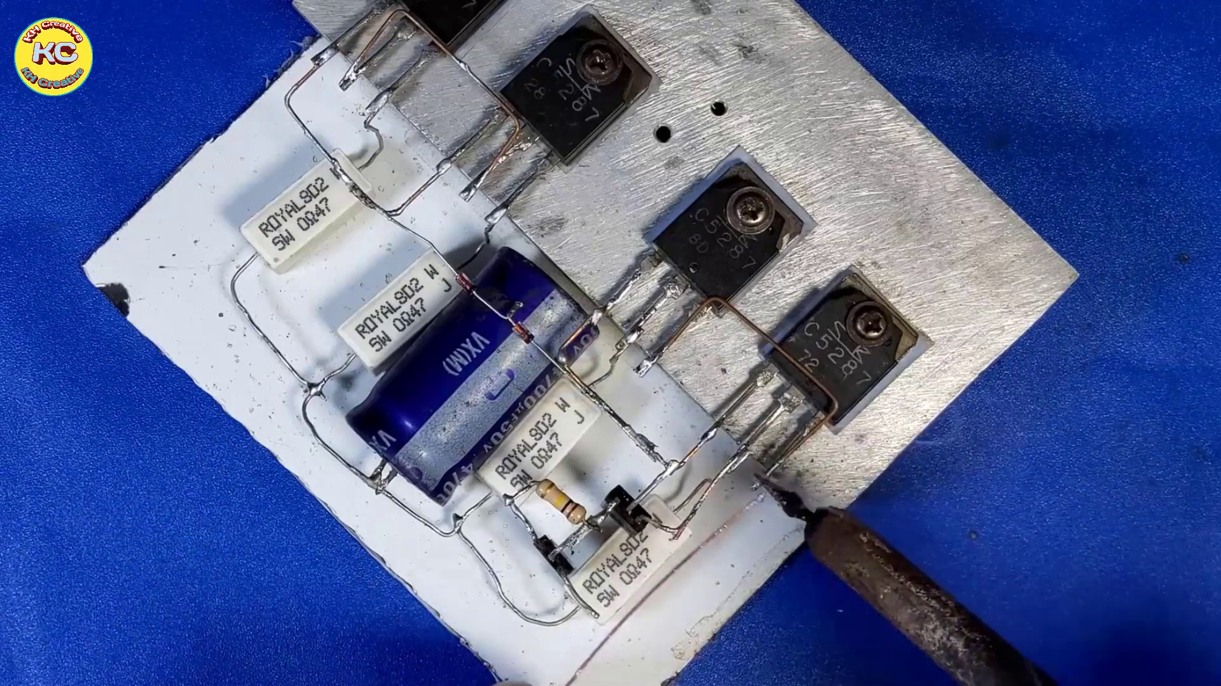 | 6:46  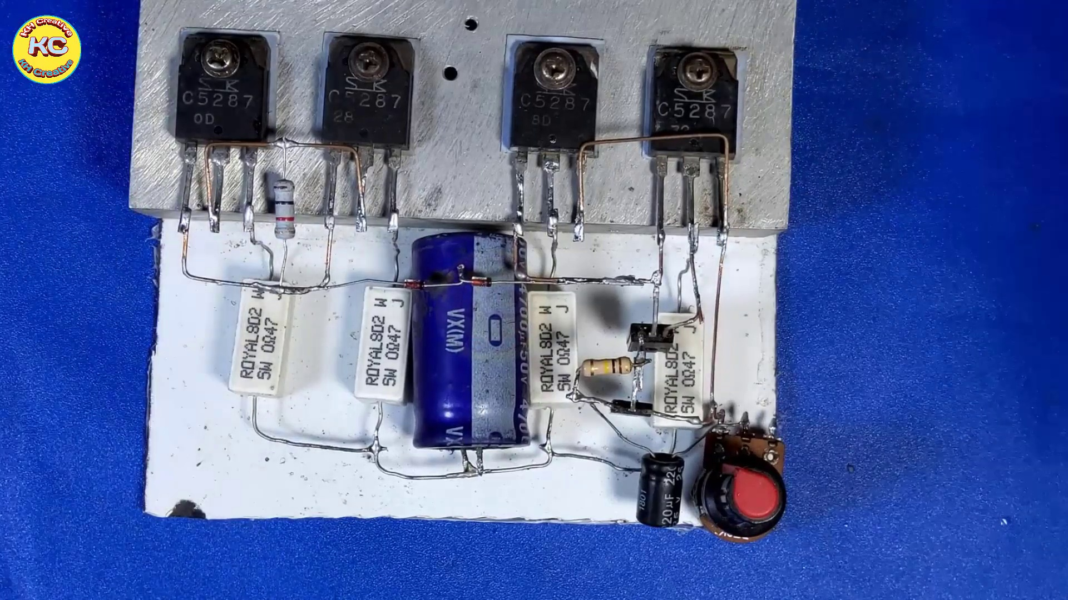 | 8:23  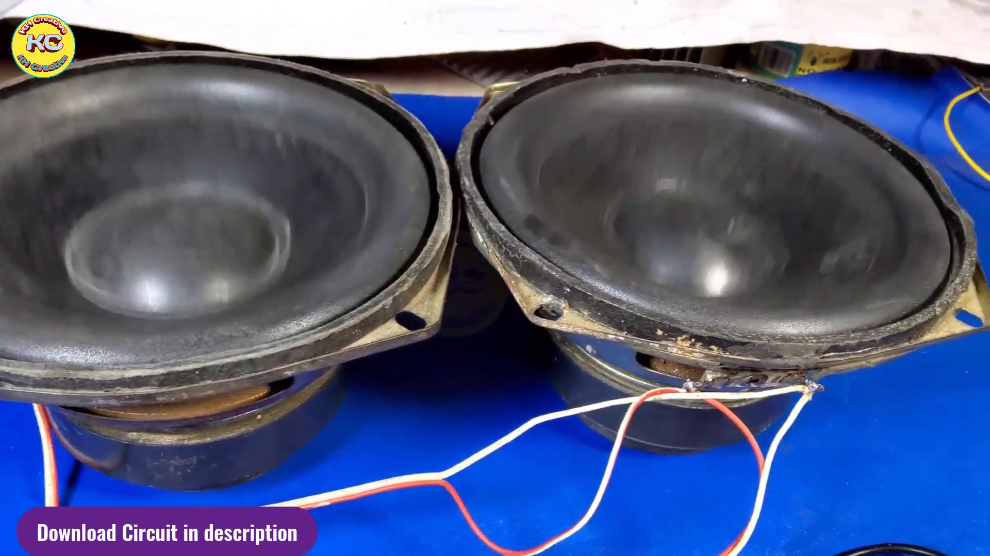

Transcript
[0:18] I'm
[0:23] saying
[0:28] Okay no
[0:34] D увер
[0:36] He didn't email me
[0:39] He sent him
[0:40] She sent me
[0:43] Max
[0:46] I'm just stuck
[0:47] He眠
[0:50] Cade
[0:53] He'sott
[0:55] ...
[1:25] The Noêtre is a plane machine with a awesome craft
[1:28] That book Spiritual Totally
[1:32] This is free from Skype
[1:37] Another 4K
[1:41] zipper
[1:42] mute
[1:51] mute
[2:03] 과연 이것은計 Очень Strapless
[2:06] Shrimp
[2:19] 그것과와서
[2:24] 몸을 꼭 학교에 있어서
[2:27] 정중력자.
[2:30] 철 cost.
[2:30] All right.
[3:00] Thank you.
[3:30] Thank you.
[4:00] Thank you.
[4:30] Thank you.
[5:00] Thank you.
[5:30] Thank you.
[6:00] Thank you.
[6:30] Thank you.
[7:00] Thank you.
[7:30] Thank you.
[8:00] Thank you.
[8:30] Thank you.
[9:00] Thank you.
[9:30] Thank you.

