Comment–Topic Correlation Report
Model: llama3

Summary
Topics processed: 1
Comments available for this video: 2
Comments correlated to ≥ 60: 0 (0.0%)
Total candidate pairs checked: 2

Most/Least correlated topics (by average score across correlated comments):
Top 3:
• Topic T1: No Specific Topic Discussed — avg 0.00, contributions 0
Bottom 3:
• Topic T1: No Specific Topic Discussed — avg 0.00, contributions 0
Correlated comment coverage (all comments):
- matched 0 topic(s), max score 0.0000: This video was about building a simple amplifier circuit using the TDA 2030 amplifier. The circuit constructed in this video only used a couple of resistors and a couple of capacitors and produced a high-quality sound. Things learned from this video is one way to construct a good sounding speaker circuit using the TDA 2030 that is relatively simple in construction that used only a couple of components. Some points of confusion regarding this video is if the plate the TDA 2030 is attached to, I wonder if that is just a general base plat or if that is supposed to be some type of heat sink. Another thing I was confused about is the positive and negative wires of the input jack and the wires connected to the speaker, I was not sure which was which when it was wired into the circuit.
Source: https://www.youtube.com/watch?v=-qCO7NUpLc0: How to make powerful amplifier. using TDA2030 ic. DIY ultra bass amplifier.
Top correlated topics:
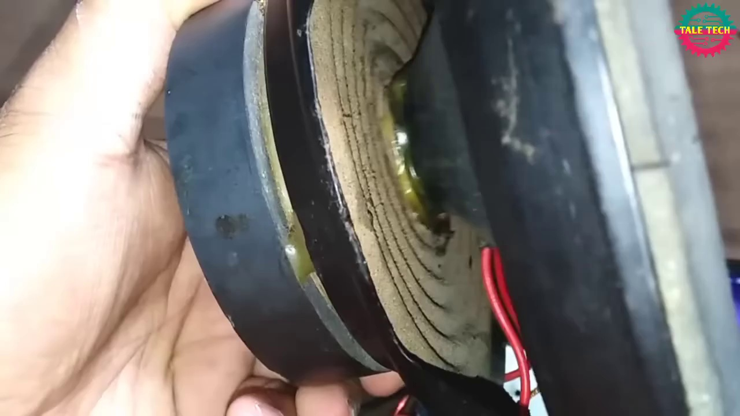 | 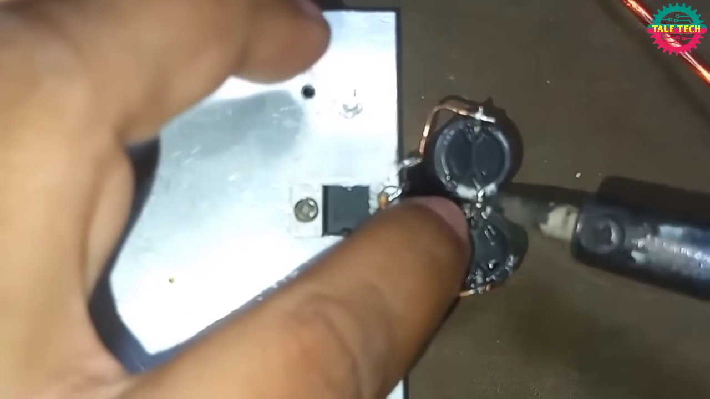 | 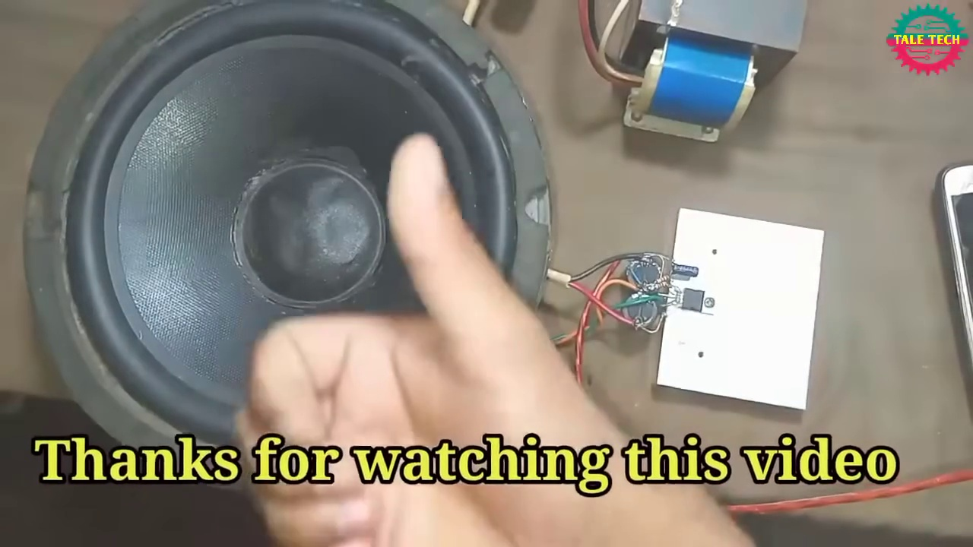
Topic T1: No Specific Topic Discussed — score 0.0000
Description: The speaker only says 'Thank you' repeatedly without discussing any specific topic.
Reason: The comment discusses a specific topic (building an amplifier circuit using TDA 2030) and shares personal thoughts and questions, whereas the topic title and description are unrelated to any discussed topics.
Least correlated topics:
 |  | 
Topic T1: No Specific Topic Discussed — score 0.0000
Description: The speaker only says 'Thank you' repeatedly without discussing any specific topic.
Reason: The comment discusses a specific topic (building an amplifier circuit using TDA 2030) and shares personal thoughts and questions, whereas the topic title and description are unrelated to any discussed topics.
- matched 0 topic(s), max score 0.0000: Gives exact parts and instructions for building an ultra bass amplifier.Doesn't mention part sources or pricing.Looks like a feasible final project circuit.
Source: https://www.youtube.com/watch?v=-qCO7NUpLc0: How to Make Powerful Amplifier Using TDA2030 IC
Top correlated topics:
 |  | 
Topic T1: No Specific Topic Discussed — score 0.0000
Description: The speaker only says 'Thank you' repeatedly without discussing any specific topic.
Reason: The topic description is about 'No Discussed Topics', which doesn't contain any specific steps or objects. The comment is about building an ultra bass amplifier, which has no overlap with the topic.
Least correlated topics:
 |  | 
Topic T1: No Specific Topic Discussed — score 0.0000
Description: The speaker only says 'Thank you' repeatedly without discussing any specific topic.
Reason: The topic description is about 'No Discussed Topics', which doesn't contain any specific steps or objects. The comment is about building an ultra bass amplifier, which has no overlap with the topic.

Topic T1: No Specific Topic Discussed
 |  | 
Description: The speaker only says 'Thank you' repeatedly without discussing any specific topic.
No strongly correlated comments found for this topic.

