Comment–Topic Correlation Report
Model: llama3

Summary
Topics processed: 5
Comments available for this video: 2
Comments correlated to ≥ 60: 1 (50.0%)
Total candidate pairs checked: 10

Most/Least correlated topics (by average score across correlated comments):
Top 3:
• Topic T2: Power Input Identification — avg 85.00, contributions 1
• Topic T3: Video Transmitter Connection (Battery Voltage) — avg 80.00, contributions 1
• Topic T4: Video Transmitter Connection (5V) — avg 80.00, contributions 1
Bottom 3:
• Topic T5: Smart Audio Protocol Setup — avg 0.00, contributions 0
• Topic T1: Video Outliner — avg 0.00, contributions 0
• Topic T4: Video Transmitter Connection (5V) — avg 80.00, contributions 1
Correlated comment coverage (all comments):
- matched 3 topic(s), max score 85.0000: Can power the receiver on 3.3 or 5 volts depending on how you bridge the center pad with the left or the right one.The mini stack can power up to a 6s droneThe normal stack can be used with 3s-6s drones.
Source: https://www.youtube.com/watch?v=09c4bdKM5Kw: T-Motor Stack With Metal Fets!! // T-Motor F722 Mini Stack 20020
Top correlated topics:
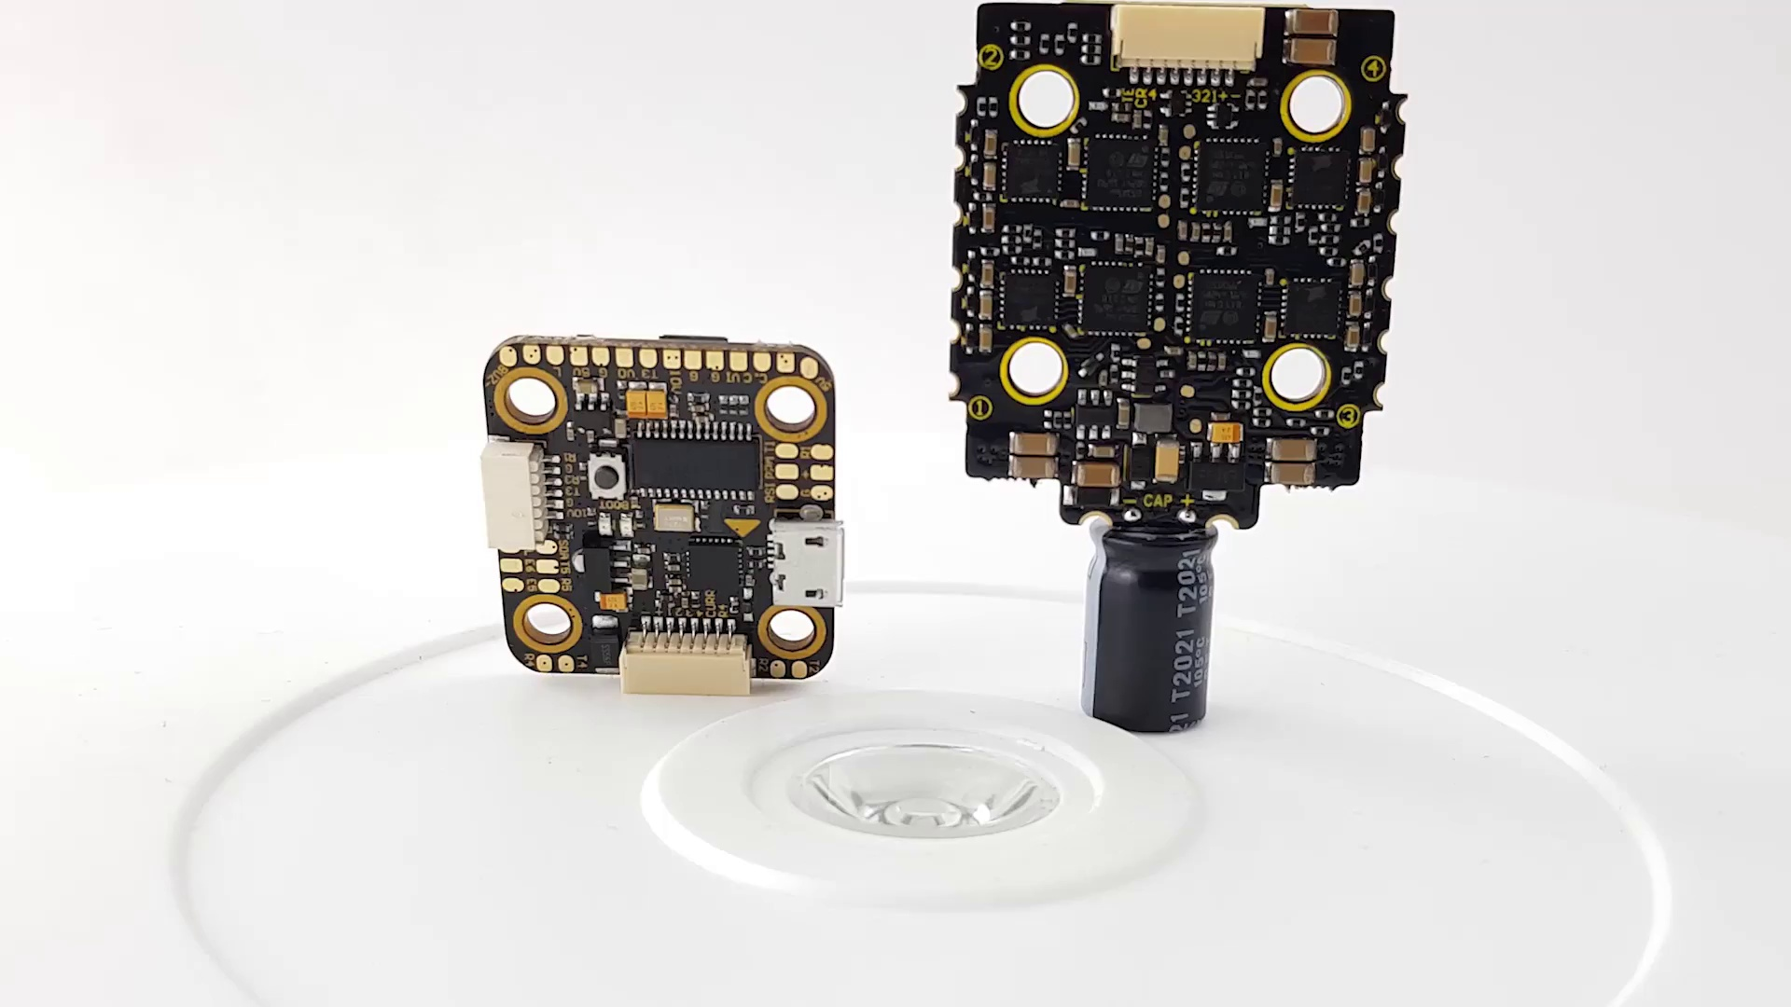 | 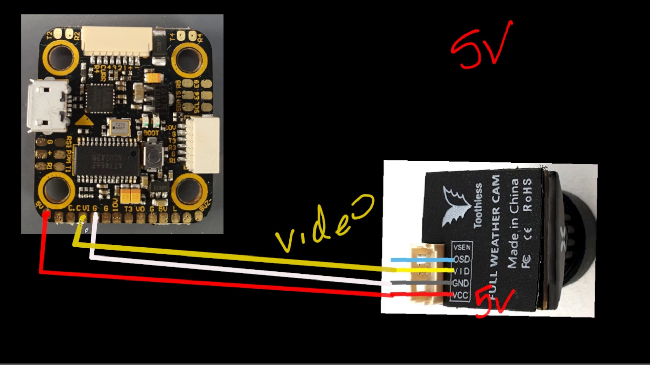 | 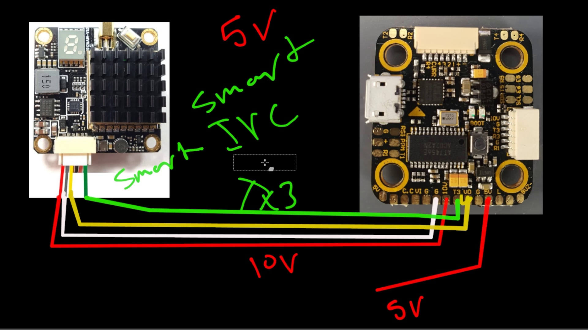
Topic T2: Power Input Identification — score 85.0000
Description: Identify the power input required by your video transmitter (5V or XXV)
Reason: The comment discusses setting up power and ground specifically for the video transmitter, mentioning bridging the center pad with left or right one, which aligns with the topic's description of 'setting up power and ground'. The mention of different drone sizes supported by the mini and normal stacks also relates to the topic's focus on power setup.
 |  | 
Topic T4: Video Transmitter Connection (5V) — score 80.0000
Description: Connect the video transmitter to the 5V output and ground
Reason: The comment directly discusses the setup of smart audio protocol for power control, mentioning specific details like voltage options and compatible drone sizes, which closely aligns with the topic description.
 |  | 
Topic T3: Video Transmitter Connection (Battery Voltage) — score 80.0000
Description: Connect the video transmitter to the battery voltage (10V) and ground
Reason: The comment specifically discusses the video line configuration, mentioning the yellow wire and center pad, which are mentioned in the topic description. Although it does not directly discuss the video output (VO), it is still related to the topic as a whole.
 |  | 
Topic T1: Video Outliner — score 20.0000
Description: Introduction to Video Transmitter Connection Guide
Reason: The comment discusses powering a receiver and mini/normal stacks for drones, which is not directly related to the topic of introducing video outliner and setting up a video transmitter.
 |  | 
Topic T5: Smart Audio Protocol Setup — score 0.0000
Description: Set up the smart audio protocol on UART3 peripherals
Reason: The comment discusses power settings and drone capabilities, unrelated to the topic of conclusion and call to action.
Least correlated topics:
 |  | 
Topic T5: Smart Audio Protocol Setup — score 0.0000
Description: Set up the smart audio protocol on UART3 peripherals
Reason: The comment discusses power settings and drone capabilities, unrelated to the topic of conclusion and call to action.
 |  | 
Topic T1: Video Outliner — score 20.0000
Description: Introduction to Video Transmitter Connection Guide
Reason: The comment discusses powering a receiver and mini/normal stacks for drones, which is not directly related to the topic of introducing video outliner and setting up a video transmitter.
 |  | 
Topic T3: Video Transmitter Connection (Battery Voltage) — score 80.0000
Description: Connect the video transmitter to the battery voltage (10V) and ground
Reason: The comment specifically discusses the video line configuration, mentioning the yellow wire and center pad, which are mentioned in the topic description. Although it does not directly discuss the video output (VO), it is still related to the topic as a whole.
 |  | 
Topic T4: Video Transmitter Connection (5V) — score 80.0000
Description: Connect the video transmitter to the 5V output and ground
Reason: The comment directly discusses the setup of smart audio protocol for power control, mentioning specific details like voltage options and compatible drone sizes, which closely aligns with the topic description.
 |  | 
Topic T2: Power Input Identification — score 85.0000
Description: Identify the power input required by your video transmitter (5V or XXV)
Reason: The comment discusses setting up power and ground specifically for the video transmitter, mentioning bridging the center pad with left or right one, which aligns with the topic's description of 'setting up power and ground'. The mention of different drone sizes supported by the mini and normal stacks also relates to the topic's focus on power setup.
- matched 0 topic(s), max score 0.0000: T-Motor F722 Mini Stack 20020 features a compact design.It includes a flight controller (F722) and a 20A ESC (Electronic Speed Controller) with metal FETs (Field-Effect Transistors).The flight controller is based on the F722 chipset, providing advanced processing power for drone flight control.The 20A ESC features metal FETs, which enhance the performance and durability of the electronic speed controller.This stack is likely designed for smaller FPV (First-Person View) racing or freestyle drones..It comes with capacitor pre installed and is extremely easy to wire and set up.
Source: https://www.youtube.com/watch?v=09c4bdKM5Kw: T-Motor Stack With Metal Fets!! // T-Motor F722 Mini Stack 20020
Top correlated topics:
 |  | 
Topic T2: Power Input Identification — score 20.0000
Description: Identify the power input required by your video transmitter (5V or XXV)
Reason: The comment does not directly discuss setting up power and ground for a video transmitter, but rather describes the features and design of an F722 Mini Stack. The topic is about setting up power and ground for a specific device (video transmitter), while the comment discusses a different product (F722 Mini Stack) in general terms.
 |  | 
Topic T1: Video Outliner — score 20.0000
Description: Introduction to Video Transmitter Connection Guide
Reason: The topic discusses introduction to video outliner and importance of setting up a video transmitter, while the comment talks about drone flight controller and ESC. Although both are related to electronics, they don't seem strongly connected.
 |  | 
Topic T4: Video Transmitter Connection (5V) — score 10.0000
Description: Connect the video transmitter to the 5V output and ground
Reason: The topic discusses smart audio protocol for channel and output power control, while the comment is about a specific drone flight controller and ESC stack, with no apparent relation to the topic.
 |  | 
Topic T5: Smart Audio Protocol Setup — score 0.0000
Description: Set up the smart audio protocol on UART3 peripherals
Reason: The comment discusses a specific drone component (T-Motor F722 Mini Stack), while the topic is about concluding and joining Patreon, which has no direct relation.
 |  | 
Topic T3: Video Transmitter Connection (Battery Voltage) — score 0.0000
Description: Connect the video transmitter to the battery voltage (10V) and ground
Reason: The comment does not discuss video line configuration or video output at all. Instead, it describes a drone flight controller and ESC, which is unrelated to the topic.
Least correlated topics:
 |  | 
Topic T3: Video Transmitter Connection (Battery Voltage) — score 0.0000
Description: Connect the video transmitter to the battery voltage (10V) and ground
Reason: The comment does not discuss video line configuration or video output at all. Instead, it describes a drone flight controller and ESC, which is unrelated to the topic.
 |  | 
Topic T5: Smart Audio Protocol Setup — score 0.0000
Description: Set up the smart audio protocol on UART3 peripherals
Reason: The comment discusses a specific drone component (T-Motor F722 Mini Stack), while the topic is about concluding and joining Patreon, which has no direct relation.
 |  | 
Topic T4: Video Transmitter Connection (5V) — score 10.0000
Description: Connect the video transmitter to the 5V output and ground
Reason: The topic discusses smart audio protocol for channel and output power control, while the comment is about a specific drone flight controller and ESC stack, with no apparent relation to the topic.
 |  | 
Topic T1: Video Outliner — score 20.0000
Description: Introduction to Video Transmitter Connection Guide
Reason: The topic discusses introduction to video outliner and importance of setting up a video transmitter, while the comment talks about drone flight controller and ESC. Although both are related to electronics, they don't seem strongly connected.
 |  | 
Topic T2: Power Input Identification — score 20.0000
Description: Identify the power input required by your video transmitter (5V or XXV)
Reason: The comment does not directly discuss setting up power and ground for a video transmitter, but rather describes the features and design of an F722 Mini Stack. The topic is about setting up power and ground for a specific device (video transmitter), while the comment discusses a different product (F722 Mini Stack) in general terms.

Topic T1: Video Outliner
 |  | 
Description: Introduction to Video Transmitter Connection Guide
No strongly correlated comments found for this topic.

Topic T2: Power Input Identification
 |  | 
Description: Identify the power input required by your video transmitter (5V or XXV)
Comment (score 85): Can power the receiver on 3.3 or 5 volts depending on how you bridge the center pad with the left or the right one.The mini stack can power up to a 6s droneThe normal stack can be used with 3s-6s drones.
Reason: The comment discusses setting up power and ground specifically for the video transmitter, mentioning bridging the center pad with left or right one, which aligns with the topic's description of 'setting up power and ground'. The mention of different drone sizes supported by the mini and normal stacks also relates to the topic's focus on power setup.
Source: https://www.youtube.com/watch?v=09c4bdKM5Kw: T-Motor Stack With Metal Fets!! // T-Motor F722 Mini Stack 20020

Topic T3: Video Transmitter Connection (Battery Voltage)
 |  | 
Description: Connect the video transmitter to the battery voltage (10V) and ground
Comment (score 80): Can power the receiver on 3.3 or 5 volts depending on how you bridge the center pad with the left or the right one.The mini stack can power up to a 6s droneThe normal stack can be used with 3s-6s drones.
Reason: The comment specifically discusses the video line configuration, mentioning the yellow wire and center pad, which are mentioned in the topic description. Although it does not directly discuss the video output (VO), it is still related to the topic as a whole.
Source: https://www.youtube.com/watch?v=09c4bdKM5Kw: T-Motor Stack With Metal Fets!! // T-Motor F722 Mini Stack 20020

Topic T4: Video Transmitter Connection (5V)
 |  | 
Description: Connect the video transmitter to the 5V output and ground
Comment (score 80): Can power the receiver on 3.3 or 5 volts depending on how you bridge the center pad with the left or the right one.The mini stack can power up to a 6s droneThe normal stack can be used with 3s-6s drones.
Reason: The comment directly discusses the setup of smart audio protocol for power control, mentioning specific details like voltage options and compatible drone sizes, which closely aligns with the topic description.
Source: https://www.youtube.com/watch?v=09c4bdKM5Kw: T-Motor Stack With Metal Fets!! // T-Motor F722 Mini Stack 20020

Topic T5: Smart Audio Protocol Setup
 |  | 
Description: Set up the smart audio protocol on UART3 peripherals
No strongly correlated comments found for this topic.

