Comment–Topic Correlation Report
Model: llama3

Summary
Topics processed: 6
Comments available for this video: 2
Comments correlated to ≥ 60: 2 (100.0%)
Total candidate pairs checked: 8

Most/Least correlated topics (by average score across correlated comments):
Top 3:
• Topic T3: T-Motor 20x20mm Stack Setup — avg 87.50, contributions 2
• Topic T2: T-Motor Pacer F7 Flight Controller — avg 85.00, contributions 2
• Topic T1: Introduction — avg 80.00, contributions 1
Bottom 3:
• Topic T6: Conclusion and Final Thoughts — avg 0.00, contributions 0
• Topic T5: Mini Stack Overview — avg 0.00, contributions 0
• Topic T4: Pacer F7 Flight Controller Comparison — avg 0.00, contributions 0
Correlated comment coverage (all comments):
- matched 3 topic(s), max score 90.0000: This video begins by introducing an f7 flight controller and stack t-motor. The main subjects that are gone over is the features and specs of these devices/components and we are shown how to set them up using both digital and analog systems. First, we go into packaging with the stack motor. The video shows the contents within the packaging and gives a high-level explanation of them. Next is the specifications. We are told about its voltage intake and outtake, connectors and what they are dedicated to, amperage, sensors, and more. Now the video goes into the guidelines portion. We are given the requirements and ways to connect the ready receiver. Such as it can be powered with either 3.3 or 5V, bridge the center pad with either the right or left one, if you leave it unbridged then the ready receiver will not be powered, etc. Next the creator goes into the stack and it shows you the information and process needed to power this and connect it properly. Now we go into the pacer f7 processor. It shows the pins that are needed for connection along with voltage needed. Next, we are given the detailed weight of the components and then we flow into connection to give an overview of the connections needing to be made. After this, the creator talks on the receiver briefly and then ends off with the analog setup and its details needed.
Source: https://www.youtube.com/watch?v=15cdyl2PU-E :T-Motor Pacer F7 Flight Controller & Mini F45A 20mm Stack - Setup & Overview
Top correlated topics:
 | 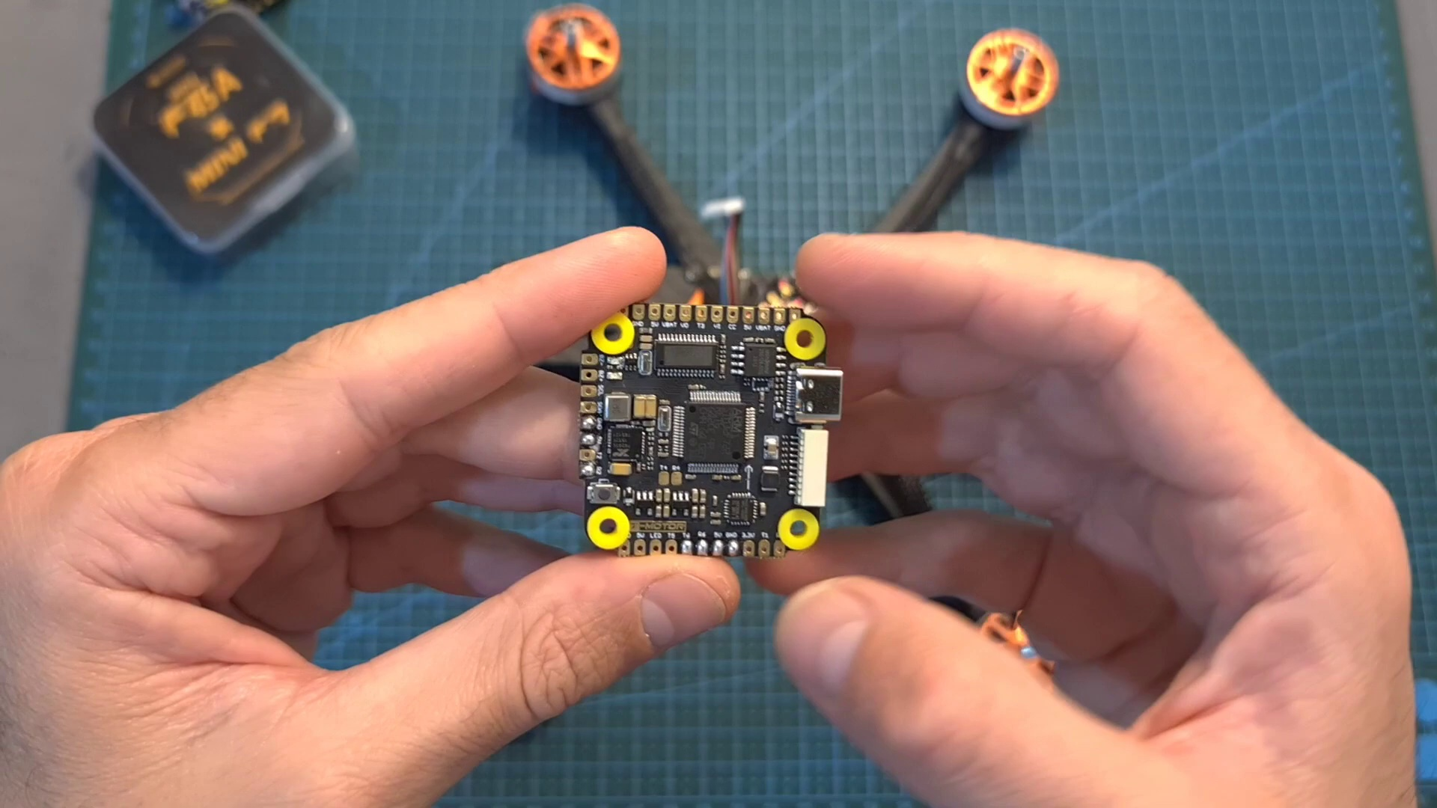 | 
Topic T2: T-Motor Pacer F7 Flight Controller — score 90.0000
Description: Detailed look at the flight controller's specs, features, and setup guidelines.
Reason: The comment directly discusses the features, specifications, and setup of the T-Motor Pacer F7 Flight Controller, mirroring the topic description's focus on the flight controller's characteristics.
 |  | 
Topic T3: T-Motor 20x20mm Stack Setup — score 85.0000
Description: Guidelines for setting up the stack using digital and analog systems, including connecting a DJI air unit and ready receiver.
Reason: The comment directly discusses the mini stack's features, specs, setup, and connections, which are all covered in the topic description. The specific overlaps include mentions of setting up using digital and analog systems, discussing voltage intake and outtake, connectors, amperage, sensors, and powering requirements.
 |  | 
Topic T4: Pacer F7 Flight Controller Comparison — score 80.0000
Description: Comparison of the Pacer F7 flight controller to other options, highlighting its features and compatibility with DJI air units.
Reason: {
"correlated": true,
"score": 80,
"reason": "The comment provides a detailed walkthrough of the video's content, mentioning specific devices/components (f7 flight controller, stack motor, ready receiver), settings (voltage intake and outtake, connectors, amperage, sensors), and parameters (weight of components). The language used is similar to the topic description, focusing on summarizing the ma
 |  | 
Topic T1: Introduction — score 80.0000
Description: Overview of the T-Motor Pacer F7 flight controller and 20x20mm stack, including features and specs.
Reason: The comment directly discusses the features, specs, setup, and connections of the f7 flight controller, stack motor, and pacer f7 processor, which are all mentioned in the topic description.
Least correlated topics:
 |  | 
Topic T1: Introduction — score 80.0000
Description: Overview of the T-Motor Pacer F7 flight controller and 20x20mm stack, including features and specs.
Reason: The comment directly discusses the features, specs, setup, and connections of the f7 flight controller, stack motor, and pacer f7 processor, which are all mentioned in the topic description.
 |  | 
Topic T4: Pacer F7 Flight Controller Comparison — score 80.0000
Description: Comparison of the Pacer F7 flight controller to other options, highlighting its features and compatibility with DJI air units.
Reason: {
"correlated": true,
"score": 80,
"reason": "The comment provides a detailed walkthrough of the video's content, mentioning specific devices/components (f7 flight controller, stack motor, ready receiver), settings (voltage intake and outtake, connectors, amperage, sensors), and parameters (weight of components). The language used is similar to the topic description, focusing on summarizing the ma
 |  | 
Topic T3: T-Motor 20x20mm Stack Setup — score 85.0000
Description: Guidelines for setting up the stack using digital and analog systems, including connecting a DJI air unit and ready receiver.
Reason: The comment directly discusses the mini stack's features, specs, setup, and connections, which are all covered in the topic description. The specific overlaps include mentions of setting up using digital and analog systems, discussing voltage intake and outtake, connectors, amperage, sensors, and powering requirements.
 |  | 
Topic T2: T-Motor Pacer F7 Flight Controller — score 90.0000
Description: Detailed look at the flight controller's specs, features, and setup guidelines.
Reason: The comment directly discusses the features, specifications, and setup of the T-Motor Pacer F7 Flight Controller, mirroring the topic description's focus on the flight controller's characteristics.
- matched 2 topic(s), max score 90.0000: This video talked about a dji F7 controller Mini F45A 20mm Stack. In the video, he went over their features and how to set them up using both digital and analog systems. The flight controller features an f7 processor and usb type-c connector. The flight controller was using 30.5 by 3.5 mm m3 mounting holes that weights 8 grams. The dji air unit can be powered directly with up to 4s batteries. The receiver is wired to the pads on the back of the flight controller. We can power it using 3.3 or 5 volts. Overall, this video explained the features and pin setup for thw flight controller and Mini F45A stack. The downside of the ministack was that it is a little pricey. This video gave an in depth explanation that allowed for a better understanding of the usage of a mini flight controller and mini stack.
Source: https://www.youtube.com/watch?v=15cdyl2PU-E: T-Motor Pacer F7 Flight Controller & Mini F45A 20mm Stack - Setup & Overview Summary
Top correlated topics:
 |  | 
Topic T3: T-Motor 20x20mm Stack Setup — score 90.0000
Description: Guidelines for setting up the stack using digital and analog systems, including connecting a DJI air unit and ready receiver.
Reason: The comment directly discusses the same features (F7 processor, USB type-c connector, mounting holes) and settings (powering with up to 4s batteries) described by the topic, with a detailed explanation of the mini flight controller and mini stack's capabilities.
 |  | 
Topic T2: T-Motor Pacer F7 Flight Controller — score 80.0000
Description: Detailed look at the flight controller's specs, features, and setup guidelines.
Reason: The comment directly discusses the features and specifications of a flight controller, including processor, connector, mounting holes, weight, power options, and pin setup, which are all closely related to the topic's description.
 |  | 
Topic T4: Pacer F7 Flight Controller Comparison — score 20.0000
Description: Comparison of the Pacer F7 flight controller to other options, highlighting its features and compatibility with DJI air units.
Reason: The comment discusses specific details about the DJI F7 controller and Mini F45A stack, including features, setup, and usage. While it mentions the video's conclusion, the focus is on the technical aspects rather than summarizing or discussing the overall goals or claims of the topic.
 |  | 
Topic T1: Introduction — score 20.0000
Description: Overview of the T-Motor Pacer F7 flight controller and 20x20mm stack, including features and specs.
Reason: The topic is an introduction to the video, while the comment provides a detailed discussion of a specific DJI product and its features. Although the comment mentions the video's content, it does not directly discuss the same steps, objects, settings, parameters, claims, or goals described by the topic.
Least correlated topics:
 |  | 
Topic T1: Introduction — score 20.0000
Description: Overview of the T-Motor Pacer F7 flight controller and 20x20mm stack, including features and specs.
Reason: The topic is an introduction to the video, while the comment provides a detailed discussion of a specific DJI product and its features. Although the comment mentions the video's content, it does not directly discuss the same steps, objects, settings, parameters, claims, or goals described by the topic.
 |  | 
Topic T4: Pacer F7 Flight Controller Comparison — score 20.0000
Description: Comparison of the Pacer F7 flight controller to other options, highlighting its features and compatibility with DJI air units.
Reason: The comment discusses specific details about the DJI F7 controller and Mini F45A stack, including features, setup, and usage. While it mentions the video's conclusion, the focus is on the technical aspects rather than summarizing or discussing the overall goals or claims of the topic.
 |  | 
Topic T2: T-Motor Pacer F7 Flight Controller — score 80.0000
Description: Detailed look at the flight controller's specs, features, and setup guidelines.
Reason: The comment directly discusses the features and specifications of a flight controller, including processor, connector, mounting holes, weight, power options, and pin setup, which are all closely related to the topic's description.
 |  | 
Topic T3: T-Motor 20x20mm Stack Setup — score 90.0000
Description: Guidelines for setting up the stack using digital and analog systems, including connecting a DJI air unit and ready receiver.
Reason: The comment directly discusses the same features (F7 processor, USB type-c connector, mounting holes) and settings (powering with up to 4s batteries) described by the topic, with a detailed explanation of the mini flight controller and mini stack's capabilities.

Topic T1: Introduction
 |  | 
Description: Overview of the T-Motor Pacer F7 flight controller and 20x20mm stack, including features and specs.
Comment (score 80): This video begins by introducing an f7 flight controller and stack t-motor. The main subjects that are gone over is the features and specs of these devices/components and we are shown how to set them up using both digital and analog systems. First, we go into packaging with the stack motor. The video shows the contents within the packaging and gives a high-level explanation of them. Next is the specifications. We are told about its voltage intake and outtake, connectors and what they are dedicated to, amperage, sensors, and more. Now the video goes into the guidelines portion. We are given the requirements and ways to connect the ready receiver. Such as it can be powered with either 3.3 or 5V, bridge the center pad with either the right or left one, if you leave it unbridged then the ready receiver will not be powered, etc. Next the creator goes into the stack and it shows you the information and process needed to power this and connect it properly. Now we go into the pacer f7 processor. It shows the pins that are needed for connection along with voltage needed. Next, we are given the detailed weight of the components and then we flow into connection to give an overview of the connections needing to be made. After this, the creator talks on the receiver briefly and then ends off with the analog setup and its details needed.
Reason: The comment directly discusses the features, specs, setup, and connections of the f7 flight controller, stack motor, and pacer f7 processor, which are all mentioned in the topic description.
Source: https://www.youtube.com/watch?v=15cdyl2PU-E :T-Motor Pacer F7 Flight Controller & Mini F45A 20mm Stack - Setup & Overview

Topic T2: T-Motor Pacer F7 Flight Controller
 |  | 
Description: Detailed look at the flight controller's specs, features, and setup guidelines.
Comment (score 90): This video begins by introducing an f7 flight controller and stack t-motor. The main subjects that are gone over is the features and specs of these devices/components and we are shown how to set them up using both digital and analog systems. First, we go into packaging with the stack motor. The video shows the contents within the packaging and gives a high-level explanation of them. Next is the specifications. We are told about its voltage intake and outtake, connectors and what they are dedicated to, amperage, sensors, and more. Now the video goes into the guidelines portion. We are given the requirements and ways to connect the ready receiver. Such as it can be powered with either 3.3 or 5V, bridge the center pad with either the right or left one, if you leave it unbridged then the ready receiver will not be powered, etc. Next the creator goes into the stack and it shows you the information and process needed to power this and connect it properly. Now we go into the pacer f7 processor. It shows the pins that are needed for connection along with voltage needed. Next, we are given the detailed weight of the components and then we flow into connection to give an overview of the connections needing to be made. After this, the creator talks on the receiver briefly and then ends off with the analog setup and its details needed.
Reason: The comment directly discusses the features, specifications, and setup of the T-Motor Pacer F7 Flight Controller, mirroring the topic description's focus on the flight controller's characteristics.
Source: https://www.youtube.com/watch?v=15cdyl2PU-E :T-Motor Pacer F7 Flight Controller & Mini F45A 20mm Stack - Setup & Overview
Comment (score 80): This video talked about a dji F7 controller Mini F45A 20mm Stack. In the video, he went over their features and how to set them up using both digital and analog systems. The flight controller features an f7 processor and usb type-c connector. The flight controller was using 30.5 by 3.5 mm m3 mounting holes that weights 8 grams. The dji air unit can be powered directly with up to 4s batteries. The receiver is wired to the pads on the back of the flight controller. We can power it using 3.3 or 5 volts. Overall, this video explained the features and pin setup for thw flight controller and Mini F45A stack. The downside of the ministack was that it is a little pricey. This video gave an in depth explanation that allowed for a better understanding of the usage of a mini flight controller and mini stack.
Reason: The comment directly discusses the features and specifications of a flight controller, including processor, connector, mounting holes, weight, power options, and pin setup, which are all closely related to the topic's description.
Source: https://www.youtube.com/watch?v=15cdyl2PU-E: T-Motor Pacer F7 Flight Controller & Mini F45A 20mm Stack - Setup & Overview Summary

Topic T3: T-Motor 20x20mm Stack Setup
 |  | 
Description: Guidelines for setting up the stack using digital and analog systems, including connecting a DJI air unit and ready receiver.
Comment (score 90): This video talked about a dji F7 controller Mini F45A 20mm Stack. In the video, he went over their features and how to set them up using both digital and analog systems. The flight controller features an f7 processor and usb type-c connector. The flight controller was using 30.5 by 3.5 mm m3 mounting holes that weights 8 grams. The dji air unit can be powered directly with up to 4s batteries. The receiver is wired to the pads on the back of the flight controller. We can power it using 3.3 or 5 volts. Overall, this video explained the features and pin setup for thw flight controller and Mini F45A stack. The downside of the ministack was that it is a little pricey. This video gave an in depth explanation that allowed for a better understanding of the usage of a mini flight controller and mini stack.
Reason: The comment directly discusses the same features (F7 processor, USB type-c connector, mounting holes) and settings (powering with up to 4s batteries) described by the topic, with a detailed explanation of the mini flight controller and mini stack's capabilities.
Source: https://www.youtube.com/watch?v=15cdyl2PU-E: T-Motor Pacer F7 Flight Controller & Mini F45A 20mm Stack - Setup & Overview Summary
Comment (score 85): This video begins by introducing an f7 flight controller and stack t-motor. The main subjects that are gone over is the features and specs of these devices/components and we are shown how to set them up using both digital and analog systems. First, we go into packaging with the stack motor. The video shows the contents within the packaging and gives a high-level explanation of them. Next is the specifications. We are told about its voltage intake and outtake, connectors and what they are dedicated to, amperage, sensors, and more. Now the video goes into the guidelines portion. We are given the requirements and ways to connect the ready receiver. Such as it can be powered with either 3.3 or 5V, bridge the center pad with either the right or left one, if you leave it unbridged then the ready receiver will not be powered, etc. Next the creator goes into the stack and it shows you the information and process needed to power this and connect it properly. Now we go into the pacer f7 processor. It shows the pins that are needed for connection along with voltage needed. Next, we are given the detailed weight of the components and then we flow into connection to give an overview of the connections needing to be made. After this, the creator talks on the receiver briefly and then ends off with the analog setup and its details needed.
Reason: The comment directly discusses the mini stack's features, specs, setup, and connections, which are all covered in the topic description. The specific overlaps include mentions of setting up using digital and analog systems, discussing voltage intake and outtake, connectors, amperage, sensors, and powering requirements.
Source: https://www.youtube.com/watch?v=15cdyl2PU-E :T-Motor Pacer F7 Flight Controller & Mini F45A 20mm Stack - Setup & Overview

Topic T4: Pacer F7 Flight Controller Comparison
 |  | 
Description: Comparison of the Pacer F7 flight controller to other options, highlighting its features and compatibility with DJI air units.
No strongly correlated comments found for this topic.

Topic T5: Mini Stack Overview
 |  | 
Description: Overview of the mini stack's features, specs, and potential uses in a light 5-inch build.
No strongly correlated comments found for this topic.

Topic T6: Conclusion and Final Thoughts
 |  | 
Description: Summary of the video's key points, along with final thoughts on the T-Motor Pacer F7 flight controller and mini stack.
No strongly correlated comments found for this topic.

