Comment–Topic Correlation Report
Model: llama3

Summary
Topics processed: 9
Comments available for this video: 1
Comments correlated to ≥ 60: 1 (100.0%)
Total candidate pairs checked: 6

Most/Least correlated topics (by average score across correlated comments):
Top 3:
• Topic T3: Quadcopter Build — avg 90.00, contributions 1
• Topic T6: Temperature Control — avg 80.00, contributions 1
• Topic T5: Soldering Safety — avg 80.00, contributions 1
Bottom 3:
• Topic T7: Topic 1: Careful Analysis — avg 0.00, contributions 0
• Topic T8: Topic 2: Soldering and Repair — avg 0.00, contributions 0
• Topic T9: Topic 3: Camera Installation — avg 0.00, contributions 0
Correlated comment coverage (all comments):
- matched 6 topic(s), max score 90.0000: rank8, This video was like hitting the easy button on building the Tyro69 quadcopter. It was a full- on beginner's guide that walked through everything without making my head spin. They showed how to wield a soldering iron like a pro, with a nod to some seriously cool tools, like that on-the- go soldering iron and the hex drivers that look like they'd last a lifetime. It was all about getting the details right, from sticking the ESCs in the right spot to making sure the motor wires were not just connected but looking neat too. And the tips on installing the wires, popping on the capacitor, and getting the receiver hooked up to the flight controller were gold – clear, concise, and totally doable. They even made sure to point out how to tuck in the camera, VTX, and receiver so they'd stay put. I'm feeling pretty good about putting together a Tyro69 that's solid and looks clean, with no solder drama on the flight controller and everything else in its perfect place. Plus, the final look with the 20x20 stack is just sweet. All in all, it's a solid guide that could be very helpful If I wanted to make one of these in the future.
Source: https://www.youtube.com/watch?v=31ArBvYoG2Q: “Beginner Guide // How To Build Budget Micro FPV Drone kit 2019 - Eachine Tyro69”
Top correlated topics:
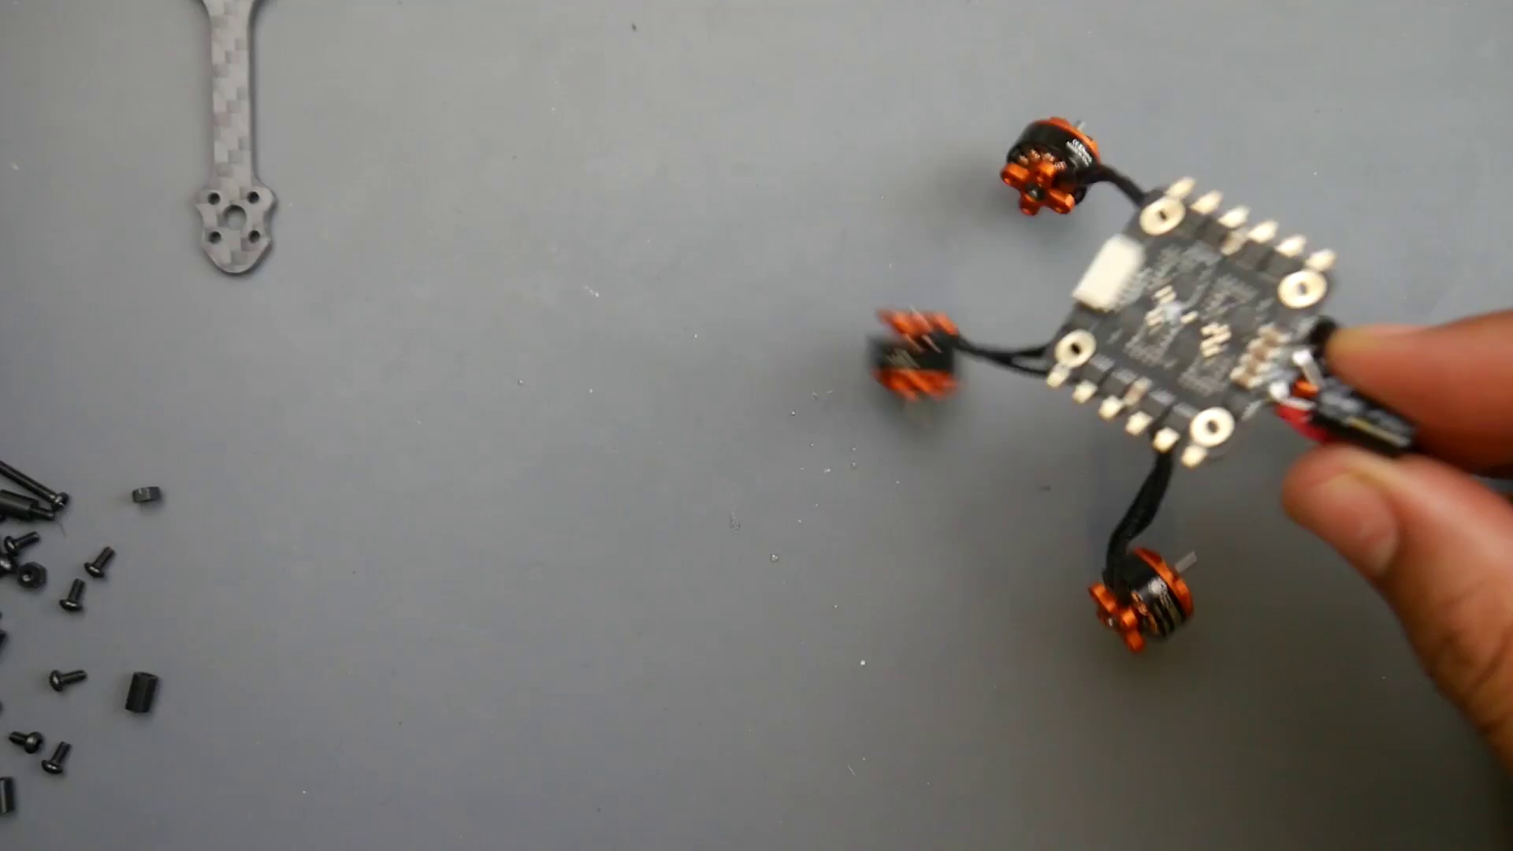 | 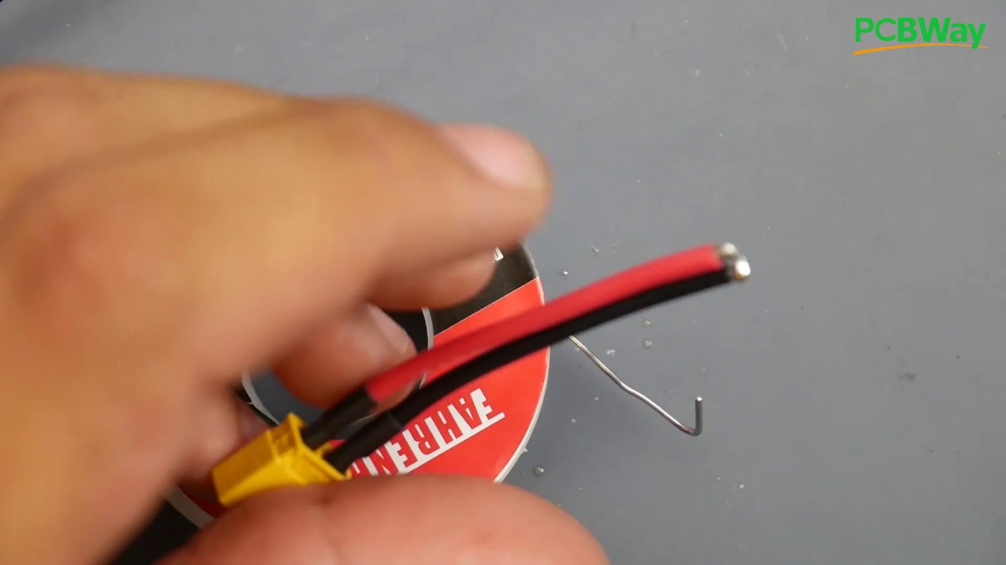 | 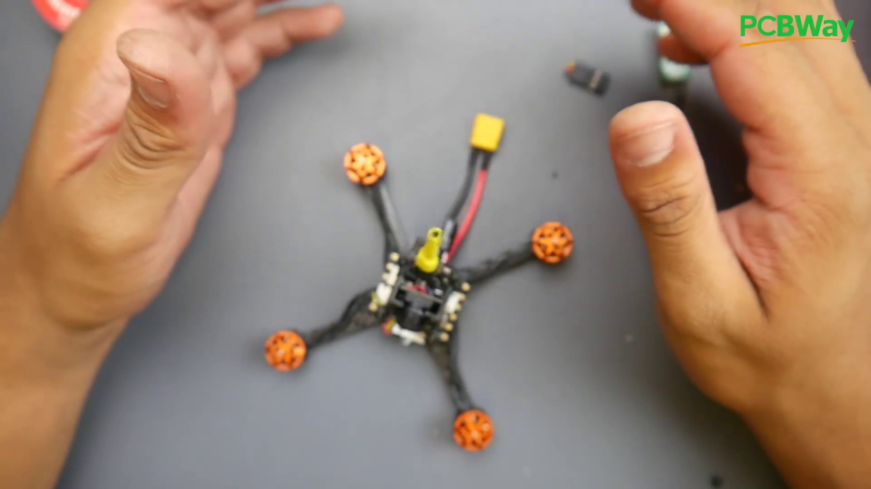
Topic T3: Quadcopter Build — score 90.0000
Description: The process of building a quadcopter, including component selection and placement.
Reason: The comment directly discusses the motor wires, ESCs, soldering iron, and installation tips, which are all key components of the topic 'Connecting the Motor Wires'. The commenter also mentions specific tools and settings described in the topic description.
 |  | 
Topic T6: Temperature Control — score 80.0000
Description: The importance of setting a suitable temperature for soldering and monitoring its effects.
Reason: The comment directly discusses building a Tyro69 quadcopter, mentioning specific steps like soldering, wiring, and component placement, which are all related to the topic's description of 'wrapping up the build'. The commenter also praises the guide for being clear and concise, making it likely that they were following along with the video's instructions.
 |  | 
Topic T5: Soldering Safety — score 80.0000
Description: The importance of caution when soldering, including avoiding overheating and ensuring proper heat transfer.
Reason: The comment specifically mentions steps and details discussed in the topic description, such as receiver placement, ESCs, motor wires, camera/VTX/receiver tucking, and flight controller setup.
 |  | 
Topic T4: Soldering Process — score 80.0000
Description: The importance of proper soldering technique, including cleaning and heating the area before soldering.
Reason: The comment discusses specific steps and details mentioned in the topic description, such as securing the antenna, soldering iron techniques, and cable management. The mention of VTX, camera, receiver, and ESCs also shows a strong connection to the topic.
 |  | 
Topic T2: Component Selection — score 80.0000
Description: The selection of components for the quadcopter, including batteries and heat shrinks.
Reason: The comment directly discusses assembling the VTX and other components (ESC, motor wires, receiver, flight controller), matching the topic's description of building the video transmission system.
 |  | 
Topic T1: Component Placement — score 80.0000
Description: The placement of components on the quadcopter, including the receiver and flight controller.
Reason: The comment directly discusses the same steps and details described by the topic, such as building a Tyro69 quadcopter, using specific tools, and getting the wiring and components installed correctly.
Least correlated topics:
 |  | 
Topic T1: Component Placement — score 80.0000
Description: The placement of components on the quadcopter, including the receiver and flight controller.
Reason: The comment directly discusses the same steps and details described by the topic, such as building a Tyro69 quadcopter, using specific tools, and getting the wiring and components installed correctly.
 |  | 
Topic T2: Component Selection — score 80.0000
Description: The selection of components for the quadcopter, including batteries and heat shrinks.
Reason: The comment directly discusses assembling the VTX and other components (ESC, motor wires, receiver, flight controller), matching the topic's description of building the video transmission system.
 |  | 
Topic T4: Soldering Process — score 80.0000
Description: The importance of proper soldering technique, including cleaning and heating the area before soldering.
Reason: The comment discusses specific steps and details mentioned in the topic description, such as securing the antenna, soldering iron techniques, and cable management. The mention of VTX, camera, receiver, and ESCs also shows a strong connection to the topic.
 |  | 
Topic T5: Soldering Safety — score 80.0000
Description: The importance of caution when soldering, including avoiding overheating and ensuring proper heat transfer.
Reason: The comment specifically mentions steps and details discussed in the topic description, such as receiver placement, ESCs, motor wires, camera/VTX/receiver tucking, and flight controller setup.
 |  | 
Topic T6: Temperature Control — score 80.0000
Description: The importance of setting a suitable temperature for soldering and monitoring its effects.
Reason: The comment directly discusses building a Tyro69 quadcopter, mentioning specific steps like soldering, wiring, and component placement, which are all related to the topic's description of 'wrapping up the build'. The commenter also praises the guide for being clear and concise, making it likely that they were following along with the video's instructions.
 |  | 
Topic T3: Quadcopter Build — score 90.0000
Description: The process of building a quadcopter, including component selection and placement.
Reason: The comment directly discusses the motor wires, ESCs, soldering iron, and installation tips, which are all key components of the topic 'Connecting the Motor Wires'. The commenter also mentions specific tools and settings described in the topic description.

Topic T1: Component Placement
 |  | 
Description: The placement of components on the quadcopter, including the receiver and flight controller.
Comment (score 80): rank8, This video was like hitting the easy button on building the Tyro69 quadcopter. It was a full- on beginner's guide that walked through everything without making my head spin. They showed how to wield a soldering iron like a pro, with a nod to some seriously cool tools, like that on-the- go soldering iron and the hex drivers that look like they'd last a lifetime. It was all about getting the details right, from sticking the ESCs in the right spot to making sure the motor wires were not just connected but looking neat too. And the tips on installing the wires, popping on the capacitor, and getting the receiver hooked up to the flight controller were gold – clear, concise, and totally doable. They even made sure to point out how to tuck in the camera, VTX, and receiver so they'd stay put. I'm feeling pretty good about putting together a Tyro69 that's solid and looks clean, with no solder drama on the flight controller and everything else in its perfect place. Plus, the final look with the 20x20 stack is just sweet. All in all, it's a solid guide that could be very helpful If I wanted to make one of these in the future.
Reason: The comment directly discusses the same steps and details described by the topic, such as building a Tyro69 quadcopter, using specific tools, and getting the wiring and components installed correctly.
Source: https://www.youtube.com/watch?v=31ArBvYoG2Q: “Beginner Guide // How To Build Budget Micro FPV Drone kit 2019 - Eachine Tyro69”

Topic T2: Component Selection
 |  | 
Description: The selection of components for the quadcopter, including batteries and heat shrinks.
Comment (score 80): rank8, This video was like hitting the easy button on building the Tyro69 quadcopter. It was a full- on beginner's guide that walked through everything without making my head spin. They showed how to wield a soldering iron like a pro, with a nod to some seriously cool tools, like that on-the- go soldering iron and the hex drivers that look like they'd last a lifetime. It was all about getting the details right, from sticking the ESCs in the right spot to making sure the motor wires were not just connected but looking neat too. And the tips on installing the wires, popping on the capacitor, and getting the receiver hooked up to the flight controller were gold – clear, concise, and totally doable. They even made sure to point out how to tuck in the camera, VTX, and receiver so they'd stay put. I'm feeling pretty good about putting together a Tyro69 that's solid and looks clean, with no solder drama on the flight controller and everything else in its perfect place. Plus, the final look with the 20x20 stack is just sweet. All in all, it's a solid guide that could be very helpful If I wanted to make one of these in the future.
Reason: The comment directly discusses assembling the VTX and other components (ESC, motor wires, receiver, flight controller), matching the topic's description of building the video transmission system.
Source: https://www.youtube.com/watch?v=31ArBvYoG2Q: “Beginner Guide // How To Build Budget Micro FPV Drone kit 2019 - Eachine Tyro69”

Topic T3: Quadcopter Build
 |  | 
Description: The process of building a quadcopter, including component selection and placement.
Comment (score 90): rank8, This video was like hitting the easy button on building the Tyro69 quadcopter. It was a full- on beginner's guide that walked through everything without making my head spin. They showed how to wield a soldering iron like a pro, with a nod to some seriously cool tools, like that on-the- go soldering iron and the hex drivers that look like they'd last a lifetime. It was all about getting the details right, from sticking the ESCs in the right spot to making sure the motor wires were not just connected but looking neat too. And the tips on installing the wires, popping on the capacitor, and getting the receiver hooked up to the flight controller were gold – clear, concise, and totally doable. They even made sure to point out how to tuck in the camera, VTX, and receiver so they'd stay put. I'm feeling pretty good about putting together a Tyro69 that's solid and looks clean, with no solder drama on the flight controller and everything else in its perfect place. Plus, the final look with the 20x20 stack is just sweet. All in all, it's a solid guide that could be very helpful If I wanted to make one of these in the future.
Reason: The comment directly discusses the motor wires, ESCs, soldering iron, and installation tips, which are all key components of the topic 'Connecting the Motor Wires'. The commenter also mentions specific tools and settings described in the topic description.
Source: https://www.youtube.com/watch?v=31ArBvYoG2Q: “Beginner Guide // How To Build Budget Micro FPV Drone kit 2019 - Eachine Tyro69”

Topic T4: Soldering Process
 |  | 
Description: The importance of proper soldering technique, including cleaning and heating the area before soldering.
Comment (score 80): rank8, This video was like hitting the easy button on building the Tyro69 quadcopter. It was a full- on beginner's guide that walked through everything without making my head spin. They showed how to wield a soldering iron like a pro, with a nod to some seriously cool tools, like that on-the- go soldering iron and the hex drivers that look like they'd last a lifetime. It was all about getting the details right, from sticking the ESCs in the right spot to making sure the motor wires were not just connected but looking neat too. And the tips on installing the wires, popping on the capacitor, and getting the receiver hooked up to the flight controller were gold – clear, concise, and totally doable. They even made sure to point out how to tuck in the camera, VTX, and receiver so they'd stay put. I'm feeling pretty good about putting together a Tyro69 that's solid and looks clean, with no solder drama on the flight controller and everything else in its perfect place. Plus, the final look with the 20x20 stack is just sweet. All in all, it's a solid guide that could be very helpful If I wanted to make one of these in the future.
Reason: The comment discusses specific steps and details mentioned in the topic description, such as securing the antenna, soldering iron techniques, and cable management. The mention of VTX, camera, receiver, and ESCs also shows a strong connection to the topic.
Source: https://www.youtube.com/watch?v=31ArBvYoG2Q: “Beginner Guide // How To Build Budget Micro FPV Drone kit 2019 - Eachine Tyro69”

Topic T5: Soldering Safety
 |  | 
Description: The importance of caution when soldering, including avoiding overheating and ensuring proper heat transfer.
Comment (score 80): rank8, This video was like hitting the easy button on building the Tyro69 quadcopter. It was a full- on beginner's guide that walked through everything without making my head spin. They showed how to wield a soldering iron like a pro, with a nod to some seriously cool tools, like that on-the- go soldering iron and the hex drivers that look like they'd last a lifetime. It was all about getting the details right, from sticking the ESCs in the right spot to making sure the motor wires were not just connected but looking neat too. And the tips on installing the wires, popping on the capacitor, and getting the receiver hooked up to the flight controller were gold – clear, concise, and totally doable. They even made sure to point out how to tuck in the camera, VTX, and receiver so they'd stay put. I'm feeling pretty good about putting together a Tyro69 that's solid and looks clean, with no solder drama on the flight controller and everything else in its perfect place. Plus, the final look with the 20x20 stack is just sweet. All in all, it's a solid guide that could be very helpful If I wanted to make one of these in the future.
Reason: The comment specifically mentions steps and details discussed in the topic description, such as receiver placement, ESCs, motor wires, camera/VTX/receiver tucking, and flight controller setup.
Source: https://www.youtube.com/watch?v=31ArBvYoG2Q: “Beginner Guide // How To Build Budget Micro FPV Drone kit 2019 - Eachine Tyro69”

Topic T6: Temperature Control
 |  | 
Description: The importance of setting a suitable temperature for soldering and monitoring its effects.
Comment (score 80): rank8, This video was like hitting the easy button on building the Tyro69 quadcopter. It was a full- on beginner's guide that walked through everything without making my head spin. They showed how to wield a soldering iron like a pro, with a nod to some seriously cool tools, like that on-the- go soldering iron and the hex drivers that look like they'd last a lifetime. It was all about getting the details right, from sticking the ESCs in the right spot to making sure the motor wires were not just connected but looking neat too. And the tips on installing the wires, popping on the capacitor, and getting the receiver hooked up to the flight controller were gold – clear, concise, and totally doable. They even made sure to point out how to tuck in the camera, VTX, and receiver so they'd stay put. I'm feeling pretty good about putting together a Tyro69 that's solid and looks clean, with no solder drama on the flight controller and everything else in its perfect place. Plus, the final look with the 20x20 stack is just sweet. All in all, it's a solid guide that could be very helpful If I wanted to make one of these in the future.
Reason: The comment directly discusses building a Tyro69 quadcopter, mentioning specific steps like soldering, wiring, and component placement, which are all related to the topic's description of 'wrapping up the build'. The commenter also praises the guide for being clear and concise, making it likely that they were following along with the video's instructions.
Source: https://www.youtube.com/watch?v=31ArBvYoG2Q: “Beginner Guide // How To Build Budget Micro FPV Drone kit 2019 - Eachine Tyro69”

Topic T7: Topic 1: Careful Analysis
 |  | 
Description: The importance of careful analysis in various contexts.
No strongly correlated comments found for this topic.

Topic T8: Topic 2: Soldering and Repair
 |  | 
Description: The challenges of soldering and repairing delicate components.
No strongly correlated comments found for this topic.

Topic T9: Topic 3: Camera Installation
 |  | 
Description: The process of installing a camera and adjusting its position.
No strongly correlated comments found for this topic.

