Comment–Topic Correlation Report
Model: llama3

Summary
Topics processed: 8
Comments available for this video: 1
Comments correlated to ≥ 60: 1 (100.0%)
Total candidate pairs checked: 4

Most/Least correlated topics (by average score across correlated comments):
Top 3:
• Topic T1: Introduction — avg 90.00, contributions 1
• Topic T4: Wiring the Bottom Layer and Vias — avg 80.00, contributions 1
• Topic T2: Designing the PCB — avg 80.00, contributions 1
Bottom 3:
• Topic T8: Conclusion — avg 0.00, contributions 0
• Topic T6: Gerber Files and Ordering the PCB — avg 0.00, contributions 0
• Topic T5: Ground Connections — avg 0.00, contributions 0
Correlated comment coverage (all comments):
- matched 3 topic(s), max score 90.0000: The design process involves starting with an idea, creating a paper schematic, building the schematic in EasyEDA, switching to PCB mode, and finalizing the PCB layout.
Source: https://www.youtube.com/watch?v=35YuILUlfGs: From Idea to Schematic to PCB: How to do it easily!
Top correlated topics:
 | 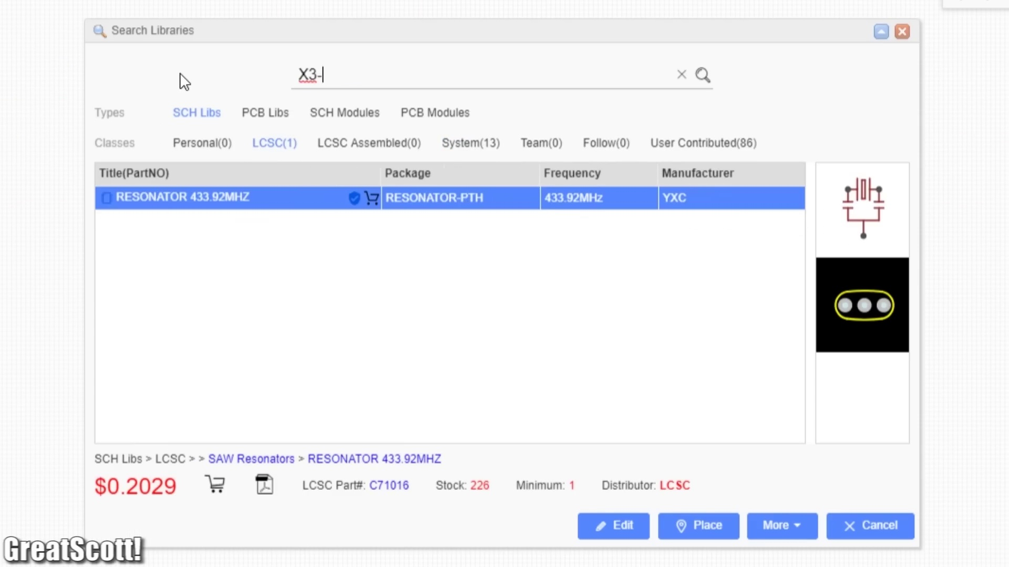 | 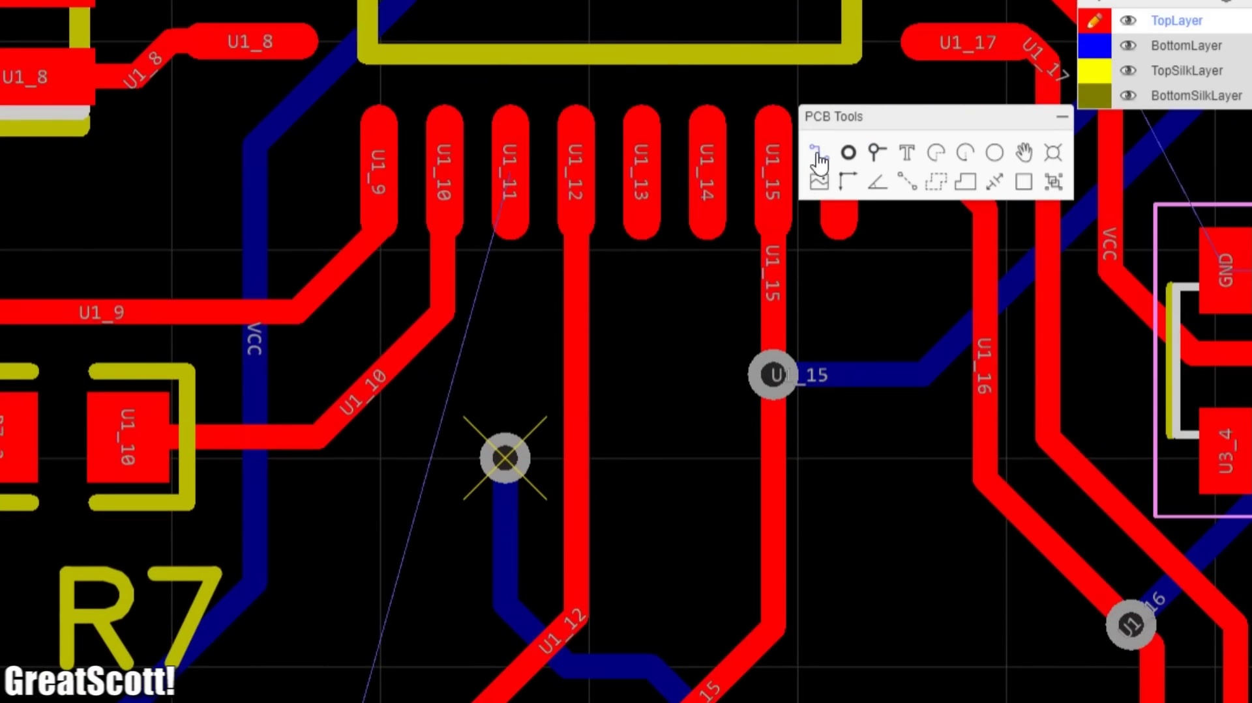
Topic T1: Introduction — score 90.0000
Description: Overview of the PCB design process
Reason: The comment directly discusses the steps involved in designing a PCB using EasyEDA, which is exactly what the topic description describes. The specific overlaps include creating a paper schematic, building the schematic in EasyEDA, and finalizing the PCB layout.
 |  | 
Topic T4: Wiring the Bottom Layer and Vias — score 80.0000
Description: Creating connections between layers for SMD components
Reason: The comment directly discusses the steps involved in finalizing a PCB design, including switching to PCB mode and finalizing the layout, which is highly related to the topic of generating Gerber files or ordering finished products from JLC PCB.
 |  | 
Topic T2: Designing the PCB — score 80.0000
Description: Creating the outline and connections for the board
Reason: The comment mentions creating a schematic in EasyEDA and switching to PCB mode, which overlaps with the topic's description of creating all possible connections on the top layer. Although it doesn't directly discuss the step of creating the top layer wiring, it provides context that is relevant to the topic.
 |  | 
Topic T3: Wiring the Top Layer — score 20.0000
Description: Connecting components on the top layer
Reason: The comment discusses a general design process, not specifically focused on the steps involved in creating the bottom layer wiring for THD and SMD components. The topic description is about wiring for those specific component types, but the comment does not mention these components or their wiring.
Least correlated topics:
 |  | 
Topic T3: Wiring the Top Layer — score 20.0000
Description: Connecting components on the top layer
Reason: The comment discusses a general design process, not specifically focused on the steps involved in creating the bottom layer wiring for THD and SMD components. The topic description is about wiring for those specific component types, but the comment does not mention these components or their wiring.
 |  | 
Topic T2: Designing the PCB — score 80.0000
Description: Creating the outline and connections for the board
Reason: The comment mentions creating a schematic in EasyEDA and switching to PCB mode, which overlaps with the topic's description of creating all possible connections on the top layer. Although it doesn't directly discuss the step of creating the top layer wiring, it provides context that is relevant to the topic.
 |  | 
Topic T4: Wiring the Bottom Layer and Vias — score 80.0000
Description: Creating connections between layers for SMD components
Reason: The comment directly discusses the steps involved in finalizing a PCB design, including switching to PCB mode and finalizing the layout, which is highly related to the topic of generating Gerber files or ordering finished products from JLC PCB.
 |  | 
Topic T1: Introduction — score 90.0000
Description: Overview of the PCB design process
Reason: The comment directly discusses the steps involved in designing a PCB using EasyEDA, which is exactly what the topic description describes. The specific overlaps include creating a paper schematic, building the schematic in EasyEDA, and finalizing the PCB layout.

Topic T1: Introduction
 |  | 
Description: Overview of the PCB design process
Comment (score 90): The design process involves starting with an idea, creating a paper schematic, building the schematic in EasyEDA, switching to PCB mode, and finalizing the PCB layout.
Reason: The comment directly discusses the steps involved in designing a PCB using EasyEDA, which is exactly what the topic description describes. The specific overlaps include creating a paper schematic, building the schematic in EasyEDA, and finalizing the PCB layout.
Source: https://www.youtube.com/watch?v=35YuILUlfGs: From Idea to Schematic to PCB: How to do it easily!

Topic T2: Designing the PCB
 |  | 
Description: Creating the outline and connections for the board
Comment (score 80): The design process involves starting with an idea, creating a paper schematic, building the schematic in EasyEDA, switching to PCB mode, and finalizing the PCB layout.
Reason: The comment mentions creating a schematic in EasyEDA and switching to PCB mode, which overlaps with the topic's description of creating all possible connections on the top layer. Although it doesn't directly discuss the step of creating the top layer wiring, it provides context that is relevant to the topic.
Source: https://www.youtube.com/watch?v=35YuILUlfGs: From Idea to Schematic to PCB: How to do it easily!

Topic T3: Wiring the Top Layer
 |  | 
Description: Connecting components on the top layer
No strongly correlated comments found for this topic.

Topic T4: Wiring the Bottom Layer and Vias
 |  | 
Description: Creating connections between layers for SMD components
Comment (score 80): The design process involves starting with an idea, creating a paper schematic, building the schematic in EasyEDA, switching to PCB mode, and finalizing the PCB layout.
Reason: The comment directly discusses the steps involved in finalizing a PCB design, including switching to PCB mode and finalizing the layout, which is highly related to the topic of generating Gerber files or ordering finished products from JLC PCB.
Source: https://www.youtube.com/watch?v=35YuILUlfGs: From Idea to Schematic to PCB: How to do it easily!

Topic T5: Ground Connections
 |  | 
Description: Isolating traces and creating a solid copper ground layer
No strongly correlated comments found for this topic.

Topic T6: Gerber Files and Ordering the PCB
 |  | 
Description: Generating Gerber files and ordering the board from JLC PCB
No strongly correlated comments found for this topic.

Topic T7: Soldering Tutorial
 |  | 
Description: A separate tutorial on soldering components to the PCB
No strongly correlated comments found for this topic.

Topic T8: Conclusion
 |  | 
Description: Final thoughts and next steps
No strongly correlated comments found for this topic.

