Comment–Topic Correlation Report
Model: llama3

Summary
Topics processed: 3
Comments available for this video: 1
Comments correlated to ≥ 60: 1 (100.0%)
Total candidate pairs checked: 3

Most/Least correlated topics (by average score across correlated comments):
Top 3:
• Topic T3: Plugging in Components — avg 90.00, contributions 1
• Topic T2: Components Needed for Binding — avg 90.00, contributions 1
• Topic T1: Binding FSIA6B Receiver to Transmitter — avg 90.00, contributions 1
Bottom 3:
• Topic T1: Binding FSIA6B Receiver to Transmitter — avg 90.00, contributions 1
• Topic T2: Components Needed for Binding — avg 90.00, contributions 1
• Topic T3: Plugging in Components — avg 90.00, contributions 1
Correlated comment coverage (all comments):
- matched 3 topic(s), max score 90.0000: This video opens up with the intent behind it, binding an fs-ia6b receiver to the transmitter of a FlySky. The creator goes on to tell you what you will need for this, an: ESC and battery to power the receiver and a bind key that activates the binding state of the receiver. Because of this, you will have to plug the bind key into the last port of the receiver that is used for input power. Then you must take the BEC wire of the ESC, which is the input power to the receiver, and plug it into any port on the receiver. The creator warns to make sure the signal (white) wire is facing upwards towards you. Lastly, he states to then plug the battery into the ESC and then the light in the receiver will begin to blink to represent it is in bind mode. He states that before turning the transmitter on to put all the switches up and the throttle down, press the bind key, and turn on the transmitter to show binding. He then states a few more facts and begins to wind up the video to a close.
Source: https://www.youtube.com/watch?v=3cFSNRG2xfA: FLYSKY Fs-i6X BINDING | Fs-ia6b RECIVER
Top correlated topics:
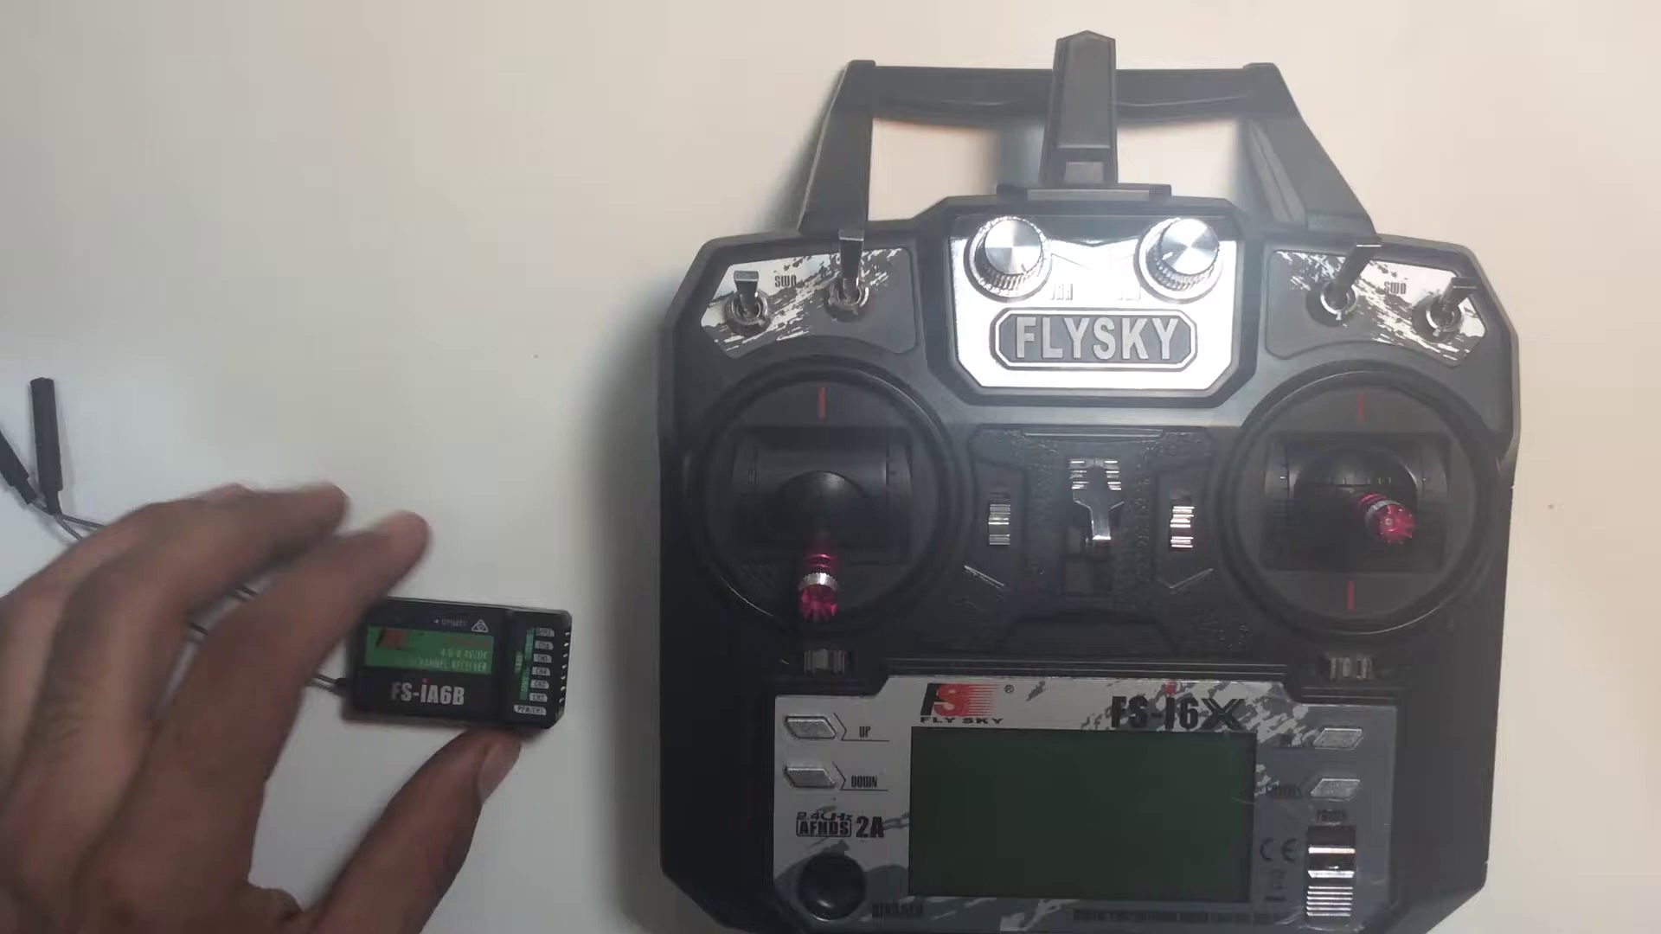 | 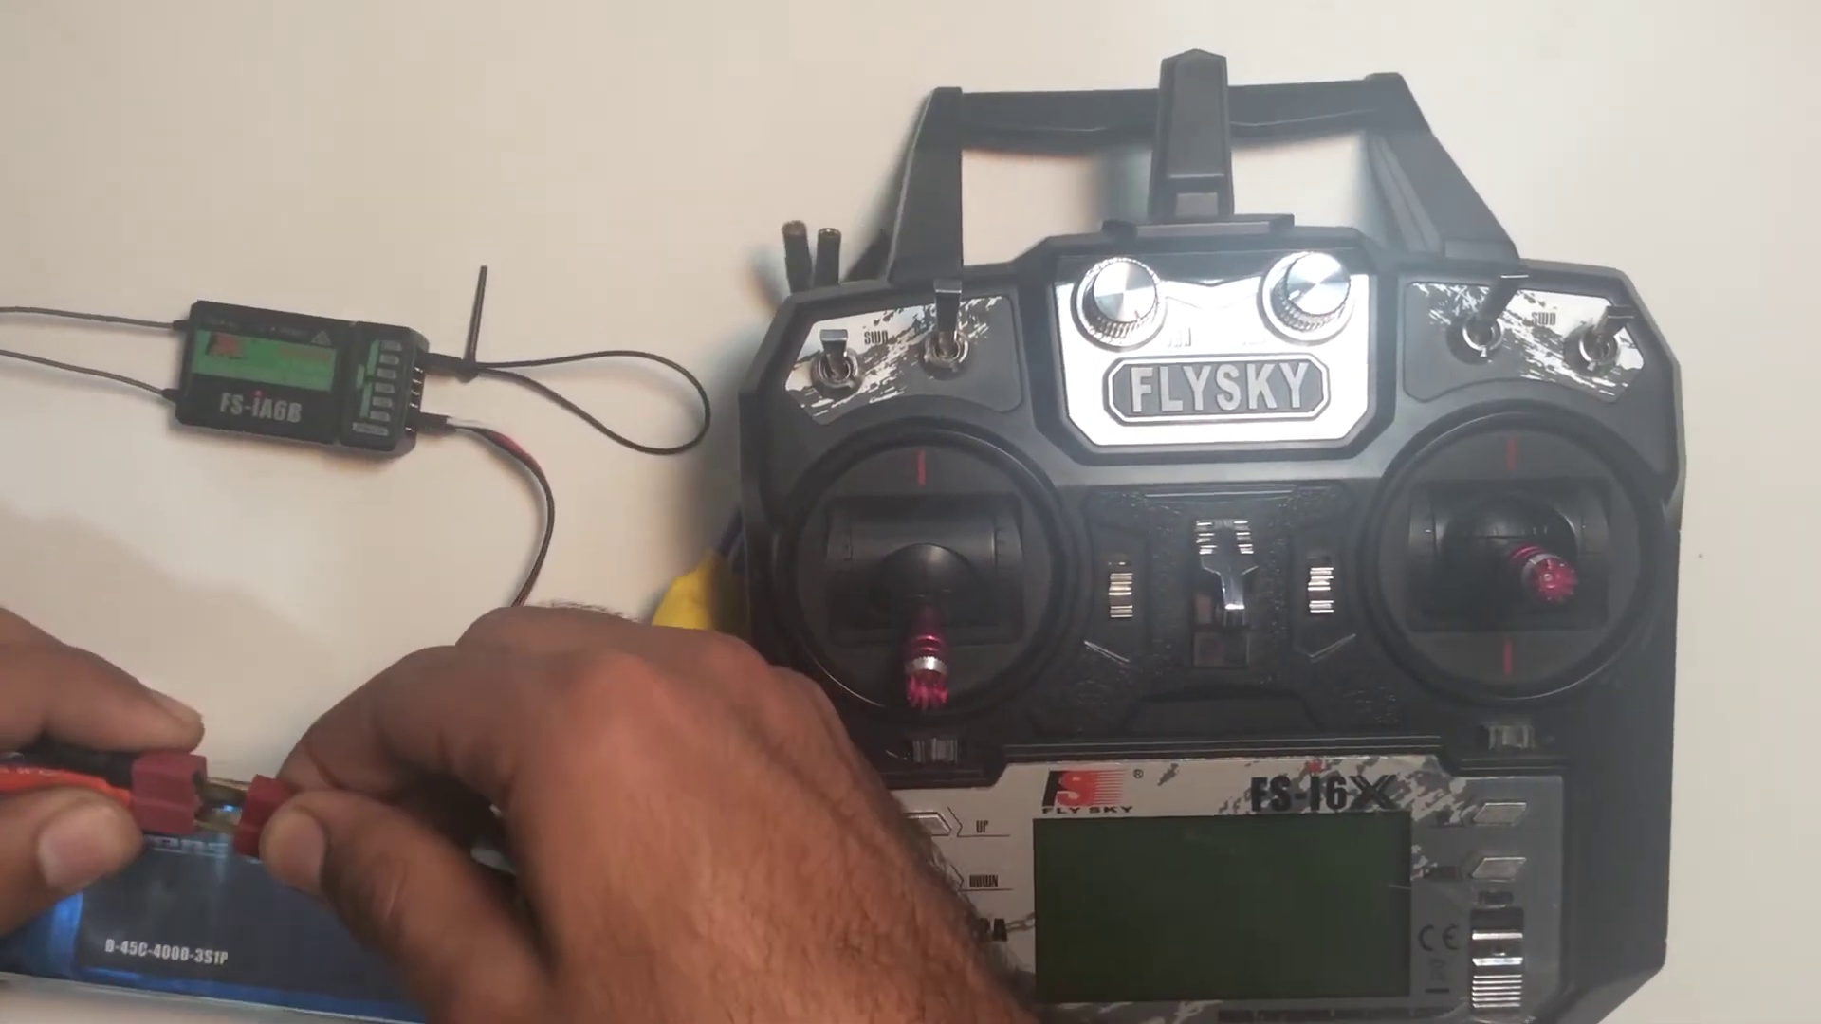 | 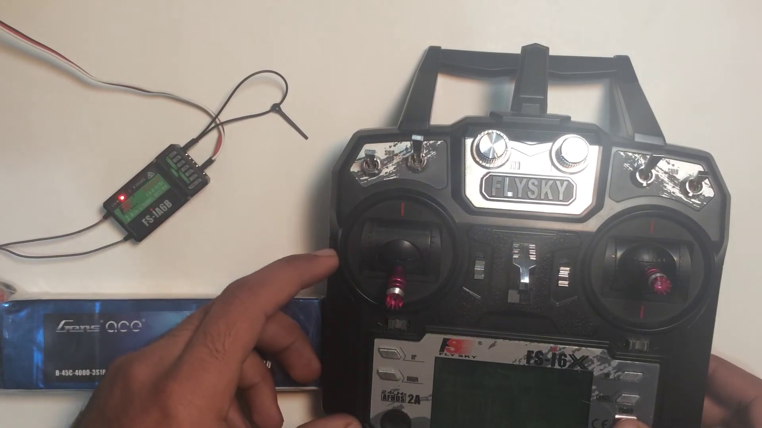
Topic T3: Plugging in Components — score 90.0000
Description: The speaker explains how to plug in the components, including the bind key into the receiver and the BEC wire from the ESC.
Reason: The comment directly discusses the steps described in the topic, including plugging in the BEC wire and the bind key into the receiver, as well as the binding process itself.
 |  | 
Topic T2: Components Needed for Binding — score 90.0000
Description: The speaker lists the necessary components required to bind the receiver, including an ESC, battery, and bind key.
Reason: The comment directly discusses the same components mentioned in the topic (ESC, battery, and bind key), as well as their specific roles and connections. The comment also mirrors the steps outlined in the topic description for binding an FS-IA6B receiver.
 |  | 
Topic T1: Binding FSIA6B Receiver to Transmitter — score 90.0000
Description: The speaker explains how to bind the FSIA6B receiver to a transmitter, including the necessary components and steps.
Reason: The comment directly discusses the same steps (binding the receiver to the transmitter using an ESC, battery, and bind key) and mentions specific details like plugging the BEC wire into any port on the receiver, making sure the signal wire is facing upwards, and pressing the bind key before turning on the transmitter.
Least correlated topics:
 |  | 
Topic T1: Binding FSIA6B Receiver to Transmitter — score 90.0000
Description: The speaker explains how to bind the FSIA6B receiver to a transmitter, including the necessary components and steps.
Reason: The comment directly discusses the same steps (binding the receiver to the transmitter using an ESC, battery, and bind key) and mentions specific details like plugging the BEC wire into any port on the receiver, making sure the signal wire is facing upwards, and pressing the bind key before turning on the transmitter.
 |  | 
Topic T2: Components Needed for Binding — score 90.0000
Description: The speaker lists the necessary components required to bind the receiver, including an ESC, battery, and bind key.
Reason: The comment directly discusses the same components mentioned in the topic (ESC, battery, and bind key), as well as their specific roles and connections. The comment also mirrors the steps outlined in the topic description for binding an FS-IA6B receiver.
 |  | 
Topic T3: Plugging in Components — score 90.0000
Description: The speaker explains how to plug in the components, including the bind key into the receiver and the BEC wire from the ESC.
Reason: The comment directly discusses the steps described in the topic, including plugging in the BEC wire and the bind key into the receiver, as well as the binding process itself.

Topic T1: Binding FSIA6B Receiver to Transmitter
 |  | 
Description: The speaker explains how to bind the FSIA6B receiver to a transmitter, including the necessary components and steps.
Comment (score 90): This video opens up with the intent behind it, binding an fs-ia6b receiver to the transmitter of a FlySky. The creator goes on to tell you what you will need for this, an: ESC and battery to power the receiver and a bind key that activates the binding state of the receiver. Because of this, you will have to plug the bind key into the last port of the receiver that is used for input power. Then you must take the BEC wire of the ESC, which is the input power to the receiver, and plug it into any port on the receiver. The creator warns to make sure the signal (white) wire is facing upwards towards you. Lastly, he states to then plug the battery into the ESC and then the light in the receiver will begin to blink to represent it is in bind mode. He states that before turning the transmitter on to put all the switches up and the throttle down, press the bind key, and turn on the transmitter to show binding. He then states a few more facts and begins to wind up the video to a close.
Reason: The comment directly discusses the same steps (binding the receiver to the transmitter using an ESC, battery, and bind key) and mentions specific details like plugging the BEC wire into any port on the receiver, making sure the signal wire is facing upwards, and pressing the bind key before turning on the transmitter.
Source: https://www.youtube.com/watch?v=3cFSNRG2xfA: FLYSKY Fs-i6X BINDING | Fs-ia6b RECIVER

Topic T2: Components Needed for Binding
 |  | 
Description: The speaker lists the necessary components required to bind the receiver, including an ESC, battery, and bind key.
Comment (score 90): This video opens up with the intent behind it, binding an fs-ia6b receiver to the transmitter of a FlySky. The creator goes on to tell you what you will need for this, an: ESC and battery to power the receiver and a bind key that activates the binding state of the receiver. Because of this, you will have to plug the bind key into the last port of the receiver that is used for input power. Then you must take the BEC wire of the ESC, which is the input power to the receiver, and plug it into any port on the receiver. The creator warns to make sure the signal (white) wire is facing upwards towards you. Lastly, he states to then plug the battery into the ESC and then the light in the receiver will begin to blink to represent it is in bind mode. He states that before turning the transmitter on to put all the switches up and the throttle down, press the bind key, and turn on the transmitter to show binding. He then states a few more facts and begins to wind up the video to a close.
Reason: The comment directly discusses the same components mentioned in the topic (ESC, battery, and bind key), as well as their specific roles and connections. The comment also mirrors the steps outlined in the topic description for binding an FS-IA6B receiver.
Source: https://www.youtube.com/watch?v=3cFSNRG2xfA: FLYSKY Fs-i6X BINDING | Fs-ia6b RECIVER

Topic T3: Plugging in Components
 |  | 
Description: The speaker explains how to plug in the components, including the bind key into the receiver and the BEC wire from the ESC.
Comment (score 90): This video opens up with the intent behind it, binding an fs-ia6b receiver to the transmitter of a FlySky. The creator goes on to tell you what you will need for this, an: ESC and battery to power the receiver and a bind key that activates the binding state of the receiver. Because of this, you will have to plug the bind key into the last port of the receiver that is used for input power. Then you must take the BEC wire of the ESC, which is the input power to the receiver, and plug it into any port on the receiver. The creator warns to make sure the signal (white) wire is facing upwards towards you. Lastly, he states to then plug the battery into the ESC and then the light in the receiver will begin to blink to represent it is in bind mode. He states that before turning the transmitter on to put all the switches up and the throttle down, press the bind key, and turn on the transmitter to show binding. He then states a few more facts and begins to wind up the video to a close.
Reason: The comment directly discusses the steps described in the topic, including plugging in the BEC wire and the bind key into the receiver, as well as the binding process itself.
Source: https://www.youtube.com/watch?v=3cFSNRG2xfA: FLYSKY Fs-i6X BINDING | Fs-ia6b RECIVER

