Comment–Topic Correlation Report
Model: llama3

Summary
Topics processed: 2
Comments available for this video: 4
Comments correlated to ≥ 60: 3 (75.0%)
Total candidate pairs checked: 16

Most/Least correlated topics (by average score across correlated comments):
Top 3:
• Topic T2: MOSFET Switching Speed and Frequency — avg 85.00, contributions 2
• Topic T1: MOSFET Heat-up Calculation — avg 85.00, contributions 2
Bottom 3:
• Topic T1: MOSFET Heat-up Calculation — avg 85.00, contributions 2
• Topic T2: MOSFET Switching Speed and Frequency — avg 85.00, contributions 2
Correlated comment coverage (all comments):
- matched 2 topic(s), max score 90.0000: One tip the speaker gives is the to include a gate resistor so that the input does not go directly into the MOSFET. Another benefit of the gate resistor is general ease of calculation; without it, the resistance and current in the connection to the MOSFET is more difficult to distinguish. Another necessity to a MOSFET circuit is a pull-down resistor connected to the MOSFET and ground and puts the MOSFET in a default state. The speaker also explains that a gate driver is the device used to power the MOFSET circuit on and off. The gate driver’s OUTH input sources the MOSFET while the OUTL input drains the MOSFET. The speaker in the video utilizes a simulation to better illustrate his ideas.
Source: https://www.youtube.com/watch?v=56p3_aORiJ0&t=22s: Designing Power MOSFET Circuits – Circuit Tips and Tricks
Top correlated topics:
 | 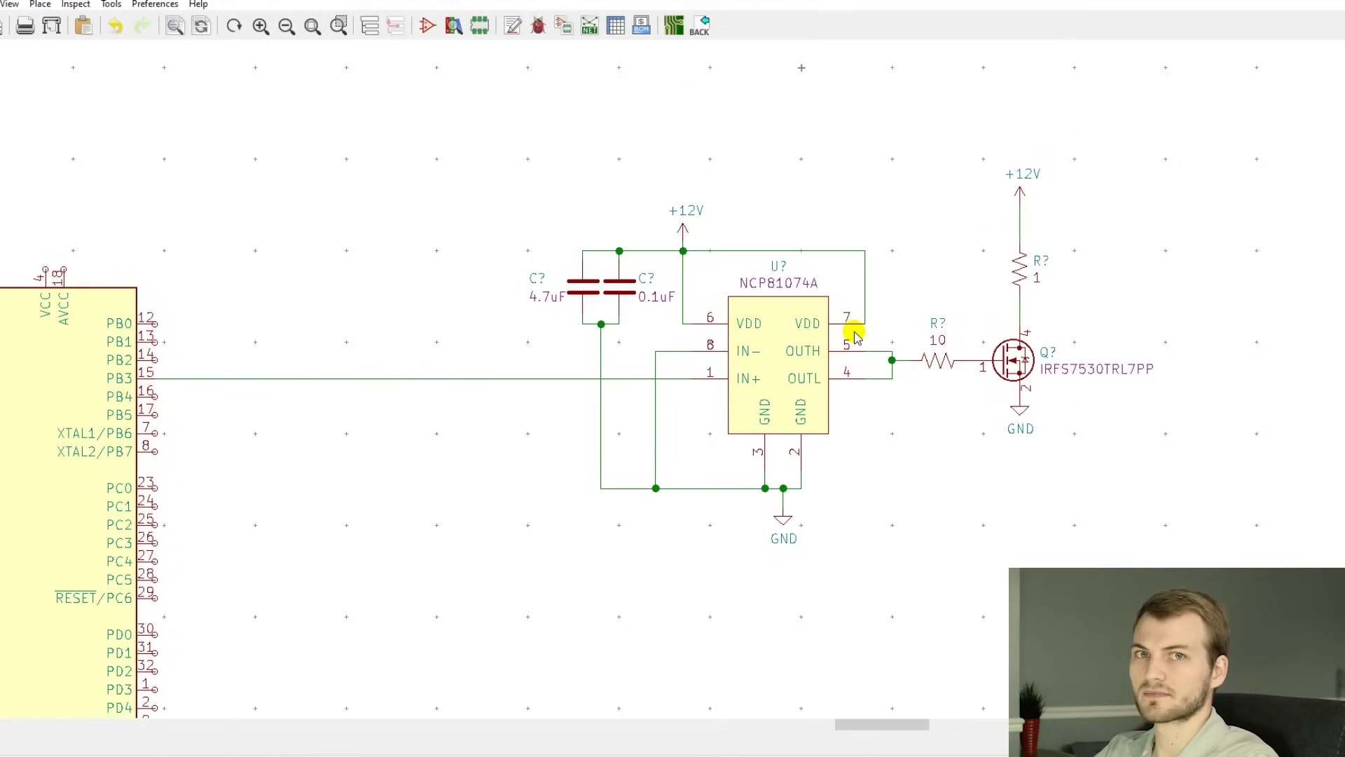 | 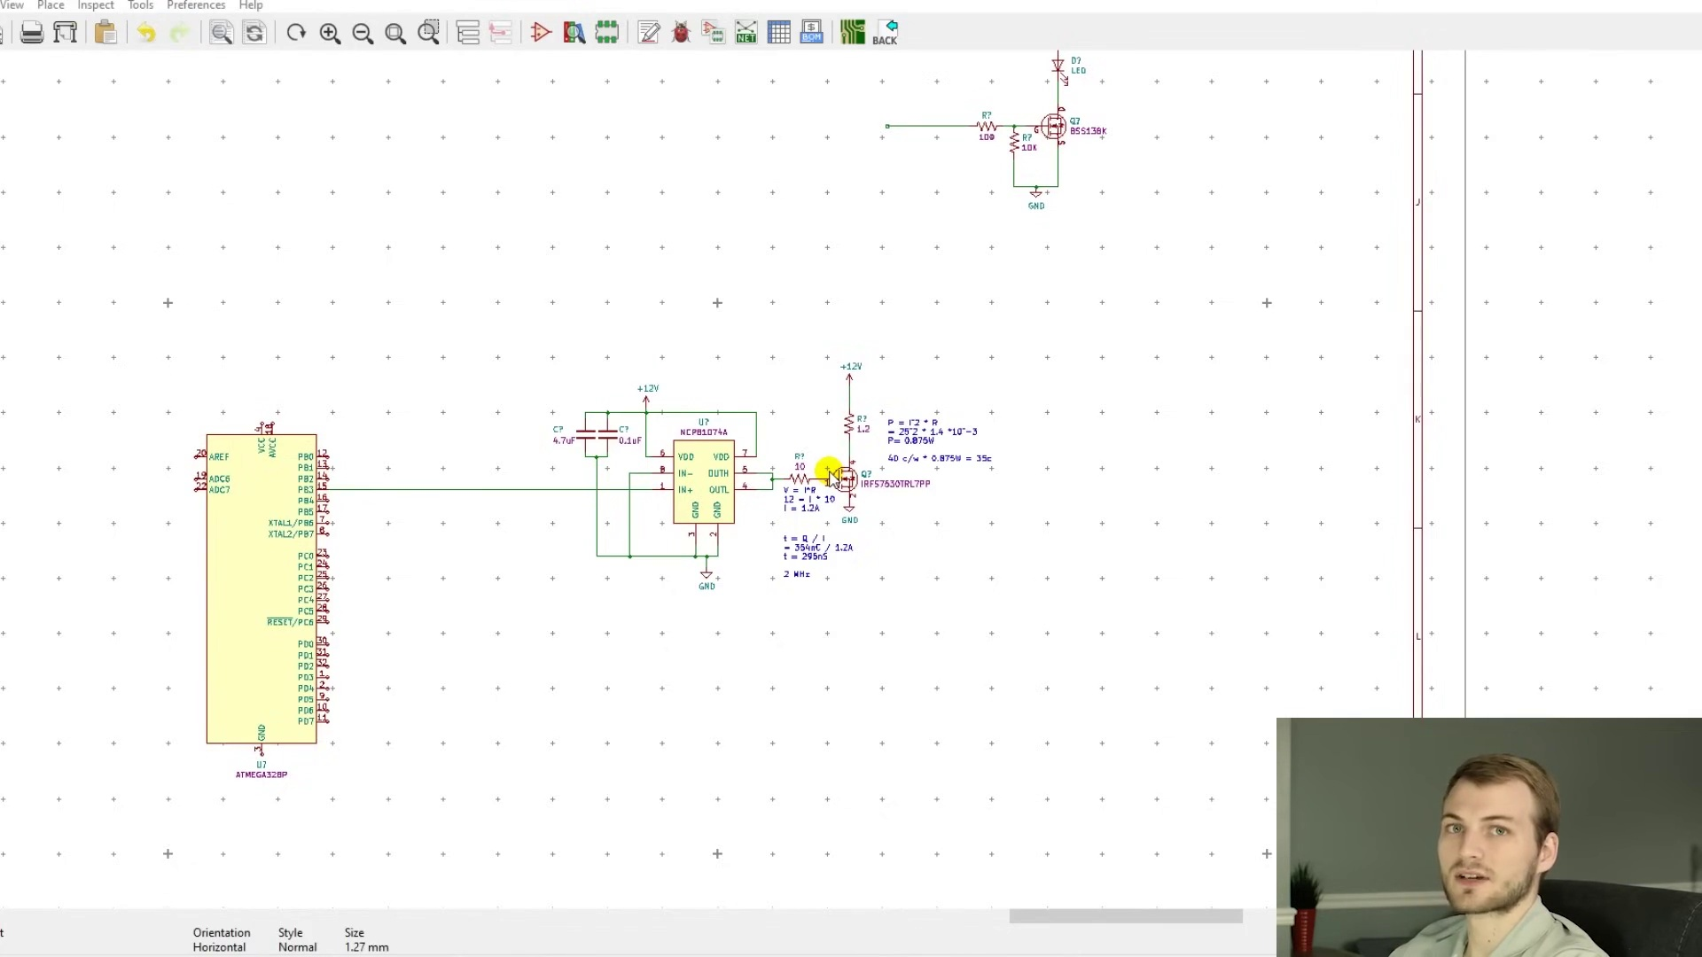
Topic T1: MOSFET Heat-up Calculation — score 90.0000
Description: time equals charge divided by current
Reason: The comment discusses specific design considerations for an H bridge driver, including the use of gate resistors and pull-down resistors, which are directly related to the topic's description of designing a high-power H bridge driver.
 |  | 
Topic T2: MOSFET Switching Speed and Frequency — score 80.0000
Description: time equals charge divided by current, double round trip time
Reason: The comment discusses specific characteristics of high power MOSFETs (gate resistor, pull-down resistor, gate driver) and provides examples that align with the topic's description (rds_on and gate charge). The language used is technical and focused on the practical aspects of MOSFET characterization, indicating a strong relationship to the topic.
Least correlated topics:
 |  | 
Topic T2: MOSFET Switching Speed and Frequency — score 80.0000
Description: time equals charge divided by current, double round trip time
Reason: The comment discusses specific characteristics of high power MOSFETs (gate resistor, pull-down resistor, gate driver) and provides examples that align with the topic's description (rds_on and gate charge). The language used is technical and focused on the practical aspects of MOSFET characterization, indicating a strong relationship to the topic.
 |  | 
Topic T1: MOSFET Heat-up Calculation — score 90.0000
Description: time equals charge divided by current
Reason: The comment discusses specific design considerations for an H bridge driver, including the use of gate resistors and pull-down resistors, which are directly related to the topic's description of designing a high-power H bridge driver.
- matched 1 topic(s), max score 90.0000: MOSFET or metal-oxide-semiconductor field-effect transistor is a type of field-effect. On this video the main type of mosfet talked was n type and logic level mosfet. Logic level mosfet only needs 5V to run. And the resistance from drain to source is low. The drain- source voltage is important in selecting mosfet. Mosfet with high VDSS rating tend to have large onstate resistance, RDS(ON). With downside being increased conduction loss.
Source: https://www.youtube.com/watch?v=56p3_aORiJ0: Designing power MOSFET circuit.
Top correlated topics:
 |  | 
Topic T2: MOSFET Switching Speed and Frequency — score 90.0000
Description: time equals charge divided by current, double round trip time
Reason: The comment discusses the same type of mosfet (n-type and logic level), drain-source voltage, and on-state resistance (RDS(ON)), which are all relevant characteristics mentioned in the topic description.
 |  | 
Topic T1: MOSFET Heat-up Calculation — score 60.0000
Description: time equals charge divided by current
Reason: {
"correlated": true,
"score": 60,
"reason": "The comment discusses MOSFETs and their characteristics (n-type, logic level, VDSS rating), which are directly related to designing an H Bridge Driver as mentioned in the topic description. Although not explicitly mentioning 'H Bridge Driver', the discussion on MOSFETs is relevant to the design considerations for high power applications."
Least correlated topics:
 |  | 
Topic T1: MOSFET Heat-up Calculation — score 60.0000
Description: time equals charge divided by current
Reason: {
"correlated": true,
"score": 60,
"reason": "The comment discusses MOSFETs and their characteristics (n-type, logic level, VDSS rating), which are directly related to designing an H Bridge Driver as mentioned in the topic description. Although not explicitly mentioning 'H Bridge Driver', the discussion on MOSFETs is relevant to the design considerations for high power applications."
 |  | 
Topic T2: MOSFET Switching Speed and Frequency — score 90.0000
Description: time equals charge divided by current, double round trip time
Reason: The comment discusses the same type of mosfet (n-type and logic level), drain-source voltage, and on-state resistance (RDS(ON)), which are all relevant characteristics mentioned in the topic description.
- matched 1 topic(s), max score 80.0000: Practical tips on selecting and designing MOSFET circuits, including specs like RDS-on and gate charge. Detailed explanation of current and charge calculations related to switching speeds.Applying learned principles to optimize MOSFET circuit designs for high-power and efficient operation.
Source: https://www.youtube.com/watch?v=56p3_aORiJ0&t=22s: Designing Power MOSFET Circuits - Circuit Tips and Tricks
Top correlated topics:
 |  | 
Topic T2: MOSFET Switching Speed and Frequency — score 95.0000
Description: time equals charge divided by current, double round trip time
Reason: {
"correlated": true,
"score": 95,
"reason": "The comment directly discusses the same characteristics (RDS-on and gate charge) mentioned in the topic description, and provides practical tips on selecting and designing MOSFET circuits, which aligns with the topic's goal of characterizing high power MOSfets."
 |  | 
Topic T1: MOSFET Heat-up Calculation — score 80.0000
Description: time equals charge divided by current
Reason: The comment directly discusses designing MOSFET circuits, including specifics like RDS-on and gate charge, which aligns with the topic's description of designing an H bridge driver for high power applications. The mention of switching speeds and optimizing circuit designs also shows strong overlap with the topic.
Least correlated topics:
 |  | 
Topic T1: MOSFET Heat-up Calculation — score 80.0000
Description: time equals charge divided by current
Reason: The comment directly discusses designing MOSFET circuits, including specifics like RDS-on and gate charge, which aligns with the topic's description of designing an H bridge driver for high power applications. The mention of switching speeds and optimizing circuit designs also shows strong overlap with the topic.
 |  | 
Topic T2: MOSFET Switching Speed and Frequency — score 95.0000
Description: time equals charge divided by current, double round trip time
Reason: {
"correlated": true,
"score": 95,
"reason": "The comment directly discusses the same characteristics (RDS-on and gate charge) mentioned in the topic description, and provides practical tips on selecting and designing MOSFET circuits, which aligns with the topic's goal of characterizing high power MOSfets."
- matched 0 topic(s), max score 0.0000: Issues on Connecting MOSFETs in Parallel
Source: Designing Power MOSFET Circuits – Circuit Tips and Tricks (https://www.youtube.com/watch?v=56p3_aORiJ0&t=22s)
Top correlated topics:
 |  | 
Topic T2: MOSFET Switching Speed and Frequency — score 20.0000
Description: time equals charge divided by current, double round trip time
Reason: The comment discusses issues with connecting MOSFETs in parallel, which is a different topic from high power MOSFET characterization. While both topics involve MOSFETs, the comment does not directly discuss the characteristics of high power MOSFETs such as rds_on and gate charge.
 |  | 
Topic T1: MOSFET Heat-up Calculation — score 10.0000
Description: time equals charge divided by current
Reason: The comment discusses issues with connecting MOSFETs in parallel, which is a specific topic unrelated to the broader concept of designing an H bridge driver for high power applications.
Least correlated topics:
 |  | 
Topic T1: MOSFET Heat-up Calculation — score 10.0000
Description: time equals charge divided by current
Reason: The comment discusses issues with connecting MOSFETs in parallel, which is a specific topic unrelated to the broader concept of designing an H bridge driver for high power applications.
 |  | 
Topic T2: MOSFET Switching Speed and Frequency — score 20.0000
Description: time equals charge divided by current, double round trip time
Reason: The comment discusses issues with connecting MOSFETs in parallel, which is a different topic from high power MOSFET characterization. While both topics involve MOSFETs, the comment does not directly discuss the characteristics of high power MOSFETs such as rds_on and gate charge.

Topic T1: MOSFET Heat-up Calculation
 |  | 
Description: time equals charge divided by current
Comment (score 90): One tip the speaker gives is the to include a gate resistor so that the input does not go directly into the MOSFET. Another benefit of the gate resistor is general ease of calculation; without it, the resistance and current in the connection to the MOSFET is more difficult to distinguish. Another necessity to a MOSFET circuit is a pull-down resistor connected to the MOSFET and ground and puts the MOSFET in a default state. The speaker also explains that a gate driver is the device used to power the MOFSET circuit on and off. The gate driver’s OUTH input sources the MOSFET while the OUTL input drains the MOSFET. The speaker in the video utilizes a simulation to better illustrate his ideas.
Reason: The comment discusses specific design considerations for an H bridge driver, including the use of gate resistors and pull-down resistors, which are directly related to the topic's description of designing a high-power H bridge driver.
Source: https://www.youtube.com/watch?v=56p3_aORiJ0&t=22s: Designing Power MOSFET Circuits – Circuit Tips and Tricks
Comment (score 80): Practical tips on selecting and designing MOSFET circuits, including specs like RDS-on and gate charge. Detailed explanation of current and charge calculations related to switching speeds.Applying learned principles to optimize MOSFET circuit designs for high-power and efficient operation.
Reason: The comment directly discusses designing MOSFET circuits, including specifics like RDS-on and gate charge, which aligns with the topic's description of designing an H bridge driver for high power applications. The mention of switching speeds and optimizing circuit designs also shows strong overlap with the topic.
Source: https://www.youtube.com/watch?v=56p3_aORiJ0&t=22s: Designing Power MOSFET Circuits - Circuit Tips and Tricks

Topic T2: MOSFET Switching Speed and Frequency
 |  | 
Description: time equals charge divided by current, double round trip time
Comment (score 90): MOSFET or metal-oxide-semiconductor field-effect transistor is a type of field-effect. On this video the main type of mosfet talked was n type and logic level mosfet. Logic level mosfet only needs 5V to run. And the resistance from drain to source is low. The drain- source voltage is important in selecting mosfet. Mosfet with high VDSS rating tend to have large onstate resistance, RDS(ON). With downside being increased conduction loss.
Reason: The comment discusses the same type of mosfet (n-type and logic level), drain-source voltage, and on-state resistance (RDS(ON)), which are all relevant characteristics mentioned in the topic description.
Source: https://www.youtube.com/watch?v=56p3_aORiJ0: Designing power MOSFET circuit.
Comment (score 80): One tip the speaker gives is the to include a gate resistor so that the input does not go directly into the MOSFET. Another benefit of the gate resistor is general ease of calculation; without it, the resistance and current in the connection to the MOSFET is more difficult to distinguish. Another necessity to a MOSFET circuit is a pull-down resistor connected to the MOSFET and ground and puts the MOSFET in a default state. The speaker also explains that a gate driver is the device used to power the MOFSET circuit on and off. The gate driver’s OUTH input sources the MOSFET while the OUTL input drains the MOSFET. The speaker in the video utilizes a simulation to better illustrate his ideas.
Reason: The comment discusses specific characteristics of high power MOSFETs (gate resistor, pull-down resistor, gate driver) and provides examples that align with the topic's description (rds_on and gate charge). The language used is technical and focused on the practical aspects of MOSFET characterization, indicating a strong relationship to the topic.
Source: https://www.youtube.com/watch?v=56p3_aORiJ0&t=22s: Designing Power MOSFET Circuits – Circuit Tips and Tricks

