Comment–Topic Correlation Report
Model: llama3

Summary
Topics processed: 2
Comments available for this video: 1
Comments correlated to ≥ 60: 0 (0.0%)
Total candidate pairs checked: 2

Most/Least correlated topics (by average score across correlated comments):
Top 3:
• Topic T2: Increasing Propeller Moment Arm — avg 0.00, contributions 0
• Topic T1: Efficient Propeller Operation — avg 0.00, contributions 0
Bottom 3:
• Topic T1: Efficient Propeller Operation — avg 0.00, contributions 0
• Topic T2: Increasing Propeller Moment Arm — avg 0.00, contributions 0
Correlated comment coverage (all comments):
- matched 0 topic(s), max score 0.0000: This video talks about how Nicholas Rahm built a tri-copter with wings that worked very well. As the video continued, he showed how he attached a servo motor to the base so that the tri-copter would spin as it was moving through the air. Although this system was much more complex in terms of stability, the power needed for the drown to hover in the air was significantly decreased. This can be very useful to extend the battery life of the drone and allow the user to fly the drone for much longer than the original build of the drone.
Source: https://www.youtube.com/watch?v=7JH1_ZKV7t4: The Spinning Drone Paradox - Part 1
Top correlated topics:
 | 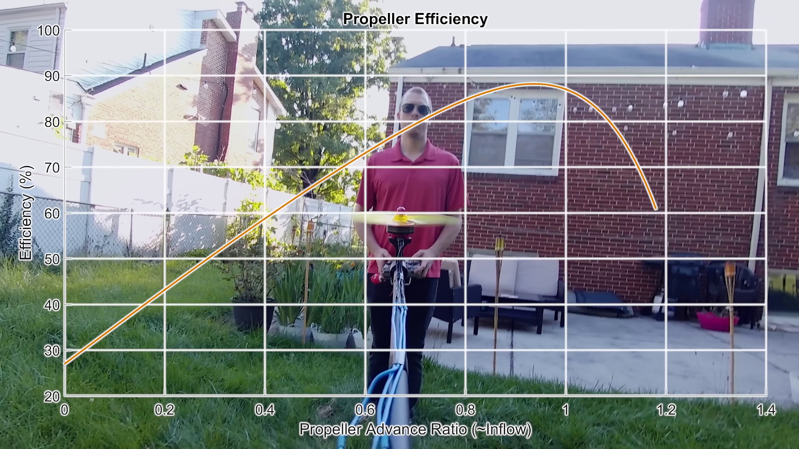 | 
Topic T1: Efficient Propeller Operation — score 20.0000
Description: The speaker shows how small drone propellers operate more efficiently in hover mode on the vehicle, without needing different designs for hover and forward flight.
Reason: The comment discusses a tri-copter and servo motor, whereas the topic is about efficient propeller operation in hover mode, with no direct overlap.
 |  | 
Topic T2: Increasing Propeller Moment Arm — score 0.0000
Description: The speaker explains how putting propellers farther out increases their moment arm, leading to less thrust required.
Reason: The comment discusses a different topic (tri-copter with servo motor) and doesn't mention propellers or moment arm, which are the key concepts in the topic.
Least correlated topics:
 |  | 
Topic T2: Increasing Propeller Moment Arm — score 0.0000
Description: The speaker explains how putting propellers farther out increases their moment arm, leading to less thrust required.
Reason: The comment discusses a different topic (tri-copter with servo motor) and doesn't mention propellers or moment arm, which are the key concepts in the topic.
 |  | 
Topic T1: Efficient Propeller Operation — score 20.0000
Description: The speaker shows how small drone propellers operate more efficiently in hover mode on the vehicle, without needing different designs for hover and forward flight.
Reason: The comment discusses a tri-copter and servo motor, whereas the topic is about efficient propeller operation in hover mode, with no direct overlap.

Topic T1: Efficient Propeller Operation
 |  | 
Description: The speaker shows how small drone propellers operate more efficiently in hover mode on the vehicle, without needing different designs for hover and forward flight.
No strongly correlated comments found for this topic.

Topic T2: Increasing Propeller Moment Arm
 |  | 
Description: The speaker explains how putting propellers farther out increases their moment arm, leading to less thrust required.
No strongly correlated comments found for this topic.

