Comment–Topic Correlation Report
Model: llama3

Summary
Topics processed: 6
Comments available for this video: 1
Comments correlated to ≥ 60: 1 (100.0%)
Total candidate pairs checked: 6

Most/Least correlated topics (by average score across correlated comments):
Top 3:
• Topic T1: Introduction — avg 80.00, contributions 1
• Topic T3: FPV Performance — avg 0.00, contributions 0
• Topic T2: Design and Build — avg 0.00, contributions 0
Bottom 3:
• Topic T5: Advantages and Disadvantages — avg 0.00, contributions 0
• Topic T4: Components and Options — avg 0.00, contributions 0
• Topic T6: Conclusion — avg 0.00, contributions 0
Correlated comment coverage (all comments):
- matched 1 topic(s), max score 80.0000: This video discusses the portability of the Darwin FPV drone. This drone is very small and can fit in your pocket. The drone is made using injection molding, so it is very tough and lightweight. The only downside of this drone is the decreased battery life since there is not a lot of space for a larger-sized battery. This is a very interesting concept of decreasing the size of the drone for easy portability and can have many implications. Such as military use civilian use such as weddings or wanting an overhead view of a city. The possibilities are endless and can potentially. Be redesigned in phase 2 of our project.
Source: https://www.youtube.com/watch?v=9fYzb1g8tzw: DarwinFPV CineAPE 25: A tough little pocket rocket
Top correlated topics:
 | 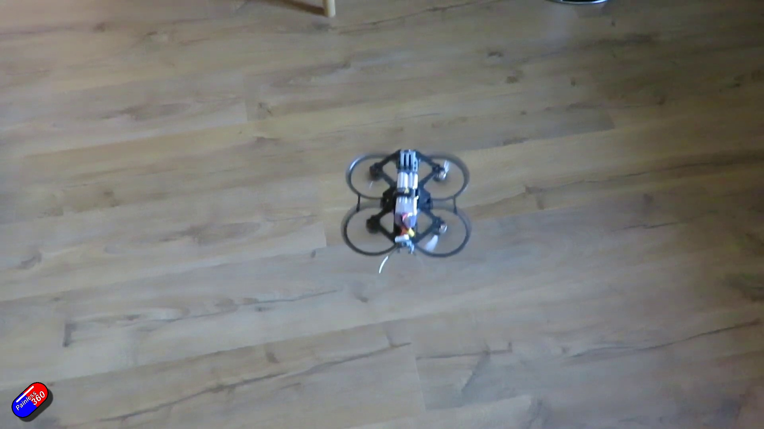 | 
Topic T1: Introduction — score 80.0000
Description: Overview of the Darwin FPV Quad
Reason: The comment directly discusses the portability and size-related features of the Darwin FPV quad, which is described in the topic as 'very small' and fitting in a pocket.
 |  | 
Topic T6: Conclusion — score 20.0000
Description: Summary and final thoughts
Reason: The comment discusses a specific product (Darwin FPV drone) and its features, whereas the topic 'Conclusion' is a summary or final thoughts on a general topic, not related to this product.
 |  | 
Topic T5: Advantages and Disadvantages — score 20.0000
Description: Pros and cons of the Darwin FPV Quad
Reason: The topic discusses general pros and cons, while the comment focuses on a specific product (Darwin FPV drone) and its features, without directly discussing the advantages and disadvantages of the topic title.
 |  | 
Topic T3: FPV Performance — score 20.0000
Description: Analysis of the analog FPV setup
Reason: The comment discusses a specific drone model (Darwin FPV) and its features (portability, battery life), whereas the topic 'FPV Performance' is more general and doesn't mention any specific drones or settings. The comment also mentions potential uses of the drone, but it's not directly related to analyzing analog FPV setup.
 |  | 
Topic T2: Design and Build — score 20.0000
Description: Size, design, and features of the quad
Reason: The topic is about 'Design and Build' (size, design, and features) of a quad, while the comment discusses the portability and size of the Darwin FPV drone. The comment does not directly discuss the same steps, objects, settings, parameters, claims, or goals as the topic.
 |  | 
Topic T4: Components and Options — score 0.0000
Description: Discussion of components, options, and limitations
Reason: The comment discusses a specific drone and its portability, whereas the topic is about components and options in general. There are no direct overlaps between the topic and the comment.
Least correlated topics:
 |  | 
Topic T4: Components and Options — score 0.0000
Description: Discussion of components, options, and limitations
Reason: The comment discusses a specific drone and its portability, whereas the topic is about components and options in general. There are no direct overlaps between the topic and the comment.
 |  | 
Topic T2: Design and Build — score 20.0000
Description: Size, design, and features of the quad
Reason: The topic is about 'Design and Build' (size, design, and features) of a quad, while the comment discusses the portability and size of the Darwin FPV drone. The comment does not directly discuss the same steps, objects, settings, parameters, claims, or goals as the topic.
 |  | 
Topic T3: FPV Performance — score 20.0000
Description: Analysis of the analog FPV setup
Reason: The comment discusses a specific drone model (Darwin FPV) and its features (portability, battery life), whereas the topic 'FPV Performance' is more general and doesn't mention any specific drones or settings. The comment also mentions potential uses of the drone, but it's not directly related to analyzing analog FPV setup.
 |  | 
Topic T5: Advantages and Disadvantages — score 20.0000
Description: Pros and cons of the Darwin FPV Quad
Reason: The topic discusses general pros and cons, while the comment focuses on a specific product (Darwin FPV drone) and its features, without directly discussing the advantages and disadvantages of the topic title.
 |  | 
Topic T6: Conclusion — score 20.0000
Description: Summary and final thoughts
Reason: The comment discusses a specific product (Darwin FPV drone) and its features, whereas the topic 'Conclusion' is a summary or final thoughts on a general topic, not related to this product.
 |  | 
Topic T1: Introduction — score 80.0000
Description: Overview of the Darwin FPV Quad
Reason: The comment directly discusses the portability and size-related features of the Darwin FPV quad, which is described in the topic as 'very small' and fitting in a pocket.

Topic T1: Introduction
 |  | 
Description: Overview of the Darwin FPV Quad
Comment (score 80): This video discusses the portability of the Darwin FPV drone. This drone is very small and can fit in your pocket. The drone is made using injection molding, so it is very tough and lightweight. The only downside of this drone is the decreased battery life since there is not a lot of space for a larger-sized battery. This is a very interesting concept of decreasing the size of the drone for easy portability and can have many implications. Such as military use civilian use such as weddings or wanting an overhead view of a city. The possibilities are endless and can potentially. Be redesigned in phase 2 of our project.
Reason: The comment directly discusses the portability and size-related features of the Darwin FPV quad, which is described in the topic as 'very small' and fitting in a pocket.
Source: https://www.youtube.com/watch?v=9fYzb1g8tzw: DarwinFPV CineAPE 25: A tough little pocket rocket

Topic T2: Design and Build
 |  | 
Description: Size, design, and features of the quad
No strongly correlated comments found for this topic.

Topic T3: FPV Performance
 |  | 
Description: Analysis of the analog FPV setup
No strongly correlated comments found for this topic.

Topic T4: Components and Options
 |  | 
Description: Discussion of components, options, and limitations
No strongly correlated comments found for this topic.

Topic T5: Advantages and Disadvantages
 |  | 
Description: Pros and cons of the Darwin FPV Quad
No strongly correlated comments found for this topic.

Topic T6: Conclusion
 |  | 
Description: Summary and final thoughts
No strongly correlated comments found for this topic.

