Comment–Topic Correlation Report
Model: llama3

Summary
Topics processed: 2
Comments available for this video: 7
Comments correlated to ≥ 60: 2 (28.6%)
Total candidate pairs checked: 14

Most/Least correlated topics (by average score across correlated comments):
Top 3:
• Topic T2: Importance of Correct Wiring — avg 80.00, contributions 2
• Topic T1: Consequences of Incorrect Wiring — avg 80.00, contributions 1
Bottom 3:
• Topic T1: Consequences of Incorrect Wiring — avg 80.00, contributions 1
• Topic T2: Importance of Correct Wiring — avg 80.00, contributions 2
Correlated comment coverage (all comments):
- matched 2 topic(s), max score 80.0000: A full bridge rectifier is composed of 4 diodes allowing current to flow in one direction. What is shown in the video is one being used to convert AC to DC. When choosing a rectifier, it is important to know voltage and current ratings given the circuit it’s being used in. Electrolytic capacitors are used to smooth out the power coming from the rectifiers. Choosing a capacitor is based on frequency, current and voltage drop.
Source: https://www.youtube.com/watch?v=CAYKno16weE: (189) How To Choose The Right Rectifier & Capacitor For Rectifing AC to DC - YouTube
Top correlated topics:
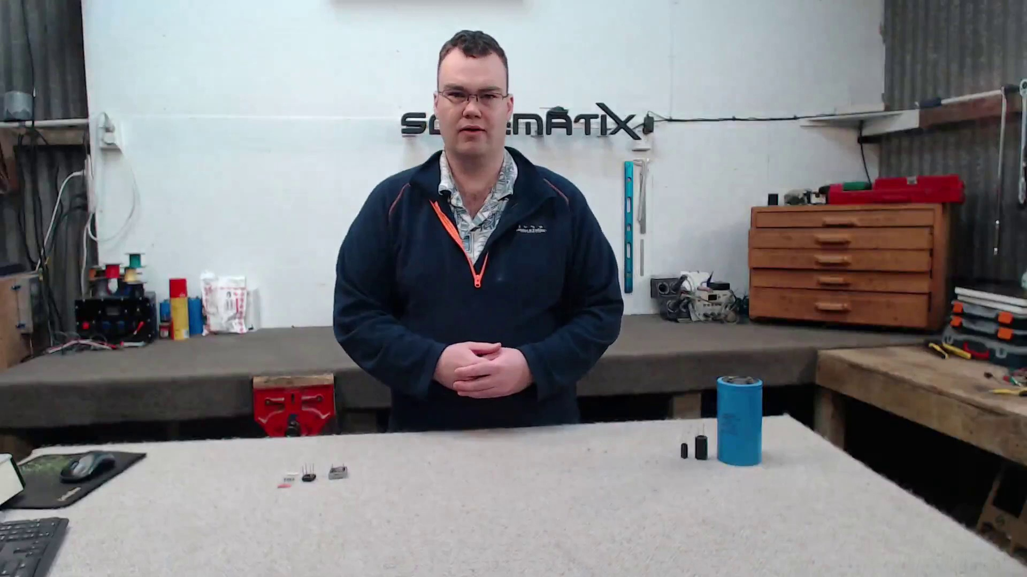 | 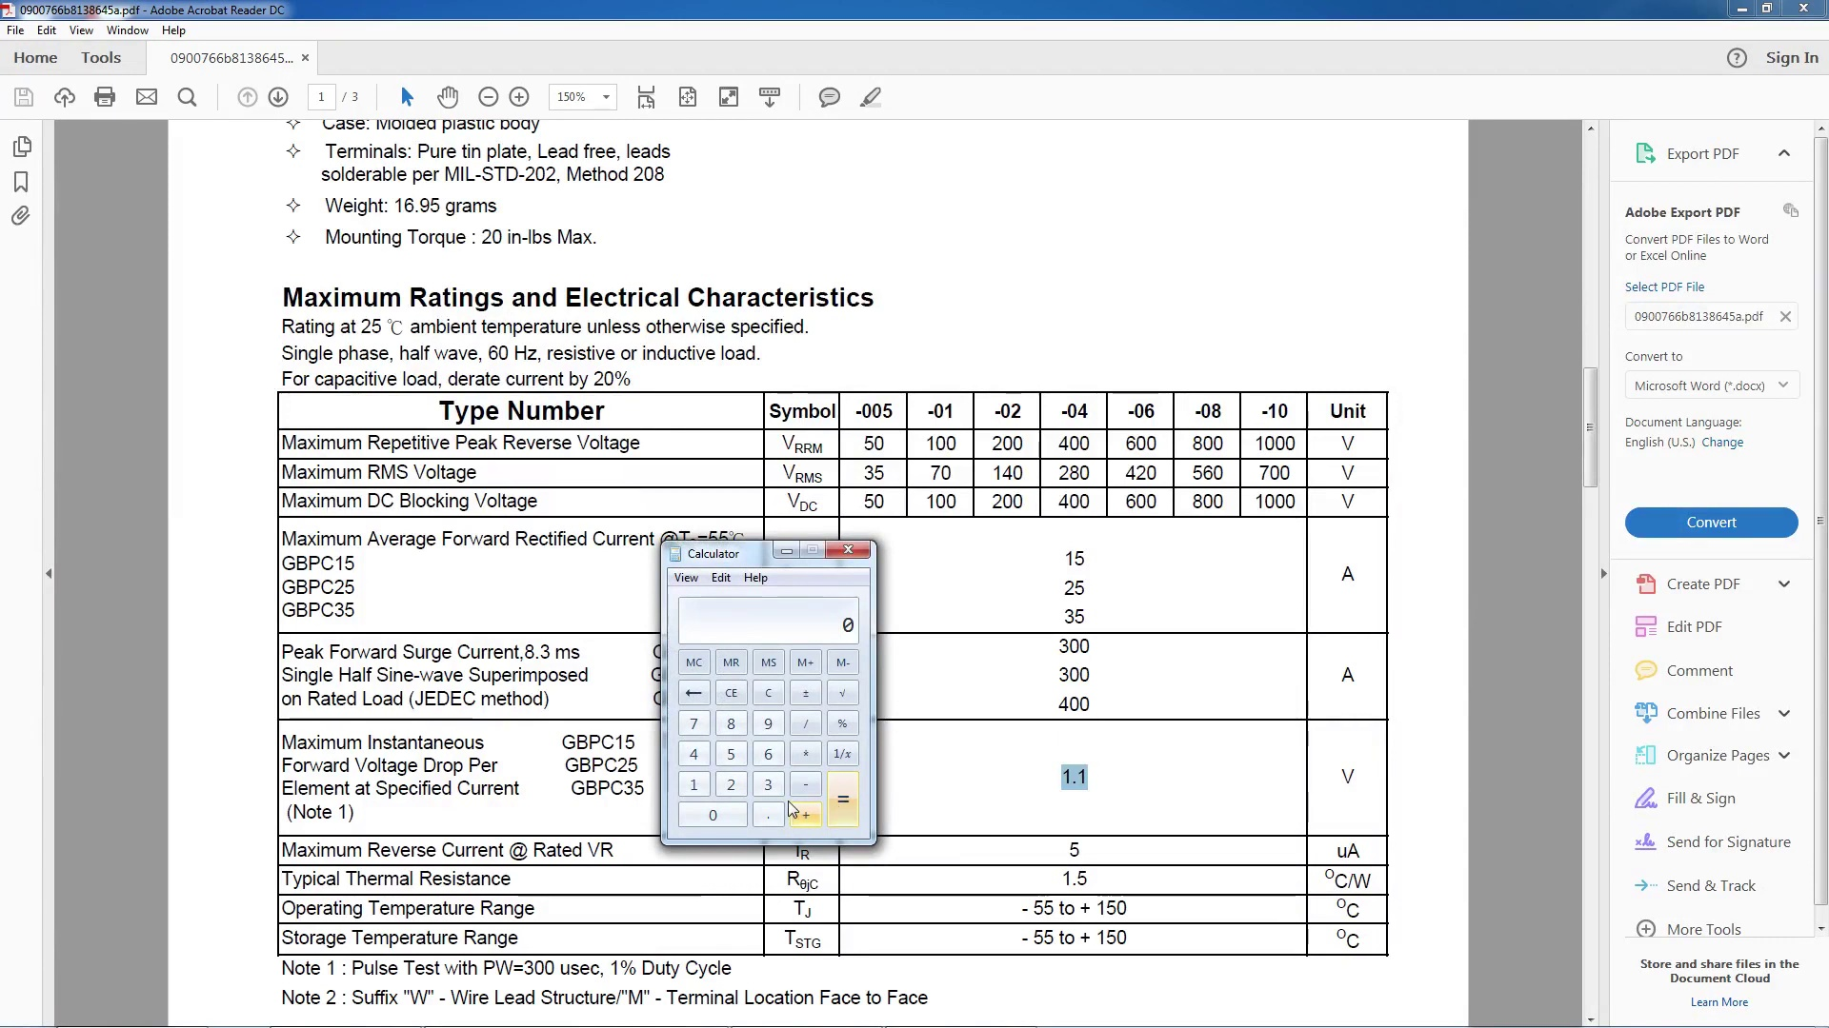 | 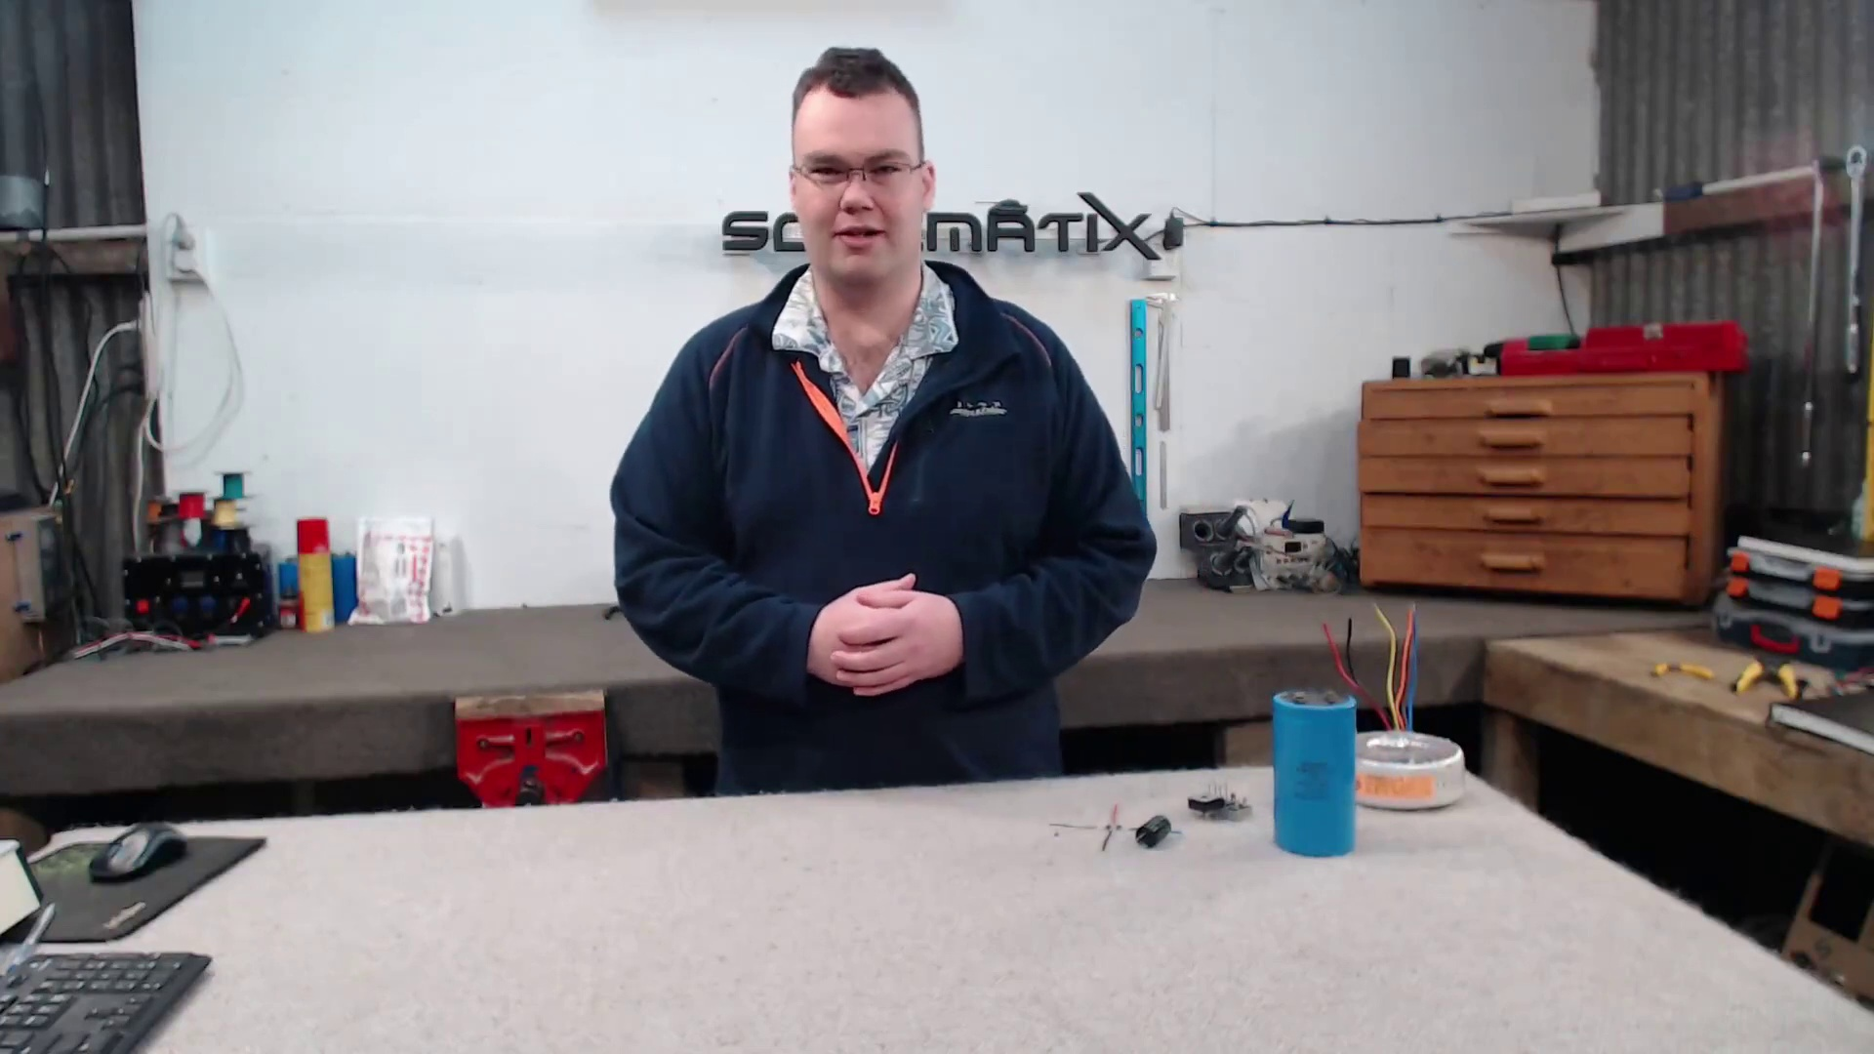
Topic T2: Importance of Correct Wiring — score 80.0000
Description: The speaker emphasizes the importance of correct wiring when it comes to electrolytic capacitors. They are polarity sensitive, and getting it backwards can cause a nasty explosion.
Reason: The comment directly discusses the importance of electrolytic capacitors in a circuit (as mentioned in the topic description), specifically their use in smoothing out power from rectifiers. The mention of polarity sensitivity and explosion risk also shows strong correlation with the topic.
 |  | 
Topic T1: Consequences of Incorrect Wiring — score 80.0000
Description: The speaker warns that getting the wiring wrong can lead to a nasty explosion and poor power supply.
Reason: The comment discusses the importance of choosing a rectifier based on voltage and current ratings, which is directly related to the topic's warning about incorrect wiring causing poor power supply. The mention of electrolytic capacitors smoothing out power also overlaps with the topic's description of potential consequences.
Least correlated topics:
 |  | 
Topic T1: Consequences of Incorrect Wiring — score 80.0000
Description: The speaker warns that getting the wiring wrong can lead to a nasty explosion and poor power supply.
Reason: The comment discusses the importance of choosing a rectifier based on voltage and current ratings, which is directly related to the topic's warning about incorrect wiring causing poor power supply. The mention of electrolytic capacitors smoothing out power also overlaps with the topic's description of potential consequences.
 |  | 
Topic T2: Importance of Correct Wiring — score 80.0000
Description: The speaker emphasizes the importance of correct wiring when it comes to electrolytic capacitors. They are polarity sensitive, and getting it backwards can cause a nasty explosion.
Reason: The comment directly discusses the importance of electrolytic capacitors in a circuit (as mentioned in the topic description), specifically their use in smoothing out power from rectifiers. The mention of polarity sensitivity and explosion risk also shows strong correlation with the topic.
- matched 1 topic(s), max score 80.0000: The video begins with an introduction of the full bridge rectifier which converts AC power to DC. The full bridge rectifier consists of two AC input pins and two DC output pins. A few things must be considered when choosing a rectifier: the amount of voltage it can handle, the amount of current it can handle, and how much heat will be generated. These specs can be referenced in a given equipment manual or in online resources. Once the full bridge rectifier has been chosen, a corresponding electrolytic capacitor can also be chosen to help smooth out the power from the rectifier. The voltage and capacitance listed on the electrolytic capacitor should be considered in the decision process.
Source: https://www.youtube.com/watch?v=CAYKno16weE: How to Choose the Right Rectifier & Capacitor for Rectifing AC to DC
Top correlated topics:
 |  | 
Topic T2: Importance of Correct Wiring — score 80.0000
Description: The speaker emphasizes the importance of correct wiring when it comes to electrolytic capacitors. They are polarity sensitive, and getting it backwards can cause a nasty explosion.
Reason: The comment directly discusses electrolytic capacitors and their importance in full bridge rectifiers, referencing voltage, current, heat generation, and capacitor specifications. The topic's emphasis on correct wiring is also relevant to the comment's discussion of choosing a corresponding electrolytic capacitor.
 |  | 
Topic T1: Consequences of Incorrect Wiring — score 20.0000
Description: The speaker warns that getting the wiring wrong can lead to a nasty explosion and poor power supply.
Reason: The comment discusses a specific component (full bridge rectifier) and its characteristics, whereas the topic is about the consequences of incorrect wiring. While both mention electrical components, they don't directly discuss the same steps, objects, settings, parameters, claims, or goals.
Least correlated topics:
 |  | 
Topic T1: Consequences of Incorrect Wiring — score 20.0000
Description: The speaker warns that getting the wiring wrong can lead to a nasty explosion and poor power supply.
Reason: The comment discusses a specific component (full bridge rectifier) and its characteristics, whereas the topic is about the consequences of incorrect wiring. While both mention electrical components, they don't directly discuss the same steps, objects, settings, parameters, claims, or goals.
 |  | 
Topic T2: Importance of Correct Wiring — score 80.0000
Description: The speaker emphasizes the importance of correct wiring when it comes to electrolytic capacitors. They are polarity sensitive, and getting it backwards can cause a nasty explosion.
Reason: The comment directly discusses electrolytic capacitors and their importance in full bridge rectifiers, referencing voltage, current, heat generation, and capacitor specifications. The topic's emphasis on correct wiring is also relevant to the comment's discussion of choosing a corresponding electrolytic capacitor.
- matched 0 topic(s), max score 0.0000: This video – as the name implies – is about choosing the diode for a rectifier. He brings in considerations such as voltage drop past the diode, and thermal dissipation needed. In the video he shows for the rectifier at maximum current (15A) will have 16.5W of heat generated. This is important as we will need a heatsink. He also briefly goes over capacitor ratings, but I didn’t get too much out of this as I pay attention to lecture.
Source: https://www.youtube.com/watch?v=CAYKno16weE: How To Choose The Right Rectifier & Capacitor For Rectifing AC to DC
Top correlated topics:
 |  | 
Topic T2: Importance of Correct Wiring — score 20.0000
Description: The speaker emphasizes the importance of correct wiring when it comes to electrolytic capacitors. They are polarity sensitive, and getting it backwards can cause a nasty explosion.
Reason: The topic is about correct wiring for electrolytic capacitors, while the comment discusses diode selection and capacitor ratings for a rectifier. Although both topics are related to electronics, they do not directly discuss the same concepts or steps, so there is limited correlation.
 |  | 
Topic T1: Consequences of Incorrect Wiring — score 20.0000
Description: The speaker warns that getting the wiring wrong can lead to a nasty explosion and poor power supply.
Reason: The comment discusses diode selection and thermal dissipation for a rectifier, which is not directly related to the topic of Consequences of Incorrect Wiring. Although the video mentions capacitor ratings briefly, it does not discuss the consequences of incorrect wiring or explosion prevention.
Least correlated topics:
 |  | 
Topic T1: Consequences of Incorrect Wiring — score 20.0000
Description: The speaker warns that getting the wiring wrong can lead to a nasty explosion and poor power supply.
Reason: The comment discusses diode selection and thermal dissipation for a rectifier, which is not directly related to the topic of Consequences of Incorrect Wiring. Although the video mentions capacitor ratings briefly, it does not discuss the consequences of incorrect wiring or explosion prevention.
 |  | 
Topic T2: Importance of Correct Wiring — score 20.0000
Description: The speaker emphasizes the importance of correct wiring when it comes to electrolytic capacitors. They are polarity sensitive, and getting it backwards can cause a nasty explosion.
Reason: The topic is about correct wiring for electrolytic capacitors, while the comment discusses diode selection and capacitor ratings for a rectifier. Although both topics are related to electronics, they do not directly discuss the same concepts or steps, so there is limited correlation.
- matched 0 topic(s), max score 0.0000: This video was helpful because most of the time in project circuit a AC power is converted to DC in order for circuit to work. The full bridge rectifier prebuild package which works with a 4-diode connected to each other. Because diode is semiconductor it blocks the current coming from 1 direction while letting the other side current flow. For step of choosing rectifier is looking at data sheet for max voltage, max average forward current and forward voltage drop. And then picking the right one for the project.
Source: https://www.youtube.com/watch?v=CAYKno16weE: How to choose the right rectifier and capacitor for rectifying AC to DC
Top correlated topics:
 |  | 
Topic T2: Importance of Correct Wiring — score 20.0000
Description: The speaker emphasizes the importance of correct wiring when it comes to electrolytic capacitors. They are polarity sensitive, and getting it backwards can cause a nasty explosion.
Reason: The comment discusses circuit design and component selection (rectifier), but does not specifically mention correct wiring or electrolytic capacitors. The topic focuses on the importance of correct wiring for polarity-sensitive components like electrolytic capacitors, which is not directly related to the viewer's comment.
 |  | 
Topic T1: Consequences of Incorrect Wiring — score 10.0000
Description: The speaker warns that getting the wiring wrong can lead to a nasty explosion and poor power supply.
Reason: The comment discusses rectifiers and choosing the right one for a project, which is not directly related to the topic's warning about incorrect wiring consequences. The only indirect connection is that both discuss electrical circuits, but the comment does not mention explosions or poor power supply.
Least correlated topics:
 |  | 
Topic T1: Consequences of Incorrect Wiring — score 10.0000
Description: The speaker warns that getting the wiring wrong can lead to a nasty explosion and poor power supply.
Reason: The comment discusses rectifiers and choosing the right one for a project, which is not directly related to the topic's warning about incorrect wiring consequences. The only indirect connection is that both discuss electrical circuits, but the comment does not mention explosions or poor power supply.
 |  | 
Topic T2: Importance of Correct Wiring — score 20.0000
Description: The speaker emphasizes the importance of correct wiring when it comes to electrolytic capacitors. They are polarity sensitive, and getting it backwards can cause a nasty explosion.
Reason: The comment discusses circuit design and component selection (rectifier), but does not specifically mention correct wiring or electrolytic capacitors. The topic focuses on the importance of correct wiring for polarity-sensitive components like electrolytic capacitors, which is not directly related to the viewer's comment.
- matched 0 topic(s), max score 0.0000: In this video we learn about the different types of rectifiers and what the best application of each one is. There are two types of rectifiers talked about in the video the first one is the full-bridge rectifier. This rectifier is best used to convert AC power to DC power. The second type is the forward rectifier. There are many things to consider when picking which type of rectifier you should use. One of the most important things being how much load can each rectifier handle. Another really important thing to consider is looking at the datasheet for each rectifier as it can help you make the best decision for your specific application.
Source: https://www.youtube.com/watch?v=CAYKno16weE: How to Choose the Right Rectifier & Capacitor for Rectifying AC to DC
Top correlated topics:
 |  | 
Topic T2: Importance of Correct Wiring — score 20.0000
Description: The speaker emphasizes the importance of correct wiring when it comes to electrolytic capacitors. They are polarity sensitive, and getting it backwards can cause a nasty explosion.
Reason: The comment discusses rectifiers and their applications, but does not mention wiring or electrolytic capacitors, which are the main focus of the topic.
 |  | 
Topic T1: Consequences of Incorrect Wiring — score 20.0000
Description: The speaker warns that getting the wiring wrong can lead to a nasty explosion and poor power supply.
Reason: The comment discusses rectifiers and their applications, which is not directly related to the consequences of incorrect wiring. The topic description mentions explosions and poor power supply, but this is not mentioned in the comment.
Least correlated topics:
 |  | 
Topic T1: Consequences of Incorrect Wiring — score 20.0000
Description: The speaker warns that getting the wiring wrong can lead to a nasty explosion and poor power supply.
Reason: The comment discusses rectifiers and their applications, which is not directly related to the consequences of incorrect wiring. The topic description mentions explosions and poor power supply, but this is not mentioned in the comment.
 |  | 
Topic T2: Importance of Correct Wiring — score 20.0000
Description: The speaker emphasizes the importance of correct wiring when it comes to electrolytic capacitors. They are polarity sensitive, and getting it backwards can cause a nasty explosion.
Reason: The comment discusses rectifiers and their applications, but does not mention wiring or electrolytic capacitors, which are the main focus of the topic.
- matched 0 topic(s), max score 0.0000: I understand the process of selecting the proper capacitor size and rectifier when converting AC to DC power.I would like to know what real-world applications require converting AC to DC.I will ensure to use proper calculations when selecting these components.
Source: https://www.youtube.com/watch?v=CAYKno16weE: How To Choose The Right Rectifier & Capacitor For Rectifying AC to DC
Top correlated topics:
 |  | 
Topic T2: Importance of Correct Wiring — score 20.0000
Description: The speaker emphasizes the importance of correct wiring when it comes to electrolytic capacitors. They are polarity sensitive, and getting it backwards can cause a nasty explosion.
Reason: The comment mentions capacitor selection and rectifier usage, but does not directly discuss the importance of correct wiring in electrolytic capacitors or the potential consequences of getting it wrong.
 |  | 
Topic T1: Consequences of Incorrect Wiring — score 20.0000
Description: The speaker warns that getting the wiring wrong can lead to a nasty explosion and poor power supply.
Reason: The comment discusses capacitor size and rectifier selection in AC-DC conversion, but does not directly discuss the consequences of incorrect wiring or explosion risks mentioned in the topic. While there is some overlap with electrical power concepts, the main focus is on component selection rather than wiring mistakes.
Least correlated topics:
 |  | 
Topic T1: Consequences of Incorrect Wiring — score 20.0000
Description: The speaker warns that getting the wiring wrong can lead to a nasty explosion and poor power supply.
Reason: The comment discusses capacitor size and rectifier selection in AC-DC conversion, but does not directly discuss the consequences of incorrect wiring or explosion risks mentioned in the topic. While there is some overlap with electrical power concepts, the main focus is on component selection rather than wiring mistakes.
 |  | 
Topic T2: Importance of Correct Wiring — score 20.0000
Description: The speaker emphasizes the importance of correct wiring when it comes to electrolytic capacitors. They are polarity sensitive, and getting it backwards can cause a nasty explosion.
Reason: The comment mentions capacitor selection and rectifier usage, but does not directly discuss the importance of correct wiring in electrolytic capacitors or the potential consequences of getting it wrong.
- matched 0 topic(s), max score 0.0000: I like how it explains how to pick the correct components, and the one that he is showing in the video was exactly like one I use to replace on a piece of old equipment in the steel business years ago. I knew it was a bridge rectifies, but I never really spent anytime knowing the details of how it works, I just knew back then when the machine would not stop and reverse the bridge rectifier was usually bad. I have always wondered how to choose the correct capacitor for the job. There is a good detailed steps to determine the correct capacitance
Source: https://www.youtube.com/watch?v=CAYKno16weE: To Choose The Right Rectifier & Capacitor For Rectifing AC to DC
Top correlated topics:
 |  | 
Topic T2: Importance of Correct Wiring — score 20.0000
Description: The speaker emphasizes the importance of correct wiring when it comes to electrolytic capacitors. They are polarity sensitive, and getting it backwards can cause a nasty explosion.
Reason: The comment does not directly discuss the importance of correct wiring for electrolytic capacitors, but rather shares a personal anecdote about replacing equipment in the steel business. The topic and comment do not have specific overlaps.
 |  | 
Topic T1: Consequences of Incorrect Wiring — score 20.0000
Description: The speaker warns that getting the wiring wrong can lead to a nasty explosion and poor power supply.
Reason: The comment mentions bridge rectifiers and choosing the correct capacitor, but does not directly discuss the consequences of incorrect wiring. The topic is only briefly mentioned as a background context for learning about component selection.
Least correlated topics:
 |  | 
Topic T1: Consequences of Incorrect Wiring — score 20.0000
Description: The speaker warns that getting the wiring wrong can lead to a nasty explosion and poor power supply.
Reason: The comment mentions bridge rectifiers and choosing the correct capacitor, but does not directly discuss the consequences of incorrect wiring. The topic is only briefly mentioned as a background context for learning about component selection.
 |  | 
Topic T2: Importance of Correct Wiring — score 20.0000
Description: The speaker emphasizes the importance of correct wiring when it comes to electrolytic capacitors. They are polarity sensitive, and getting it backwards can cause a nasty explosion.
Reason: The comment does not directly discuss the importance of correct wiring for electrolytic capacitors, but rather shares a personal anecdote about replacing equipment in the steel business. The topic and comment do not have specific overlaps.

Topic T1: Consequences of Incorrect Wiring
 |  | 
Description: The speaker warns that getting the wiring wrong can lead to a nasty explosion and poor power supply.
Comment (score 80): A full bridge rectifier is composed of 4 diodes allowing current to flow in one direction. What is shown in the video is one being used to convert AC to DC. When choosing a rectifier, it is important to know voltage and current ratings given the circuit it’s being used in. Electrolytic capacitors are used to smooth out the power coming from the rectifiers. Choosing a capacitor is based on frequency, current and voltage drop.
Reason: The comment discusses the importance of choosing a rectifier based on voltage and current ratings, which is directly related to the topic's warning about incorrect wiring causing poor power supply. The mention of electrolytic capacitors smoothing out power also overlaps with the topic's description of potential consequences.
Source: https://www.youtube.com/watch?v=CAYKno16weE: (189) How To Choose The Right Rectifier & Capacitor For Rectifing AC to DC - YouTube

Topic T2: Importance of Correct Wiring
 |  | 
Description: The speaker emphasizes the importance of correct wiring when it comes to electrolytic capacitors. They are polarity sensitive, and getting it backwards can cause a nasty explosion.
Comment (score 80): The video begins with an introduction of the full bridge rectifier which converts AC power to DC. The full bridge rectifier consists of two AC input pins and two DC output pins. A few things must be considered when choosing a rectifier: the amount of voltage it can handle, the amount of current it can handle, and how much heat will be generated. These specs can be referenced in a given equipment manual or in online resources. Once the full bridge rectifier has been chosen, a corresponding electrolytic capacitor can also be chosen to help smooth out the power from the rectifier. The voltage and capacitance listed on the electrolytic capacitor should be considered in the decision process.
Reason: The comment directly discusses electrolytic capacitors and their importance in full bridge rectifiers, referencing voltage, current, heat generation, and capacitor specifications. The topic's emphasis on correct wiring is also relevant to the comment's discussion of choosing a corresponding electrolytic capacitor.
Source: https://www.youtube.com/watch?v=CAYKno16weE: How to Choose the Right Rectifier & Capacitor for Rectifing AC to DC
Comment (score 80): A full bridge rectifier is composed of 4 diodes allowing current to flow in one direction. What is shown in the video is one being used to convert AC to DC. When choosing a rectifier, it is important to know voltage and current ratings given the circuit it’s being used in. Electrolytic capacitors are used to smooth out the power coming from the rectifiers. Choosing a capacitor is based on frequency, current and voltage drop.
Reason: The comment directly discusses the importance of electrolytic capacitors in a circuit (as mentioned in the topic description), specifically their use in smoothing out power from rectifiers. The mention of polarity sensitivity and explosion risk also shows strong correlation with the topic.
Source: https://www.youtube.com/watch?v=CAYKno16weE: (189) How To Choose The Right Rectifier & Capacitor For Rectifing AC to DC - YouTube

