Comment–Topic Correlation Report
Model: llama3

Summary
Topics processed: 1
Comments available for this video: 3
Comments correlated to ≥ 60: 0 (0.0%)
Total candidate pairs checked: 3

Most/Least correlated topics (by average score across correlated comments):
Top 3:
• Topic T1: Repetition of Let's Go — avg 0.00, contributions 0
Bottom 3:
• Topic T1: Repetition of Let's Go — avg 0.00, contributions 0
Correlated comment coverage (all comments):
- matched 0 topic(s), max score 0.0000: This video builds a dc motor with speed control using IRFP250N chip as it’s logic gate. It uses a resistor, potentiometer, and DC power source of 25V. This was not really helpful in the class project but it was really cool to watch and see how the simple dc motor can be build with very few components.
Source: https://www.youtube.com/watch?v=CvMDlG_AF3Q&t=18s: how to make a simple dc motor speed control circuit.
Top correlated topics:
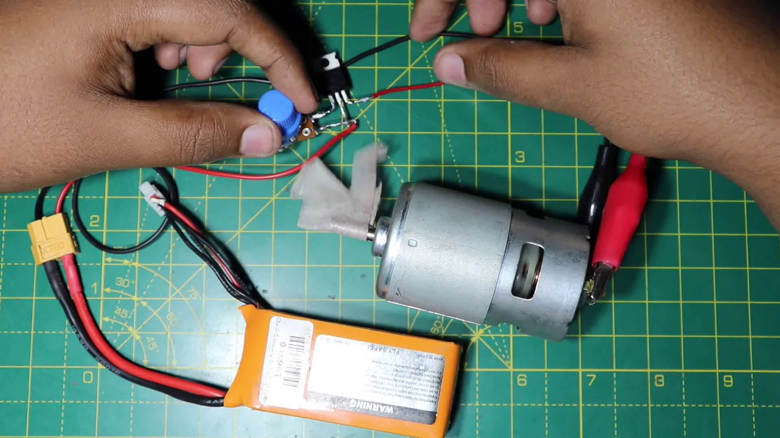 | 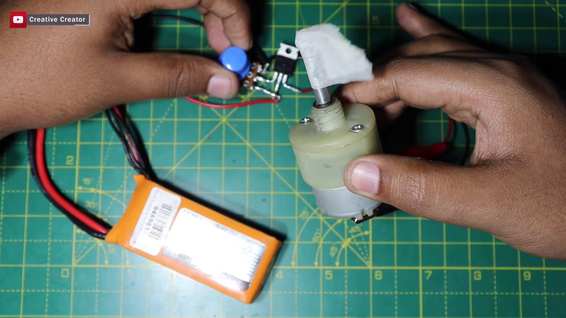 | 
Topic T1: Repetition of Let's Go — score 20.0000
Description: The speaker repeatedly says 'Let's go' without any further context or explanation.
Reason: The topic is about repetition of 'Let's go' with no further context or explanation, while the comment discusses building a DC motor with speed control. The two topics are unrelated and do not share specific overlaps.
Least correlated topics:
 |  | 
Topic T1: Repetition of Let's Go — score 20.0000
Description: The speaker repeatedly says 'Let's go' without any further context or explanation.
Reason: The topic is about repetition of 'Let's go' with no further context or explanation, while the comment discusses building a DC motor with speed control. The two topics are unrelated and do not share specific overlaps.
- matched 0 topic(s), max score 0.0000: Starts off with using a large heat sink to mount his mosfet and rectifiers, along with a potentiometer, there are several videos where people just solder the component to each other without using a board for a base. I guess this is an easier way to do, but it seems a little sloppy to me. It is very interesting to see the control of the motor with very little electronics. The motor is moving pretty fast for only a hand full of electronics used. I do wonder how hot the mosfet was controlling the motor.
Source: https://www.youtube.com/watch?v=CvMDlG_AF3Q: how to make simple dc motor speed control circuit
Top correlated topics:
 |  | 
Topic T1: Repetition of Let's Go — score 0.0000
Description: The speaker repeatedly says 'Let's go' without any further context or explanation.
Reason: The comment discusses electronics and a motor control, but does not mention the repetition of 'Let's go' or any context related to the topic title.
Least correlated topics:
 |  | 
Topic T1: Repetition of Let's Go — score 0.0000
Description: The speaker repeatedly says 'Let's go' without any further context or explanation.
Reason: The comment discusses electronics and a motor control, but does not mention the repetition of 'Let's go' or any context related to the topic title.
- matched 0 topic(s), max score 0.0000: In order to build a simple DC motor speed control circuit, you will need the following materials a MOSFET, a potentiometer, a resistor, a power supply of a 25 voltage, a multimeter, a soldering iron, and wires. In order to assemble the circuit, you start by connecting a wire to the MOSFET. Next you connect the middle pin of the MOSFET to the resistor and the other end of the resistor to the middle pin of the potentiometer. The other pins of the potentiometer can be connected to wires. One will be connected to the MOSFET and the other to the pin will be used to attach the power supply and the multimeter. When all of those connections are made the multimeter will be able to read the voltage going across the circuit. Finally, you can attach the DC motor to the circuit, and it will start spinning due to the correct assembly of the circuit.
Source: https://www.youtube.com/watch?v=CvMDlG_AF3Q: how to make simple dc motor speed control circuit.
Top correlated topics:
 |  | 
Topic T1: Repetition of Let's Go — score 0.0000
Description: The speaker repeatedly says 'Let's go' without any further context or explanation.
Reason: {
"correlated": false,
"score": 0,
"reason": "The topic is about repetition of 'Let's go' without context or explanation, whereas the comment discusses building a DC motor speed control circuit with specific materials and connections. There is no overlap between the two."
Least correlated topics:
 |  | 
Topic T1: Repetition of Let's Go — score 0.0000
Description: The speaker repeatedly says 'Let's go' without any further context or explanation.
Reason: {
"correlated": false,
"score": 0,
"reason": "The topic is about repetition of 'Let's go' without context or explanation, whereas the comment discusses building a DC motor speed control circuit with specific materials and connections. There is no overlap between the two."

Topic T1: Repetition of Let's Go
 |  | 
Description: The speaker repeatedly says 'Let's go' without any further context or explanation.
No strongly correlated comments found for this topic.

