Comment–Topic Correlation Report
Model: llama3

Summary
Topics processed: 4
Comments available for this video: 1
Comments correlated to ≥ 60: 0 (0.0%)
Total candidate pairs checked: 4

Most/Least correlated topics (by average score across correlated comments):
Top 3:
• Topic T3: The Power of Engineering — avg 0.00, contributions 0
• Topic T1: The Drone Show — avg 0.00, contributions 0
• Topic T4: Crunch Labs Box Subscription — avg 0.00, contributions 0
Bottom 3:
• Topic T2: Abdul's Story — avg 0.00, contributions 0
• Topic T4: Crunch Labs Box Subscription — avg 0.00, contributions 0
• Topic T1: The Drone Show — avg 0.00, contributions 0
Correlated comment coverage (all comments):
- matched 0 topic(s), max score 0.0000: This video discusses the positives of drones delivering packages. Specifically, a company called Zipline. This company has started a drone delivery system of packages that will drop it off at your doorstep! This system has an ever-increasing potential for the growing economy. The positives include the decrease in traffic within the cities. No more Amazon vans and reducing the loads for truck drivers. Zipline’s delivery system would also decrease the amount of time for a package to be delivered, potentially being a big competitor against Amazon. This system of delivery also proposes the prospects of human transportation. Although I would not feel safe having a drone transport me, it is a very interesting idea. Maybe I would feel better about it after more security measures are in place or it becomes more common.
Source: https://www.youtube.com/watch?v=DOWDNBu9DkU: Amazing Invention- This Drone Will Change Everything
Top correlated topics:
 | 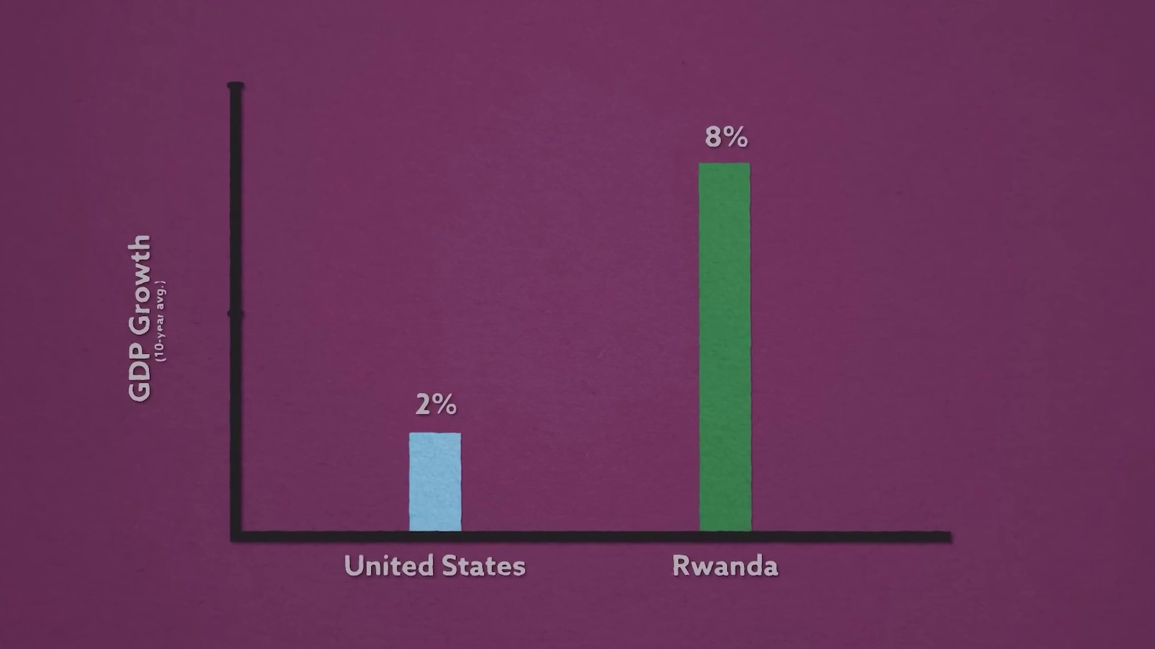 | 
Topic T3: The Power of Engineering — score 20.0000
Description: Importance of engineering and problem-solving skills.
Reason: The comment discusses drones and delivery systems, but does not mention engineering or problem-solving skills directly. The topic is about the importance of engineering and problem-solving skills, which are not explicitly discussed in the comment.
 |  | 
Topic T1: The Drone Show — score 20.0000
Description: Story about Abdul and the drones he built.
Reason: The comment discusses drone delivery systems and their benefits, but the topic is about a person's story about building drones, not about the use of drones for delivery. The comment does not discuss Abdul or his drones at all.
 |  | 
Topic T4: Crunch Labs Box Subscription — score 0.0000
Description: Information about the monthly subscription box service.
Reason: The comment discusses drones delivering packages, while the topic is about Crunch Labs Box Subscription, a monthly subscription box service. There is no overlap in topics or concepts.
 |  | 
Topic T2: Abdul's Story — score 0.0000
Description: Story of Abdul's journey from refugee to engineer.
Reason: The comment discusses drone delivery and its potential benefits, which is unrelated to Abdul's story about his journey from refugee to engineer.
Least correlated topics:
 |  | 
Topic T2: Abdul's Story — score 0.0000
Description: Story of Abdul's journey from refugee to engineer.
Reason: The comment discusses drone delivery and its potential benefits, which is unrelated to Abdul's story about his journey from refugee to engineer.
 |  | 
Topic T4: Crunch Labs Box Subscription — score 0.0000
Description: Information about the monthly subscription box service.
Reason: The comment discusses drones delivering packages, while the topic is about Crunch Labs Box Subscription, a monthly subscription box service. There is no overlap in topics or concepts.
 |  | 
Topic T1: The Drone Show — score 20.0000
Description: Story about Abdul and the drones he built.
Reason: The comment discusses drone delivery systems and their benefits, but the topic is about a person's story about building drones, not about the use of drones for delivery. The comment does not discuss Abdul or his drones at all.
 |  | 
Topic T3: The Power of Engineering — score 20.0000
Description: Importance of engineering and problem-solving skills.
Reason: The comment discusses drones and delivery systems, but does not mention engineering or problem-solving skills directly. The topic is about the importance of engineering and problem-solving skills, which are not explicitly discussed in the comment.

Topic T1: The Drone Show
 |  | 
Description: Story about Abdul and the drones he built.
No strongly correlated comments found for this topic.

Topic T2: Abdul's Story
 |  | 
Description: Story of Abdul's journey from refugee to engineer.
No strongly correlated comments found for this topic.

Topic T3: The Power of Engineering
 |  | 
Description: Importance of engineering and problem-solving skills.
No strongly correlated comments found for this topic.

Topic T4: Crunch Labs Box Subscription
 |  | 
Description: Information about the monthly subscription box service.
No strongly correlated comments found for this topic.

