Comment–Topic Correlation Report
Model: llama3

Summary
Topics processed: 4
Comments available for this video: 1
Comments correlated to ≥ 60: 1 (100.0%)
Total candidate pairs checked: 4

Most/Least correlated topics (by average score across correlated comments):
Top 3:
• Topic T2: Setting Up Aux Channels in the Transmitter — avg 80.00, contributions 1
• Topic T1: Introduction to Droning — avg 80.00, contributions 1
• Topic T4: Setting Up Modes in Beta Flight — avg 0.00, contributions 0
Bottom 3:
• Topic T3: Configuring Double Switch Arming in Beta Flight — avg 0.00, contributions 0
• Topic T4: Setting Up Modes in Beta Flight — avg 0.00, contributions 0
• Topic T1: Introduction to Droning — avg 80.00, contributions 1
Correlated comment coverage (all comments):
- matched 2 topic(s), max score 80.0000: Change aux channels – channels 1-4: throttle, yaw, pitch, row.Might have 2 or 6 additional channels depending on software.Can program these other channels to a multitude of different functions.
Source: https://www.youtube.com/watch?v=DQOt-m7rg80: Dual switch arming on Flysky FS-i6
Top correlated topics:
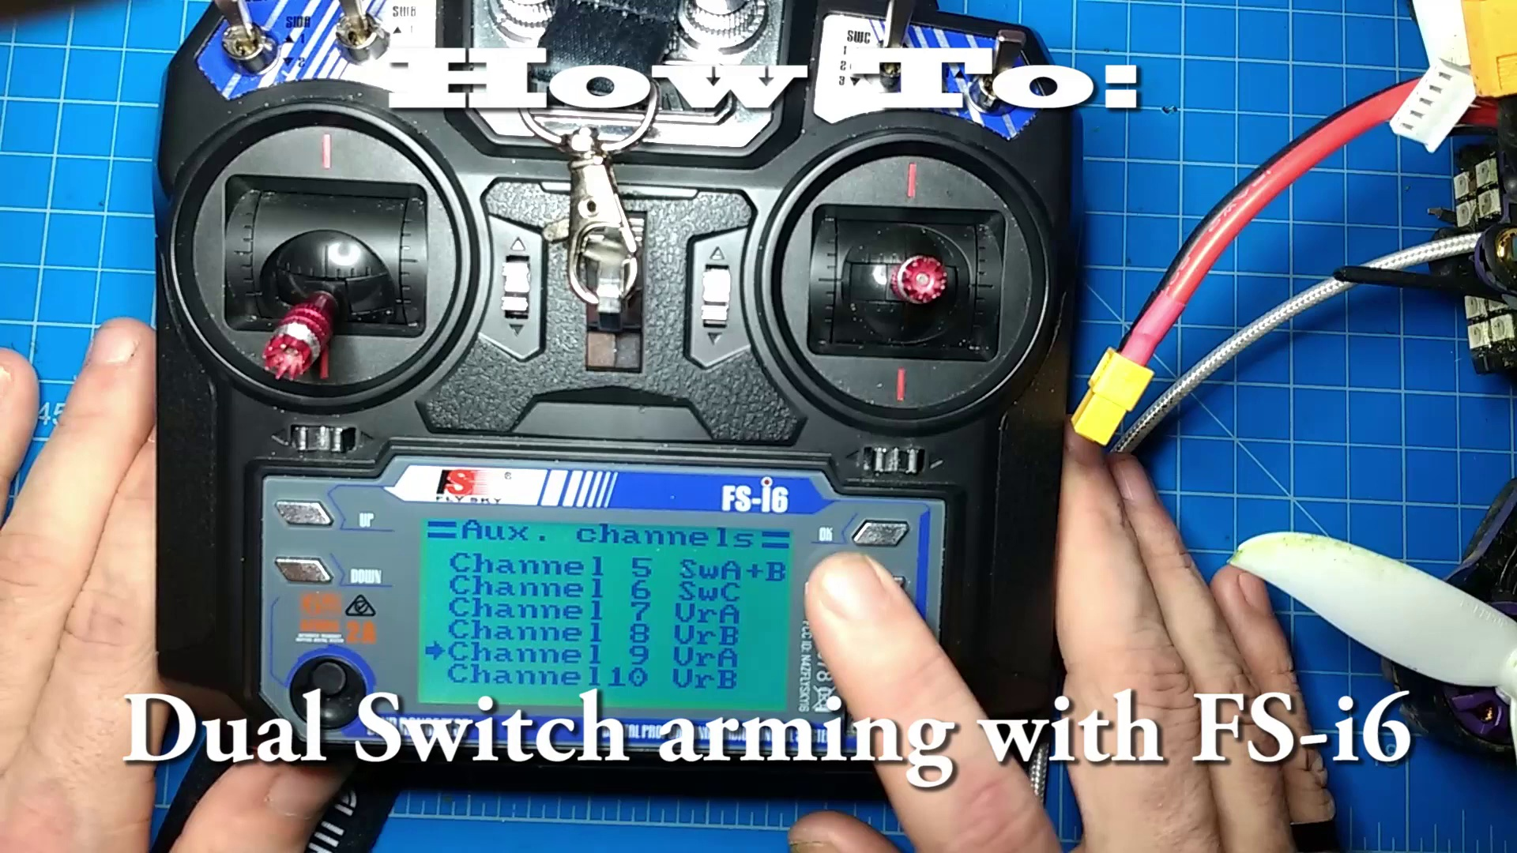 | 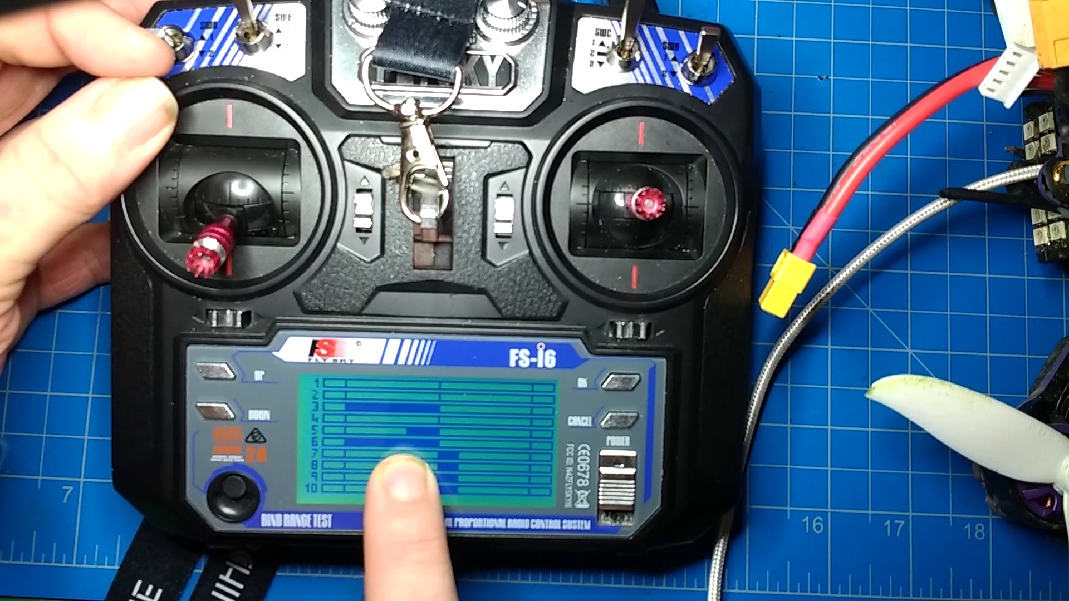 | 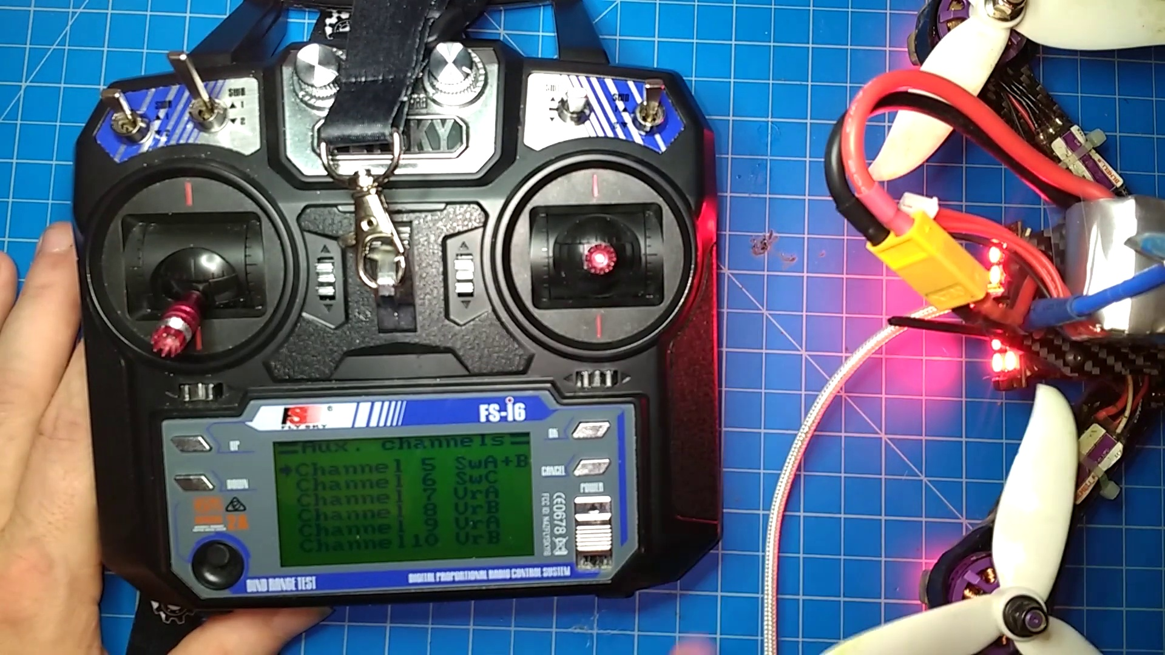
Topic T2: Setting Up Aux Channels in the Transmitter — score 80.0000
Description: The host explains how to set up aux channels in the transmitter for double switch arming.
Reason: The comment directly discusses setting up aux channels in the transmitter, specifically mentioning channels 1-4 and their potential customization to different functions, which strongly relates to the topic's description of setting up aux channels for double switch arming.
 |  | 
Topic T1: Introduction to Droning — score 80.0000
Description: The host introduces themselves and shares their experience with learning about droning.
Reason: The comment directly discusses the setting (aux channels) and parameters (1-4 channels) mentioned in the topic description about droning.
 |  | 
Topic T4: Setting Up Modes in Beta Flight — score 20.0000
Description: The host explains how to set up modes in beta flight, including adding ranges for double switch arming.
Reason: The comment discusses changing aux channels and programming them for different functions, but it does not directly discuss setting up modes in beta flight as described in the topic. There is no mention of double switch arming or ranges.
 |  | 
Topic T3: Configuring Double Switch Arming in Beta Flight — score 20.0000
Description: The host shows how to configure double switch arming in beta flight and explains its functionality.
Reason: The comment discusses AUX channel settings and programming, which is related to the topic of configuring double switch arming in Beta Flight, but not directly discussing the same steps, objects, settings, parameters, claims, or goals described by the topic. The connection is indirect, focusing on auxiliary channels rather than double switch arming.
Least correlated topics:
 |  | 
Topic T3: Configuring Double Switch Arming in Beta Flight — score 20.0000
Description: The host shows how to configure double switch arming in beta flight and explains its functionality.
Reason: The comment discusses AUX channel settings and programming, which is related to the topic of configuring double switch arming in Beta Flight, but not directly discussing the same steps, objects, settings, parameters, claims, or goals described by the topic. The connection is indirect, focusing on auxiliary channels rather than double switch arming.
 |  | 
Topic T4: Setting Up Modes in Beta Flight — score 20.0000
Description: The host explains how to set up modes in beta flight, including adding ranges for double switch arming.
Reason: The comment discusses changing aux channels and programming them for different functions, but it does not directly discuss setting up modes in beta flight as described in the topic. There is no mention of double switch arming or ranges.
 |  | 
Topic T1: Introduction to Droning — score 80.0000
Description: The host introduces themselves and shares their experience with learning about droning.
Reason: The comment directly discusses the setting (aux channels) and parameters (1-4 channels) mentioned in the topic description about droning.
 |  | 
Topic T2: Setting Up Aux Channels in the Transmitter — score 80.0000
Description: The host explains how to set up aux channels in the transmitter for double switch arming.
Reason: The comment directly discusses setting up aux channels in the transmitter, specifically mentioning channels 1-4 and their potential customization to different functions, which strongly relates to the topic's description of setting up aux channels for double switch arming.

Topic T1: Introduction to Droning
 |  | 
Description: The host introduces themselves and shares their experience with learning about droning.
Comment (score 80): Change aux channels – channels 1-4: throttle, yaw, pitch, row.Might have 2 or 6 additional channels depending on software.Can program these other channels to a multitude of different functions.
Reason: The comment directly discusses the setting (aux channels) and parameters (1-4 channels) mentioned in the topic description about droning.
Source: https://www.youtube.com/watch?v=DQOt-m7rg80: Dual switch arming on Flysky FS-i6

Topic T2: Setting Up Aux Channels in the Transmitter
 |  | 
Description: The host explains how to set up aux channels in the transmitter for double switch arming.
Comment (score 80): Change aux channels – channels 1-4: throttle, yaw, pitch, row.Might have 2 or 6 additional channels depending on software.Can program these other channels to a multitude of different functions.
Reason: The comment directly discusses setting up aux channels in the transmitter, specifically mentioning channels 1-4 and their potential customization to different functions, which strongly relates to the topic's description of setting up aux channels for double switch arming.
Source: https://www.youtube.com/watch?v=DQOt-m7rg80: Dual switch arming on Flysky FS-i6

Topic T3: Configuring Double Switch Arming in Beta Flight
 |  | 
Description: The host shows how to configure double switch arming in beta flight and explains its functionality.
No strongly correlated comments found for this topic.

Topic T4: Setting Up Modes in Beta Flight
 |  | 
Description: The host explains how to set up modes in beta flight, including adding ranges for double switch arming.
No strongly correlated comments found for this topic.

