Comment–Topic Correlation Report
Model: llama3

Summary
Topics processed: 7
Comments available for this video: 1
Comments correlated to ≥ 60: 1 (100.0%)
Total candidate pairs checked: 7

Most/Least correlated topics (by average score across correlated comments):
Top 3:
• Topic T1: Introduction and Overview — avg 90.00, contributions 1
• Topic T2: Designing the Drone — avg 90.00, contributions 1
• Topic T7: Conclusion — avg 90.00, contributions 1
Bottom 3:
• Topic T5: Configuring Betaflight — avg 0.00, contributions 0
• Topic T6: First Flight Tests — avg 80.00, contributions 1
• Topic T4: Assembling the Drone — avg 90.00, contributions 1
Correlated comment coverage (all comments):
- matched 6 topic(s), max score 90.0000: This guide details the process of building a custom FPV drone. Unlike standard drones designed for slow, controlled flight and high-quality recordings, this FPV drone offers a faster, more immersive experience with a mounted GoPro for unique footage. The process involved selecting and assembling various components like the frame, motors, battery, receiver, camera, and flight controller. The creator faced challenges in understanding the large volume of available drone hardware, communication protocols, and software, but successfully navigated these to build a functional drone. The video provides insights into each component's role and highlights the importance of matching parts to the drone's size. The video includes tips on 3D printing parts, choosing motors and batteries, and configuring the drone with BetaFlight software. The creator's initial test flights reveal the need for practice and adjustment, especially when using the goggles for an enhanced flying experience.
Source: https://www.youtube.com/watch?v=DeSDjjicGWY: The Idiot's Guide to Making a DIY Drone!
Top correlated topics:
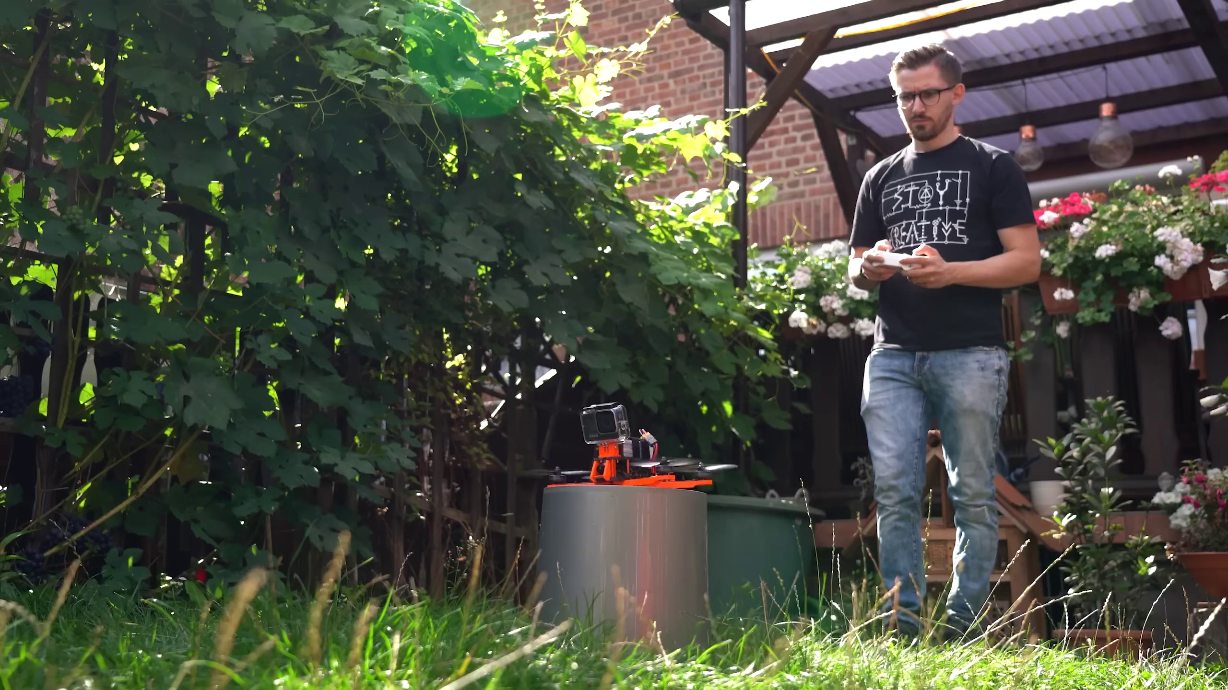 | 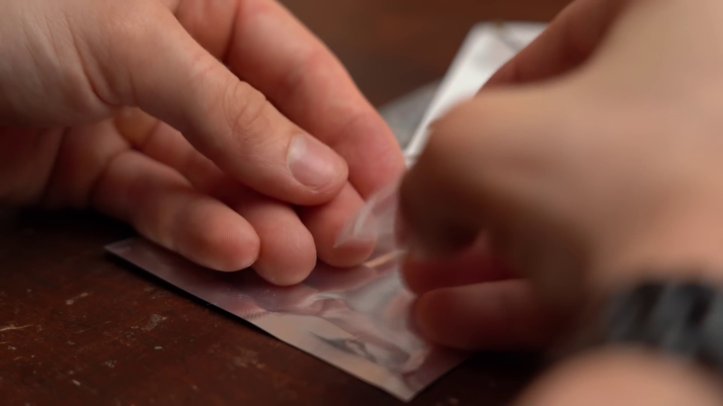 | 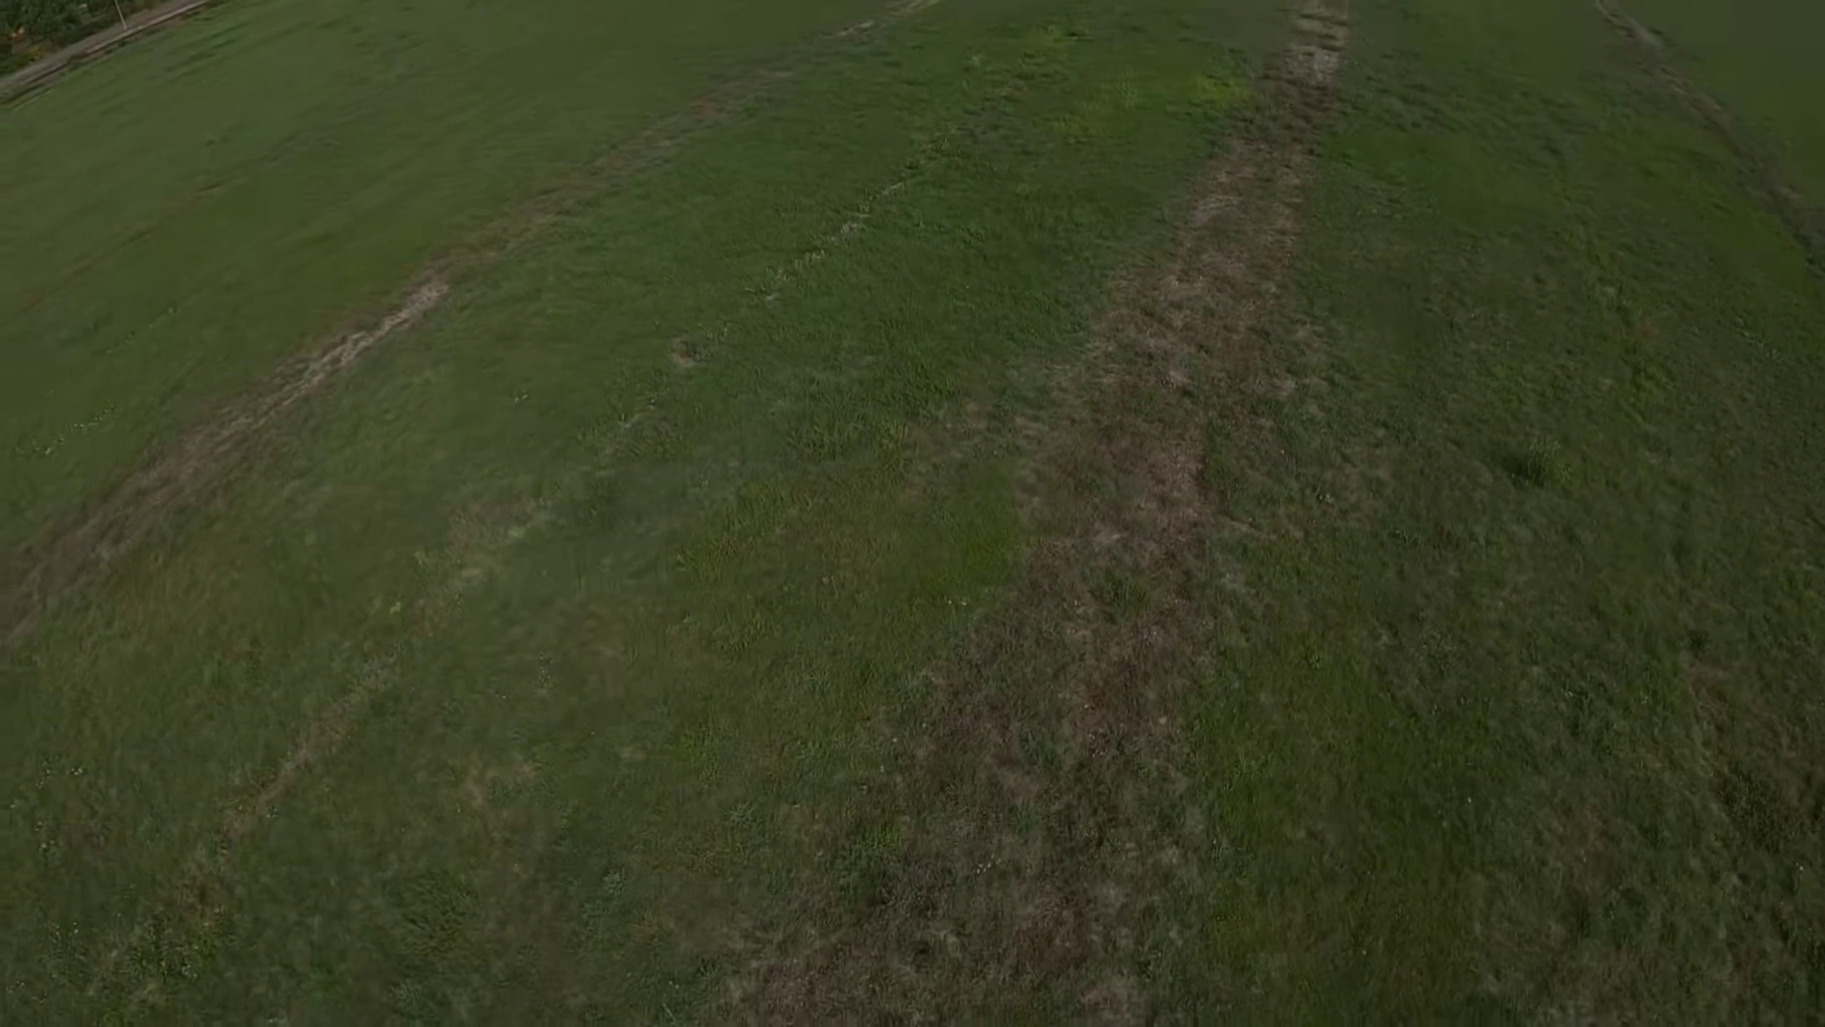
Topic T7: Conclusion — score 90.0000
Description: The host wraps up the video by summarizing the key takeaways and sharing his thoughts on building a drone. He encourages viewers to share their own experiences in the comments.
Reason: The comment directly discusses the steps involved in building a custom FPV drone, including selecting and assembling components, overcoming challenges, and configuring the drone with BetaFlight software. The description of the process and importance of matching parts to the drone's size matches the topic 'Conclusion' perfectly.
 |  | 
Topic T4: Assembling the Drone — score 90.0000
Description: The host walks viewers through the process of assembling the drone's components. He explains how he connected the frame to the flight controller and motor.
Reason: The comment directly discusses the same steps and components (frame, motors, flight controller) described in the topic. Additionally, it mentions the importance of matching parts to the drone's size, which is also highlighted in the topic description.
 |  | 
Topic T3: Building the Frame — score 90.0000
Description: The host talks about building the frame of the drone using 3D printed parts. He explains how he modified some of the parts to fit his design.
Reason: The comment directly discusses building a custom FPV drone, mentioning specific components like frame, motors, battery, receiver, camera, and flight controller. The topic description about building the frame of a drone using 3D printed parts is closely related to these details, showing strong correlation.
 |  | 
Topic T2: Designing the Drone — score 90.0000
Description: The host discusses his design decisions and how he created the drone's body. He also explains why certain components were chosen.
Reason: The comment directly discusses the design decisions and components involved in building a custom FPV drone, including the frame, motors, battery, receiver, camera, flight controller, and software. It also mentions the creator's process of selecting and assembling these components, matching parts to the drone's size, and configuring BetaFlight software.
 |  | 
Topic T1: Introduction and Overview — score 90.0000
Description: The host introduces himself and his expertise in building drones. He explains that this video will cover the process of building a drone from scratch.
Reason: The comment directly discusses building a custom FPV drone from scratch, including selecting and assembling components like frame, motors, battery, receiver, camera, and flight controller. It also mentions the importance of matching parts to the drone's size, configuring with BetaFlight software, and overcoming initial challenges, which are all covered in the topic description.
 |  | 
Topic T6: First Flight Tests — score 80.0000
Description: The host shares his experiences with the first few flights of his drone. He discusses the challenges he faced and what he learned from the experience.
Reason: The comment details a process of building and testing a custom FPV drone, which is directly related to the topic 'First Flight Tests'. The description of challenges faced in understanding drone hardware, software, and communication protocols matches with the host's experiences discussed in the topic.
 |  | 
Topic T5: Configuring Betaflight — score 20.0000
Description: The host explains how he configured the drone's flight settings using the Betaflight software. He talks about calibrating the accelerometer and setting up modes.
Reason: The comment discusses building a custom FPV drone, mentioning BetaFlight software configuration in the context of choosing and assembling components, but does not directly discuss configuring the flight settings or calibrating the accelerometer as mentioned in the topic description.
Least correlated topics:
 |  | 
Topic T5: Configuring Betaflight — score 20.0000
Description: The host explains how he configured the drone's flight settings using the Betaflight software. He talks about calibrating the accelerometer and setting up modes.
Reason: The comment discusses building a custom FPV drone, mentioning BetaFlight software configuration in the context of choosing and assembling components, but does not directly discuss configuring the flight settings or calibrating the accelerometer as mentioned in the topic description.
 |  | 
Topic T6: First Flight Tests — score 80.0000
Description: The host shares his experiences with the first few flights of his drone. He discusses the challenges he faced and what he learned from the experience.
Reason: The comment details a process of building and testing a custom FPV drone, which is directly related to the topic 'First Flight Tests'. The description of challenges faced in understanding drone hardware, software, and communication protocols matches with the host's experiences discussed in the topic.
 |  | 
Topic T1: Introduction and Overview — score 90.0000
Description: The host introduces himself and his expertise in building drones. He explains that this video will cover the process of building a drone from scratch.
Reason: The comment directly discusses building a custom FPV drone from scratch, including selecting and assembling components like frame, motors, battery, receiver, camera, and flight controller. It also mentions the importance of matching parts to the drone's size, configuring with BetaFlight software, and overcoming initial challenges, which are all covered in the topic description.
 |  | 
Topic T2: Designing the Drone — score 90.0000
Description: The host discusses his design decisions and how he created the drone's body. He also explains why certain components were chosen.
Reason: The comment directly discusses the design decisions and components involved in building a custom FPV drone, including the frame, motors, battery, receiver, camera, flight controller, and software. It also mentions the creator's process of selecting and assembling these components, matching parts to the drone's size, and configuring BetaFlight software.
 |  | 
Topic T3: Building the Frame — score 90.0000
Description: The host talks about building the frame of the drone using 3D printed parts. He explains how he modified some of the parts to fit his design.
Reason: The comment directly discusses building a custom FPV drone, mentioning specific components like frame, motors, battery, receiver, camera, and flight controller. The topic description about building the frame of a drone using 3D printed parts is closely related to these details, showing strong correlation.
 |  | 
Topic T4: Assembling the Drone — score 90.0000
Description: The host walks viewers through the process of assembling the drone's components. He explains how he connected the frame to the flight controller and motor.
Reason: The comment directly discusses the same steps and components (frame, motors, flight controller) described in the topic. Additionally, it mentions the importance of matching parts to the drone's size, which is also highlighted in the topic description.
 |  | 
Topic T7: Conclusion — score 90.0000
Description: The host wraps up the video by summarizing the key takeaways and sharing his thoughts on building a drone. He encourages viewers to share their own experiences in the comments.
Reason: The comment directly discusses the steps involved in building a custom FPV drone, including selecting and assembling components, overcoming challenges, and configuring the drone with BetaFlight software. The description of the process and importance of matching parts to the drone's size matches the topic 'Conclusion' perfectly.

Topic T1: Introduction and Overview
 |  | 
Description: The host introduces himself and his expertise in building drones. He explains that this video will cover the process of building a drone from scratch.
Comment (score 90): This guide details the process of building a custom FPV drone. Unlike standard drones designed for slow, controlled flight and high-quality recordings, this FPV drone offers a faster, more immersive experience with a mounted GoPro for unique footage. The process involved selecting and assembling various components like the frame, motors, battery, receiver, camera, and flight controller. The creator faced challenges in understanding the large volume of available drone hardware, communication protocols, and software, but successfully navigated these to build a functional drone. The video provides insights into each component's role and highlights the importance of matching parts to the drone's size. The video includes tips on 3D printing parts, choosing motors and batteries, and configuring the drone with BetaFlight software. The creator's initial test flights reveal the need for practice and adjustment, especially when using the goggles for an enhanced flying experience.
Reason: The comment directly discusses building a custom FPV drone from scratch, including selecting and assembling components like frame, motors, battery, receiver, camera, and flight controller. It also mentions the importance of matching parts to the drone's size, configuring with BetaFlight software, and overcoming initial challenges, which are all covered in the topic description.
Source: https://www.youtube.com/watch?v=DeSDjjicGWY: The Idiot's Guide to Making a DIY Drone!

Topic T2: Designing the Drone
 |  | 
Description: The host discusses his design decisions and how he created the drone's body. He also explains why certain components were chosen.
Comment (score 90): This guide details the process of building a custom FPV drone. Unlike standard drones designed for slow, controlled flight and high-quality recordings, this FPV drone offers a faster, more immersive experience with a mounted GoPro for unique footage. The process involved selecting and assembling various components like the frame, motors, battery, receiver, camera, and flight controller. The creator faced challenges in understanding the large volume of available drone hardware, communication protocols, and software, but successfully navigated these to build a functional drone. The video provides insights into each component's role and highlights the importance of matching parts to the drone's size. The video includes tips on 3D printing parts, choosing motors and batteries, and configuring the drone with BetaFlight software. The creator's initial test flights reveal the need for practice and adjustment, especially when using the goggles for an enhanced flying experience.
Reason: The comment directly discusses the design decisions and components involved in building a custom FPV drone, including the frame, motors, battery, receiver, camera, flight controller, and software. It also mentions the creator's process of selecting and assembling these components, matching parts to the drone's size, and configuring BetaFlight software.
Source: https://www.youtube.com/watch?v=DeSDjjicGWY: The Idiot's Guide to Making a DIY Drone!

Topic T3: Building the Frame
 |  | 
Description: The host talks about building the frame of the drone using 3D printed parts. He explains how he modified some of the parts to fit his design.
Comment (score 90): This guide details the process of building a custom FPV drone. Unlike standard drones designed for slow, controlled flight and high-quality recordings, this FPV drone offers a faster, more immersive experience with a mounted GoPro for unique footage. The process involved selecting and assembling various components like the frame, motors, battery, receiver, camera, and flight controller. The creator faced challenges in understanding the large volume of available drone hardware, communication protocols, and software, but successfully navigated these to build a functional drone. The video provides insights into each component's role and highlights the importance of matching parts to the drone's size. The video includes tips on 3D printing parts, choosing motors and batteries, and configuring the drone with BetaFlight software. The creator's initial test flights reveal the need for practice and adjustment, especially when using the goggles for an enhanced flying experience.
Reason: The comment directly discusses building a custom FPV drone, mentioning specific components like frame, motors, battery, receiver, camera, and flight controller. The topic description about building the frame of a drone using 3D printed parts is closely related to these details, showing strong correlation.
Source: https://www.youtube.com/watch?v=DeSDjjicGWY: The Idiot's Guide to Making a DIY Drone!

Topic T4: Assembling the Drone
 |  | 
Description: The host walks viewers through the process of assembling the drone's components. He explains how he connected the frame to the flight controller and motor.
Comment (score 90): This guide details the process of building a custom FPV drone. Unlike standard drones designed for slow, controlled flight and high-quality recordings, this FPV drone offers a faster, more immersive experience with a mounted GoPro for unique footage. The process involved selecting and assembling various components like the frame, motors, battery, receiver, camera, and flight controller. The creator faced challenges in understanding the large volume of available drone hardware, communication protocols, and software, but successfully navigated these to build a functional drone. The video provides insights into each component's role and highlights the importance of matching parts to the drone's size. The video includes tips on 3D printing parts, choosing motors and batteries, and configuring the drone with BetaFlight software. The creator's initial test flights reveal the need for practice and adjustment, especially when using the goggles for an enhanced flying experience.
Reason: The comment directly discusses the same steps and components (frame, motors, flight controller) described in the topic. Additionally, it mentions the importance of matching parts to the drone's size, which is also highlighted in the topic description.
Source: https://www.youtube.com/watch?v=DeSDjjicGWY: The Idiot's Guide to Making a DIY Drone!

Topic T5: Configuring Betaflight
 |  | 
Description: The host explains how he configured the drone's flight settings using the Betaflight software. He talks about calibrating the accelerometer and setting up modes.
No strongly correlated comments found for this topic.

Topic T6: First Flight Tests
 |  | 
Description: The host shares his experiences with the first few flights of his drone. He discusses the challenges he faced and what he learned from the experience.
Comment (score 80): This guide details the process of building a custom FPV drone. Unlike standard drones designed for slow, controlled flight and high-quality recordings, this FPV drone offers a faster, more immersive experience with a mounted GoPro for unique footage. The process involved selecting and assembling various components like the frame, motors, battery, receiver, camera, and flight controller. The creator faced challenges in understanding the large volume of available drone hardware, communication protocols, and software, but successfully navigated these to build a functional drone. The video provides insights into each component's role and highlights the importance of matching parts to the drone's size. The video includes tips on 3D printing parts, choosing motors and batteries, and configuring the drone with BetaFlight software. The creator's initial test flights reveal the need for practice and adjustment, especially when using the goggles for an enhanced flying experience.
Reason: The comment details a process of building and testing a custom FPV drone, which is directly related to the topic 'First Flight Tests'. The description of challenges faced in understanding drone hardware, software, and communication protocols matches with the host's experiences discussed in the topic.
Source: https://www.youtube.com/watch?v=DeSDjjicGWY: The Idiot's Guide to Making a DIY Drone!

Topic T7: Conclusion
 |  | 
Description: The host wraps up the video by summarizing the key takeaways and sharing his thoughts on building a drone. He encourages viewers to share their own experiences in the comments.
Comment (score 90): This guide details the process of building a custom FPV drone. Unlike standard drones designed for slow, controlled flight and high-quality recordings, this FPV drone offers a faster, more immersive experience with a mounted GoPro for unique footage. The process involved selecting and assembling various components like the frame, motors, battery, receiver, camera, and flight controller. The creator faced challenges in understanding the large volume of available drone hardware, communication protocols, and software, but successfully navigated these to build a functional drone. The video provides insights into each component's role and highlights the importance of matching parts to the drone's size. The video includes tips on 3D printing parts, choosing motors and batteries, and configuring the drone with BetaFlight software. The creator's initial test flights reveal the need for practice and adjustment, especially when using the goggles for an enhanced flying experience.
Reason: The comment directly discusses the steps involved in building a custom FPV drone, including selecting and assembling components, overcoming challenges, and configuring the drone with BetaFlight software. The description of the process and importance of matching parts to the drone's size matches the topic 'Conclusion' perfectly.
Source: https://www.youtube.com/watch?v=DeSDjjicGWY: The Idiot's Guide to Making a DIY Drone!

