Comment–Topic Correlation Report
Model: llama3

Summary
Topics processed: 5
Comments available for this video: 1
Comments correlated to ≥ 60: 1 (100.0%)
Total candidate pairs checked: 5

Most/Least correlated topics (by average score across correlated comments):
Top 3:
• Topic T3: Primary Circuit — avg 80.00, contributions 1
• Topic T2: Monostable Circuit — avg 80.00, contributions 1
• Topic T5: Trigger Pin — avg 0.00, contributions 0
Bottom 3:
• Topic T1: Clap Switch — avg 0.00, contributions 0
• Topic T4: Secondary Circuit — avg 0.00, contributions 0
• Topic T5: Trigger Pin — avg 0.00, contributions 0
Correlated comment coverage (all comments):
- matched 2 topic(s), max score 80.0000: I like the videos using the 555 timer, this is something I have looked at a lot to see how it works. He is using sound to trigger the LED light on. Interesting that the LED may try to stay on, so the load resistance may need to be increased in order for the LED to not stay on
Source: https://www.youtube.com/watch?v=DkbfBIMSdgo: Clap Switch circuit on Breadboard (Sound triggered LED) | Transistor + 555 timer projects
Top correlated topics:
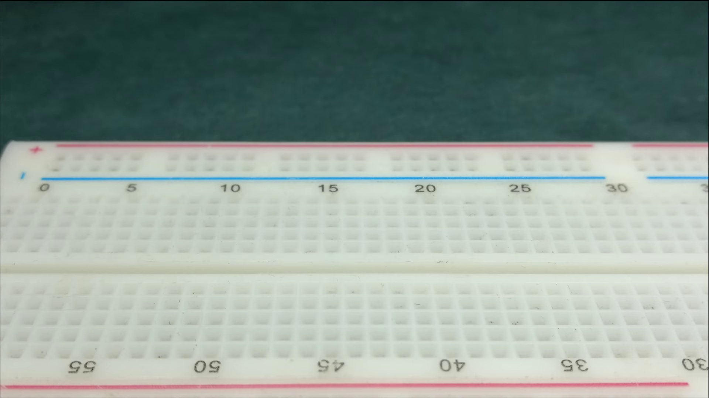 | 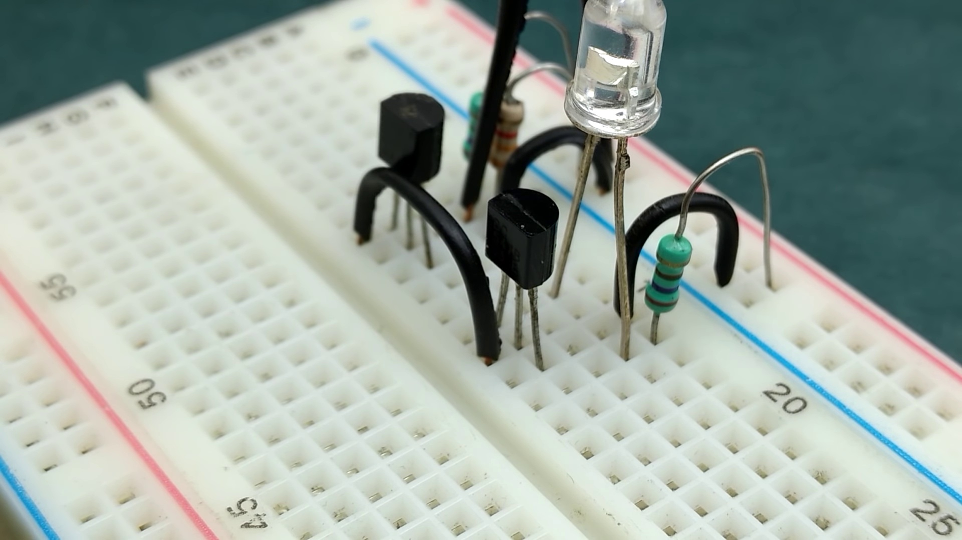 | 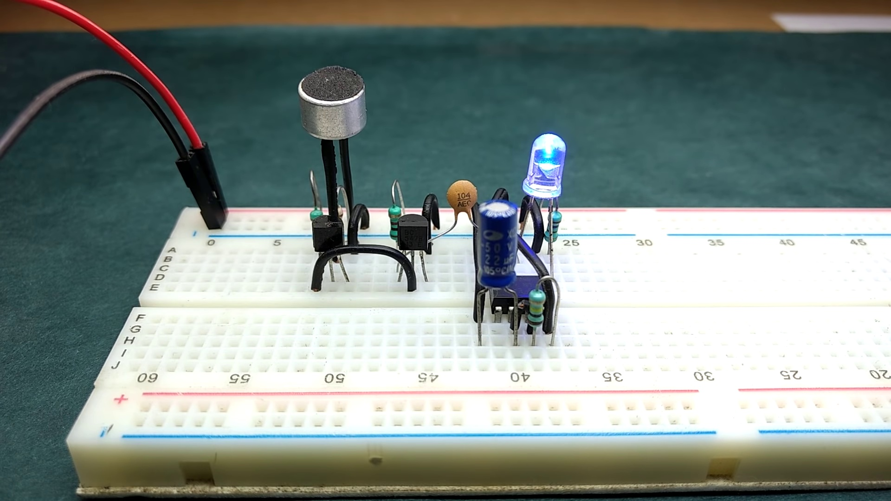
Topic T3: Primary Circuit — score 80.0000
Description: The primary circuit used in the sound triggered LED application.
Reason: The comment mentions the specific application of a sound triggered LED and references the primary circuit, which is directly discussed in the topic description. Although it does not explicitly mention the 555 timer, it shows understanding of the concept and provides a relevant suggestion for adjusting load resistance.
 |  | 
Topic T2: Monostable Circuit — score 80.0000
Description: Using a 555 timer IC to create a monostable circuit.
Reason: The comment mentions the use of a 555 timer IC and discusses the circuit's behavior, specifically mentioning the LED light and load resistance, which are directly related to the topic of creating a monostable circuit using a 555 timer IC.
 |  | 
Topic T5: Trigger Pin — score 20.0000
Description: The trigger pin and its role in the monostable circuit.
Reason: The comment mentions the 555 timer and an LED light being triggered, but it doesn't specifically discuss the trigger pin or its role in a monostable circuit. The topic is focused on a specific electronic component, while the comment is more general and discusses the use of sound to trigger an LED.
 |  | 
Topic T4: Secondary Circuit — score 20.0000
Description: The secondary circuit used in the sound triggered LED application.
Reason: The comment mentions the use of a 555 timer and LED light, but does not directly discuss the secondary circuit used in sound triggered LED application as described by the topic.
 |  | 
Topic T1: Clap Switch — score 20.0000
Description: Creating a clap switch or sound triggered LED circuit.
Reason: The comment does not directly discuss the same steps or objects described by the topic. Although it mentions the LED and sound triggering, the focus is on the 555 timer and the commentator's experience with the circuit, rather than a specific clap switch or sound triggered LED circuit.
Least correlated topics:
 |  | 
Topic T1: Clap Switch — score 20.0000
Description: Creating a clap switch or sound triggered LED circuit.
Reason: The comment does not directly discuss the same steps or objects described by the topic. Although it mentions the LED and sound triggering, the focus is on the 555 timer and the commentator's experience with the circuit, rather than a specific clap switch or sound triggered LED circuit.
 |  | 
Topic T4: Secondary Circuit — score 20.0000
Description: The secondary circuit used in the sound triggered LED application.
Reason: The comment mentions the use of a 555 timer and LED light, but does not directly discuss the secondary circuit used in sound triggered LED application as described by the topic.
 |  | 
Topic T5: Trigger Pin — score 20.0000
Description: The trigger pin and its role in the monostable circuit.
Reason: The comment mentions the 555 timer and an LED light being triggered, but it doesn't specifically discuss the trigger pin or its role in a monostable circuit. The topic is focused on a specific electronic component, while the comment is more general and discusses the use of sound to trigger an LED.
 |  | 
Topic T2: Monostable Circuit — score 80.0000
Description: Using a 555 timer IC to create a monostable circuit.
Reason: The comment mentions the use of a 555 timer IC and discusses the circuit's behavior, specifically mentioning the LED light and load resistance, which are directly related to the topic of creating a monostable circuit using a 555 timer IC.
 |  | 
Topic T3: Primary Circuit — score 80.0000
Description: The primary circuit used in the sound triggered LED application.
Reason: The comment mentions the specific application of a sound triggered LED and references the primary circuit, which is directly discussed in the topic description. Although it does not explicitly mention the 555 timer, it shows understanding of the concept and provides a relevant suggestion for adjusting load resistance.

Topic T1: Clap Switch
 |  | 
Description: Creating a clap switch or sound triggered LED circuit.
No strongly correlated comments found for this topic.

Topic T2: Monostable Circuit
 |  | 
Description: Using a 555 timer IC to create a monostable circuit.
Comment (score 80): I like the videos using the 555 timer, this is something I have looked at a lot to see how it works. He is using sound to trigger the LED light on. Interesting that the LED may try to stay on, so the load resistance may need to be increased in order for the LED to not stay on
Reason: The comment mentions the use of a 555 timer IC and discusses the circuit's behavior, specifically mentioning the LED light and load resistance, which are directly related to the topic of creating a monostable circuit using a 555 timer IC.
Source: https://www.youtube.com/watch?v=DkbfBIMSdgo: Clap Switch circuit on Breadboard (Sound triggered LED) | Transistor + 555 timer projects

Topic T3: Primary Circuit
 |  | 
Description: The primary circuit used in the sound triggered LED application.
Comment (score 80): I like the videos using the 555 timer, this is something I have looked at a lot to see how it works. He is using sound to trigger the LED light on. Interesting that the LED may try to stay on, so the load resistance may need to be increased in order for the LED to not stay on
Reason: The comment mentions the specific application of a sound triggered LED and references the primary circuit, which is directly discussed in the topic description. Although it does not explicitly mention the 555 timer, it shows understanding of the concept and provides a relevant suggestion for adjusting load resistance.
Source: https://www.youtube.com/watch?v=DkbfBIMSdgo: Clap Switch circuit on Breadboard (Sound triggered LED) | Transistor + 555 timer projects

Topic T4: Secondary Circuit
 |  | 
Description: The secondary circuit used in the sound triggered LED application.
No strongly correlated comments found for this topic.

Topic T5: Trigger Pin
 |  | 
Description: The trigger pin and its role in the monostable circuit.
No strongly correlated comments found for this topic.

