Comment–Topic Correlation Report
Model: llama3

Summary
Topics processed: 3
Comments available for this video: 2
Comments correlated to ≥ 60: 0 (0.0%)
Total candidate pairs checked: 6

Most/Least correlated topics (by average score across correlated comments):
Top 3:
• Topic T3: Free Trial and Access — avg 0.00, contributions 0
• Topic T2: Collaboration and Feedback — avg 0.00, contributions 0
• Topic T1: Altyum Designer Introduction — avg 0.00, contributions 0
Bottom 3:
• Topic T1: Altyum Designer Introduction — avg 0.00, contributions 0
• Topic T2: Collaboration and Feedback — avg 0.00, contributions 0
• Topic T3: Free Trial and Access — avg 0.00, contributions 0
Correlated comment coverage (all comments):
- matched 0 topic(s), max score 0.0000: What I have learned from the video is How to make a DC motor speed controller. What confused me: is that Not in English and he does not show a circuit. How I plan to use the electrical system in the future is To control a DC motor.
Source: https://www.youtube.com/watch?v=ERLMO-nay30: How to make simple DC motor speed control circuit
Top correlated topics:
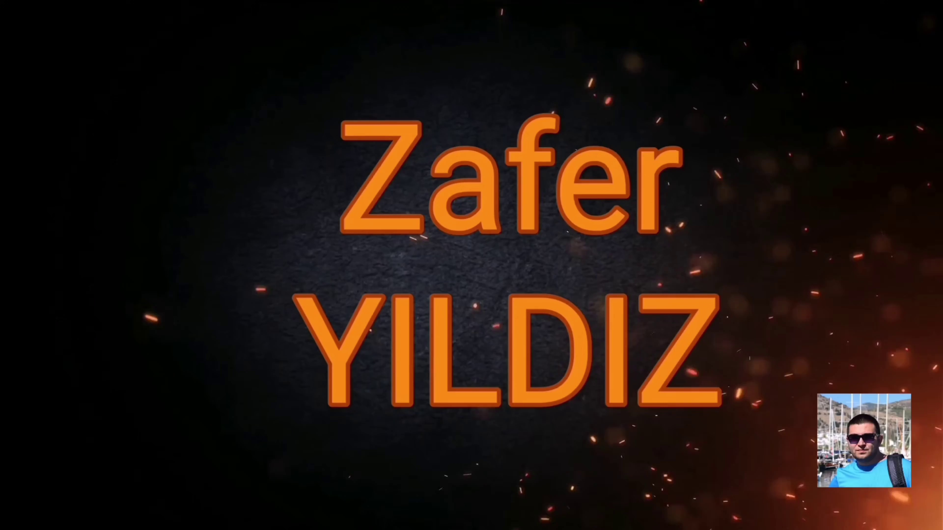 | 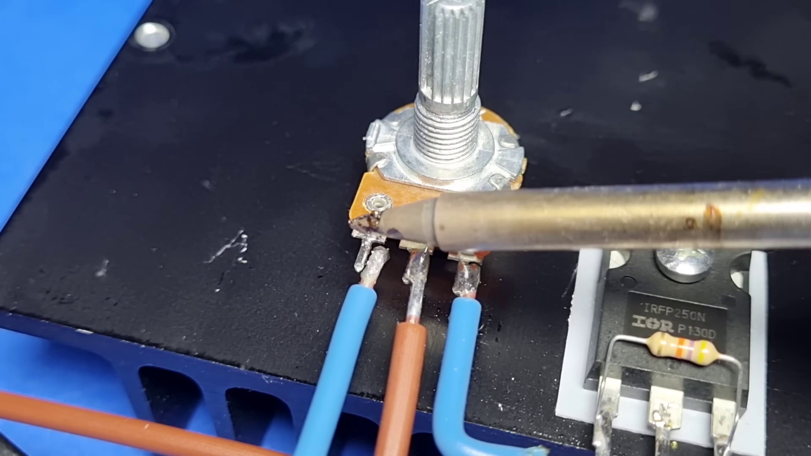 | 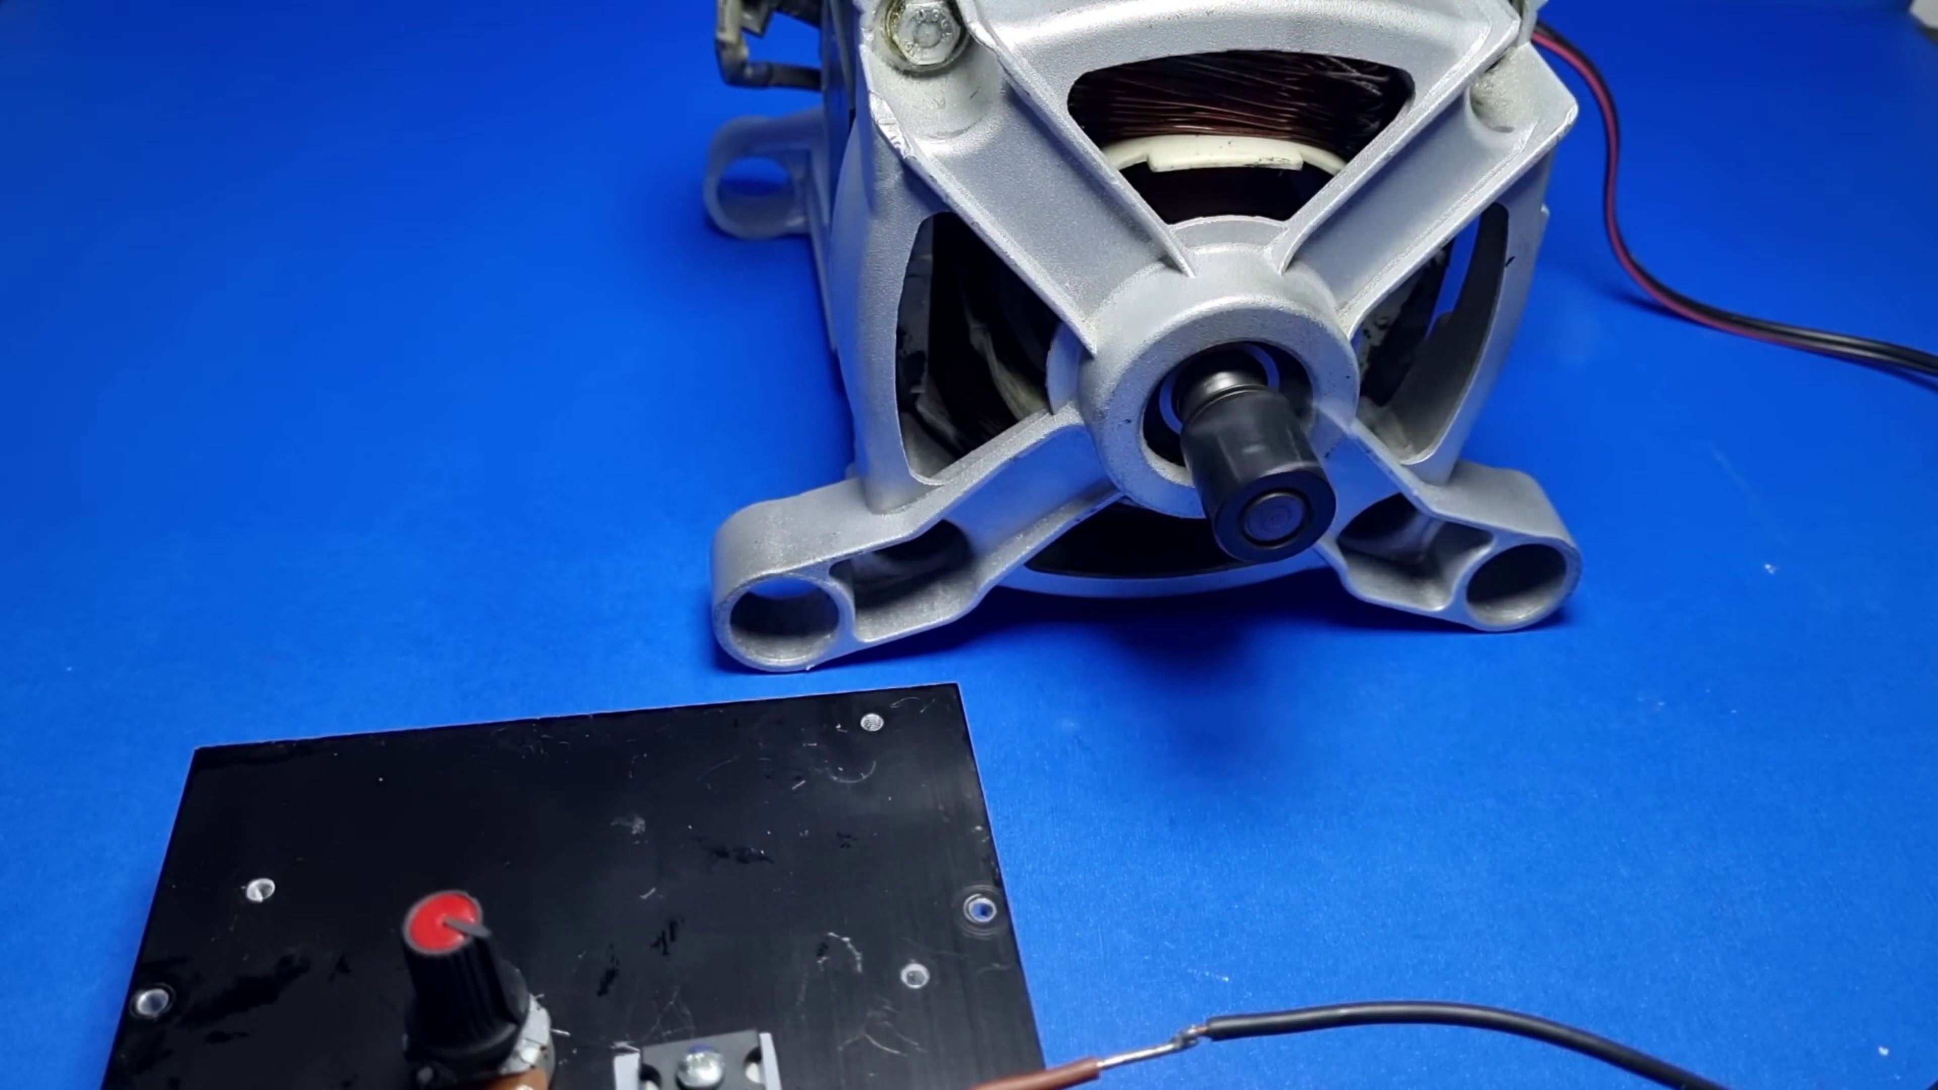
Topic T3: Free Trial and Access — score 20.0000
Description: The speaker explains that there is no extra cost or license required to use the platform, and users can access it directly from Altyum Designer.
Reason: The comment discusses controlling a DC motor, which is not directly related to the topic of free trial and access. The only connection is that it mentions using an electrical system, but this is a vague mention without any clear relevance to the topic.
 |  | 
Topic T1: Altyum Designer Introduction — score 10.0000
Description: The speaker introduces Altyum 365 as an electronic product design platform that combines PCB design, MCAT data management, and team collaboration.
Reason: The comment discusses controlling a DC motor, but the topic is about Altyum Designer Introduction and has no direct relation to speed controllers or circuit design.
 |  | 
Topic T2: Collaboration and Feedback — score 0.0000
Description: The speaker highlights the platform's collaboration features, allowing users to share their work with others and receive feedback and evaluations.
Reason: The comment discusses building a DC motor speed controller and controlling a DC motor, which is unrelated to the topic of collaboration and feedback. The topic does not mention circuit design or electrical systems.
Least correlated topics:
 |  | 
Topic T2: Collaboration and Feedback — score 0.0000
Description: The speaker highlights the platform's collaboration features, allowing users to share their work with others and receive feedback and evaluations.
Reason: The comment discusses building a DC motor speed controller and controlling a DC motor, which is unrelated to the topic of collaboration and feedback. The topic does not mention circuit design or electrical systems.
 |  | 
Topic T1: Altyum Designer Introduction — score 10.0000
Description: The speaker introduces Altyum 365 as an electronic product design platform that combines PCB design, MCAT data management, and team collaboration.
Reason: The comment discusses controlling a DC motor, but the topic is about Altyum Designer Introduction and has no direct relation to speed controllers or circuit design.
 |  | 
Topic T3: Free Trial and Access — score 20.0000
Description: The speaker explains that there is no extra cost or license required to use the platform, and users can access it directly from Altyum Designer.
Reason: The comment discusses controlling a DC motor, which is not directly related to the topic of free trial and access. The only connection is that it mentions using an electrical system, but this is a vague mention without any clear relevance to the topic.
- matched 0 topic(s), max score 0.0000: This video is 5:44 minutes long. What I learned from this video – I found this video interesting. The man controls the speed of a DC motor with a potentiometer using the circuit shown in the video. He uses an IRFP25ON to do this. I noticed some good soldering techniques in this video which I will put into practice when working on my project. Questions – I would like to know what kind of conductive sheet the man laid down between the heatsink and the chip he used. I’m also curious about how this works because the only way of controlling DC motor speed I knew of before seeing this was PWM. Conclusions The most significant things I’ve learned from these videos are that we should use a large heatsink for the two TDA2030 amplifiers we will use in phase 2. I also found two good TDA2030 circuits which we can use for the project. I found the second and fifth videos I watched to be interesting. I didn’t realize how important power factor is for conserving energy. I also didn’t realize that a circuit could be made to control the speed of a DC motor using a potentiometer. I only knew of using PWM to control DC motor speed.
Source: https://www.youtube.com/watch?v=ERLMO-nay30 : how to make simple dc motor speed control circuit
Top correlated topics:
 |  | 
Topic T3: Free Trial and Access — score 20.0000
Description: The speaker explains that there is no extra cost or license required to use the platform, and users can access it directly from Altyum Designer.
Reason: The comment does not directly discuss the topic of 'Free Trial and Access', but rather shares a personal experience and learning from a different video. The only mention of access is a passing remark about accessing videos.
 |  | 
Topic T2: Collaboration and Feedback — score 20.0000
Description: The speaker highlights the platform's collaboration features, allowing users to share their work with others and receive feedback and evaluations.
Reason: The comment does not directly discuss the topic of collaboration and feedback. The commenter's focus is on learning from a specific video about controlling DC motor speed and sharing their observations, whereas the topic is about platform features for sharing work and receiving feedback.
 |  | 
Topic T1: Altyum Designer Introduction — score 20.0000
Description: The speaker introduces Altyum 365 as an electronic product design platform that combines PCB design, MCAT data management, and team collaboration.
Reason: The comment does not directly discuss the topic's focus on Altyum Designer and its features. Instead, it discusses a specific video, DC motor control, and related techniques, without mentioning Altyum at all.
Least correlated topics:
 |  | 
Topic T1: Altyum Designer Introduction — score 20.0000
Description: The speaker introduces Altyum 365 as an electronic product design platform that combines PCB design, MCAT data management, and team collaboration.
Reason: The comment does not directly discuss the topic's focus on Altyum Designer and its features. Instead, it discusses a specific video, DC motor control, and related techniques, without mentioning Altyum at all.
 |  | 
Topic T2: Collaboration and Feedback — score 20.0000
Description: The speaker highlights the platform's collaboration features, allowing users to share their work with others and receive feedback and evaluations.
Reason: The comment does not directly discuss the topic of collaboration and feedback. The commenter's focus is on learning from a specific video about controlling DC motor speed and sharing their observations, whereas the topic is about platform features for sharing work and receiving feedback.
 |  | 
Topic T3: Free Trial and Access — score 20.0000
Description: The speaker explains that there is no extra cost or license required to use the platform, and users can access it directly from Altyum Designer.
Reason: The comment does not directly discuss the topic of 'Free Trial and Access', but rather shares a personal experience and learning from a different video. The only mention of access is a passing remark about accessing videos.

Topic T1: Altyum Designer Introduction
 |  | 
Description: The speaker introduces Altyum 365 as an electronic product design platform that combines PCB design, MCAT data management, and team collaboration.
No strongly correlated comments found for this topic.

Topic T2: Collaboration and Feedback
 |  | 
Description: The speaker highlights the platform's collaboration features, allowing users to share their work with others and receive feedback and evaluations.
No strongly correlated comments found for this topic.

Topic T3: Free Trial and Access
 |  | 
Description: The speaker explains that there is no extra cost or license required to use the platform, and users can access it directly from Altyum Designer.
No strongly correlated comments found for this topic.

