Comment–Topic Correlation Report
Model: llama3

Summary
Topics processed: 2
Comments available for this video: 1
Comments correlated to ≥ 60: 1 (100.0%)
Total candidate pairs checked: 2

Most/Least correlated topics (by average score across correlated comments):
Top 3:
• Topic T2: Altyum Designer and Octopart — avg 70.00, contributions 1
• Topic T1: Altium 365 Platform — avg 0.00, contributions 0
Bottom 3:
• Topic T1: Altium 365 Platform — avg 0.00, contributions 0
• Topic T2: Altyum Designer and Octopart — avg 70.00, contributions 1
Correlated comment coverage (all comments):
- matched 1 topic(s), max score 70.0000: This video shows a simple circuit that includes a proximity sensor that could be added to the speaker for use. We looked at this option when deciding on the design of our speaker. This could be used to increase volume using proximity or to turn the speaker on and off.
Source: https://www.youtube.com/watch?v=FNG9f2qJdWk: How To Make A New Generation Proximity Sensor Circuit - Approach Level Indicator
Top correlated topics:
 | 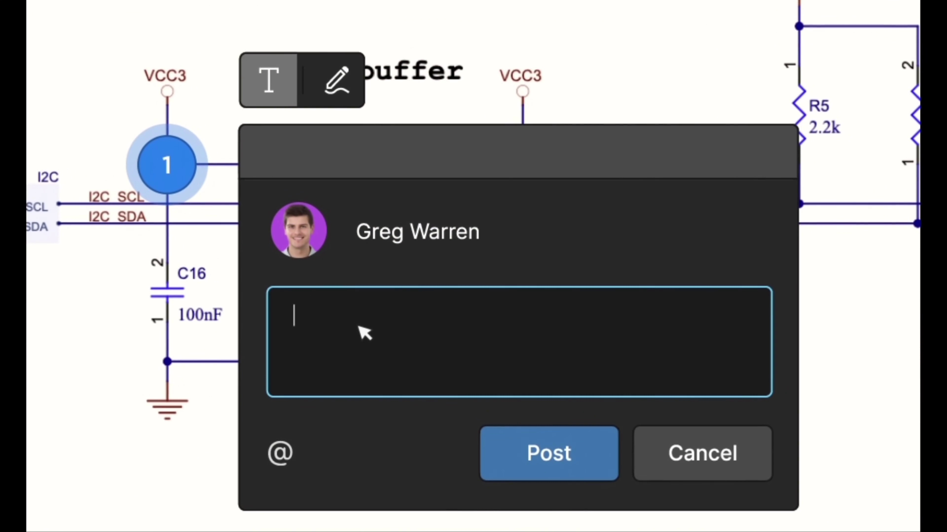 | 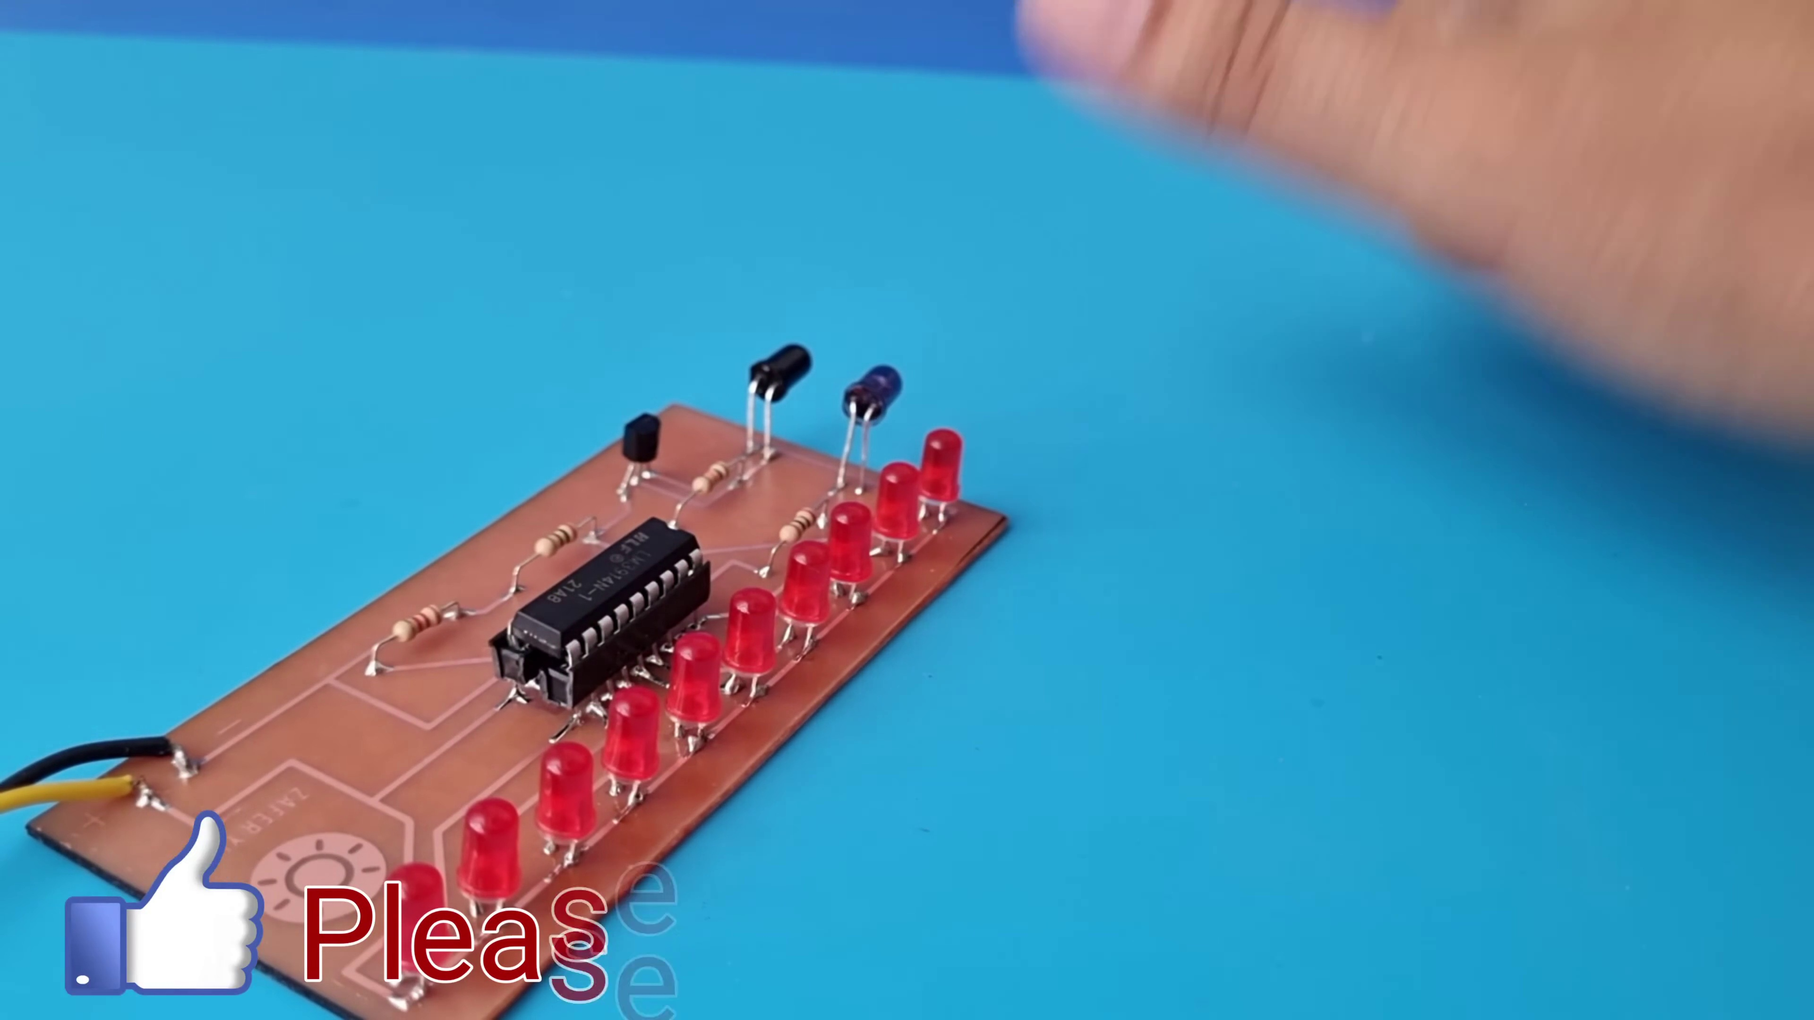
Topic T2: Altyum Designer and Octopart — score 70.0000
Description: The speaker describes Altium Designer as a tool for creating PCB designs with an intuitive interface. Octopart is also mentioned as a free search engine for electronic components.
Reason: The comment discusses PCB design (Altium Designer), electronic components (Octopart) and a specific circuit application (proximity sensor in speaker design), which directly relates to the topic's description.
 |  | 
Topic T1: Altium 365 Platform — score 20.0000
Description: The speaker mentions Altium 365 as a platform that allows seamless integration and does not require extra setup or configuration.
Reason: The topic is about Altium 365, but the comment discusses a different aspect (a circuit design) and doesn't mention any direct relationships with the platform.
Least correlated topics:
 |  | 
Topic T1: Altium 365 Platform — score 20.0000
Description: The speaker mentions Altium 365 as a platform that allows seamless integration and does not require extra setup or configuration.
Reason: The topic is about Altium 365, but the comment discusses a different aspect (a circuit design) and doesn't mention any direct relationships with the platform.
 |  | 
Topic T2: Altyum Designer and Octopart — score 70.0000
Description: The speaker describes Altium Designer as a tool for creating PCB designs with an intuitive interface. Octopart is also mentioned as a free search engine for electronic components.
Reason: The comment discusses PCB design (Altium Designer), electronic components (Octopart) and a specific circuit application (proximity sensor in speaker design), which directly relates to the topic's description.

Topic T1: Altium 365 Platform
 |  | 
Description: The speaker mentions Altium 365 as a platform that allows seamless integration and does not require extra setup or configuration.
No strongly correlated comments found for this topic.

Topic T2: Altyum Designer and Octopart
 |  | 
Description: The speaker describes Altium Designer as a tool for creating PCB designs with an intuitive interface. Octopart is also mentioned as a free search engine for electronic components.
Comment (score 70): This video shows a simple circuit that includes a proximity sensor that could be added to the speaker for use. We looked at this option when deciding on the design of our speaker. This could be used to increase volume using proximity or to turn the speaker on and off.
Reason: The comment discusses PCB design (Altium Designer), electronic components (Octopart) and a specific circuit application (proximity sensor in speaker design), which directly relates to the topic's description.
Source: https://www.youtube.com/watch?v=FNG9f2qJdWk: How To Make A New Generation Proximity Sensor Circuit - Approach Level Indicator

