Comment–Topic Correlation Report
Model: llama3

Summary
Topics processed: 3
Comments available for this video: 4
Comments correlated to ≥ 60: 0 (0.0%)
Total candidate pairs checked: 12

Most/Least correlated topics (by average score across correlated comments):
Top 3:
• Topic T3: Videoma Sponsorship — avg 0.00, contributions 0
• Topic T2: Altium Designer Integration — avg 0.00, contributions 0
• Topic T1: Altium 365 and Component Comparison — avg 0.00, contributions 0
Bottom 3:
• Topic T1: Altium 365 and Component Comparison — avg 0.00, contributions 0
• Topic T2: Altium Designer Integration — avg 0.00, contributions 0
• Topic T3: Videoma Sponsorship — avg 0.00, contributions 0
Correlated comment coverage (all comments):
- matched 0 topic(s), max score 0.0000: This video helped me realize that MOSFET can be used for a lot of applications not only to amplify signal. I plan to save the video to try one of the applications over Christmas break.
Source: https://www.youtube.com/watch?v=GbdF6th5PZk:Unbelievable : 3 Mind-Blowing Mosfet Projects That Even Beginners Can Create!
Top correlated topics:
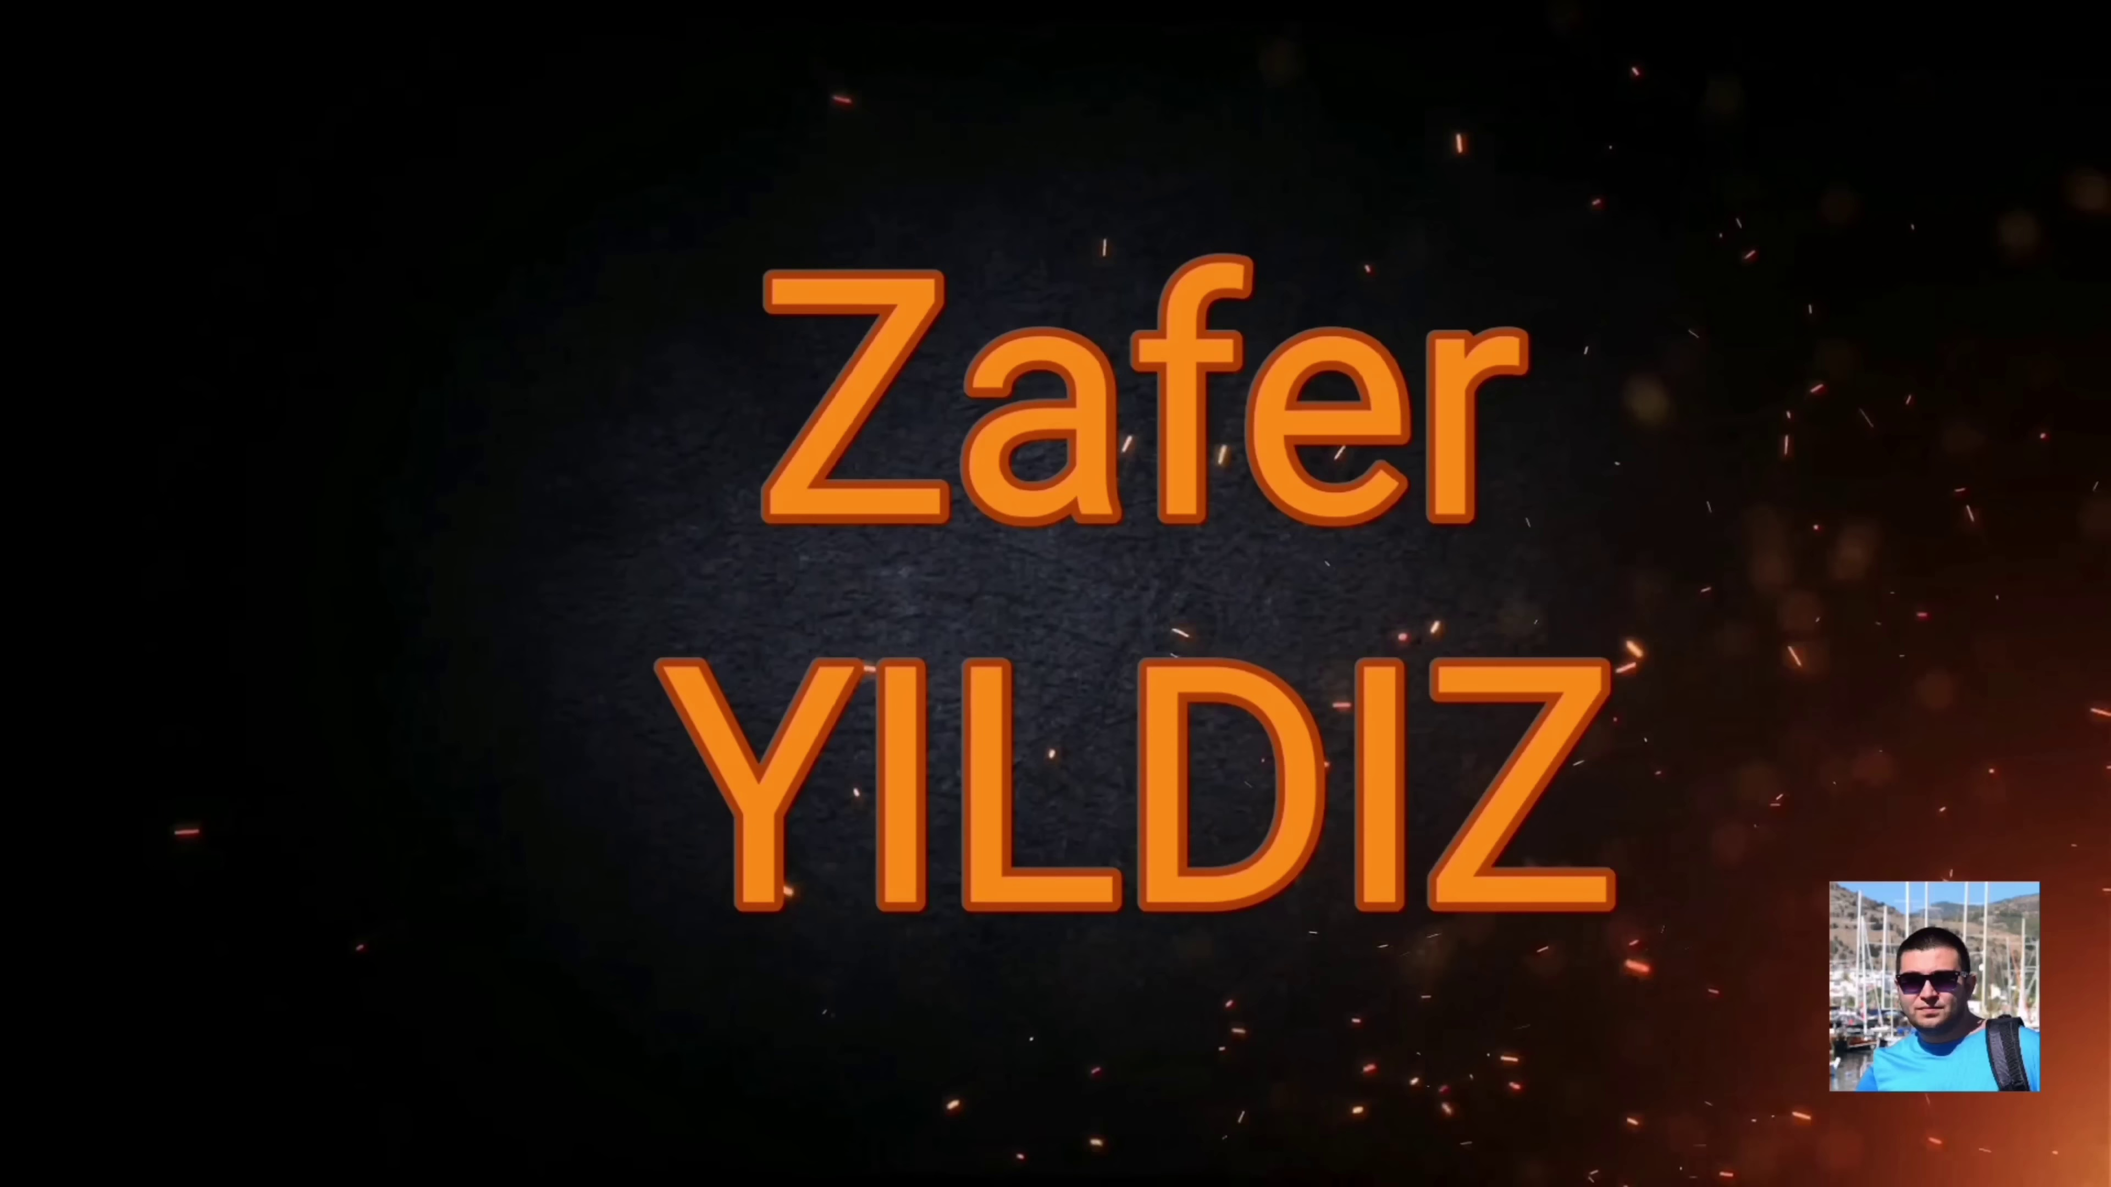 | 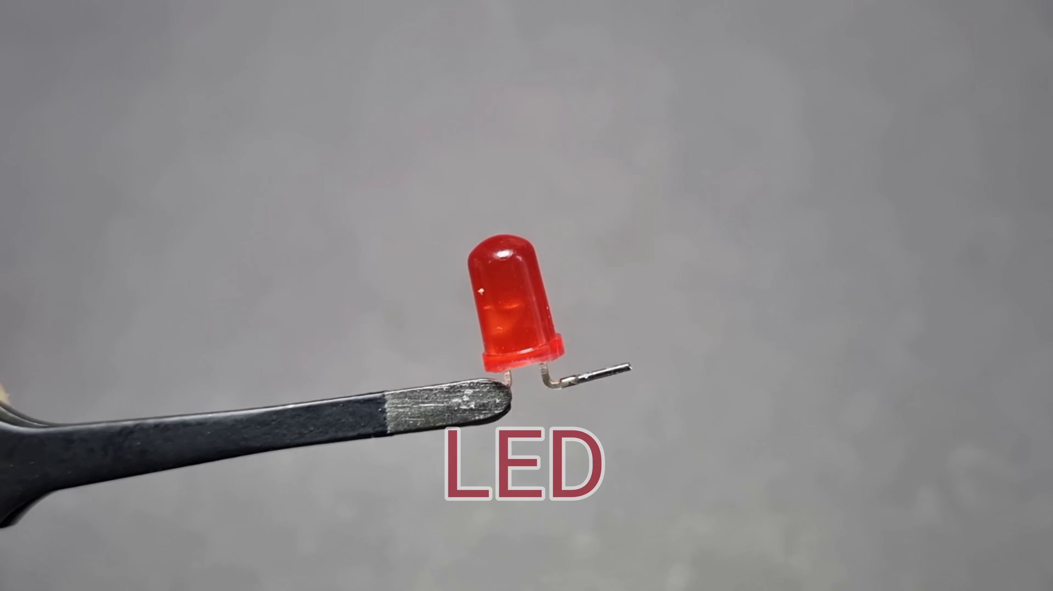 | 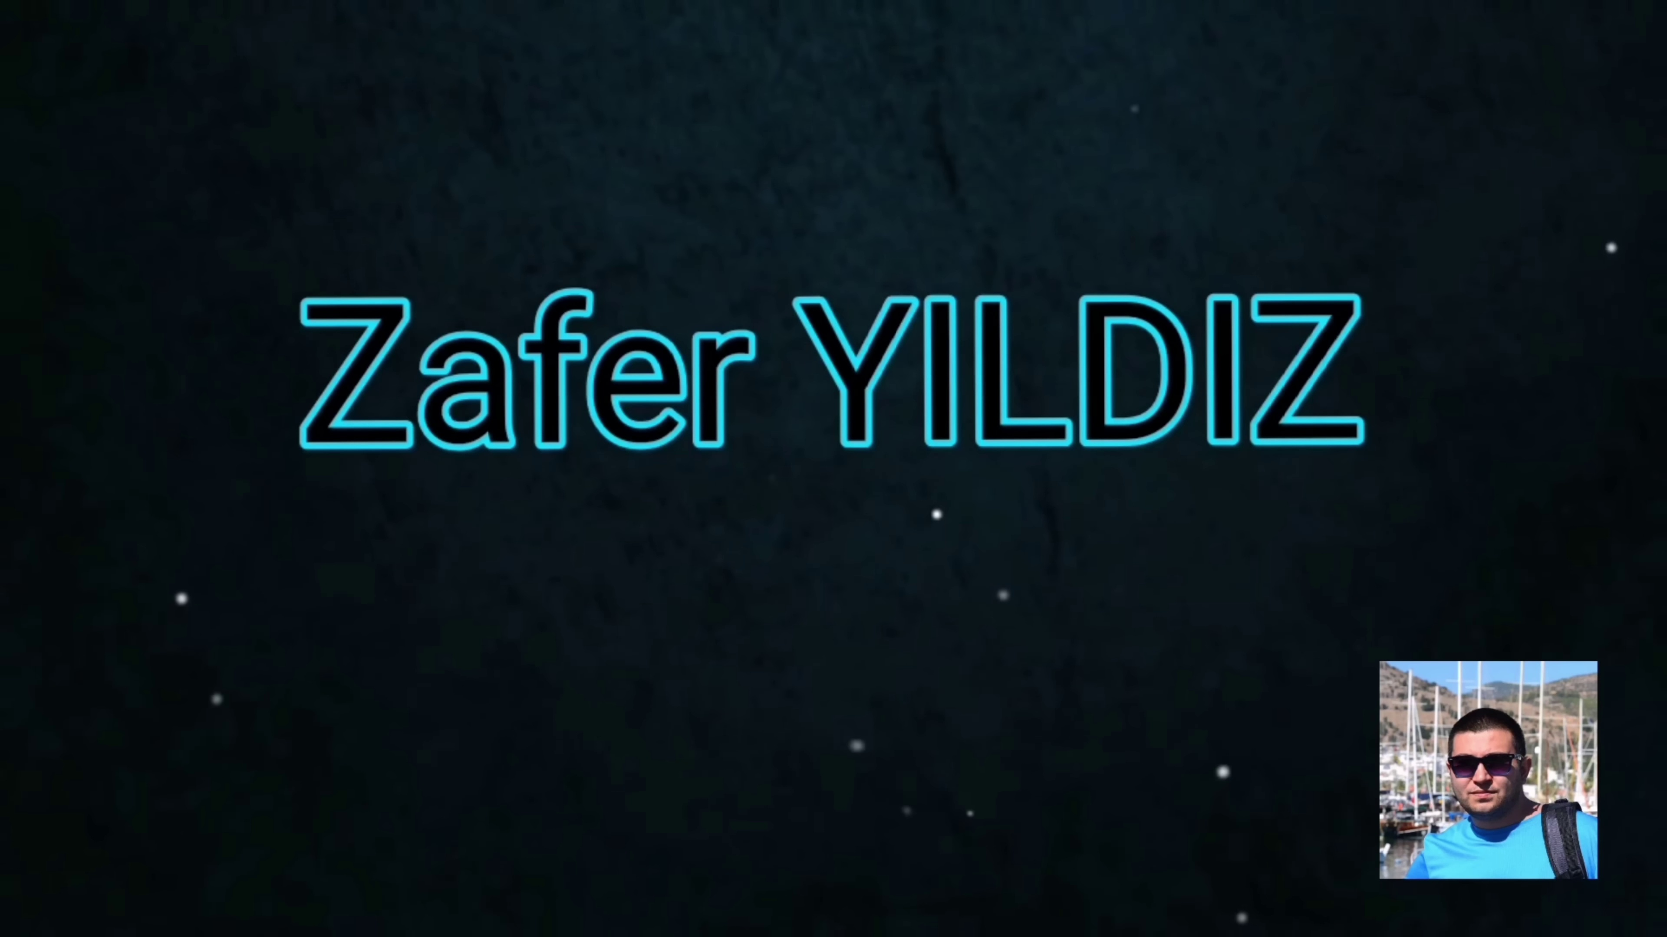
Topic T1: Altium 365 and Component Comparison — score 20.0000
Description: The speaker suggests comparing electronic components across hundreds of suppliers using Altium 365.
Reason: The comment doesn't directly discuss the topic of comparing electronic components using Altium 365. Instead, it talks about MOSFET applications and saving a video to try one over Christmas break.
 |  | 
Topic T3: Videoma Sponsorship — score 0.0000
Description: The speaker thanks Videoma for sponsoring.
Reason: The comment does not discuss Videoma sponsorship or the topic's content. It mentions MOSFET and a Christmas break application, unrelated to the topic.
 |  | 
Topic T2: Altium Designer Integration — score 0.0000
Description: The speaker explains that customers or team members can view and comment on work directly from the internet.
Reason: The comment does not discuss Altium Designer or its integration at all. Instead, it mentions MOSFETs and a completely unrelated topic of applying them.
Least correlated topics:
 |  | 
Topic T2: Altium Designer Integration — score 0.0000
Description: The speaker explains that customers or team members can view and comment on work directly from the internet.
Reason: The comment does not discuss Altium Designer or its integration at all. Instead, it mentions MOSFETs and a completely unrelated topic of applying them.
 |  | 
Topic T3: Videoma Sponsorship — score 0.0000
Description: The speaker thanks Videoma for sponsoring.
Reason: The comment does not discuss Videoma sponsorship or the topic's content. It mentions MOSFET and a Christmas break application, unrelated to the topic.
 |  | 
Topic T1: Altium 365 and Component Comparison — score 20.0000
Description: The speaker suggests comparing electronic components across hundreds of suppliers using Altium 365.
Reason: The comment doesn't directly discuss the topic of comparing electronic components using Altium 365. Instead, it talks about MOSFET applications and saving a video to try one over Christmas break.
- matched 0 topic(s), max score 0.0000: This one is getting into what we are studying now in chapter 5. The first project is a car light bulb and an LED that are flashing form the Mosfet connection and the use of 12 volts. The second one is a high sensitive fire detector, using and IR sensor to detect a fire, up close it activates quickly. The third one is a heat sensitive fan, this I could have used years ago for my intro to engineering class, it was one of our projects. He used a 5k NTC thermistor to actuate the fan circuit. It is actually really close to what I used in my intro to engineer course.
Source: https://www.youtube.com/watch?v=GbdF6th5PZk: 3 Mind-Blowing Mosfet Projects That Even Beginners Can Create!
Top correlated topics:
 |  | 
Topic T3: Videoma Sponsorship — score 20.0000
Description: The speaker thanks Videoma for sponsoring.
Reason: The comment discusses engineering projects and their details (e.g., car light bulb, fire detector, heat sensitive fan), but does not directly discuss Videoma sponsorship, which is the topic. The only connection is a mention of an intro to engineering class, but it's not related to the topic.
 |  | 
Topic T2: Altium Designer Integration — score 20.0000
Description: The speaker explains that customers or team members can view and comment on work directly from the internet.
Reason: The topic is about Altium Designer Integration and the comment discusses a different topic (projects in chapter 5) with no apparent connection to electronics design or integration tools.
 |  | 
Topic T1: Altium 365 and Component Comparison — score 20.0000
Description: The speaker suggests comparing electronic components across hundreds of suppliers using Altium 365.
Reason: The topic is about comparing electronic components using Altium 365, whereas the comment describes specific projects and components used in an intro to engineering class, without any direct relation to the topic.
Least correlated topics:
 |  | 
Topic T1: Altium 365 and Component Comparison — score 20.0000
Description: The speaker suggests comparing electronic components across hundreds of suppliers using Altium 365.
Reason: The topic is about comparing electronic components using Altium 365, whereas the comment describes specific projects and components used in an intro to engineering class, without any direct relation to the topic.
 |  | 
Topic T2: Altium Designer Integration — score 20.0000
Description: The speaker explains that customers or team members can view and comment on work directly from the internet.
Reason: The topic is about Altium Designer Integration and the comment discusses a different topic (projects in chapter 5) with no apparent connection to electronics design or integration tools.
 |  | 
Topic T3: Videoma Sponsorship — score 20.0000
Description: The speaker thanks Videoma for sponsoring.
Reason: The comment discusses engineering projects and their details (e.g., car light bulb, fire detector, heat sensitive fan), but does not directly discuss Videoma sponsorship, which is the topic. The only connection is a mention of an intro to engineering class, but it's not related to the topic.
- matched 0 topic(s), max score 0.0000: The video showcased creative MOSFET project examples for beginners.The video only had music and lacked explanations of theory or calculations.
Source: https://www.youtube.com/watch?v=GbdF6th5PZk: Unbelievable: 3 Mind-Blowing Mosfet Projects That Even Beginners Can Create!
Top correlated topics:
 |  | 
Topic T3: Videoma Sponsorship — score 10.0000
Description: The speaker thanks Videoma for sponsoring.
Reason: The comment discusses a MOSFET project and creative examples, whereas the topic is about Videoma sponsorship. The only overlap is the mention of Videoma, but it's not directly related to the same steps, objects, settings, parameters, claims, or goals described by the topic.
 |  | 
Topic T2: Altium Designer Integration — score 0.0000
Description: The speaker explains that customers or team members can view and comment on work directly from the internet.
Reason: The comment does not discuss Altium Designer Integration at all. Instead, it talks about a MOSFET project video that has no relation to the topic.
 |  | 
Topic T1: Altium 365 and Component Comparison — score 0.0000
Description: The speaker suggests comparing electronic components across hundreds of suppliers using Altium 365.
Reason: The comment discusses a MOSFET project for beginners, whereas the topic is about comparing electronic components using Altium 365. There are no overlaps between the topic and the comment.
Least correlated topics:
 |  | 
Topic T1: Altium 365 and Component Comparison — score 0.0000
Description: The speaker suggests comparing electronic components across hundreds of suppliers using Altium 365.
Reason: The comment discusses a MOSFET project for beginners, whereas the topic is about comparing electronic components using Altium 365. There are no overlaps between the topic and the comment.
 |  | 
Topic T2: Altium Designer Integration — score 0.0000
Description: The speaker explains that customers or team members can view and comment on work directly from the internet.
Reason: The comment does not discuss Altium Designer Integration at all. Instead, it talks about a MOSFET project video that has no relation to the topic.
 |  | 
Topic T3: Videoma Sponsorship — score 10.0000
Description: The speaker thanks Videoma for sponsoring.
Reason: The comment discusses a MOSFET project and creative examples, whereas the topic is about Videoma sponsorship. The only overlap is the mention of Videoma, but it's not directly related to the same steps, objects, settings, parameters, claims, or goals described by the topic.
- matched 0 topic(s), max score 0.0000: I learned that Mosfets can be easily used to create fun LED light setups that sync with speakers. The video also showed how Mosfets could be used in practical applications like a high-sensitivity fire detector and a heat-sensitive fan. Overall, I found that Mosfets are extremely versatile and surprisingly simple to use. None specifically, though I’m curious about how to safely power higher-current Mosfet circuits.
Source: https://www.youtube.com/watch?v=GbdF6th5PZk: Unbelievable: 3 Mind-Blowing Mosfet Projects That Even Beginners Can Create!
Top correlated topics:
 |  | 
Topic T1: Altium 365 and Component Comparison — score 20.0000
Description: The speaker suggests comparing electronic components across hundreds of suppliers using Altium 365.
Reason: The comment discusses Mosfets and their practical applications, but does not mention Altium 365 or component comparison, the main topics.
 |  | 
Topic T3: Videoma Sponsorship — score 0.0000
Description: The speaker thanks Videoma for sponsoring.
Reason: The topic and comment have no direct relation. The topic is about Videoma sponsorship, while the comment discusses Mosfets and their applications.
 |  | 
Topic T2: Altium Designer Integration — score 0.0000
Description: The speaker explains that customers or team members can view and comment on work directly from the internet.
Reason: The comment discusses Mosfets and their uses in LED light setups and fire detectors, whereas the topic is about Altium Designer Integration, with no overlap.
Least correlated topics:
 |  | 
Topic T2: Altium Designer Integration — score 0.0000
Description: The speaker explains that customers or team members can view and comment on work directly from the internet.
Reason: The comment discusses Mosfets and their uses in LED light setups and fire detectors, whereas the topic is about Altium Designer Integration, with no overlap.
 |  | 
Topic T3: Videoma Sponsorship — score 0.0000
Description: The speaker thanks Videoma for sponsoring.
Reason: The topic and comment have no direct relation. The topic is about Videoma sponsorship, while the comment discusses Mosfets and their applications.
 |  | 
Topic T1: Altium 365 and Component Comparison — score 20.0000
Description: The speaker suggests comparing electronic components across hundreds of suppliers using Altium 365.
Reason: The comment discusses Mosfets and their practical applications, but does not mention Altium 365 or component comparison, the main topics.

Topic T1: Altium 365 and Component Comparison
 |  | 
Description: The speaker suggests comparing electronic components across hundreds of suppliers using Altium 365.
No strongly correlated comments found for this topic.

Topic T2: Altium Designer Integration
 |  | 
Description: The speaker explains that customers or team members can view and comment on work directly from the internet.
No strongly correlated comments found for this topic.

Topic T3: Videoma Sponsorship
 |  | 
Description: The speaker thanks Videoma for sponsoring.
No strongly correlated comments found for this topic.

