Comment–Topic Correlation Report
Model: llama3

Summary
Topics processed: 6
Comments available for this video: 1
Comments correlated to ≥ 60: 1 (100.0%)
Total candidate pairs checked: 6

Most/Least correlated topics (by average score across correlated comments):
Top 3:
• Topic T1: Introduction — avg 90.00, contributions 1
• Topic T3: Balanced Robot Overview — avg 90.00, contributions 1
• Topic T5: Wii Nunchuck Control — avg 0.00, contributions 0
Bottom 3:
• Topic T4: Code Explanation — avg 0.00, contributions 0
• Topic T6: Conclusion and Future Work — avg 0.00, contributions 0
• Topic T2: Tuning PID Controller — avg 0.00, contributions 0
Correlated comment coverage (all comments):
- matched 2 topic(s), max score 90.0000: The video is about creating a balancing robot. The creator uses NEMA 17 stepper motors along with a custom designed 3D printed body. The robot uses a PCB that includes spaces for two stepper motor drivers, a buck converter for 5-volt regulation, connections for a Bluetooth module, an IMU module for angle measurement, an OLED display, and a microcontroller. The PCB also has pads for adjusting the micro stepping amount for the stepper motors.The video covers the assembling of the robot, including the 3D printed body, attaching the motors, assembling the PCB, and connecting the components. The creator discusses the importance of the robot's weight distribution and the difficulty of balancing when most of the weight is at the bottom.In terms of coding, the creator explains how the robot uses PID control, reading data from the gyro and accelerometer of the IMU, and adjusting the stepper motors' speed based on the PID output. The robot is programmed to stay horizontal, adjusting its wheels' speed based on its tilt.The video is a detailed walkthrough of building a balancing robot, covering both hardware assembly and software programming aspects. It emphasizes the challenges in achieving stable PID control for such a project.
Source: https://www.youtube.com/watch?v=Gpm-TI21x9s: BALANCING ROBOT WITH PID | MINI ROBOT PCB:
Top correlated topics:
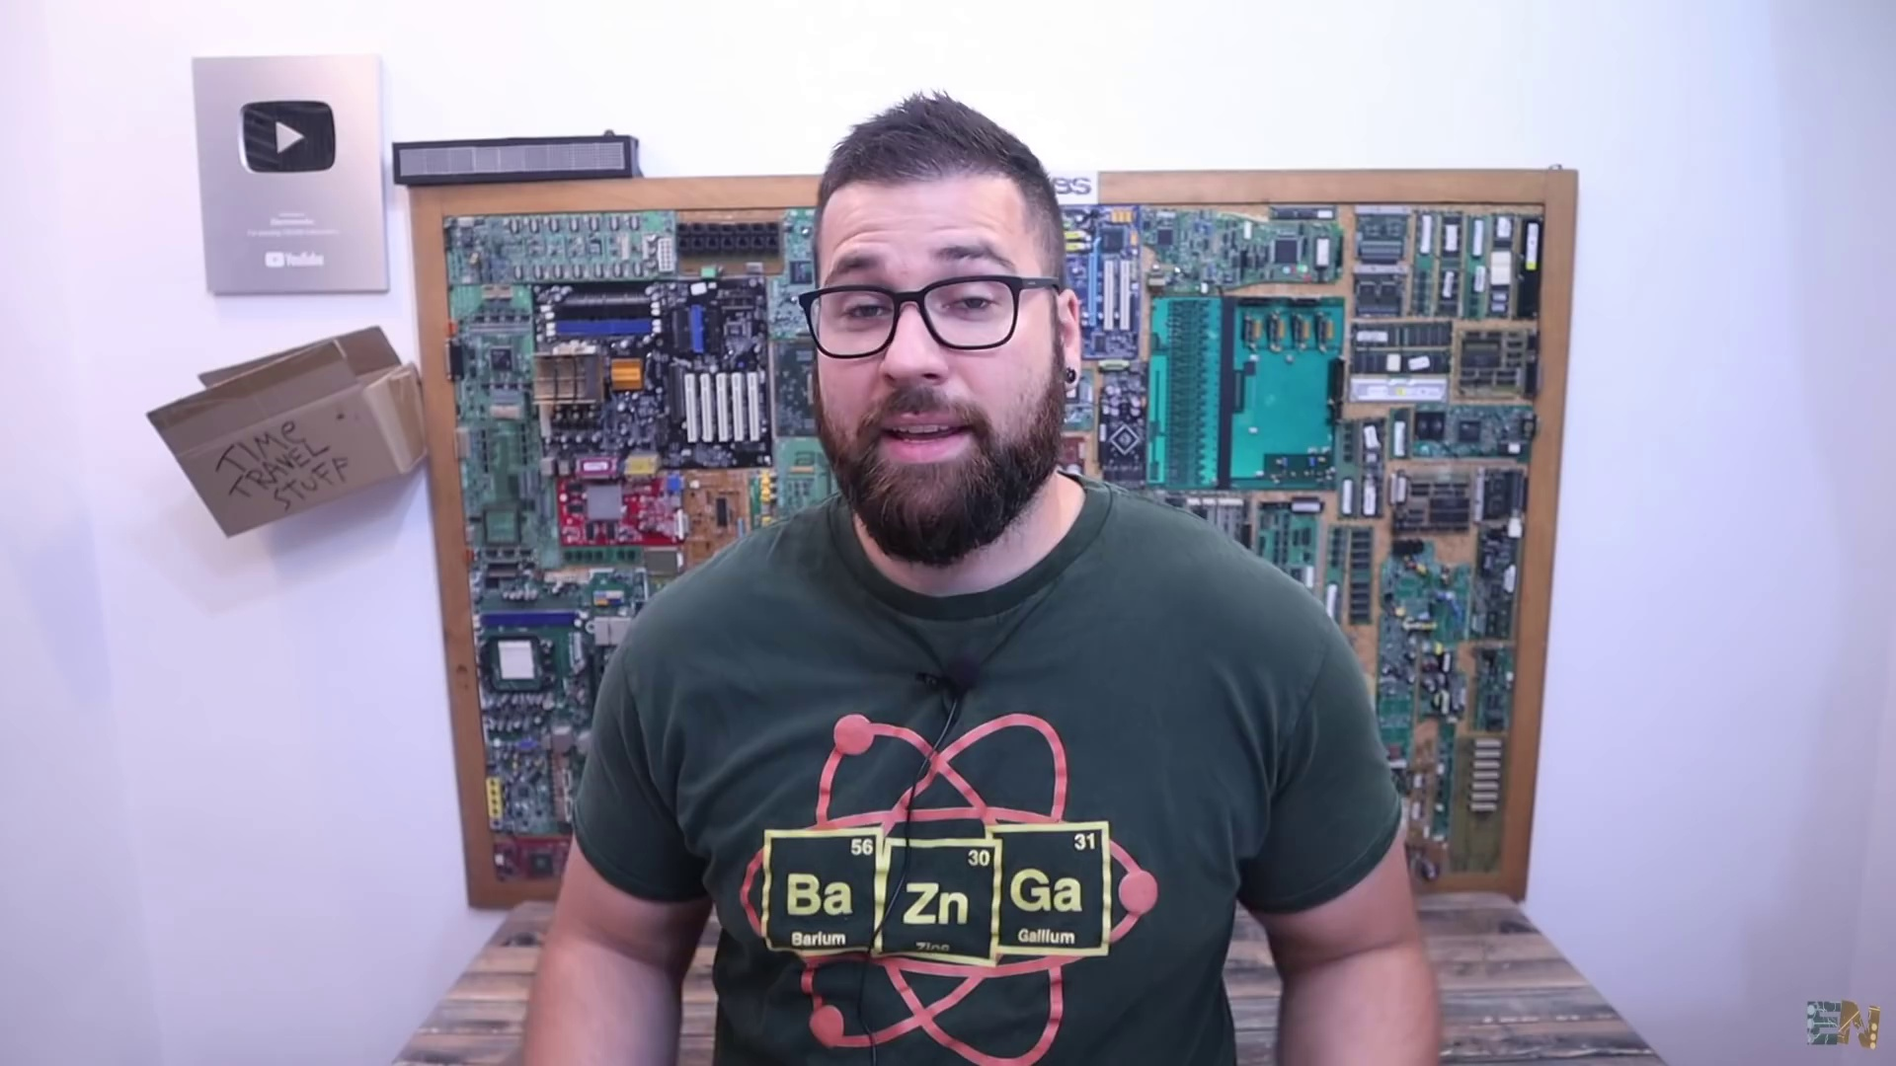 | 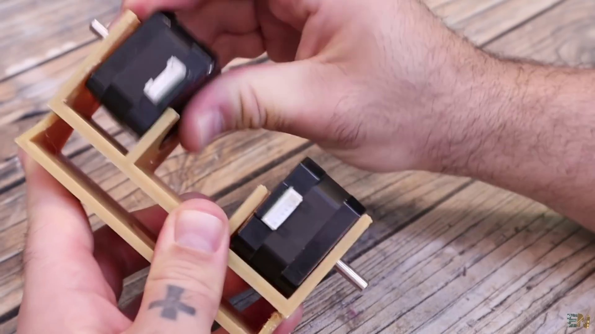 | 
Topic T4: Code Explanation — score 90.0000
Description: Explanation of the code used to control the stepper motors and PID controller
Reason: {
"correlated": true,
"score": 90,
"reason": "The comment directly discusses the same steps (assembling the robot), objects (stepper motors, PID controller, IMU, OLED display), settings (micro stepping amount adjustment), and parameters (weight distribution, tilt) described by the topic. The creator's explanation of the code used for the balancing robot, including PID control and adjusting stepper
 |  | 
Topic T3: Balanced Robot Overview — score 90.0000
Description: How a balanced robot works and its components
Reason: The comment directly discusses the components and assembly process of a balancing robot, matching the topic's description. It also mentions specific details like stepper motors, PCB design, PID control, and IMU usage, which are all relevant to the topic.
 |  | 
Topic T1: Introduction — score 90.0000
Description: Overview of the project and its components
Reason: The comment directly discusses the same components (NEMA 17 stepper motors, PCB, Bluetooth module, IMU module, OLED display, microcontroller), settings (weight distribution, PID control), and goals (balancing) described by the topic.
 |  | 
Topic T6: Conclusion and Future Work — score 20.0000
Description: Summary of the project and future plans for improvements
Reason: The comment discusses the details of building a balancing robot, including hardware assembly and software programming, but does not directly discuss the topic's focus on conclusion and future work.
 |  | 
Topic T5: Wii Nunchuck Control — score 20.0000
Description: How to use a Wii nunchuck to control the robot remotely
Reason: The comment discusses building a balancing robot using NEMA 17 stepper motors and a custom PCB, but does not specifically mention Wii nunchuck control or remote operation.
 |  | 
Topic T2: Tuning PID Controller — score 20.0000
Description: Explanation of how to tune the PID controller for the stepper motor robot
Reason: The comment discusses a balancing robot and its components, but does not specifically mention PID controller tuning, which is the main topic. The only overlap is the mention of PID control as a method used in the project.
Least correlated topics:
 |  | 
Topic T2: Tuning PID Controller — score 20.0000
Description: Explanation of how to tune the PID controller for the stepper motor robot
Reason: The comment discusses a balancing robot and its components, but does not specifically mention PID controller tuning, which is the main topic. The only overlap is the mention of PID control as a method used in the project.
 |  | 
Topic T5: Wii Nunchuck Control — score 20.0000
Description: How to use a Wii nunchuck to control the robot remotely
Reason: The comment discusses building a balancing robot using NEMA 17 stepper motors and a custom PCB, but does not specifically mention Wii nunchuck control or remote operation.
 |  | 
Topic T6: Conclusion and Future Work — score 20.0000
Description: Summary of the project and future plans for improvements
Reason: The comment discusses the details of building a balancing robot, including hardware assembly and software programming, but does not directly discuss the topic's focus on conclusion and future work.
 |  | 
Topic T1: Introduction — score 90.0000
Description: Overview of the project and its components
Reason: The comment directly discusses the same components (NEMA 17 stepper motors, PCB, Bluetooth module, IMU module, OLED display, microcontroller), settings (weight distribution, PID control), and goals (balancing) described by the topic.
 |  | 
Topic T3: Balanced Robot Overview — score 90.0000
Description: How a balanced robot works and its components
Reason: The comment directly discusses the components and assembly process of a balancing robot, matching the topic's description. It also mentions specific details like stepper motors, PCB design, PID control, and IMU usage, which are all relevant to the topic.
 |  | 
Topic T4: Code Explanation — score 90.0000
Description: Explanation of the code used to control the stepper motors and PID controller
Reason: {
"correlated": true,
"score": 90,
"reason": "The comment directly discusses the same steps (assembling the robot), objects (stepper motors, PID controller, IMU, OLED display), settings (micro stepping amount adjustment), and parameters (weight distribution, tilt) described by the topic. The creator's explanation of the code used for the balancing robot, including PID control and adjusting stepper

Topic T1: Introduction
 |  | 
Description: Overview of the project and its components
Comment (score 90): The video is about creating a balancing robot. The creator uses NEMA 17 stepper motors along with a custom designed 3D printed body. The robot uses a PCB that includes spaces for two stepper motor drivers, a buck converter for 5-volt regulation, connections for a Bluetooth module, an IMU module for angle measurement, an OLED display, and a microcontroller. The PCB also has pads for adjusting the micro stepping amount for the stepper motors.The video covers the assembling of the robot, including the 3D printed body, attaching the motors, assembling the PCB, and connecting the components. The creator discusses the importance of the robot's weight distribution and the difficulty of balancing when most of the weight is at the bottom.In terms of coding, the creator explains how the robot uses PID control, reading data from the gyro and accelerometer of the IMU, and adjusting the stepper motors' speed based on the PID output. The robot is programmed to stay horizontal, adjusting its wheels' speed based on its tilt.The video is a detailed walkthrough of building a balancing robot, covering both hardware assembly and software programming aspects. It emphasizes the challenges in achieving stable PID control for such a project.
Reason: The comment directly discusses the same components (NEMA 17 stepper motors, PCB, Bluetooth module, IMU module, OLED display, microcontroller), settings (weight distribution, PID control), and goals (balancing) described by the topic.
Source: https://www.youtube.com/watch?v=Gpm-TI21x9s: BALANCING ROBOT WITH PID | MINI ROBOT PCB:

Topic T2: Tuning PID Controller
 |  | 
Description: Explanation of how to tune the PID controller for the stepper motor robot
No strongly correlated comments found for this topic.

Topic T3: Balanced Robot Overview
 |  | 
Description: How a balanced robot works and its components
Comment (score 90): The video is about creating a balancing robot. The creator uses NEMA 17 stepper motors along with a custom designed 3D printed body. The robot uses a PCB that includes spaces for two stepper motor drivers, a buck converter for 5-volt regulation, connections for a Bluetooth module, an IMU module for angle measurement, an OLED display, and a microcontroller. The PCB also has pads for adjusting the micro stepping amount for the stepper motors.The video covers the assembling of the robot, including the 3D printed body, attaching the motors, assembling the PCB, and connecting the components. The creator discusses the importance of the robot's weight distribution and the difficulty of balancing when most of the weight is at the bottom.In terms of coding, the creator explains how the robot uses PID control, reading data from the gyro and accelerometer of the IMU, and adjusting the stepper motors' speed based on the PID output. The robot is programmed to stay horizontal, adjusting its wheels' speed based on its tilt.The video is a detailed walkthrough of building a balancing robot, covering both hardware assembly and software programming aspects. It emphasizes the challenges in achieving stable PID control for such a project.
Reason: The comment directly discusses the components and assembly process of a balancing robot, matching the topic's description. It also mentions specific details like stepper motors, PCB design, PID control, and IMU usage, which are all relevant to the topic.
Source: https://www.youtube.com/watch?v=Gpm-TI21x9s: BALANCING ROBOT WITH PID | MINI ROBOT PCB:

Topic T4: Code Explanation
 |  | 
Description: Explanation of the code used to control the stepper motors and PID controller
No strongly correlated comments found for this topic.

Topic T5: Wii Nunchuck Control
 |  | 
Description: How to use a Wii nunchuck to control the robot remotely
No strongly correlated comments found for this topic.

Topic T6: Conclusion and Future Work
 |  | 
Description: Summary of the project and future plans for improvements
No strongly correlated comments found for this topic.

