Comment–Topic Correlation Report
Model: llama3

Summary
Topics processed: 2
Comments available for this video: 2
Comments correlated to ≥ 60: 1 (50.0%)
Total candidate pairs checked: 4

Most/Least correlated topics (by average score across correlated comments):
Top 3:
• Topic T2: Low Pass Filter Design — avg 90.00, contributions 1
• Topic T1: Capacitor Operation — avg 0.00, contributions 0
Bottom 3:
• Topic T1: Capacitor Operation — avg 0.00, contributions 0
• Topic T2: Low Pass Filter Design — avg 90.00, contributions 1
Correlated comment coverage (all comments):
- matched 1 topic(s), max score 90.0000: This video shows how to design and calculate the cutoff frequencies of a first-order low pass circuit. He demonstrated the effects of the filter using an oscilloscope and how resistor values affect circuit outputs.None. He did a great job of explaining everything.
Source: https://www.youtube.com/watch?v=GqCn94Ksdbo&t=374s: The Low Pass Filter
Top correlated topics:
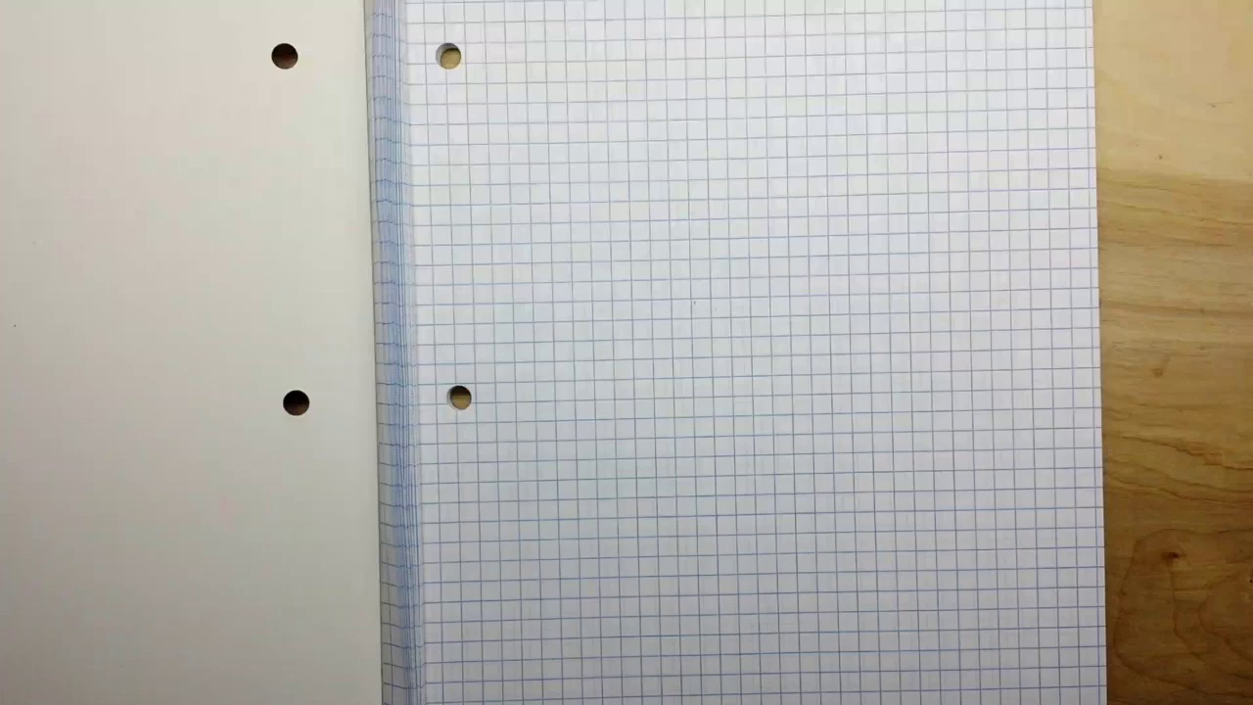 | 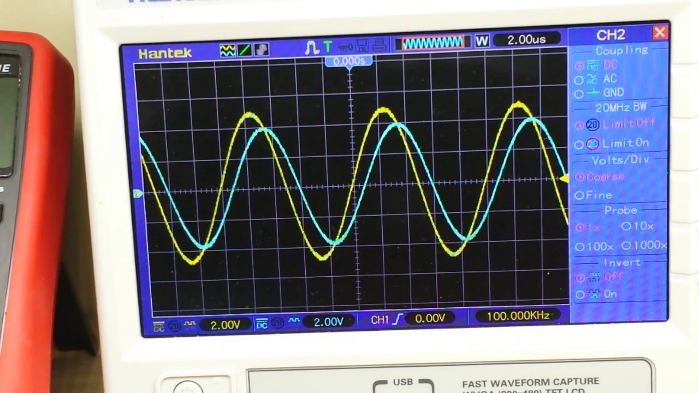 | 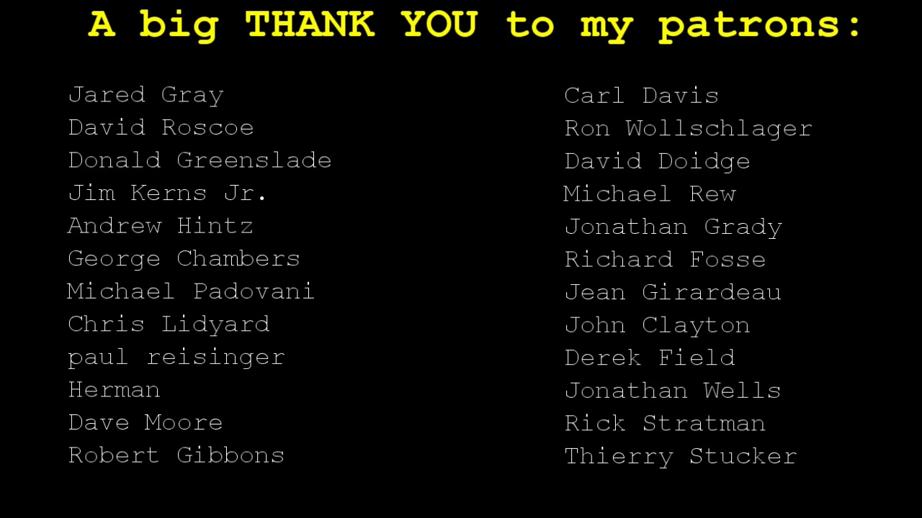
Topic T2: Low Pass Filter Design — score 90.0000
Description: Discussion on how to design a low pass filter using RC circuits and capacitors.
Reason: The comment directly discusses designing and calculating cutoff frequencies of a first-order low pass circuit, which is a specific topic of the description. The mention of RC circuits, capacitors, and oscilloscope usage also aligns with the topic's content.
 |  | 
Topic T1: Capacitor Operation — score 20.0000
Description: Explanation on how capacitors operate, including charging and discharging times.
Reason: The comment discusses circuit design and calculation of cutoff frequencies, which is unrelated to the topic's focus on capacitor operation, charging, and discharging times.
Least correlated topics:
 |  | 
Topic T1: Capacitor Operation — score 20.0000
Description: Explanation on how capacitors operate, including charging and discharging times.
Reason: The comment discusses circuit design and calculation of cutoff frequencies, which is unrelated to the topic's focus on capacitor operation, charging, and discharging times.
 |  | 
Topic T2: Low Pass Filter Design — score 90.0000
Description: Discussion on how to design a low pass filter using RC circuits and capacitors.
Reason: The comment directly discusses designing and calculating cutoff frequencies of a first-order low pass circuit, which is a specific topic of the description. The mention of RC circuits, capacitors, and oscilloscope usage also aligns with the topic's content.
- matched 0 topic(s), max score 0.0000: This video explains how to design and calculate the cutoff frequencies of a first-order low pass circuit. It showed the filter’s effect using an oscilloscope and how resistor values affect circuit outputs.None, he did a great job of explaining everything.
Source: https://www.youtube.com/watch?v=GqCn94Ksdbo&t=374s: The Low Pass Filter
Top correlated topics:
 |  | 
Topic T2: Low Pass Filter Design — score 90.0000
Description: Discussion on how to design a low pass filter using RC circuits and capacitors.
Reason: {
"correlated": true,
"score": 90,
"reason": "The comment directly discusses the design and calculation of a first-order low pass circuit, which is exactly what the topic title and description are about. The mention of cutoff frequencies, oscilloscope usage, and resistor values also matches with the topic's focus on designing low pass filters."
 |  | 
Topic T1: Capacitor Operation — score 20.0000
Description: Explanation on how capacitors operate, including charging and discharging times.
Reason: The comment discusses circuit design and calculation, which is related to electronics but not directly about capacitor operation. The topic description mentions charging and discharging times, which are not discussed in the comment.
Least correlated topics:
 |  | 
Topic T1: Capacitor Operation — score 20.0000
Description: Explanation on how capacitors operate, including charging and discharging times.
Reason: The comment discusses circuit design and calculation, which is related to electronics but not directly about capacitor operation. The topic description mentions charging and discharging times, which are not discussed in the comment.
 |  | 
Topic T2: Low Pass Filter Design — score 90.0000
Description: Discussion on how to design a low pass filter using RC circuits and capacitors.
Reason: {
"correlated": true,
"score": 90,
"reason": "The comment directly discusses the design and calculation of a first-order low pass circuit, which is exactly what the topic title and description are about. The mention of cutoff frequencies, oscilloscope usage, and resistor values also matches with the topic's focus on designing low pass filters."

Topic T1: Capacitor Operation
 |  | 
Description: Explanation on how capacitors operate, including charging and discharging times.
No strongly correlated comments found for this topic.

Topic T2: Low Pass Filter Design
 |  | 
Description: Discussion on how to design a low pass filter using RC circuits and capacitors.
Comment (score 90): This video shows how to design and calculate the cutoff frequencies of a first-order low pass circuit. He demonstrated the effects of the filter using an oscilloscope and how resistor values affect circuit outputs.None. He did a great job of explaining everything.
Reason: The comment directly discusses designing and calculating cutoff frequencies of a first-order low pass circuit, which is a specific topic of the description. The mention of RC circuits, capacitors, and oscilloscope usage also aligns with the topic's content.
Source: https://www.youtube.com/watch?v=GqCn94Ksdbo&t=374s: The Low Pass Filter

