Comment–Topic Correlation Report
Model: llama3

Summary
Topics processed: 3
Comments available for this video: 2
Comments correlated to ≥ 60: 2 (100.0%)
Total candidate pairs checked: 6

Most/Least correlated topics (by average score across correlated comments):
Top 3:
• Topic T3: Troubleshooting Issues — avg 85.00, contributions 2
• Topic T2: LM386 Audio Amplifier Setup — avg 85.00, contributions 2
• Topic T1: Channel Maintenance and Support — avg 0.00, contributions 0
Bottom 3:
• Topic T1: Channel Maintenance and Support — avg 0.00, contributions 0
• Topic T2: LM386 Audio Amplifier Setup — avg 85.00, contributions 2
• Topic T3: Troubleshooting Issues — avg 85.00, contributions 2
Correlated comment coverage (all comments):
- matched 2 topic(s), max score 90.0000: How to set up an LM386 audio amplifier with minimal components and assembly tips.Troubleshooting unexpected issues and understanding circuit debugging steps.Creating basic audio amplifiers and improving troubleshooting techniques for circuit building.
Source: https://www.youtube.com/watch?v=HWMq1WjvgfE: LM386 Audio Amplifier Simple Setup
Top correlated topics:
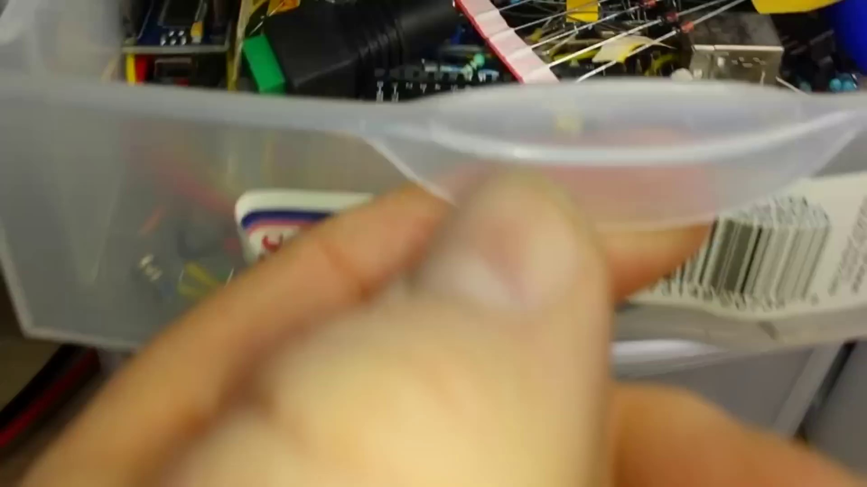 | 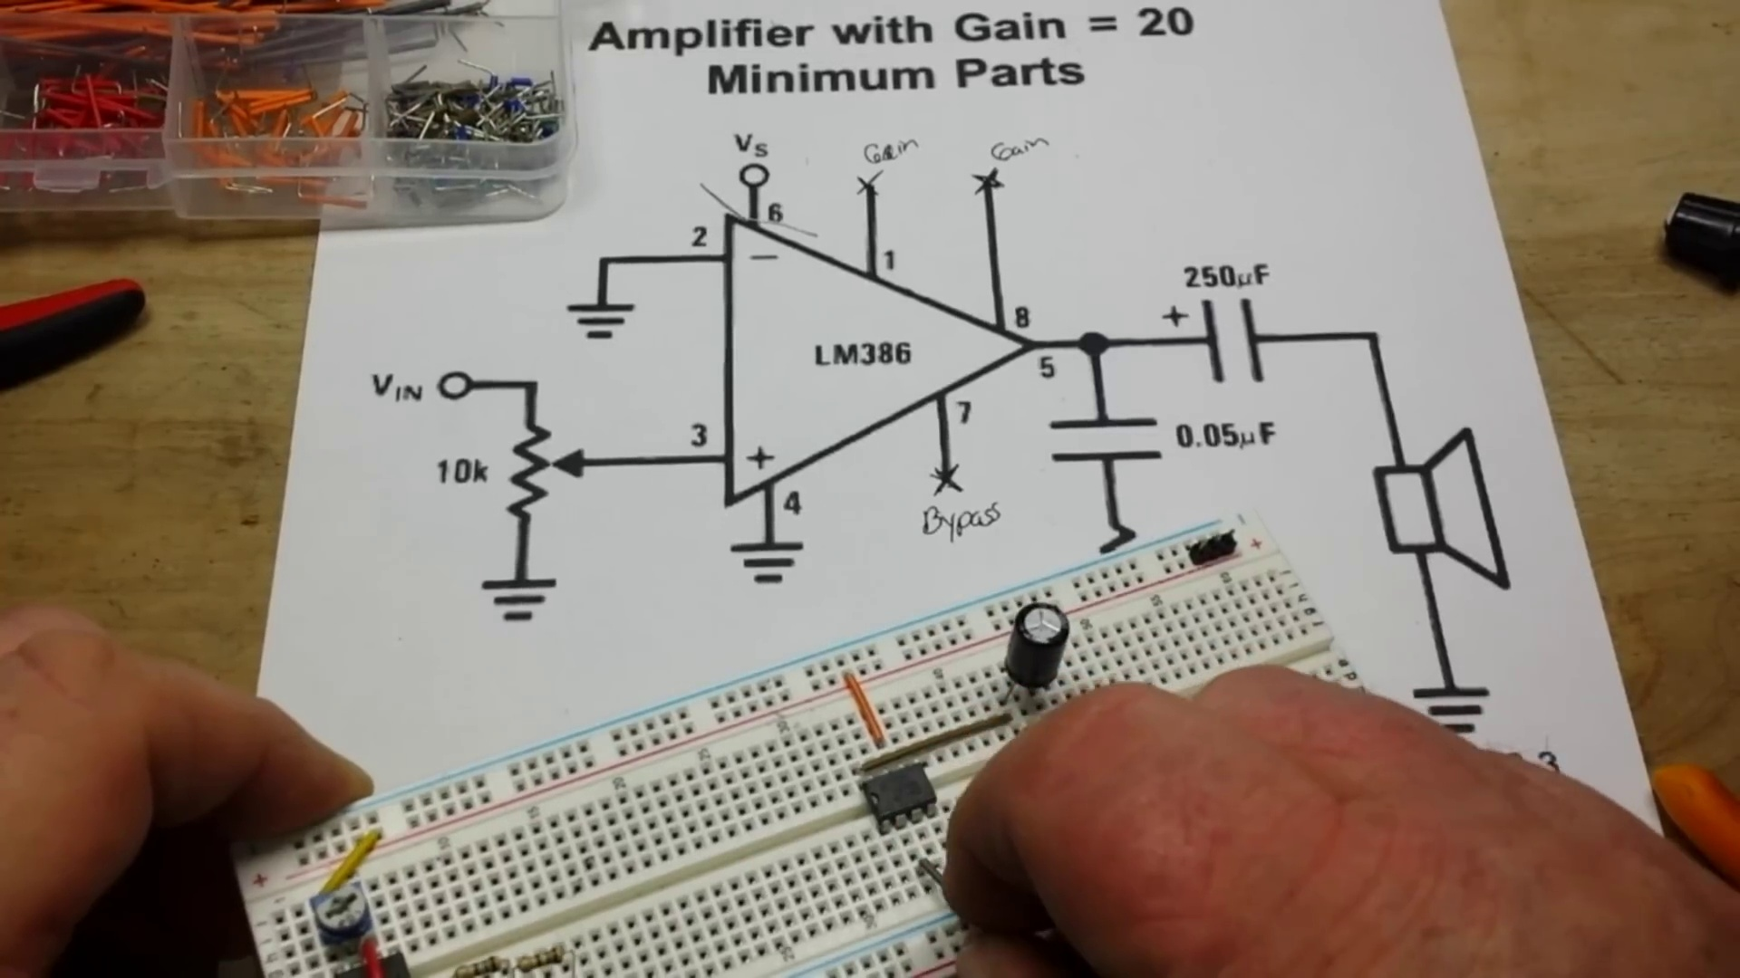 | 
Topic T3: Troubleshooting Issues — score 90.0000
Description: The speaker encounters issues with the LM386 audio amplifier, but eventually gets it to work
Reason: The comment directly discusses the same steps (troubleshooting unexpected issues and understanding circuit debugging steps) and topics (LM386 audio amplifier, circuit building) described in the topic.
 |  | 
Topic T2: LM386 Audio Amplifier Setup — score 90.0000
Description: The setup process for the LM386 audio amplifier
Reason: The comment directly discusses the setup process of LM386 audio amplifier, mentioning specific steps like assembly tips, troubleshooting issues and debugging circuit building, which is highly related to the topic's description.
 |  | 
Topic T1: Channel Maintenance and Support — score 20.0000
Description: The speaker thanks the audience for watching and encourages support through Patreon and Amazon shop
Reason: The topic is about channel maintenance and support, while the comment is about setting up an audio amplifier. Although both mention troubleshooting, they are unrelated topics.
Least correlated topics:
 |  | 
Topic T1: Channel Maintenance and Support — score 20.0000
Description: The speaker thanks the audience for watching and encourages support through Patreon and Amazon shop
Reason: The topic is about channel maintenance and support, while the comment is about setting up an audio amplifier. Although both mention troubleshooting, they are unrelated topics.
 |  | 
Topic T2: LM386 Audio Amplifier Setup — score 90.0000
Description: The setup process for the LM386 audio amplifier
Reason: The comment directly discusses the setup process of LM386 audio amplifier, mentioning specific steps like assembly tips, troubleshooting issues and debugging circuit building, which is highly related to the topic's description.
 |  | 
Topic T3: Troubleshooting Issues — score 90.0000
Description: The speaker encounters issues with the LM386 audio amplifier, but eventually gets it to work
Reason: The comment directly discusses the same steps (troubleshooting unexpected issues and understanding circuit debugging steps) and topics (LM386 audio amplifier, circuit building) described in the topic.
- matched 2 topic(s), max score 80.0000: This video was recorded to show a simple non-inverting op-amp setup with an LM386. It was a practical demonstration with clear explanations on how to correlate the breadboard with the wiring diagram.
Source: https://www.youtube.com/watch?v=HWMq1WjvgfE: (188) LM386 Audio Amplifier Simple Setup - YouTube
Top correlated topics:
 |  | 
Topic T3: Troubleshooting Issues — score 80.0000
Description: The speaker encounters issues with the LM386 audio amplifier, but eventually gets it to work
Reason: The comment mentions the LM386 amplifier and provides a practical demonstration with clear explanations, which closely aligns with the topic of troubleshooting issues with the LM386 audio amplifier.
 |  | 
Topic T2: LM386 Audio Amplifier Setup — score 80.0000
Description: The setup process for the LM386 audio amplifier
Reason: The comment directly discusses the LM386 audio amplifier setup, which is exactly what the topic is about. The mention of non-inverting op-amp and practical demonstration with wiring diagram also matches the topic's description.
 |  | 
Topic T1: Channel Maintenance and Support — score 20.0000
Description: The speaker thanks the audience for watching and encourages support through Patreon and Amazon shop
Reason: The comment discusses a specific electronic circuit setup and breadboard wiring diagram, which is unrelated to the topic of Channel Maintenance and Support. The only overlap is that it's a video recording, but the topic description does not mention electronics or any related topics.
Least correlated topics:
 |  | 
Topic T1: Channel Maintenance and Support — score 20.0000
Description: The speaker thanks the audience for watching and encourages support through Patreon and Amazon shop
Reason: The comment discusses a specific electronic circuit setup and breadboard wiring diagram, which is unrelated to the topic of Channel Maintenance and Support. The only overlap is that it's a video recording, but the topic description does not mention electronics or any related topics.
 |  | 
Topic T2: LM386 Audio Amplifier Setup — score 80.0000
Description: The setup process for the LM386 audio amplifier
Reason: The comment directly discusses the LM386 audio amplifier setup, which is exactly what the topic is about. The mention of non-inverting op-amp and practical demonstration with wiring diagram also matches the topic's description.
 |  | 
Topic T3: Troubleshooting Issues — score 80.0000
Description: The speaker encounters issues with the LM386 audio amplifier, but eventually gets it to work
Reason: The comment mentions the LM386 amplifier and provides a practical demonstration with clear explanations, which closely aligns with the topic of troubleshooting issues with the LM386 audio amplifier.

Topic T1: Channel Maintenance and Support
 |  | 
Description: The speaker thanks the audience for watching and encourages support through Patreon and Amazon shop
No strongly correlated comments found for this topic.

Topic T2: LM386 Audio Amplifier Setup
 |  | 
Description: The setup process for the LM386 audio amplifier
Comment (score 90): How to set up an LM386 audio amplifier with minimal components and assembly tips.Troubleshooting unexpected issues and understanding circuit debugging steps.Creating basic audio amplifiers and improving troubleshooting techniques for circuit building.
Reason: The comment directly discusses the setup process of LM386 audio amplifier, mentioning specific steps like assembly tips, troubleshooting issues and debugging circuit building, which is highly related to the topic's description.
Source: https://www.youtube.com/watch?v=HWMq1WjvgfE: LM386 Audio Amplifier Simple Setup
Comment (score 80): This video was recorded to show a simple non-inverting op-amp setup with an LM386. It was a practical demonstration with clear explanations on how to correlate the breadboard with the wiring diagram.
Reason: The comment directly discusses the LM386 audio amplifier setup, which is exactly what the topic is about. The mention of non-inverting op-amp and practical demonstration with wiring diagram also matches the topic's description.
Source: https://www.youtube.com/watch?v=HWMq1WjvgfE: (188) LM386 Audio Amplifier Simple Setup - YouTube

Topic T3: Troubleshooting Issues
 |  | 
Description: The speaker encounters issues with the LM386 audio amplifier, but eventually gets it to work
Comment (score 90): How to set up an LM386 audio amplifier with minimal components and assembly tips.Troubleshooting unexpected issues and understanding circuit debugging steps.Creating basic audio amplifiers and improving troubleshooting techniques for circuit building.
Reason: The comment directly discusses the same steps (troubleshooting unexpected issues and understanding circuit debugging steps) and topics (LM386 audio amplifier, circuit building) described in the topic.
Source: https://www.youtube.com/watch?v=HWMq1WjvgfE: LM386 Audio Amplifier Simple Setup
Comment (score 80): This video was recorded to show a simple non-inverting op-amp setup with an LM386. It was a practical demonstration with clear explanations on how to correlate the breadboard with the wiring diagram.
Reason: The comment mentions the LM386 amplifier and provides a practical demonstration with clear explanations, which closely aligns with the topic of troubleshooting issues with the LM386 audio amplifier.
Source: https://www.youtube.com/watch?v=HWMq1WjvgfE: (188) LM386 Audio Amplifier Simple Setup - YouTube

