Comment–Topic Correlation Report
Model: llama3

Summary
Topics processed: 3
Comments available for this video: 7
Comments correlated to ≥ 60: 0 (0.0%)
Total candidate pairs checked: 21

Most/Least correlated topics (by average score across correlated comments):
Top 3:
• Topic T3: Introduction and Name — avg 0.00, contributions 0
• Topic T2: Flight Availability — avg 0.00, contributions 0
• Topic T1: Box Consideration — avg 0.00, contributions 0
Bottom 3:
• Topic T1: Box Consideration — avg 0.00, contributions 0
• Topic T2: Flight Availability — avg 0.00, contributions 0
• Topic T3: Introduction and Name — avg 0.00, contributions 0
Correlated comment coverage (all comments):
- matched 0 topic(s), max score 0.0000: Very clear explanation of all components and their connections to the TDA2030 chip. Best bass demonstration among all videos.No new questions from this video. Overall Reflection: I believe that the two most important things I learned from these videos are the type of chip I want to use for Phase 2, as well as how to properly connect each chip to the speaker to get the desired amplifier effect. Based on the clarity and performance shown, I will probably end up choosing the TDA chip.
Source: https://www.youtube.com/watch?v=K4aI2t5T00c: DIY Powerful Ultra Bass Amplifier TDA2030
Top correlated topics:
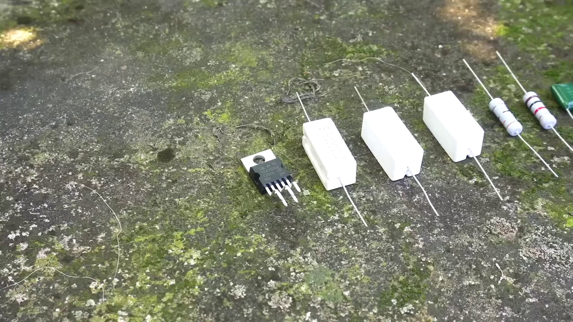 | 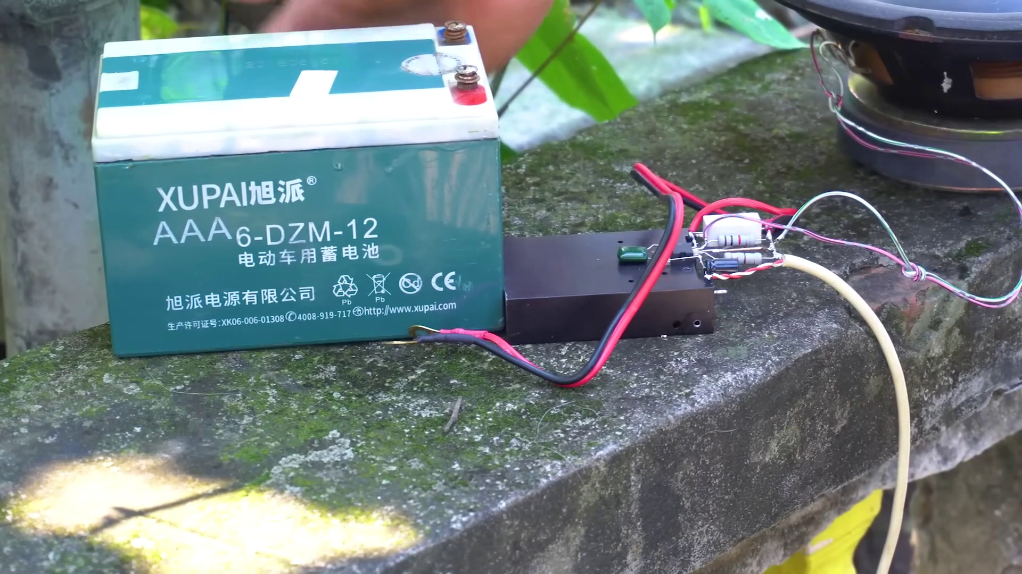 | 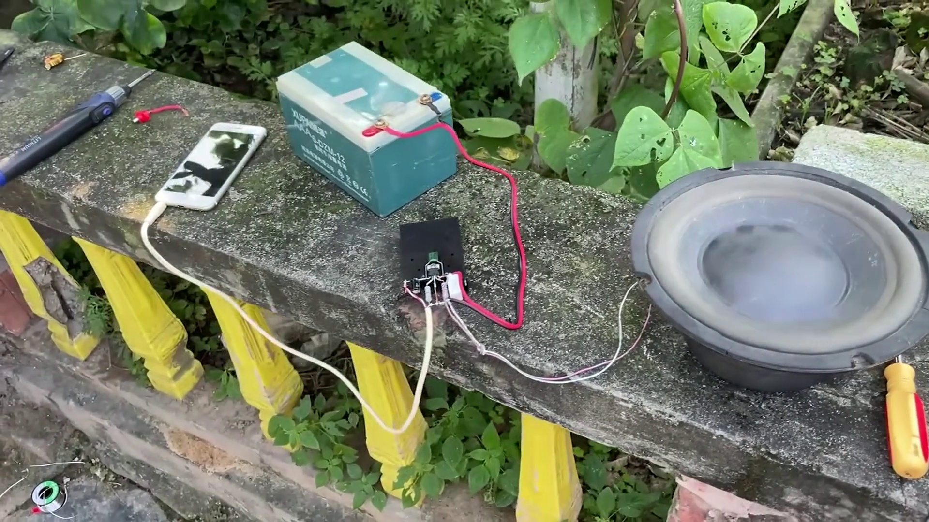
Topic T1: Box Consideration — score 20.0000
Description: The speaker discusses considering one box.
Reason: The topic 'Box Consideration' does not match the comment's focus on audio amplifiers and chip selection. The only mention of a box is in the phrase 'consider one box', but it seems to be referring to a different context altogether.
 |  | 
Topic T3: Introduction and Name — score 10.0000
Description: The speaker introduces themselves and their name.
Reason: The comment discusses a specific audio amplifier chip (TDA2030) and its connections to speakers, whereas the topic is about introducing oneself and their name. Although there are some vague mentions of learning important concepts from videos, there is no direct correlation between the topic and the comment.
 |  | 
Topic T2: Flight Availability — score 0.0000
Description: The speaker mentions the sounds of flight availability.
Reason: The comment discusses audio amplification and chip selection, which has no direct relation to the topic of flight availability.
Least correlated topics:
 |  | 
Topic T2: Flight Availability — score 0.0000
Description: The speaker mentions the sounds of flight availability.
Reason: The comment discusses audio amplification and chip selection, which has no direct relation to the topic of flight availability.
 |  | 
Topic T3: Introduction and Name — score 10.0000
Description: The speaker introduces themselves and their name.
Reason: The comment discusses a specific audio amplifier chip (TDA2030) and its connections to speakers, whereas the topic is about introducing oneself and their name. Although there are some vague mentions of learning important concepts from videos, there is no direct correlation between the topic and the comment.
 |  | 
Topic T1: Box Consideration — score 20.0000
Description: The speaker discusses considering one box.
Reason: The topic 'Box Consideration' does not match the comment's focus on audio amplifiers and chip selection. The only mention of a box is in the phrase 'consider one box', but it seems to be referring to a different context altogether.
- matched 0 topic(s), max score 0.0000: This video does not say anything but shows putting electronics together also on a heat sink, soldered out in mid air off the heat sink. This is also a basic circuit you can purchase online fairly cheap and I believe they have soldering kits to build your own. From what I have read you can add a pair of PNP and NPN output transistors to increase current and reduce the load impedanceI n on this. In Summary I would have to say that I would rank How to make a simple LED flasher as my first video, that is something I want to add to project 2 but using a led to show power doing to the amplifier. The second video would be How to make a laser security alarm, I actually have always wanted to build one just to try, but I think I will try to make one with more of a range to it. My Third pick will be setting up MyDaq as that is very useful and I know that I will need that in the future. My fourth pick will be Mosfets and how to use them, I know that I will need to study this much more for the next exam and this will be a good review video. My fifth video will be Make all component Tester using BC547. I know this can be accomplished by just using a multimeter, but It will help me understand the components of the multimeter better. Number six video will be 3 mind blowing mosfet project, as I can review this often to get a better understanding of what we are studying now in chapter 5 that will most likely me part of the next exam. Video number seven will be Clap Switch circuit on Breadboard (Sound triggered LED) | Transistor + 555 timer projects. This is something I have always wanted to make time to build also, the 555 timer is fascinating to me and I do not have much experience with it. My number eight video will be Basic 4-Transistor MOSFET H-Bridge, as I stated earlier I think this could be very useful if I want to build my own little robot to control the motors, and it was a much simpler method of motor control than anything that I have seen before. Number nine video pick will be how to make simple dc motor speed control circuit, because this goes along with number eight video on how to control motors on a more simple method. I feel like this would be a huge part of small robot arm building that could be simplified but still managed to be controlled smoothly. Finally my number ten pick, the top ten video will have to be the Opto-Couplers Theory and Circuits. I have to say this was very interesting on not only protecting the circuit by using the light to control the switching in the circuit. I feel this would be very useful in many circuits with great precision to control the correct amount of voltage in a certain range. All of the videos are very informative and I enjoyed watching them. I feel I have learned a good deal from just watching the videos, but I also know this a great deal of information, and I will have to keep watching in order to understand on a better level.
Source: https://www.youtube.com/watch?v=K4aI2t5T00c: DIY Powerful Ultra Bass Amplifier TDA2030, Upradge Power to 100W
Top correlated topics:
 |  | 
Topic T3: Introduction and Name — score 20.0000
Description: The speaker introduces themselves and their name.
Reason: {
"correlated": false,
"score": 20,
"reason": "The comment discusses its own video preferences and tutorials, but does not directly relate to the topic 'Introduction and Name', which is about introducing oneself and their name. The two are unrelated."
 |  | 
Topic T2: Flight Availability — score 20.0000
Description: The speaker mentions the sounds of flight availability.
Reason: The topic 'Flight Availability' does not match the comment's discussion about electronics and circuitry. The only mention of 'sounds' in the topic description is not directly related to the comment.
 |  | 
Topic T1: Box Consideration — score 0.0000
Description: The speaker discusses considering one box.
Reason: The comment does not discuss the topic 'Box Consideration' at all, instead discussing various electronics and circuit projects.
Least correlated topics:
 |  | 
Topic T1: Box Consideration — score 0.0000
Description: The speaker discusses considering one box.
Reason: The comment does not discuss the topic 'Box Consideration' at all, instead discussing various electronics and circuit projects.
 |  | 
Topic T2: Flight Availability — score 20.0000
Description: The speaker mentions the sounds of flight availability.
Reason: The topic 'Flight Availability' does not match the comment's discussion about electronics and circuitry. The only mention of 'sounds' in the topic description is not directly related to the comment.
 |  | 
Topic T3: Introduction and Name — score 20.0000
Description: The speaker introduces themselves and their name.
Reason: {
"correlated": false,
"score": 20,
"reason": "The comment discusses its own video preferences and tutorials, but does not directly relate to the topic 'Introduction and Name', which is about introducing oneself and their name. The two are unrelated."
- matched 0 topic(s), max score 0.0000: This video demonstrated how to build an ultra bass amplifier using a TDA2030 IC. It covered proper soldering and best wiring practices, producing strong bass output and good sound quality.I would like to know how to wire a similar amplifier using a breadboard.
Source: https://www.youtube.com/watch?v=K4aI2t5T00c&t=324s: DIY Powerful Ultra Bass Amplifier TDA2030, Upradge Power to 100W
Top correlated topics:
 |  | 
Topic T3: Introduction and Name — score 0.0000
Description: The speaker introduces themselves and their name.
Reason: The topic is about introduction and name, while the comment is about building an ultra bass amplifier using a TDA2030 IC, which has no connection to the topic.
 |  | 
Topic T2: Flight Availability — score 0.0000
Description: The speaker mentions the sounds of flight availability.
Reason: The topic is about flight availability, while the comment is about building an ultra bass amplifier, with no overlap between the two topics.
 |  | 
Topic T1: Box Consideration — score 0.0000
Description: The speaker discusses considering one box.
Reason: The topic is about considering one box, while the comment is about building an ultra bass amplifier using a TDA2030 IC, with no connection to box consideration.
Least correlated topics:
 |  | 
Topic T1: Box Consideration — score 0.0000
Description: The speaker discusses considering one box.
Reason: The topic is about considering one box, while the comment is about building an ultra bass amplifier using a TDA2030 IC, with no connection to box consideration.
 |  | 
Topic T2: Flight Availability — score 0.0000
Description: The speaker mentions the sounds of flight availability.
Reason: The topic is about flight availability, while the comment is about building an ultra bass amplifier, with no overlap between the two topics.
 |  | 
Topic T3: Introduction and Name — score 0.0000
Description: The speaker introduces themselves and their name.
Reason: The topic is about introduction and name, while the comment is about building an ultra bass amplifier using a TDA2030 IC, which has no connection to the topic.
- matched 0 topic(s), max score 0.0000: This video demonstrated how to build an ultra bass amplifier circuit using a TDA2030 IC. It showed proper soldering techniques and the best wiring method for this amplifier. The bass output was very significant and the speaker produced good sound quality.I would like to know how to wire a similar amplifier using a breadboard.
Source: https://www.youtube.com/watch?v=K4aI2t5T00c&t=324s: DIY Powerful Ultra Bass Amplifier TDA2030, Upradge Power to 100W
Top correlated topics:
 |  | 
Topic T1: Box Consideration — score 20.0000
Description: The speaker discusses considering one box.
Reason: The topic is about considering one box, while the comment discusses building an ultra bass amplifier circuit using a TDA2030 IC. The topic and comment are unrelated.
 |  | 
Topic T3: Introduction and Name — score 0.0000
Description: The speaker introduces themselves and their name.
Reason: The comment discusses building an ultra bass amplifier circuit and wiring techniques, which has no relation to the topic of introducing oneself and their name.
 |  | 
Topic T2: Flight Availability — score 0.0000
Description: The speaker mentions the sounds of flight availability.
Reason: The comment discusses building an ultra bass amplifier circuit and its related techniques, which has no direct connection to flight availability.
Least correlated topics:
 |  | 
Topic T2: Flight Availability — score 0.0000
Description: The speaker mentions the sounds of flight availability.
Reason: The comment discusses building an ultra bass amplifier circuit and its related techniques, which has no direct connection to flight availability.
 |  | 
Topic T3: Introduction and Name — score 0.0000
Description: The speaker introduces themselves and their name.
Reason: The comment discusses building an ultra bass amplifier circuit and wiring techniques, which has no relation to the topic of introducing oneself and their name.
 |  | 
Topic T1: Box Consideration — score 20.0000
Description: The speaker discusses considering one box.
Reason: The topic is about considering one box, while the comment discusses building an ultra bass amplifier circuit using a TDA2030 IC. The topic and comment are unrelated.
- matched 0 topic(s), max score 0.0000: This video demonstrated another way to construct a TDA 2030 amplifier speaker circuit. Like in Video 1, the constructed circuit was fairly simple and consisted of only a couple of resistors and capacitors. However, the actual design of the circuit was different as this circuit used different values of resistors and capacitors and in a different circuit layout as well. This demonstrates that there are multiple different ways to create a good sounding speaker with a simple circuit using the TDA 2030 amplifier chip. The questions and points of confusion that I had for Video 1 are the same for this video.
Source: https://www.youtube.com/watch?v=K4aI2t5T00c: DIY Powerful Ultra Bass Amplifier TDA2030, Upradge Power to 100W
Top correlated topics:
 |  | 
Topic T3: Introduction and Name — score 0.0000
Description: The speaker introduces themselves and their name.
Reason: The comment discusses a different topic (amplifier speaker circuit) and does not mention the introduction or name of the speaker at all.
 |  | 
Topic T2: Flight Availability — score 0.0000
Description: The speaker mentions the sounds of flight availability.
Reason: The topic is about flight availability and the comment discusses a different topic altogether (amplifier circuit design), with no overlap or relation to flights.
 |  | 
Topic T1: Box Consideration — score 0.0000
Description: The speaker discusses considering one box.
Reason: No mention of 'box consideration' or any related concept in the comment, which discusses amplifier speaker circuits and compares different designs.
Least correlated topics:
 |  | 
Topic T1: Box Consideration — score 0.0000
Description: The speaker discusses considering one box.
Reason: No mention of 'box consideration' or any related concept in the comment, which discusses amplifier speaker circuits and compares different designs.
 |  | 
Topic T2: Flight Availability — score 0.0000
Description: The speaker mentions the sounds of flight availability.
Reason: The topic is about flight availability and the comment discusses a different topic altogether (amplifier circuit design), with no overlap or relation to flights.
 |  | 
Topic T3: Introduction and Name — score 0.0000
Description: The speaker introduces themselves and their name.
Reason: The comment discusses a different topic (amplifier speaker circuit) and does not mention the introduction or name of the speaker at all.
- matched 0 topic(s), max score 0.0000: The TDA2030 is a powerful chip ideal for boosting subwoofer output. It’s very effective for upgrading audio systems.The chip’s pinout is unusual, which could be confusing during circuit assembly.This chip will be valuable when working on the subwoofer project in Phase II.
Source: https://www.youtube.com/watch?v=K4aI2t5T00c: DIY Powerful Ultra Bass Amplifier TDA2030, Upgrade Power to 100W
Top correlated topics:
 |  | 
Topic T1: Box Consideration — score 20.0000
Description: The speaker discusses considering one box.
Reason: The comment discusses a specific audio chip and its pinout, whereas the topic is about considering one box, with no apparent connection or overlap.
 |  | 
Topic T3: Introduction and Name — score 0.0000
Description: The speaker introduces themselves and their name.
Reason: The comment discusses a specific chip and its usage for audio systems, whereas the topic is about introducing oneself and their name, which has no direct relation.
 |  | 
Topic T2: Flight Availability — score 0.0000
Description: The speaker mentions the sounds of flight availability.
Reason: The comment discusses a chip and its application to audio systems, whereas the topic is about flight availability. There are no overlaps in terms of steps, objects, settings, parameters, claims, or goals.
Least correlated topics:
 |  | 
Topic T2: Flight Availability — score 0.0000
Description: The speaker mentions the sounds of flight availability.
Reason: The comment discusses a chip and its application to audio systems, whereas the topic is about flight availability. There are no overlaps in terms of steps, objects, settings, parameters, claims, or goals.
 |  | 
Topic T3: Introduction and Name — score 0.0000
Description: The speaker introduces themselves and their name.
Reason: The comment discusses a specific chip and its usage for audio systems, whereas the topic is about introducing oneself and their name, which has no direct relation.
 |  | 
Topic T1: Box Consideration — score 20.0000
Description: The speaker discusses considering one box.
Reason: The comment discusses a specific audio chip and its pinout, whereas the topic is about considering one box, with no apparent connection or overlap.
- matched 0 topic(s), max score 0.0000: Shows how to use the TDA2030 amplifier to upgrade power output.Any questions not answered through the video: No narration; all info is visual, which limits explanation clarity. How I plan to use the electrical system in the future: Helpful for building the subwoofer in Phase 2, especially for capacitor needs.
Source: https://www.youtube.com/watch?v=K4aI2t5T00c: DIY Powerful Ultra Bass Amplifier TDA2030 - Upgrade Power to 100W
Top correlated topics:
 |  | 
Topic T3: Introduction and Name — score 20.0000
Description: The speaker introduces themselves and their name.
Reason: The comment discusses a different topic (amplifier upgrade) and mentions the video, but does not directly relate to introducing oneself and their name.
 |  | 
Topic T1: Box Consideration — score 20.0000
Description: The speaker discusses considering one box.
Reason: The topic is about considering one box, while the comment discusses amplifiers and building a subwoofer. Although it mentions future plans, there is no direct discussion of the box consideration topic.
 |  | 
Topic T2: Flight Availability — score 0.0000
Description: The speaker mentions the sounds of flight availability.
Reason: The topic is about flight availability, while the comment discusses amplifier upgrades and building a subwoofer, with no connection between the two.
Least correlated topics:
 |  | 
Topic T2: Flight Availability — score 0.0000
Description: The speaker mentions the sounds of flight availability.
Reason: The topic is about flight availability, while the comment discusses amplifier upgrades and building a subwoofer, with no connection between the two.
 |  | 
Topic T1: Box Consideration — score 20.0000
Description: The speaker discusses considering one box.
Reason: The topic is about considering one box, while the comment discusses amplifiers and building a subwoofer. Although it mentions future plans, there is no direct discussion of the box consideration topic.
 |  | 
Topic T3: Introduction and Name — score 20.0000
Description: The speaker introduces themselves and their name.
Reason: The comment discusses a different topic (amplifier upgrade) and mentions the video, but does not directly relate to introducing oneself and their name.

Topic T1: Box Consideration
 |  | 
Description: The speaker discusses considering one box.
No strongly correlated comments found for this topic.

Topic T2: Flight Availability
 |  | 
Description: The speaker mentions the sounds of flight availability.
No strongly correlated comments found for this topic.

Topic T3: Introduction and Name
 |  | 
Description: The speaker introduces themselves and their name.
No strongly correlated comments found for this topic.

