Comment–Topic Correlation Report
Model: llama3

Summary
Topics processed: 7
Comments available for this video: 2
Comments correlated to ≥ 60: 0 (0.0%)
Total candidate pairs checked: 14

Most/Least correlated topics (by average score across correlated comments):
Top 3:
• Topic T7: Throttle Hold — avg 0.00, contributions 0
• Topic T3: Throttle Curve — avg 0.00, contributions 0
• Topic T1: Subtrim Settings — avg 0.00, contributions 0
Bottom 3:
• Topic T6: Assigned Switches — avg 0.00, contributions 0
• Topic T2: Dual Rate and Exponential Settings — avg 0.00, contributions 0
• Topic T5: LE One Setup — avg 0.00, contributions 0
Correlated comment coverage (all comments):
- matched 0 topic(s), max score 0.0000: it was a good guide to the controller. I was surprised to know we can give the drones names and have up to 20 different models saved to it.
Source: https://www.youtube.com/watch?v=LYJDlz5w77Y: FLYSKY FS-I6X FUNCTIONS MENU | EXPALINED
Top correlated topics:
 | 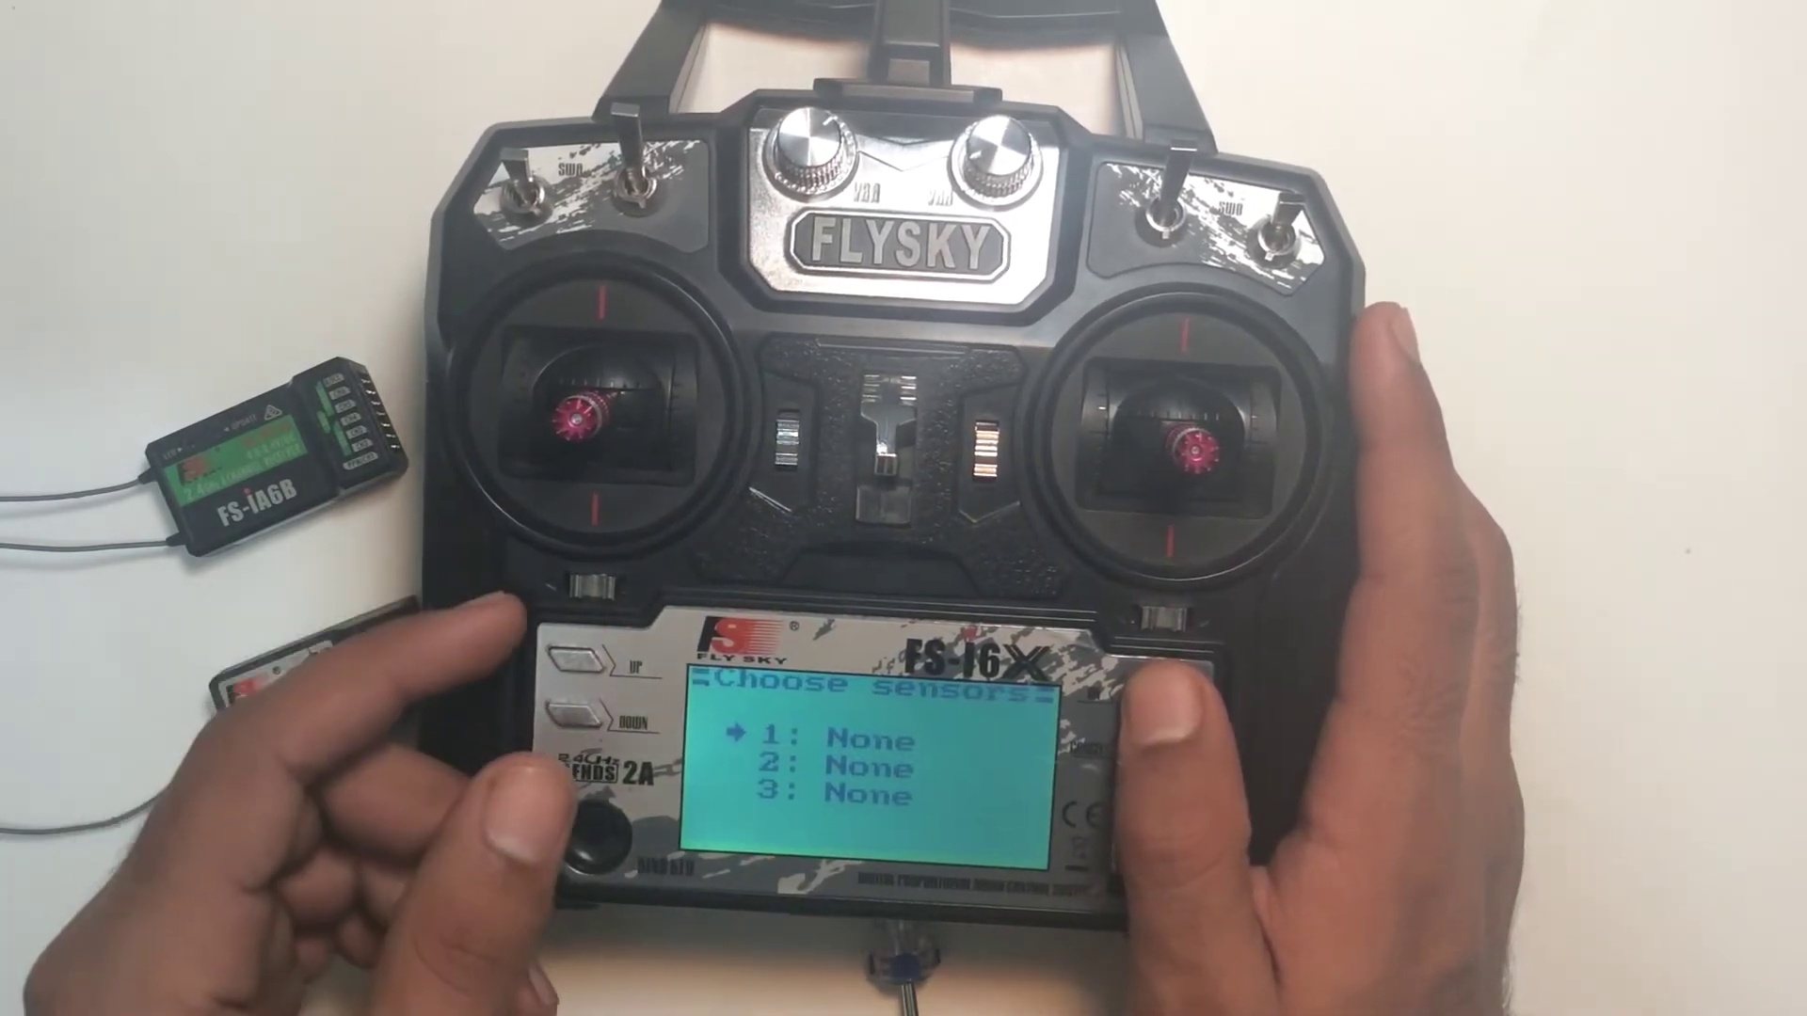 | 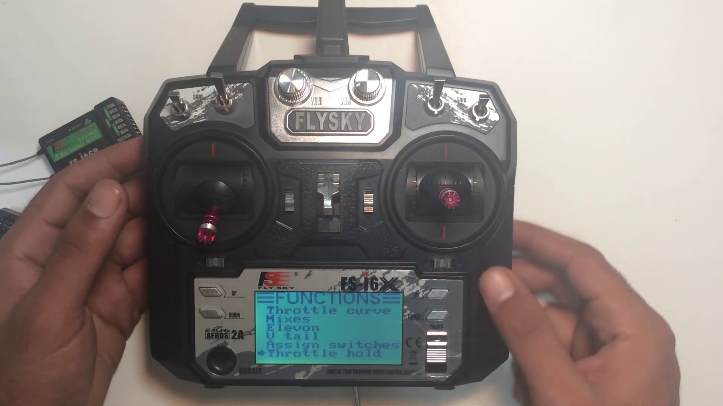
Topic T5: LE One Setup — score 10.0000
Description: Aircraft setup options
Reason: The comment mentions the controller and drone setup, but it's not directly discussing the aircraft setup options described in the topic. The comment also veers off-topic by mentioning naming drones and saving models, which is unrelated to the topic.
 |  | 
Topic T7: Throttle Hold — score 0.0000
Description: Automatically holding throttle at a set position
Reason: The comment does not discuss the topic of 'Throttle Hold' and instead talks about giving drones names and saving models to a controller.
 |  | 
Topic T6: Assigned Switches — score 0.0000
Description: Customizing switch functionality
Reason: The comment mentions a guide to the controller and naming drones, which has no direct relation to customizing switch functionality.
 |  | 
Topic T4: Mixer Setup — score 0.0000
Description: Master and slave channels for aircraft control
Reason: The comment does not directly discuss the topic of mixer setup for aircraft control. Instead, it mentions a guide to a controller and discusses features unrelated to the topic.
 |  | 
Topic T3: Throttle Curve — score 0.0000
Description: How throttle increases upon movement
Reason: The comment discusses the controller and drone features, but does not mention throttle curve or how it increases upon movement.
 |  | 
Topic T2: Dual Rate and Exponential Settings — score 0.0000
Description: Sensitivity of controls
Reason: The comment discusses the controller and its features (naming drones and saving models), but does not mention dual rate or exponential settings, nor is it related to sensitivity of controls.
 |  | 
Topic T1: Subtrim Settings — score 0.0000
Description: Aligning control surfaces and tuning aircraft
Reason: The comment does not discuss the topic's description of aligning control surfaces and tuning aircraft, instead it talks about a guide for a drone controller and its features.
Least correlated topics:
 |  | 
Topic T1: Subtrim Settings — score 0.0000
Description: Aligning control surfaces and tuning aircraft
Reason: The comment does not discuss the topic's description of aligning control surfaces and tuning aircraft, instead it talks about a guide for a drone controller and its features.
 |  | 
Topic T2: Dual Rate and Exponential Settings — score 0.0000
Description: Sensitivity of controls
Reason: The comment discusses the controller and its features (naming drones and saving models), but does not mention dual rate or exponential settings, nor is it related to sensitivity of controls.
 |  | 
Topic T3: Throttle Curve — score 0.0000
Description: How throttle increases upon movement
Reason: The comment discusses the controller and drone features, but does not mention throttle curve or how it increases upon movement.
 |  | 
Topic T4: Mixer Setup — score 0.0000
Description: Master and slave channels for aircraft control
Reason: The comment does not directly discuss the topic of mixer setup for aircraft control. Instead, it mentions a guide to a controller and discusses features unrelated to the topic.
 |  | 
Topic T6: Assigned Switches — score 0.0000
Description: Customizing switch functionality
Reason: The comment mentions a guide to the controller and naming drones, which has no direct relation to customizing switch functionality.
 |  | 
Topic T7: Throttle Hold — score 0.0000
Description: Automatically holding throttle at a set position
Reason: The comment does not discuss the topic of 'Throttle Hold' and instead talks about giving drones names and saving models to a controller.
 |  | 
Topic T5: LE One Setup — score 10.0000
Description: Aircraft setup options
Reason: The comment mentions the controller and drone setup, but it's not directly discussing the aircraft setup options described in the topic. The comment also veers off-topic by mentioning naming drones and saving models, which is unrelated to the topic.
- matched 0 topic(s), max score 0.0000: This video provides an in-depth look at the Fly Sky FSI 6X transmitter, showcasing its various features and capabilities. It begins by illustrating how to activate the transmitter, access its home screen, and interpret important information such as battery level, model details, and protocol. The guide also instructs on navigating the setup menu, customizing settings, and saving these adjustments. Key aspects covered include system settings like model selection and naming, as well as functional setup for adjusting sensitivity and assigning switches to suit different aircraft and quadcopter models. Furthermore, the guide delves into advanced functionalities, such as utilizing different sensors to measure parameters like speed, distance, and altitude pressure. It explains how to adjust servo frequency, reverse channel movements for precise control, and configure display settings for real-time feedback. Setting control limits through end points and assigning auxiliary channels are also detailed. The guide emphasizes fine-tuning aircraft controls using subtrim settings, dual rate, exponential settings for control sensitivity, and throttle curve adjustments for nuanced control. Additionally, it addresses complex configurations, including elevon and V-tail setups, and shows how to assign switches for specific functions like throttle hold, ensuring meticulous control over the transmitter's functionalities.
Source: https://www.youtube.com/watch?v=LYJDlz5w77Y: FLYSKY FS-I6X FUNCTIONS MENU | EXPALINED
Top correlated topics:
 |  | 
Topic T7: Throttle Hold — score 20.0000
Description: Automatically holding throttle at a set position
Reason: The comment discusses a different topic (transmitter setup and features) and only mentions throttle hold as one of the many switch assignments, without any specific discussion about automatically holding throttle at a set position.
 |  | 
Topic T6: Assigned Switches — score 20.0000
Description: Customizing switch functionality
Reason: The comment discusses a different topic (Fly Sky FSI 6X transmitter) and its features, with no direct relation to customizing switch functionality.
 |  | 
Topic T5: LE One Setup — score 20.0000
Description: Aircraft setup options
Reason: The comment discusses a specific transmitter setup guide, which is related to aircraft setup options. However, the topic 'LE One Setup' does not mention the Fly Sky FSI 6X transmitter or any specific details about it.
 |  | 
Topic T4: Mixer Setup — score 20.0000
Description: Master and slave channels for aircraft control
Reason: The topic is about mixer setup for aircraft control, while the comment is a review of a transmitter's features and capabilities. The topic does not appear to be directly discussed in the comment.
 |  | 
Topic T2: Dual Rate and Exponential Settings — score 20.0000
Description: Sensitivity of controls
Reason: The comment discusses various features and settings of a transmitter, including sensitivity, but does not specifically mention exponential settings or dual rate, which are key aspects highlighted in the topic description.
 |  | 
Topic T1: Subtrim Settings — score 20.0000
Description: Aligning control surfaces and tuning aircraft
Reason: The comment discusses a different topic (Fly Sky FSI 6X transmitter) and does not mention subtrim settings or aircraft control directly. While it mentions adjusting servo frequency and configuring display settings, these are specific to the transmitter and not related to the topic of subtrim settings for aligning control surfaces.
 |  | 
Topic T3: Throttle Curve — score 0.0000
Description: How throttle increases upon movement
Reason: The comment discusses a specific radio transmitter and its features, while the topic is about throttle curves and how they increase upon movement. The two are not directly related.
Least correlated topics:
 |  | 
Topic T3: Throttle Curve — score 0.0000
Description: How throttle increases upon movement
Reason: The comment discusses a specific radio transmitter and its features, while the topic is about throttle curves and how they increase upon movement. The two are not directly related.
 |  | 
Topic T1: Subtrim Settings — score 20.0000
Description: Aligning control surfaces and tuning aircraft
Reason: The comment discusses a different topic (Fly Sky FSI 6X transmitter) and does not mention subtrim settings or aircraft control directly. While it mentions adjusting servo frequency and configuring display settings, these are specific to the transmitter and not related to the topic of subtrim settings for aligning control surfaces.
 |  | 
Topic T2: Dual Rate and Exponential Settings — score 20.0000
Description: Sensitivity of controls
Reason: The comment discusses various features and settings of a transmitter, including sensitivity, but does not specifically mention exponential settings or dual rate, which are key aspects highlighted in the topic description.
 |  | 
Topic T4: Mixer Setup — score 20.0000
Description: Master and slave channels for aircraft control
Reason: The topic is about mixer setup for aircraft control, while the comment is a review of a transmitter's features and capabilities. The topic does not appear to be directly discussed in the comment.
 |  | 
Topic T5: LE One Setup — score 20.0000
Description: Aircraft setup options
Reason: The comment discusses a specific transmitter setup guide, which is related to aircraft setup options. However, the topic 'LE One Setup' does not mention the Fly Sky FSI 6X transmitter or any specific details about it.
 |  | 
Topic T6: Assigned Switches — score 20.0000
Description: Customizing switch functionality
Reason: The comment discusses a different topic (Fly Sky FSI 6X transmitter) and its features, with no direct relation to customizing switch functionality.
 |  | 
Topic T7: Throttle Hold — score 20.0000
Description: Automatically holding throttle at a set position
Reason: The comment discusses a different topic (transmitter setup and features) and only mentions throttle hold as one of the many switch assignments, without any specific discussion about automatically holding throttle at a set position.

Topic T1: Subtrim Settings
 |  | 
Description: Aligning control surfaces and tuning aircraft
No strongly correlated comments found for this topic.

Topic T2: Dual Rate and Exponential Settings
 |  | 
Description: Sensitivity of controls
No strongly correlated comments found for this topic.

Topic T3: Throttle Curve
 |  | 
Description: How throttle increases upon movement
No strongly correlated comments found for this topic.

Topic T4: Mixer Setup
 |  | 
Description: Master and slave channels for aircraft control
No strongly correlated comments found for this topic.

Topic T5: LE One Setup
 |  | 
Description: Aircraft setup options
No strongly correlated comments found for this topic.

Topic T6: Assigned Switches
 |  | 
Description: Customizing switch functionality
No strongly correlated comments found for this topic.

Topic T7: Throttle Hold
 |  | 
Description: Automatically holding throttle at a set position
No strongly correlated comments found for this topic.

