Comment–Topic Correlation Report
Model: llama3

Summary
Topics processed: 6
Comments available for this video: 1
Comments correlated to ≥ 60: 1 (100.0%)
Total candidate pairs checked: 6

Most/Least correlated topics (by average score across correlated comments):
Top 3:
• Topic T3: Master Multiplier Settings — avg 90.00, contributions 1
• Topic T4: Pitch Dampening — avg 85.00, contributions 1
• Topic T2: Master Multiplier Limitations — avg 85.00, contributions 1
Bottom 3:
• Topic T1: Flight testing — avg 0.00, contributions 0
• Topic T5: Tuning PID for quadcopter — avg 0.00, contributions 0
• Topic T6: Using PID toolbox for analysis — avg 80.00, contributions 1
Correlated comment coverage (all comments):
- matched 4 topic(s), max score 90.0000: Rank4, The Betaflight configuration tutorial provided a detailed exploration into the art of drone tuning, emphasizing the necessity of customizing settings for optimal quadcopter performance. The introduction of Black Box for detailed flight data logging set the stage for a nuanced approach to advanced tuning techniques. Through systematic adjustments of PID values and mastering the use of tools like the Black Box Explorer and PID Toolbox, the tutorial underscored the precision required to fine-tune the delicate interplay between drone responsiveness and stability. Understanding the intricacies of Feed Forward, I-Term, Dynamic Damping, and the master multiplier, and then seeing these adjustments reflected in flight characteristics, showcased the impact of meticulous tuning. The process was not only about making theoretical changes but also about validating these through practical flight tests, ensuring motor temperatures remained within safe limits for sustained performance. The tutorial culminated with real flight footage, demonstrating the successful application of tuning, and invited viewers to engage in a dialogue to further refine the tuning process. This comprehensive guide has armed me with a strategic framework for approaching Betaflight configurations, elevating my capability to tailor drone behavior to precise flying conditions.
Source: https://www.youtube.com/watch?v=N5DbiWFjbh8: “How to Get that Perfect PID Tune in Betaflight 4.4 | 2023”
Top correlated topics:
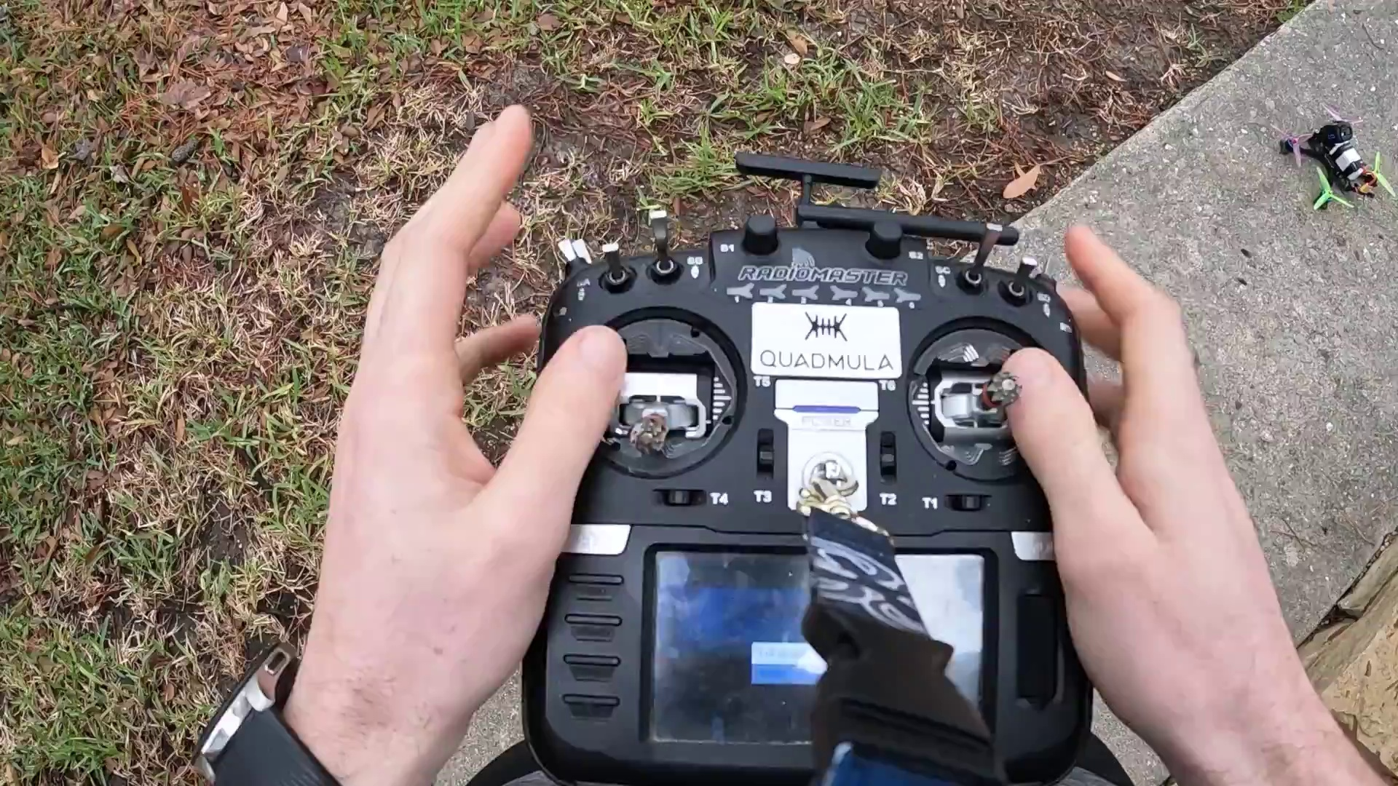 | 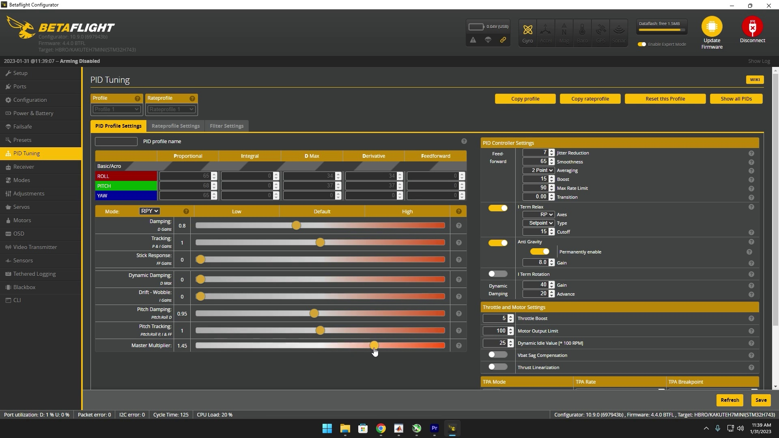 | 
Topic T5: Tuning PID for quadcopter — score 95.0000
Description: The process of fine-tuning the PID (proportional-integral-derivative) settings for a quadcopter to achieve stable flight.
Reason: {
"correlated": true,
"score": 95,
"reason": "The comment directly discusses the process of tuning PID settings for a quadcopter, mentioning specific parameters like Feed Forward, I-Term, and Dynamic Damping, which are all related to the topic. The comment also mentions practical flight tests and validating changes, aligning with the description's emphasis on fine-tuning for stable flight."
 |  | 
Topic T3: Master Multiplier Settings — score 90.0000
Description: Adjusting master multiplier for fast control links
Reason: The comment discusses the importance of customizing master multiplier settings for optimal quadcopter performance, mentioning specific tuning techniques like PID values and Black Box Explorer, which are directly related to the topic's description about adjusting master multiplier for fast control links.
 |  | 
Topic T1: Flight testing — score 90.0000
Description: The process of flying the quadcopter and testing its stability and performance.
Reason: {
"correlated": true,
"score": 90,
"reason": "The comment directly discusses the process of tuning quadcopter settings for optimal performance and stability, which is a crucial part of flight testing, as described in the topic. The mention of specific terms like PID values, Black Box, and motor temperatures further strengthens the correlation."
 |  | 
Topic T4: Pitch Dampening — score 85.0000
Description: Adjusting pitch dampening for under-damped response
Reason: The comment discusses adjusting PID values, mastering the use of tools like Black Box Explorer and PID Toolbox, and fine-tuning the interplay between drone responsiveness and stability, which are all directly related to the topic 'Pitch Dampening' and its description 'Adjusting pitch dampening for under-damped response'.
 |  | 
Topic T2: Master Multiplier Limitations — score 85.0000
Description: Determining the limit for master multiplier adjustments
Reason: The comment discusses the importance of customizing settings for optimal quadcopter performance, mentioning specific tools and techniques like PID values, Black Box Explorer, and Feed Forward, which are all directly related to the topic 'Master Multiplier Limitations' about determining the limit for master multiplier adjustments.
 |  | 
Topic T6: Using PID toolbox for analysis — score 80.0000
Description: The use of the PID toolbox software for analyzing and fine-tuning the PID settings for a quadcopter.
Reason: The comment directly discusses the use of PID toolbox for analysis, emphasizing the importance of customizing settings and fine-tuning PID values, which is exactly what the topic description describes. The mention of specific tools like Black Box Explorer and PID Toolbox, as well as techniques like feed-forward and dynamic damping, further strengthens the correlation.
Least correlated topics:
 |  | 
Topic T6: Using PID toolbox for analysis — score 80.0000
Description: The use of the PID toolbox software for analyzing and fine-tuning the PID settings for a quadcopter.
Reason: The comment directly discusses the use of PID toolbox for analysis, emphasizing the importance of customizing settings and fine-tuning PID values, which is exactly what the topic description describes. The mention of specific tools like Black Box Explorer and PID Toolbox, as well as techniques like feed-forward and dynamic damping, further strengthens the correlation.
 |  | 
Topic T2: Master Multiplier Limitations — score 85.0000
Description: Determining the limit for master multiplier adjustments
Reason: The comment discusses the importance of customizing settings for optimal quadcopter performance, mentioning specific tools and techniques like PID values, Black Box Explorer, and Feed Forward, which are all directly related to the topic 'Master Multiplier Limitations' about determining the limit for master multiplier adjustments.
 |  | 
Topic T4: Pitch Dampening — score 85.0000
Description: Adjusting pitch dampening for under-damped response
Reason: The comment discusses adjusting PID values, mastering the use of tools like Black Box Explorer and PID Toolbox, and fine-tuning the interplay between drone responsiveness and stability, which are all directly related to the topic 'Pitch Dampening' and its description 'Adjusting pitch dampening for under-damped response'.
 |  | 
Topic T1: Flight testing — score 90.0000
Description: The process of flying the quadcopter and testing its stability and performance.
Reason: {
"correlated": true,
"score": 90,
"reason": "The comment directly discusses the process of tuning quadcopter settings for optimal performance and stability, which is a crucial part of flight testing, as described in the topic. The mention of specific terms like PID values, Black Box, and motor temperatures further strengthens the correlation."
 |  | 
Topic T3: Master Multiplier Settings — score 90.0000
Description: Adjusting master multiplier for fast control links
Reason: The comment discusses the importance of customizing master multiplier settings for optimal quadcopter performance, mentioning specific tuning techniques like PID values and Black Box Explorer, which are directly related to the topic's description about adjusting master multiplier for fast control links.
 |  | 
Topic T5: Tuning PID for quadcopter — score 95.0000
Description: The process of fine-tuning the PID (proportional-integral-derivative) settings for a quadcopter to achieve stable flight.
Reason: {
"correlated": true,
"score": 95,
"reason": "The comment directly discusses the process of tuning PID settings for a quadcopter, mentioning specific parameters like Feed Forward, I-Term, and Dynamic Damping, which are all related to the topic. The comment also mentions practical flight tests and validating changes, aligning with the description's emphasis on fine-tuning for stable flight."

Topic T1: Flight testing
 |  | 
Description: The process of flying the quadcopter and testing its stability and performance.
No strongly correlated comments found for this topic.

Topic T2: Master Multiplier Limitations
 |  | 
Description: Determining the limit for master multiplier adjustments
Comment (score 85): Rank4, The Betaflight configuration tutorial provided a detailed exploration into the art of drone tuning, emphasizing the necessity of customizing settings for optimal quadcopter performance. The introduction of Black Box for detailed flight data logging set the stage for a nuanced approach to advanced tuning techniques. Through systematic adjustments of PID values and mastering the use of tools like the Black Box Explorer and PID Toolbox, the tutorial underscored the precision required to fine-tune the delicate interplay between drone responsiveness and stability. Understanding the intricacies of Feed Forward, I-Term, Dynamic Damping, and the master multiplier, and then seeing these adjustments reflected in flight characteristics, showcased the impact of meticulous tuning. The process was not only about making theoretical changes but also about validating these through practical flight tests, ensuring motor temperatures remained within safe limits for sustained performance. The tutorial culminated with real flight footage, demonstrating the successful application of tuning, and invited viewers to engage in a dialogue to further refine the tuning process. This comprehensive guide has armed me with a strategic framework for approaching Betaflight configurations, elevating my capability to tailor drone behavior to precise flying conditions.
Reason: The comment discusses the importance of customizing settings for optimal quadcopter performance, mentioning specific tools and techniques like PID values, Black Box Explorer, and Feed Forward, which are all directly related to the topic 'Master Multiplier Limitations' about determining the limit for master multiplier adjustments.
Source: https://www.youtube.com/watch?v=N5DbiWFjbh8: “How to Get that Perfect PID Tune in Betaflight 4.4 | 2023”

Topic T3: Master Multiplier Settings
 |  | 
Description: Adjusting master multiplier for fast control links
Comment (score 90): Rank4, The Betaflight configuration tutorial provided a detailed exploration into the art of drone tuning, emphasizing the necessity of customizing settings for optimal quadcopter performance. The introduction of Black Box for detailed flight data logging set the stage for a nuanced approach to advanced tuning techniques. Through systematic adjustments of PID values and mastering the use of tools like the Black Box Explorer and PID Toolbox, the tutorial underscored the precision required to fine-tune the delicate interplay between drone responsiveness and stability. Understanding the intricacies of Feed Forward, I-Term, Dynamic Damping, and the master multiplier, and then seeing these adjustments reflected in flight characteristics, showcased the impact of meticulous tuning. The process was not only about making theoretical changes but also about validating these through practical flight tests, ensuring motor temperatures remained within safe limits for sustained performance. The tutorial culminated with real flight footage, demonstrating the successful application of tuning, and invited viewers to engage in a dialogue to further refine the tuning process. This comprehensive guide has armed me with a strategic framework for approaching Betaflight configurations, elevating my capability to tailor drone behavior to precise flying conditions.
Reason: The comment discusses the importance of customizing master multiplier settings for optimal quadcopter performance, mentioning specific tuning techniques like PID values and Black Box Explorer, which are directly related to the topic's description about adjusting master multiplier for fast control links.
Source: https://www.youtube.com/watch?v=N5DbiWFjbh8: “How to Get that Perfect PID Tune in Betaflight 4.4 | 2023”

Topic T4: Pitch Dampening
 |  | 
Description: Adjusting pitch dampening for under-damped response
Comment (score 85): Rank4, The Betaflight configuration tutorial provided a detailed exploration into the art of drone tuning, emphasizing the necessity of customizing settings for optimal quadcopter performance. The introduction of Black Box for detailed flight data logging set the stage for a nuanced approach to advanced tuning techniques. Through systematic adjustments of PID values and mastering the use of tools like the Black Box Explorer and PID Toolbox, the tutorial underscored the precision required to fine-tune the delicate interplay between drone responsiveness and stability. Understanding the intricacies of Feed Forward, I-Term, Dynamic Damping, and the master multiplier, and then seeing these adjustments reflected in flight characteristics, showcased the impact of meticulous tuning. The process was not only about making theoretical changes but also about validating these through practical flight tests, ensuring motor temperatures remained within safe limits for sustained performance. The tutorial culminated with real flight footage, demonstrating the successful application of tuning, and invited viewers to engage in a dialogue to further refine the tuning process. This comprehensive guide has armed me with a strategic framework for approaching Betaflight configurations, elevating my capability to tailor drone behavior to precise flying conditions.
Reason: The comment discusses adjusting PID values, mastering the use of tools like Black Box Explorer and PID Toolbox, and fine-tuning the interplay between drone responsiveness and stability, which are all directly related to the topic 'Pitch Dampening' and its description 'Adjusting pitch dampening for under-damped response'.
Source: https://www.youtube.com/watch?v=N5DbiWFjbh8: “How to Get that Perfect PID Tune in Betaflight 4.4 | 2023”

Topic T5: Tuning PID for quadcopter
 |  | 
Description: The process of fine-tuning the PID (proportional-integral-derivative) settings for a quadcopter to achieve stable flight.
No strongly correlated comments found for this topic.

Topic T6: Using PID toolbox for analysis
 |  | 
Description: The use of the PID toolbox software for analyzing and fine-tuning the PID settings for a quadcopter.
Comment (score 80): Rank4, The Betaflight configuration tutorial provided a detailed exploration into the art of drone tuning, emphasizing the necessity of customizing settings for optimal quadcopter performance. The introduction of Black Box for detailed flight data logging set the stage for a nuanced approach to advanced tuning techniques. Through systematic adjustments of PID values and mastering the use of tools like the Black Box Explorer and PID Toolbox, the tutorial underscored the precision required to fine-tune the delicate interplay between drone responsiveness and stability. Understanding the intricacies of Feed Forward, I-Term, Dynamic Damping, and the master multiplier, and then seeing these adjustments reflected in flight characteristics, showcased the impact of meticulous tuning. The process was not only about making theoretical changes but also about validating these through practical flight tests, ensuring motor temperatures remained within safe limits for sustained performance. The tutorial culminated with real flight footage, demonstrating the successful application of tuning, and invited viewers to engage in a dialogue to further refine the tuning process. This comprehensive guide has armed me with a strategic framework for approaching Betaflight configurations, elevating my capability to tailor drone behavior to precise flying conditions.
Reason: The comment directly discusses the use of PID toolbox for analysis, emphasizing the importance of customizing settings and fine-tuning PID values, which is exactly what the topic description describes. The mention of specific tools like Black Box Explorer and PID Toolbox, as well as techniques like feed-forward and dynamic damping, further strengthens the correlation.
Source: https://www.youtube.com/watch?v=N5DbiWFjbh8: “How to Get that Perfect PID Tune in Betaflight 4.4 | 2023”

