Comment–Topic Correlation Report
Model: llama3

Summary
Topics processed: 3
Comments available for this video: 5
Comments correlated to ≥ 60: 5 (100.0%)
Total candidate pairs checked: 15

Most/Least correlated topics (by average score across correlated comments):
Top 3:
• Topic T1: H-Bridge Circuit Schematic — avg 86.00, contributions 5
• Topic T2: Improved H-Bridge Motor Control — avg 85.00, contributions 5
• Topic T3: MOSFET Selection — avg 82.50, contributions 4
Bottom 3:
• Topic T3: MOSFET Selection — avg 82.50, contributions 4
• Topic T2: Improved H-Bridge Motor Control — avg 85.00, contributions 5
• Topic T1: H-Bridge Circuit Schematic — avg 86.00, contributions 5
Correlated comment coverage (all comments):
- matched 3 topic(s), max score 90.0000: The video shows how to build a MOSFET H-Bridge. You will need a total of four MOSFETS, two tactile switches, four resistors, two Zener diodes, a motor, and a power supply. This circuit can operate using anywhere between 5 and 24 Volts. Two of the MOSFETs needed are P channel MOSFETs, while the other two are IRFC 44N MOSFETs which are sensitive gate MOSFETs. Once the circuit is built successfully you will be able to control the motor using the two tactile switches.
Source: https://www.youtube.com/watch?v=NQvVeLHzfSs: Basic 4-Transistor MOSFET H-Bridge
Top correlated topics:
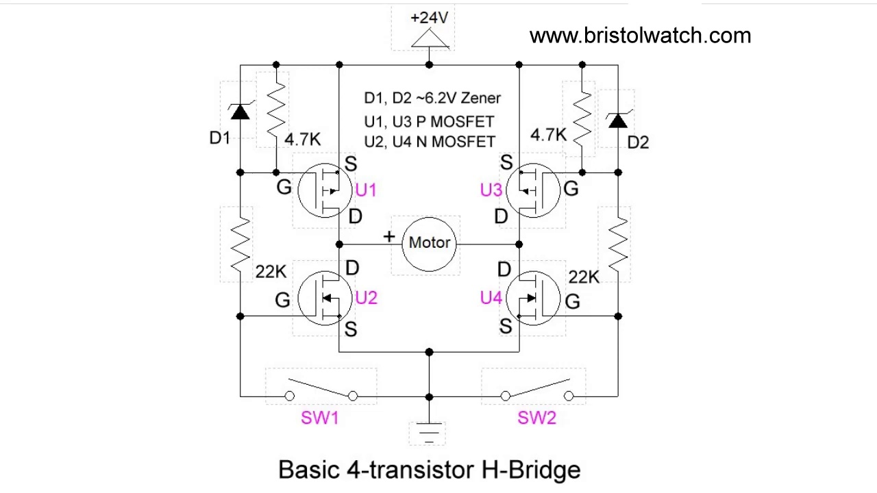 | 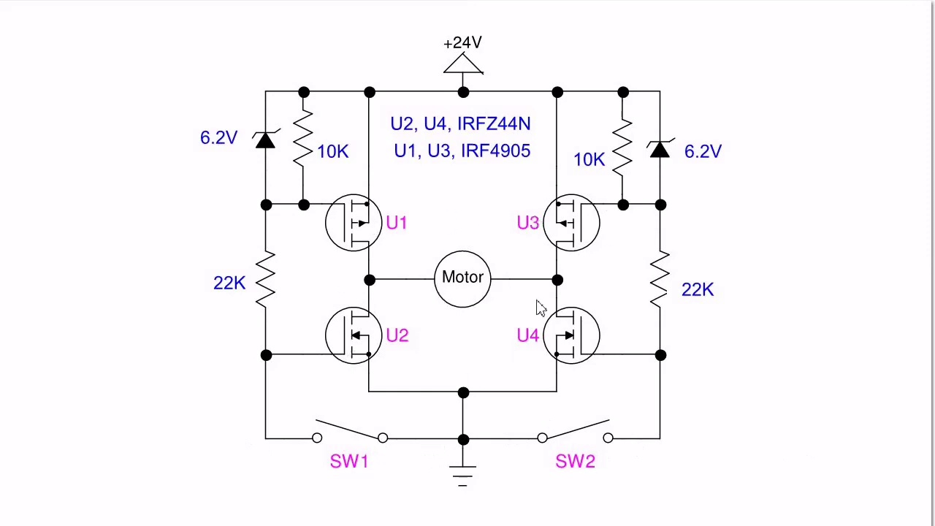 | 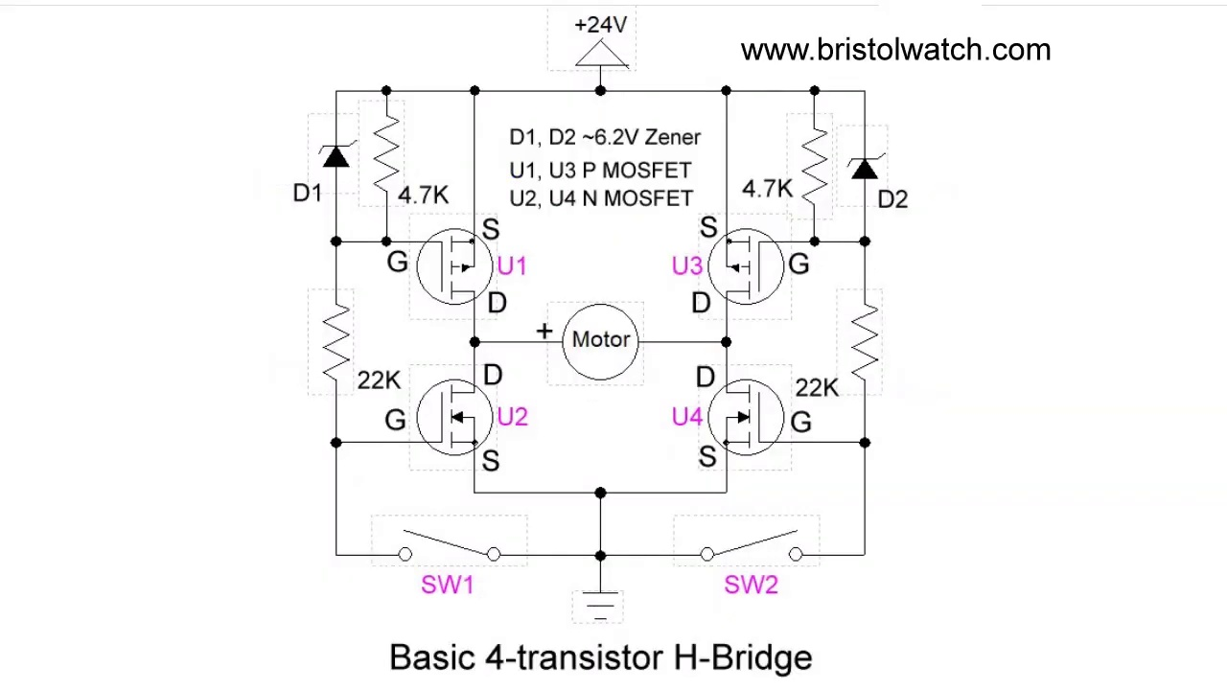
Topic T2: Improved H-Bridge Motor Control — score 90.0000
Description: The speaker presents an improved version of a previously published H-Bridge motor control circuit, highlighting its enhancements.
Reason: The comment provides a detailed list of components and specifications required for the H-Bridge motor control circuit, which aligns closely with the topic description's focus on enhancements to the previous circuit.
 |  | 
Topic T1: H-Bridge Circuit Schematic — score 90.0000
Description: The speaker shares the schematic for the H-Bridge circuit, showing its components and layout.
Reason: The comment directly discusses the same components and layout described in the topic, including MOSFETs, resistors, Zener diodes, motor, power supply, tactile switches, and operating voltage range.
 |  | 
Topic T3: MOSFET Selection — score 80.0000
Description: The speaker discusses the selection of MOSFETs used in the H-Bridge circuit, highlighting their specific characteristics.
Reason: The comment directly discusses the selection of MOSFETs in an H-Bridge circuit, highlighting specific characteristics and requirements (e.g. P-channel vs IRFC44N MOSFETs), which strongly overlaps with the topic description.
Least correlated topics:
 |  | 
Topic T3: MOSFET Selection — score 80.0000
Description: The speaker discusses the selection of MOSFETs used in the H-Bridge circuit, highlighting their specific characteristics.
Reason: The comment directly discusses the selection of MOSFETs in an H-Bridge circuit, highlighting specific characteristics and requirements (e.g. P-channel vs IRFC44N MOSFETs), which strongly overlaps with the topic description.
 |  | 
Topic T1: H-Bridge Circuit Schematic — score 90.0000
Description: The speaker shares the schematic for the H-Bridge circuit, showing its components and layout.
Reason: The comment directly discusses the same components and layout described in the topic, including MOSFETs, resistors, Zener diodes, motor, power supply, tactile switches, and operating voltage range.
 |  | 
Topic T2: Improved H-Bridge Motor Control — score 90.0000
Description: The speaker presents an improved version of a previously published H-Bridge motor control circuit, highlighting its enhancements.
Reason: The comment provides a detailed list of components and specifications required for the H-Bridge motor control circuit, which aligns closely with the topic description's focus on enhancements to the previous circuit.
- matched 3 topic(s), max score 90.0000: Explanation of H-bridge motor control using MOSFETs and its practical schematic.Details about the operation of the zener diodes for gate protection. Applying H-bridge concepts for motor control in robotics and automation projects.
Source: https://www.youtube.com/watch?v=NQvVeLHzfSs: Basic 4-Transistor MOSFET H-Bridge
Top correlated topics:
 |  | 
Topic T3: MOSFET Selection — score 90.0000
Description: The speaker discusses the selection of MOSFETs used in the H-Bridge circuit, highlighting their specific characteristics.
Reason: The comment directly discusses the selection of MOSFETs in an H-Bridge circuit, mentioning specific characteristics and gate protection, which aligns with the topic's description on MOSFET selection for the H-Bridge circuit.
 |  | 
Topic T1: H-Bridge Circuit Schematic — score 90.0000
Description: The speaker shares the schematic for the H-Bridge circuit, showing its components and layout.
Reason: The comment directly discusses the H-Bridge circuit schematic, its components and layout, and its practical application in motor control for robotics and automation projects, which matches the topic description.
 |  | 
Topic T2: Improved H-Bridge Motor Control — score 80.0000
Description: The speaker presents an improved version of a previously published H-Bridge motor control circuit, highlighting its enhancements.
Reason: The comment discusses the same topic (H-Bridge motor control) and mentions specific components (MOSFETs, zener diodes) and concepts (gate protection), which are directly related to the topic's description of an improved H-Bridge motor control circuit.
Least correlated topics:
 |  | 
Topic T2: Improved H-Bridge Motor Control — score 80.0000
Description: The speaker presents an improved version of a previously published H-Bridge motor control circuit, highlighting its enhancements.
Reason: The comment discusses the same topic (H-Bridge motor control) and mentions specific components (MOSFETs, zener diodes) and concepts (gate protection), which are directly related to the topic's description of an improved H-Bridge motor control circuit.
 |  | 
Topic T1: H-Bridge Circuit Schematic — score 90.0000
Description: The speaker shares the schematic for the H-Bridge circuit, showing its components and layout.
Reason: The comment directly discusses the H-Bridge circuit schematic, its components and layout, and its practical application in motor control for robotics and automation projects, which matches the topic description.
 |  | 
Topic T3: MOSFET Selection — score 90.0000
Description: The speaker discusses the selection of MOSFETs used in the H-Bridge circuit, highlighting their specific characteristics.
Reason: The comment directly discusses the selection of MOSFETs in an H-Bridge circuit, mentioning specific characteristics and gate protection, which aligns with the topic's description on MOSFET selection for the H-Bridge circuit.
- matched 3 topic(s), max score 90.0000: AN H-bridge is alluding to the circuit that is made to control the direction of motors and/or or types of loads. The circuit requires: 4 MOSFETS, diodes, controls, load(s), and a power supply. It’s divided in two pairs: upper, with MOSFETS between positive and load, and lower, with MOSFETS between ground and load.
Source: https://www.youtube.com/watch?v=NQvVeLHzfSs: (189) Basic 4-Transistor MOSFET H-Bridge - YouTube
Top correlated topics:
 |  | 
Topic T2: Improved H-Bridge Motor Control — score 90.0000
Description: The speaker presents an improved version of a previously published H-Bridge motor control circuit, highlighting its enhancements.
Reason: The comment directly discusses the same components (MOSFETS, diodes) and parameters (direction of motors/load control) mentioned in the topic description, highlighting the specific structure of an H-Bridge circuit.
 |  | 
Topic T1: H-Bridge Circuit Schematic — score 90.0000
Description: The speaker shares the schematic for the H-Bridge circuit, showing its components and layout.
Reason: The comment directly discusses the components (4 MOSFETS, diodes), layout and requirements (upper/lower pairs) of the H-Bridge circuit, which is also described in the topic. The overlap is strong as the comment provides a detailed breakdown of the circuit's structure.
 |  | 
Topic T3: MOSFET Selection — score 80.0000
Description: The speaker discusses the selection of MOSFETs used in the H-Bridge circuit, highlighting their specific characteristics.
Reason: The comment directly discusses the same H-Bridge circuit mentioned in the topic description, specifically highlighting the requirement of MOSFETs and other components, which shows a strong correlation with the topic.
Least correlated topics:
 |  | 
Topic T3: MOSFET Selection — score 80.0000
Description: The speaker discusses the selection of MOSFETs used in the H-Bridge circuit, highlighting their specific characteristics.
Reason: The comment directly discusses the same H-Bridge circuit mentioned in the topic description, specifically highlighting the requirement of MOSFETs and other components, which shows a strong correlation with the topic.
 |  | 
Topic T1: H-Bridge Circuit Schematic — score 90.0000
Description: The speaker shares the schematic for the H-Bridge circuit, showing its components and layout.
Reason: The comment directly discusses the components (4 MOSFETS, diodes), layout and requirements (upper/lower pairs) of the H-Bridge circuit, which is also described in the topic. The overlap is strong as the comment provides a detailed breakdown of the circuit's structure.
 |  | 
Topic T2: Improved H-Bridge Motor Control — score 90.0000
Description: The speaker presents an improved version of a previously published H-Bridge motor control circuit, highlighting its enhancements.
Reason: The comment directly discusses the same components (MOSFETS, diodes) and parameters (direction of motors/load control) mentioned in the topic description, highlighting the specific structure of an H-Bridge circuit.
- matched 3 topic(s), max score 80.0000: H bridge motor control that was built using tactile switches to control the motor using 24 volts. This is actually really useful to know how to do. If I wanted to make a Robot on my own with my own boards to control the Robot itself I could use this method for sure. He is using 4 mosfets in his circuit to control the motor. Very brief video and I will go to his website to learn more about this.
Source: https://www.youtube.com/watch?v=NQvVeLHzfSs: Basic 4-Transistor MOSFET H-Bridge
Top correlated topics:
 |  | 
Topic T3: MOSFET Selection — score 80.0000
Description: The speaker discusses the selection of MOSFETs used in the H-Bridge circuit, highlighting their specific characteristics.
Reason: The comment directly discusses the use of MOSFETs in an H-Bridge circuit, which is a specific topic described in the topic description. The mention of '4 mosfets' and their application in motor control also shows strong overlap with the topic.
 |  | 
Topic T2: Improved H-Bridge Motor Control — score 80.0000
Description: The speaker presents an improved version of a previously published H-Bridge motor control circuit, highlighting its enhancements.
Reason: The comment discusses a specific implementation of H-Bridge motor control using tactile switches and 24 volts, which is directly related to the topic's description of an improved H-Bridge motor control circuit. The mention of MOSFETs in the comment also overlaps with the topic.
 |  | 
Topic T1: H-Bridge Circuit Schematic — score 80.0000
Description: The speaker shares the schematic for the H-Bridge circuit, showing its components and layout.
Reason: The comment directly discusses the same H-Bridge circuit schematic and its application in controlling a motor using tactile switches and MOSFETs, showing strong overlaps with the topic.
Least correlated topics:
 |  | 
Topic T1: H-Bridge Circuit Schematic — score 80.0000
Description: The speaker shares the schematic for the H-Bridge circuit, showing its components and layout.
Reason: The comment directly discusses the same H-Bridge circuit schematic and its application in controlling a motor using tactile switches and MOSFETs, showing strong overlaps with the topic.
 |  | 
Topic T2: Improved H-Bridge Motor Control — score 80.0000
Description: The speaker presents an improved version of a previously published H-Bridge motor control circuit, highlighting its enhancements.
Reason: The comment discusses a specific implementation of H-Bridge motor control using tactile switches and 24 volts, which is directly related to the topic's description of an improved H-Bridge motor control circuit. The mention of MOSFETs in the comment also overlaps with the topic.
 |  | 
Topic T3: MOSFET Selection — score 80.0000
Description: The speaker discusses the selection of MOSFETs used in the H-Bridge circuit, highlighting their specific characteristics.
Reason: The comment directly discusses the use of MOSFETs in an H-Bridge circuit, which is a specific topic described in the topic description. The mention of '4 mosfets' and their application in motor control also shows strong overlap with the topic.
- matched 2 topic(s), max score 85.0000: Loflin begins by demonstrating his circuit which used two low power tactile switches to control a 24V 3A motor. The circuit also consisted of two Zener diodes, four MOSFETs, and four resistors. Loflin prefaced his demonstration by stating that the circuit shown had improved upon an old H-bridge design of his. This could have stemmed from the fact that he used sensitive gate MOSFETs instead of cheap transistors which grew hot very easily. Additionally, he said the addition of the Zener diodes ultimately acted as protection for the gate circuits of the two IRF4905 MOSFETs. The other two MOSFETs were IRFZ44N MOSFETs.
Source: https://www.youtube.com/watch?v=NQvVeLHzfSs: Basic 4-Transistor MOSFET H-Bridge
Top correlated topics:
 |  | 
Topic T2: Improved H-Bridge Motor Control — score 85.0000
Description: The speaker presents an improved version of a previously published H-Bridge motor control circuit, highlighting its enhancements.
Reason: The comment directly discusses the same components used in the H-Bridge motor control circuit (MOSFETs, resistors, Zener diodes), and mentions specific improvements made to a previously published design, which is closely related to the topic of improved H-Bridge motor control.
 |  | 
Topic T3: MOSFET Selection — score 80.0000
Description: The speaker discusses the selection of MOSFETs used in the H-Bridge circuit, highlighting their specific characteristics.
Reason: {
"correlated": true,
"score": 80,
"reason": "The comment discusses the specific selection and characteristics of MOSFETs used in an H-Bridge circuit, including the use of IRF4905 and IRFZ44N MOSFETs, which is directly related to the topic of MOSFET Selection."
 |  | 
Topic T1: H-Bridge Circuit Schematic — score 80.0000
Description: The speaker shares the schematic for the H-Bridge circuit, showing its components and layout.
Reason: The comment directly discusses the same components and layout described in the topic, specifically mentioning MOSFETs, resistors, Zener diodes, and tactile switches. The mention of specific transistor types (IRF4905 and IRFZ44N) and their purposes also align with the topic's description.
Least correlated topics:
 |  | 
Topic T1: H-Bridge Circuit Schematic — score 80.0000
Description: The speaker shares the schematic for the H-Bridge circuit, showing its components and layout.
Reason: The comment directly discusses the same components and layout described in the topic, specifically mentioning MOSFETs, resistors, Zener diodes, and tactile switches. The mention of specific transistor types (IRF4905 and IRFZ44N) and their purposes also align with the topic's description.
 |  | 
Topic T3: MOSFET Selection — score 80.0000
Description: The speaker discusses the selection of MOSFETs used in the H-Bridge circuit, highlighting their specific characteristics.
Reason: {
"correlated": true,
"score": 80,
"reason": "The comment discusses the specific selection and characteristics of MOSFETs used in an H-Bridge circuit, including the use of IRF4905 and IRFZ44N MOSFETs, which is directly related to the topic of MOSFET Selection."
 |  | 
Topic T2: Improved H-Bridge Motor Control — score 85.0000
Description: The speaker presents an improved version of a previously published H-Bridge motor control circuit, highlighting its enhancements.
Reason: The comment directly discusses the same components used in the H-Bridge motor control circuit (MOSFETs, resistors, Zener diodes), and mentions specific improvements made to a previously published design, which is closely related to the topic of improved H-Bridge motor control.

Topic T1: H-Bridge Circuit Schematic
 |  | 
Description: The speaker shares the schematic for the H-Bridge circuit, showing its components and layout.
Comment (score 90): AN H-bridge is alluding to the circuit that is made to control the direction of motors and/or or types of loads. The circuit requires: 4 MOSFETS, diodes, controls, load(s), and a power supply. It’s divided in two pairs: upper, with MOSFETS between positive and load, and lower, with MOSFETS between ground and load.
Reason: The comment directly discusses the components (4 MOSFETS, diodes), layout and requirements (upper/lower pairs) of the H-Bridge circuit, which is also described in the topic. The overlap is strong as the comment provides a detailed breakdown of the circuit's structure.
Source: https://www.youtube.com/watch?v=NQvVeLHzfSs: (189) Basic 4-Transistor MOSFET H-Bridge - YouTube
Comment (score 90): The video shows how to build a MOSFET H-Bridge. You will need a total of four MOSFETS, two tactile switches, four resistors, two Zener diodes, a motor, and a power supply. This circuit can operate using anywhere between 5 and 24 Volts. Two of the MOSFETs needed are P channel MOSFETs, while the other two are IRFC 44N MOSFETs which are sensitive gate MOSFETs. Once the circuit is built successfully you will be able to control the motor using the two tactile switches.
Reason: The comment directly discusses the same components and layout described in the topic, including MOSFETs, resistors, Zener diodes, motor, power supply, tactile switches, and operating voltage range.
Source: https://www.youtube.com/watch?v=NQvVeLHzfSs: Basic 4-Transistor MOSFET H-Bridge
Comment (score 90): Explanation of H-bridge motor control using MOSFETs and its practical schematic.Details about the operation of the zener diodes for gate protection. Applying H-bridge concepts for motor control in robotics and automation projects.
Reason: The comment directly discusses the H-Bridge circuit schematic, its components and layout, and its practical application in motor control for robotics and automation projects, which matches the topic description.
Source: https://www.youtube.com/watch?v=NQvVeLHzfSs: Basic 4-Transistor MOSFET H-Bridge
Comment (score 80): Loflin begins by demonstrating his circuit which used two low power tactile switches to control a 24V 3A motor. The circuit also consisted of two Zener diodes, four MOSFETs, and four resistors. Loflin prefaced his demonstration by stating that the circuit shown had improved upon an old H-bridge design of his. This could have stemmed from the fact that he used sensitive gate MOSFETs instead of cheap transistors which grew hot very easily. Additionally, he said the addition of the Zener diodes ultimately acted as protection for the gate circuits of the two IRF4905 MOSFETs. The other two MOSFETs were IRFZ44N MOSFETs.
Reason: The comment directly discusses the same components and layout described in the topic, specifically mentioning MOSFETs, resistors, Zener diodes, and tactile switches. The mention of specific transistor types (IRF4905 and IRFZ44N) and their purposes also align with the topic's description.
Source: https://www.youtube.com/watch?v=NQvVeLHzfSs: Basic 4-Transistor MOSFET H-Bridge
Comment (score 80): H bridge motor control that was built using tactile switches to control the motor using 24 volts. This is actually really useful to know how to do. If I wanted to make a Robot on my own with my own boards to control the Robot itself I could use this method for sure. He is using 4 mosfets in his circuit to control the motor. Very brief video and I will go to his website to learn more about this.
Reason: The comment directly discusses the same H-Bridge circuit schematic and its application in controlling a motor using tactile switches and MOSFETs, showing strong overlaps with the topic.
Source: https://www.youtube.com/watch?v=NQvVeLHzfSs: Basic 4-Transistor MOSFET H-Bridge

Topic T2: Improved H-Bridge Motor Control
 |  | 
Description: The speaker presents an improved version of a previously published H-Bridge motor control circuit, highlighting its enhancements.
Comment (score 90): AN H-bridge is alluding to the circuit that is made to control the direction of motors and/or or types of loads. The circuit requires: 4 MOSFETS, diodes, controls, load(s), and a power supply. It’s divided in two pairs: upper, with MOSFETS between positive and load, and lower, with MOSFETS between ground and load.
Reason: The comment directly discusses the same components (MOSFETS, diodes) and parameters (direction of motors/load control) mentioned in the topic description, highlighting the specific structure of an H-Bridge circuit.
Source: https://www.youtube.com/watch?v=NQvVeLHzfSs: (189) Basic 4-Transistor MOSFET H-Bridge - YouTube
Comment (score 90): The video shows how to build a MOSFET H-Bridge. You will need a total of four MOSFETS, two tactile switches, four resistors, two Zener diodes, a motor, and a power supply. This circuit can operate using anywhere between 5 and 24 Volts. Two of the MOSFETs needed are P channel MOSFETs, while the other two are IRFC 44N MOSFETs which are sensitive gate MOSFETs. Once the circuit is built successfully you will be able to control the motor using the two tactile switches.
Reason: The comment provides a detailed list of components and specifications required for the H-Bridge motor control circuit, which aligns closely with the topic description's focus on enhancements to the previous circuit.
Source: https://www.youtube.com/watch?v=NQvVeLHzfSs: Basic 4-Transistor MOSFET H-Bridge
Comment (score 85): Loflin begins by demonstrating his circuit which used two low power tactile switches to control a 24V 3A motor. The circuit also consisted of two Zener diodes, four MOSFETs, and four resistors. Loflin prefaced his demonstration by stating that the circuit shown had improved upon an old H-bridge design of his. This could have stemmed from the fact that he used sensitive gate MOSFETs instead of cheap transistors which grew hot very easily. Additionally, he said the addition of the Zener diodes ultimately acted as protection for the gate circuits of the two IRF4905 MOSFETs. The other two MOSFETs were IRFZ44N MOSFETs.
Reason: The comment directly discusses the same components used in the H-Bridge motor control circuit (MOSFETs, resistors, Zener diodes), and mentions specific improvements made to a previously published design, which is closely related to the topic of improved H-Bridge motor control.
Source: https://www.youtube.com/watch?v=NQvVeLHzfSs: Basic 4-Transistor MOSFET H-Bridge
Comment (score 80): Explanation of H-bridge motor control using MOSFETs and its practical schematic.Details about the operation of the zener diodes for gate protection. Applying H-bridge concepts for motor control in robotics and automation projects.
Reason: The comment discusses the same topic (H-Bridge motor control) and mentions specific components (MOSFETs, zener diodes) and concepts (gate protection), which are directly related to the topic's description of an improved H-Bridge motor control circuit.
Source: https://www.youtube.com/watch?v=NQvVeLHzfSs: Basic 4-Transistor MOSFET H-Bridge
Comment (score 80): H bridge motor control that was built using tactile switches to control the motor using 24 volts. This is actually really useful to know how to do. If I wanted to make a Robot on my own with my own boards to control the Robot itself I could use this method for sure. He is using 4 mosfets in his circuit to control the motor. Very brief video and I will go to his website to learn more about this.
Reason: The comment discusses a specific implementation of H-Bridge motor control using tactile switches and 24 volts, which is directly related to the topic's description of an improved H-Bridge motor control circuit. The mention of MOSFETs in the comment also overlaps with the topic.
Source: https://www.youtube.com/watch?v=NQvVeLHzfSs: Basic 4-Transistor MOSFET H-Bridge

Topic T3: MOSFET Selection
 |  | 
Description: The speaker discusses the selection of MOSFETs used in the H-Bridge circuit, highlighting their specific characteristics.
Comment (score 90): Explanation of H-bridge motor control using MOSFETs and its practical schematic.Details about the operation of the zener diodes for gate protection. Applying H-bridge concepts for motor control in robotics and automation projects.
Reason: The comment directly discusses the selection of MOSFETs in an H-Bridge circuit, mentioning specific characteristics and gate protection, which aligns with the topic's description on MOSFET selection for the H-Bridge circuit.
Source: https://www.youtube.com/watch?v=NQvVeLHzfSs: Basic 4-Transistor MOSFET H-Bridge
Comment (score 80): AN H-bridge is alluding to the circuit that is made to control the direction of motors and/or or types of loads. The circuit requires: 4 MOSFETS, diodes, controls, load(s), and a power supply. It’s divided in two pairs: upper, with MOSFETS between positive and load, and lower, with MOSFETS between ground and load.
Reason: The comment directly discusses the same H-Bridge circuit mentioned in the topic description, specifically highlighting the requirement of MOSFETs and other components, which shows a strong correlation with the topic.
Source: https://www.youtube.com/watch?v=NQvVeLHzfSs: (189) Basic 4-Transistor MOSFET H-Bridge - YouTube
Comment (score 80): The video shows how to build a MOSFET H-Bridge. You will need a total of four MOSFETS, two tactile switches, four resistors, two Zener diodes, a motor, and a power supply. This circuit can operate using anywhere between 5 and 24 Volts. Two of the MOSFETs needed are P channel MOSFETs, while the other two are IRFC 44N MOSFETs which are sensitive gate MOSFETs. Once the circuit is built successfully you will be able to control the motor using the two tactile switches.
Reason: The comment directly discusses the selection of MOSFETs in an H-Bridge circuit, highlighting specific characteristics and requirements (e.g. P-channel vs IRFC44N MOSFETs), which strongly overlaps with the topic description.
Source: https://www.youtube.com/watch?v=NQvVeLHzfSs: Basic 4-Transistor MOSFET H-Bridge
Comment (score 80): H bridge motor control that was built using tactile switches to control the motor using 24 volts. This is actually really useful to know how to do. If I wanted to make a Robot on my own with my own boards to control the Robot itself I could use this method for sure. He is using 4 mosfets in his circuit to control the motor. Very brief video and I will go to his website to learn more about this.
Reason: The comment directly discusses the use of MOSFETs in an H-Bridge circuit, which is a specific topic described in the topic description. The mention of '4 mosfets' and their application in motor control also shows strong overlap with the topic.
Source: https://www.youtube.com/watch?v=NQvVeLHzfSs: Basic 4-Transistor MOSFET H-Bridge

