Comment–Topic Correlation Report
Model: llama3

Summary
Topics processed: 3
Comments available for this video: 5
Comments correlated to ≥ 60: 2 (40.0%)
Total candidate pairs checked: 15

Most/Least correlated topics (by average score across correlated comments):
Top 3:
• Topic T3: Capacitor Effect — avg 90.00, contributions 1
• Topic T1: Amplifier Performance — avg 87.50, contributions 2
• Topic T2: Board Quality — avg 80.00, contributions 1
Bottom 3:
• Topic T2: Board Quality — avg 80.00, contributions 1
• Topic T1: Amplifier Performance — avg 87.50, contributions 2
• Topic T3: Capacitor Effect — avg 90.00, contributions 1
Correlated comment coverage (all comments):
- matched 3 topic(s), max score 95.0000: The speaker details the construction and testing of a simple audio amplifier circuit using the LM386 IC. The speaker shows the audience the schematic design, circuit layout, and the integration of potentiometers. The building process, testing procedures, including power and distortion measurement, are also demonstrated in this video. The speaker emphasizes the significance of avoiding clipping in the amplifier output and demonstrated how adjustments can improve performance. Overall, the content covers a step-by-step walkthrough of creating and optimizing the LM386 audio amplifier. One key takeaway is the importance of incorporating a capacitor from the inverting input to ground, as opposed to shorting it, to achieve a more symmetrical output and maximize power efficiency in the circuit.
Source: https://www.youtube.com/watch?v=P4GsoMTv-SY&t=105s: Make the PERFECT LM386 audio amplifier?
Top correlated topics:
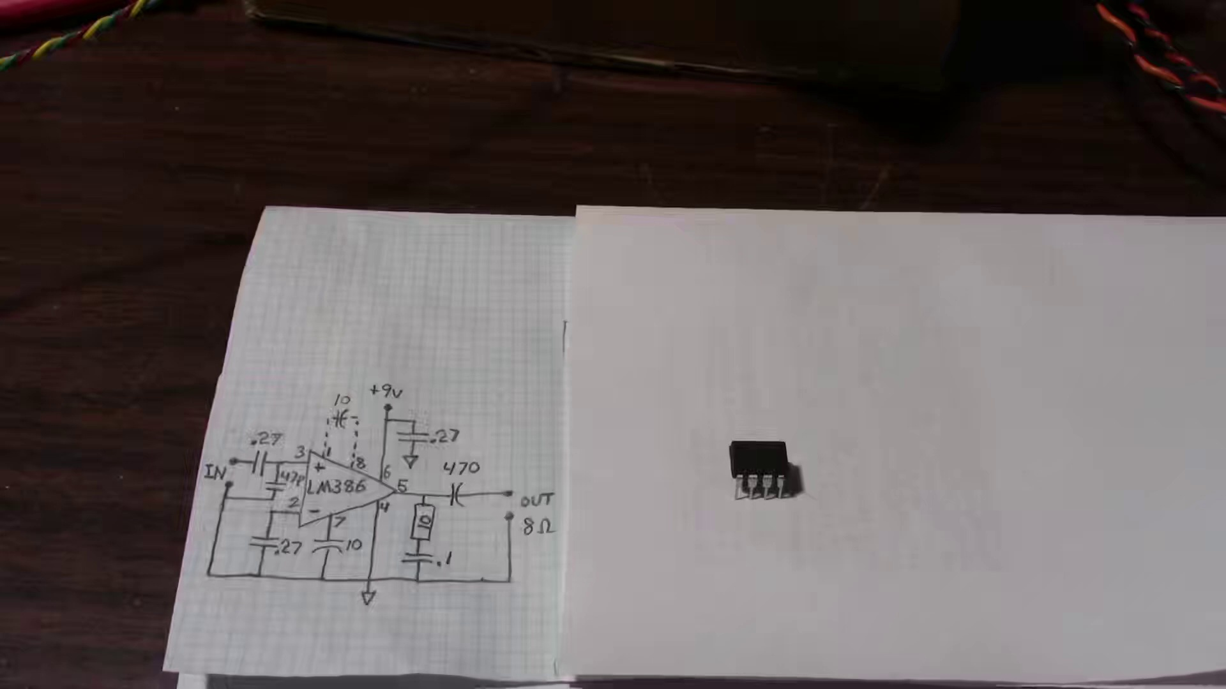 | 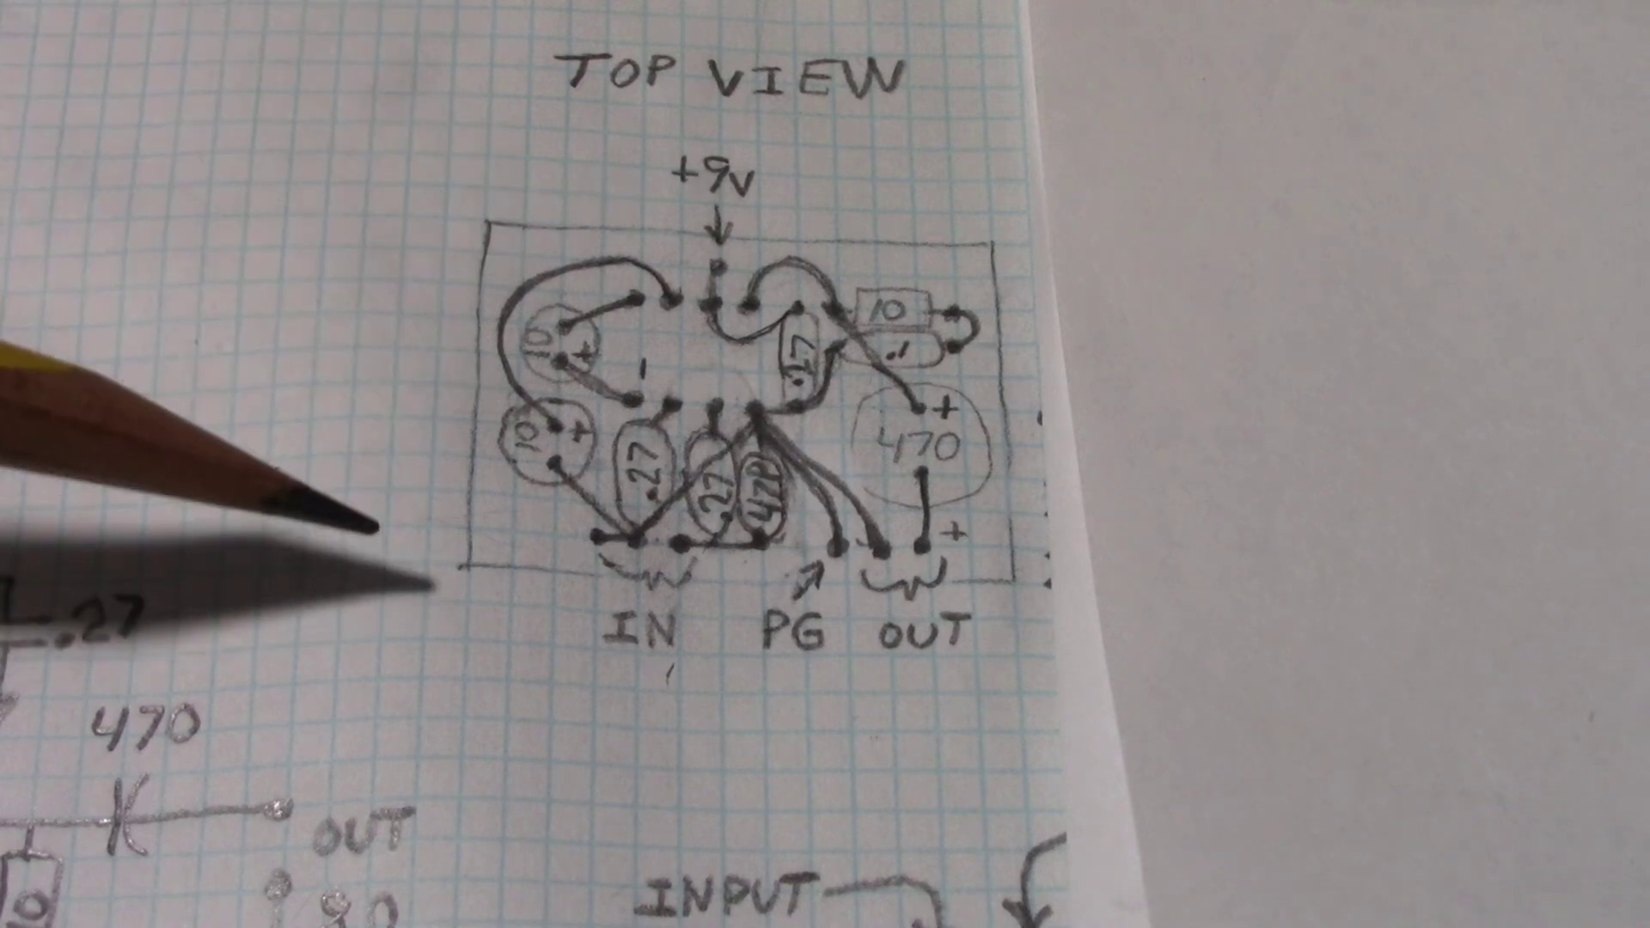 | 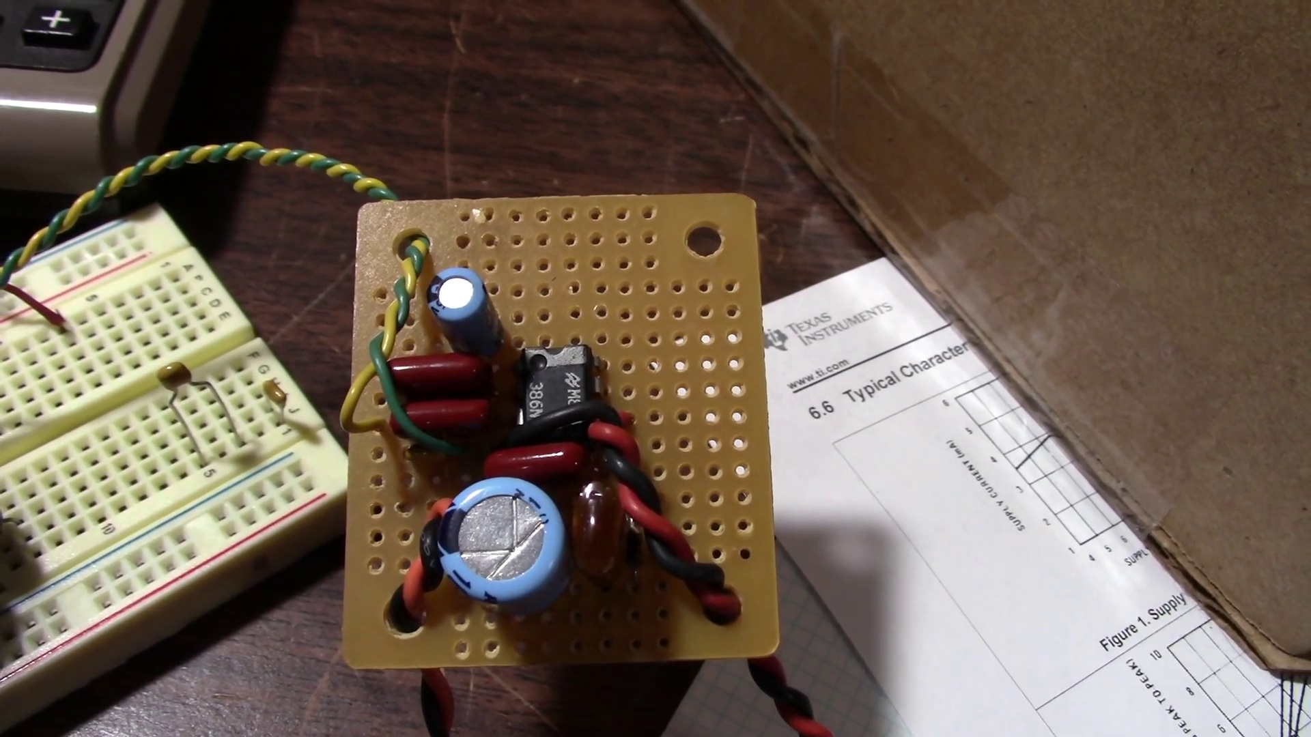
Topic T1: Amplifier Performance — score 95.0000
Description: The analyst tests the amplifier's performance, discussing its output power and distortion.
Reason: The comment directly discusses amplifier performance, specifically the testing and optimization of an LM386 audio amplifier circuit, which matches the topic description's focus on output power and distortion. The mention of potentiometers, power measurement, and avoiding clipping also strongly correlates with the topic.
 |  | 
Topic T3: Capacitor Effect — score 90.0000
Description: The analyst shows how using the capacitor from the inverting input to ground affects the amplifier's output and reduces clipping.
Reason: The comment details a step-by-step walkthrough of creating and optimizing the LM386 audio amplifier, which includes using a capacitor from the inverting input to ground to achieve a more symmetrical output. The topic description mentions reducing clipping by using this capacitor, and the comment explicitly discusses avoiding clipping and demonstrates adjustments to improve performance.
 |  | 
Topic T2: Board Quality — score 80.0000
Description: The analyst discusses how soldering a board directly instead of using a socket board improves the amplifier's performance.
Reason: The comment details a step-by-step walkthrough of creating and optimizing an audio amplifier circuit, which directly relates to the topic's description about soldering a board improving amplifier performance.
Least correlated topics:
 |  | 
Topic T2: Board Quality — score 80.0000
Description: The analyst discusses how soldering a board directly instead of using a socket board improves the amplifier's performance.
Reason: The comment details a step-by-step walkthrough of creating and optimizing an audio amplifier circuit, which directly relates to the topic's description about soldering a board improving amplifier performance.
 |  | 
Topic T3: Capacitor Effect — score 90.0000
Description: The analyst shows how using the capacitor from the inverting input to ground affects the amplifier's output and reduces clipping.
Reason: The comment details a step-by-step walkthrough of creating and optimizing the LM386 audio amplifier, which includes using a capacitor from the inverting input to ground to achieve a more symmetrical output. The topic description mentions reducing clipping by using this capacitor, and the comment explicitly discusses avoiding clipping and demonstrates adjustments to improve performance.
 |  | 
Topic T1: Amplifier Performance — score 95.0000
Description: The analyst tests the amplifier's performance, discussing its output power and distortion.
Reason: The comment directly discusses amplifier performance, specifically the testing and optimization of an LM386 audio amplifier circuit, which matches the topic description's focus on output power and distortion. The mention of potentiometers, power measurement, and avoiding clipping also strongly correlates with the topic.
- matched 1 topic(s), max score 80.0000: This video shows an LM386 audio amplifier to make it perform the best it can. When exploring options for which amplifier we wanted to use we watched this video to see if the LM386 was a viable option. In the video he shows the schematic, circuit layout, the build, testing, and all results. He doesn’t show the process of building the circuit so it’s a little hard to follow along. Shows sine wave output from the circuit and shows how different setups affect the wave. Explains how to get rid of clipping by adjusting the signal output and how including a capacitor can improve the amount of signal output you can have without clipping. I was surprised to see that the LM386 had little distortion output on the waveform. We decided against this as it's not as strong as other amplifier options.
Source: https://www.youtube.com/watch?v=P4GsoMTv-SY&t=105s: Make the PERFECT LM386 audio amplifier?
Top correlated topics:
 |  | 
Topic T1: Amplifier Performance — score 80.0000
Description: The analyst tests the amplifier's performance, discussing its output power and distortion.
Reason: The comment directly discusses the LM386 audio amplifier's performance, specifically its output power and distortion, as described in the topic. The comment also mentions testing and results, which aligns with the topic's focus on amplifier performance.
 |  | 
Topic T3: Capacitor Effect — score 20.0000
Description: The analyst shows how using the capacitor from the inverting input to ground affects the amplifier's output and reduces clipping.
Reason: The comment does mention the topic of reducing clipping and improving signal output by using a capacitor, but it's not directly discussing the same steps or objects as the topic. The comment is more focused on the LM386 amplifier and its capabilities, rather than specifically highlighting the effect of the capacitor.
 |  | 
Topic T2: Board Quality — score 20.0000
Description: The analyst discusses how soldering a board directly instead of using a socket board improves the amplifier's performance.
Reason: The comment mentions the LM386 audio amplifier and its performance, but does not specifically discuss soldering a board or socket boards, which are the key points of the topic. The comment is more focused on the amplifier's capabilities and limitations.
Least correlated topics:
 |  | 
Topic T2: Board Quality — score 20.0000
Description: The analyst discusses how soldering a board directly instead of using a socket board improves the amplifier's performance.
Reason: The comment mentions the LM386 audio amplifier and its performance, but does not specifically discuss soldering a board or socket boards, which are the key points of the topic. The comment is more focused on the amplifier's capabilities and limitations.
 |  | 
Topic T3: Capacitor Effect — score 20.0000
Description: The analyst shows how using the capacitor from the inverting input to ground affects the amplifier's output and reduces clipping.
Reason: The comment does mention the topic of reducing clipping and improving signal output by using a capacitor, but it's not directly discussing the same steps or objects as the topic. The comment is more focused on the LM386 amplifier and its capabilities, rather than specifically highlighting the effect of the capacitor.
 |  | 
Topic T1: Amplifier Performance — score 80.0000
Description: The analyst tests the amplifier's performance, discussing its output power and distortion.
Reason: The comment directly discusses the LM386 audio amplifier's performance, specifically its output power and distortion, as described in the topic. The comment also mentions testing and results, which aligns with the topic's focus on amplifier performance.
- matched 0 topic(s), max score 0.0000: Useful tips on minimizing noise in audio circuits, such as proper shielding and component placement, were covered to ensure high-quality audio output. What confused me: Some sections discussing how to eliminate electrical interference needed clearer, real-world examples, which made it hard to understand how to apply these tips. How I plan to use the electrical system in the future: Use noise reduction techniques in future projects to build high-fidelity audio amplifiers for better listening experiences.
Source: https://www.youtube.com/watch?v=P4GsoMTv-SY&t=105s: Make the PERFECT LM386 Audio Amplifier?
Top correlated topics:
 |  | 
Topic T3: Capacitor Effect — score 20.0000
Description: The analyst shows how using the capacitor from the inverting input to ground affects the amplifier's output and reduces clipping.
Reason: The topic discusses the capacitor effect on an amplifier's output and noise reduction techniques, while the comment talks about general audio circuit considerations, component placement, and noise elimination without specifically mentioning capacitors or amplifier clipping.
 |  | 
Topic T2: Board Quality — score 20.0000
Description: The analyst discusses how soldering a board directly instead of using a socket board improves the amplifier's performance.
Reason: The comment mentions audio circuits and noise reduction techniques, but does not directly discuss soldering a board or improving amplifier performance, which are the main points of the topic.
 |  | 
Topic T1: Amplifier Performance — score 20.0000
Description: The analyst tests the amplifier's performance, discussing its output power and distortion.
Reason: {
"correlated": false,
"score": 20,
"reason": "The comment discusses general tips on minimizing noise in audio circuits and its application to future projects, but does not directly discuss the amplifier's performance, output power, or distortion as described in the topic. The mention of high-fidelity audio amplifiers is also a generic term that does not specifically relate to the topic."
Least correlated topics:
 |  | 
Topic T1: Amplifier Performance — score 20.0000
Description: The analyst tests the amplifier's performance, discussing its output power and distortion.
Reason: {
"correlated": false,
"score": 20,
"reason": "The comment discusses general tips on minimizing noise in audio circuits and its application to future projects, but does not directly discuss the amplifier's performance, output power, or distortion as described in the topic. The mention of high-fidelity audio amplifiers is also a generic term that does not specifically relate to the topic."
 |  | 
Topic T2: Board Quality — score 20.0000
Description: The analyst discusses how soldering a board directly instead of using a socket board improves the amplifier's performance.
Reason: The comment mentions audio circuits and noise reduction techniques, but does not directly discuss soldering a board or improving amplifier performance, which are the main points of the topic.
 |  | 
Topic T3: Capacitor Effect — score 20.0000
Description: The analyst shows how using the capacitor from the inverting input to ground affects the amplifier's output and reduces clipping.
Reason: The topic discusses the capacitor effect on an amplifier's output and noise reduction techniques, while the comment talks about general audio circuit considerations, component placement, and noise elimination without specifically mentioning capacitors or amplifier clipping.
- matched 0 topic(s), max score 0.0000: This video went more in depth than the previous video into building an amplifier using the LM386. In this video the man used a 470 uF capacitor to protect the speaker. I wonder what is best.
Source: https://www.youtube.com/watch?v=P4GsoMTv-SY: Make the PERFECT LM386 audio amplifier?
Top correlated topics:
 |  | 
Topic T3: Capacitor Effect — score 20.0000
Description: The analyst shows how using the capacitor from the inverting input to ground affects the amplifier's output and reduces clipping.
Reason: The comment mentions a capacitor in the context of building an amplifier using LM386, but it doesn't directly discuss the topic's specific description about reducing clipping and affecting output. The mention is more general.
 |  | 
Topic T1: Amplifier Performance — score 20.0000
Description: The analyst tests the amplifier's performance, discussing its output power and distortion.
Reason: The comment discusses a specific amplifier build using the LM386, but does not directly discuss the topic's focus on amplifier performance (output power and distortion). The mention of a capacitor to protect the speaker is related, but not strongly correlated with the topic.
 |  | 
Topic T2: Board Quality — score 10.0000
Description: The analyst discusses how soldering a board directly instead of using a socket board improves the amplifier's performance.
Reason: The topic is about board quality, but the comment discusses amplifier building and capacitor selection, with no direct connection to the topic's description.
Least correlated topics:
 |  | 
Topic T2: Board Quality — score 10.0000
Description: The analyst discusses how soldering a board directly instead of using a socket board improves the amplifier's performance.
Reason: The topic is about board quality, but the comment discusses amplifier building and capacitor selection, with no direct connection to the topic's description.
 |  | 
Topic T1: Amplifier Performance — score 20.0000
Description: The analyst tests the amplifier's performance, discussing its output power and distortion.
Reason: The comment discusses a specific amplifier build using the LM386, but does not directly discuss the topic's focus on amplifier performance (output power and distortion). The mention of a capacitor to protect the speaker is related, but not strongly correlated with the topic.
 |  | 
Topic T3: Capacitor Effect — score 20.0000
Description: The analyst shows how using the capacitor from the inverting input to ground affects the amplifier's output and reduces clipping.
Reason: The comment mentions a capacitor in the context of building an amplifier using LM386, but it doesn't directly discuss the topic's specific description about reducing clipping and affecting output. The mention is more general.
- matched 0 topic(s), max score 0.0000: JohnAudioTech is a great channel that has a lot of helpful videos. This video was helpful in building our circuit for phase 1. In specific, the circuit build up along with the values of capacitors and resistors.
Source: https://www.youtube.com/watch?v=P4GsoMTv-SY: Make the PERFECT LM386 audio amplifier?
Top correlated topics:
 |  | 
Topic T3: Capacitor Effect — score 20.0000
Description: The analyst shows how using the capacitor from the inverting input to ground affects the amplifier's output and reduces clipping.
Reason: The comment mentions the helpfulness of the video and its impact on building a circuit, but does not directly discuss the capacitor effect or any specific details about the amplifier's output or clipping. The mention of capacitors and resistors is too general to be considered strongly related.
 |  | 
Topic T2: Board Quality — score 20.0000
Description: The analyst discusses how soldering a board directly instead of using a socket board improves the amplifier's performance.
Reason: The comment mentions circuit building and component values, but does not specifically discuss board quality or soldering, which are the main points of the topic. The mention of JohnAudioTech is also unrelated to the topic.
 |  | 
Topic T1: Amplifier Performance — score 20.0000
Description: The analyst tests the amplifier's performance, discussing its output power and distortion.
Reason: The comment mentions a circuit build and component values, but it's not directly discussing amplifier performance or output power/distortion, the topic's focus.
Least correlated topics:
 |  | 
Topic T1: Amplifier Performance — score 20.0000
Description: The analyst tests the amplifier's performance, discussing its output power and distortion.
Reason: The comment mentions a circuit build and component values, but it's not directly discussing amplifier performance or output power/distortion, the topic's focus.
 |  | 
Topic T2: Board Quality — score 20.0000
Description: The analyst discusses how soldering a board directly instead of using a socket board improves the amplifier's performance.
Reason: The comment mentions circuit building and component values, but does not specifically discuss board quality or soldering, which are the main points of the topic. The mention of JohnAudioTech is also unrelated to the topic.
 |  | 
Topic T3: Capacitor Effect — score 20.0000
Description: The analyst shows how using the capacitor from the inverting input to ground affects the amplifier's output and reduces clipping.
Reason: The comment mentions the helpfulness of the video and its impact on building a circuit, but does not directly discuss the capacitor effect or any specific details about the amplifier's output or clipping. The mention of capacitors and resistors is too general to be considered strongly related.

Topic T1: Amplifier Performance
 |  | 
Description: The analyst tests the amplifier's performance, discussing its output power and distortion.
Comment (score 95): The speaker details the construction and testing of a simple audio amplifier circuit using the LM386 IC. The speaker shows the audience the schematic design, circuit layout, and the integration of potentiometers. The building process, testing procedures, including power and distortion measurement, are also demonstrated in this video. The speaker emphasizes the significance of avoiding clipping in the amplifier output and demonstrated how adjustments can improve performance. Overall, the content covers a step-by-step walkthrough of creating and optimizing the LM386 audio amplifier. One key takeaway is the importance of incorporating a capacitor from the inverting input to ground, as opposed to shorting it, to achieve a more symmetrical output and maximize power efficiency in the circuit.
Reason: The comment directly discusses amplifier performance, specifically the testing and optimization of an LM386 audio amplifier circuit, which matches the topic description's focus on output power and distortion. The mention of potentiometers, power measurement, and avoiding clipping also strongly correlates with the topic.
Source: https://www.youtube.com/watch?v=P4GsoMTv-SY&t=105s: Make the PERFECT LM386 audio amplifier?
Comment (score 80): This video shows an LM386 audio amplifier to make it perform the best it can. When exploring options for which amplifier we wanted to use we watched this video to see if the LM386 was a viable option. In the video he shows the schematic, circuit layout, the build, testing, and all results. He doesn’t show the process of building the circuit so it’s a little hard to follow along. Shows sine wave output from the circuit and shows how different setups affect the wave. Explains how to get rid of clipping by adjusting the signal output and how including a capacitor can improve the amount of signal output you can have without clipping. I was surprised to see that the LM386 had little distortion output on the waveform. We decided against this as it's not as strong as other amplifier options.
Reason: The comment directly discusses the LM386 audio amplifier's performance, specifically its output power and distortion, as described in the topic. The comment also mentions testing and results, which aligns with the topic's focus on amplifier performance.
Source: https://www.youtube.com/watch?v=P4GsoMTv-SY&t=105s: Make the PERFECT LM386 audio amplifier?

Topic T2: Board Quality
 |  | 
Description: The analyst discusses how soldering a board directly instead of using a socket board improves the amplifier's performance.
Comment (score 80): The speaker details the construction and testing of a simple audio amplifier circuit using the LM386 IC. The speaker shows the audience the schematic design, circuit layout, and the integration of potentiometers. The building process, testing procedures, including power and distortion measurement, are also demonstrated in this video. The speaker emphasizes the significance of avoiding clipping in the amplifier output and demonstrated how adjustments can improve performance. Overall, the content covers a step-by-step walkthrough of creating and optimizing the LM386 audio amplifier. One key takeaway is the importance of incorporating a capacitor from the inverting input to ground, as opposed to shorting it, to achieve a more symmetrical output and maximize power efficiency in the circuit.
Reason: The comment details a step-by-step walkthrough of creating and optimizing an audio amplifier circuit, which directly relates to the topic's description about soldering a board improving amplifier performance.
Source: https://www.youtube.com/watch?v=P4GsoMTv-SY&t=105s: Make the PERFECT LM386 audio amplifier?

Topic T3: Capacitor Effect
 |  | 
Description: The analyst shows how using the capacitor from the inverting input to ground affects the amplifier's output and reduces clipping.
Comment (score 90): The speaker details the construction and testing of a simple audio amplifier circuit using the LM386 IC. The speaker shows the audience the schematic design, circuit layout, and the integration of potentiometers. The building process, testing procedures, including power and distortion measurement, are also demonstrated in this video. The speaker emphasizes the significance of avoiding clipping in the amplifier output and demonstrated how adjustments can improve performance. Overall, the content covers a step-by-step walkthrough of creating and optimizing the LM386 audio amplifier. One key takeaway is the importance of incorporating a capacitor from the inverting input to ground, as opposed to shorting it, to achieve a more symmetrical output and maximize power efficiency in the circuit.
Reason: The comment details a step-by-step walkthrough of creating and optimizing the LM386 audio amplifier, which includes using a capacitor from the inverting input to ground to achieve a more symmetrical output. The topic description mentions reducing clipping by using this capacitor, and the comment explicitly discusses avoiding clipping and demonstrates adjustments to improve performance.
Source: https://www.youtube.com/watch?v=P4GsoMTv-SY&t=105s: Make the PERFECT LM386 audio amplifier?

