Comment–Topic Correlation Report
Model: llama3

Summary
Topics processed: 5
Comments available for this video: 2
Comments correlated to ≥ 60: 2 (100.0%)
Total candidate pairs checked: 10

Most/Least correlated topics (by average score across correlated comments):
Top 3:
• Topic T1: Introduction — avg 90.00, contributions 1
• Topic T3: Step 2: Change Motor Spin Direction — avg 80.00, contributions 1
• Topic T2: Step 1: Verify Motor Spins — avg 80.00, contributions 1
Bottom 3:
• Topic T4: Step 3: Verify Motor Spins Again — avg 0.00, contributions 0
• Topic T5: Conclusion and Next Steps — avg 80.00, contributions 2
• Topic T2: Step 1: Verify Motor Spins — avg 80.00, contributions 1
Correlated comment coverage (all comments):
- matched 4 topic(s), max score 90.0000: This video talked about how to setup your quadcopter motors in Betaflight. We learned that setting up your motor is important, so the motor’s order and direction is correct. The first step in this process is to figure out the components you have. In this video, he used a ESC (Electronic Speed Controller) and FPV drone. The video showed us how to set the ESC protocol on Betaflight. The flight controller was connected to Betaflight. To find the protocol you need to go to the t-motors manufacturers website or manual. Something else that was learned was that you need to unplug your video transmitter and to remove your propellers while the battery is connected, or it could overheat.
Source: https://www.youtube.com/watch?v=PWyqVEkZGWk&t=35s: How to Set Up Motors (ESCs) in BetaFlight - ESC Protocol, Motor Order, Spin Direction, Reverse Props
Top correlated topics:
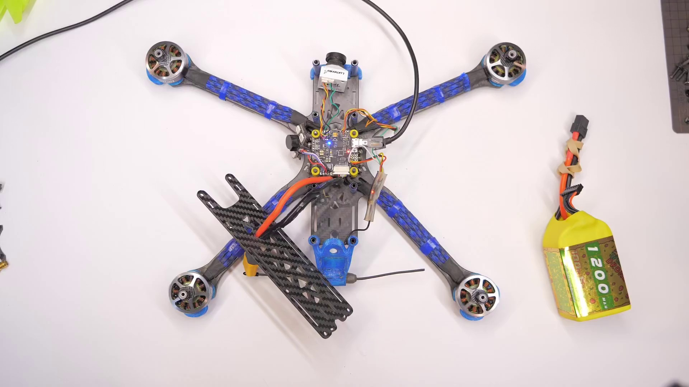 | 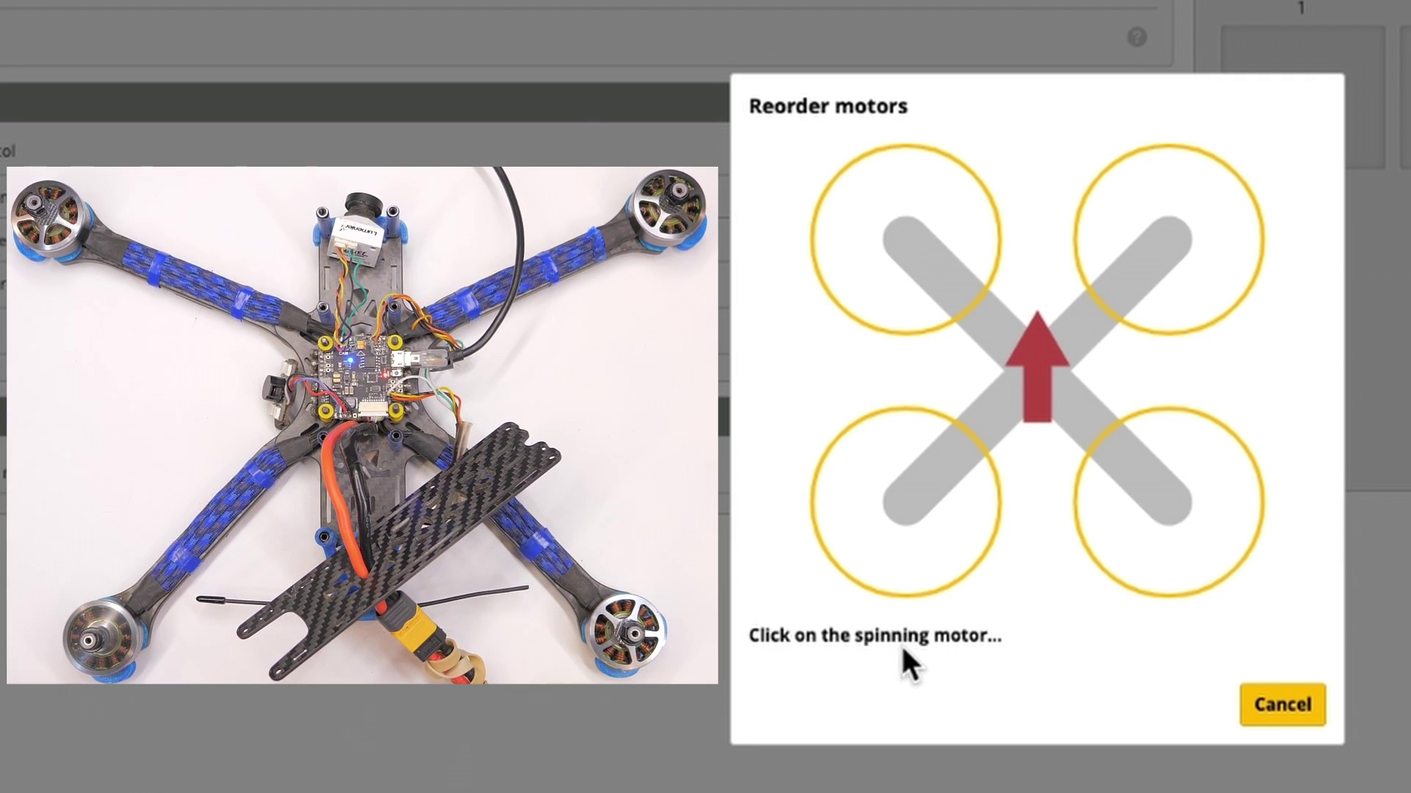 | 
Topic T1: Introduction — score 90.0000
Description: Initial setup and background information.
Reason: The comment directly discusses the same topic of setting up a quadcopter motor in Betaflight, mentioning specific components like ESC and FPV drone, as well as steps to set the ESC protocol on Betaflight, which closely aligns with the topic's description of 'initial setup and background information'.
 |  | 
Topic T5: Conclusion and Next Steps — score 80.0000
Description: Wrap-up of the video, with next steps for quadcopter setup and configuration.
Reason: The comment directly discusses the setup of a quadcopter's motors and configuration in Betaflight, which is strongly related to the topic title and description about setting up and configuring a quadcopter.
 |  | 
Topic T3: Step 2: Change Motor Spin Direction — score 80.0000
Description: Change the spin direction of each motor to match your desired setup.
Reason: The comment discusses setting up motor spin direction in Betaflight, which directly matches the topic's description of changing motor spin direction to match desired setup.
 |  | 
Topic T2: Step 1: Verify Motor Spins — score 80.0000
Description: Check if the motors are spinning in the correct direction.
Reason: The comment discusses setting up quadcopter motors in Betaflight, which directly relates to the topic of verifying motor spins. The mention of ESC protocol and t-motors manufacturers website also shows overlap with the topic description.
 |  | 
Topic T4: Step 3: Verify Motor Spins Again — score 20.0000
Description: Verify that all motors are spinning in the correct direction after changes.
Reason: The comment discusses motor setup and protocol settings on Betaflight, but does not directly verify that all motors are spinning in the correct direction after changes as described in the topic. Instead, it provides general information on setting up quadcopter motors and components.
Least correlated topics:
 |  | 
Topic T4: Step 3: Verify Motor Spins Again — score 20.0000
Description: Verify that all motors are spinning in the correct direction after changes.
Reason: The comment discusses motor setup and protocol settings on Betaflight, but does not directly verify that all motors are spinning in the correct direction after changes as described in the topic. Instead, it provides general information on setting up quadcopter motors and components.
 |  | 
Topic T2: Step 1: Verify Motor Spins — score 80.0000
Description: Check if the motors are spinning in the correct direction.
Reason: The comment discusses setting up quadcopter motors in Betaflight, which directly relates to the topic of verifying motor spins. The mention of ESC protocol and t-motors manufacturers website also shows overlap with the topic description.
 |  | 
Topic T3: Step 2: Change Motor Spin Direction — score 80.0000
Description: Change the spin direction of each motor to match your desired setup.
Reason: The comment discusses setting up motor spin direction in Betaflight, which directly matches the topic's description of changing motor spin direction to match desired setup.
 |  | 
Topic T5: Conclusion and Next Steps — score 80.0000
Description: Wrap-up of the video, with next steps for quadcopter setup and configuration.
Reason: The comment directly discusses the setup of a quadcopter's motors and configuration in Betaflight, which is strongly related to the topic title and description about setting up and configuring a quadcopter.
 |  | 
Topic T1: Introduction — score 90.0000
Description: Initial setup and background information.
Reason: The comment directly discusses the same topic of setting up a quadcopter motor in Betaflight, mentioning specific components like ESC and FPV drone, as well as steps to set the ESC protocol on Betaflight, which closely aligns with the topic's description of 'initial setup and background information'.
- matched 1 topic(s), max score 80.0000: I thought this could be helpful if we need help mapping the motors in the correct place on the drone.
Source: https://www.youtube.com/watch?v=PWyqVEkZGWk: How to Set Up Motors (ESCs) in BetaFlight - ESC Protocol, Motor Order, Spin Direction, Reverse Props
Top correlated topics:
 |  | 
Topic T5: Conclusion and Next Steps — score 80.0000
Description: Wrap-up of the video, with next steps for quadcopter setup and configuration.
Reason: The comment mentions 'motors' which are explicitly discussed in the topic description for quadcopter setup and configuration, indicating a strong connection to the topic.
 |  | 
Topic T4: Step 3: Verify Motor Spins Again — score 20.0000
Description: Verify that all motors are spinning in the correct direction after changes.
Reason: The comment doesn't directly discuss motor spins or verification, but mentions a potential application related to the topic.
 |  | 
Topic T3: Step 2: Change Motor Spin Direction — score 20.0000
Description: Change the spin direction of each motor to match your desired setup.
Reason: The comment is related to the topic but does not directly discuss changing motor spin direction. It mentions mapping motors on a drone, which is a different aspect of the topic.
 |  | 
Topic T2: Step 1: Verify Motor Spins — score 20.0000
Description: Check if the motors are spinning in the correct direction.
Reason: The comment mentions using the motor mapping technique to help with a different aspect of drone setup, not directly discussing the same steps or parameters mentioned in the topic.
 |  | 
Topic T1: Introduction — score 20.0000
Description: Initial setup and background information.
Reason: The comment mentions a specific scenario (mapping motors on a drone) that is not directly related to the topic's description of initial setup and background information.
Least correlated topics:
 |  | 
Topic T1: Introduction — score 20.0000
Description: Initial setup and background information.
Reason: The comment mentions a specific scenario (mapping motors on a drone) that is not directly related to the topic's description of initial setup and background information.
 |  | 
Topic T2: Step 1: Verify Motor Spins — score 20.0000
Description: Check if the motors are spinning in the correct direction.
Reason: The comment mentions using the motor mapping technique to help with a different aspect of drone setup, not directly discussing the same steps or parameters mentioned in the topic.
 |  | 
Topic T3: Step 2: Change Motor Spin Direction — score 20.0000
Description: Change the spin direction of each motor to match your desired setup.
Reason: The comment is related to the topic but does not directly discuss changing motor spin direction. It mentions mapping motors on a drone, which is a different aspect of the topic.
 |  | 
Topic T4: Step 3: Verify Motor Spins Again — score 20.0000
Description: Verify that all motors are spinning in the correct direction after changes.
Reason: The comment doesn't directly discuss motor spins or verification, but mentions a potential application related to the topic.
 |  | 
Topic T5: Conclusion and Next Steps — score 80.0000
Description: Wrap-up of the video, with next steps for quadcopter setup and configuration.
Reason: The comment mentions 'motors' which are explicitly discussed in the topic description for quadcopter setup and configuration, indicating a strong connection to the topic.

Topic T1: Introduction
 |  | 
Description: Initial setup and background information.
Comment (score 90): This video talked about how to setup your quadcopter motors in Betaflight. We learned that setting up your motor is important, so the motor’s order and direction is correct. The first step in this process is to figure out the components you have. In this video, he used a ESC (Electronic Speed Controller) and FPV drone. The video showed us how to set the ESC protocol on Betaflight. The flight controller was connected to Betaflight. To find the protocol you need to go to the t-motors manufacturers website or manual. Something else that was learned was that you need to unplug your video transmitter and to remove your propellers while the battery is connected, or it could overheat.
Reason: The comment directly discusses the same topic of setting up a quadcopter motor in Betaflight, mentioning specific components like ESC and FPV drone, as well as steps to set the ESC protocol on Betaflight, which closely aligns with the topic's description of 'initial setup and background information'.
Source: https://www.youtube.com/watch?v=PWyqVEkZGWk&t=35s: How to Set Up Motors (ESCs) in BetaFlight - ESC Protocol, Motor Order, Spin Direction, Reverse Props

Topic T2: Step 1: Verify Motor Spins
 |  | 
Description: Check if the motors are spinning in the correct direction.
Comment (score 80): This video talked about how to setup your quadcopter motors in Betaflight. We learned that setting up your motor is important, so the motor’s order and direction is correct. The first step in this process is to figure out the components you have. In this video, he used a ESC (Electronic Speed Controller) and FPV drone. The video showed us how to set the ESC protocol on Betaflight. The flight controller was connected to Betaflight. To find the protocol you need to go to the t-motors manufacturers website or manual. Something else that was learned was that you need to unplug your video transmitter and to remove your propellers while the battery is connected, or it could overheat.
Reason: The comment discusses setting up quadcopter motors in Betaflight, which directly relates to the topic of verifying motor spins. The mention of ESC protocol and t-motors manufacturers website also shows overlap with the topic description.
Source: https://www.youtube.com/watch?v=PWyqVEkZGWk&t=35s: How to Set Up Motors (ESCs) in BetaFlight - ESC Protocol, Motor Order, Spin Direction, Reverse Props

Topic T3: Step 2: Change Motor Spin Direction
 |  | 
Description: Change the spin direction of each motor to match your desired setup.
Comment (score 80): This video talked about how to setup your quadcopter motors in Betaflight. We learned that setting up your motor is important, so the motor’s order and direction is correct. The first step in this process is to figure out the components you have. In this video, he used a ESC (Electronic Speed Controller) and FPV drone. The video showed us how to set the ESC protocol on Betaflight. The flight controller was connected to Betaflight. To find the protocol you need to go to the t-motors manufacturers website or manual. Something else that was learned was that you need to unplug your video transmitter and to remove your propellers while the battery is connected, or it could overheat.
Reason: The comment discusses setting up motor spin direction in Betaflight, which directly matches the topic's description of changing motor spin direction to match desired setup.
Source: https://www.youtube.com/watch?v=PWyqVEkZGWk&t=35s: How to Set Up Motors (ESCs) in BetaFlight - ESC Protocol, Motor Order, Spin Direction, Reverse Props

Topic T4: Step 3: Verify Motor Spins Again
 |  | 
Description: Verify that all motors are spinning in the correct direction after changes.
No strongly correlated comments found for this topic.

Topic T5: Conclusion and Next Steps
 |  | 
Description: Wrap-up of the video, with next steps for quadcopter setup and configuration.
Comment (score 80): This video talked about how to setup your quadcopter motors in Betaflight. We learned that setting up your motor is important, so the motor’s order and direction is correct. The first step in this process is to figure out the components you have. In this video, he used a ESC (Electronic Speed Controller) and FPV drone. The video showed us how to set the ESC protocol on Betaflight. The flight controller was connected to Betaflight. To find the protocol you need to go to the t-motors manufacturers website or manual. Something else that was learned was that you need to unplug your video transmitter and to remove your propellers while the battery is connected, or it could overheat.
Reason: The comment directly discusses the setup of a quadcopter's motors and configuration in Betaflight, which is strongly related to the topic title and description about setting up and configuring a quadcopter.
Source: https://www.youtube.com/watch?v=PWyqVEkZGWk&t=35s: How to Set Up Motors (ESCs) in BetaFlight - ESC Protocol, Motor Order, Spin Direction, Reverse Props
Comment (score 80): I thought this could be helpful if we need help mapping the motors in the correct place on the drone.
Reason: The comment mentions 'motors' which are explicitly discussed in the topic description for quadcopter setup and configuration, indicating a strong connection to the topic.
Source: https://www.youtube.com/watch?v=PWyqVEkZGWk: How to Set Up Motors (ESCs) in BetaFlight - ESC Protocol, Motor Order, Spin Direction, Reverse Props

