Comment–Topic Correlation Report
Model: llama3

Summary
Topics processed: 1
Comments available for this video: 1
Comments correlated to ≥ 60: 0 (0.0%)
Total candidate pairs checked: 1

Most/Least correlated topics (by average score across correlated comments):
Top 3:
• Topic T1: Repetitive Statements — avg 0.00, contributions 0
Bottom 3:
• Topic T1: Repetitive Statements — avg 0.00, contributions 0
Correlated comment coverage (all comments):
- matched 0 topic(s), max score 0.0000: Demonstrates the TDA7496 amplifier with multiple soldering points.Limited explanation; not beginner-friendly.Still a useful reference for the final project.
Source: https://www.youtube.com/watch?v=PfFkm0Kgkn0: DIY Powerful Ultra Bass Amplifier, TDA7496
Top correlated topics:
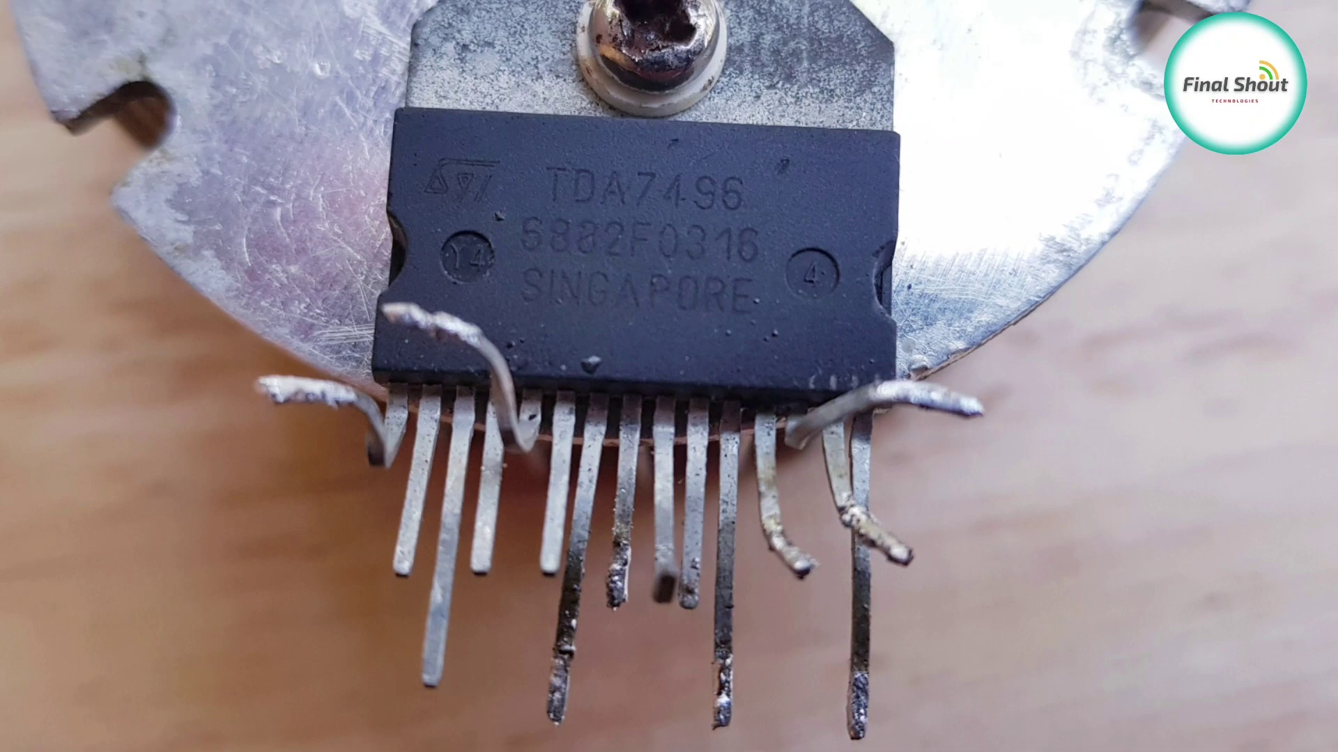 | 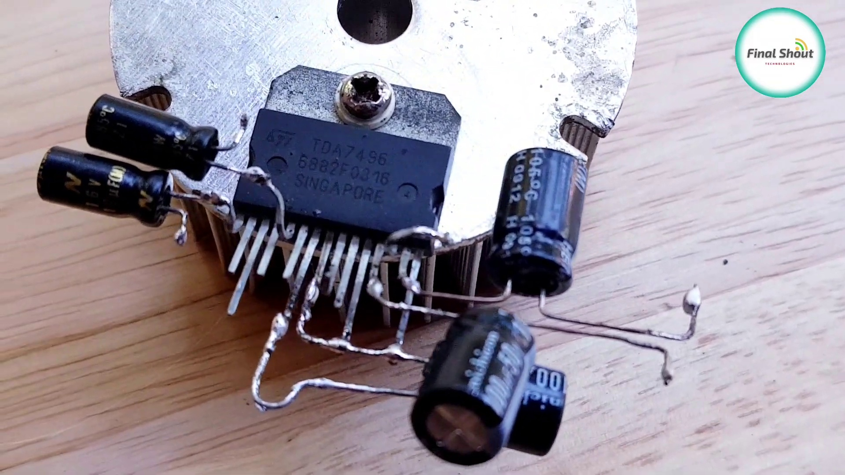 | 
Topic T1: Repetitive Statements — score 0.0000
Description: The speaker repeatedly says thank you without any clear purpose or context.
Reason: The topic is about repetitive statements in a speaker's speech, while the comment is about a different topic (amplifier demonstration) and doesn't mention anything about statements or speeches.
Least correlated topics:
 |  | 
Topic T1: Repetitive Statements — score 0.0000
Description: The speaker repeatedly says thank you without any clear purpose or context.
Reason: The topic is about repetitive statements in a speaker's speech, while the comment is about a different topic (amplifier demonstration) and doesn't mention anything about statements or speeches.

Topic T1: Repetitive Statements
 |  | 
Description: The speaker repeatedly says thank you without any clear purpose or context.
No strongly correlated comments found for this topic.

