Comment–Topic Correlation Report
Model: llama3

Summary
Topics processed: 1
Comments available for this video: 2
Comments correlated to ≥ 60: 0 (0.0%)
Total candidate pairs checked: 2

Most/Least correlated topics (by average score across correlated comments):
Top 3:
• Topic T1: Repetitive Thank You's — avg 0.00, contributions 0
Bottom 3:
• Topic T1: Repetitive Thank You's — avg 0.00, contributions 0
Correlated comment coverage (all comments):
- matched 0 topic(s), max score 0.0000: What I have learned from the video is How to convert a bridge rectifier diode into a powerful 220V inverter without external power.What confused me is That he does not show a circuit.How I plan to use the electrical system in the future is To go from low to higher voltage.
Source: https://www.youtube.com/watch?v=R2UqeJbK2yc: How to turn the BRIDGE DIODE into a powerful 220V INVERTER?
Top correlated topics:
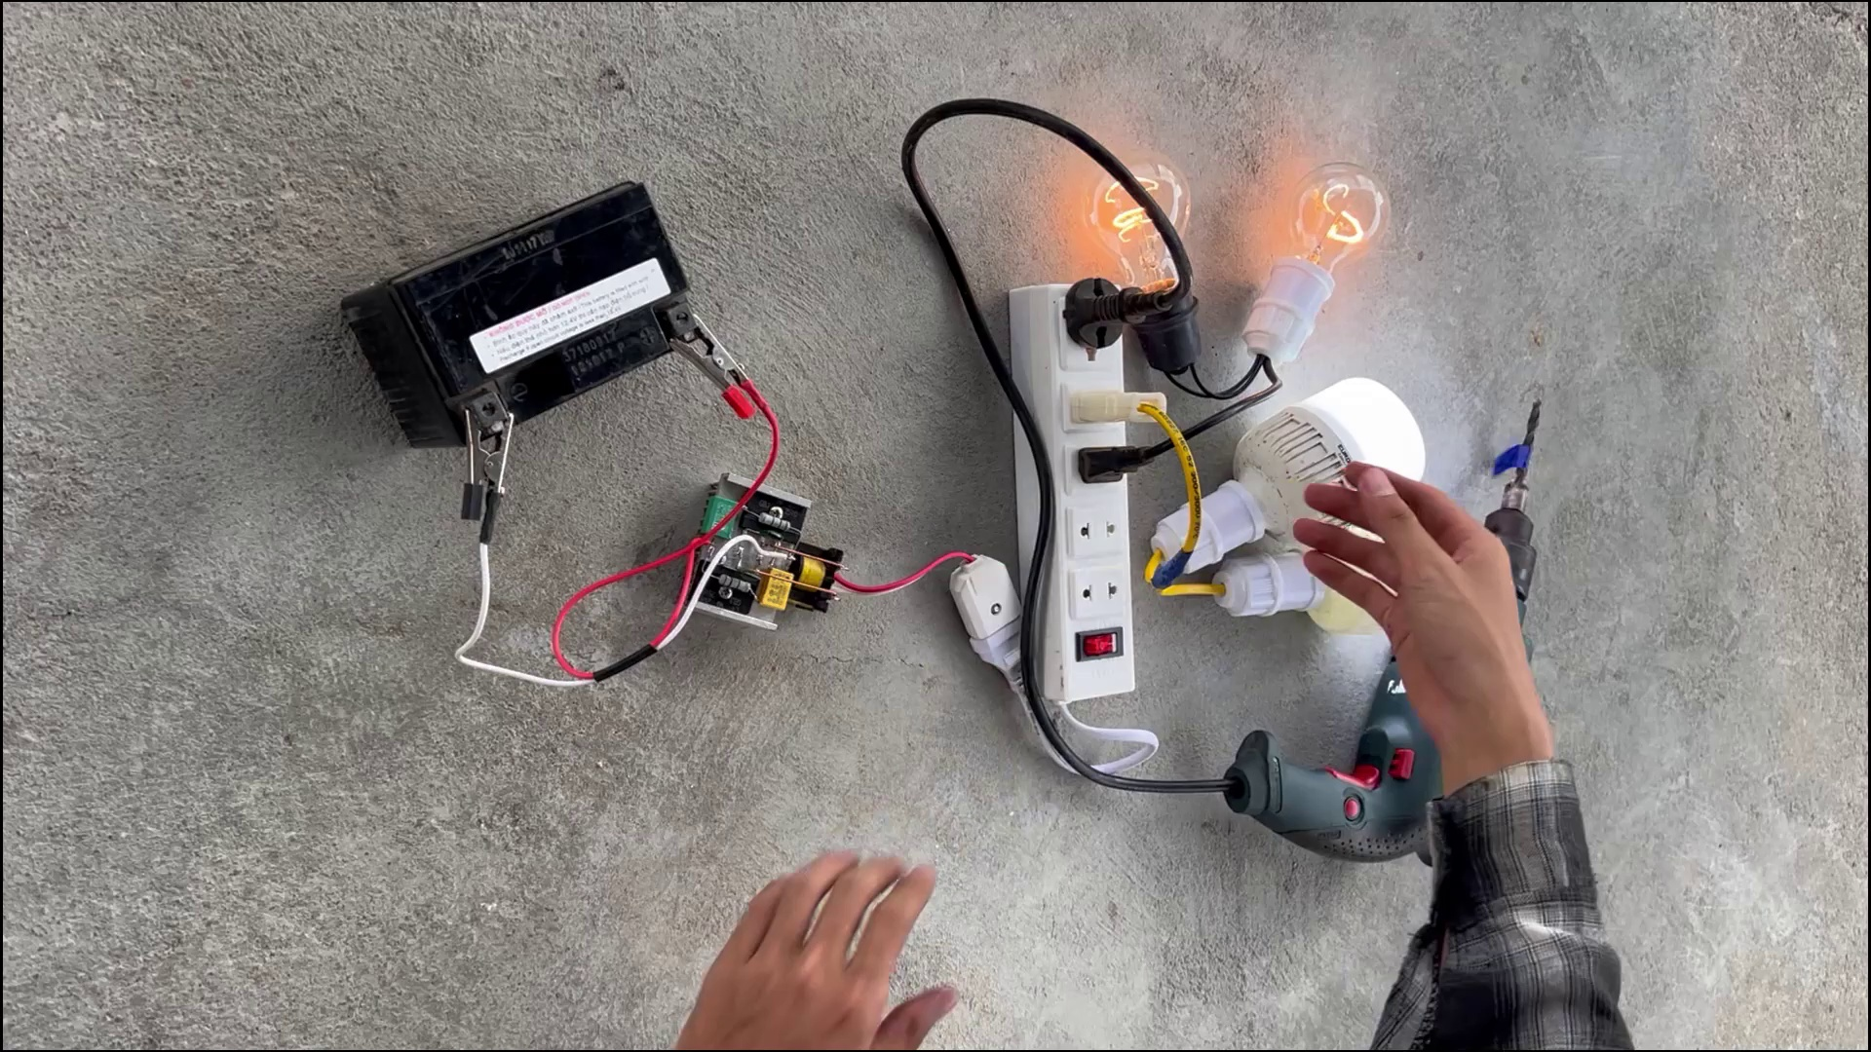 | 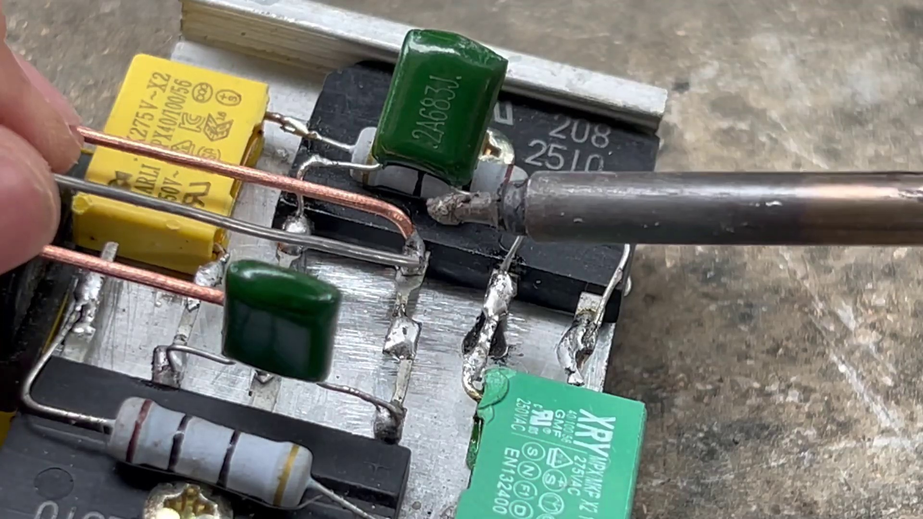 | 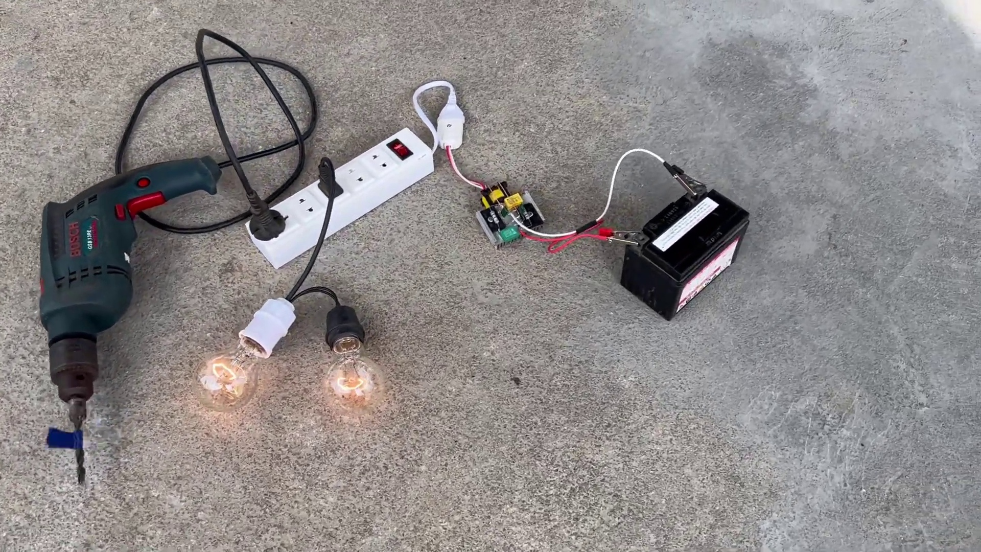
Topic T1: Repetitive Thank You's — score 0.0000
Description: The speaker repeatedly says 'Thank you' without any context or meaningful content.
Reason: The comment discusses circuit design and power conversion, which is unrelated to the topic of repetitive 'Thank you's without context or meaningful content.
Least correlated topics:
 |  | 
Topic T1: Repetitive Thank You's — score 0.0000
Description: The speaker repeatedly says 'Thank you' without any context or meaningful content.
Reason: The comment discusses circuit design and power conversion, which is unrelated to the topic of repetitive 'Thank you's without context or meaningful content.
- matched 0 topic(s), max score 0.0000: This video showed a creative method to create a portable power device capable of delivering high voltage using bridge diodes.I would like to know if there are real-world examples of similar setups.When boosting voltage, I will consider connecting bridge diodes in this configuration.
Source: https://www.youtube.com/watch?v=R2UqeJbK2yc: How to turn the BRIDGE DIODE into a powerful 220V INVERTER?
Top correlated topics:
 |  | 
Topic T1: Repetitive Thank You's — score 10.0000
Description: The speaker repeatedly says 'Thank you' without any context or meaningful content.
Reason: The comment discusses a technical topic unrelated to the repetitive 'Thank you's in the video title and description, focusing on bridge diodes and voltage boosting.
Least correlated topics:
 |  | 
Topic T1: Repetitive Thank You's — score 10.0000
Description: The speaker repeatedly says 'Thank you' without any context or meaningful content.
Reason: The comment discusses a technical topic unrelated to the repetitive 'Thank you's in the video title and description, focusing on bridge diodes and voltage boosting.

Topic T1: Repetitive Thank You's
 |  | 
Description: The speaker repeatedly says 'Thank you' without any context or meaningful content.
No strongly correlated comments found for this topic.

