Comment–Topic Correlation Report
Model: llama3

Summary
Topics processed: 6
Comments available for this video: 1
Comments correlated to ≥ 60: 1 (100.0%)
Total candidate pairs checked: 6

Most/Least correlated topics (by average score across correlated comments):
Top 3:
• Topic T1: Introduction to FPV — avg 90.00, contributions 1
• Topic T2: FPV Modes: Angle Mode — avg 90.00, contributions 1
• Topic T3: FPV Modes: Acro Mode — avg 80.00, contributions 1
Bottom 3:
• Topic T6: Conclusion and Next Steps — avg 0.00, contributions 0
• Topic T5: Flying in Acro Mode — avg 0.00, contributions 0
• Topic T4: Using FPV in Angle Mode — avg 0.00, contributions 0
Correlated comment coverage (all comments):
- matched 3 topic(s), max score 90.0000: In this video, a professional drone flyer discusses how to fly a drone. He introduces the basic flight controls of the sticks and how they correlate to roll, pitch, and yaw. He also discusses the different flight modes, what they mean, and how they function for the user. The main mode that was discussed was the angle mode, where the user inputs the control of the drone, but is easier for beginners because it does not allow the drone to do flips. Then he introduces acro-mode, which allows advanced users to do flips because the input controller has more of an effect on the rotation speed and angle of the drone. He suggests using online simulations beforehand to get comfortable with the precision of the throttle and stick control to prevent any damage to your drone when first starting out.
Source: https://www.youtube.com/watch?v=WoHjWZFTnpQ: How to Fly a FPV Drone: Complete Guide for Beginners!
Top correlated topics:
 | 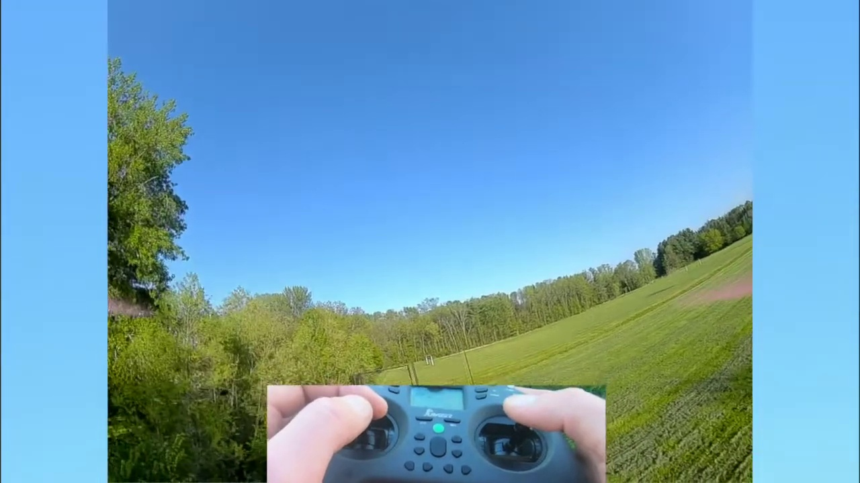 | 
Topic T2: FPV Modes: Angle Mode — score 90.0000
Description: Explaining angle mode and how to use it
Reason: The comment directly discusses the same topic of FPV angle mode, explaining its functionality and differences from other modes (acro-mode), which is in line with the topic description.
 |  | 
Topic T1: Introduction to FPV — score 90.0000
Description: Overview of FPV and its modes
Reason: The comment directly discusses the same topics described by the topic, including FPV flight modes (angle and acro) and their functions. The description of basic flight controls and online simulations also overlaps with the topic's overview of FPV.
 |  | 
Topic T4: Using FPV in Angle Mode — score 80.0000
Description: Tips and tricks for flying in angle mode
Reason: {
"correlated": true,
"score": 80,
"reason": "The comment directly discusses the same topic of flying a drone in angle mode, explaining its characteristics and differences with other flight modes. It also mentions related concepts like control inputs and precision, which are all covered in the topic 'Using FPV in Angle Mode'."
 |  | 
Topic T3: FPV Modes: Acro Mode — score 80.0000
Description: Explaining acro mode and how to use it
Reason: The comment discusses the specific flight mode 'acro-mode' and its characteristics (allowing flips), which aligns with the topic description's focus on explaining acro mode. The mention of flight controls, roll, pitch, and yaw also overlaps with the topic description's explanation.
 |  | 
Topic T6: Conclusion and Next Steps — score 20.0000
Description: Summary of the tutorial and suggestions for further learning
Reason: The topic is about conclusion and next steps, while the comment discusses drone flying techniques. Although the comment mentions online simulations as a suggestion for beginners, there are no direct connections to the topic's themes of conclusion and next steps.
 |  | 
Topic T5: Flying in Acro Mode — score 20.0000
Description: How to fly in acro mode and perform flips and turns
Reason: The topic is specific to flying in acro mode and performing flips/turns, while the comment discusses general drone flying concepts, including flight modes and controls. While it mentions acro-mode, the focus is on beginner-friendly aspects rather than advanced maneuvers.
Least correlated topics:
 |  | 
Topic T5: Flying in Acro Mode — score 20.0000
Description: How to fly in acro mode and perform flips and turns
Reason: The topic is specific to flying in acro mode and performing flips/turns, while the comment discusses general drone flying concepts, including flight modes and controls. While it mentions acro-mode, the focus is on beginner-friendly aspects rather than advanced maneuvers.
 |  | 
Topic T6: Conclusion and Next Steps — score 20.0000
Description: Summary of the tutorial and suggestions for further learning
Reason: The topic is about conclusion and next steps, while the comment discusses drone flying techniques. Although the comment mentions online simulations as a suggestion for beginners, there are no direct connections to the topic's themes of conclusion and next steps.
 |  | 
Topic T3: FPV Modes: Acro Mode — score 80.0000
Description: Explaining acro mode and how to use it
Reason: The comment discusses the specific flight mode 'acro-mode' and its characteristics (allowing flips), which aligns with the topic description's focus on explaining acro mode. The mention of flight controls, roll, pitch, and yaw also overlaps with the topic description's explanation.
 |  | 
Topic T4: Using FPV in Angle Mode — score 80.0000
Description: Tips and tricks for flying in angle mode
Reason: {
"correlated": true,
"score": 80,
"reason": "The comment directly discusses the same topic of flying a drone in angle mode, explaining its characteristics and differences with other flight modes. It also mentions related concepts like control inputs and precision, which are all covered in the topic 'Using FPV in Angle Mode'."
 |  | 
Topic T1: Introduction to FPV — score 90.0000
Description: Overview of FPV and its modes
Reason: The comment directly discusses the same topics described by the topic, including FPV flight modes (angle and acro) and their functions. The description of basic flight controls and online simulations also overlaps with the topic's overview of FPV.
 |  | 
Topic T2: FPV Modes: Angle Mode — score 90.0000
Description: Explaining angle mode and how to use it
Reason: The comment directly discusses the same topic of FPV angle mode, explaining its functionality and differences from other modes (acro-mode), which is in line with the topic description.

Topic T1: Introduction to FPV
 |  | 
Description: Overview of FPV and its modes
Comment (score 90): In this video, a professional drone flyer discusses how to fly a drone. He introduces the basic flight controls of the sticks and how they correlate to roll, pitch, and yaw. He also discusses the different flight modes, what they mean, and how they function for the user. The main mode that was discussed was the angle mode, where the user inputs the control of the drone, but is easier for beginners because it does not allow the drone to do flips. Then he introduces acro-mode, which allows advanced users to do flips because the input controller has more of an effect on the rotation speed and angle of the drone. He suggests using online simulations beforehand to get comfortable with the precision of the throttle and stick control to prevent any damage to your drone when first starting out.
Reason: The comment directly discusses the same topics described by the topic, including FPV flight modes (angle and acro) and their functions. The description of basic flight controls and online simulations also overlaps with the topic's overview of FPV.
Source: https://www.youtube.com/watch?v=WoHjWZFTnpQ: How to Fly a FPV Drone: Complete Guide for Beginners!

Topic T2: FPV Modes: Angle Mode
 |  | 
Description: Explaining angle mode and how to use it
Comment (score 90): In this video, a professional drone flyer discusses how to fly a drone. He introduces the basic flight controls of the sticks and how they correlate to roll, pitch, and yaw. He also discusses the different flight modes, what they mean, and how they function for the user. The main mode that was discussed was the angle mode, where the user inputs the control of the drone, but is easier for beginners because it does not allow the drone to do flips. Then he introduces acro-mode, which allows advanced users to do flips because the input controller has more of an effect on the rotation speed and angle of the drone. He suggests using online simulations beforehand to get comfortable with the precision of the throttle and stick control to prevent any damage to your drone when first starting out.
Reason: The comment directly discusses the same topic of FPV angle mode, explaining its functionality and differences from other modes (acro-mode), which is in line with the topic description.
Source: https://www.youtube.com/watch?v=WoHjWZFTnpQ: How to Fly a FPV Drone: Complete Guide for Beginners!

Topic T3: FPV Modes: Acro Mode
 |  | 
Description: Explaining acro mode and how to use it
Comment (score 80): In this video, a professional drone flyer discusses how to fly a drone. He introduces the basic flight controls of the sticks and how they correlate to roll, pitch, and yaw. He also discusses the different flight modes, what they mean, and how they function for the user. The main mode that was discussed was the angle mode, where the user inputs the control of the drone, but is easier for beginners because it does not allow the drone to do flips. Then he introduces acro-mode, which allows advanced users to do flips because the input controller has more of an effect on the rotation speed and angle of the drone. He suggests using online simulations beforehand to get comfortable with the precision of the throttle and stick control to prevent any damage to your drone when first starting out.
Reason: The comment discusses the specific flight mode 'acro-mode' and its characteristics (allowing flips), which aligns with the topic description's focus on explaining acro mode. The mention of flight controls, roll, pitch, and yaw also overlaps with the topic description's explanation.
Source: https://www.youtube.com/watch?v=WoHjWZFTnpQ: How to Fly a FPV Drone: Complete Guide for Beginners!

Topic T4: Using FPV in Angle Mode
 |  | 
Description: Tips and tricks for flying in angle mode
No strongly correlated comments found for this topic.

Topic T5: Flying in Acro Mode
 |  | 
Description: How to fly in acro mode and perform flips and turns
No strongly correlated comments found for this topic.

Topic T6: Conclusion and Next Steps
 |  | 
Description: Summary of the tutorial and suggestions for further learning
No strongly correlated comments found for this topic.

