Comment–Topic Correlation Report
Model: llama3

Summary
Topics processed: 8
Comments available for this video: 1
Comments correlated to ≥ 60: 1 (100.0%)
Total candidate pairs checked: 8

Most/Least correlated topics (by average score across correlated comments):
Top 3:
• Topic T5: Previewing the UI — avg 80.00, contributions 1
• Topic T1: Introduction — avg 80.00, contributions 1
• Topic T2: Configuring the Project — avg 80.00, contributions 1
Bottom 3:
• Topic T4: Generating Files — avg 0.00, contributions 0
• Topic T7: Sending and Receiving Data — avg 0.00, contributions 0
• Topic T6: Uploading the Project to the Display — avg 0.00, contributions 0
Correlated comment coverage (all comments):
- matched 5 topic(s), max score 80.0000: Smart home automation with ESP32 and a DWIN HMI Display can replace expensive systems and allow for full customization.Messing up the tech setup could be difficult to fix, which is a bit intimidating.could be adapted to create a smart classroom with automated controls for various devices.
Source: https://www.youtube.com/watch?v=WpE4mQegNLgESP32 : Smart Home Automation using DWIN HMI Display
Top correlated topics:
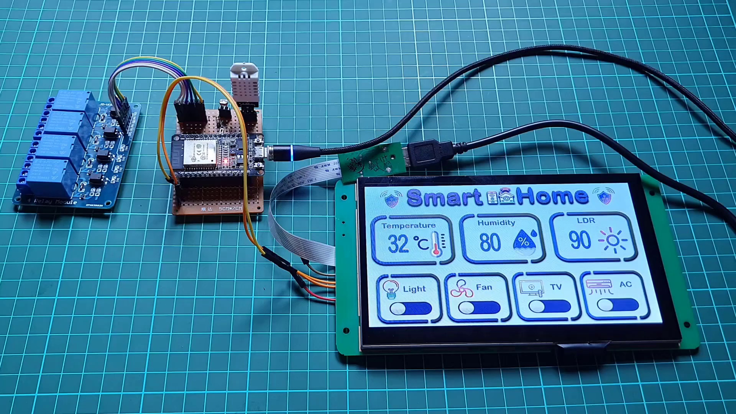 | 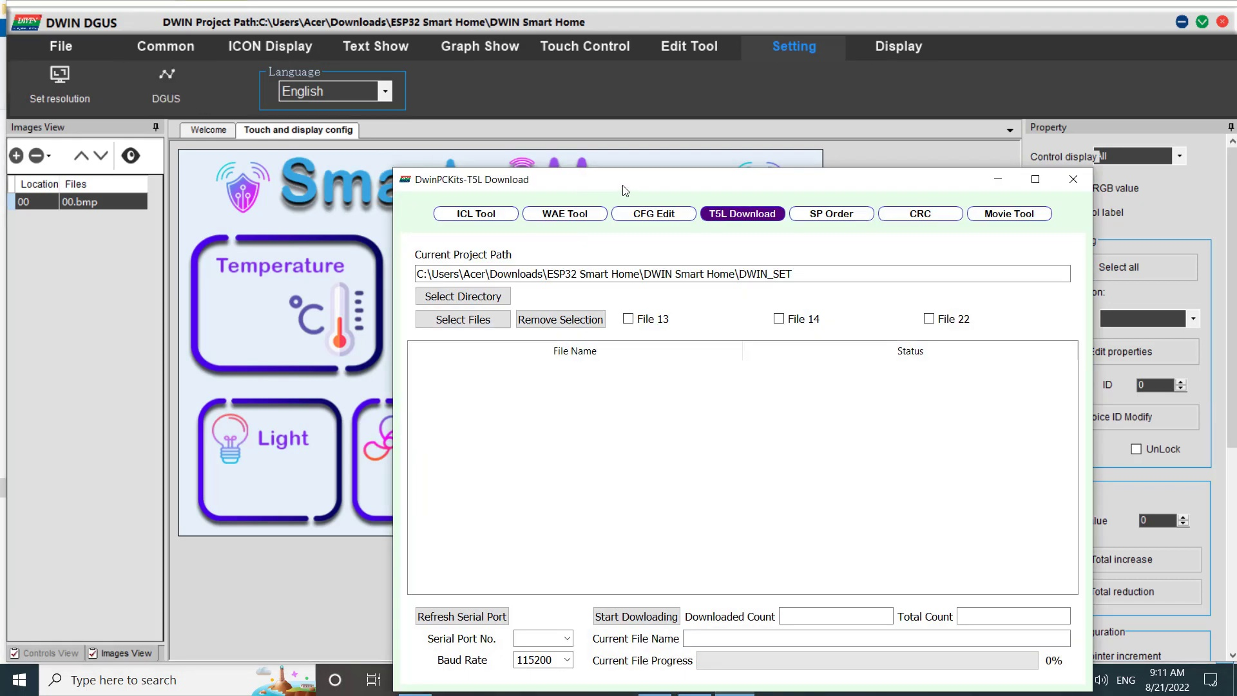 | 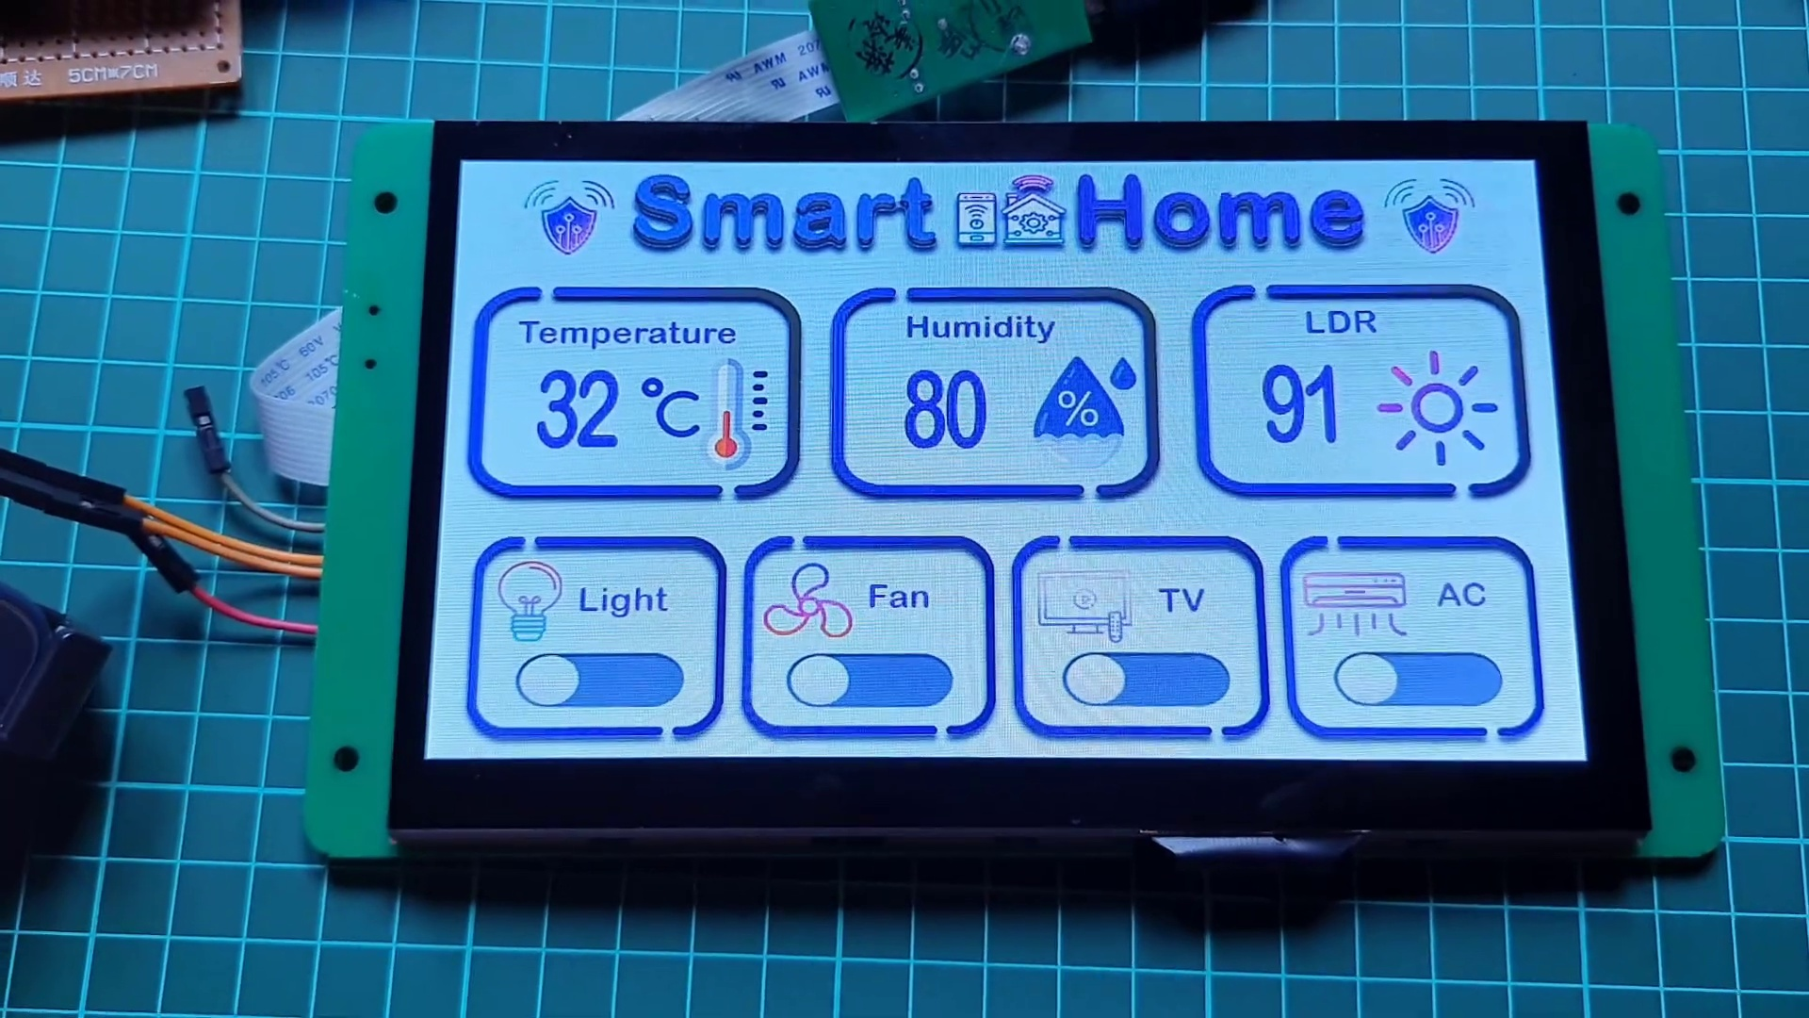
Topic T8: Conclusion and Next Steps — score 80.0000
Description: Summarizing the smart home controller project and encouraging viewers to like and subscribe.
Reason: The comment discusses the same project ('smart home controller') and technology (ESP32, DWIN HMI Display) mentioned in the topic, indicating a strong connection.
 |  | 
Topic T5: Previewing the UI — score 80.0000
Description: Showing the preview of the smart home UI on the Dwin HMI display.
Reason: The comment mentions the DWIN HMI Display, which is specifically mentioned in the topic description. Additionally, it discusses smart home automation and UI customization, which aligns with the 'previewing the UI' aspect of the topic.
 |  | 
Topic T3: Adding Modules — score 80.0000
Description: Creating modules for sensors and appliances using var icon module and increment adjustment module.
Reason: The comment mentions 'adding modules' and 'customization', which are key concepts related to the topic of creating modules for sensors and appliances. Although it's a more general discussion about smart home automation, the mention of specific technologies like ESP32 and DWIN HMI Display shows some overlap with the topic.
 |  | 
Topic T2: Configuring the Project — score 80.0000
Description: Explaining the necessary steps to create a smart home UI with Dwin HMI display and ESP32.
Reason: The comment mentions the same technologies (ESP32 and DWIN HMI Display) and use case (smart home automation) as described in the topic, with some overlap in the concept of customization.
 |  | 
Topic T1: Introduction — score 80.0000
Description: Getting started with Dwin HMI display and ESP32 project tutorial.
Reason: The comment discusses the same ESP32 and DWIN HMI Display project tutorial mentioned in the topic description, showing strong overlap in topics.
 |  | 
Topic T7: Sending and Receiving Data — score 20.0000
Description: Explaining how data is sent from the ESP32 web server to the Dwin HMI display and received back.
Reason: The topic discusses data transmission between ESP32 and DWIN HMI Display, while the comment is about smart home automation using those technologies. The topics don't overlap directly.
 |  | 
Topic T6: Uploading the Project to the Display — score 10.0000
Description: Explaining how to upload the project file to the Dwin HMI display using HD card and T5L download tool.
Reason: The comment discusses DWIN HMI Display in the context of smart home automation and smart classroom, but does not directly discuss uploading a project file to the display using an HD card and T5L download tool.
 |  | 
Topic T4: Generating Files — score 0.0000
Description: Saving the project as touch file, show file, and config bin files.
Reason: The topic is about generating files (touch, show, and config), while the comment discusses smart home automation and tech setup, with no overlap in topics.
Least correlated topics:
 |  | 
Topic T4: Generating Files — score 0.0000
Description: Saving the project as touch file, show file, and config bin files.
Reason: The topic is about generating files (touch, show, and config), while the comment discusses smart home automation and tech setup, with no overlap in topics.
 |  | 
Topic T6: Uploading the Project to the Display — score 10.0000
Description: Explaining how to upload the project file to the Dwin HMI display using HD card and T5L download tool.
Reason: The comment discusses DWIN HMI Display in the context of smart home automation and smart classroom, but does not directly discuss uploading a project file to the display using an HD card and T5L download tool.
 |  | 
Topic T7: Sending and Receiving Data — score 20.0000
Description: Explaining how data is sent from the ESP32 web server to the Dwin HMI display and received back.
Reason: The topic discusses data transmission between ESP32 and DWIN HMI Display, while the comment is about smart home automation using those technologies. The topics don't overlap directly.
 |  | 
Topic T1: Introduction — score 80.0000
Description: Getting started with Dwin HMI display and ESP32 project tutorial.
Reason: The comment discusses the same ESP32 and DWIN HMI Display project tutorial mentioned in the topic description, showing strong overlap in topics.
 |  | 
Topic T2: Configuring the Project — score 80.0000
Description: Explaining the necessary steps to create a smart home UI with Dwin HMI display and ESP32.
Reason: The comment mentions the same technologies (ESP32 and DWIN HMI Display) and use case (smart home automation) as described in the topic, with some overlap in the concept of customization.
 |  | 
Topic T3: Adding Modules — score 80.0000
Description: Creating modules for sensors and appliances using var icon module and increment adjustment module.
Reason: The comment mentions 'adding modules' and 'customization', which are key concepts related to the topic of creating modules for sensors and appliances. Although it's a more general discussion about smart home automation, the mention of specific technologies like ESP32 and DWIN HMI Display shows some overlap with the topic.
 |  | 
Topic T5: Previewing the UI — score 80.0000
Description: Showing the preview of the smart home UI on the Dwin HMI display.
Reason: The comment mentions the DWIN HMI Display, which is specifically mentioned in the topic description. Additionally, it discusses smart home automation and UI customization, which aligns with the 'previewing the UI' aspect of the topic.
 |  | 
Topic T8: Conclusion and Next Steps — score 80.0000
Description: Summarizing the smart home controller project and encouraging viewers to like and subscribe.
Reason: The comment discusses the same project ('smart home controller') and technology (ESP32, DWIN HMI Display) mentioned in the topic, indicating a strong connection.

Topic T1: Introduction
 |  | 
Description: Getting started with Dwin HMI display and ESP32 project tutorial.
Comment (score 80): Smart home automation with ESP32 and a DWIN HMI Display can replace expensive systems and allow for full customization.Messing up the tech setup could be difficult to fix, which is a bit intimidating.could be adapted to create a smart classroom with automated controls for various devices.
Reason: The comment discusses the same ESP32 and DWIN HMI Display project tutorial mentioned in the topic description, showing strong overlap in topics.
Source: https://www.youtube.com/watch?v=WpE4mQegNLgESP32 : Smart Home Automation using DWIN HMI Display

Topic T2: Configuring the Project
 |  | 
Description: Explaining the necessary steps to create a smart home UI with Dwin HMI display and ESP32.
Comment (score 80): Smart home automation with ESP32 and a DWIN HMI Display can replace expensive systems and allow for full customization.Messing up the tech setup could be difficult to fix, which is a bit intimidating.could be adapted to create a smart classroom with automated controls for various devices.
Reason: The comment mentions the same technologies (ESP32 and DWIN HMI Display) and use case (smart home automation) as described in the topic, with some overlap in the concept of customization.
Source: https://www.youtube.com/watch?v=WpE4mQegNLgESP32 : Smart Home Automation using DWIN HMI Display

Topic T3: Adding Modules
 |  | 
Description: Creating modules for sensors and appliances using var icon module and increment adjustment module.
Comment (score 80): Smart home automation with ESP32 and a DWIN HMI Display can replace expensive systems and allow for full customization.Messing up the tech setup could be difficult to fix, which is a bit intimidating.could be adapted to create a smart classroom with automated controls for various devices.
Reason: The comment mentions 'adding modules' and 'customization', which are key concepts related to the topic of creating modules for sensors and appliances. Although it's a more general discussion about smart home automation, the mention of specific technologies like ESP32 and DWIN HMI Display shows some overlap with the topic.
Source: https://www.youtube.com/watch?v=WpE4mQegNLgESP32 : Smart Home Automation using DWIN HMI Display

Topic T4: Generating Files
 |  | 
Description: Saving the project as touch file, show file, and config bin files.
No strongly correlated comments found for this topic.

Topic T5: Previewing the UI
 |  | 
Description: Showing the preview of the smart home UI on the Dwin HMI display.
Comment (score 80): Smart home automation with ESP32 and a DWIN HMI Display can replace expensive systems and allow for full customization.Messing up the tech setup could be difficult to fix, which is a bit intimidating.could be adapted to create a smart classroom with automated controls for various devices.
Reason: The comment mentions the DWIN HMI Display, which is specifically mentioned in the topic description. Additionally, it discusses smart home automation and UI customization, which aligns with the 'previewing the UI' aspect of the topic.
Source: https://www.youtube.com/watch?v=WpE4mQegNLgESP32 : Smart Home Automation using DWIN HMI Display

Topic T6: Uploading the Project to the Display
 |  | 
Description: Explaining how to upload the project file to the Dwin HMI display using HD card and T5L download tool.
No strongly correlated comments found for this topic.

Topic T7: Sending and Receiving Data
 |  | 
Description: Explaining how data is sent from the ESP32 web server to the Dwin HMI display and received back.
No strongly correlated comments found for this topic.

Topic T8: Conclusion and Next Steps
 |  | 
Description: Summarizing the smart home controller project and encouraging viewers to like and subscribe.
Comment (score 80): Smart home automation with ESP32 and a DWIN HMI Display can replace expensive systems and allow for full customization.Messing up the tech setup could be difficult to fix, which is a bit intimidating.could be adapted to create a smart classroom with automated controls for various devices.
Reason: The comment discusses the same project ('smart home controller') and technology (ESP32, DWIN HMI Display) mentioned in the topic, indicating a strong connection.
Source: https://www.youtube.com/watch?v=WpE4mQegNLgESP32 : Smart Home Automation using DWIN HMI Display

