Comment–Topic Correlation Report
Model: llama3

Summary
Topics processed: 3
Comments available for this video: 1
Comments correlated to ≥ 60: 1 (100.0%)
Total candidate pairs checked: 3

Most/Least correlated topics (by average score across correlated comments):
Top 3:
• Topic T2: Basic Aerobatics Techniques — avg 80.00, contributions 1
• Topic T3: Basic Loop Demonstration — avg 0.00, contributions 0
• Topic T1: Aerobatics Input Control — avg 0.00, contributions 0
Bottom 3:
• Topic T1: Aerobatics Input Control — avg 0.00, contributions 0
• Topic T3: Basic Loop Demonstration — avg 0.00, contributions 0
• Topic T2: Basic Aerobatics Techniques — avg 80.00, contributions 1
Correlated comment coverage (all comments):
- matched 1 topic(s), max score 80.0000: Because, umm, fun!Flips and rolls. Add throttle flip, drop throttle. Keeps motion more linear. Loops, add throttle pull back on the stick let off on the throttle. Fuuuun
Source: https://www.youtube.com/watch?v=YQ8ZhHBraZg : Basics of Drone Flight – Aerobatics
Top correlated topics:
 | 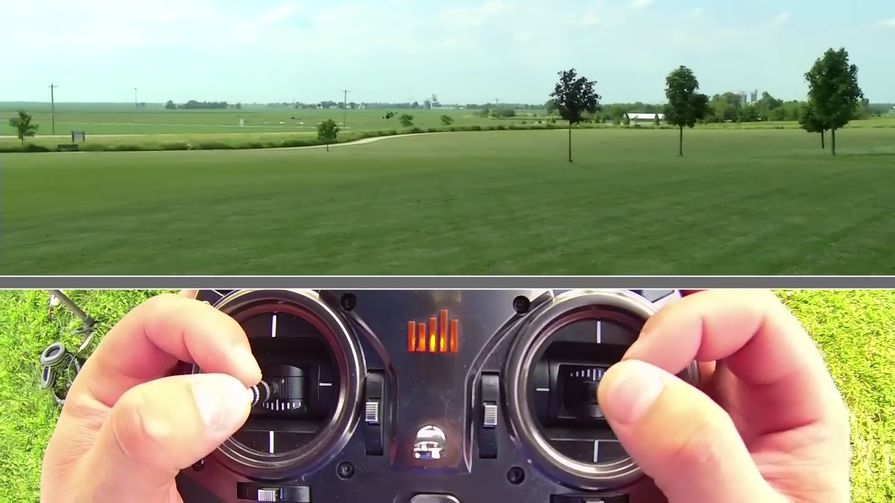 | 
Topic T2: Basic Aerobatics Techniques — score 80.0000
Description: The instructor demonstrates basic aerobatics techniques such as right and left rolls, flips, and stalls.
Reason: The comment specifically mentions aerobatics techniques like flips and rolls, which are mentioned in the topic description. It also uses phrases like 'Add throttle flip' and 'drop throttle' that align with the steps described in the topic.
 |  | 
Topic T3: Basic Loop Demonstration — score 20.0000
Description: The instructor demonstrates how to perform a basic loop, including adding throttle and pulling back.
Reason: The comment mentions 'loops' and 'add throttle pull back on the stick let off on the throttle', which shows some relation to the topic. However, the majority of the comment is focused on the excitement and fun aspects of flying, rather than specifically discussing the same steps, objects, settings, parameters, claims, or goals described by the topic.
 |  | 
Topic T1: Aerobatics Input Control — score 20.0000
Description: The instructor emphasizes the importance of controlling inputs while performing aerobatics to avoid aggressive snaps and maintain stability.
Reason: The comment mentions aerobatics and specific flight maneuvers (flips, rolls, loops), but does not directly discuss controlling inputs to avoid aggressive snaps and maintain stability, as described in the topic.
Least correlated topics:
 |  | 
Topic T1: Aerobatics Input Control — score 20.0000
Description: The instructor emphasizes the importance of controlling inputs while performing aerobatics to avoid aggressive snaps and maintain stability.
Reason: The comment mentions aerobatics and specific flight maneuvers (flips, rolls, loops), but does not directly discuss controlling inputs to avoid aggressive snaps and maintain stability, as described in the topic.
 |  | 
Topic T3: Basic Loop Demonstration — score 20.0000
Description: The instructor demonstrates how to perform a basic loop, including adding throttle and pulling back.
Reason: The comment mentions 'loops' and 'add throttle pull back on the stick let off on the throttle', which shows some relation to the topic. However, the majority of the comment is focused on the excitement and fun aspects of flying, rather than specifically discussing the same steps, objects, settings, parameters, claims, or goals described by the topic.
 |  | 
Topic T2: Basic Aerobatics Techniques — score 80.0000
Description: The instructor demonstrates basic aerobatics techniques such as right and left rolls, flips, and stalls.
Reason: The comment specifically mentions aerobatics techniques like flips and rolls, which are mentioned in the topic description. It also uses phrases like 'Add throttle flip' and 'drop throttle' that align with the steps described in the topic.

Topic T1: Aerobatics Input Control
 |  | 
Description: The instructor emphasizes the importance of controlling inputs while performing aerobatics to avoid aggressive snaps and maintain stability.
No strongly correlated comments found for this topic.

Topic T2: Basic Aerobatics Techniques
 |  | 
Description: The instructor demonstrates basic aerobatics techniques such as right and left rolls, flips, and stalls.
Comment (score 80): Because, umm, fun!Flips and rolls. Add throttle flip, drop throttle. Keeps motion more linear. Loops, add throttle pull back on the stick let off on the throttle. Fuuuun
Reason: The comment specifically mentions aerobatics techniques like flips and rolls, which are mentioned in the topic description. It also uses phrases like 'Add throttle flip' and 'drop throttle' that align with the steps described in the topic.
Source: https://www.youtube.com/watch?v=YQ8ZhHBraZg : Basics of Drone Flight – Aerobatics

Topic T3: Basic Loop Demonstration
 |  | 
Description: The instructor demonstrates how to perform a basic loop, including adding throttle and pulling back.
No strongly correlated comments found for this topic.

