Comment–Topic Correlation Report
Model: llama3

Summary
Topics processed: 6
Comments available for this video: 1
Comments correlated to ≥ 60: 1 (100.0%)
Total candidate pairs checked: 6

Most/Least correlated topics (by average score across correlated comments):
Top 3:
• Topic T6: Conclusion and Best Practices — avg 90.00, contributions 1
• Topic T5: Testing the GPS Rescue Feature — avg 80.00, contributions 1
• Topic T4: OSD Elements Configuration — avg 0.00, contributions 0
Bottom 3:
• Topic T3: Calibrating the Gyro Board — avg 0.00, contributions 0
• Topic T2: Configuring the GPS Unit — avg 0.00, contributions 0
• Topic T1: Introduction to GPS Rescue Feature — avg 0.00, contributions 0
Correlated comment coverage (all comments):
- matched 2 topic(s), max score 90.0000: Rank 5, In my study of the instructional video, I have deepened my comprehension of GPS technology's integral role in enhancing the operational efficacy of quadcopters, particularly for long-range and recovery applications. The detailed exposition of the GPS rescue feature, a failsafe mechanism that autonomously guides the drone back to a predefined home point upon control signal loss, was particularly instructive. The video, supported by Vaunt, also provided practical insights into selecting cost-efficient GPS modules like the HLRC M80 and their integration with the drone's flight controller. It included a meticulous step-by-step guide for setting up and configuring GPS in Betaflight, ensuring optimal performance through correct wiring and voltage supply. Additionally, the tutorial covered advanced settings such as failsafe parameters and on- screen display elements, reinforcing the importance of thorough testing protocols for safe drone operation. This knowledge is directly applicable to the second phase of our drone project, where incorporating such advanced navigational features could be a significant enhancement.
Source: https://www.youtube.com/watch?v=YQeOmeMGpvE : “Betaflight GPS Rescue Mode - All You Need To Know”
Top correlated topics:
 | 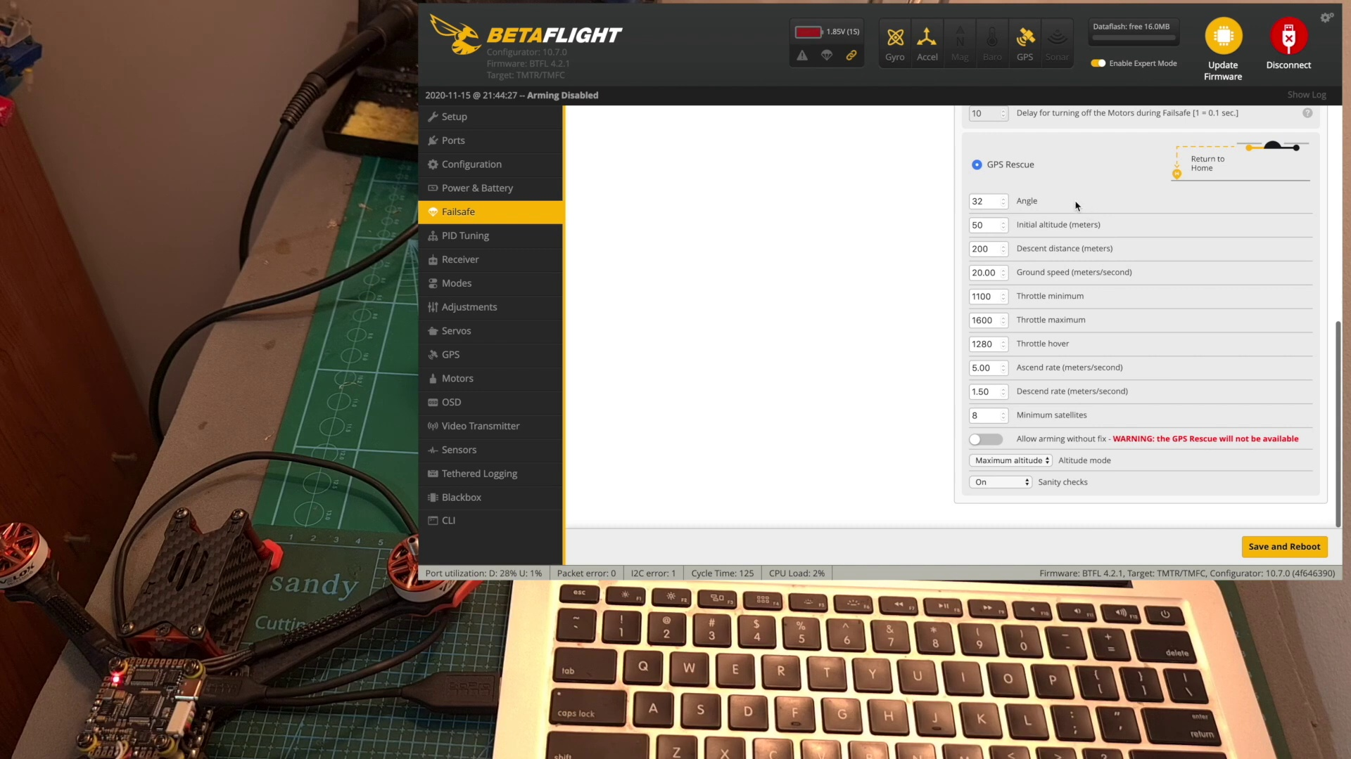 | 
Topic T6: Conclusion and Best Practices — score 90.0000
Description: Summary of the video and best practices for configuring and testing the GPS rescue feature.
Reason: The comment directly discusses the same steps (setting up and configuring GPS in Betaflight) and settings (failsafe parameters and on-screen display elements) described by the topic. It also mentions specific objects (GPS modules like the HLRC M80), which reinforces the strong correlation.
 |  | 
Topic T1: Introduction to GPS Rescue Feature — score 90.0000
Description: Overview of the GPS rescue feature in Betaflight and its importance.
Reason: {
"correlated": true,
"score": 90,
"reason": "The comment directly discusses the GPS rescue feature, its integral role in quadcopter operation, and its configuration in Betaflight, aligning with the topic's title and description. The mention of specific settings (e.g., failsafe parameters) and modules (e.g., HLRC M80) further strengthens the correlation."
 |  | 
Topic T4: OSD Elements Configuration — score 85.0000
Description: How to configure OSD elements such as home distance, direction, and GPS coordinates.
Reason: {
"correlated": true,
"score": 85,
"reason": "The comment directly discusses GPS technology, home point configuration, and setting up GPS in Betaflight, which are all key elements mentioned in the topic description. The specific examples of GPS modules and flight controllers also demonstrate a strong understanding of the topic's concepts."
 |  | 
Topic T5: Testing the GPS Rescue Feature — score 80.0000
Description: Steps to test the GPS rescue feature using an auxiliary switch.
Reason: The comment directly discusses the GPS rescue feature, its settings and parameters, and even mentions specific GPS modules and their integration with a flight controller, showing strong relevance to the topic's focus on testing the GPS rescue feature.
 |  | 
Topic T3: Calibrating the Gyro Board — score 20.0000
Description: Importance of calibrating the gyro board for accurate attitude values.
Reason: The comment discusses GPS technology and quadcopters, but the topic is about calibrating the gyro board. Although it mentions GPS modules and settings, there's no direct discussion of gyroscope calibration or its importance for attitude values.
 |  | 
Topic T2: Configuring the GPS Unit — score 20.0000
Description: How to configure the GPS unit for the first time and power it using the USB port.
Reason: The comment discusses GPS technology and its applications in drone operation, but does not directly relate to configuring the GPS unit for the first time and powering it using a USB port. The topic description mentions configuration and power supply, which are not addressed in the comment.
Least correlated topics:
 |  | 
Topic T2: Configuring the GPS Unit — score 20.0000
Description: How to configure the GPS unit for the first time and power it using the USB port.
Reason: The comment discusses GPS technology and its applications in drone operation, but does not directly relate to configuring the GPS unit for the first time and powering it using a USB port. The topic description mentions configuration and power supply, which are not addressed in the comment.
 |  | 
Topic T3: Calibrating the Gyro Board — score 20.0000
Description: Importance of calibrating the gyro board for accurate attitude values.
Reason: The comment discusses GPS technology and quadcopters, but the topic is about calibrating the gyro board. Although it mentions GPS modules and settings, there's no direct discussion of gyroscope calibration or its importance for attitude values.
 |  | 
Topic T5: Testing the GPS Rescue Feature — score 80.0000
Description: Steps to test the GPS rescue feature using an auxiliary switch.
Reason: The comment directly discusses the GPS rescue feature, its settings and parameters, and even mentions specific GPS modules and their integration with a flight controller, showing strong relevance to the topic's focus on testing the GPS rescue feature.
 |  | 
Topic T4: OSD Elements Configuration — score 85.0000
Description: How to configure OSD elements such as home distance, direction, and GPS coordinates.
Reason: {
"correlated": true,
"score": 85,
"reason": "The comment directly discusses GPS technology, home point configuration, and setting up GPS in Betaflight, which are all key elements mentioned in the topic description. The specific examples of GPS modules and flight controllers also demonstrate a strong understanding of the topic's concepts."
 |  | 
Topic T1: Introduction to GPS Rescue Feature — score 90.0000
Description: Overview of the GPS rescue feature in Betaflight and its importance.
Reason: {
"correlated": true,
"score": 90,
"reason": "The comment directly discusses the GPS rescue feature, its integral role in quadcopter operation, and its configuration in Betaflight, aligning with the topic's title and description. The mention of specific settings (e.g., failsafe parameters) and modules (e.g., HLRC M80) further strengthens the correlation."
 |  | 
Topic T6: Conclusion and Best Practices — score 90.0000
Description: Summary of the video and best practices for configuring and testing the GPS rescue feature.
Reason: The comment directly discusses the same steps (setting up and configuring GPS in Betaflight) and settings (failsafe parameters and on-screen display elements) described by the topic. It also mentions specific objects (GPS modules like the HLRC M80), which reinforces the strong correlation.

Topic T1: Introduction to GPS Rescue Feature
 |  | 
Description: Overview of the GPS rescue feature in Betaflight and its importance.
No strongly correlated comments found for this topic.

Topic T2: Configuring the GPS Unit
 |  | 
Description: How to configure the GPS unit for the first time and power it using the USB port.
No strongly correlated comments found for this topic.

Topic T3: Calibrating the Gyro Board
 |  | 
Description: Importance of calibrating the gyro board for accurate attitude values.
No strongly correlated comments found for this topic.

Topic T4: OSD Elements Configuration
 |  | 
Description: How to configure OSD elements such as home distance, direction, and GPS coordinates.
No strongly correlated comments found for this topic.

Topic T5: Testing the GPS Rescue Feature
 |  | 
Description: Steps to test the GPS rescue feature using an auxiliary switch.
Comment (score 80): Rank 5, In my study of the instructional video, I have deepened my comprehension of GPS technology's integral role in enhancing the operational efficacy of quadcopters, particularly for long-range and recovery applications. The detailed exposition of the GPS rescue feature, a failsafe mechanism that autonomously guides the drone back to a predefined home point upon control signal loss, was particularly instructive. The video, supported by Vaunt, also provided practical insights into selecting cost-efficient GPS modules like the HLRC M80 and their integration with the drone's flight controller. It included a meticulous step-by-step guide for setting up and configuring GPS in Betaflight, ensuring optimal performance through correct wiring and voltage supply. Additionally, the tutorial covered advanced settings such as failsafe parameters and on- screen display elements, reinforcing the importance of thorough testing protocols for safe drone operation. This knowledge is directly applicable to the second phase of our drone project, where incorporating such advanced navigational features could be a significant enhancement.
Reason: The comment directly discusses the GPS rescue feature, its settings and parameters, and even mentions specific GPS modules and their integration with a flight controller, showing strong relevance to the topic's focus on testing the GPS rescue feature.
Source: https://www.youtube.com/watch?v=YQeOmeMGpvE : “Betaflight GPS Rescue Mode - All You Need To Know”

Topic T6: Conclusion and Best Practices
 |  | 
Description: Summary of the video and best practices for configuring and testing the GPS rescue feature.
Comment (score 90): Rank 5, In my study of the instructional video, I have deepened my comprehension of GPS technology's integral role in enhancing the operational efficacy of quadcopters, particularly for long-range and recovery applications. The detailed exposition of the GPS rescue feature, a failsafe mechanism that autonomously guides the drone back to a predefined home point upon control signal loss, was particularly instructive. The video, supported by Vaunt, also provided practical insights into selecting cost-efficient GPS modules like the HLRC M80 and their integration with the drone's flight controller. It included a meticulous step-by-step guide for setting up and configuring GPS in Betaflight, ensuring optimal performance through correct wiring and voltage supply. Additionally, the tutorial covered advanced settings such as failsafe parameters and on- screen display elements, reinforcing the importance of thorough testing protocols for safe drone operation. This knowledge is directly applicable to the second phase of our drone project, where incorporating such advanced navigational features could be a significant enhancement.
Reason: The comment directly discusses the same steps (setting up and configuring GPS in Betaflight) and settings (failsafe parameters and on-screen display elements) described by the topic. It also mentions specific objects (GPS modules like the HLRC M80), which reinforces the strong correlation.
Source: https://www.youtube.com/watch?v=YQeOmeMGpvE : “Betaflight GPS Rescue Mode - All You Need To Know”

