Comment–Topic Correlation Report
Model: llama3

Summary
Topics processed: 5
Comments available for this video: 2
Comments correlated to ≥ 60: 2 (100.0%)
Total candidate pairs checked: 10

Most/Least correlated topics (by average score across correlated comments):
Top 3:
• Topic T2: Building the First Circuit — avg 90.00, contributions 1
• Topic T1: Introduction — avg 85.00, contributions 2
• Topic T4: Adding Bass Control — avg 85.00, contributions 1
Bottom 3:
• Topic T3: Adding a Gain Control and Volume Control — avg 80.00, contributions 1
• Topic T5: Conclusion and Future Plans — avg 80.00, contributions 2
• Topic T4: Adding Bass Control — avg 85.00, contributions 1
Correlated comment coverage (all comments):
- matched 5 topic(s), max score 90.0000: It explains how to modify the LM386 circuit to enhance low-frequency sounds, giving richer bass output. This includes adjusting component values to improve bass response. The video touched on the feedback loop in the amplifier circuit, which affects the overall sound quality, but the technical details were hard to grasp. How I plan to use the electrical system in the future: Implement bass boost features in custom audio devices to improve sound quality, especially for music that relies heavily on bass.
Source: https://www.youtube.com/watch?v=ZOuZWE_tfgQ&t=96s: LM386 BASS BOOST
Top correlated topics:
 | 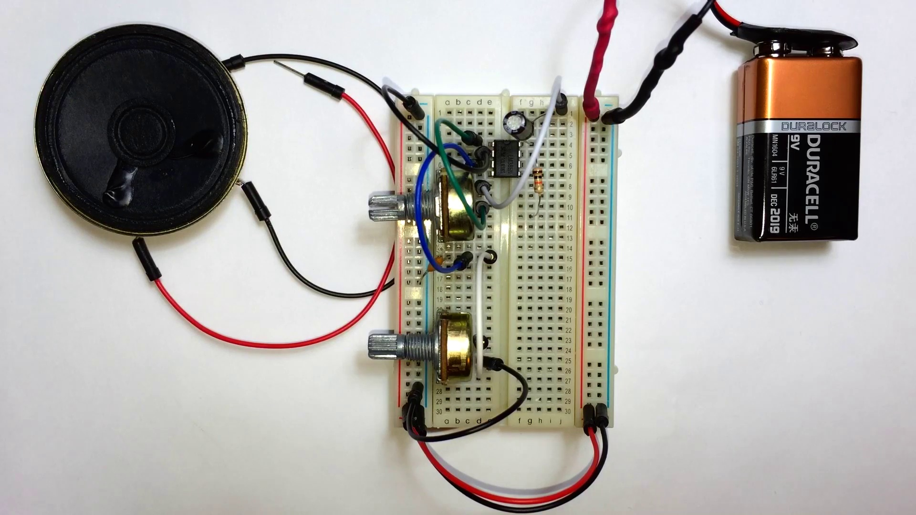 | 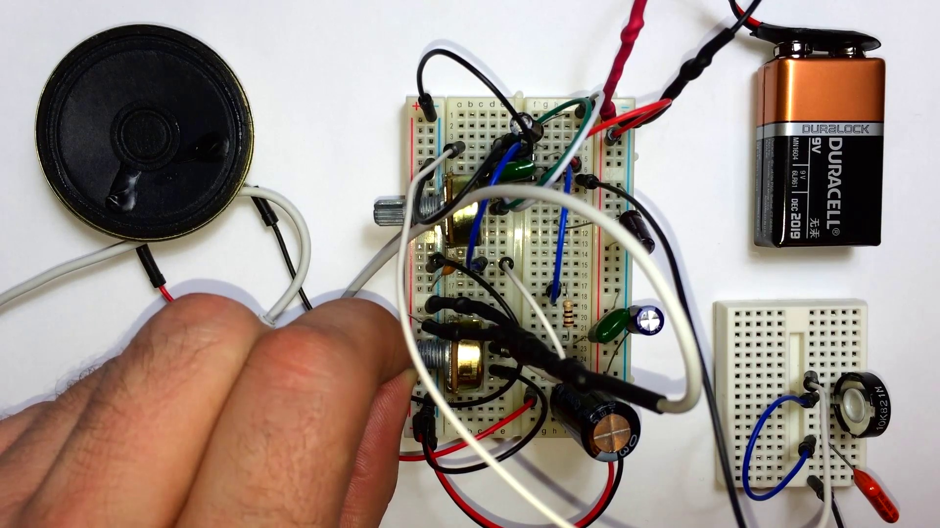
Topic T2: Building the First Circuit — score 90.0000
Description: Building the first simple audio circuit
Reason: The comment directly discusses the same technical details and component values mentioned in the topic description, specifically modifying the LM386 circuit to enhance low-frequency sounds and adjusting component values for bass response. The mention of the feedback loop and its impact on sound quality also aligns with the topic.
 |  | 
Topic T1: Introduction — score 90.0000
Description: Introduction to the audio circuit
Reason: The comment directly discusses the audio circuit and its modification to enhance low-frequency sounds, which is strongly related to the topic's introduction to the audio circuit. The mention of adjusting component values and implementing bass boost features in custom devices also overlaps with the topic's description.
 |  | 
Topic T4: Adding Bass Control — score 85.0000
Description: Adding bass control to the circuit
Reason: The comment directly discusses adding bass control to the LM386 circuit, adjusting component values for better bass response, and implementing bass boost features in custom audio devices. These specifics align with the topic's goal of enhancing low-frequency sounds.
 |  | 
Topic T5: Conclusion and Future Plans — score 80.0000
Description: Conclusion of the video and future plans for more audio circuits
Reason: The comment discusses modifying the LM386 circuit to enhance low-frequency sounds and adjusting component values for bass response, which directly relates to the topic's description of future plans for more audio circuits. The mention of implementing bass boost features in custom devices also aligns with the topic's focus on enhancing sound quality.
 |  | 
Topic T3: Adding a Gain Control and Volume Control — score 80.0000
Description: Adding gain control and volume control to the circuit
Reason: The comment discusses modifying the LM386 circuit to enhance low-frequency sounds and adjusting component values for better bass response, which aligns with the topic's description of adding gain control and volume control.
Least correlated topics:
 |  | 
Topic T3: Adding a Gain Control and Volume Control — score 80.0000
Description: Adding gain control and volume control to the circuit
Reason: The comment discusses modifying the LM386 circuit to enhance low-frequency sounds and adjusting component values for better bass response, which aligns with the topic's description of adding gain control and volume control.
 |  | 
Topic T5: Conclusion and Future Plans — score 80.0000
Description: Conclusion of the video and future plans for more audio circuits
Reason: The comment discusses modifying the LM386 circuit to enhance low-frequency sounds and adjusting component values for bass response, which directly relates to the topic's description of future plans for more audio circuits. The mention of implementing bass boost features in custom devices also aligns with the topic's focus on enhancing sound quality.
 |  | 
Topic T4: Adding Bass Control — score 85.0000
Description: Adding bass control to the circuit
Reason: The comment directly discusses adding bass control to the LM386 circuit, adjusting component values for better bass response, and implementing bass boost features in custom audio devices. These specifics align with the topic's goal of enhancing low-frequency sounds.
 |  | 
Topic T1: Introduction — score 90.0000
Description: Introduction to the audio circuit
Reason: The comment directly discusses the audio circuit and its modification to enhance low-frequency sounds, which is strongly related to the topic's introduction to the audio circuit. The mention of adjusting component values and implementing bass boost features in custom devices also overlaps with the topic's description.
 |  | 
Topic T2: Building the First Circuit — score 90.0000
Description: Building the first simple audio circuit
Reason: The comment directly discusses the same technical details and component values mentioned in the topic description, specifically modifying the LM386 circuit to enhance low-frequency sounds and adjusting component values for bass response. The mention of the feedback loop and its impact on sound quality also aligns with the topic.
- matched 2 topic(s), max score 80.0000: How to build a much better sounding amplifier by adding multiple decoupling capacitors to the power supply.What confused me is the potentiometer.How I plan to use the electrical system in the future is To make a better speaker.
Source: https://www.youtube.com/watch?v=ZOuZWE_tfgQ&t=94s: Make a Great Sounding LM386 Audio Amplifier with Bass Boost
Top correlated topics:
 |  | 
Topic T5: Conclusion and Future Plans — score 80.0000
Description: Conclusion of the video and future plans for more audio circuits
Reason: The comment discusses the future plans of building a better amplifier, which is directly related to the topic's description of planning for more audio circuits. Although it doesn't specifically mention 'conclusion', the context implies that the speaker is wrapping up their thoughts on improving an existing circuit.
 |  | 
Topic T1: Introduction — score 80.0000
Description: Introduction to the audio circuit
Reason: The comment directly discusses the topic's description of an 'audio circuit' and mentions specific components like decoupling capacitors and a potentiometer, which are relevant to building a better sounding amplifier. The comment also shows interest in using the electrical system for a speaker, aligning with the topic's focus on introducing audio circuits.
 |  | 
Topic T4: Adding Bass Control — score 20.0000
Description: Adding bass control to the circuit
Reason: The topic discusses adding bass control to the circuit, but the comment talks about amplifier design and speaker improvement. While it mentions power supply and electrical system, the connection is not strong enough to demonstrate direct correlation with the topic.
 |  | 
Topic T3: Adding a Gain Control and Volume Control — score 20.0000
Description: Adding gain control and volume control to the circuit
Reason: The comment discusses building an amplifier and adding decoupling capacitors to the power supply, which is unrelated to the topic of adding gain control and volume control. The only slight overlap is the mention of a potentiometer, but it's not directly related to the topic.
 |  | 
Topic T2: Building the First Circuit — score 20.0000
Description: Building the first simple audio circuit
Reason: The comment mentions amplifiers and decoupling capacitors, but does not directly discuss building the first circuit or audio system. The topic is about building a simple circuit, while the comment focuses on amplifier design and future plans.
Least correlated topics:
 |  | 
Topic T2: Building the First Circuit — score 20.0000
Description: Building the first simple audio circuit
Reason: The comment mentions amplifiers and decoupling capacitors, but does not directly discuss building the first circuit or audio system. The topic is about building a simple circuit, while the comment focuses on amplifier design and future plans.
 |  | 
Topic T3: Adding a Gain Control and Volume Control — score 20.0000
Description: Adding gain control and volume control to the circuit
Reason: The comment discusses building an amplifier and adding decoupling capacitors to the power supply, which is unrelated to the topic of adding gain control and volume control. The only slight overlap is the mention of a potentiometer, but it's not directly related to the topic.
 |  | 
Topic T4: Adding Bass Control — score 20.0000
Description: Adding bass control to the circuit
Reason: The topic discusses adding bass control to the circuit, but the comment talks about amplifier design and speaker improvement. While it mentions power supply and electrical system, the connection is not strong enough to demonstrate direct correlation with the topic.
 |  | 
Topic T1: Introduction — score 80.0000
Description: Introduction to the audio circuit
Reason: The comment directly discusses the topic's description of an 'audio circuit' and mentions specific components like decoupling capacitors and a potentiometer, which are relevant to building a better sounding amplifier. The comment also shows interest in using the electrical system for a speaker, aligning with the topic's focus on introducing audio circuits.
 |  | 
Topic T5: Conclusion and Future Plans — score 80.0000
Description: Conclusion of the video and future plans for more audio circuits
Reason: The comment discusses the future plans of building a better amplifier, which is directly related to the topic's description of planning for more audio circuits. Although it doesn't specifically mention 'conclusion', the context implies that the speaker is wrapping up their thoughts on improving an existing circuit.

Topic T1: Introduction
 |  | 
Description: Introduction to the audio circuit
Comment (score 90): It explains how to modify the LM386 circuit to enhance low-frequency sounds, giving richer bass output. This includes adjusting component values to improve bass response. The video touched on the feedback loop in the amplifier circuit, which affects the overall sound quality, but the technical details were hard to grasp. How I plan to use the electrical system in the future: Implement bass boost features in custom audio devices to improve sound quality, especially for music that relies heavily on bass.
Reason: The comment directly discusses the audio circuit and its modification to enhance low-frequency sounds, which is strongly related to the topic's introduction to the audio circuit. The mention of adjusting component values and implementing bass boost features in custom devices also overlaps with the topic's description.
Source: https://www.youtube.com/watch?v=ZOuZWE_tfgQ&t=96s: LM386 BASS BOOST
Comment (score 80): How to build a much better sounding amplifier by adding multiple decoupling capacitors to the power supply.What confused me is the potentiometer.How I plan to use the electrical system in the future is To make a better speaker.
Reason: The comment directly discusses the topic's description of an 'audio circuit' and mentions specific components like decoupling capacitors and a potentiometer, which are relevant to building a better sounding amplifier. The comment also shows interest in using the electrical system for a speaker, aligning with the topic's focus on introducing audio circuits.
Source: https://www.youtube.com/watch?v=ZOuZWE_tfgQ&t=94s: Make a Great Sounding LM386 Audio Amplifier with Bass Boost

Topic T2: Building the First Circuit
 |  | 
Description: Building the first simple audio circuit
Comment (score 90): It explains how to modify the LM386 circuit to enhance low-frequency sounds, giving richer bass output. This includes adjusting component values to improve bass response. The video touched on the feedback loop in the amplifier circuit, which affects the overall sound quality, but the technical details were hard to grasp. How I plan to use the electrical system in the future: Implement bass boost features in custom audio devices to improve sound quality, especially for music that relies heavily on bass.
Reason: The comment directly discusses the same technical details and component values mentioned in the topic description, specifically modifying the LM386 circuit to enhance low-frequency sounds and adjusting component values for bass response. The mention of the feedback loop and its impact on sound quality also aligns with the topic.
Source: https://www.youtube.com/watch?v=ZOuZWE_tfgQ&t=96s: LM386 BASS BOOST

Topic T3: Adding a Gain Control and Volume Control
 |  | 
Description: Adding gain control and volume control to the circuit
Comment (score 80): It explains how to modify the LM386 circuit to enhance low-frequency sounds, giving richer bass output. This includes adjusting component values to improve bass response. The video touched on the feedback loop in the amplifier circuit, which affects the overall sound quality, but the technical details were hard to grasp. How I plan to use the electrical system in the future: Implement bass boost features in custom audio devices to improve sound quality, especially for music that relies heavily on bass.
Reason: The comment discusses modifying the LM386 circuit to enhance low-frequency sounds and adjusting component values for better bass response, which aligns with the topic's description of adding gain control and volume control.
Source: https://www.youtube.com/watch?v=ZOuZWE_tfgQ&t=96s: LM386 BASS BOOST

Topic T4: Adding Bass Control
 |  | 
Description: Adding bass control to the circuit
Comment (score 85): It explains how to modify the LM386 circuit to enhance low-frequency sounds, giving richer bass output. This includes adjusting component values to improve bass response. The video touched on the feedback loop in the amplifier circuit, which affects the overall sound quality, but the technical details were hard to grasp. How I plan to use the electrical system in the future: Implement bass boost features in custom audio devices to improve sound quality, especially for music that relies heavily on bass.
Reason: The comment directly discusses adding bass control to the LM386 circuit, adjusting component values for better bass response, and implementing bass boost features in custom audio devices. These specifics align with the topic's goal of enhancing low-frequency sounds.
Source: https://www.youtube.com/watch?v=ZOuZWE_tfgQ&t=96s: LM386 BASS BOOST

Topic T5: Conclusion and Future Plans
 |  | 
Description: Conclusion of the video and future plans for more audio circuits
Comment (score 80): It explains how to modify the LM386 circuit to enhance low-frequency sounds, giving richer bass output. This includes adjusting component values to improve bass response. The video touched on the feedback loop in the amplifier circuit, which affects the overall sound quality, but the technical details were hard to grasp. How I plan to use the electrical system in the future: Implement bass boost features in custom audio devices to improve sound quality, especially for music that relies heavily on bass.
Reason: The comment discusses modifying the LM386 circuit to enhance low-frequency sounds and adjusting component values for bass response, which directly relates to the topic's description of future plans for more audio circuits. The mention of implementing bass boost features in custom devices also aligns with the topic's focus on enhancing sound quality.
Source: https://www.youtube.com/watch?v=ZOuZWE_tfgQ&t=96s: LM386 BASS BOOST
Comment (score 80): How to build a much better sounding amplifier by adding multiple decoupling capacitors to the power supply.What confused me is the potentiometer.How I plan to use the electrical system in the future is To make a better speaker.
Reason: The comment discusses the future plans of building a better amplifier, which is directly related to the topic's description of planning for more audio circuits. Although it doesn't specifically mention 'conclusion', the context implies that the speaker is wrapping up their thoughts on improving an existing circuit.
Source: https://www.youtube.com/watch?v=ZOuZWE_tfgQ&t=94s: Make a Great Sounding LM386 Audio Amplifier with Bass Boost

